Software for the intelligent operation of the lighting of public spaces
Author: Prof. Assoc. Dr. Ragmi Mustafa
Numerous automatic systems in high electronic technologies in all areas of social and economic life today are based on sensors and microcontrollers. This paper presents the system built based on the sensor connected to the microcontroller Arduino Uno ATMEGA 328P [1], [2], [3]. Microcontrollers of different types enable the construction of smart systems, which in most cases are called intelligent systems or even robots. This is made possible by the programmable logical components, respectively software and undoubtedly also the hardware components [8]. Microcontrollers are, in fact, a type of microcomputer that, unlike ordinary computers, electronic devices such as sensors, microswitches, push-buttons and the like can be connected to their input. As long as their outputs can also be connected to electronic devices such as actuators, signal lights such as LEDs (Light-Emitting Diode), contact relays with NO (Normal Open) and NC (Normal Close) contacts, sound and light alarm devices and similar [6] , [9]. In fact, the microcontroller represents a perfect communication interface that enables communication between the input and output devices of the system as a whole. This communication is enabled by the source code according to an algorithm written in the programming language C or C++ within the environment of the Arduino Uno microcontroller in most cases because the possibility of source codes in other programming languages ​​such as Payton, Basic and Pascal is not excluded [ 10], [19]. The block diagram of the connections of the input and output devices in the microcontroller looks like in Figure 1.
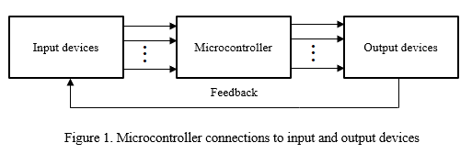

In the specific case of this paper, we are dealing with the electronic system built based on the LDR (Light Dependent Resistor) sensor technology, which is connected to the input of the microcontroller and to the analog pin-port A0 [1], [4], [29], [30]. At the output of the microcontroller, an electromagnetic relay with two contacts NO and NC is connected to the electromagnetic coil 5 [VDC] that enables the lighting system of the spaces, either private or public, with a voltage source of the electrical network of 220 [VAC] [13], [22]. Of course, for the operation of this system built based on the LDR sensor, it is necessary to write the program code in the C++ programming language inside the Arduino Uno environment. The software code works on the basis of the analog input signal brought by the LDR sensor depending on the degree of brightness of the environment where the system is located. Therefore, the analog signal is variable [4], [5]. Depending on the degree of brightness of the environment where the LDR sensor is located, its resistance also changes according to the function given in Figure 2.

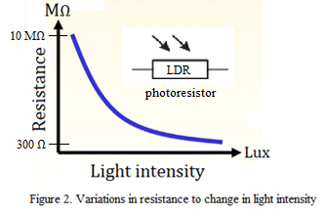
For any value of the change in the resistance of the LDR sensor under the influence of light, be it natural within 24 hours or the influence of an artificial light caused by alternative electrical sources, the measurements are performed and at the same time, through the program code loaded in the Arduino Uno module, it is ordered to turn on or off the contact relay so that the system based on the LDR sensor works [7], [11], [14]. The essential purpose of this paper is to measure not only the change in resistance but also the voltage and current intensity in the LDR sensor circuit within every second if we want that too without completely disconnecting the electrical circuit in the system. These measurements serve us for certain values ​​to activate the electrical circuit of the 220 [VAC] network in order to illuminate the darkened environment or in special cases it can also be used in medicine to determine the wavelength of light which affects in the human eye. This will be the subject of the study of the next paper in collaboration with health professionals and optical physics [12], [15], [16].
The block diagram of the connection system for public lighting based on the sensor consists of various electronic elements and programmable technology, respectively microcontroller, and is presented as in Figure 3.
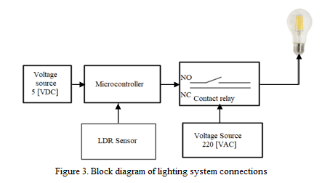
The graphic algorithm for switching on or off the public lighting looks like in Figure 10:

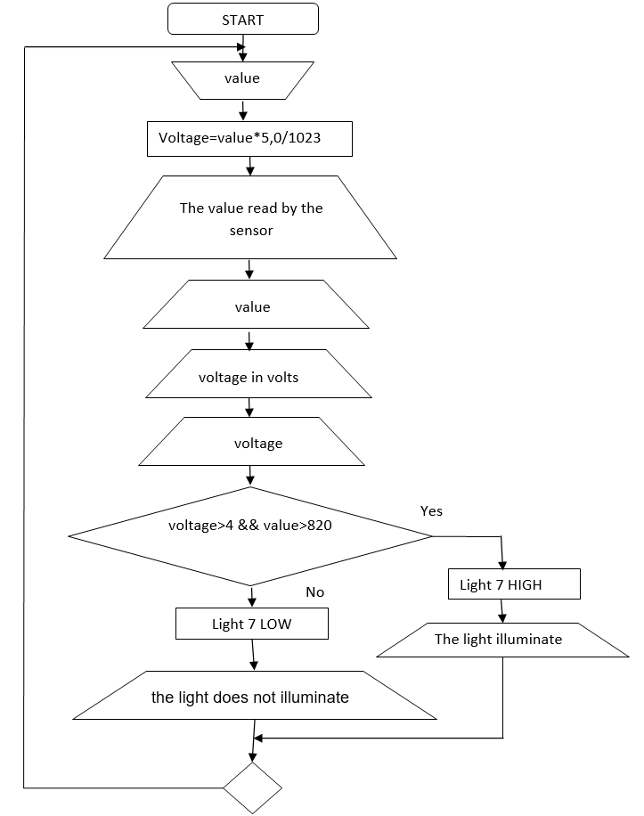

Figure: The graphic algorithm for switching on or off the public lighting
The program code for the intelligent operation of the lighting of public spaces or any space where people want to implement them looks like the following:

int light = 7; //output pin 7 on the Arduino turns on the light and connects to the IN1 pin of the relay
void setup(){
pinMode(light, OUTPUT); // pin 7 is declared output
Serial.begin(9600); // microcontroller communication with computer
}
void loop()
{
int value=analogRead(A0); //read luminance values ​​[0.1023]
float voltage=(value*5.0)/1023; //voltage calculation
Serial.print("The value read by the sensor:\t"); //text to Serial Monitor
Serial.print(value); //print the values ​​read in the range [0,1023]
Serial.print("\t"); //tab between texts in Serial Monitor
Serial.print("Voltage in Volts:\t"); //print the text
Serial.print(voltage);// print calculated voltage values ​​in volts
if ((voltage > 4)&&(value > 820)) // the condition when for voltage > than 4 volts the light turns on
{
digitalWrite(light, HIGH);// light turns on and illuminates
Serial.println("\t the light illuminate ");
}
otherwise
{
digitalWrite(light, LOW);// the light turns off and does not illuminate
Serial.println("\t the light does not illuminate ");// text in Serial Monitor
}
delay(1000);// read analog signals in LDR Sensor every second
}
After uploading this program code to the microcontroller Arduino Uno ATMEGA 328P in the Serial Monitor window we will have the read analog values ​​converted through the A/D converter into digital numerical values ​​as well as the voltage values ​​in the LDR sensor depending on the level of ambient brightness as in Figure 11.

Figure: Serial Monitor window with measured voltage, and reading the analog signals converted to digital and displaying the information that the 220 [VAC] light is lighting or not

