## Web Programming & Framework 1 - ITE-5315-0NA

Step 1:

Step 2:

Step 3:

http://localhost:3000/

<http://localhost:3000/users>

http://localhost:3000/notExist

Step 4:

1. Main.hbs is a main layout for all the route in our application. This layout includes dynamic title and body which we are sending from app.js when a route is called. We are calling main.hbs using template engine which automatically detects the layout from the layout folder in views.
2. In index.hbs we are displaying the title “Express” to the user on the browser. We are using template engine which call index.hbs from views and provide data for title “Express”. This same applies to error.hbs in which if user enters an invalid route error.hbs will show message attribute “Wrong route”.
3. If we comment this line “app.use(express.static(path.join(__dirname, 'public')));”, we won’t be able to use public directory. In our case we speciallt won’t be able to use our stylesheet for our application.
4. Comments

Step 5:

Step 6:

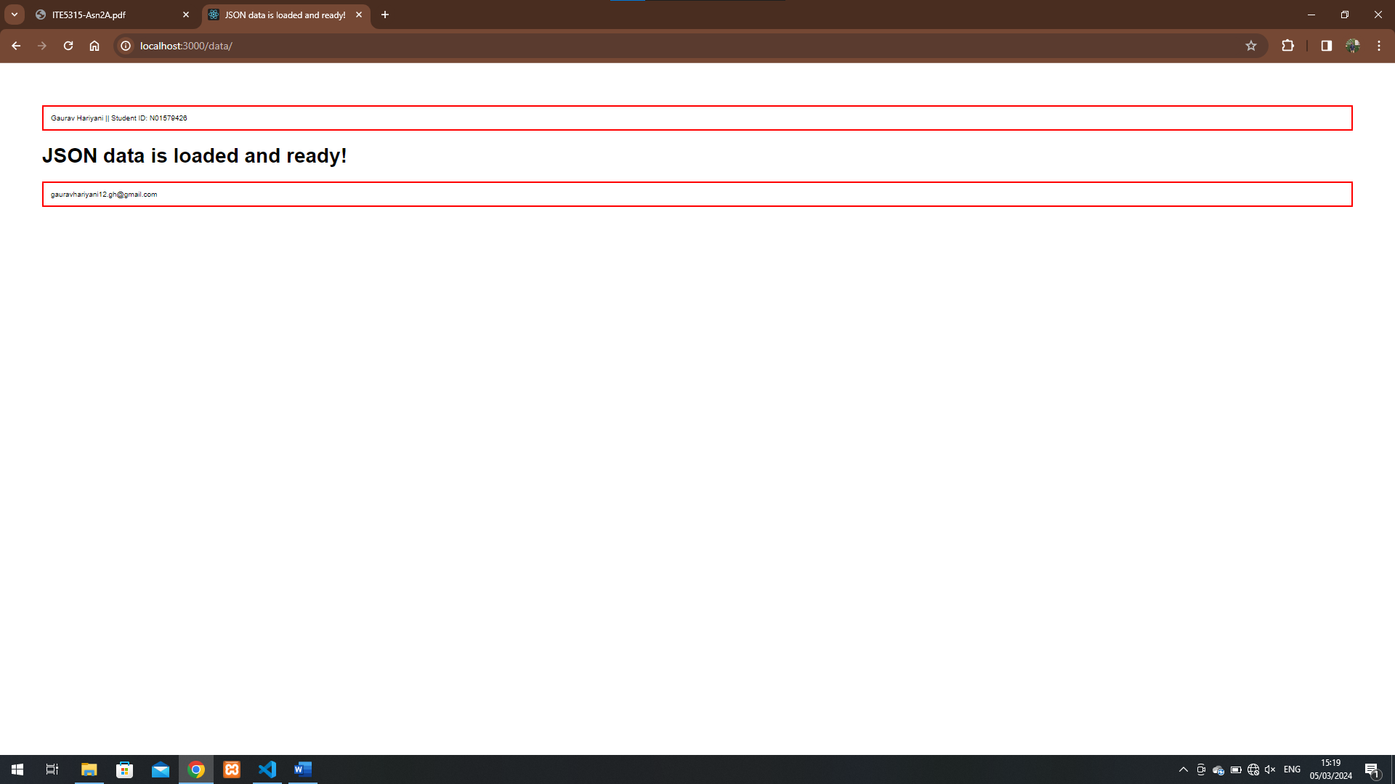

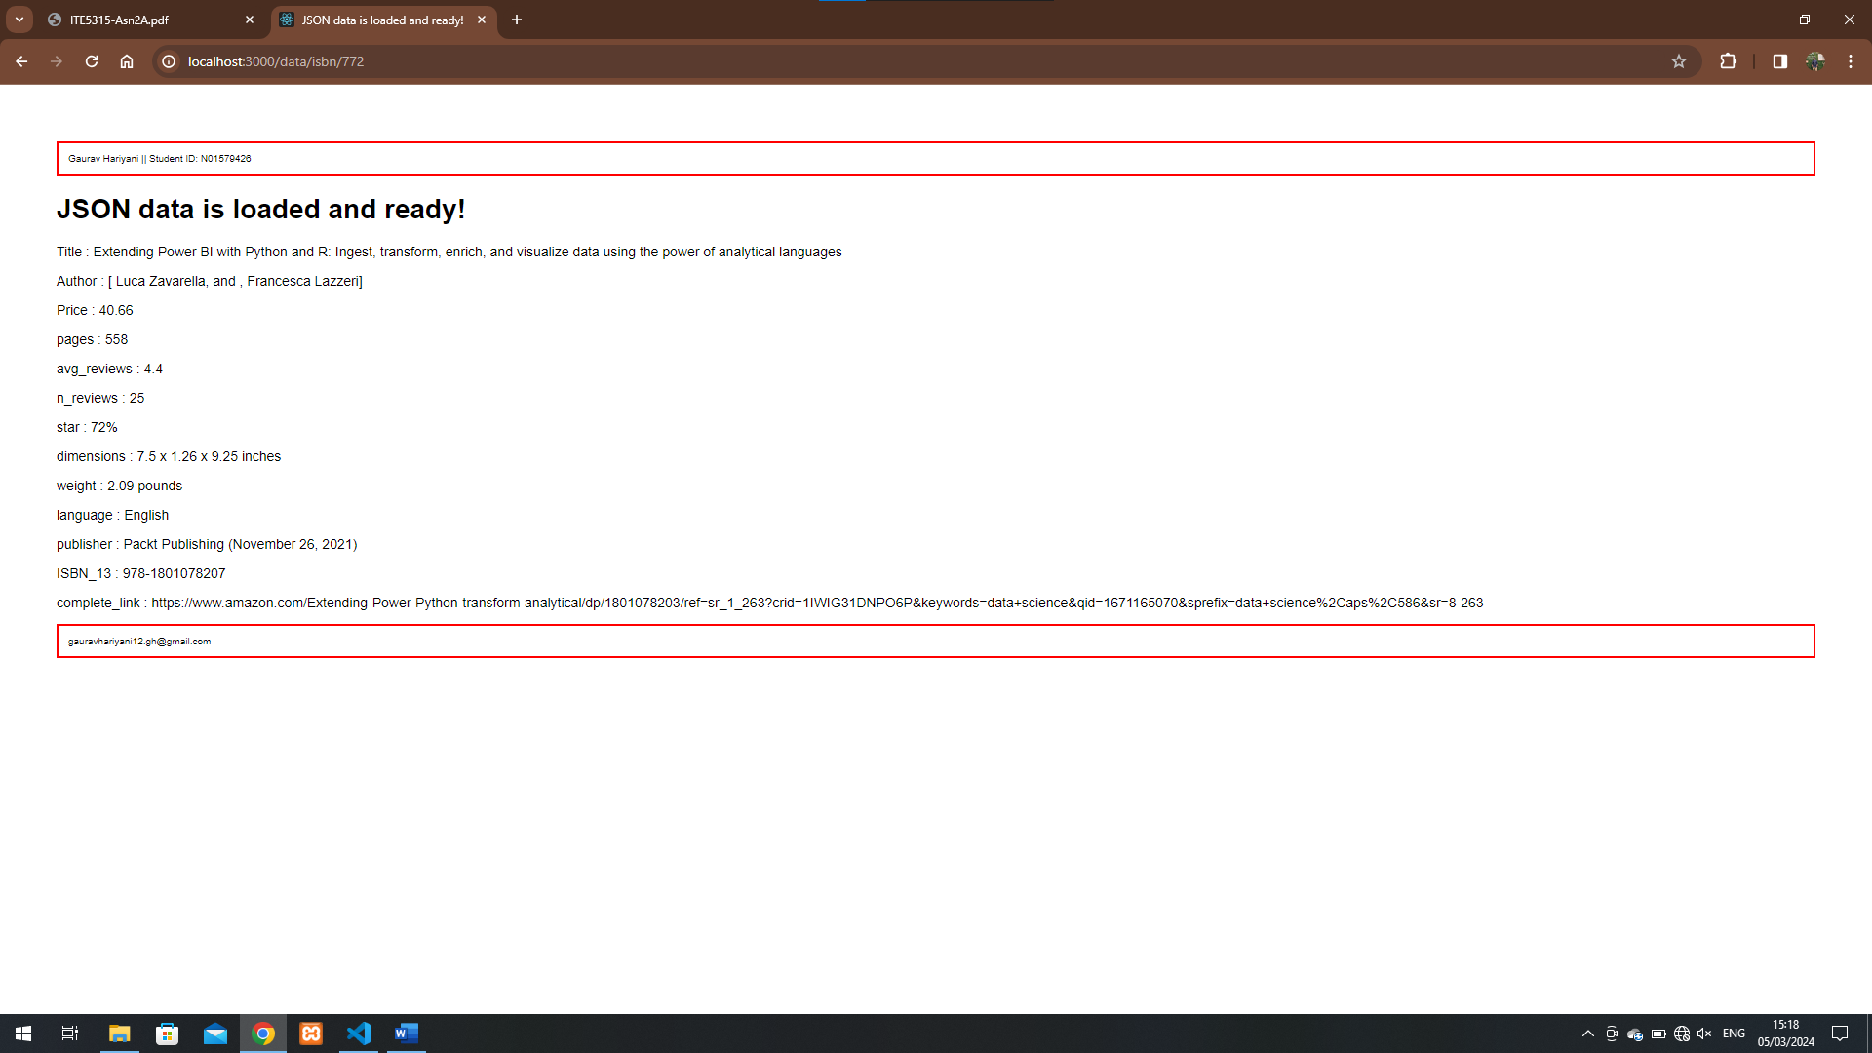

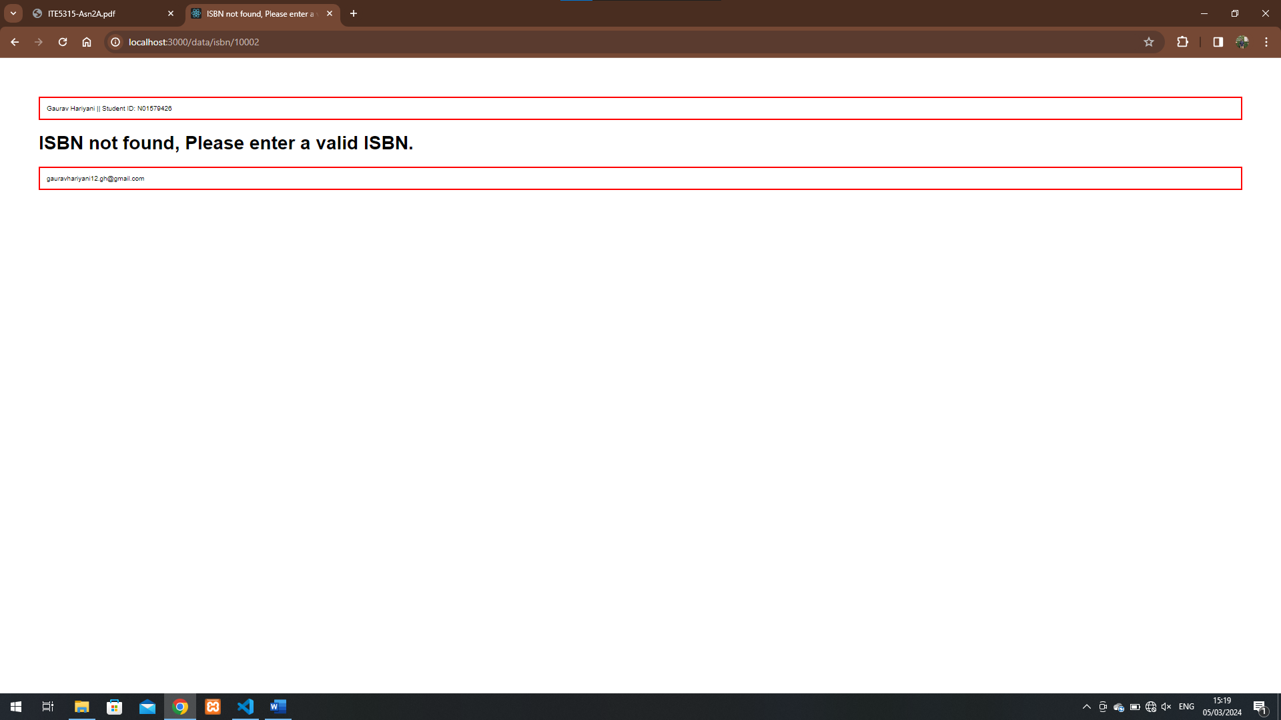

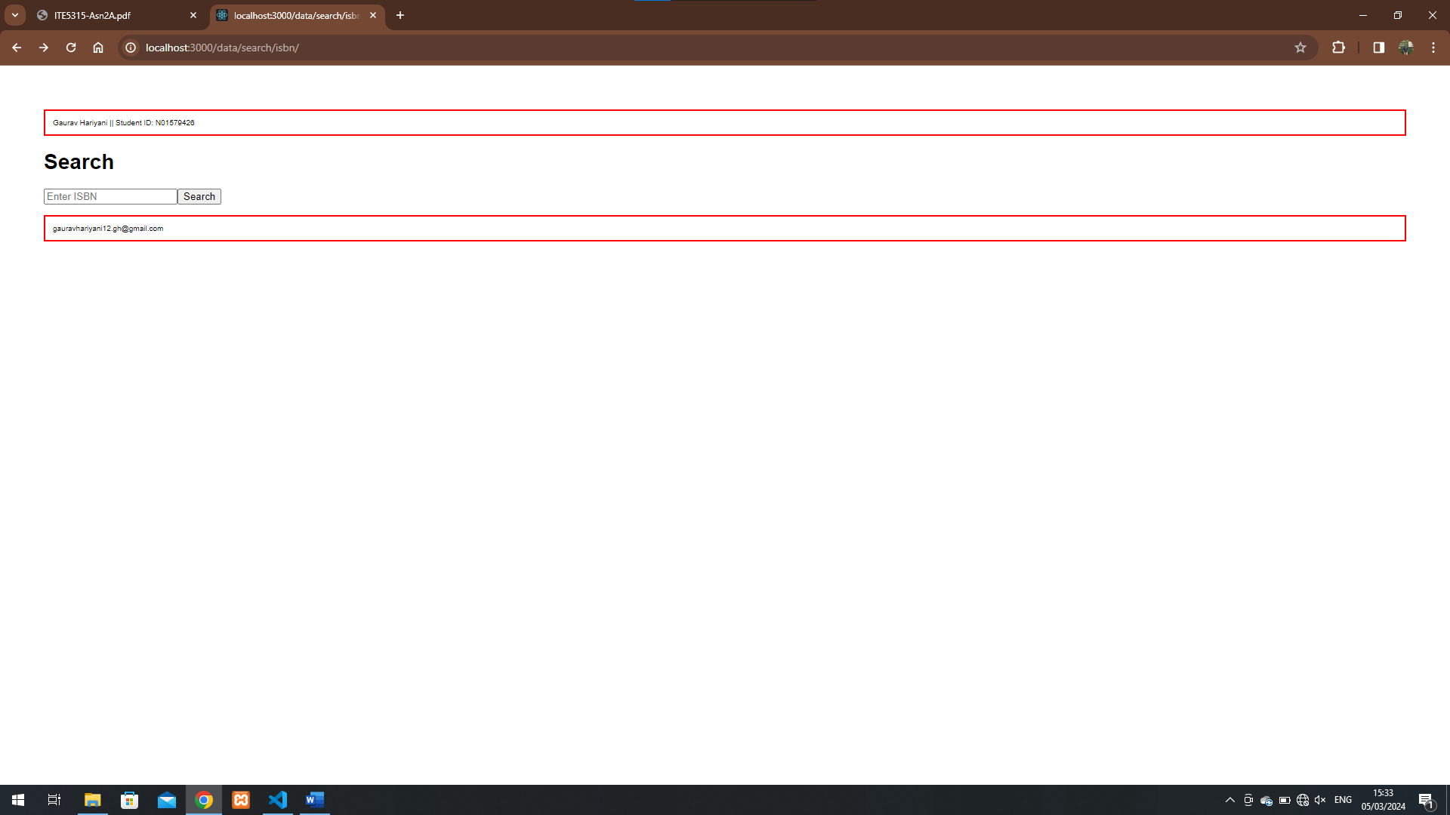

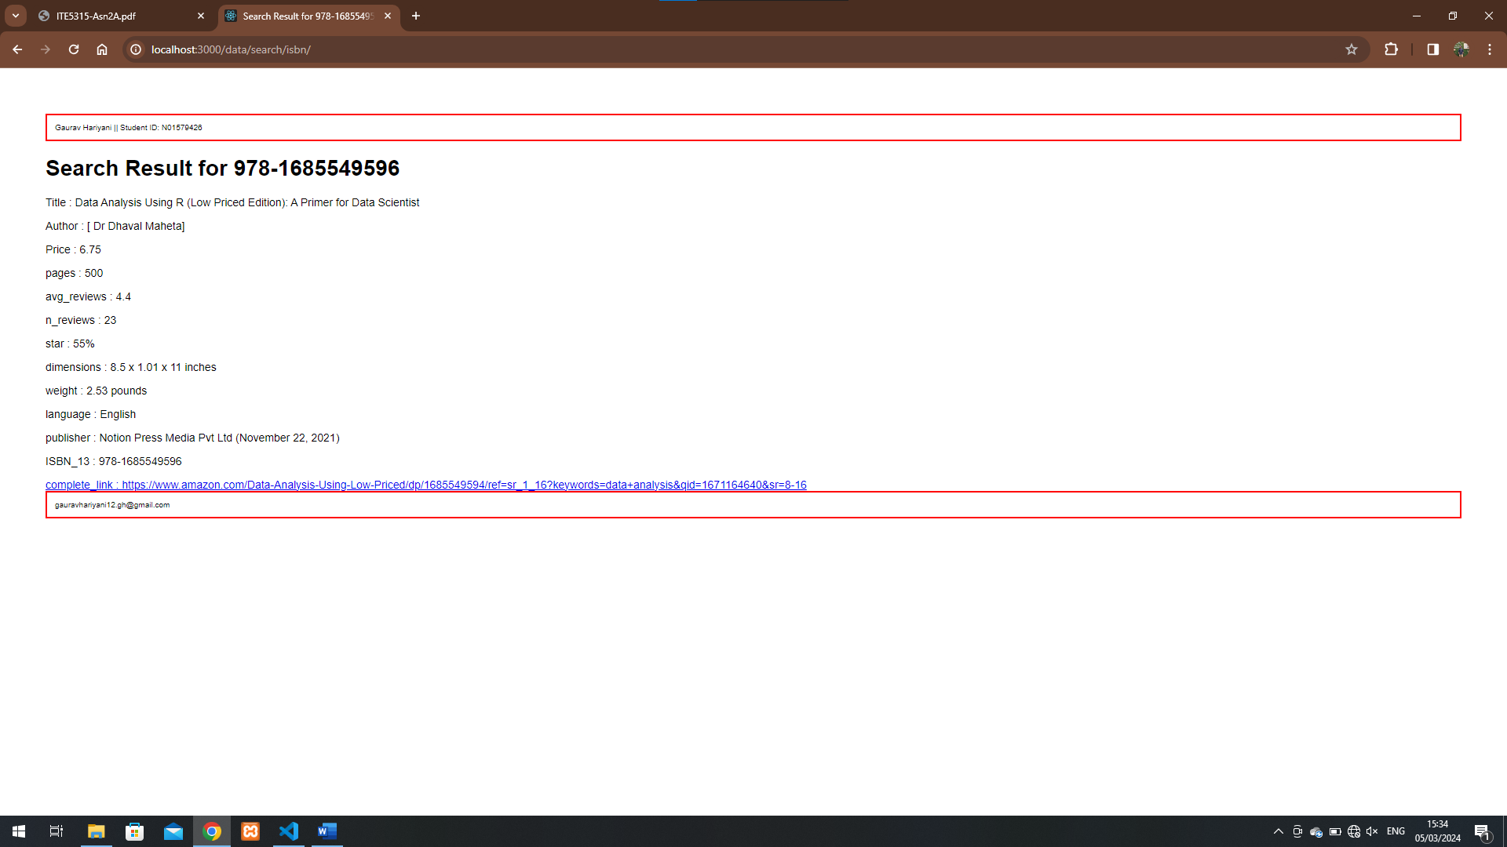

Step 7:

Step 8:

Step 9:

Step 10:

No, I did not find any use of partial templates in this activity.

Step 11:

<https://super-elk-tutu.cyclic.app/>