AUTONOMOUS CONTROL AND DIAGNOSTIC FRAMEWORKS FOR ADVANCED NUCLEAR FISSION REACTORS: A PHYSICS-INFORMED CYBER-PHYSICAL ARCHITECTURE
[Author Name]¹
¹ [Department], [Institution], [City], [Country]
Corresponding author: [email]

Abstract
Abstract — The integration of artificial intelligence (AI) into nuclear power engineering has advanced rapidly over the past two decades, yet the resulting methods remain fragmented across scales: plant-level cyber-physical architectures, microphysical nuclear-data surrogates, organisational human-factor diagnostics, and explainability research have each matured largely in isolation. This paper reviews four complementary bodies of work and synthesises them into a single, explicitly layered architecture for supervised autonomy in advanced fission reactors, which we designate the Physics-Informed Cyber-Physical Nuclear Control (PI-CPNC) framework. The review component surveys the applications of AI to reactor design optimisation and to operation and maintenance (O&M), and tabulates the distribution of method families across 106 reviewed studies. The synthesis component formalises a five-tuple architecture comprising a human-operator layer, an AI-enabled cyber layer, a physical plant layer, a digital-twin data infrastructure, and explicit feedback and decision pathways. Within this architecture, Gaussian mixture models (GMM) and Gaussian process regression (GPR) are positioned as probabilistic surrogates that supply calibrated uncertainty for sparse nuclear data; generative-adversarial and isolation-forest analyses of administrative, operational, and maintenance loops are positioned as an organisational risk channel that conventional plant instrumentation does not observe; and physics-informed neural networks (PINNs), Shapley attribution, and causal inference are positioned as the mechanisms that render the cyber layer auditable. A numerical demonstration on one-delayed-group point kinetics shows that imposing the governing balance equations as collocation constraints reduces the mean absolute extrapolation error of a sparse-data surrogate from 4.16 to 0.005 in normalised neutron density over a horizon in which no training data exist — a factor of roughly 830. Four architectural design constraints follow from the synthesis: uncertainty must be propagated end-to-end and must gate autonomy; AI must never hold authority over the reactor protection system; explainability is necessary but not sufficient for reliability; and predictive accuracy is not evidence of physical validity or of regulatory acceptability. The paper closes with a staged qualification pathway and a five-level autonomy ladder intended to structure the transition from monitoring to restricted autonomy. This work is a review and architectural synthesis; it does not report a licensed or deployed autonomous control system.
Keywords: nuclear power plant; artificial intelligence; cyber-physical systems; digital twin; Gaussian process regression; Gaussian mixture model; fission product yield; human factors engineering; physics-informed neural networks; explainable AI; causal inference; supervised autonomy; small modular reactors.

Nomenclature
AANN | Auto-associative neural network | LSTM | Long short-term memory network
AAKR | Auto-associative kernel regression | MCC | Matthews correlation coefficient
ACE | Average causal effect | NPP | Nuclear power plant
ANFIS | Adaptive neuro-fuzzy inference system | NPPHCPS | NPP human-cyber-physical system
ANN | Artificial neural network | O&M | Operation and maintenance
BPNN | Back-propagation neural network | OODG | Out-of-distribution generalisation
CHF | Critical heat flux | PCA | Principal component analysis
CNN | Convolutional neural network | PHM | Prognostics and health management
DRL | Deep reinforcement learning | PI-CPNC | Physics-informed cyber-physical nuclear control
EM | Expectation-maximisation | PINN | Physics-informed neural network
FDD | Fault detection and diagnosis | PWR | Pressurised water reactor
FPY | Fission product yield | RBF | Radial basis function
GAN | Generative adversarial network | ROM | Reduced-order model
GMM | Gaussian mixture model | RPS | Reactor protection system
GPR | Gaussian process regression | RUL | Remaining useful life
HPC | High-performance computing | SHAP | Shapley additive explanations
iForest | Isolation forest | SMR | Small modular reactor
JENDL | Japanese Evaluated Nuclear Data Library | SVM | Support vector machine
LIME | Local interpretable model-agnostic explanations | XAI | Explainable artificial intelligence

1. Introduction

1.1 Motivation
Nuclear energy occupies a distinctive position among low-carbon generation technologies. Unlike wind and solar generation, whose output is intermittent and whose large-scale integration remains contingent on the maturity of energy-storage technology, nuclear fission supplies dispatchable base-load electricity with negligible direct carbon emissions during operation [1,4]. As decarbonisation targets tighten and as electrification extends into transport, heating, and hydrogen production, the demand for stable zero-carbon capacity is expected to grow accordingly. Global installed nuclear capacity exceeded 390 GW across 447 operating units at the time of the most recent systemic surveys, with more than sixty units under construction and a further one hundred and sixty planned [1].
Whether that capacity is realised, however, depends less on the physics of fission than on the economics and the safety case of plant operation. O&M costs account for approximately 60–70% of the total operating cost of a nuclear power plant, compared with the 15–30% attributable to fuel [4]. Reducing O&M expenditure without eroding safety margins is therefore the single most effective lever available for improving the competitiveness of nuclear generation. At the same time, nuclear power plants (NPPs) have accumulated decades of instrumentation data that remain substantially underexploited. The conjunction of a strong economic incentive, a large latent data asset, and the maturation of modern machine learning has produced a rapid expansion of AI research in the nuclear sector, particularly since 2016 (Fig. 3a).
The engineering problem, however, is not simply one of increasing computational intelligence. It is the problem of integrating intelligence into a safety-critical system whose behaviour emerges across several distinct spatial and temporal scales simultaneously. At the microphysical scale, neutron transport, fission-fragment distributions, and radiation–material interactions determine the fundamental data on which every downstream model depends. At the component scale, coolant flow, heat transfer, and material degradation govern equipment behaviour. At the plant scale, control logic, protection systems, and instrumentation determine observable state. At the organisational scale, staffing levels, maintenance backlogs, procedural discipline, and operator workload determine whether the designed safety functions are in fact delivered. A framework that addresses only one of these scales cannot make a credible claim about the safety of the whole.

1.2 Limitations of current practice
The systemic review of AI in NPPs identifies three recurring limitations of contemporary plant operation [1], each of which motivates a distinct element of the architecture developed in this paper.
First, faults and instrument degradation are pervasive in a system of this complexity. Sensor drift, missed information, spurious alarms, and equipment failure all degrade performance. Drift in steam-generator feed-water flow sensors alone can reduce reactor power output by as much as 3% [1]. Errors during turbine testing were a proximate contributor to the most severe nuclear release in history [1]. Fault detection and diagnosis (FDD) is consequently the most active application area for AI in the nuclear sector, and the one in which the most substantial progress has been achieved [4].
Second, the degree of automation remains low relative to other safety-critical industries. The automation of NPP safety functions has not reached autonomous control, and operator intervention remains essential to a large fraction of plant control [1]. Increasing digital connectivity, moreover, introduces information-security exposure that legacy electrical and instrumentation systems were never designed to resist [1].
Third, the burden placed on human operators is cognitive as well as procedural. Human error is estimated to contribute to 70–90% of NPP incidents [1]. During abnormal events, many alarms arising from different systems may annunciate simultaneously, making the selection of the correct response difficult. Digitalisation of the control room has not straightforwardly resolved this: while digital interfaces increase the quantity of information available, they also introduce interface-management tasks that can increase rather than reduce workload [1].
A fourth limitation arises within the machine-learning layer itself rather than within the plant. The review of AI applied to nuclear reactors identifies two categories of obstacle to real-world deployment [4]: data issues — insufficient experimental data, distribution drift between training and deployment, and severe class imbalance between normal and fault samples — and the black-box dilemma, in which the models that perform best are precisely those whose internal reasoning is least accessible to inspection. Both categories are directly relevant to licensing, because a regulator cannot accept a control function whose failure modes cannot be characterised.

1.3 Contribution
This paper makes four contributions.
- It reviews four complementary bodies of work — a systemic review of AI in NPPs under the Industry 4.0 paradigm [1]; a human-factors study of administrative, operational, and maintenance control loops using AI classification, multivariate ANOVA, generative adversarial networks (GAN), and isolation forests [2]; a machine-learning treatment of fission product yields using GMM and GPR on evaluated nuclear data [3]; and a review of AI applied to nuclear reactor design and O&M with emphasis on scientific machine learning, explainability, and causal learning [4] — and tabulates the distribution of AI method families across the reviewed study inventories.
- It synthesises these into a single formally specified architecture, PI-CPNC, in which each source contributes a distinct and non-overlapping layer, and in which the interfaces between layers are stated explicitly rather than assumed.
- It provides a numerical demonstration, on one-delayed-group point kinetics, of the quantitative benefit that physics constraints confer on a sparse-data surrogate operating outside its training envelope.
- It derives four architectural design constraints and a staged qualification pathway, and proposes a five-level autonomy ladder for structuring the transition from monitoring to restricted autonomy.

The scope of the paper should be stated plainly. This is a review and architectural synthesis. The reviewed sources collectively demonstrate a set of methodological building blocks; they do not collectively demonstrate an autonomous nuclear reactor, and this paper does not claim that they do. The architecture proposed here is a design proposal whose components have differing levels of experimental maturity, and Section 9 states explicitly which components remain unvalidated.

1.4 Organisation
Section 2 describes the review methodology and the source corpus. Section 3 surveys the landscape of AI applications to reactor design optimisation and to O&M. Section 4 develops the PI-CPNC architecture. Section 5 presents the probabilistic physics-surrogate layer. Section 6 presents the human-factor diagnostic layer. Section 7 develops the physics-informed and explainable control layer, including the numerical demonstration. Section 8 addresses uncertainty propagation, distribution drift, cybersecurity, and the qualification pathway. Section 9 discusses open challenges and sets out a research agenda. Section 10 concludes.

2. Review Methodology and Source Corpus
The synthesis presented in this paper rests on a corpus of four primary sources selected for scale complementarity rather than for topical similarity. Each addresses a different level of the nuclear engineering problem, and each employs a methodology that the others do not. Table 1 summarises the corpus, the methodological contribution of each source, and the layer of the proposed architecture to which each contributes.
Table 1. Source corpus, methodological contribution, and architectural role.
Src | Study type and scale | Methodological contribution | Role in the PI-CPNC architecture
A [1] | Systemic review, plant and organisational scale; 106 studies over two decades | NPPHCPS three-layer top-level design; taxonomy of physical-plant-centred and human-operator-centred applications; HPC requirement | Supplies the macro-architecture: the human, cyber, and physical layers and their interfaces
B [2] | Simulated human-factors study, organisational scale | Administrative, operational, and maintenance loop parameterisation; naive Bayes classification; multivariate ANOVA; GAN interdependency analysis; isolation-forest dependency screening | Supplies the organisational risk channel and the criticality thresholds used by the diagnostic engine
C [3] | Applied machine-learning study, microphysical scale | GMM formulation and EM estimation; GPR formulation with constant, RBF, rational-quadratic, and ExpSineSquared kernels; JENDL-based fission-yield modelling with uncertainty quantification | Supplies the probabilistic surrogate layer and its calibrated uncertainty estimates
D [4] | Review, method scale | Design-optimisation and O&M application taxonomy; data drift and black-box dilemma; scientific machine learning and PINNs; SHAP/LIME; causal learning for out-of-distribution generalisation | Supplies the physics-informed and explainability layer and the diagnosis of open problems

Supporting literature cited throughout the paper is drawn from the bibliographies of these four sources and is used to substantiate specific technical claims. Where a quantity, threshold, or performance figure is attributed to a source, it is reported as that source states it. Where an expression is introduced by the present synthesis and is not reported by any source, this is stated explicitly at the point of introduction. This convention is applied consistently, because the distinction between reviewed evidence and proposed extension is precisely what determines whether a claim can be relied upon for a safety argument.

3. The Landscape of Artificial Intelligence in Nuclear Reactors

3.1 Design optimisation
A nuclear reactor core is a coupled multiphysics system spanning neutronics, thermal hydraulics, materials science, and radiation shielding. Its design involves combinatorial and continuous optimisation problems whose objective landscapes are non-convex, high-dimensional, and expensive to evaluate. Evolutionary computation was consequently the first family of AI methods to find sustained application in the field.
In-core fuel management and loading-pattern optimisation have been addressed with genetic algorithms (GA) since the early 1990s [11,12], subsequently extended to constrained formulations with penalty functions [13], multi-objective variants [14,15], and parallel implementations that improve both computational efficiency and solution quality [16]. Swarm-intelligence approaches followed: ant-colony optimisation has been applied to boiling-water-reactor fuel lattice design and to pressurised-water-reactor loading patterns [17,18], and the artificial bee colony method has been shown to reduce computational cost substantially by employing significantly fewer control parameters than comparable population-based algorithms [19]. Hopfield artificial neural networks have been used to obtain suitable power-peaking factors and effective multiplication factors for VVER-1000 fuel management [20] and to determine axial enrichment distributions that flatten the neutronic flux [21]. Reinforcement learning has been applied to fuel-assembly optimisation and shown to outperform alternative methods for boiling-water-reactor assemblies [22]; a hybrid rule-based framework combining reinforcement learning with evolutionary computation has been reported to reduce computing time while improving optimisation performance [23].
Thermal-hydraulic analysis presents a different computational bottleneck: the cost of the underlying computational fluid dynamics and system codes. Surrogate modelling addresses this directly. Deep neural network models with scaled exponential linear unit activation have been used for rapid prediction of steam-generator thermal-hydraulic parameters with results in agreement with established system codes [24,25]; physics–deep-learning coupled frameworks have accelerated the convergence of Reynolds-averaged Navier–Stokes simulations [26]; and deep-learning-based reduced-order models have achieved computational speed-ups of nearly two orders of magnitude at acceptable error [27,28]. Critical heat flux (CHF) prediction, historically dependent on empirical correlations and look-up tables, has been extensively addressed with neural networks [29,30] and, more recently, with the physics-informed machine-learning-aided framework (PIMLAF), which models the residual between mechanistic prediction and experiment and has demonstrated both higher accuracy and stronger generalisation than the underlying mechanistic model alone [31].
Radiation shielding design is an inherently multi-objective “dose–weight–volume” problem [32] whose conventional solution by discrete-ordinates or Monte Carlo methods is computationally expensive in high dimension. GA has been applied to both single- and multi-objective formulations [33]; the macroscopic near-optimal shielding method determines optimal thickness and material configuration under constraint [34]; and neural-network surrogates have estimated mass attenuation coefficients with error below 0.0033 relative to Monte Carlo results [35]. Particle-swarm optimisation combined with Monte Carlo has been used to adjust shield material type and thickness automatically for marine reactors [36].

3.2 Operation and maintenance
The O&M domain accounts for the majority of AI applications in the nuclear sector, and divides into three functional areas: online condition monitoring, fault diagnosis, and predictive maintenance.
Online condition monitoring aims to track safety parameters in real time, to reduce excessive conservatism in operating procedures, and to support economical refuelling planning [4]. Auto-associative neural networks (AANN), whose input and output are the same set of plant parameters, were among the first architectures proposed for online monitoring and sensor calibration [37,38], and have been applied to simultaneous instrument faults [39], online sensor calibration for boiling-water reactors [40], and sensor error verification for U-tube steam generators [41]. Recurrent architectures have been validated on data generated by high-temperature gas-cooled reactor simulators [42]. Radial-basis-function networks, the group method of data handling, and the Levenberg–Marquardt algorithm have been adopted for control-rod position monitoring from in-core neutron flux measurements [43]. For short-term trend prediction, neuro-fuzzy techniques have been applied to steam-generator water level under transient conditions [44], and ensemble online sequential extreme learning machines have achieved fast learning without significant overfitting for flow-oscillation pattern recognition [45]. Deep networks combined with genetic optimisation have predicted water-level changes during severe accidents [46], and DNN/LSTM models have predicted loss-of-coolant-accident outputs — temperature, pressure, break flow rate, water level — with minimum accuracy of 92% and maximum accuracy of 99%, reported as 100 000 times faster than the original simulation tool [47].
Fault diagnosis may be the most active application of AI in the nuclear field [4], and divides into system-level and component-level work. At system level, self-optimising networks with dynamic node architecture [48], dual-channel convolutional networks [49], deeply structured accident-identification systems capable of responding to “don’t know” events [50], and kernel-PCA with similarity clustering [51] have all been reported. Accident identification accuracies of 99.82% have been reported for deep-learning classifiers on the standard scenario sets [4]. At component level, unsupervised clustering has discriminated pressuriser transients [52], auto-associative kernel regression has been applied to reactor coolant pumps [53], weakly supervised LSTM has extracted anomalous features from rotating-bearing time series [54], and convolutional recurrent networks have shown the best performance among four deep-learning methods for rotating machinery [55]. For steam generators specifically, the group method of data handling with PCA has generated fault signatures [56], optimised SVM has detected incipient and large leakages [57], and ANFIS applied to simulated steam-generator tube-rupture scenarios has reported errors below 1% against thermal-hydraulic code [58].
Predictive maintenance seeks to replace the prevailing time-based preventive strategy — which uses average service life and ignores the actual condition of specific equipment — with condition-based intervention driven by remaining-useful-life (RUL) prediction [59]. Two classes of method are distinguished [4]: direct mapping, in which models learn the relationship between sensor data and RUL directly [60,61], and degenerate trajectory modelling, in which the degradation process is described by a trajectory metric and failure is declared at a threshold [62]. An improved temporal convolutional network integrating a high-performance convolutional autoencoder layer has been applied to the RUL estimation of electric gate valves in NPPs, using differential pressure, flow, and acoustic-wave signals as features representing valve ageing [63].

3.3 Quantitative characterisation of the field
Fig. 3 characterises the field quantitatively. Panel (a) shows the temporal distribution of the 106 studies reviewed in the systemic survey [1]: research activity remained approximately flat from 2001 to 2015 at two to five publications per year, then accelerated sharply after 2016, reaching twenty-one publications in 2020 alone. This inflection coincides with the diffusion of deep learning beyond computer vision and natural language processing into engineering domains [4].
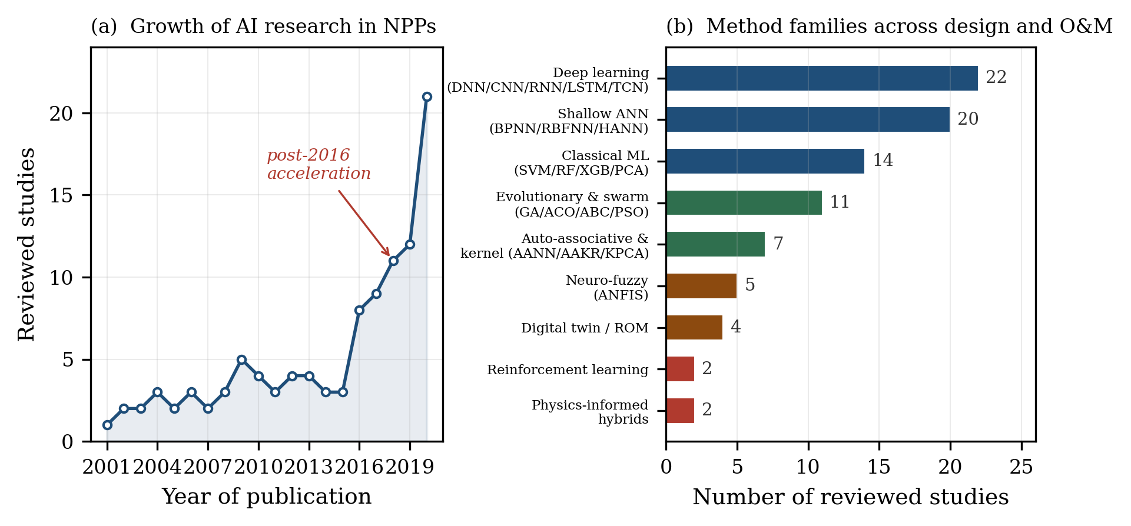
Fig. 3. Quantitative characterisation of AI research in nuclear reactors. (a) Temporal distribution of reviewed studies, showing the post-2016 acceleration; values are approximate counts digitised from the distribution reported in [1]. (b) Distribution of AI method families across the study inventories of [1] and [4], tabulated by the present author. A single study may employ more than one method family.
Panel (b) tabulates the distribution of method families across the combined study inventories. Three observations follow. First, deep learning and shallow neural architectures together account for the substantial majority of applications, reflecting the field’s orientation toward supervised function approximation. Second, evolutionary and swarm methods retain a distinct and durable niche in design optimisation, where the objective is combinatorial search rather than pattern recognition. Third — and most consequential for the argument of this paper — the two categories most relevant to safety qualification, reinforcement learning and physics-informed hybrids, are represented by the fewest studies. The methods with the strongest claim to physical validity are the least developed, and the methods with the strongest predictive performance are the least interpretable. Section 7 addresses this asymmetry directly.
Table 2. Representative AI applications in nuclear reactor design optimisation and O&M, with reported outcomes.
Application | Method | Reported finding | Ref.
In-core fuel management | GA | Global search advantage over simulated annealing for parallel computing | [11]
Fuel loading pattern | Multi-objective GA | Improved design instability of fast breeder reactors through proper control | [15]
Core design | Parallel GA | Gains in both computational efficiency and optimisation outcome | [16]
In-core fuel management | Artificial bee colony | Reduced computational cost using significantly fewer control parameters | [19]
Nuclear assembly design | RL-guided EA | Outperformed standalone algorithms by a wide margin in exploration capability | [23]
Thermal-hydraulic acceleration | DL-based ROM | Runtime reduced by nearly two orders of magnitude at acceptable error | [27]
CHF prediction | PIMLAF | Higher accuracy and stronger generalisation than the mechanistic model alone | [31]
Shielding material attenuation | ANN | Determination coefficient of 1 and RMS error of 0.0033 against Monte Carlo | [35]
Online monitoring and verification | AANN | Applicable to online sensor verification; identical input and output parameter sets | [37]
Control-rod position monitoring | RBFNN, GMDH, LM | All three methods unfolded rod position from in-core flux measurements | [43]
LOCA parameter prediction | DNN/LSTM | 92–99% accuracy; 100 000× faster than the original simulation tool | [47]
System-level fault diagnosis | Deep learning | Accident identification at 99.82% accuracy including unknown-situation handling | [50]
Fault diagnosis, rotating machinery | CRNN | Best sample-learning capability and anti-noise robustness among four DL methods | [55]
Steam-generator tube rupture | ANFIS | Error below 1% against thermal-hydraulic code on simulated SGTR scenarios | [58]
RUL of electric gate valves | TCN with autoencoder | Improved feature extraction; addressed high computational cost of LSTM and RNN | [63]

4. The PI-CPNC Architecture

4.1 Formal specification
The architectural foundation adopted here is the Nuclear Power Plant Human-Cyber-Physical System (NPPHCPS), developed in [1] by adapting the Human-Cyber-Physical System paradigm and the Healthy Operator 4.0 concept to the nuclear domain. NPPHCPS comprises three interacting layers — human operator, cyber system, and physical system — in which the cyber layer functions as the interface and the connective tissue between the other two [1]. The present synthesis extends this by making the data infrastructure and the decision pathways first-class architectural elements rather than implicit couplings, giving the five-tuple
A_{PI}-CPNC = { H, C, P, D, F } (1)
where H denotes the human-operator layer, C the AI-enabled cyber layer, P the physical plant layer, D the data and digital-twin infrastructure, and F the set of feedback and decision pathways connecting them. The explicit inclusion of D and F is the contribution of this synthesis: the reviewed literature treats data infrastructure as an enabling technology and decision pathways as an operational detail, whereas in a safety argument both are load-bearing. Fig. 1 presents the resulting architecture.
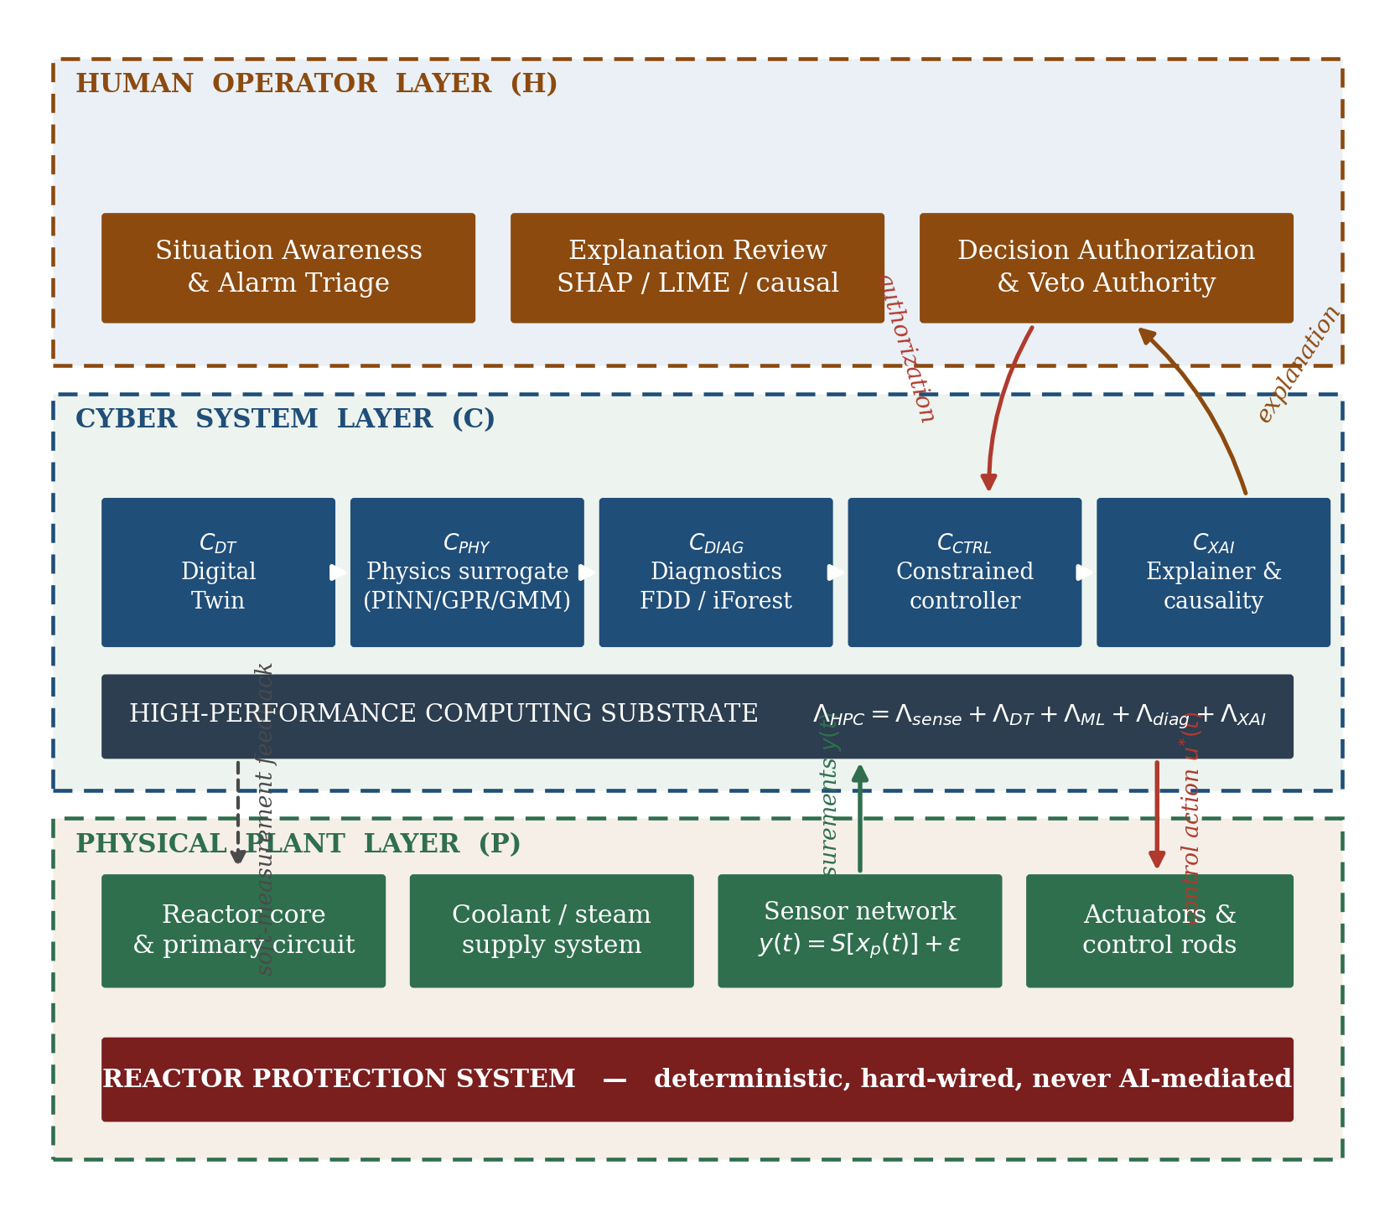
Fig. 1. The PI-CPNC architecture. Three layers interact through explicit information and decision pathways. The cyber layer decomposes into five engines sharing a high-performance computing substrate. The reactor protection system remains outside the AI-mediated path entirely and retains unconditional trip authority.

4.2 Physical plant layer
The physical layer contains the reactor, the primary and secondary circuits, fuel, sensors, actuators, instrumentation, and associated hardware. Its computational role within the architecture is the conversion of physical state into measurable digital information. The plant state vector is written
x_{p}(t) = [ P(t), T(t), p(t), ṁ(t), ϕ(r,t), C(t), u(t), s₁(t), …, s_{N}(t) ]ᵀ (2)
with P thermal power, T temperature field, p pressure, ṁ coolant mass flow, ϕ(r,t) the neutron flux distribution, C the delayed-neutron precursor concentration, u the control input, and sᵢ the auxiliary system states. The observation model is
y(t) = S[ x_{p}(t) ] + ε(t) (3)
where S is the sensor map and ε(t) the measurement noise, which in practice includes drift, quantisation, and intermittent dropout as well as stochastic noise. The distinction between xₚ and y is not merely notational. A substantial fraction of the state a controller would wish to act upon — the three-dimensional power distribution, local fuel temperature, crud deposition, incipient tube degradation — is not directly measured. The digital twin exists precisely to close that gap through soft measurement, and every claim made by the cyber layer about unmeasured state is therefore a model claim carrying model uncertainty.
The reactor protection system is deliberately excluded from the AI-mediated path. It is shown in Fig. 1 as a separate deterministic block retaining unconditional trip authority. This is a design constraint, not an implementation detail, and Section 7.6 develops its consequences.

4.3 Cyber system layer
The cyber layer is the computational core of the architecture. Following [1], it performs large-scale data processing, learning, perception, cognition, monitoring, and autonomous-control functions. The present synthesis decomposes it into five engines with distinct responsibilities:
C = { C_{DT}, C_{PHY}, C_{DIAG}, C_{CTRL}, C_{XAI} } (4)
where C_{DT} is the digital-twin engine, C_{PHY} the physics-surrogate engine, C_{DIAG} the diagnostic and anomaly engine, C_{CTRL} the constrained decision and control engine, and C_{XAI} the explainability and causal-analysis engine. Table 3 states the responsibility, the principal method families, the source of each engine within the reviewed corpus, and the current maturity of each. The maturity column is important: it makes visible that the architecture is not uniformly evidenced, and that its least mature elements are the ones nearest to control authority.
Table 3. Decomposition of the cyber layer: responsibility, methods, source, and maturity.
Engine | Responsibility | Principal methods | Source | Maturity in reviewed corpus
C_{DT} digital twin | Soft measurement of unobserved state; ultra-real-time consequence simulation | Mechanistic models, ROM, ML residual models | [1,4] | Demonstrated for specific quantities; uncertainty propagation open [4]
C_{PHY} physics surrogate | Fast prediction with calibrated uncertainty; nuclear-data augmentation | GPR, GMM, PINN, PIMLAF | [3,4] | Strong at component and data scale; not integrated at plant scale
C_{DIAG} diagnostics | Fault detection, isolation, classification; organisational anomaly screening | CNN, LSTM, AANN, AAKR, PCA/KPCA, iForest | [1,2,4] | Most mature area; high reported accuracies on confined datasets
C_{CTRL} control | Candidate action generation under explicit safety constraints | Constrained optimisation, DRL (proposed) | [1] | Proposed extension; not demonstrated by any reviewed source
C_{XAI} explainability | Attribution, causal analysis, audit trail generation | SHAP, LIME, causal graphs | [4] | Rarely applied in nuclear engineering; identified as a gap [4]

4.4 Human operator layer
In the NPPHCPS formulation the human-operator layer sits at the top of the framework, and operators are treated as an integral part of the intelligent system rather than as an external element acting upon it [1]. The reviewed literature is explicit that this reframing is motivated by workload: operators must be relieved of the fixed procedural tasks that generate error while retaining the judgement functions that machines cannot discharge [1].
Within PI-CPNC the human layer has three functions. It maintains situation awareness and triages alarms. It reviews the explanations produced by C_{XAI} — which requires that those explanations be intelligible under time pressure, a human-factors requirement that the XAI literature does not generally address. And it authorises or vetoes candidate control actions. The third function is what makes the architecture supervised rather than autonomous, and Section 7.6 discusses the conditions under which authority may be progressively delegated.

4.5 Computational infrastructure
The reviewed systemic survey identifies high-performance computing as a necessary condition for NPPHCPS, on the grounds that a deeply AI-integrated framework generates a large volume of data requiring processing each second, and that neural methods are computation- and time-intensive [1]. The aggregate computational load is
Λ_{HPC} = Λ_{sense} + Λ_{DT} + Λ_{ML} + Λ_{diag} + Λ_{XAI} (5)
subject to the hard real-time constraint
T_{compute} < T_{decision} (6)
Equation (6) is the constraint that most sharply limits which methods may occupy which position in the architecture. A method that improves accuracy at the cost of violating (6) is not an improvement, because a control decision delivered after the decision window has closed is worse than no decision at all: it may act on a state that no longer obtains. This consideration favours surrogate and reduced-order approaches within the control path, and confines expensive high-fidelity computation to offline model development, periodic revalidation, and non-time-critical consequence analysis.

4.6 Digital-twin integration
The digital twin is described in the reviewed literature as a cyberspace representation of the physical plant capable of supplying soft measurements of quantities that cannot be sensed directly, and of conducting ultra-real-time simulation of the consequences of alternative operating decisions [1,4]. Formally, the twin state is
x̂_{p}(t) = M( y_{0:t}, u_{0:t}, θ ) (7)
with M the twin model and θ its parameter set, updated continuously on the measurement–model mismatch by
θ_{t+1} = θ_{t} + η ∇_θ L_{DT} (8)
Digital-twin approaches reported in the reviewed corpus include data-enabled physics-informed machine learning for reduced-order modelling of neutron flux and power distributions [64], and an autonomous online calibration method that compensates the computational bias of low-precision models using an offline error database and continuous online measurement [65]. The reviewed literature is equally explicit that uncertainty quantification and propagation remain the principal open challenge for digital-twin application in nuclear engineering [4,66] — which is why uncertainty is treated in this architecture as a first-class signal rather than as a diagnostic afterthought (Section 8.1).

4.7 Information and decision workflow
Fig. 2 presents the operating workflow as an ordered pipeline. Measurements enter the estimator; the twin reconstructs full state; the physics surrogate supplies prediction with calibrated uncertainty; the controller proposes a candidate action; the safety projection filters that action against explicitly defined constraints; the explainer generates an attribution and a causal account; the operator authorises; and only then is the action actuated.
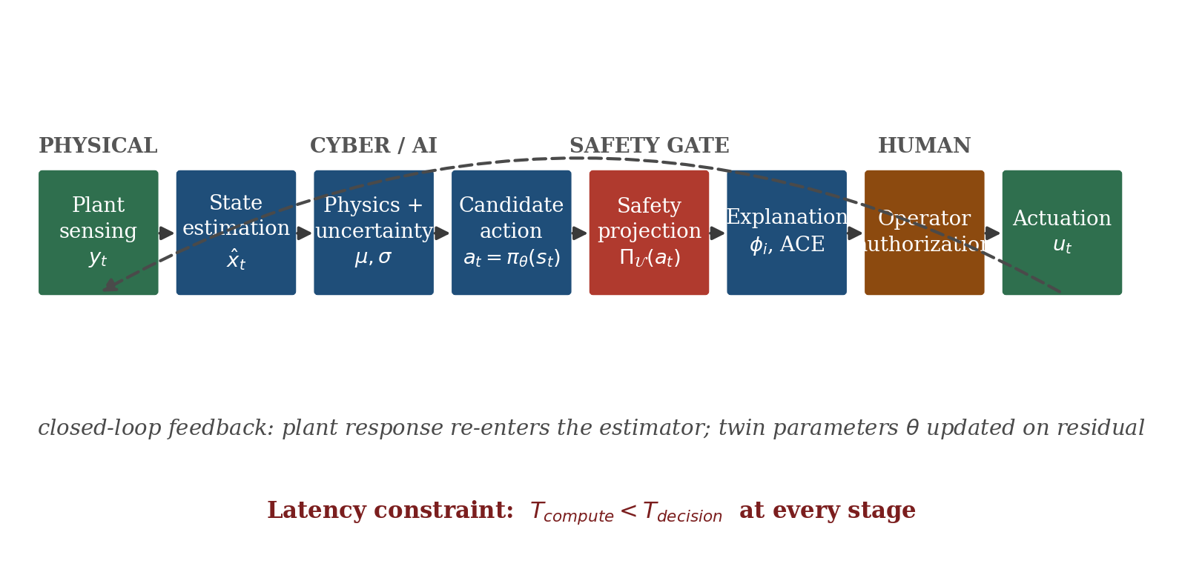
Fig. 2. Information and decision workflow in PI-CPNC. Every candidate action passes through an explicit safety projection and an operator authorisation gate before actuation. The latency constraint of Eq. (6) applies at every stage.
The ordering carries the safety argument. The safety projection precedes explanation, and explanation precedes authorisation, because an operator asked to authorise an action that has not yet been constrained is being asked to perform the constraint check personally under time pressure — which is the workload failure that the architecture exists to prevent. Placing the projection first means the operator is always reviewing an action already known to lie within the admissible set, and the explanation answers why this admissible action rather than why this action is safe.

5. The Probabilistic Physics-Surrogate Layer

5.1 Data sparsity in nuclear physics
Beneath plant-level control lies a data problem that constrains every model built above it. Investigating the mechanisms of nuclear fission is central to reactor physics, yet a key difficulty in neutron-induced fission research is the limited availability of experimental data at various neutron energies [3]. The predominant evaluated nuclear data libraries — ENDF, JENDL, JEFF, and CENDL — offer fission-yield evaluations principally at thermal energies and around 0.5 MeV, with substantially less extensive coverage at fast and 14 MeV high-energy neutrons [3]. This creates a noticeable gap in access to critical observables including yields, total kinetic energy of fission fragments, and neutron multiplicity.
The consequence for the architecture is direct. A digital twin that must reconstruct unmeasured plant state depends on nuclear data whose uncertainty is itself unevenly characterised across the energy domain. If that uncertainty is not represented explicitly, it propagates silently into every downstream estimate and eventually into control decisions. The design response adopted here is to require that the surrogate layer be probabilistic rather than deterministic: it must return a distribution, not a point estimate. The observable tuple is written
z = ( E_{n}, A, Z, Y ) (9)
with E_{n} the incident neutron energy, A the fragment mass number, Z the fragment charge number, and Y the associated yield.
Deep architectures such as Bayesian neural networks and mixture density networks have been proposed for this task [3], but the complexity of deep models poses a difficulty of its own: substantial data are required to capture correlations accurately, and substantial data are exactly what the domain lacks. An alternative is to generate synthetic datasets derived from existing evaluated data, and then to compare candidate generators on their fidelity in reproducing the fission-yield distribution. This is the approach taken in [3], and it is the approach adopted for the C_{PHY} engine here.

5.2 Gaussian mixture model
The Gaussian mixture model is an unsupervised clustering method that represents an observed distribution as a weighted combination of K Gaussian components, each component corresponding to a cluster and characterised by a mean, a covariance, and a mixing weight [3]:
p( x | Θ ) = Σ_{k=1}^{K} π_{k} · N( x | μ_{k}, Σ_{k} ) (10)
π_{k} ≥ 0 , Σ_{k=1}^{K} π_{k} = 1 (11)
with the multivariate Gaussian density
N( x | μ_{k}, Σ_{k} ) = [ (2π)^{d/2} |Σ_{k}|^{1/2} ]⁻¹ exp[ −½ (x−μ_{k})ᵀ Σ_{k}⁻¹ (x−μ_{k}) ] (12)
Parameters are estimated by expectation-maximisation. In the expectation step the responsibility of component k for observation i is computed as
γ_{ik} = π_{k} N( x_{i} | μ_{k}, Σ_{k} ) / Σ_{j} π_{j} N( x_{i} | μ_{j}, Σ_{j} ) (13)
and in the maximisation step the parameters are updated by the responsibility-weighted moments,
N_{k} = Σ_{i} γ_{ik} , μ_{k} = N_{k}⁻¹ Σ_{i} γ_{ik} x_{i} , Σ_{k} = N_{k}⁻¹ Σ_{i} γ_{ik} (x_{i}−μ_{k})(x_{i}−μ_{k})ᵀ (14)
GMM performs soft rather than hard clustering: each observation receives a probability of membership in every component rather than an exclusive assignment, which allows overlapping clusters and non-spherical cluster geometry to be represented in a way that k-means cannot [3]. It also performs well in high dimension, and can identify outliers as points with low probability of belonging to any component — a property directly useful to the diagnostic engine. Its limitations are equally well established: it is sensitive to initial parameter settings, poor initialisation can yield sub-optimal clustering, the EM algorithm is computationally intensive on large or high-dimensional datasets, and the number of components must be selected, typically by the Bayesian or Akaike information criterion [3].

5.3 Gaussian process regression
Gaussian process regression is a supervised, non-parametric, kernel-based method for continuous-valued prediction. It places a prior directly over functions,
f(x) ~ GP( m(x), k(x, x′) ) (15)
with mean function m(x) and covariance function k(x,x′). Given training inputs with covariance matrix K_{ij} = k(x_{i}, x_{j}) and observations corrupted by independent Gaussian noise,
y = f + ε , ε ~ N( 0, σ_{n}² I ) (16)
the posterior at a test point x* is Gaussian with mean and variance
μ* = k*ᵀ ( K + σ_{n}² I )⁻¹ y (17)
σ*² = k(x*, x*) − k*ᵀ ( K + σ_{n}² I )⁻¹ k* (18)
Equation (18) is the property that makes GPR architecturally significant. The predictive variance is available in closed form, it is computed without recourse to ensembling or sampling, and — critically — it grows automatically in regions of input space where training data are sparse. A surrogate built on GPR therefore signals its own ignorance. This is precisely the behaviour required of a component whose output feeds a safety-relevant decision, and it is why GPR rather than a deterministic neural surrogate is placed at this position in the architecture.

5.4 Kernel selection
The choice of kernel encodes the assumptions made about the underlying function and significantly influences the model’s ability to generalise from training data to unseen data [3]. The four kernels employed in the reviewed fission-yield study are summarised in Table 4 and plotted in Fig. 7.
Table 4. Covariance kernels used in the probabilistic surrogate layer, after [3].
Kernel | Functional form | Modelling role
Constant | k(x,x′) = σ² | Assumes uniform covariance across the input space; useful in combination with other kernels to model functions with varying means
Radial basis function | k(x,x′) = exp( −‖x−x′‖² / 2ℓ² ) | Squared-exponential kernel; captures smooth transitions and variations in data; the default choice for infinitely differentiable functions
Rational quadratic | k(x,x′) = ( 1 + ‖x−x′‖² / 2αℓ² )^{−α} | Scale mixture of RBF kernels; accommodates datasets exhibiting both local fluctuation and broader global variation
ExpSineSquared | k(x,x′) = exp( −2 sin²( π|x−x′| / p ) / ℓ² ) | Periodic kernel; suited to datasets exhibiting consistent cyclic behaviour with periodicity p

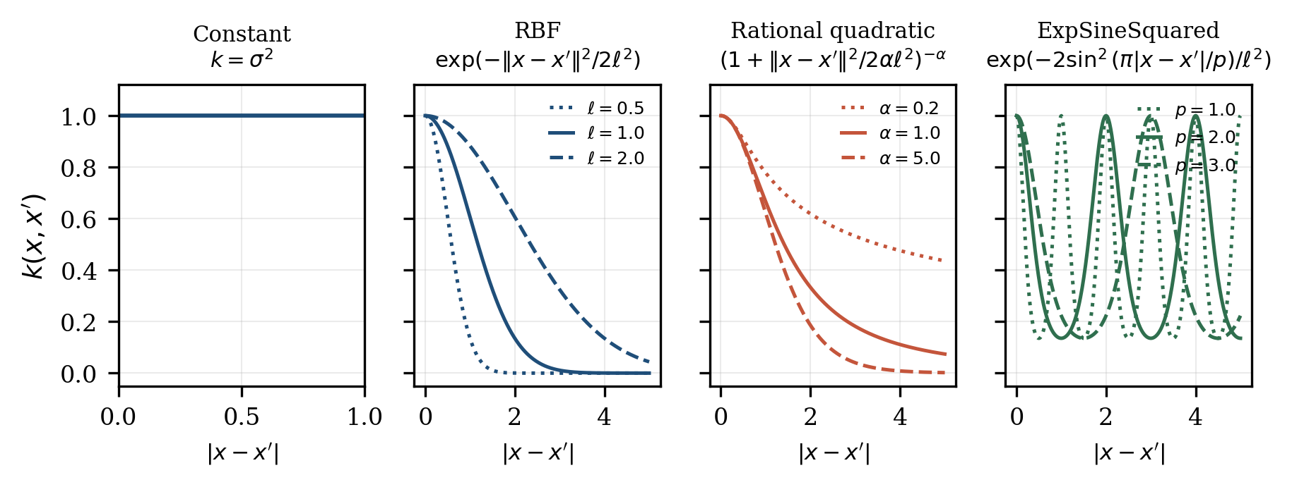
Fig. 7. The four covariance kernels of Table 4, plotted against separation |x−x′| for representative hyperparameter values. The length-scale ℓ controls the correlation range; the mixture parameter α interpolates the rational quadratic between the RBF limit (large α) and heavy-tailed behaviour (small α); the periodicity p sets the cycle of the ExpSineSquared kernel.
The selection is deliberate rather than exhaustive, each kernel playing a role in predicting the characteristically bimodal distribution of fission yields [3]. In the architecture, kernel choice is a design decision that should be documented and justified as part of the model qualification package, since it constitutes a physical assumption about the smoothness and structure of the modelled quantity — and an assumption of that kind is exactly the sort of thing that must be visible to a reviewer.

5.5 Surrogate behaviour and augmentation
Fig. 5 illustrates the behaviour of GPR applied to the mass-yield distributions of neutron-induced fission for three representative systems. The characteristic double-humped structure of the asymmetric mass split is reproduced across all three cases, and the 95% confidence interval remains narrow in the high-density regions around the light and heavy peaks while widening at the distribution tails where data are sparse. The reviewed study reports the same qualitative behaviour on JENDL-derived data for ²³⁵U at 14 MeV, ²⁴⁰Pu at 0.5 MeV, and ²⁴⁵Cm at thermal neutron energies, noting that GPR maintains low uncertainties in critical regions such as the peaks and valleys and that its generated samples effectively capture both the overall shape and the specific features of the distribution [3].
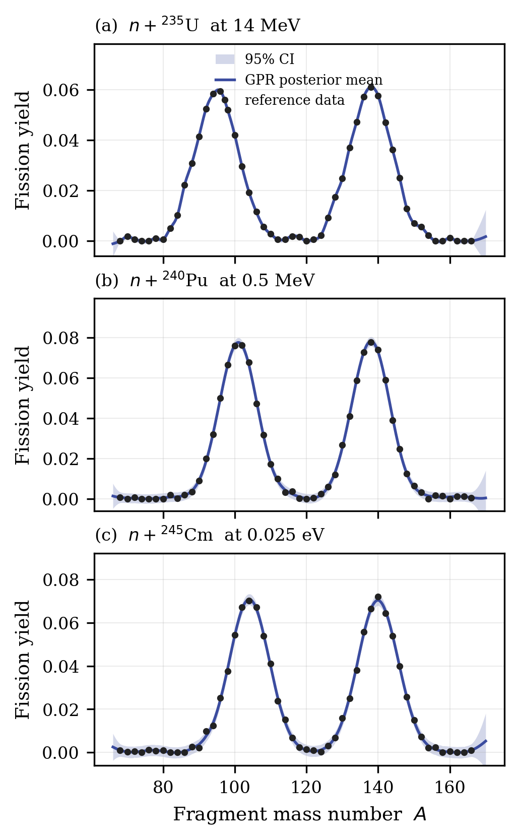
Fig. 5. Gaussian process regression of fragment mass-yield distributions with 95% confidence intervals, for three representative neutron-induced fission systems. The confidence band narrows in the data-dense peak regions and widens in the sparse tails, so the surrogate reports its own reliability as a function of input location. Curves are generated for methodological illustration and reproduce the qualitative behaviour reported in [3]; they are not evaluated library data.
Fig. 6 compares the density of augmented samples generated by the two methods against the reference distribution, using kernel density estimation as the comparison instrument. Kernel density estimation is a non-parametric method for estimating the probability density function of a random variable, and its smoothing of the sample data provides clear visualisation of the underlying distribution — particularly valuable when the exact form of the distribution is unknown or difficult to define, and when the distribution is multi-modal [3].
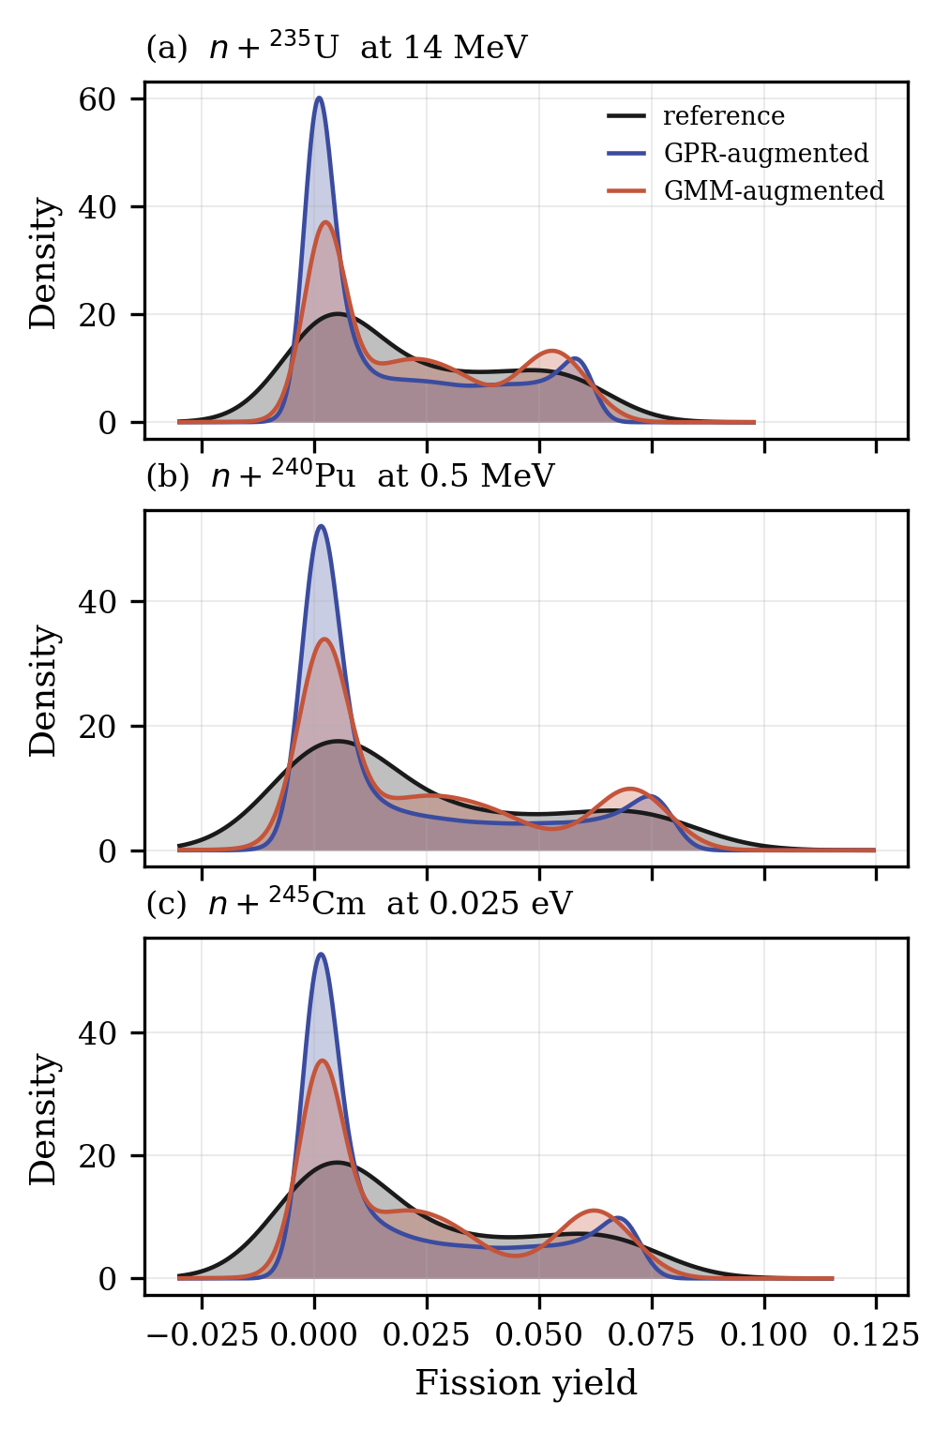
Fig. 6. Kernel-density comparison of augmented sample distributions against the reference, for the three systems of Fig. 5. The GPR-augmented samples track the reference density more closely than the GMM-augmented samples, particularly in the secondary mode. Generated for methodological illustration, reproducing the comparison reported in [3].
The reviewed study reports that GPR clearly excelled in capturing the mass-yield distributions, that despite minor deviations the achieved precision is more than satisfactory, and that GPR’s effectiveness in modelling isotopes underscores its value as a tool for nuclear physics research capable of generating high-quality datasets for advanced analysis [3]. The division of labour indicated by this result is the one adopted in the architecture: GMM is used for pattern recognition, distribution modelling, and outlier identification, while GPR is used for prediction, uncertainty estimation, and sample generation. The two are complementary rather than competing.

5.6 Role within the architecture
The surrogate layer supplies three things to the layers above it. It supplies fast prediction where high-fidelity computation would violate the latency constraint of Eq. (6). It supplies augmented training data where evaluated data are sparse, enabling downstream models that would otherwise be untrainable. And, most importantly, it supplies the calibrated uncertainty σ*(x) that the uncertainty budget of Section 8.1 consumes and that ultimately gates the delegation of control authority.
A caution belongs here. Sample augmentation improves the statistical adequacy of a training set; it does not create new physical information. A generator trained on data that are sparse in a particular energy region will produce samples in that region that are statistically plausible under the fitted model, but the fitted model is the only warrant for them. Physics-constrained generation — in which the generator is required to satisfy conservation relations and known systematics in addition to fitting the observed distribution — is identified in Section 9 as a priority research direction precisely because it addresses this gap. The combination of a GPR posterior with a GMM density prior,
p( Y | x, D ) ∝ p_{GPR}( Y | x, D ) · p_{GMM}( Y | x ) (19)
is proposed by the present synthesis as one route to a jointly calibrated surrogate; it is an architectural formulation and is not reported as an empirical result by any reviewed source.

6. The Human-Factor Diagnostic Layer

6.1 Rationale and structure
The layers described so far observe the plant. They do not observe the organisation that operates it — and the organisation is where the majority of incident causation originates, human error contributing to an estimated 70–90% of NPP accidents [1]. A control architecture that treats human factors as an external boundary condition rather than as an instrumented channel is therefore blind to its own dominant risk term. This section develops the layer that closes that gap.
The reviewed human-factors study divides nuclear reactor control into three domains — administrative, operational, and maintenance — and analyses each as a distinct loop with its own parameter set [2]. Its methodology combines simulated data organised around parameters closely related to catastrophic events, AI-based classification of parameters into critical (C) and non-critical (NC) groups, multivariate ANOVA to characterise parameter interactions, attribution analysis to validate the statistical outputs of the model, GAN-based unsupervised learning to investigate interdependencies, and isolation-forest analysis to examine dependency and independency relationships [2]. Formally,
H_{NPP} = H_{A} ∪ H_{O} ∪ H_{M} (20)
Table 5 lists the parameters of each loop.
Table 5. Parameters of the administrative, operational, and maintenance control loops, after [2].
Loop | Symbol | Parameter | Reported criticality threshold
Administrative | VP | Vacancy percentage in manpower | ≥ 5% (target criterion)
 | LER | License event reports per year | ≥ 15
 | NRV | Number of repeat violations of norms | ≥ 14
 | HE | Human errors accumulated in a year | ≥ 81
 | RHE | Repeated human errors | ≥ 34 (severity level 1)
 | OTW | Overtime worked in functional area | ≥ 379
 | C/PP | Contractor to plant personnel ratio | ≥ 0.24 (severity level 2)
 | SR | Supervisory personnel ratio | < 0.88
Operational | OFR | Operator failure rate | ≥ 3.5 (severity level 1)
 | OLC | Operations at limiting time frame | ≥ 25 (severity level 1)
 | OEE | Errors occurring in operator-processed events | ≥ 11 (severity level 1)
 | CRIO | Non-operability of control-room machines | Binary; YES indicates criticality
 | ARC | Annunciation of repeated alarming | Binary
 | NTP | Number of temporary procedures | ≥ 35.5 (severity level 1)
Maintenance | EOS | Equipment existing out-of-service percentage | Loop-critical parameter
 | SSR | Reworks requested in system safety | —
 | BMW | Backlog work remaining in maintenance | —
 | PRMR | Progressive maintenance schedule not achieved | Loop-critical parameter
 | PMRC | Incomplete requests of preventive maintenance | Loop-critical parameter
 | NMR | Maintenance requests placed in number | —
 | RARM | Error observed in realignment request | —
 | WTE | Wrong training leading to errors | —

6.2 Administrative loop
The administrative loop concerns staffing, licensing, procedural compliance, and supervisory structure. Its state vector and criticality mapping are
x_{A} = [ VP, LER, NRV, HE, RHE, OTW, C/PP, SR ]ᵀ , C_{A} = f_{A}( x_{A} ) (21)
The reviewed analysis identifies C/PP, LER, NRV, and RHE as the key characteristics determining criticality of the damage-control unit, with HE, OTW, and SR classified as secondary [2]. Two findings deserve emphasis because they are counter-intuitive from a purely technical standpoint.
The first concerns the contractor-to-plant-personnel ratio. The classification algorithm places C/PP at severity level 2 in conjunction with NRV, and identifies a criticality threshold at C/PP ≥ 0.24 [2] — that is, the proportion of contracted to permanent staff is treated as a leading indicator of damage-control criticality. The second concerns repeated human errors. RHE is identified as one of the crucial characteristics determining the criticality of a damage-control unit, with a criticality range beginning at 34 [2]. What distinguishes RHE from HE is repetition: an isolated error is a discrete event, whereas a repeated error indicates that the corrective mechanism itself is not functioning. Fig. 9(a) shows the relationship between vacancy percentage and repeated human errors across the reported dataset, with the criticality threshold marked.
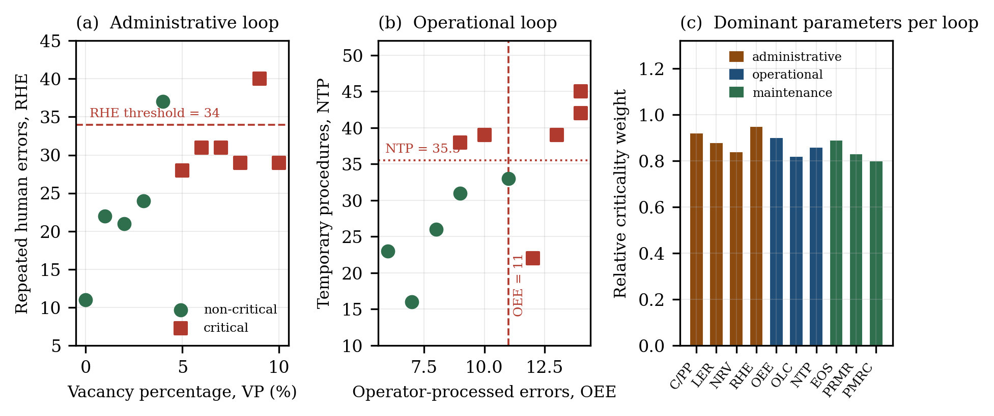
Fig. 9. Human-factor loop analysis. (a) Repeated human errors against manpower vacancy in the administrative loop, with the reported criticality threshold RHE = 34 and the classifier’s critical/non-critical labelling. (b) Temporary procedures against operator-processed errors in the operational loop, with the reported thresholds OEE = 11 and NTP = 35.5. (c) Relative criticality weighting of the dominant parameters identified for each loop. Data in (a) and (b) as reported in [2]; weights in (c) are a synthesis-level summary of the criticality rankings reported there.

6.3 Operational loop
The operational loop concerns the conduct of operations in the control room:
x_{O} = [ OFR, OLC, OEE, CRIO, ARC, NTP ]ᵀ , R_{O} = f_{O}( x_{O} ) (22)
The reported classification tree selects the non-operability of control-room machines, CRIO, as the root discriminant, classified as YES when some machines are not in working condition and NO when no single machine is experiencing issues [2]. Below that root, OEE, OLC, and NTP are identified as the key critical parameters, with criticality levels of OEE ≥ 11, OLC ≥ 25, OFR ≥ 3.5, and NTP ≥ 35.5, all at severity level 1 [2]. Fig. 9(b) shows the OEE–NTP plane with these thresholds.
The prominence of NTP is worth drawing out. Temporary procedures are, by construction, operations conducted outside the qualified procedural baseline. A high count indicates that the plant is being operated substantially through improvisation, and the analysis identifies the difference in leaf lengths as greatest in the case of NTP, demonstrating the significance of the parameter [2]. In architectural terms, NTP is an observable proxy for the gap between the plant as designed and the plant as operated — and that gap is exactly what a model trained on design-basis data cannot see. This connects the human-factor layer directly to the distribution-drift problem of Section 8.2.

6.4 Maintenance loop
The maintenance loop concerns equipment availability and the maintenance backlog:
x_{M} = [ EOS, SSR, BMW, PRMR, PMRC, NMR, RARM, WTE ]ᵀ , R_{M} = f_{M}( x_{M} ) (23)
The reviewed analysis reports interdependence between equipment out-of-service status, the progressive maintenance schedule, and preventive maintenance schedules [2]. The mechanism is intuitive: equipment removed from service increases the load on remaining equipment and defers scheduled work, which increases backlog, which further increases out-of-service duration. The loop is self-reinforcing, which is why it is instrumented as a loop rather than as a set of independent indicators.

6.5 Interdependency analysis by GAN and isolation forest
Interdependency among parameters is investigated using GAN-based unsupervised learning, with the interdependency determinant factor formulated as
I(D,G) = E_{r~q_r}[ log D(r) ] + E_{t~q_t}[ log( 1 − D(G(t)) ) ] (24)
where D is the discriminative factor, G the generative factor, r a randomly selected sample from the dataset, and t a latent-variable selection [2]. The GAN model, which utilises unsupervised machine learning, is employed to iteratively create and identify interdependent variables among specified parameters [2], while the associated isolation-forest analysis examines dependency and independency relationships.
The value of this approach within the architecture is that it detects couplings that a univariate threshold cannot. A parameter may remain individually below its criticality threshold while participating in a joint configuration that is nonetheless critical — and the multivariate ANOVA reported in [2] confirms exactly this, showing that RHE is severely affected by the influence of the LER, NRV, and C/PP factors rather than varying independently. For architectural aggregation the present synthesis defines an interdependency matrix and a parameter-level exposure score,
A_{H} = [ a_{ij} ] , a_{ij} = I( x_{i}, x_{j} ) , S_{i} = Σ_{j≠i} | a_{ij} | w_{j} (25)
and an aggregate human-risk index combining the three loops,
R_{H} = w_{A} R_{A} + w_{O} R_{O} + w_{M} R_{M} , w_{A} + w_{O} + w_{M} = 1 (26)
Equations (25) and (26) are synthesis-level aggregation mechanisms introduced for this architecture. They are not reported as empirical relations by the source, and the weights w_{A}, w_{O}, w_{M} would require plant-specific calibration before any operational use. They are included because the architecture requires a scalar organisational risk term to enter the uncertainty budget of Section 8.1, not because their form is established.

6.6 Classifier validation
The reviewed study validates its classification using a naive Bayes classifier, reporting the metrics reproduced in Table 6 and plotted in Fig. 10 [2].
Table 6. Naive Bayes classifier results for the administrative loop, as reported in [2].
Class | TP rate | FP rate | Precision | Recall | F-measure | MCC | ROC area | PRC area
Non-critical | 0.800 | 0.167 | 0.800 | 0.800 | 0.800 | 0.633 | 0.817 | 0.731
Critical | 0.833 | 0.200 | 0.833 | 0.833 | 0.833 | 0.633 | 0.817 | 0.785
Weighted avg. | 0.818 | 0.185 | 0.818 | 0.818 | 0.818 | 0.633 | 0.817 | 0.761

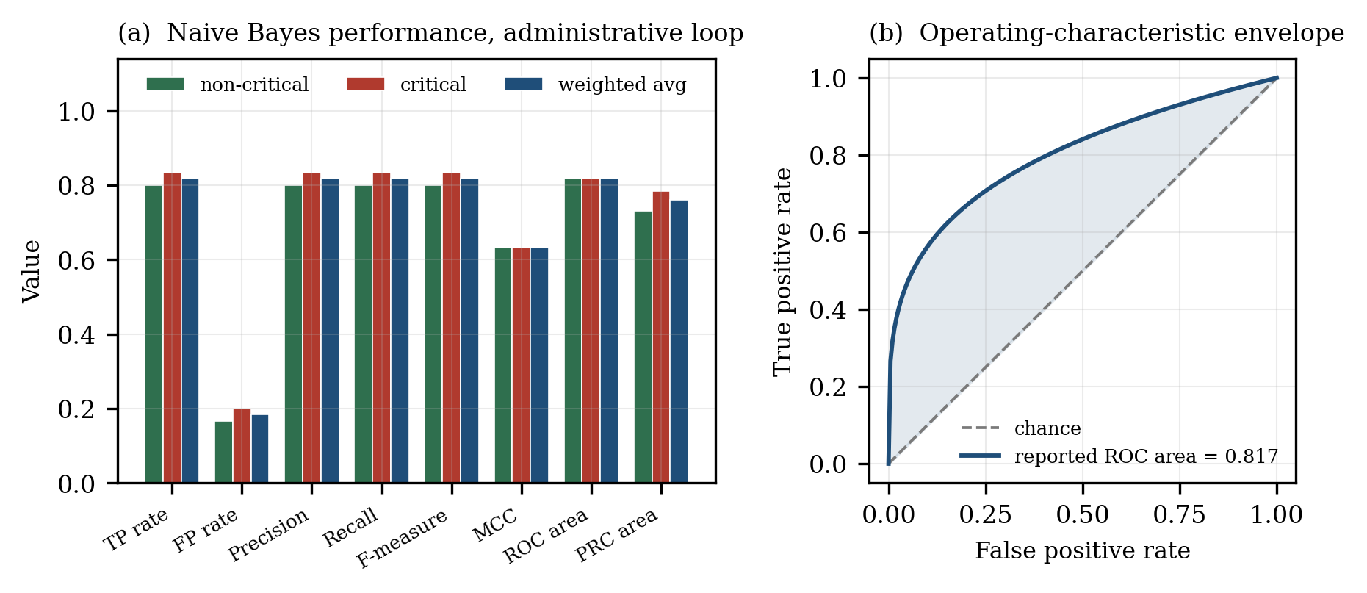
Fig. 10. Validation of the human-factor classifier. (a) Naive Bayes performance metrics for the administrative loop, as reported in [2]. (b) Operating-characteristic envelope corresponding to the reported ROC area of 0.817.
These figures require careful interpretation, and the interpretation matters for how the layer may be used. The reported F-measure of 0.818 and ROC area of 0.817 indicate a classifier performing well above chance, and the source concludes on this basis that the AI test run is valid [2]. But a false-positive rate of 0.185 means that roughly one in five non-critical configurations is flagged as critical, and a true-positive rate of 0.833 means that roughly one in six genuinely critical configurations is missed. A Matthews correlation coefficient of 0.633 indicates moderate rather than strong agreement between observed and predicted classification.
Two consequences follow for the architecture. First, this layer must be advisory: a miss rate near one in six is not compatible with automatic action, and the human-factor channel therefore feeds the operator and the risk budget rather than the controller directly. Second, the underlying study uses simulated data derived from a source that remains private [2], so the reported metrics characterise performance on the simulation rather than established performance on plant data. Validation against operational records is a prerequisite for any deployed use of this layer, and is listed accordingly in Section 9.

7. Physics-Informed and Explainable Control

7.1 The black-box dilemma
Deep learning models represent complex nonlinear relationships by encoding features through multiple layers of neuron clusters, which renders the mapping between input and output obscure to human inspection [4]. The reviewed literature characterises the resulting tension as an explainability–performance paradox: models with better performance usually have a more complex internal mechanism and are therefore difficult to explain, whereas models with a clearer mechanism, such as linear models and rule-based models, lack the ability to deal with complex nonlinear problems [4]. An ideal model would possess both good performance and high explainability. Fig. 8 maps the principal model families onto this plane.
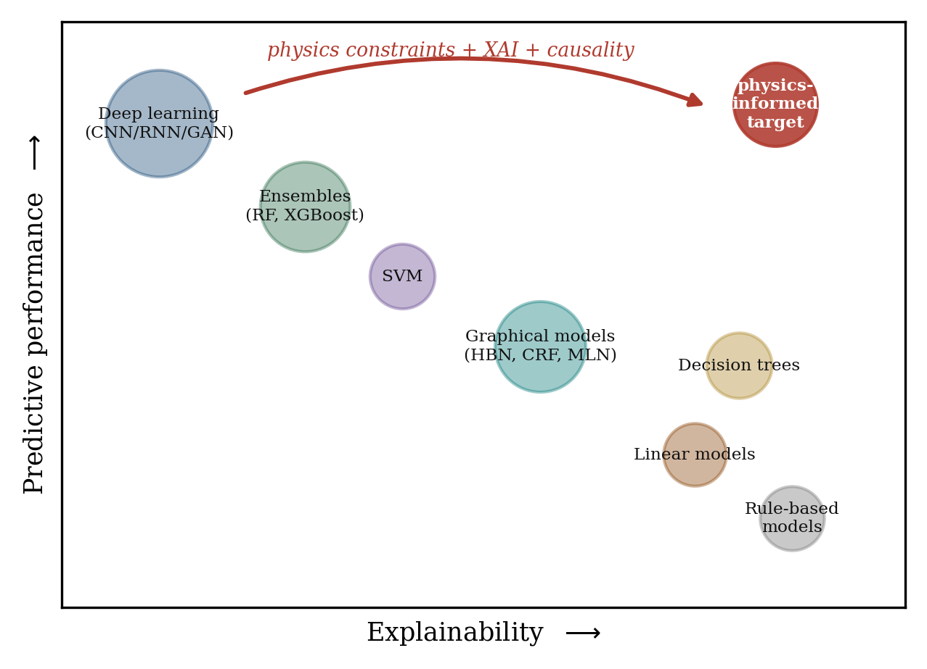
Fig. 8. The explainability–performance plane. Model families occupy a frontier along which performance and interpretability trade against one another. The objective of physics-informed and explainable methods is to displace the frontier toward the upper-right region rather than to select a point along it. Redrawn conceptually after the trade-off discussed in [4].
The dilemma is not merely aesthetic. Two robustness results reported in the reviewed literature establish that opacity is a safety concern in its own right. Slight perturbation of the sample set can significantly mislead an otherwise advanced neural network [67], and deep networks can be easily fooled by misleading images into making false judgements with high confidence, including recognising noise as a recognisable object [68]. If a network can assign high confidence to a wholly incorrect conclusion, then confidence itself is not evidence of correctness — and a control architecture that treats a model’s reported confidence as a reliability signal has no defence against this failure mode. The reviewed literature poses the question directly: can existing AI models withstand adversarial attacks such as escape attacks [69]?
The high requirement in terms of safety performance is among the most important fundamental criteria for the design and O&M of nuclear reactors, and researchers must therefore continue to improve the transparency, robustness, and accountability of AI models rather than confining themselves to accuracy-only measurements [4]. This is the design principle that governs the remainder of this section.

7.2 Physics-informed neural networks
Scientific machine learning addresses the dependence of AI algorithms on large quantities of labelled training data by using physical principles as prior knowledge, integrating them with machine-learning models so as to improve accuracy, representation ability, and robustness on specific scientific problems [4]. Existing methods are classified into two categories according to research purpose: knowledge embedding and knowledge discovery [70].
Knowledge embedding projects the physical mechanism from the symbolic semantic space into the vector feature space of the data-driven model. Mainstream research focuses on using prior physical knowledge to constrain the model convergence mechanism, especially the loss function [4]. Physics-guided neural networks constrain convergence by introducing the difference between prediction and physical mechanism into the loss [71]. Physics-informed neural networks incorporate the governing partial differential equations, initial conditions, and boundary conditions as soft constraints within the loss function [72], and have been validated as an excellent method for data-driven solution of PDEs as well as for inverse problems such as parameter determination [4].
For a governing system written in residual form,
F( u, ∇u, ∇²u, ∂u/∂t, x, t ) = 0 , r_{PDE} = F( u_θ, ∇u_θ, ∇²u_θ, ∂u_θ/∂t, x, t ) (27)
the composite training objective is
L_{PINN} = λ_{d} L_{data} + λ_{p} L_{PDE} + λ_{b} L_{BC} + λ_{i} L_{IC} (28)
with the individual terms
L_{PDE} = N_{f}⁻¹ Σ_{i} | r_{PDE}(x_{i},t_{i}) |² , L_{BC} = N_{b}⁻¹ Σ_{i} | u_θ(x_{i},t_{i}) − u_{b}(x_{i},t_{i}) |² , L_{IC} = N_{i}⁻¹ Σ_{i} | u_θ(x_{i},0) − u₀(x_{i}) |² (29)
Equations (28) and (29) state the composite objective in the form used by this synthesis. The reviewed literature supports the principle of embedding governing equations, initial conditions, and boundary conditions into learning objectives, and reports PINN applications in nuclear and related fields — Navier–Stokes models in velocity–pressure and velocity–vorticity form applied to laminar flow and channel turbulence [73], reconstruction of natural convection flow fields from temperature and velocity measurements [74], forward and inverse problems in radiative transfer [75], and the PIMLAF architecture for CHF prediction on a residual-modelling basis [31] — but does not report this exact composite expression, which is stated here for architectural completeness.

7.3 Numerical demonstration: physics constraints under extrapolation
The architectural claim made for physics constraints is that they preserve validity outside the training envelope. Because that claim is central to the safety argument, it is worth demonstrating quantitatively rather than asserting. This section reports a small numerical experiment on the one-delayed-group point-kinetics equations, which are the simplest system possessing the essential structure of reactor dynamics: a fast prompt-neutron balance coupled to a slow delayed-precursor balance.
With n the neutron density normalised to its initial value, ĉ the precursor concentration scaled by its equilibrium value, β the delayed-neutron fraction, Λ the prompt-neutron generation time, λ the precursor decay constant, and ρ(t) the imposed reactivity, the system is
dn/dt = [ (ρ(t) − β) / Λ ] n + λ c₀ ĉ , dĉ/dt = λ ( n − ĉ ) , c₀ = β / (Λλ) (30)
Parameters were set to β = 0.0065, Λ = 2×10⁻⁵ s, and λ = 0.0784 s⁻¹, values representative of a thermal reactor. A reactivity ramp of 0.0020 Δk/k, approximately 0.31 dollars, was applied smoothly about t = 10 s, and the reference solution was obtained by stiff numerical integration over a 60 s horizon. Fifteen noisy observations of n, corrupted by 1.5% multiplicative noise, were generated over the first 25 s only; the interval from 25 s to 60 s constitutes an extrapolation region in which no training data exist.
Two surrogates were fitted to the same observations using an identical radial-basis expansion of 26 centres. The first was fitted to the data alone by regularised least squares. The second was fitted to the data together with the residuals of Eq. (30) evaluated at 300 collocation points distributed across the full 60 s horizon, and with the initial conditions imposed as additional constraints — the linear analogue of the composite objective in Eq. (28). Neither surrogate received any information about the reference solution beyond t = 25 s.
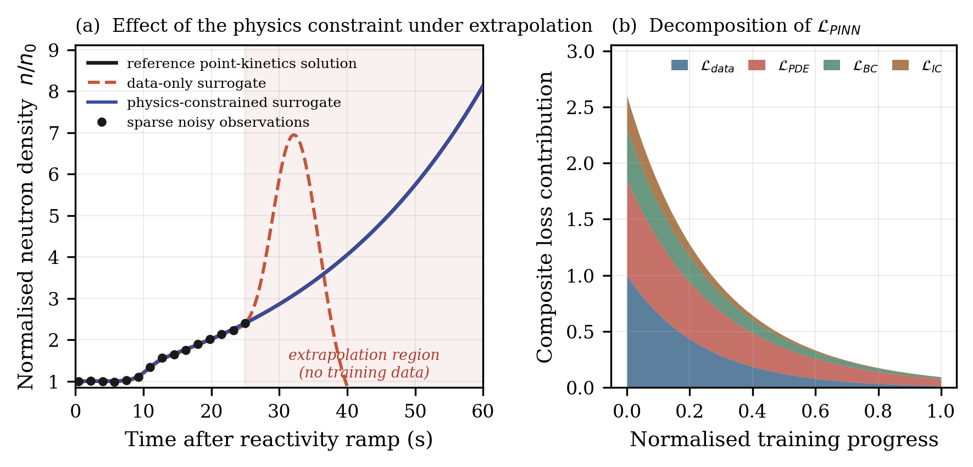
Fig. 11. Physics constraints under extrapolation. (a) Data-only and physics-constrained surrogates fitted to identical sparse noisy observations covering the first 25 s of a point-kinetics transient. Beyond 25 s the data-only surrogate diverges from the reference solution, while the physics-constrained surrogate continues to track it. (b) Schematic decomposition of the composite PINN objective of Eq. (28) over training.
Fig. 11(a) shows the outcome. Within the data region both surrogates fit the observations adequately. Beyond it they separate sharply: the data-only surrogate loses the exponential growth structure entirely and returns to a spurious decay, while the physics-constrained surrogate continues to track the reference solution across the full extrapolation horizon. The mean absolute error over the region t > 25 s is 4.16 in normalised neutron density for the data-only surrogate and 0.005 for the physics-constrained surrogate — an improvement of approximately a factor of 830 in a region where the two models had access to exactly the same data.
The result should not be over-read. It is a linear-in-parameters demonstration on a low-order system with exactly known governing equations, and it establishes a mechanism rather than a plant-scale capability; a real PINN trained on a distributed multiphysics system faces optimisation difficulties that this experiment does not exhibit. But the mechanism it establishes is precisely the one at issue in Section 7.1. The data-only surrogate is not merely less accurate outside its training envelope — it is confidently wrong there, in the manner of the adversarial failures reported in [67,68], because nothing in its construction constrains it to remain physical. The physics-constrained surrogate cannot fail in that way for as long as the imposed equations hold, since violating them incurs loss directly. This is why physics constraints occupy a structural rather than a merely performance-enhancing position in the architecture.

7.4 Post-hoc attribution
Explainable AI research is committed to promoting the construction of more transparent and reliable AI systems, so that humans not only acquire decision support from AI but also understand how AI systems make decisions [4]. The reviewed literature classifies the XAI taxonomy along three dimensions: stage, distinguishing ante-hoc from post-hoc methods, the latter further divided into model-agnostic and model-specific; scope, distinguishing local from global explanations; and output format, distinguishing numeric from visualisation outputs [4].
Shapley additive explanations decompose a prediction into additive feature contributions,
f(x) = ϕ₀ + Σ_{i=1}^{M} ϕ_{i} (31)
with each attribution given by the Shapley value
ϕ_{i} = Σ_{S ⊆ N∖{i}} [ |S|! ( M − |S| − 1 )! / M! ] · [ f( S ∪ {i} ) − f(S) ] (32)
while local interpretable model-agnostic explanations fit a locally faithful interpretable surrogate g in the neighbourhood π_{x} of the instance being explained,
g* = arg min_{g ∈ G} [ L( f, g, π_{x} ) + Ω(g) ] (33)
Both methods possess global and local properties in terms of the scope of explainability [4]. Their application within nuclear engineering remains limited: the reviewed literature reports SHAP used to calculate the importance of input features in predicting turbulent eddy viscosity in RANS simulations and their influence on the results [26], and observes that few researchers have shown sufficient interest in XAI within the nuclear field, so that adopting XAI methodology would provide additional opportunities for the fusion of nuclear engineering and AI [4].
Within PI-CPNC, attribution serves an auditing function rather than a debugging one. Every action proposed by C_{CTRL} and authorised by the operator carries an attribution record identifying which state variables drove the proposal. This record is what makes post-event reconstruction possible, and post-event reconstruction is a regulatory requirement independent of whether the action was correct.

7.5 From attribution to causation
The reviewed literature is explicit about the limits of attribution. Existing XAI methodology with post-hoc methods as the mainstream standard cannot address the out-of-distribution generalisation problem, in which spurious correlations exist in the training data or unexpected changes occur in the deployment environment [4]. XAI methods can help determine whether an original model is reliable to some extent, but they cannot make the original model reliable. The underlying reason is that most existing AI algorithms are driven by association: models usually only know the how — the correlation — but do not know the why, the causality [4].
Causal inference addresses this by distinguishing the observational quantity P(Y|X) from the interventional quantity P(Y|do(X)). Over a causal graph G_{c} = (V,E), the average causal effect of a binary intervention is
ACE = E[ Y | do(X=1) ] − E[ Y | do(X=0) ] (34)
The distinction is directly consequential for control. A controller is an intervention device: it does not observe the plant passively, it acts on it. A model that has learned an association valid under the historical operating policy may therefore be invalid precisely when the controller departs from that policy — which is the situation in which its guidance is most needed. Extending causal inference to machine learning, removing false associations and using causal associations to guide model learning, are identified as critical fundamental ways to improve the stability of models in unknown environments [4], with causal learning providing effective theoretical support for feature-importance estimation and fairness measurement [76,77]. The reviewed literature also notes the principal difficulty: for transferability and robustness, most existing causal-inference methods require further improvement, the main obstacle lying in the high-dimensional complexity caused by the high coupling of explicit data features, which makes effective causal variables difficult to extract [78,79].

7.6 Constrained control and the delegation of authority
The control engine C_{CTRL} generates candidate actions. The reviewed sources do not demonstrate an AI-based autonomous reactor controller, and the deep reinforcement learning formulation given here is introduced by this synthesis as a proposed extension rather than as a reviewed capability. With the augmented state
s_{t} = [ x_{p}(t), x̂_{p}(t), R_{H}(t), z_{FPY}(t), σ(t) ] (35)
comprising measured state, twin-reconstructed state, the organisational risk index of Eq. (26), the nuclear-data context, and the surrogate uncertainty, a policy π_θ proposes an action a_{t} = π_θ(s_{t}) under a multi-term reward
r_{t} = − λ₁ L_{state} − λ₂ L_{risk} − λ₃ L_{control} − λ₄ L_{uncertainty} (36)
optimised in the usual discounted sense,
θ* = arg max_θ E_π [ Σ_{t=0}^{T} γ^{t} r_{t} ] (37)
The inclusion of L_{uncertainty} is deliberate: a policy penalised for operating in high-uncertainty regions of state space is a policy with an incentive to remain within its own validated envelope.
The proposed action is not executed. It is projected onto the admissible set
A_{safe} = { a : g_{j}(s,a) ≤ 0, j = 1,…,m } , a_{exec} = Π_{A_safe}( a_{AI} ) (38)
with the fallback rule
a_{exec} = a_{AI} if a_{AI} ∈ A_{safe} ; a_{fallback} otherwise (39)
The constraint functions g_{j} must be specified independently of the learned policy and verified by conventional means. If they were learned from the same data, or derived from the same model, a systematic error in that data or model would corrupt both the policy and the constraint that is supposed to catch it, and the safety argument would be circular.
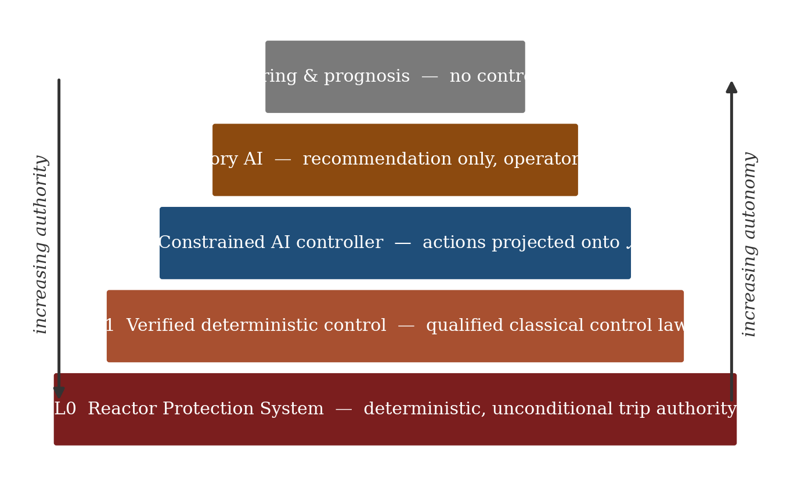
Fig. 13. Hierarchical decision authority. Authority decreases and autonomy increases from the base upward. The reactor protection system at L0 retains unconditional trip authority and lies outside the AI-mediated path entirely; AI functions occupy L2 and above and can be revoked to a lower level at any time.
Fig. 13 sets out the resulting authority hierarchy. The reactor protection system occupies L0 with unconditional trip authority and no AI mediation. Verified deterministic control occupies L1. The constrained AI controller occupies L2 and may act only within A_{safe}. Advisory AI occupies L3, generating recommendations that the operator executes. Monitoring and prognosis occupy L4 with no control authority at all. Autonomy is delegated upward from L4 through L2 only as evidence accumulates, and is revoked downward automatically whenever the uncertainty budget of Section 8.1 exceeds its threshold. Under no circumstances does any AI function acquire authority over L0.

8. Uncertainty, Drift, Security, and Qualification

8.1 End-to-end uncertainty propagation
Each layer of the architecture introduces uncertainty, and those uncertainties compose. For a differentiable transformation Y = f(X), first-order propagation gives
Σ_{Y} ≈ J_{f} Σ_{X} J_{f}ᵀ , J_{f} = ∂f / ∂X (40)
The present synthesis aggregates the individual contributions into a single scalar budget,
U_{total} = w₁ U_{sensor} + w₂ U_{GPR} + w₃ U_{DT} + w₄ U_{human} + w₅ U_{control} (41)
subject to the autonomy condition
U_{total} < U_{max} (42)
Equations (41) and (42) are architectural constructs introduced here; they are not reported by any reviewed source, and the weights would require plant-specific calibration. Their function is to make the delegation of autonomy conditional on a measured quantity rather than on a standing assumption. Fig. 12(a) illustrates the behaviour: as the prediction horizon lengthens, the surrogate and twin contributions grow while the sensor contribution remains approximately constant, and when the total crosses U_{max}, authority reverts automatically to the operator.
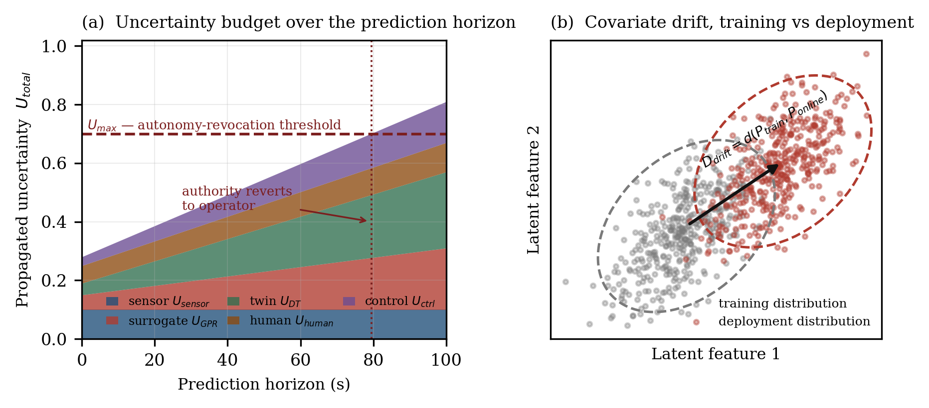
Fig. 12. Uncertainty and drift. (a) Composition of the propagated uncertainty budget over a lengthening prediction horizon; crossing U_{max} triggers reversion of authority to the operator. (b) Covariate drift between the training and deployment distributions in a latent feature space, the condition described in Eq. (43). Both panels are illustrative of the architectural constructs of Section 8.
This mechanism is the architectural response to the observation that uncertainty quantification and propagation remain the principal open challenge for digital-twin applications in nuclear engineering [4,66]. It does not solve that problem; it makes its consequences explicit and bounded, so that an unquantified uncertainty results in reduced autonomy rather than in unnoticed error.

8.2 Distribution drift
The most fundamental limitation identified by the reviewed AI literature is the mismatch between training data and real plant conditions. A high proportion of the data used to train and test models in the reviewed studies is derived from simulation, owing to the high cost of acquiring experimental data from NPPs and the impossibility of reproducing some operating conditions, such as severe accident scenarios [4]. The characteristics represented by the training data are likely to differ significantly from real-world data, creating a high probability of data distribution drift caused by non-stationary environments,
P_{train}(X,Y) ≠ P_{deploy}(X,Y) , D_{drift} = d( P_{train}, P_{online} ) (43)
so that the deployment risk
E_{deploy} = E_{(X,Y) ~ P_deploy} [ L( f(X), Y ) ] (44)
is not bounded by the empirical training risk. The reviewed literature reports that a lack of real experimental data adversely affected model performance in identifying accidental falls of control rods [80], and raises concern about the inconsistency caused by confined data sets selected by laboratory studies, noting that some algorithms will only show their best performance on those confined sets [81]. It calls for the development of standard datasets for specific targets in the nuclear reactor field [4].
A second and related data pathology is class imbalance. The vast quantity of data accumulated by NPPs over decades is overwhelmingly normal-operation data; the difference between normal samples and fault samples is massive, resulting in weak classification ability for the small-sample fault class [4]. Data-augmentation methods such as the synthetic minority over-sampling technique have been developed to address this [82], but the reviewed literature emphasises that a high-performance AI model requires high-value-density and high-quality data rather than merely a large quantity of data [4]. Fig. 12(b) illustrates the drift condition in a latent feature space.
Within the architecture, drift is not treated as a training-time problem to be solved once. It is treated as a runtime monitored quantity: D_{drift} is computed continuously, it enters the uncertainty budget, and sustained drift reduces the level of autonomy in the hierarchy of Fig. 13 automatically.

8.3 Cybersecurity
Deep integration of cyber and physical systems creates security exposure that the reviewed literature identifies explicitly: the use of network and information technology has brought new threats and challenges to nuclear security, and in NPPs currently in use and being rebuilt, such as electrical systems, effective protection measures for system information security throughout the life cycle are lacking and information-security protection capabilities are weak [1]. Long times are required for nuclear-industry systems to be qualified, which compounds the difficulty of maintaining current security postures.
The architecture treats five properties as constraints rather than as features:
C_{AI} = { integrity, availability, authentication, isolation, auditability } (45)
The specific threat that concerns the learned components is adversarial manipulation of the sensing path. If an adversary can perturb the measurement vector such that
y′ = y + δ with ‖δ‖ small, yet f(y′) ≠ f(y) (46)
then a perturbation small enough to evade conventional signal validation can nonetheless flip a model’s conclusion — the mechanism established in the adversarial-robustness results of [67,68,69]. Two architectural features mitigate this. The physics-surrogate engine provides an independent consistency check, since a perturbation that satisfies the sensor model but violates the governing balance equations is detectable as a physics residual. And the deterministic protection system at L0 is not reachable through the learned path at all, so no adversarial input to the cyber layer can suppress a trip.

8.4 Verification, validation, and qualification
None of the reviewed sources establishes a complete regulatory qualification pathway for an integrated autonomous architecture of this kind. The staged sequence of Fig. 14 is proposed here as a structure for that work.
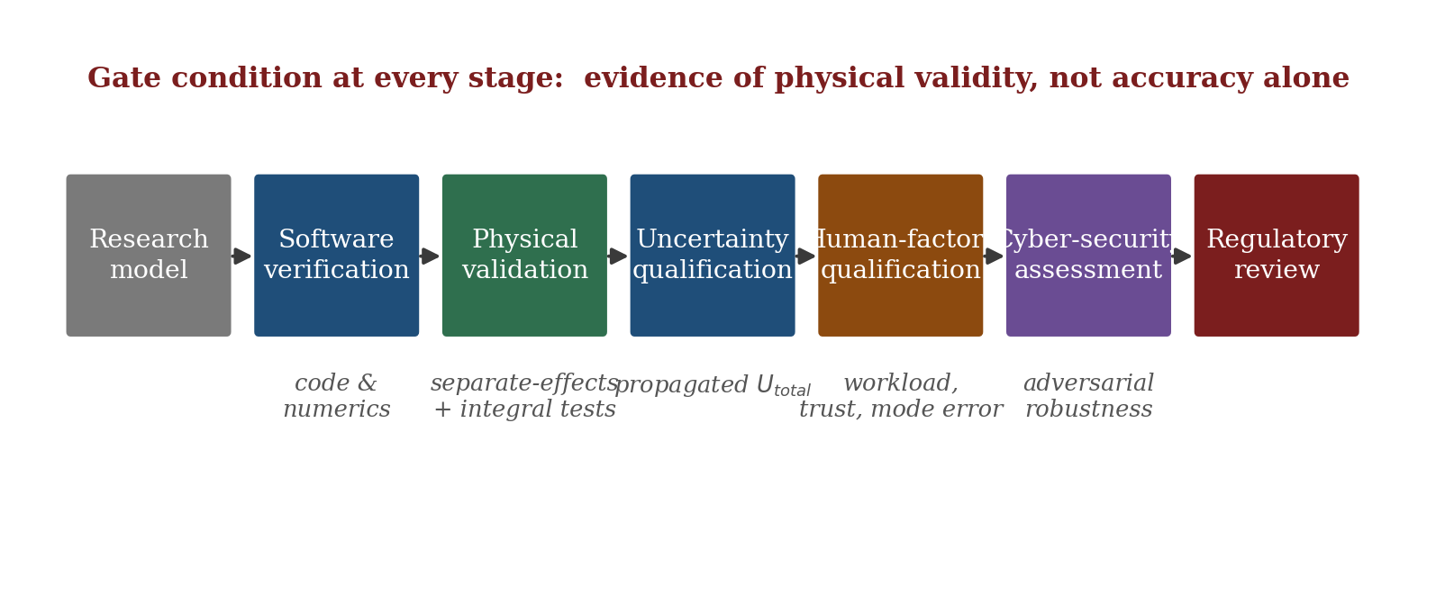
Fig. 14. Proposed staged qualification pathway. Each stage gates the next, and the gate condition at every stage is evidence of physical validity and of characterised failure modes, not predictive accuracy alone.
The essential point is stated in the reviewed literature and bears repeating without qualification: high machine-learning accuracy alone does not establish physical validity, software verification, or regulatory acceptability. A model may achieve excellent metrics on a confined dataset while remaining unlicensable, because the licensing question is not how often the model is right but what happens when it is wrong, and whether that failure mode has been characterised and bounded. Table 7 maps the open problems identified across the reviewed corpus onto the architectural features intended to mitigate them, and states the residual risk that each mitigation leaves unaddressed.
Table 7. Open problems, architectural mitigations, and residual risk.
Open problem | Source | Architectural mitigation | Residual risk
Sparse and imbalanced training data | [4] | GPR/GMM augmentation with calibrated uncertainty (§5) | Augmentation adds statistical, not physical, information
Distribution drift between training and deployment | [4] | Runtime D_{drift} monitoring feeding the autonomy budget (§8.2) | Drift metric choice is itself a modelling assumption
Black-box opacity | [4] | PINN constraints, SHAP/LIME attribution, causal analysis (§7) | Explainability does not entail reliability
Adversarial fragility of learned models | [67,68,69] | Physics-residual consistency check; RPS outside the learned path (§8.3) | Attacks consistent with the physics model remain possible
Uncertainty quantification in digital twins | [4,66] | End-to-end propagation with autonomy revocation (§8.1) | First-order propagation understates strongly nonlinear regimes
Human error as the dominant incident contributor | [1,2] | Instrumented organisational loops feeding the risk index (§6) | Classifier miss rate near one in six; simulated-data validation only
Absence of a licensing pathway | [1,2,3,4] | Staged qualification sequence (§8.4) | Proposed, not agreed with any regulator

9. Discussion and Research Agenda

9.1 What the reviewed evidence does and does not establish
The most important conclusion of this synthesis is a negative one, and stating it plainly is a condition of the positive claims being usable. The four reviewed sources do not collectively demonstrate an autonomous nuclear reactor. They supply separate methodological building blocks: NPPHCPS supplies a system architecture [1]; GPR and GMM supply probabilistic nuclear-data modelling with calibrated uncertainty [3]; GAN and isolation-forest analysis supply human-factor interdependency detection [2]; and physics-informed, explainable, and causal methods supply the beginnings of a trust framework [4]. Most of the reviewed studies achieved excellent results on limited datasets [4]. The gap between excellent results on limited datasets and industrial-grade deployment is the substance of the remaining problem.
Four design constraints follow, and they are the durable output of this work:
- Uncertainty must be propagated end to end and must gate the delegation of autonomy. A prediction without a calibrated uncertainty is not usable in a safety argument, and unquantified uncertainty must reduce autonomy rather than pass unnoticed.
- AI must never hold authority over the reactor protection system. The deterministic protection path must remain independently verifiable and unreachable through the learned path.
- Explainability is necessary but not sufficient for reliability. An explanation of an unreliable decision is an unreliable decision that has been explained.
- Predictive accuracy is not evidence of physical validity, software correctness, or regulatory acceptability. These are distinct properties requiring distinct evidence.

Compactly, the trustworthiness of a nuclear AI system is a function of several arguments and not of accuracy alone:
Trustworthy AI = f( Accuracy, Physics, Uncertainty, Explainability, Causality, Robustness ) (47)

9.2 Research directions
Six directions follow from the analysis, ordered by their proximity to the licensing bottleneck.
- Physics-constrained surrogate learning. Couple GPR and GMM generation with conservation relations and known systematics, so that augmented samples are physically admissible and not merely statistically plausible. The demonstration of Section 7.3 indicates the magnitude of the benefit available; extending it from a linear expansion on a low-order system to a distributed multiphysics surrogate is the substantive work.
- Hybrid digital twins. Combine mechanistic models, reduced-order models, and machine-learned residual models, with uncertainty propagated across the composition rather than characterised only within each component.
- Causal human-factor modelling. Complement the GAN and isolation-forest associations of Section 6 with explicit causal graphs, so that organisational interventions can be evaluated by their interventional effect rather than by observed correlation, and validate against operational rather than simulated records.
- Uncertainty-aware policy learning. Condition control decisions explicitly on predictive uncertainty, so that a policy has a structural incentive to remain within its validated envelope, and characterise policy behaviour at the envelope boundary.
- Continuous model monitoring. Track distribution, performance, physical consistency, and explanation stability as runtime quantities. A model that has drifted must be detectable as drifted before its outputs are acted upon.
- Human-centred autonomy. Progress through the levels of Table 8 in sequence, accumulating operational evidence at each level before delegating further, rather than attempting to demonstrate restricted autonomy directly.

Table 8. Proposed autonomy ladder for the staged delegation of control authority.
Level | Function | AI role | Evidence required to advance
A0 | Monitoring | Reports plant state and detected anomalies; no recommendation | Sensor validation; false-alarm rate characterised on plant data
A1 | Prediction | Forecasts state evolution with calibrated uncertainty | Predictive intervals demonstrated well-calibrated over operational range
A2 | Recommendation | Proposes actions with attribution; operator decides and executes | Recommendation quality assessed against operator judgement over extended trial
A3 | Supervised autonomy | Executes within A_{safe} after explicit operator authorisation | Constraint set independently verified; authorisation workload characterised
A4 | Restricted autonomy | Executes within A_{safe} without per-action authorisation, in bounded operating modes | Sustained A3 operating record; failure modes bounded; regulatory acceptance

9.3 Limitations of this study
Three limitations bound the conclusions. First, the corpus comprises four primary sources selected for scale complementarity; a systematic review with formal inclusion criteria across a larger corpus would characterise the field more completely, and the method-family tabulation of Fig. 3(b) reflects the inventories of two reviews rather than an independent survey. Second, the architecture is a design proposal that has not been implemented; its components are drawn from work at different levels of maturity, as Table 3 records, and no claim is made that the composition inherits the validity of its parts. Third, the numerical demonstration of Section 7.3 is deliberately minimal — a linear-in-parameters surrogate on a one-delayed-group system with exactly known governing equations — and establishes a mechanism rather than a plant-scale capability.

10. Conclusion
This paper has reviewed four complementary bodies of work on artificial intelligence in nuclear engineering and synthesised them into a single layered architecture for supervised autonomy in advanced fission reactors. The review component surveyed AI applications to reactor design optimisation and to operation and maintenance, and characterised the distribution of method families across the reviewed inventories, finding that the two categories most relevant to safety qualification — reinforcement learning and physics-informed hybrids — are the least developed.
The synthesis component formalised the PI-CPNC architecture as a five-tuple of human, cyber, and physical layers together with an explicit data infrastructure and explicit decision pathways. Within it, the NPPHCPS framework supplies the macro-architecture; Gaussian process regression and Gaussian mixture models supply a probabilistic surrogate layer whose calibrated uncertainty gates the delegation of autonomy; administrative, operational, and maintenance loop analysis supplies an organisational risk channel that plant instrumentation does not observe; and physics-informed neural networks, Shapley attribution, and causal inference supply the mechanisms by which the cyber layer becomes auditable. A numerical demonstration on point kinetics showed that imposing the governing equations as collocation constraints reduced mean absolute extrapolation error by approximately a factor of 830 relative to an identically-informed data-only surrogate, establishing the mechanism by which physics constraints preserve validity outside the training envelope.
The architecture places the reactor protection system outside the AI-mediated path entirely, projects every candidate action onto an independently verified admissible set before it reaches an operator, and revokes autonomy automatically when the propagated uncertainty budget is exceeded. These are not conservative embellishments on an otherwise autonomous design; they are the features that make the design discussable in a licensing context at all.
The principal research challenge remains the transition from individually successful AI methods to an integrated system that is uncertainty-aware, physically constrained, cyber-secure, explainable, and independently verifiable. The reviewed evidence does not yet support that transition, and this paper does not claim otherwise. What it offers is a structure within which the necessary evidence can be accumulated in a defined order, and a statement of which pieces are currently missing.

Declarations
Author contribution statement. [Author Name] conceived the study, conducted the literature synthesis, performed the numerical demonstration, prepared the figures, and wrote the manuscript.
Funding statement. [To be completed by the author.]
Data availability statement. The numerical demonstration of Section 7.3 uses synthetic data generated from the point-kinetics equations with the parameters stated in the text; no experimental data were used. Figures 5 and 6 are generated for methodological illustration and do not reproduce evaluated library data. Figures 9 and 10 use values as reported in [2].
Declaration of competing interest. The author declares no known competing financial interests or personal relationships that could have appeared to influence the work reported in this paper.
Scope statement. This paper is a review and architectural synthesis. It does not report the construction, testing, or licensing of an autonomous nuclear reactor control system, and the proposed architecture has not been implemented or independently verified.

References
[1] C. Lu, J. Lyu, L. Zhang, A. Gong, Y. Fan, J. Yan, X. Li, Nuclear power plants with artificial intelligence in Industry 4.0 era: top-level design and current applications — a systemic review, IEEE Access 8 (2020) 194315–194332.
[2] A. Khamaj, A.M. Ali, R. Saminathan, M. Shanmugasundaram, Human factors engineering simulated analysis in administrative, operational and maintenance loops of nuclear reactor control unit using artificial intelligence and machine learning techniques, Heliyon 10 (2024) e30866.
[3] V. Tsioulos, V. Prassa, Machine learning analysis of fission product yields, EPJ Web of Conferences 304 (2024) 01015.
[4] Q. Huang, S. Peng, J. Deng, H. Zeng, Z. Zhang, Y. Liu, P. Yuan, A review of the application of artificial intelligence to nuclear reactors: where we are and what's next, Heliyon 9 (2023) e13883.
[5] K.W. Li, et al., Comparison of geothermal with solar and wind power generation systems, Renew. Sustain. Energy Rev. 42 (2015) 1464–1474.
[6] L.Z. Yao, et al., Challenges and progresses of energy storage technology and its application in power systems, J. Mod. Power Syst. Clean Energy 4 (4) (2016) 519–528.
[7] D. Basu, V.W. Miroshnik, Advantages of nuclear power, in: The Political Economy of Nuclear Energy, Springer, 2019, pp. 7–21.
[8] S. Zhou, X.L. Zhang, Nuclear energy development in China: a study of opportunities and challenges, Energy 35 (11) (2010) 4282–4288.
[9] G. Tecuci, Artificial intelligence, Wiley Interdiscip. Rev. Comput. Stat. 4 (2) (2012) 168–180.
[10] Y. LeCun, Y. Bengio, G. Hinton, Deep learning, Nature 521 (7553) (2015) 436–444.
[11] P.W. Poon, G.T. Parks, Application of genetic algorithms to in-core nuclear fuel management optimization, Kernforschungszentrum Karlsruhe GmbH, Germany (1993) 777–786.
[12] M.D. Dechaine, M.A. Feltus, Nuclear fuel management optimization using genetic algorithms, Nucl. Technol. 111 (1) (1995) 109–114.
[13] C.M. del Campo, J.L. François, XAIAL: a system for boiling water reactor fuel assembly axial optimization using genetic algorithms, Ann. Nucl. Energy 28 (16) (2001) 1667–1682.
[14] C. Pereira, Evolutionary multicriteria optimization in core designs: basic investigations and case study, Ann. Nucl. Energy 31 (11) (2004) 1251–1264.
[15] V.G. Toshinsky, H. Sekimoto, G.I. Toshinsky, Multiobjective fuel management optimization for self-fuel-providing LMFBR using genetic algorithms, Ann. Nucl. Energy 26 (9) (1999) 783–802.
[16] C. Pereira, C.M.F. Lapa, Coarse-grained parallel genetic algorithm applied to a nuclear reactor core design optimization problem, Ann. Nucl. Energy 30 (5) (2003) 555–565.
[17] J.L. Montes, et al., Fuel lattice design in a boiling water reactor using an ant-colony-based system, Ann. Nucl. Energy 38 (6) (2011) 1327–1338.
[18] C. Lin, B.F. Lin, Automatic pressurized water reactor loading pattern design using ant colony algorithms, Ann. Nucl. Energy 43 (2012) 91–98.
[19] J.M.S. de Oliveira, R. Schirru, Swarm intelligence of artificial bees applied to in-core fuel management optimization, Ann. Nucl. Energy 38 (5) (2011) 1039–1045.
[20] A. Pazirandeh, S. Tayefi, Optimizing the fuel management in a VVER-1000 reactor using an artificial neural network, Ann. Nucl. Energy 42 (2012) 112–118.
[21] S. Tayefi, A. Pazirandeh, Using Hopfield neural network to optimize fuel rod loading patterns in VVER/1000 reactor by applying axial variation of enrichment distribution, Appl. Soft Comput. 21 (2014) 501–508.
[22] M.I. Radaideh, et al., Physics-informed reinforcement learning optimization of nuclear assembly design, Nucl. Eng. Des. 372 (2021) 110966.
[23] M.I. Radaideh, R. Shirvan, Rule-based reinforcement learning methodology to inform evolutionary algorithms for constrained optimization of engineering applications, Knowl. Based Syst. 217 (2021) 106836.
[24] Q. Lu, et al., Prediction method for thermal-hydraulic parameters of nuclear reactor system based on deep learning algorithm, Appl. Therm. Eng. 196 (2021) 117272.
[25] K. Cheng, et al., Development and validation of a thermal hydraulic transient analysis code for offshore floating nuclear reactor based on RELAP5/SCDAPSIM/MOD3.4, Ann. Nucl. Energy 127 (2019) 215–226.
[26] A. Ayodeji, et al., Deep learning for safety assessment of nuclear power reactors: reliability, explainability, and research opportunities, Prog. Nucl. Energy 151 (2022) 104339.
[27] A. Rhadia-Heredia, et al., A predictive hybrid reduced order model based on proper orthogonal decomposition combined with deep learning architectures, Expert Syst. Appl. 187 (2022) 115910.
[28] S. Fresca, A. Manzoni, POD-DL-ROM: enhancing deep learning-based reduced order models for nonlinear parametrized PDEs by proper orthogonal decomposition, Comput. Methods Appl. Mech. Eng. 388 (2022) 114181.
[29] A.S. Nafey, Neural network based correlation for critical heat flux in steam-water flows in pipes, Int. J. Therm. Sci. 48 (2009) 2264–2270.
[30] G.H. Su, et al., Application of an artificial neural network in reactor thermohydraulic problem: prediction of critical heat flux, J. Nucl. Sci. Technol. 39 (2002) 564–571.
[31] X.G. Zhao, R.K. Salko, K. Shirvan, On the prediction of critical heat flux using a physics-informed machine learning-aided framework, Appl. Therm. Eng. 164 (2020) 114540.
[32] J.K. Shultis, R.E. Faw, Radiation Shielding, American Nuclear Society, 1996.
[33] D. Ying, et al., Multi-objective optimization methods of nuclear reactor radiation shielding design based on genetic algorithm, Nucl. Power Syst. 37 (4) (2016) 160–164.
[34] B.S. Kim, J.H. Moon, Use of a genetic algorithm in the search for a near-optimal shielding design, Ann. Nucl. Energy 37 (2010) 120–129.
[35] O. Gencel, The application of artificial neural networks technique to estimate mass attenuation coefficient of shielding barrier, Int. J. Phys. Sci. 4 (2009) 743–751.
[36] X. Wu, et al., Multi-objective optimization method for nuclear reactor radiation shielding design based on PSO with MCM, Ann. Nucl. Energy 160 (2021) 108386.
[37] J.W. Hines, R.E. Uhrig, D.J. Wrest, Use of autoassociative neural networks for signal validation, J. Intell. Robot. Syst. 21 (2) (1998) 143–154.
[38] M.A. Kramer, Autoassociative neural networks, Comput. Chem. Eng. 16 (4) (1992) 313–328.
[39] P.F. Fantoni, et al., On-line monitoring of instrument channel performance in nuclear power plant using PEANO, Prog. Nucl. Energy 43 (1–4) (2003) 83–89.
[40] M. Marseguerra, E. Zio, Approximating the AutoAssociative Neural Network in signal analysis: application to on-line monitoring of a simulated BWR component, Ann. Nucl. Energy 32 (11) (2005) 1207–1223.
[41] M. Marseguerra, E. Zio, P. Marcucci, Continuous monitoring and calibration of UTSG process sensors by autoassociative artificial neural network, Nucl. Technol. 154 (2) (2006) 224–236.
[42] S. Seker, E. Ayaz, E. Turkcan, Elman's recurrent neural network applications to condition monitoring in nuclear power plant and rotating machinery, Eng. Appl. Artif. Intell. 16 (7–8) (2003) 647–656.
[43] X.J. Peng, G. Li, K. Wang, Development of three methods for control rod position monitoring based on fixed in-core neutron detectors, Ann. Nucl. Energy 79 (2015) 78–86.
[44] M. Marseguerra, E. Zio, Model identification by neuro-fuzzy techniques: predicting the water level in a steam generator of a PWR, Prog. Nucl. Energy 44 (3) (2004) 237–252.
[45] H.Y. Chen, et al., Online sequential condition prediction method of natural circulation systems based on EOS-ELM and phase space reconstruction, Ann. Nucl. Energy 110 (2017) 1107–1120.
[46] Y.D. Koo, et al., Nuclear reactor vessel water level prediction during severe accidents using deep neural networks, Nucl. Eng. Technol. 51 (3) (2019) 723–730.
[47] M.I. Radaideh, et al., Neural-based time series forecasting of loss of coolant accidents in nuclear power plants, Expert Syst. Appl. 160 (2020) 113699.
[48] S. Park, J. Park, G. Heo, Transient diagnosis and prognosis for secondary system in nuclear power plants, Nucl. Technol. 48 (5) (2016) 1184–1191.
[49] G. Lee, S.J. Lee, C. Lee, A convolutional neural network model for abnormality diagnosis in a nuclear power plant, Appl. Soft Comput. 99 (2021) 106874.
[50] M.C. Santos, C. Pereira, R. Schirru, A multiple-architecture deep learning approach for nuclear power plants accidents classification including anomaly detection and 'don't know' response, Ann. Nucl. Energy 162 (2021) 108521.
[51] H. Wang, et al., Fault identification and diagnosis based on KPCA and similarity clustering for nuclear power plants, Ann. Nucl. Energy 150 (2021) 107786.
[52] P. Baraldi, F. Di Maio, E. Zio, Unsupervised clustering for fault diagnosis in nuclear power plant components, Int. J. Comput. Intell. Syst. 6 (4) (2013) 764–777.
[53] F. Di Maio, et al., Fault detection in nuclear power plants components by a combination of statistical methods, IEEE Trans. Reliab. 62 (4) (2013) 833–845.
[54] D. Miki, K. Demachi, Bearing fault diagnosis using weakly supervised long short-term memory, J. Nucl. Sci. Technol. 57 (9) (2020) 1091–1100.
[55] G. Sun, J.Q. Liu, A comparative study of deep learning-based fault diagnosis methods for rotating machines in nuclear power plants, Ann. Nucl. Energy 165 (2022) 108783.
[56] B. Lu, B.R. Upadhyaya, Monitoring and fault diagnosis of the steam generator system of a nuclear power plant using data-driven modeling and residual space analysis, Ann. Nucl. Energy 32 (9) (2005) 897–912.
[57] A. Ayodeji, Y.K. Liu, SVM optimization with soft computing algorithms for incipient SGTR diagnosis, Ann. Nucl. Energy 121 (2018) 89–100.
[58] A.M. Mwaura, Y.K. Liu, Adaptive neuro-fuzzy inference system (ANFIS) modelling of incipient steam generator tube rupture diagnosis, Ann. Nucl. Energy 121 (2018) 157–163.
[59] L.J. Bond, et al., Prognostics and life beyond 60 years for nuclear power plants, in: IEEE Conference on Prognostics and Health Management, 2011.
[60] X.S. Si, et al., Remaining useful life estimation — a review on the statistical data driven approaches, Eur. J. Oper. Res. 213 (1) (2011) 1–14.
[61] F.O. Heimes, Recurrent neural networks for remaining useful life estimation, in: International Conference on Prognostics and Health Management, IEEE, 2008.
[62] M. Ahsan, S. Stoyanov, C. Bailey, Data driven prognostics for predicting remaining useful life of IGBT, in: 39th International Spring Seminar on Electronics Technology, IEEE, 2016.
[63] H. Wang, et al., Remaining useful life prediction based on improved temporal convolutional network for nuclear power plant valves, Front. Energy Res. 8 (2020) 584463.
[64] H.L. Gong, et al., Data-enabled physics-informed machine learning for reduced-order modeling digital twin: application to nuclear reactor physics, Nucl. Sci. Eng. 196 (6) (2022) 668–693.
[65] H.D. Song, M.Q. Song, X.J. Liu, Online autonomous calibration of digital twins using machine learning with application to nuclear power plants, Appl. Energy 292 (2021) 116889.
[66] V. Kochunas, X. Huan, Digital twin concepts with uncertainty for nuclear power applications, Energies 14 (14) (2021) 4235.
[67] C. Szegedy, W. Zaremba, et al., Intriguing properties of neural networks, arXiv:1312.6199 (2013).
[68] A. Nguyen, J. Yosinski, J. Clune, Deep neural networks are easily fooled: high confidence predictions for unrecognizable images, in: IEEE Conference on Computer Vision and Pattern Recognition, 2015.
[69] N. Pitropakis, et al., A taxonomy and survey of attacks against machine learning, Comput. Sci. Rev. 34 (2019) 100199.
[70] Y. Chen, D.J. Zhang, Integration of Knowledge and Data in Machine Learning, arXiv:2202.10337 (2022).
[71] A. Daw, et al., Physics-guided neural networks (PGNN): an application in lake temperature modeling, in: Knowledge-Guided Machine Learning, Chapman and Hall/CRC, 2017, pp. 353–372.
[72] M. Raissi, P. Perdikaris, G.E. Karniadakis, Physics-informed neural networks: a deep learning framework for solving forward and inverse problems involving nonlinear partial differential equations, J. Comput. Phys. 378 (2019) 686–707.
[73] X.W. Jin, et al., NSFnets (Navier–Stokes flow nets): physics-informed neural networks for the incompressible Navier–Stokes equations, J. Comput. Phys. 426 (2021) 109951.
[74] T.S. Wang, et al., Reconstruction of natural convection within an enclosure using deep neural network, Int. J. Heat Mass Transf. 164 (2021) 120626.
[75] S. Mishra, R. Molinaro, Physics informed neural networks for simulating radiative transfer, J. Quant. Spectrosc. Radiat. Transf. 270 (2021) 107705.
[76] P. Cui, S. Athey, Stable learning establishes some common ground between causal inference and machine learning, Nat. Mach. Intell. 4 (2) (2022) 110–115.
[77] G. Xu, et al., Causality learning: a new perspective for interpretable machine learning, arXiv:2006.16789 (2020).
[78] B. Schölkopf, et al., Toward causal representation learning, Proc. IEEE 109 (5) (2021) 612–634.
[79] R.C. Guo, et al., A survey of learning causality with data: problems and methods, ACM Comput. Surv. 53 (4) (2020) 1–37.
[80] T.J. Souza, J. Medeiros, A.C. Goncalves, Identification model of an accidental drop of a control rod in PWR reactors using thermocouple readings and radial basis function neural networks, Ann. Nucl. Energy 103 (2017) 204–211.
[81] S. Suman, Artificial intelligence in nuclear industry: chimera or solution?, J. Clean. Prod. 278 (2021) 124022.
[82] N.V. Chawla, et al., SMOTE: synthetic minority over-sampling technique, J. Artif. Intell. Res. 16 (2002) 321–357.
[83] S.M. Lundberg, S.I. Lee, A unified approach to interpreting model predictions, in: 31st Conference on Neural Information Processing Systems (NIPS), 2017.
[84] M.T. Ribeiro, S. Singh, C. Guestrin, 'Why should I trust you?' Explaining the predictions of any classifier, in: 22nd ACM SIGKDD International Conference on Knowledge Discovery and Data Mining, 2016.
[85] G. Vilone, L. Longo, Classification of explainable artificial intelligence methods through their output formats, Mach. Learn. Knowl. Extract. 3 (3) (2021) 615–661.
[86] C.M. Bishop, Pattern Recognition and Machine Learning, Springer, 2006.
[87] C.E. Rasmussen, C.K.I. Williams, Gaussian Processes for Machine Learning, MIT Press, 2006.
[88] A.P. Dempster, N.M. Laird, D.B. Rubin, Maximum likelihood from incomplete data via the EM algorithm, J. R. Stat. Soc. Ser. B 39 (1) (1977) 1–22.
[89] G.J. McLachlan, D. Peel, Finite Mixture Models, Wiley, 2004.
[90] G. Schwarz, Estimating the dimension of a model, Ann. Stat. 6 (2) (1978) 461–464.
[91] K. Shibata, et al., JENDL-4.0: a new library for nuclear science and engineering, J. Nucl. Sci. Technol. 48 (1) (2011) 1–30.
[92] M.B. Chadwick, et al., ENDF/B-VII.1 nuclear data for science and technology, Nucl. Data Sheets 112 (12) (2011) 2887–2996.
[93] N. Schunck, L.M. Robledo, Microscopic theory of nuclear fission: a review, Rep. Prog. Phys. 79 (11) (2016) 116301.
[94] K.-H. Schmidt, B. Jurado, Review on the progress in nuclear fission — experimental methods and theoretical descriptions, Rep. Prog. Phys. 81 (10) (2018) 106301.
[95] A. Boehnlein, et al., Colloquium: machine learning in nuclear physics, Rev. Mod. Phys. 94 (3) (2022) 031003.
[96] Z.A. Wang, et al., Bayesian evaluation of incomplete fission yields, Phys. Rev. Lett. 123 (2019) 122501.
[97] A.E. Lovell, et al., Machine learning approach to fission yield calculations, arXiv:2005.03198 (2020).
[98] I. Goodfellow, et al., Generative adversarial networks, Commun. ACM 63 (11) (2020) 139–144.
[99] F.T. Liu, K.M. Ting, Z.H. Zhou, Isolation forest, in: 8th IEEE International Conference on Data Mining, 2008, pp. 413–422.
[100] D.L. Hetrick, Dynamics of Nuclear Reactors, University of Chicago Press, 1971.
[101] J.J. Duderstadt, L.J. Hamilton, Nuclear Reactor Analysis, Wiley, 1976.
[102] E. Sun, et al., Healthy Operator 4.0: a human cyber-physical system architecture for smart workplaces, Comput. Ind. Eng. 139 (2020) 106117.
[103] B.R. Upadhyaya, et al., Autonomous control of space reactor systems, Nucl. Technol. 158 (2007) 32–45.
[104] R.T. Wood, et al., A framework for autonomous control of small modular reactors, Nucl. Technol. 200 (2017) 1–18.
[105] J. Lee, S.J. Kim, Guided reinforcement learning-based AI system for autonomous control of nuclear power plant startup and shutdown, Nucl. Eng. Technol. 52 (11) (2020) 2509–2521.
[106] U.S. Nuclear Regulatory Commission, Domestic Licensing of Production and Utilization Facilities, 10 CFR Part 50.

