RAGULANDIRAN M – 22CSR157 || KONGU ENGINNERING COLLEGE

DAY 1 Tasks – Worked in docker for images creation and container creation with Nginx, Tomcat, Ubuntu images, creating react images

**Docker:**

Docker is a platform that provides virtual containers on which an application can be deployed independent of the underlying OS of the server. Further the container can be created from a replica called docker image which contains all the dependencies and can run on any OS that has docker engine, with similar results.

**VIRTUALIZATION:**

Virtualization is the process of sharing hardware resources across several virtually isolated and mutually independent systems. It is achieved by using a hypervisor which acts as a bridge between the Operating System of each of the virtual machines and the underlying hardware.

Applications in virtual environments run on a host operating system on top of the hypervisor.

**Day 1**

**Docker Commands**

**To check currently running containers**

- docker ps

**To check images**

- docker images

**To run the image**

- docker run -d -p 8085:8080 --name <name-of-the-container> <image-id>(need to assign both name and port)

- docker run -itd -p 8085:8080 <image-id> (-p represents we need to specify the port)

- docker run -itd -p 8085:8080 <image-id> (-p represents we need to specify the port)

- docker run -itd -P <image-id> (-P automaticaly assigns the port and name for the container)

**To check the inside containers**

- docker exec -it <Container-id> /bin/bash (tomcat)

- docker exec -it <Container-id> /bin/sh (nginx)

**For manipulate html,**

**Traverse into the path,**

- usr/share/nginx/html

**need to install nano || vim,**

- apt update && apt install -y nano

- apt update && apt install -y vim

**manipulate html file using,**

- nano index.html || vi index.html

**DockerFile:**

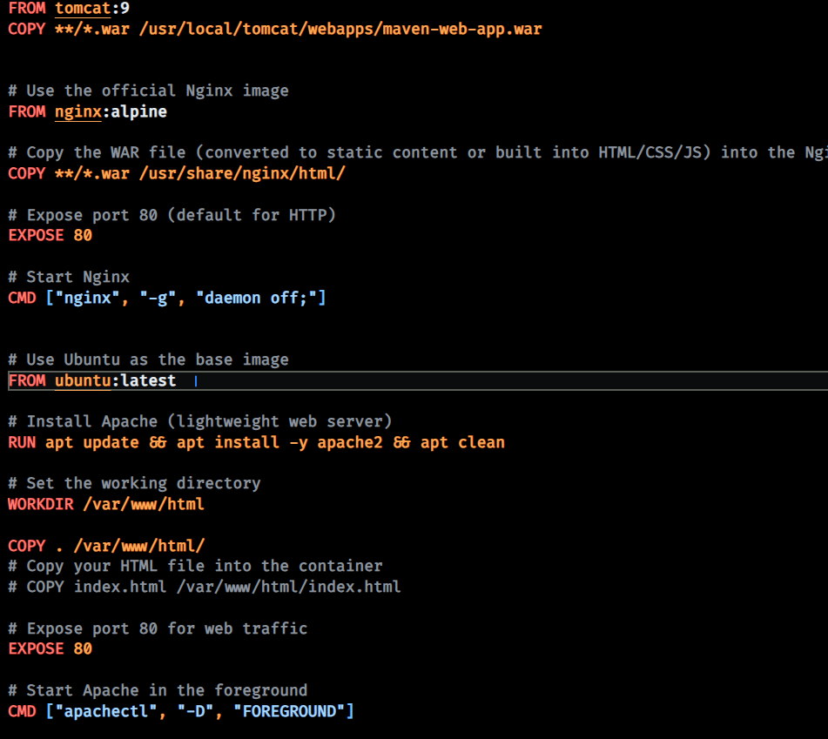

ScreenShots:

**Docker:**

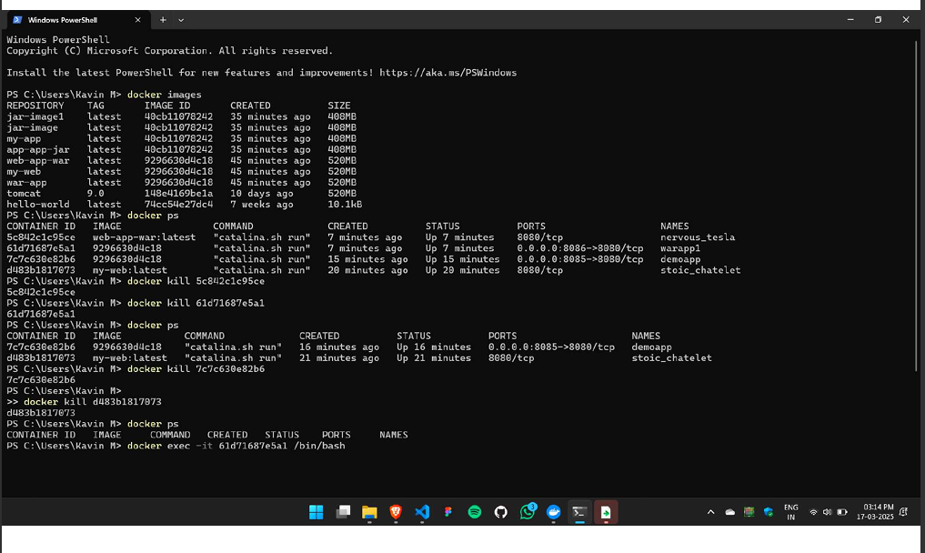

**Tomcat:**

Nginx:

**Docker Desktop:**

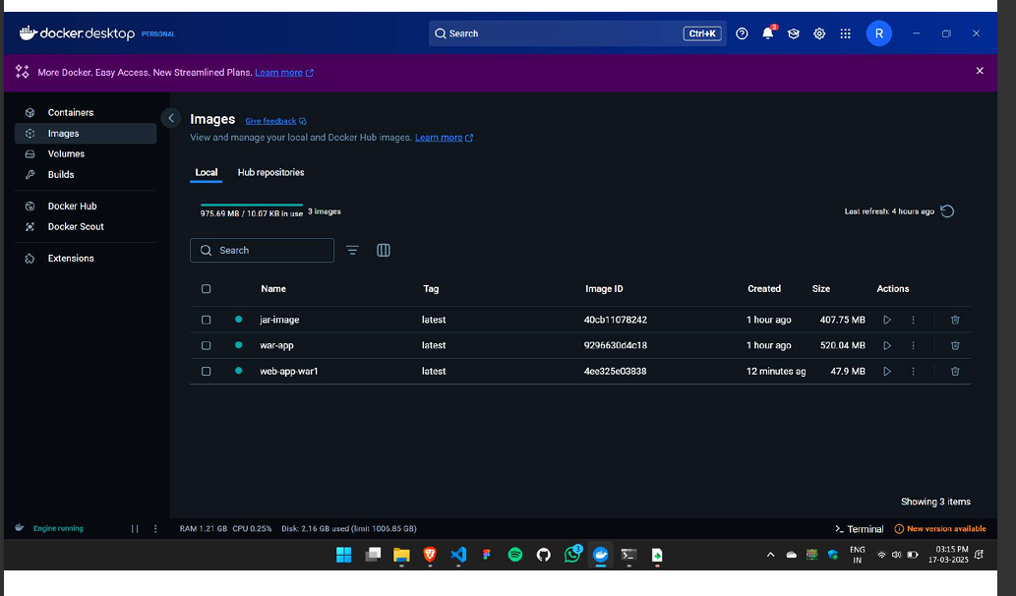

**Nginx With Ubuntu:**

