**RAGULANDIRAN M – 22CSR157 || KONGU ENGINNERING COLLEGE**

**DAY 6 – Java Application Minikube deployment**

**minikube deployment of java:**

**Stage View of pipeline project:**

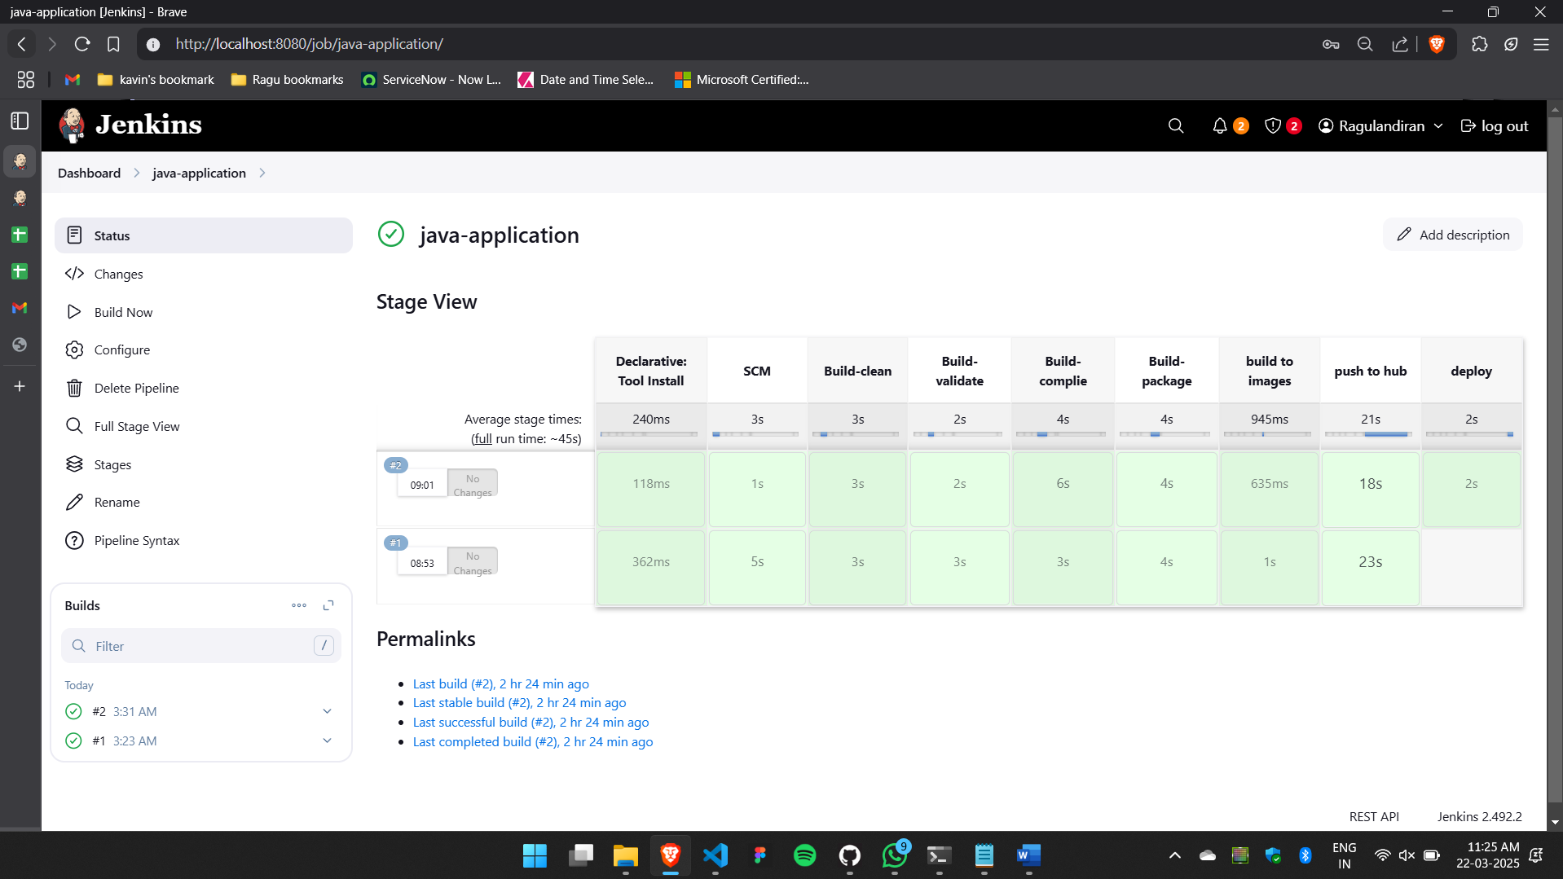

* Minikube srv my-service

