“Audio Steganography”

1.1 INFORMATION SECURITY
The phenomenal growth in e-commerce applications through the Internet in the past few years has led to a genuine need, as well as a sense of urgency, for both small office and home office (SOHO) and corporate users to protect their data transactions through the Internet. These data transactions may include sensitive document transfer, digital signature authentication, digital watermarking for copyright protection, and digital data storage and linkage.
In any communication, security is the most important task. With the advancement of technology and the wide use of World Wide Web for communication increase the challenges of security. However, the challenges can be manageable with the advanced technologies of secure networks but every time these technologies may not be reliable for communication of secrete information over a long distance that produce a need of additional security mechanisms to secure secrete information. In this context, to provide the security two techniques has been used widely, Cryptography and Steganography. Cryptography is used to scramble the information, deals with changing the meaning and appearance of message. It changes the plain text into cipher text by the process of encryption, uses the mathematical techniques and various algorithms such as public key cryptography, private key or symmetric and asymmetric algorithm for securing the information. However, cryptography provide secure solutions to a set of parties, by encrypting plain text into cipher text but the cyber attacker easily arouse these text and intercepts the communication between two separate users to modify, inject, or drop any communication packet. To improve these limitations and to reduce the issues of cryptographic methods an alternative mechanism, the steganography has use widely. Generally the concepts of this techniques differ from the cryptography, where the cryptography method converted the information in a encrypted form that an eavesdropper and cannot be understand, the Steganography technique embeds hidden content in unremarkable cover media so as not to arouse an eavesdropper’s suspicion in some cases, sending encrypted information may draw attention, while invisible information will not. However, both cryptography and steganography provide the security but no one standalone techniques are enough of secure information efficiently and different security categories have different requirements and problems.

1.2 INTRODUCTION TO STEGANOGRAPHY
Today the Steganography deals with many electronic media rather than physical objects the Medias are used for digitally embedding message such as plain text hyper text audio or video still images and network traffic. There are many Steganography techniques which are used for hiding the data in a cover file. Broadband communication networks and multimedia data available in a digital format opened many challenges and opportunities for innovation. Multimedia information hiding is widely used to protect personal privacy and many effective methods have made progresses over the recently years. The word Steganography comes from the Greek and it means covered or secret writing [2]. Nowadays, embedding techniques are used for hiding information into something else for the sole purpose of hiding that information from the casual spectator. Audio Steganography describe methods to embed information into a carrier signal. In this technique audio file is sampled and then an appropriate bit of each alternate sample is altered to embed the textual information.

1.2.1 HISTORY OF STEGANOGRAPHY
FEATURES OF STEGANOGRAPHY Embedding of data into an audio signal should be with the following restrictions and features:
1. The data should be in encrypted format and directly embedded into the media, instead of embedding into a header or cover, so that the data remain undamaged across varying data file formats [1][3].
2. The audio signal should not be corrupted and the embedded data should not be traceable. Data must be hidden, inaudible, not recognizable, and unseen to mean that an observer does not notice the presence of the data, even if they are perceptible[1] [3].

3. The embedded data should be immune to modifications variety from planned and intellectual wound at removal to anticipated manipulations.
4. Asymmetrical coding of the embedded data is desirable, since the purpose of data hiding is to keep the data in the host signal, but not necessarily to make the data difficult to access.
5. Error detection and correction coding should be used to ensure data integrity [1] [3] [4]. Characteristics of Steganography: • Confidentiality • Imperceptibility • Accurateness • High capacity • Resistance • Visibility • Survivability • No detection The main idea of Steganography is to provide secure data at the receiver end like the cryptography. Both have been used to protect information. The cryptographic technique scramble messages so if intercepted, the messages cannot be understood. The Steganography involves making the content of the secret message unreadable while not preventing non intended observers from learning about its existence[9][10]. The goal of Steganography is to hide the data from third party whereas the goal of cryptography is to make data unreadable by third party.

1.3 STEGANOGRAPHY TECHNIQUES

STEGANOGRAPHY TECHNIQUES Echo Hiding: Encodes and echoes the secret message in the form of the binary forms in audio signal with minimal degradation at the data. In echo hiding information is embedded in a sound file by introducing an echo into the discrete signal, Echo Hiding places embedded message in cover audio by introducing an echo.

The steganography can be classified according to its importance and goals. So; various types of steganography are:
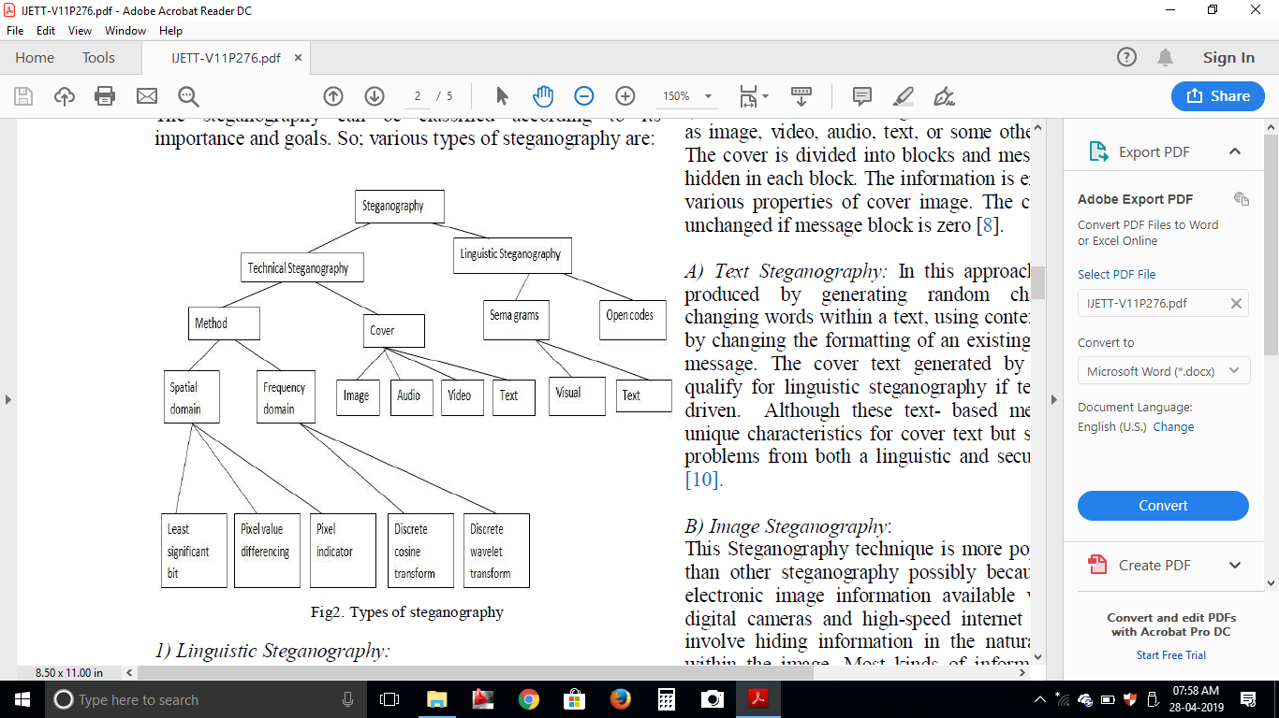
Figure 1.5: types of steganography

1.3.1Linguistic Steganography:
Linguistic technique is used to hide the message within the cover text in non-obvious way such that the presence of message is imperceptible to an outsider. It is divided into two types:
A) Semagrams: It uses only symbols and signs to hide the information. It is further categorized into two ways:
i) Visual Semagrams:A visual semagrams uses physical objects used every day to convey a message. For example: the positioning of items on a particular website.

LSB Technique: It is the way to embed information in a digital audio file. By substituting the least significant bit of each sampling point with a binary message, LSB coding allows for a large amount of data to be encoded.
Parity Coding: It is way to break the sound signal into areas then hides the message in the parity bit. If the parity does not match, it adjusts the LSB of one of the samples to get the required (even) parity. Spread Spectrum: In the context of audio Steganography, the basic spread spectrum (SS) method attempts to spread secret information across the audio signal's frequency spectrum as much as possible [6].

Spread spectrum makes use of the fact that small changes are more difficult for the human eye or ear to detect at high energy levels (loud audio or bright video). The message is hidden in those areas of the carrier file with the greatest energy

ii)Text Semagrams:This type is used to hides a message by modify the appearance of the carrier text, or by changing font size and type, or by adding extra space between words and by using different flourished in letters or handwritten text.
B) Open Code: In this approach the message is embedded in legitimate paraphrases of cover text in the way such that it appears not obvious to an unsuspecting observer. It can be achieved by two ways viz., Jargon which is understood only by a group of peoples and Cipher which uses some concealed ciphers to hide a message openly in the carrier medium. A subset of jargon codes are cue codes, where certain prearranged phrases convey meaning.
1.3.2 Technical Steganography:
Technical steganography uses special tools, devices or scientific methods to hide a message. In this type one can use invisible ink, microdots, computer based methods or various hiding places to keep message secret
1.3.2.1Cover:
The cover message is the carrier of the message such as image, video, audio, text, or some other digital media. The cover is divided into blocks and message bits which are hidden in each block. The information is encoded by changing various properties of cover image. The cover blocks remain unchanged if message block is zero.
1.Image Steganography:
This Steganography technique is more popular in recent year than other steganography possibly because of the flood of electronic image information available with the advent of digital cameras and high-speed internet distribution. It can involve hiding information in the naturally occurred noise within the image. Most kinds of information contain some kind of noise. Noise refers to the imperfections inherent in the process of rendering an analog picture as a digital image. In Image steganography we can hide message in pixels of an image. An imagesteganographic scheme is one kind of steganographic systems, where the secret message is hidden in a digital image with some hiding method. Someone can then use a proper decoding procedure to recover the hidden message from the image. The original image is called a cover imagein steganography, and the message-embedded image is called a stegoimage.Various methods of image steganography are:

- Data Hiding Method:hiding the data, a username and password are required prior to use the system. Once the user has been login into the system, the user can use the information (data) together with the secret key to hide the data inside the chosen image. This method is used to hiding the existence of a message by hiding information into various carriers. This prevents the detection of hidden information.

- Data Embedding Method: For retrieving the data, a secret key is required to retrieving back the data that have been embedded inside the image. Without the secret key, the data cannot be retrieved from the image. This is to ensure the integrity and confidentiality of the data. The process of embedding the message inside the image, a secret key is needed for retrieving the message back from the image, the secret message that is extracted from the system is transfer into text file and then the text file is compressed into the zip file and zip text file is converting it into the binary codes.

- Data Extracting Method: It is used to retrieve an original message from the image; a secret key is needed for the verification. And for extracting method, a secret key is needed to check the key is correct with the decodes from the series of binary code. If key is matched, the process continues by forming the binary code to a zipped text file, the unzip the text file and transfer the secret message from the text file to retrieve the original secret message.

Features of Image Steganography:
- Transparency: The steganography should not affect the quality of the original image after steganography.
- Robustness: Steganography could be removed intentionally or unintentionally by simple image processing operations like contrast or enhancement brightest gamma correction, steganography should be robust against variety of such attacks.
- Data payload or capacity: This property describes how much data should be embedded as a steganography to successfully detect during extraction.

2. Audio steganography:
The technique that provided secured message transfer between two parties commonly in Internet is audio Steganography. Secret information is hidden in digital sound of an audio file in audio Steganography system. The secret information is hidden by marginally changing the binary sequence of a audio file. Hiding secret information in audio file is normally a higher difficult method than hiding information in other media. A variety of techniques for hiding secret message in audio file have been developed in order to conceal secret messages successfully.
Types of audio steganography:
- Least significant bit
- Spread spectrum
- Parity coding
- Echo coding
- Phase coding
3. Video Steganography:
Most of the methods on audio and image can be used to video which are generally a collection of sound and image. Hence, video Steganography is nothing but a combination of audio and image Steganography. The evaluations for audio and image Steganography can be taken together for the evaluation of video Steganography. Important benefit of video steganography is the huge quantity of information that can be embedded inside of sounds and images. Thus, any small perceptible distortions might go by secret by people due to the uninterrupted flow of message. A video stream consists of collection of frames and the secret information is embedded in these frames as payload.

4. Text steganography:
Text steganography can be achieved by altering the text formatting, or by altering certain characteristics of textual elements (e.g., characters). The goal in the design of coding methods is to develop alterations that are reliably decodable (even in the presence of noise) yet largely indiscernible to the reader. These criteria, reliable decoding and minimum visible change, are somewhat conflicting; herein lies the challenge in designing document marking techniques. There are three coding techniques, the techniques can be used either separately or jointly. Each technique enjoys certain advantages or applicability as discussing below.

Line-Shift Coding:
This is a method of altering a document by vertically shifting the locations of text lines to encode the document uniquely. This encoding may be applied either to the format file or to the bitmap of a page image. The embedded code word may be extracted from the format file or bitmap. In certain cases this decoding can be accomplished without need of the original image, since the original is known to have uniform line spacing between adjacent lines within a paragraph.

Word-Shift Coding:
This is a method of altering a document by horizontally shifting the locations of words within text lines to encode the document uniquely. This encoding can be applied to either the format file or to the bitmap of a page image. Decoding may be performed from the format file or bitmap. The method is applicable only to documents with variable spacing between adjacent words. Variable spacing in text documents is commonly used to distribute white space when justifying text. Because of this variable spacing, decoding requires the original image - or more specifically, the spacing between words in the un-encoded document.

Feature Coding:
This is a coding method that is applied either to a format file or to a bitmap image of a document. The image is examined for chosen text features, and those features are altered, or not altered, depending on the code word. Decoding requires the original image, or more specifically, a specification of the change in pixels at a feature. There are many possible choices of text features; here, we choose to alter upward, vertical endlines - that is the tops of letters, b, d, h, etc. These endlines are altered by extending or shortening their lengths by one (or more) pixels, but otherwise not changing the endline feature.
1.3.2.2 Method:
In spatial domain, images are represented by pixels. Simple watermarks could be embedded by modifying the pixel values or the least significant bit (LSB) values. It directly loads the raw data into the image pixels. Some of its algorithms are LSB, SSM Modulation based technique.
Spatial Domain: In this technique only the least significant bits of the cover object is replaced without modifying the complete cover object. It is a simplest method for data hiding but it is very weak in resisting even simple attacks such as compression, transforms

- Least Significant Bit (LSB):
This is the most common, simple approach for embedding data in a cover image. The least significant bit (8th bit) of one or all of the bytes inside an image is changed to a bit of the secret message. When we use 24-bit image, three color bits components are used which are red, green, blue, each byte store 3 bits in every pixel. An 800 × 600 pixel image, can thus store a total amount of 1,440,000 bits or 180,000 bytes of embedded data. For example a grid for 3 pixels of a 24-bit image can be as follows:
(00101101 00011100 11011100)
(10100110 11000100 00001100)
(11010010 10101101 01100011)
When the number 200, which binary representation is 11001000, is embedded into the least significant bits of this part of the image, the resulting grid is as follows:
(00101101 00011101 11011100)
(10100110 11000101 00001100)
(11010010 10101100 01100011)
The number was embedded into the first 8 bytes of the grid, only the 3 underlined bits needed to be changed according to the embedded message. On average, only half of the bits in an image will modified to hide a secret message using the maximum cover size. Since there are 256 possible intensities of each primary color, changing the LSB of a pixel results in small changes in the intensity of the colors. These changes cannot be visible by the human eye due to the message hidden. In these consecutive bytes of the image data – from the first byte to the end of the message – are used to embed the information. And easy to detect, more secure system for the sender and receiver to share a secret key that specifies only some pixels to be changed in its simplest form, LSB makes use of BMP images, since they use lossless compression. It hide a secret message inside a BMP file, one would require a very large cover image. In BMP images of 800 × 600 Pixels are not often used on the Internet and might arouse suspicion. For this reason, LSB steganography has also been developed for use with other image file formats. It is a simple method for embedding data in a cover image. This is the simplest algorithm in which information can be inserted into every bit of image information. Given an image with pixels, and each pixel being represented by an 8-bit sequence, the watermarks are embedded in the last (least significant bit) of selected pixels of the image proposed a simple data hiding technique by simple LSB substitution. In this technique last bit of host data is randomly changed and produce the watermarked data at output. The cover LSB media data are used to hide the message.
- Pixel Value Differencing:
It provides both high embed-ding capacity and outstanding imperceptibility for the stego-image; this segments the cover image into non overlapping blocks containing two connecting pixels and it modifies the pixel difference in each pair for data embedding.
- Pixel Indicator:
This method gives the stego images of better quality than the traditional method while maintaining a high embedding capacity and it also uses concept of hiding the data using the difference between the pixel values. It’s more complex way of hiding information in an image. Transformations are used on the image to hide information in. Transform domain embedding can be termed as a domain of embedding techniques in frequency domain; image is represented in terms of its frequencies.
Frequency Domain:
- Discrete Cosine Transformation: These methods convert the uncompressed image into JPEG compressed type. It is based on data hiding used in the JPEG compression algorithm to transform successive 8x8pixel blocks of the image from spatial domain to 64 DCT coefficients each in frequency domain. The main advantage of this method is its ability to minimize the block like appearance resulting when boundaries between the 8x8 sub-images become visible (known as blocking artefact).

- Discrete Wavelet Transformation: It gives the best result of image transformation.it splits the signal into set of basic functions .there are two types of wavelet transformation one is continuous and other is discrete This is the new idea in the application of wavelets, in this the information is stored in the wavelet coefficients of an image, instead of changing bits of the actual pixels. It also performs local analysis and multi-resolution analysis. DWT transforms the object in wavelet domain and then processes the coefficients and performs inverse wavelet transform to show the original format of the stego object.

CHAPTER 2
LITERATURE SURVEY ON AUDIO STEGANOGRAPHY

2.1 INTRODUCTION
In this chapter, we serve to review some basic theory of information hiding (steganography) that is necessary for a better understanding of this work, we approach thismissionbyfirstfurnishingmodelsfromancienthistoryandthenproceedingto thecurrentera,thefollowingbackgroundmaterialispresentedtoprovidecontextfor this work. First, basic steganography along with its challenges and applications are presented, then, we present a discussion of the various steganography properties, requirements, scheme, with particular focuses on data hiding, including watermarking,cryptography,biometricshiding,steganalysisandstate-of-the-art.It is then reviewed to previous works that provide a foundation for our work.
Informationhidingisageneraltermofembeddingmessagesinthecontent.The termhiding referstoeitherproducingthedatatobe hiddenormakingtheexistenceof secret information unnoticeable. The word steganography was invented by Trithemius. It derived from the Greek words Steganos, which means “covered,” and graphical, which means “writing”. Steganographyreferstotheartandscienceofconcealinginformation.Itfocuses on how can two communication entities embedded the secret message in a cover media and transmit the secret message over a public channel that the existence of information is imperceptible by the third party.
Steganography and cryptography are very important techniques used in data security to hide and secure secret messages in transmitted data. Rasras, Rashad J., Ziad A. AlQadi, and Mutaz Rasmi Abu Sara introduced, implement and test a novel methodology which can be used as a secure and highly efficient method of data hiding and data extracting. Some efficiency parameters will be experimentally obtained and compared with other existing methods parameters to prove the efficiency of the proposed methodology.
The proposed methodology was based on selecting a position in the color image to starthiding the secret message and matrix blocking to encrypt - decrypt the holding color image.
Recently, there has been a lot of interest in the fields of Steganography and Steganalysis. Steganography involves hiding information in a cover (carrier) media to obtain the stego media, in such a way that the cover media is perceived not to have any embedded message for its unintended recipients. Steganalysis is the mechanism of detecting the presence of hidden information in the stego media and it can lead to the prevention of disastrous security incidents. Meghanathan, Natarajan, and LopamudraNayak, provided a critical review of the steganalysis algorithms available to analyze the characteristics of an image, audio or video stego media vis-à-vis the corresponding cover media (without the hidden information) and understand the process of embedding the information and its detection.They have analyzed the steganalysis algorithms available for three commonly used domains of steganography (Image, Audio and Video). In summary, each carrier media has its own special attributes and reacts differently when a message is embeddedin it. Therefore, the steganalysis algorithms have also been developed in a manner specific tothe target stego file and the algorithms developed for one cover media are generally noteffective for a different media.
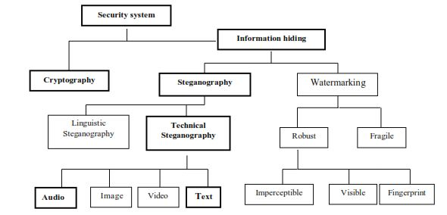
Figure2.1:Adifferentdisciplineofinformationhiding,theboldfaceindicatesthefocusstudy.

Steganography methodology forinformation hidingiswidelyused indifferentapplications using various steganography strategies, these methods had been describedforhidinginformation,suchashidingintext,hidinginimage,hidingin diskspace, hidinginnetwork packets, hidinginsoftware andcircuitry, hidinginaudioandvideo,andcountermeasuresagainstattacks.Fordecades,peopletry andstrovetodevelopinnovativemethodsforsecretcommunication,fromthissurvey, the need for ageneral methodology alongwith performance metrics bywhich to compare steganographic algorithms becomes evident and compute it by using a variousfactors.Figure.2.1.Indicatethedifferentembodimentdisciplinesof information hiding,theboldfaceindicatesthefocusofthestudymethodsofcombiningtextand Audio.
The literature of a steganographic method lies exactly on the embedding and extractionalgorithm,wheretheembeddingalgorithmdescribeshowtohidea secret messageintothecoverobjectandtheextractionalgorithmillustrateshowtoextract the secret message from the Stego object that can be found. The act of digitalsteganographyinavarioustechniquesreferredtoasinformationhidingwhich falls under the umbrella of security system that can be characteristics utilizing the theories of communication. The parameters of hidden communication can be related tothecharacteristicsof communication systems. For instance,the highly secured of a secret message where the steganography messages may be first encrypted then decrypted,protectingthecontentofahiddenmessage,themaximumamountofdata thatcanbehiddenandsuccessfullyextractediscommensuratewiththemajorfactor of the steganography algorithm of a communication channel.
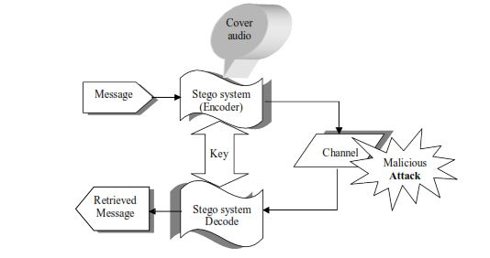
Figure2.2:OverviewofBlindsteganographicsystemscheme

A blockdiagramofagenericblindsteganographysystemscheme,whichusesan audioasacover,isdepictedinFigure2.2.Amessageasatextandaudioisembedded inadigital audiobythestego-system encoder, whichusesakeyorpassword to ensurethesecurityapproach.Theresultingaudio,orstego-audio,istransmittedover a channeltotherecipient,whereitisprocessedbythestego-systemdecoderusingthe matchingkey orpasswordfordetectingorretrievingthehiddendata.During transmission,thestego-audiocanbemonitoredbymanyviewers,whowillnotice onlythetransmittaloftheinnocuousaudiowithoutrealizingahiddenmessage.Overthesefewyears,anumberofsteganographyalgorithmshavebeenpropose.
2.2 REVIEW ON AUDIO STEGANOGRAPHIC TECHNIQUE
Today’s large demand of internet applications requires data to be transmitted in a secure manner. Data transmission in public communication system is not secure because of interception and improper manipulation by eavesdropper. So the attractive solution for this problem is Steganography, which is the art and science of writing hidden messages in such a way that no one, apart from the sender and intend recipient, suspects the existence of the message, a form of security through obscurity.Jayaram, P., H. R. Ranganatha, and H. S. Anupama proposed that Audio steganography is the scheme of hiding the existence of secret information by concealing it into another medium such as audio file. Thus they concluded that audio data hiding techniques can be used for a number of purposes other than covert communication or deniable data storage, information tracing and finger printing, tamper detection.
Audio steganography is more challenging than image steganography because the HAS has more precision than human visual system (HVS). . Balgurgi, Puja P., and Sonal K. Jagtap proposed the method of LSB coding along with the encryption to hide the data indigital audio files. The method used is XORing method in which information is hidden by performing XOR operation on LSB’s.
There is no difference between stego audio signal & the original audio signal i.e. hidden information is recovered without any error. It gives great security & the embedded message cannot be extracted without the knowledge of embedding process.
The conventional LSB modification technique is vulnerable to steganalysis.Assad, Muhammad, Junaid Gilani, and Adnan Khalid proposed two ways to improve the conventional LSB modification technique. The first way is to randomize bit number of host message used for embedding secret message while the second way is to randomize sample number containing next secret message bit. They also extended the conventional LSB modification technique for audio steganography to make it more secure against steganalysis. On average, the technique embeds one secret message bit per four samples of host message. The maximum embedding rate is one secret message bit per sample of host message while minimum embedding rate is one secret message bit per eight samples of host message. In order to make sure the secret message is completely embedded, the samples of host message should be eight times the number of bits of secret message.
A Steganographic technique for embedding text information in audio using LSB basedalgorithm is presented in the paper proposed by Binny, Anu, and MadduletyKoilakuntla. In the proposed method each audio sample is converted into bits and then the text data is embedded. In embedding process, first the message characteris converted into its equivalent binary. By using proposed LSBbased algorithm, the capacity of stego system to hide the textincreases. Theefficacy of proposed method is verified using the parameterslike SNR. Future work consist of enhanced security and robustness by means of addition of cryptographic key algorithms.
LSB techniques generally embed data in the same LSB position of consecutive samples which helps intruders to extract secret information easily. Datta, Biswajita, Prithwish Kumar Pal, and Samir Kumar Bandyopadhyay proposed paper to solve this problem by introducinga robust audio steganography technique where data is embedded in multiple layers of LSB chosen randomly and in non-consecutive samples. The choice of random LSB layers and non-consecutive pixels for embedding increases robustness as well as the strength of proposed steganography algorithm. It is seriously a problem that the data hiding at non-contiguous sample locations loses the capacity of stego audio. The robustness of the technique is also achieved by selectingmultiple LSB Layers randomly for embedding. Here two levelsof randomness is introduced one by performing permutationfor selecting three from five LSB locations and then byselecting arrangements in random manner. These makes theintruder’s works more hard to get the secret message duringtransit.
Audio watermarking using echo hiding has fairly good perceptual quality. However, security and the tradeoff between robustness and imperceptibility are still relevant issues.Chen, Oscal T-C., and Wen-Chih Wu presented a paper the echo hiding scheme in which the analysis-by-synthesis approach, interlaced kernels, and frequency hopping are adopted to achieve high robustness, security, and perceptual quality. This work adapts the amplitudes of echoes by an analysis-bysynthesisapproach, to exploit the properties of host signals andthen minimize the amplitudes of the echo signals.
Xiang, Yong, IynkaranNatgunanathan, DezhongPeng, Wanlei Zhou, and Shui Yu proposed a novel dual-channel tim e-spread echo method for audio watermarking, aiming to improve robustness and perceptual quality. It is more robustagainst common attacks and has better perceptual qualitythan existing echo-hiding based watermarking methods.
Hu, Peng, DezhongPeng, Zhang Yi, and Yong Xiang Proposed a robust audio watermarking method based on the time-spread (TS) echo hiding scheme. Compared with existing TS watermarking methods, the approach is more robust as it exploits the characteristics of host signals in the encoding stage. Theoretical analysis and simulation examples demonstrate the effectiveness and advantages of the method. As a result, the proposed method provides superior robustness compared with the method in without sacriﬁcing imperceptibility, as demonstrated by simulation tests.
Kirovski, Darko, and Henrique S. Malvarpresented several novel mechanisms for effective encoding and detection of direct-sequence spread-spectrum watermarks in audiosignals. The developed techniques aim at i) improving detection convergence and robustness, ii) improving watermark imperceptiveness, iii) preventing desynchronization attacks, iv) alleviating estimation/removal attacks, and finally, v) establishing covert communication over a public audio channel. They explore the security implications of the developed mechanisms and review watermark robustness on a benchmark suite that includes a combination of audio processing primitives including: time- and frequency-scaling with wow-and-flutter, additive and multiplicative noise, resampling, requantization, noise reduction, and filtering.
Dong, Xiaoxiao, Mark F. Bocko, and ZeljkoIgnjatovicpresented a technique for inserting and recovering “hidden” data in audio files. In this technique the phase of chosen components of the host audio signal is manipulated in a way that may be detected by a receiver with the proper “key”. Without the key, the hidden data is undetectable, both aurally and via blind digital signal processing attacks. The method described is both aurally transparent and robust and can be applied to both analog and digital audio signals, the latter including uncompressed as well as compressed audio file formats such as MP3. The proposed method allow up to 20 kbits of data per minute to be embedded in uncompressed
or compressed audio files. Additionally, they described three effective techniques for reducing the phasediscontinuity, and the associated aural artifacts, caused bythe phase coding methods.
A novel perception-based data hiding technique for digital audio is proposed by Ansari, Rashid, Hafiz Malik, and Ashfaq Khokhar It exploits lower sensitivity of humanauditory system (HAS) to phase distortion in audiocompared with magnitude distortion. Audio isdecomposed into subband signals some of which areselected for embedding data with a controlled alterationof phase using suitable all pass digital filters. Theproposed scheme is robust to standard data manipulationsyielding less than 2% error probability againstcompression, re-sampling, re-quantization, random chopping and noise addition. The proposed method is alsorobust to the desynchronization attacks. The proposedtechnique is robust to standard data manipulationsyielding less than 2% error probability against noise addition, compression, random chopping and re-sampling. The error probability performance can be improvedfurther by using channel coding scheme with higher error correction capability. Data detection results show that proposed scheme can embed data 10-15 times more data in a unit duration audio samples compared with existing schemes, but this was based on informal tests for imperceptibility. The performance will be evaluated using formal listening tests that are being set up.
Zeng, Wei, Haojun Ai, and Ruimin Hu proposed a novel algorithm to detect phase coding steganography in audio signal. It is based on analysis of the phase discontinuities, and can be described as follows. Firstly, it takes FFT transform of special segment of audio and unwraps the phases of each audio sample, then extracts the phase difference between neighboring samples. Secondly, in order to monitor the change of phase difference, it calculates the five statistical features of phase difference for steganalysis. Thirdly, the SVM classifier is utilized for classification. All of the 800 various audios are trained and tested in our experimental work. With various embedding parameters for training and testing audios, the proposed algorithm can achieve a good classification, and the correct rate of detecting is up to 95%. Phase coding is one of the most effective coding methods in terms of the signal-to perceived noise ratio.In this paper, we present a novel method to detecthidden message by typical phase coding in audiosignal. We use statistical analysis of phase differenceto monitor the phase discontinuities and use SVM classifier to capture the faint changes of phase causing by embedding. Experiments are conducted on a set ofvarious types of audios and the correct rate of classification reaches to 95%.
Hardwick, John C., and Daniel W. Griffin proposed an audio watermarking system which conveys information using an audio channel by modulating an audio signal to produce a modulated signal by embedding additional information into the audio signal. Modulating the audio signal includes segmenting the audio signal into overlapping time segments using a non - rectangular analysis window function produce a windowed audio signal , processing the windowed audio signal for a time segment to produce frequency coefficientsrepresenting the windowed time segment and having phase values and magnitude values , selecting one or more of the frequency coefficients , modifying phase values of the selected frequency coefficients using the additional information to map the phase values onto a known phase constellation , and processing the frequency coefficients including the modified phase values to produce the modulated signal.
Classification of audio documents as bearing hidden information or not is a security issue addressed in the context of steganalysis. A cover audio object can be converted into a stego-audio object via steganographic methods. Ozer, Hamza, Ismail Avcibas, BulentSankur, and Nasir D. Memon presented a statistical method to detect the presence of hidden messages in audio signals. The basic idea is that, the distribution of various statistical distance measures, calculated on cover audio signals and on stego-audio signals vis-à-vis their denoised versions, are statistically different. The design of audio steganalyzer relies on the choice of these audio quality measures and the construction of a two-class classifier. Experimental results show that the proposed technique can be used to detect the presence of hidden messages in digital audio data.
Today, a large number of audio features exists in audio retrieval for different purposes, such as automatic speech recognition, music information retrieval, audio segmentation, and environmental sound retrieval. The goal is to review latest research in the context of audio feature extractionand to give an application-independent overview of the most important existing techniques and survey state-of-the-art features from various domains. Mitrović, Dalibor, Matthias Zeppelzauer, and Christian Breiteneder proposed a novel taxonomy for the organization of audio features. Additionally, they identified the building blocks of audio features and propose a scheme that allows for the description of arbitrary features.

CHAPTER 3
PROPOSED SYSTEM AND IT’s IMPLIMENTATION
3.1 AUDIO STEGANOGRAPHY
Audio Steganography is a technique used to transmit hidden information by modifying an audio signal in an imperceptible manner. It is the science of hiding some secret text or audio information in a host message. The host message before steganography and stego message after steganography have the same characteristics.
Audio files are common and existing abundantly. One of the properties being excessively used for concealing the secret information in audio files is that they have large space. The sensitivity of Human Auditory System(HAS)makes the information hiding in the audio files a tricky task .But, a few general environmentaldistortionsareleftunnoticedbylistenersinnearlyallcases.These properties are exploited by researchers to hide the secret information using audio signals as carriers.

The audio signals are analog signals. To use digital signal processing method son ananalog signal, it is sampled periodically in time. It produces sequence of samples. The audio files are available in various file formats. WAV file is the simplestformat.UnlikeMP3and other compressed formats, the WAVs store samples ‘in the raw ’where no pre-processing is required.
In audio steganography, the cover is an audio and the secret information can be a text file, an image, or an audio. It is usually a more difficult process than embedding messages in other media. Audio Steganography methods can embed messages in WAV,AU, andevenMP3soundfiles.Thepropertiesofthehumanauditory system (HAS)are exploited in the process of audio Steganography. Auditory ear where a frequency-to-location transformation takes place along the basilar membrane. The power spectra of the received sounds are not represented on a linear frequency scale buton limited frequency bands called critical bands.

3.2DIGITAL AUDIO
Digital audio is discrete rather than continuous signal as found in analog audio. A discrete signal is created by sampling a continuous analog signal at a specified rate. For example,the standard sampling rate for CD digital audio is about44 kHz.

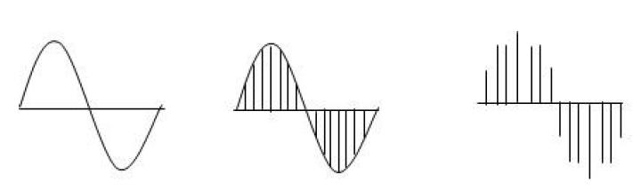
Figure3.1: Continuous analog sound wave
is sampledtoproducedigitalsignal

Digital audio is stored in a computer as a sequenceof0's and 1's. With the right tools, it is possible to change the individual bits that make up a digital audio file. Such precise control allows changes to be made to the binary sequence that are not discernible to the human ear. In the digital domain, PCM(Pulse Code Modulation)isthe most straight forward mechanism tostoreau+-dio. The analog audio is sampled in accordance with the Nyquist the oremand the sequentially in binary format. The wave file is the most common format for storing PCM data and the WAVE file format is a subset of Microsoft's RIFF(specification for the storage of multimedia files. That’s why. Wav files have been used here for below mentioned experiments.

3.3 Techniques used for audio data hiding
- Least Significant bit (LSB) coding
- Spread Spectrum
- Parity coding
- Echo coding
- Phase coding

3.3.1 Least Significant bit (LSB) coding
This method is one of the earliest methods used for information hiding. Traditionally, it is based on embedding each bit from the message in the least significant bit of the cover audio in a deterministic way. The LSB method allows high embedding capacity for data an dis relatively easy to implement or to combine with other hiding techniques. However, this technique is characterized by low robustness to noise addition which reduces
its security performance since it becomes vulnerable even to simple attacks. Filtration, amplification, noise addition and lossy compression of the stego-audio will very likely destroy the data. Furthermore, since data are embedded in a very deterministic way, an attacker can easily uncover the message by just removing the entire LSB plane.

Figure 3.2:LSB coding
3.3.2 Spread spectrum
In audio steganography, the basic spread spectrum (SS) method attempts to spread secret information across the frequency spectrum of the audio signal using a code which is independent of the actual signal.
Two versions of Spread Spectrum can be used in audio Steganography:
Direct-sequence: Direct-sequence SS attempts to spread out the secret message by a constant called the chip rate and then modulated with a pseudorandom signal and interleaved with the cover-signal.
Frequency-hopping schemes: In frequency-hopping SS, the frequency spectrum of audio files is changed so that it hops rapidly between frequencies. Steps of spread spectrum are given below.

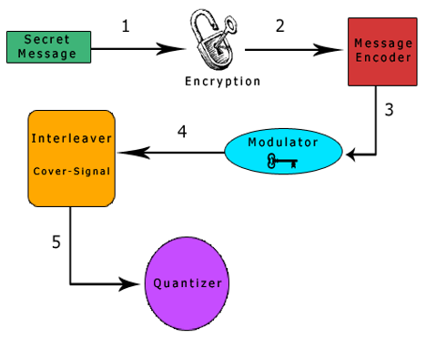
Figure 3.3: Spread spectrum coding

The figure demonstrates the steps of spread spectrum as:

- The secret message is encrypted using a symmetric key k1.
- Then encode encrypted message using a low rate error correcting code that increase overall robustness of the system.
- The encoded message is then modulated with a pseudorandom signal that was generated using a second symmetric key.
- The resulting random signal that contains the message is interleaved with cover signal.
- The final signal is quantized to create a new digital audio file that contains the message.
- This process is reversed for message extraction.

The main disadvantage of this method is that it is vulnerable to time scale modification and the final signal occupies a bandwidth which is more than what is actually required for transmission.

3.3.3 Parity Coding
Instead ofbreaking a signal down into individual samples, the parity coding method breaks a signaldown into separate regions of samples and encodes each bit from the secret message in asample region's parity bit. If the parity bit of a selected region does not match the secret bit tobe encoded, the process flips the LSB of one of the samples in the region. Thus, the senderhas more of a choice in encoding the secret bit, and the signal can be changed in a moreunobtrusive fashion. The main disadvantages associated with the use of methods like spread spectrum and parity coding are humanear is very sensitive to noise and it can often detect even the slightest bit of noise introduced into a sound file andanother problem is robustness.

Figure 3.4: Parity Coding
3.3.4 Echo Coding
Echo hiding embeds its data by creating an echo to the source audio. Three parameters of this Artificial echo are used to hide the embedded data, the delay, the decay rate and the initial amplitude. As the delay between the original source audio and the echo decrease it becomes harder for the human ear to distinguish between the two signals until eventually a created carrier sound’s echo is just heard as extra resonance. In addition, offset is varied to represent the binary message to be encoded. One offset value represents a binary one, and a second offset value represents a binary zero. If only one echo was produced from the original signal, only one bit of information could be encoded. Therefore, the original signal is broken down into blocks before the encoding process begins. Once the encoding process is completed, the blocks are concatenated back together to create the final signal.
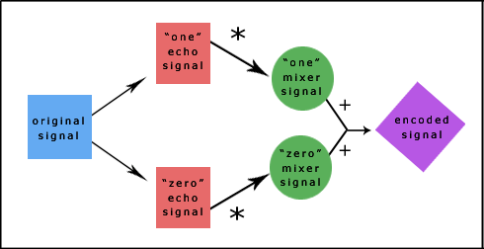
Figure 3.5: summarizes the second implementation of the echo hiding process.
The "one" echo signal is then multiplied by the "one" mixer signal and the "zero" echo signal is multiplied by the "zero" mixer signal. Then the two results are added together to get the final signal. The final signal is less abrupt than the one obtained using the first echo hiding implementation. This is because the two mixer echoes are complements of each other and that ramp transitions are used within each signal. These two characteristics of the mixer signals produce smoother transitions between echoes.
Figure 3.6: Echo hiding

3.3.5 Phase Coding
Phase coding addresses the disadvantages of the noise-inducing methods of audio Steganography. Phase coding is robust to small amounts of additive noise, since the noise won’t affect to the distortion of the phase in most of the frequency slots. Phase Coding works by substituting the phase of an initial audio segment with a reference phase that represents the data. The phase of subsequent segments is adjusted in order to preserve the relative phase between segments.

- Secret message: A Secret message is information that is not immediately noticeable, and that must be covered. Secret messages may be coverd in a audio file, vedio file or text file.
- Stego Key: The Stego file contains the modified version of cover file that contains the secret message.
- Cover File: Cover file is a audio file which is used to cover the secret message
- Embedding Algorithm :Phase coding Algorithm is used as embedding

3.6 Summary

This chapter gives an overview of audio steganography. It can enhance confidentiality of information and provides a means of communicating privately. It then discusses about the various audio steganography techniques. We have also presented an audio steganographic system using phase coding approach. This technique overcomes the disadvantages of noise inducing methods of audio steganography. This is defined based on the perceptual transparency,robustness and tamper resistance achieved by this method. This will lead us to define the best approach of steganography to hide information.

4.1Support Vector Machine
Definition: Support vector machine is a representation of the training data as points in space separated into categories by a clear gap that is as wide as possible. New examples are then mapped into that same space and predicted to belong to a category based on which side of the gap they fall.
Advantages: Effective in high dimensional spaces and uses a subset of training points in the decision function so it is also memory efficient.
Disadvantages: The algorithm does not directly provide probability estimates, these are calculated using an expensive five-fold cross-validation.
4.2 SVM Classifier
- Support Vector Machines are based on the concept of decision planes that define decision boundaries.
- A decision plane is one that separates a set of objects having different class memberships.
- A schematic example is shown in the illustration in fig 4.1
- In this example, the objects belong either to class GREEN or RED. The separating line defines a boundary on the right side of which all objects are GREEN and to the left of which all objects are RED. Any new object (white circle) falling to the right is labelled, i.e., classified, as GREEN (or classified as RED should it fall to the left of the separating line).
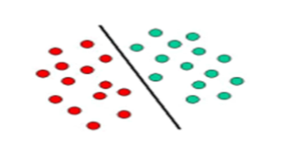
Figure 4.1 Example of Linear Classifier.
- The above Figure 4.1 is classic example of a linear classifier, i.e., a classifier that separates a set of objects into their respective groups (GREEN and RED in this case) with a line.
- Most classification tasks, however, are not that simple and often more complex structures are needed in order to make an optimal separation, i.e., correctly classify new objects (test cases) on the basis of the examples that are available (train cases).
- This situation is depicted in the illustration below.
- Compared to the previous schematic, it is clear that a full separation of the GREEN and RED objects would require a curve (which is more complex than a line).
- Classification tasks based on drawing separating lines to distinguish between objects of different class memberships are known as Wavelet based SVM classifiers as shown in Figure 4.2.
- Support vector machines are particularly suited to handle such task.
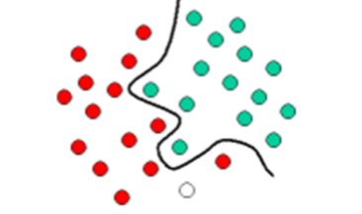
Figure 4.2 Example of Wavelet based SVM classifier
- The Figure 4.3 shows the basic idea behind support vector machines.
- Here, see the original objects (left side of the schematic) mapped, i.e., rearranged, using a set of mathematical functions, known as kernels.
- The process of rearranging the objects is known as mapping (transformation).
- Note that in this new setting, the mapped objects (right side of the schematic) is linearly separable and thus instead of constructing the complex curve (left schematic), all we have to do is to find an optimal line that can separate the GREEN and the RED image.
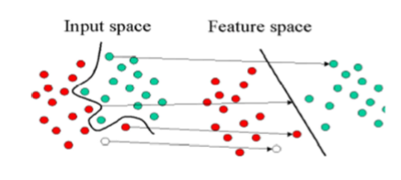
Figure 4.3 Mapped objects.

Implementation
This present work puts forth a novel method to encrypt ‘.wav’, which are basically sound files in image formats such as PNG, TIF and JPEG. The sound file is fetched and the values corresponding to the sample range is put in a column matrix which is then put in a two dimensional matrix having “double” as data-type. Using ‘imwrite’ function of MATLAB, this matrix defined in the class ‘double’ is put in a graphics file or image file. After encryption the data is retrieved from the image file and compared with the original wave file to show the variation in encrypted and decrypted data. This methodology can not only be used as stenographic means but possibly as a technique for data compression. The illustrated method for data encryption of sensitive user information can be used as a viable method to further secure cloud computing transactions.

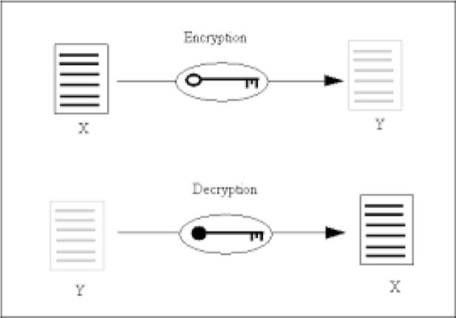
Figure 1

Wave bitstream format

Waveform Audio File Format (WAVE) is an application of RIFF or Resource Interchange File Format which stores audio bit streams in “chunks”. WAVE encodes the sound in LPCM format i.e. Linear Pulse Code Modulation.
Sound is basically a pressure wave or mechanical energy having pressure variance in an elastic medium. The variance propagates as compression and rarefaction wherein compression occurs when pressure is higher than the ambient pressure and rarefaction occurs when the pressure of the propagating wave is less than the ambient pressure. Exactly in the same manner a WAVE file just represents the sampled sound waves which happen to be above or below the equilibrium or ambient air pressure. The plot of wave file is shown in fig 1.
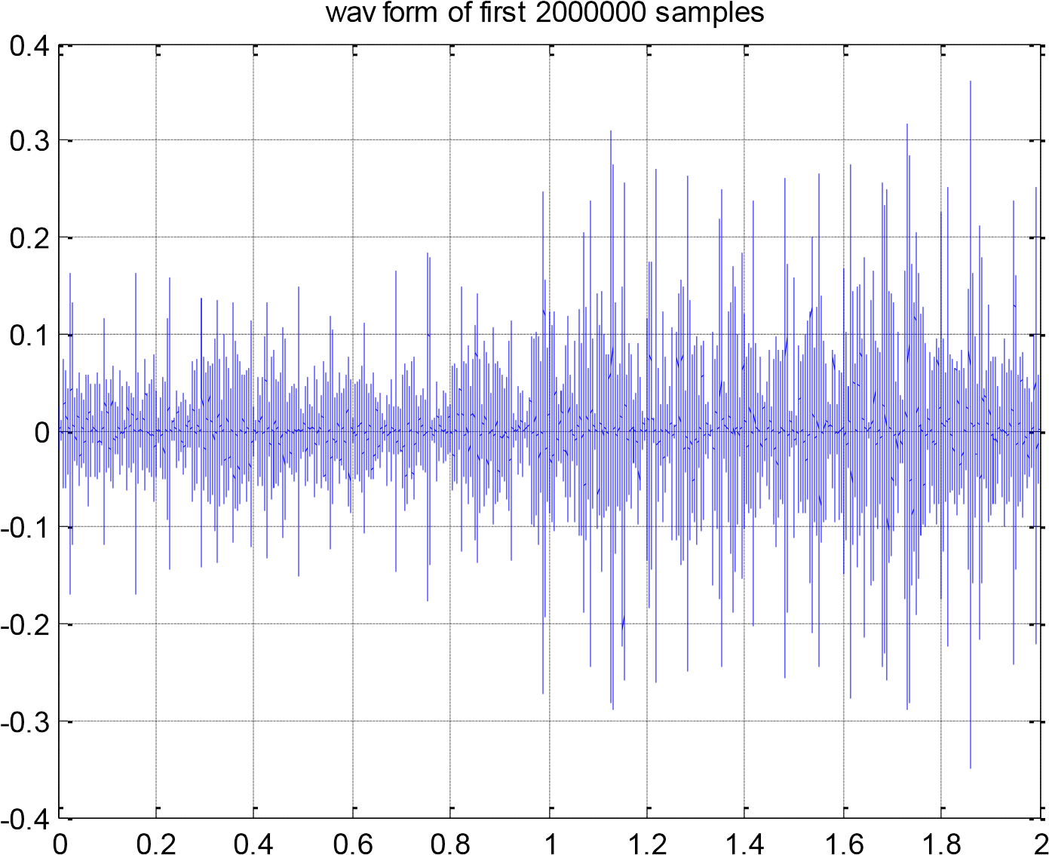
6
x 10
Figure 2

Image Formats and Image Compression

Digital image formats are means of storing digital images in either uncompressed (e.g. TIFF), compressed (e.g. JPEG) and vector formats. On rasterization an image is converted into a grid of pixels. Basically there are two types of image file compression algorithm- lossless and lossy. In losslesscompression the entire digital data is preserved during compression thus preserving image quality. In lossy compressions, the digital data preservation takes place by compromising image quality . Here we will be discussing PNG, TIFF and JPEG formats and these are the very formats in which the wave file will be encrypted into.
MASTER IMAGE FORMATS
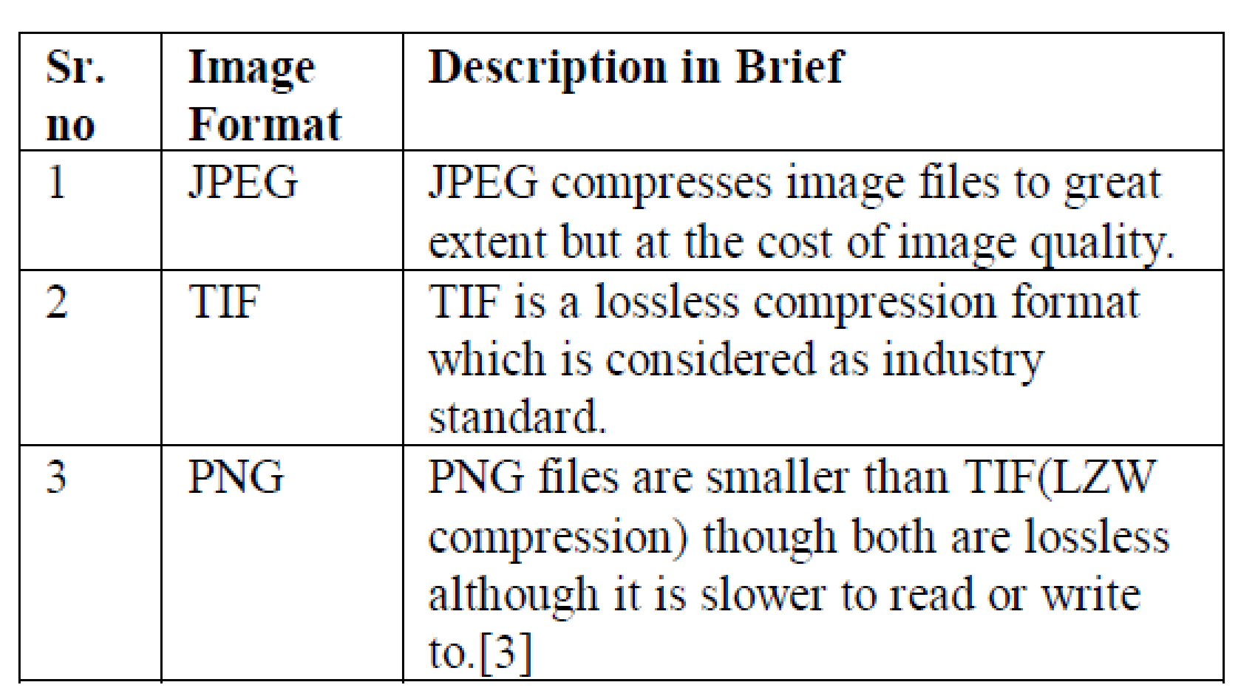

Encryption

Obtaining data of wave file in column matrix

We will be using “dil.wav” wave file as a example whose wave representation is show above in fig 1. The sampling length of this tone is 2000000 samples. Following is the MATLAB code which fetches the wave file using ‘wavread’ function. Amplitude values are obtained in the range of 0 and +1.
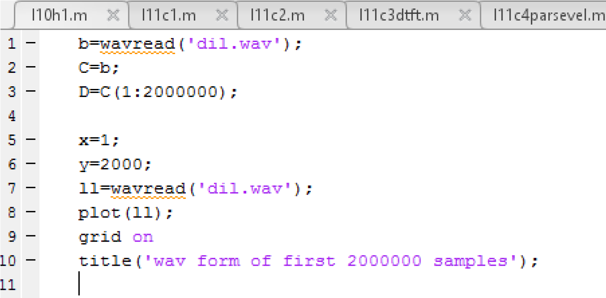
Variable ‘D’ which holds first 2000000 samples. It is to be noted that the variable D is basically a column vector.

Converting column matrix into M x N matrix.

A ‘grayscale’ image of M by N pixels is represented in MATLAB as an M X N matrix having “double” data type wherein each element of the matrix denotes a pixel within an intensity of 0 and 1. It is to be noted that the variable D is a column matrix with “double” type and intensity within 0 and 1. So to convert variable D in an image format we have to transform D into a 1000 X 2000 matrix.

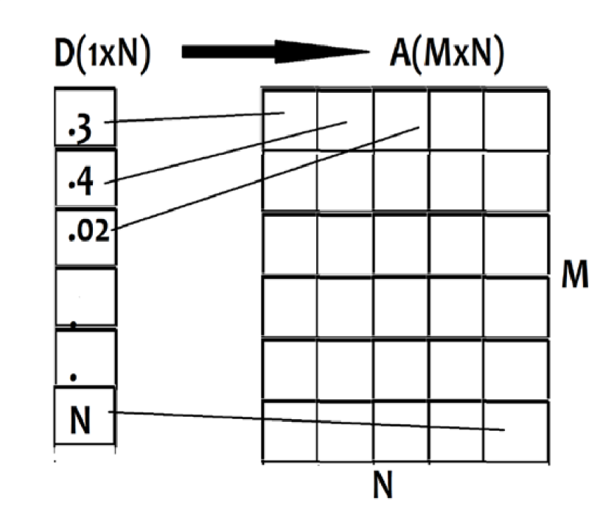
Figure 3 conversion from 1d to 2d

Code to convert to convert matrix A into MxN is shown in fig.4
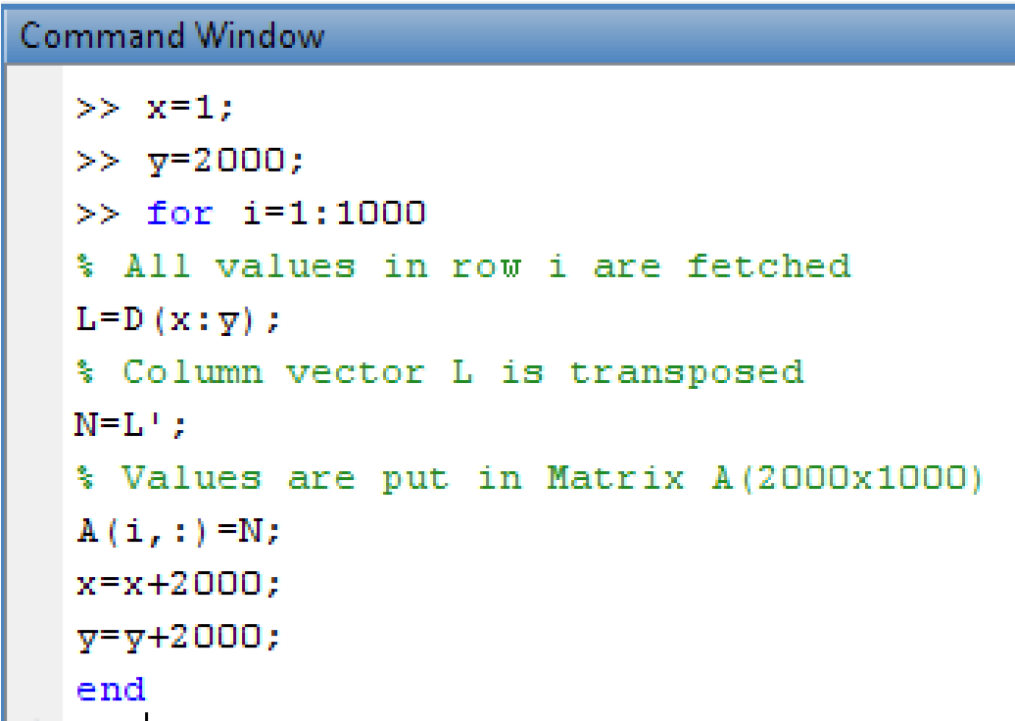
Figure 4

Converting matrix into Image File.

We convert matrix A into JPEG , PNG and TIF formats using MATLAB function called “imwrite”.
Imwrite (A,’.../filename.xyz’);
The above syntax stores matrix A in the file path mentioned. We also save column matrix D in a new wave file using “wavwrite” function.

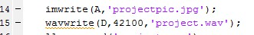
How the wave file appears in JPEG format (this is a cropped image as the actual file is far bigger).also shown in fig.5
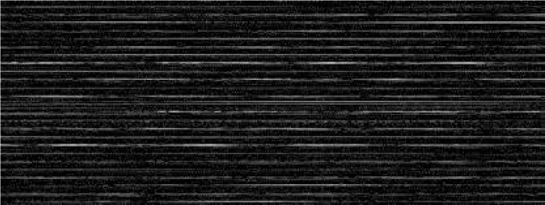
Figure 5

Decryption of wave from image
This method is just the opposite of encryption with minor variations. When the image is created during encryption it is basically an MxN matrix with “double” data type, however on fetching the same image back to MATLAB we get an MxN matrix with datatype “uint8” i.e. unsigned integer of 8 bit.
Thus we need to first convert all elements of matrix obtained into double precision .
Decryption can be basically understood as a data mining method to fetch, audit and understand the pattern of data stored in the encrypted file.
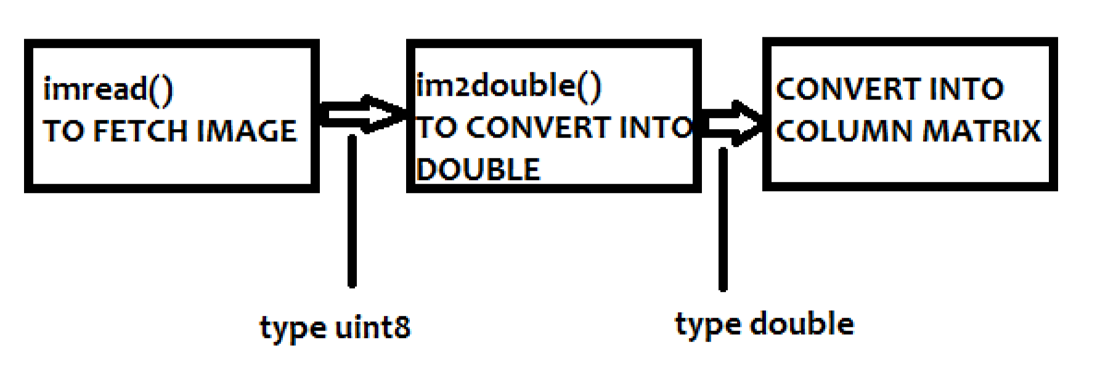

3.1 Data type conversion

“im2double” function of MATLAB takes an image as input and converts it into another image or matrix having all elements with type double. As already stated, the image files retrieved by MATLAB are in unsigned integer form and before they are put in column matrix representing a WAVE file, it has to be converted into data type of double precision.
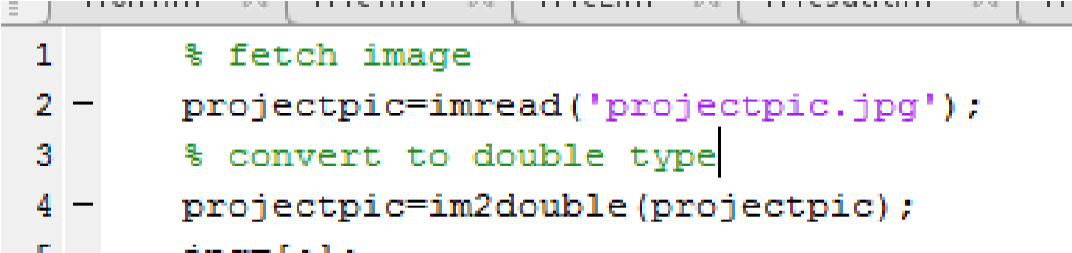

3.2 Algorithm to convert image matrix into column matrix and hence .wav.
“wavwrite ( X, FS, ‘.../filename.wav’);”
The above function is used to save X column vector in the given ‘filename’ () with a desired frequency ‘FS’. The column vector X is obtained by converting image matrix of double precision into column matrix. The method is explained in the following programming code of MATLAB.

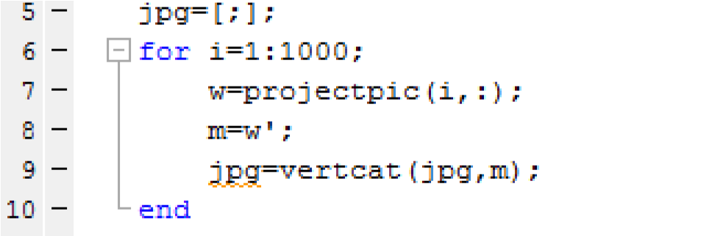

3.3 Audio Recorder:
Matlab build in function recorder = audiorecorder(Fs,nBits,nChannels) which allows us to to record the sound for specific time is used is to record the audio message of user for 50 seconds.

Implementation

Steganography and LSB Technique
In this research, we improve the conventional LSB algorithm, by embedding the message bits to the audio bit stream (16 bit per sample) in random samples (section 5.0) to increase robustness, then apply bit modification technique (section 6.0) on the samples to decrease the error and to maintain the high perceptual transparency of the resulting audio signal In our proposed model we take two consecutive bits from the secret message and instead of changing a single bit in a sample we change two bits (for example 3rd and 4th position) of the sample. If there is change in these two bits we flip rest of the LSB otherwise there is no change. For example, if the original sample value was (0...01000)2=(8)10, and the hidden message bits “01” are to be embedded into 3rd and 4th LSB layer, the standard algorithm will produce the value (0...00000)2=(0)10 to embed the 1st bit only and for the 2nd bit we need another sample, to embed the 2nd bit. Our proposed algorithm will produce (0...00111)2 = (7)10 to embed the two bits in one sample and after the sample reshaping, this sample is much closer to the original sample and contains two hidden bits (here 0 and 1) instead of one bit.
Steps of data Encoding algorithm:
1. Get the Tn input text to be embedded. Where n=1...m. Length of secret text is m, where m must be less than 65535 characters.
2. Convert the text into ASCII binary code.
3. Read the An input audio file as cover file. Where n=1...k. The total number of samples of audio cover is k.
4. Check the condition k > (m *8) +16. If yes, then execute the embedding process. Where 16 is the number of bits represent the total size of the message required to be hidden.
5. Embed the size of the message (m represented in bits) in the first 16 samples in the LSB of the WAV file
6. Select the sample according to the PN sequence generator
7. In the audio sample (k samples) hide the binary codes of secret text in the corresponding LSB bits of WAV file.
8. Sample reshaping to get the minimum effect due to the message hiding.
9. Repeat above procedure from point 6, till the entire message embedded in audio.

Steps of data Decoding algorithm:
1. Read the cover audio file
2. Extract the size of the hidden message by reading the LSB of the first 16 samples
3. Extract the binary code by reading the samples of LSB according to the PN sequence generator
4. Convert binary code into characters.
5. Display the secret message Tn.

FLOWCHART:

ENCRYPTION:

- The process of encryption involves embedding the secret message into the cover image to obtain a stego image.
- Encryption process is carried out on the cover image.
- Stego image is an image similar to cover image with secret message embedded into it.
- The encryption process is shown in Fig 4.2
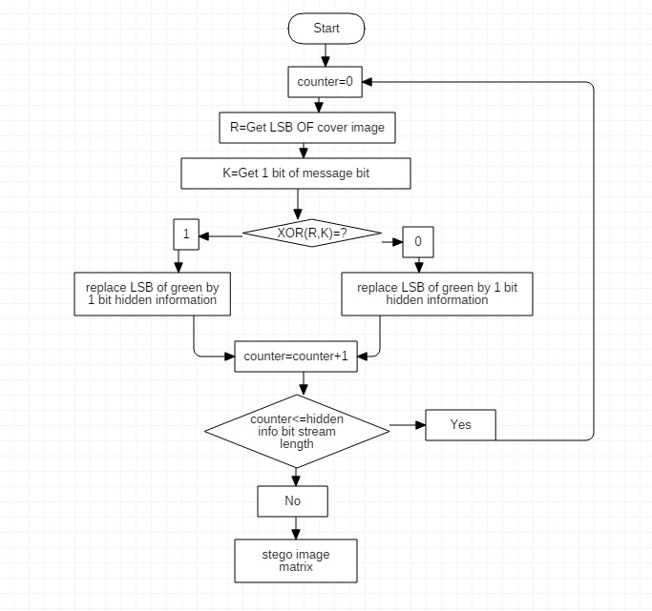

Fig 4.4 Process of encryption

The steps involved in encryption process are listed below:

- Initially the counter is set to 0.
- Get the LSB of cover image and store it in an array R.
- Keep the first bit of the message to be hidden in an array say K.
- Perform XOR operation on the elements of R and K.
- If the output of XOR operation is ‘1’, then replace LSB bit of green by 1 bit of information to be hidden.
- Else if the output is say ‘0’ then replace LSB bit of blue by 1 bit of hidden information.
- In both the cases increment the counter variable by 1.
- Now check if the counter value is less than the length of hidden information bit stream.
- If the condition holds true, counter is again set to 0 and the process repeats.
- Else if the condition holds false, then stego image matrix is obtained that contains the hidden information.

DECRYPTION:

- Decryption process involves extracting the secret message that was embedded in the encrytion process.
- Decryption process is carried out on the stego image.
- Decryption process is performed exactly in the reverse process as of encryption.
- Fig 4.3 shows the decryption process. The steps involved in decryption process if listed below:
- Initially the counter variable is set to 0.
- Get the LSB of cover image and store it in array element say R.
- Get the first message bit and store it in an array element say K.
- Perform XOR operation on the elemnts in R and K.
- If the result of XOR operation is 1, replace LSB of the green matrix by the value 1.
- Else if the result of XOR operation results in 0, replace the LSB of blue matrix by the value 0.
- In either case save the bit in a 1-D array.
- Increment the counter by a value 1.
- If the value in the counter is less than the length of the hidden information bit stream, then counter value is set to 0.
- If the condition holds false, then the 1-D array of information is said to be the hidden information.
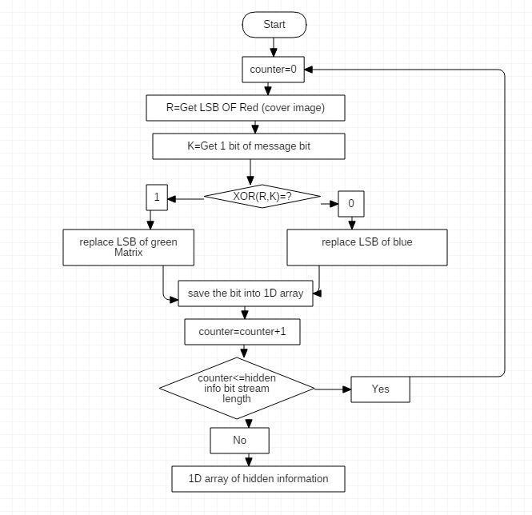

Fig Process of Decryption

- Software Tools Details:
MATLAB

For the project, I chose to use Mat lab as the programming language. It is a high-level language that specializes in data analysis and computing mathematical problems. Mat lab’s official website can be found at www.mathworks.com.

The program environment has an interactive command window that allows users to test and experiment with the code line by line. Users can also save their codes into an M-file and run the program. The Mat lab Help Navigator is also very useful. It properly categorizes and provides detailed explanations and sample usages of all functions. Just like C++ and Java, the language syntax provides loops and condition statements for programming purposes.

The language was chosen over C++ and Java because there are a lot of built-in functions that are specific for image processing. As well, the compiler can compute large mathematical equations faster than other languages. These advantages suit the project perfectly due to the large matrix computations required during the extraction process.

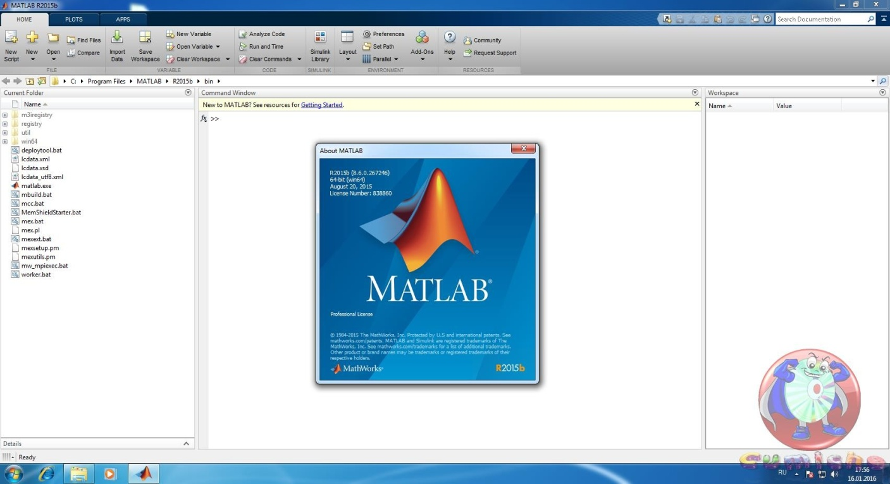

Fig3.15 MAT LAB command window
There were some minor problems that occurred during the working of the project. The first problem was that Mat lab is a complete new language and environment for me. I had to get myself familiarized with Mat lab by practicing simple tutorials and exploring with the programming environment. Another problem that arose is that Mat lab takes a long time running the segmentation code. When compared to C++ and Java, Mat lab can calculate matrices quicker, but the large video files take a long time for a scripting language to compile. Lastly, the Mat lab software environment requires a lot of memory to run. During the process of starting up and compiling, windows often cannot provide enough memory for Mat lab and windows will sometimes shutdown automatically.

Starting MATLAB

After logging into your account, you can enter Matlab by double-clicking on the Matlab shortcut icon (Matlab R2014a)on your Windows desktop. When you start Matlab,a special window called the Matlab desktop appears. The desktop is a window that contains other windows. Them a jor tools within or accessible from the desktop are:
• The Command History
• The Workspace
• The Current Directory
• The Help Browser
• The Start button
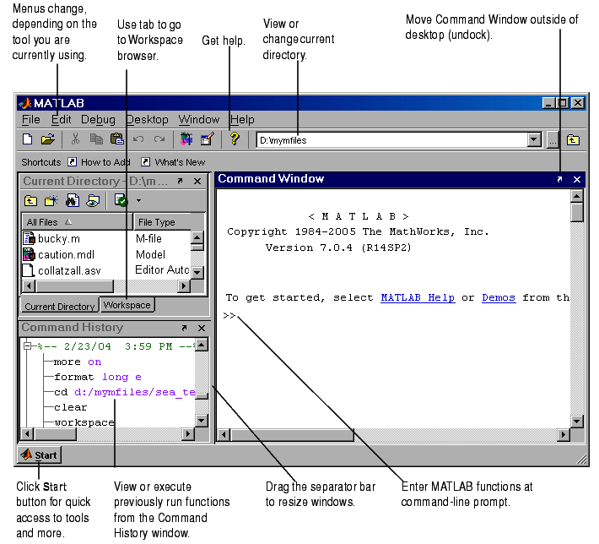

Figure1.1:ThegraphicalinterfacetotheMatlabworkspace
WhenMatlabisstartedforthefirsttime,thescreenlooksliketheonethatshown in the Figure 1.1. This illustration also shows the default configuration of the Matlab desktop. You can customize the arrangement of tools and documents to suit your needs.

Now, we are interested in doing some simple calculations. We will assume that you havesufficientunderstandingofyourcomputerunderwhichMatlabisbeingrun.

YouarenowfacedwiththeMatlabdesktoponyourcomputer,whichcontainstheprompt(>>)in the Command Window. Usually,thereare2typesofprompt:
>> for full version
EDU> for educational version

Note: To simplify the notation, we will use this prompt, >>, as a standard prompt sign, though our Matlab version is for educational purpose.

6.2 Using Matlab as a calculator:

As an example of a simple interactive calculation, just type the expression you want to evaluate. Let’s start at the very beginning. For example, let’s suppose you want to calculate the expression, 1 + 2 × 3. You type it at the prompt command (>>) as follows,
>>1+2*3
ans= 7

You will have noticed that if you do not specify an output variable, Matlab uses a default variable ans, short for answer, to store the results of the current calculation. Note that the variable ansiscreated (or overwritten,if it is already existed). To avoid this, you may assign a value to a variable or outpu targument name. For example,

>>x=1+2*3
x= 7

Willresultinxbeinggiventhe value1+2×3=7. This variablenamecanalways beusedtorefertotheresults ofthepreviouscomputations.
Therefore,computing 4xwill resultin
>>4*x
ans =28.0000

6.3 Images and Matlab
1. Greyscale images
Suppose you are sitting at your computer and have started Matlab. You will have a Matlab command window open, and in it the Matlab prompt
>>
Ready to receive commands. Type in the command
>> w = imread(‘cameraman.tif');
This takes the grey values of all the pixels in the greyscale image cameraman.tif and puts them all into a matrix w. This matrix w is now a Matlab variable, and so we can perform various matrix operations on it. In general the imread function reads the pixel values from an image le, and returns a matrix of all the pixel values.
Two things to note about this command:
a. It ends in a semicolon; this has the effect of not displaying the results of the command to the screen. As the result of this particular command is a matrix of size 256X256, or with elements, we don’t really want all its values displayed.
b. The name cameraman.tif is given in single quote marks. Without them, Matlab would assume that cameraman.tif was the name of a variable, rather than the name of a file.
2. RGB image
Matlab handles 24-bit RGB images in much the same way as greyscale. We can save the colour values to a matrix and view the result:
>> a=imread('autumn.tif');
>> figure,imshow(a)
Note now that the pixel values now consist of a list of three values, giving the red, green and blue components of the colour of the given pixel.
An important difference between this type of image and a greyscale image can be seen by the command
>> size(a)
Which returns three values: the number of rows, columns, and ‘pages’ of a, which is a three dimensional matrix, also called a multidimensional array. Matlab can handle arrays of any dimension, and is an example. We can think of a as being a stack of three matrices, each of the same size.
Information about your image:
A great deal of information can be obtained with the imfinfo function. For example, suppose we take our indexed image emu.tif from above.
>> imfinfo('emu.tif')
ans =
Filename: 'emu.tif'
FileModDate: '26-Nov-2002 14:23:01'
FileSize: 119804
Format: 'tif'
FormatVersion: []
Width: 331
Height: 384
BitDepth: 8
ColorType: 'indexed'
FormatSignature: [73 73 42 0]
ByteOrder: 'little-endian'
NewSubfileType: 0
BitsPerSample: 8
Compression: 'PackBits'
PhotometricInterpretation: 'RGB Palette'
StripOffsets: [16x1 double]
SamplesPerPixel: 1
RowsPerStrip: 24
StripByteCounts: [16x1 double]
XResolution: 72
YResolution: 72
6.4 Data types and conversions
Elements in Matlab matrices may have a number of different numeric data types; the most common are listed in table. There are others; see the help for datatypes.
Table 6.1: Data types in Matlab
Double | Double precision, floating point numbers the Approximate
Uint8 | Unsigned 8_bit integers in the range[0,255](1 byte per element)
Uint16 | Unsigned 16_bit integers in the range[0, 65535](2 byte per element)
Uint32 | Unsigned 32_bit integers in the range[0, 4294967295](4 bytes per element)
Int8 | Signed 8_bit integers in the range [-128, 127] (1 byte per element)
Int 16 | Signed 16_byte integers in the range [-32768, 32767] (2 bytes per element)
Int 32 | Signed 32_byte integers in the range [-2147483648, 21474833647] (4 bytes per element)
Single | Single precision floating_point numbers with values in the approximate range (4 bytes per elements)
Char | Character (2 bytes per elements)
Logical | Values are 0 to 1 (1 byte per element)

A greyscale image may consist of pixels whose values are of data type uint8. These images are thus reasonably e-cient in terms of storage space, since each pixel requires only one byte. However, arithmetic operations are not permitted on this data type; a uint8 image must be converted to double before any arithmetic is attempted. We can convert images from one image type to another. Table 3.2 lists all of Matlab's functions for converting between different image types. Note that the gray2rgb function, does not create a colour image, but an image all of whose pixel colours were the same as before.
Table 6.2: Converting images in Matlab
Function | Use | Format
Ind2gray | Indexed to Grayscale | Y=ind2gray(x,map);
Gray2ind | Greyscale to Indexed | [y,map]=gray2ind(x)
Rgb2gray | RGB to Greyscale | Y=rgb2gray(x);
Gray2rgb | Greyscale to RGB | Y=gray2rgb(x);
Rgb2ind | RGB to Indexed | [y,map]=rgb2ind;
Ind2rgb | Indexed to RGB | Y=ind2rgb(x,map);

6.5 MATLAB GUI
6.5.1 What Is a GUI?
A graphical user interface (GUI) is a graphical display in one or more windows containing controls, called components that enable a user to perform interactive tasks. The user of the GUI does not have to create a script or type commands at the command line to accomplish the tasks. Unlike coding programs to accomplish tasks, the user of a GUI need not understand the details of how the tasks are performed. GUI components can include menus, toolbars, push buttons, radio buttons, list boxes, and sliders—just to name a few. GUIs created using MATLAB® tools can also perform any type of computation, read and write data files, communicate with other GUIs, and display data as tables or as plots.

6.5.2How Does a GUI Work?
In the GUI described in “What Is a GUI?” on page 1-2, the user selects a data set from the pop-up menu, then clicks one of the plot type buttons. The mouse click invokes a function that plots the selected data in the axes. Most GUIs wait for their user to manipulate a control, and then respond to each action in turn. Each control, and the GUI itself, has one or more user-written routines (executable MATLAB code) known as callbacks, named for the fact that they “call back” to MATLAB to ask it to do things. The execution of each callback is triggered by a particular user action such as pressing a screen button, clicking a mouse button, selecting a menu item, typing a string or a numeric value, or passing the cursor over a component. The GUI then responds to these events. You, as the creator of the GUI, provide callbacks which define what the components do to handle events. This kind of programming is often referred to as event-driven programming. In the example, a button click is one such event. In event-driven programming, callback execution is asynchronous, that is, it is triggered by events external to the software. In the case of MATLAB GUIs, most events are user interactions with the GUI, but the GUI can respond to other kinds of events as well, for example, the creation of a file or connecting a device to the computer.
6.5.3 You can code callbacks in two distinct ways:
As MATLAB language functions stored in files As strings containing MATLAB expressions or commands (such as 'c =sqrt(a*a + b*b);'or 'print') Using functions stored in code files as callbacks is preferable to using strings, as functions have access to arguments and are more powerful and flexible. MATLAB scripts (sequences of statements stored in code files that do not define functions) cannot be used as callbacks. Although you can provide a callback with certain data and make it do anything you want, you cannot control when callbacks will execute. That is, when your GUI is being used, you have no control over the sequence of events that trigger particular callbacks or what other callbacks might still be running at those times. This distinguishes event-driven programming from other types of control flow, for example, processing sequential data files.

6.5.4 Designing a Graphical User Interface

6.5.5 Ways to Build MATLAB GUIs
A MATLAB GUI is a figure window to which you add user-operated controls. You can select, size, and position these components as you like. Using callbacks you can make the components do what you want when the user clicks or manipulates them with keystrokes.
You can build MATLAB GUIs in two ways:
• Use GUIDE (GUI Development Environment), an interactive GUI construction kit.
• Create code files that generate GUIs as functions or scripts (programmatic GUI construction). The first approach starts with a figure that you populate with components from within a graphic layout editor. GUIDE creates an associated code file containing callbacks for the GUI and its components. GUIDE saves both the figure (as a FIG-file) and the code file. Opening either one also opens the other to run the GUI. In the second, programmatic, GUI-building approach, you create a code file that defines all component properties and behaviors; when a user executes the file, it creates a figure, populates it with components, and handles user interactions. The figure is not normally saved between sessions because the code in the file creates a new one each time it runs.
As a result, the code files of the two approaches look different. Programmatic GUI files are generally longer, because they explicitly define every property of the figure and its controls, as well as the callbacks. GUIDE GUIs define most of the properties within the figure itself. They store the definitions in its FIG-file rather than in its code file. The code file contains callbacks and other functions that initialize the GUI when it opens. MATLAB software also provides functions that simplify the creation of standard dialog boxes, for example to issue warnings or to open and save files. The GUI-building technique you choose depends on your experience, your preferences, and the kind of application you need the GUI to operate.

This table outlines some possibilities.
You can combine the two approaches to some degree. You can create a GUI with GUIDE and then modify it programmatically. However, you cannot create a GUI programmatically and later modify it with GUIDE.
Open a New GUI in the GUIDE Layout Editor
- Start GUIDE by typing guide at the MATLAB prompt. The GUIDE Quick Start dialog displays, as shown in the following figure.
2.In the GUIDE Quick Start dialog box, select the Blank GUI (Default) template. Click OK to display the blank GUI in the Layout Editor, asshown in the following figure.
3. Display the names of the GUI components in the component palette. Select File > Preferences. Then select GUIDE > Show names in componentpalette, and then click OK. The Layout Editor then appears as shown in the following figure.

4. Set the GUI Figure Size in GUIDE
Set the size of the GUI by resizing the grid area in the Layout Editor. Click the lower right corner and drag it until the GUI is approximately 3 in. high and 4 in. wide. If necessary, make the window larger.
5. Add Components to the Simple GUIDE GUI
Add the three push buttons to the GUI. Select the push button tool from the component palette at the left side of the Layout Editor and drag it into the layout area. Create three buttons this way, positioning them approximately as shown in the following figure.
Add the remaining components to the GUI.
• A static text area
• A pop-up menu
• An axes

Arrange the components as shown in the following figure. Resize the axes component to approximately 2-by-2 inches.

Align the Components
If several components have the same parent, you can use the Alignment Tool
to align them to one another. To align the three push buttons:
- Select all three push buttons by pressing Ctrl and clicking them.
- Select Tools > Align Objects.
- Make these settings in the Alignment Tool, as shown in the following figure.
- Left-aligned in the horizontal direction.
- 20 pixels spacing between push buttons in the vertical direction.
6. Click OK. Your GUI now looks like this in the Layout Editor.
The push buttons, pop-up menu, and static text have default labels when you create them. Their text is generic, for example Push Button 1. Change the text to be specific to your GUI, so that it explains what the component is for. This topic shows you how to modify the default text.
• “Label the Push Buttons” on page 2-19
• “List Pop-Up Menu Items” on page 2-21
• “Modify the Static Text” on page 2-22
After you have added the appropriate text, the GUI will look like this in the Layout Editor.

Label the Push Buttons.
Each of the three push buttons lets the GUI user choose a plot type: surf, mesh, and contour. This topic shows you how to label the buttons with those choices
1. Select Property Inspector from the View menu.

2. In the layout area, select the top push button by clicking it.

- In the Property Inspector, select the String property and then replace the existing value with
The word Surf.
4.Click outside the String field. The push button label changes to Surf.
5. Select each of the remaining push buttons in turn and repeat steps 3 and 4.
Label the middle push button Mesh, and the bottom button Contour.
List Pop-Up Menu Items.
The pop-up menu provides a choice of three data sets: peaks, membrane, and sinc. These data sets correspond to MATLAB functions of the same name. This topic shows you how to list those data sets as choices in the pop-menu.
1 In the layout area, select the pop-up menu by clicking it.
2 In the Property Inspector, click the button next to String. The Stringdialog box displays.

CHAPTER 5
CONCLUSION
This research paper has extended the conventional LSB modification technique for audio steganography to make it more secure against steganography analysis. An intelligent algorithm used to embed the message bits in the deeper layers of samples and alter other bits to decrease the error. Objective tests showed the algorithm succeeds in increasing capacity, while keeping SNR value close to the level of SNR obtained by standard LSB embedding with lower capacity. The stego message formed on the basis of proposed methodology cannot be differentiated from host message. The secret message on the receiver side can be extracted from the stego message as well.

CHAPTER 6
Advantages and Applications
Described algorithm succeeds in not only increasing the depth of the embedding layer but also sample was chosen randomly without affecting the perceptual transparency of the audio signal.
- That is, two-way of robustness, first, the selected frame is randomly chosen, Second, Additive noise has less effect on the hidden message as a higher order bits are modified.
- The proposed algorithm obtains significantly lower bit error rate than the standard algorithm.
- The stega-analysis of the proposed algorithm is more challenging as well, because there is a significant number of bits flipped in a number in bit layers and the opponent cannot identify exactly, which bit layer is used for the data hiding.
- In addition, tests showed that the algorithm succeeds in increasing capacity, while keeping SNR value close to the level of SNR obtained by standard LSB embedding with lower capacity.

REFERENCES:
[1] Anuradha, Kriti, Harish "Audio Steganography step toward the secure data transmission: An overview" National Conference on emerging computing technology ISBN Number 978-81-89547-85-1 , 2010.
[2] Nedeljko Cvejic ,Tapio Seppben " Increasing the capacity of LSB Based audio Steganography", IEEE 2002.
[3] S.K.Moon, R.S.Kawitkar "Data Security using Data Hiding" International Conference on Intelligence and multimedia Application. IEEE 2007
[4] Tanmay Bhowmik, Pramatha Nath Basu "On Embedding of text in Audio- A case of Stegnography" International conference on recent trends in information, Telecommunication and computing, IEEE 2010.
[5] H. B.Kekre, Archana Athawale, Uttara Athawale "Information Hiding in Audio Signals" International Journal of Computer Applications (0975 - 8887) Volume 7- No.9, October 2010 [6] R Sridevi, Dr A Damodaram, Dr SVL.Narasimham , "Efficient Methods Of Audio Steganography By ModifiedLSB And Strong Encription" Journal of Theoretical and Applied Infonnation Technology 2009 [7] Matsuoka, H ,"Spread spectrum audio Steganography using sub-band phase shifting", Proceeding of the 2006 International conference on intelligent infonnation hiding and multimedia signal processing, IEEE2006
[8] Pradeep Kumar Singh, Hitesh Singh,Kriti Saroha " A Survey on Steganography in Audio" National Conference on Computing for Nation Development, Indiacom 2009
[9] R.Anderson,F.petitcolas On the Limits of Steganography, IEEE journal selected areas in communication, Vo1.16,No 4, 1998.
[10] Ping Wah Wong and E J Depl editor Security and watermarking of Multimedia contents vohne 3657.Society of Photo-optical Instrumentation Engineers 1990
[11] K. Gopalan "Audio Steganography using bit modification ", proc.lEEE Int. conf acoustics, speech, and signal processing Vo1 2, pp 421-424. April 2003.
[12] P. Bassia, I. Pitas, N. Nikolaidis, “Robust audio watermarking in the time domain,” IEEE Transactions on Multimedia, vol3, 2, June 2001.
[13] R. L. Peterson et al., “Introduction to Spread-Spectrum Communications”, Prentice Hall, 1995.
[14] M. K. Simon and J. K. Omura, “Spread Spectrum Communications Handbook”, McGraw-Hill, 2002.
[15] D. Torrieri, “Principles of Spread-Spectrum Communication Systems”, Springer, 2005. [16] J. J. Spilker, “Digital Communications by Satellites”, Prentice-Hall, 1977

