Stubborn Alarm

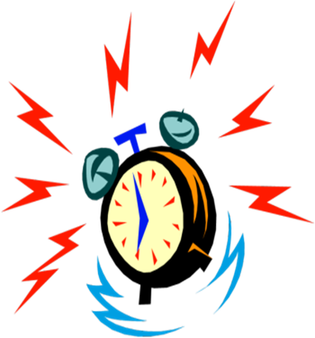

Set Alarm

Insert Time

Puzzle:

\*Question\*

Option 3

Option 2

Option 1