1. Displaying Images.

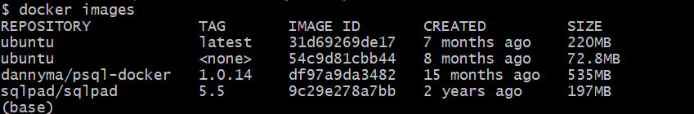

1. Running the container from the Ubuntu image in detach mode.



1. See the list of running containers.

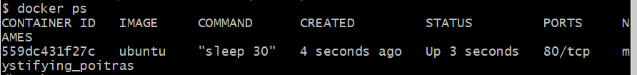

1. List of both running and non running containers.

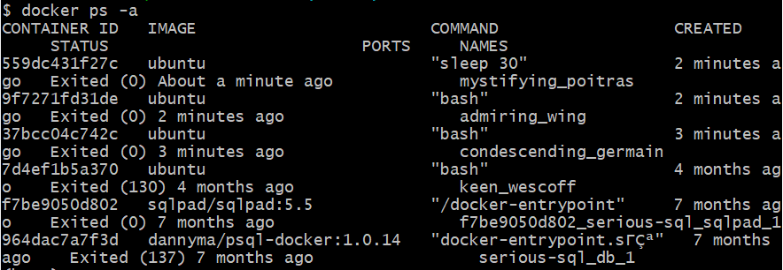

1. After running the image, if the image is not in local directory, by default the image will be pulled from docker hub. We can also name the container name on our own.

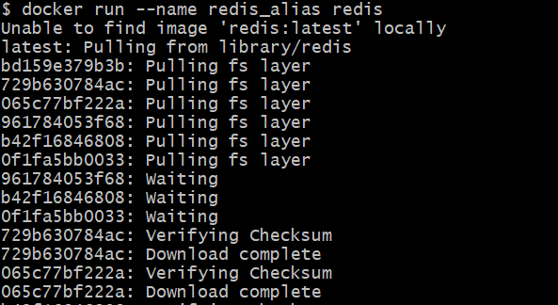

1. Pull the image from the docker hub without running it.

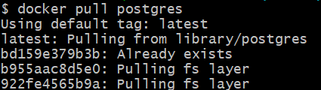

1. Start the container. We can only start the stopped containers.



1. Stopping the container.



1. Entering into the container at a time while running the container for the first time.
2. Enter into already running container.

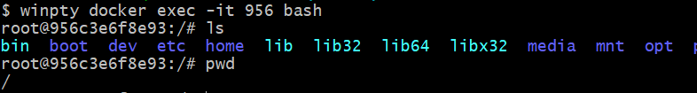

1. Checking the logs of a specific container.

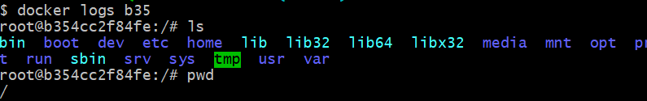

1. To know deep Details of the container.

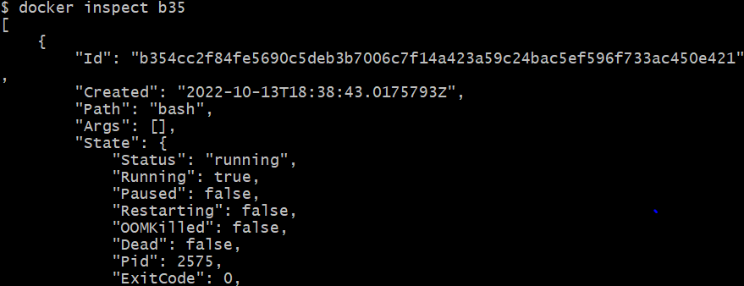

1. Remove the stopped container.



1. Remove the all the stopped containers at a time.

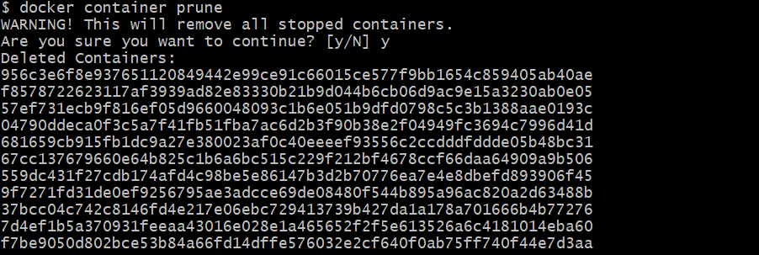

1. Removing the image.

