1. Pulling the Hello-World image from docker hub.

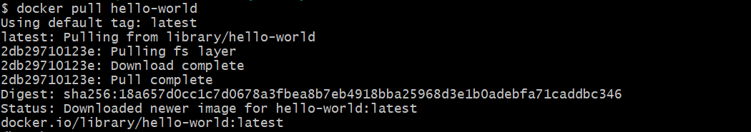

1. Running the Hello-World Image.

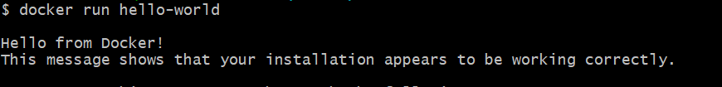

Assignment 3 and 4 are done successfully and pushed into github.