1.Create Ec2 instance with type t2.micro using the terraform with Docker,Nginx and Jenkins installed on the machine.
a.)Provider
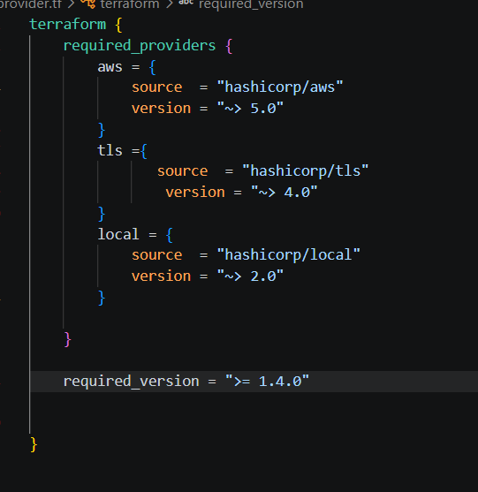
b.Resource Block:
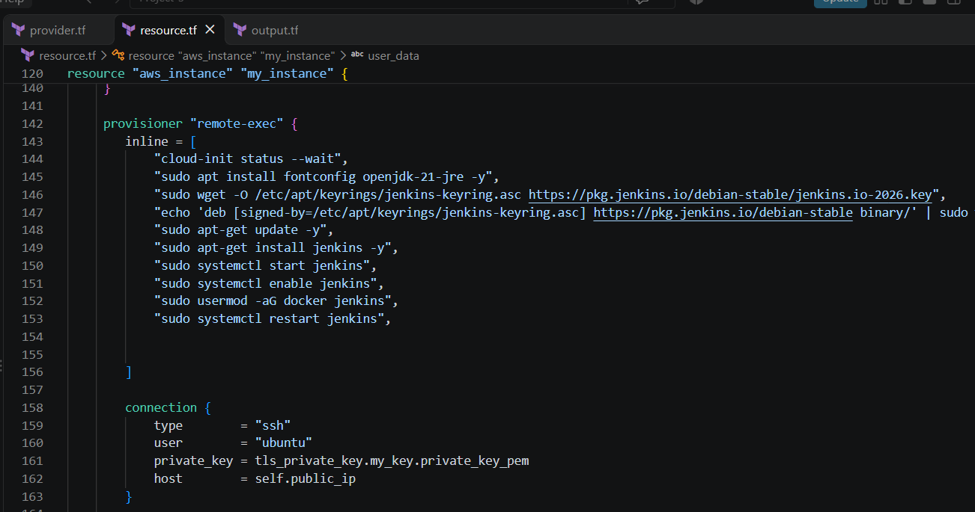
C.Output Block:
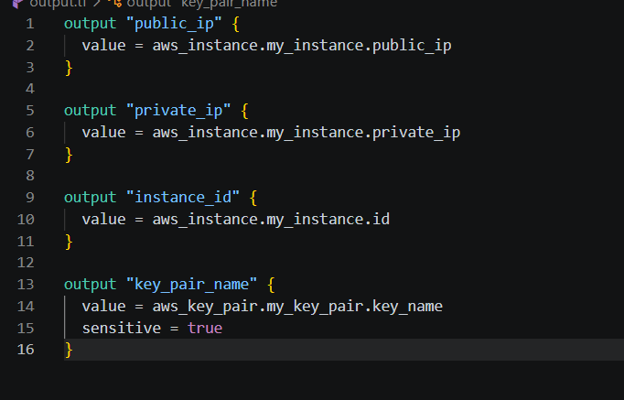

2.Verify the resources is created in the AWS.
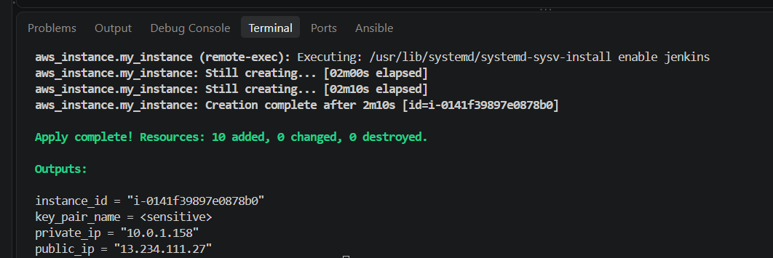

3.Clone the repository using Git clone and containerize the image using docker compose.
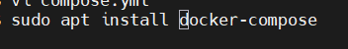
Docker file:
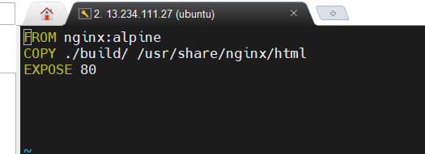
Docker Compose.yml:
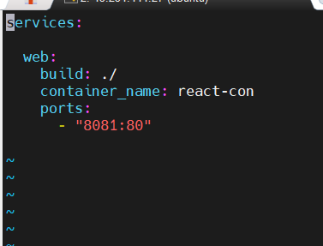
4.Validate the container is running and browse on the Application.

5.Push the Images in the Docker Hub with Dev and Prod Repo.
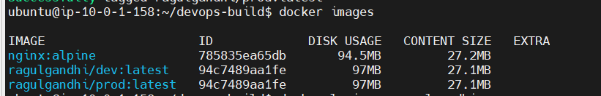
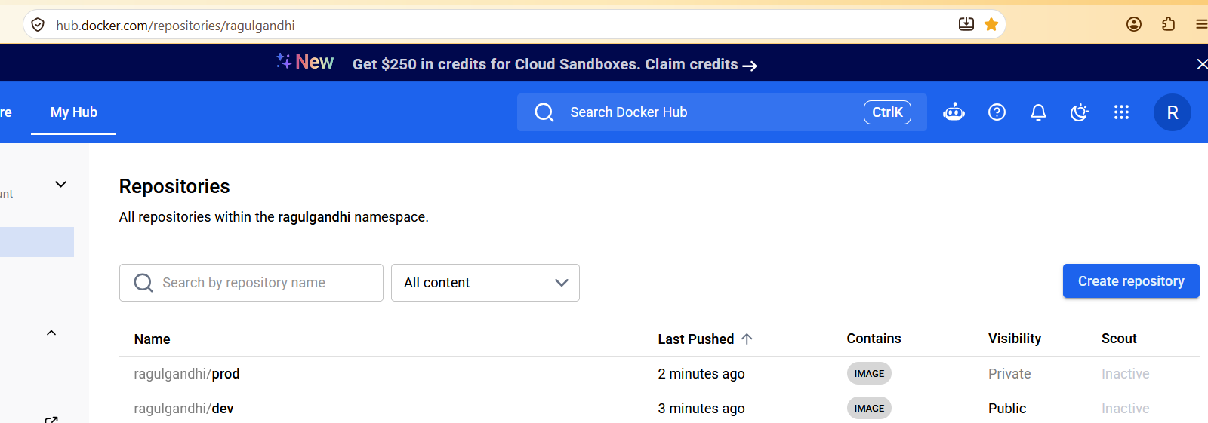
6.Install Prometheus and Grafana for the Monitoring stack.
For Prometheus Installation,run the below commands:
wget https://github.com/prometheus/prometheus/releases/download/v2.46.0/prometheus-2.46.0.linux-amd64.tar.gz
tar xvf prometheus-2.46.0.linux-amd64.tar.gz

./prometheus –config.file=prometheus.yml
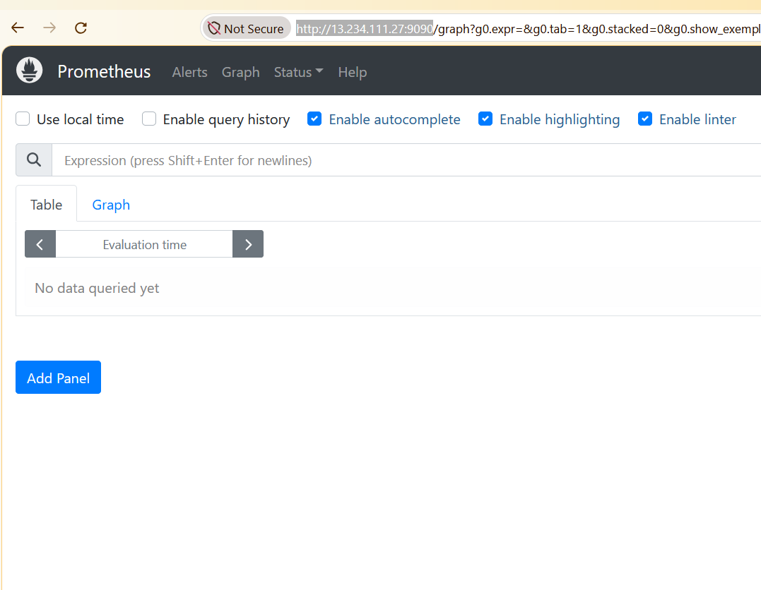

To scrape the metrics install node exporter:

wget https://github.com/prometheus/node_exporter/releases/download/v1.6.1/node_exporter-1.6.1.linux-amd64.tar.gz
tar xvf node_exporter-1.6.1.linux-amd64.tar.gz
./node_exporter
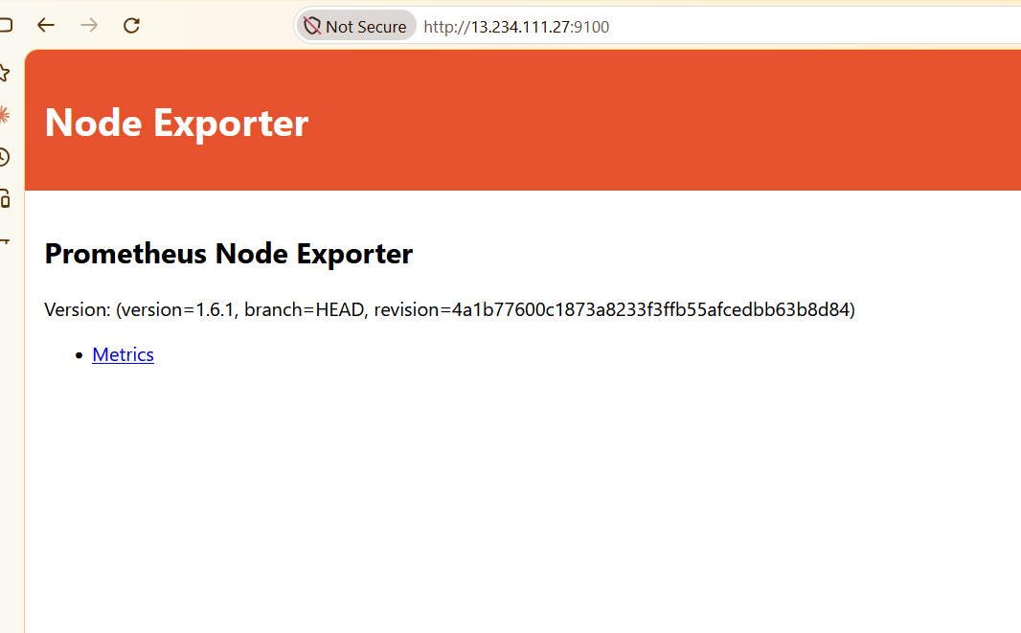

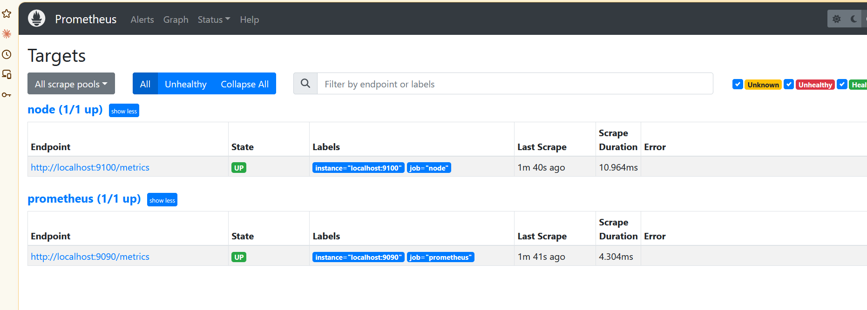

For Grafana Installation,use the below commands:
sudo apt-get install -y apt-transport-https wget gnupg

sudo mkdir -p /etc/apt/keyrings
sudo wget -O /etc/apt/keyrings/grafana.asc https://apt.grafana.com/gpg-full.key
sudo chmod 644 /etc/apt/keyrings/grafana.asc

echo "deb [signed-by=/etc/apt/keyrings/grafana.asc] https://apt.grafana.com stable main" | sudo tee -a /etc/apt/sources.list.d/grafana.list

sudo apt-get update
sudo apt-get install grafana
Sudo systemctl start grafana-server
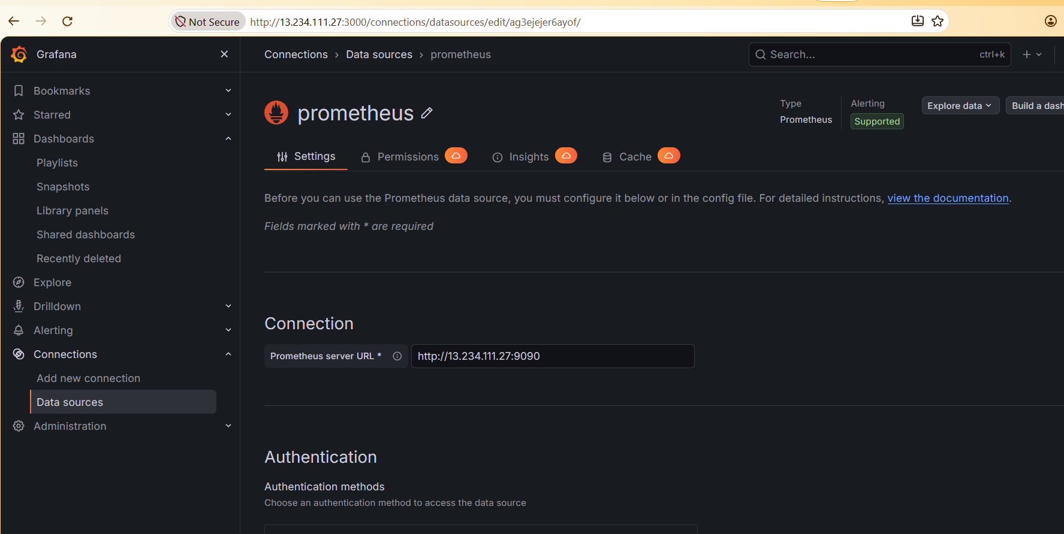
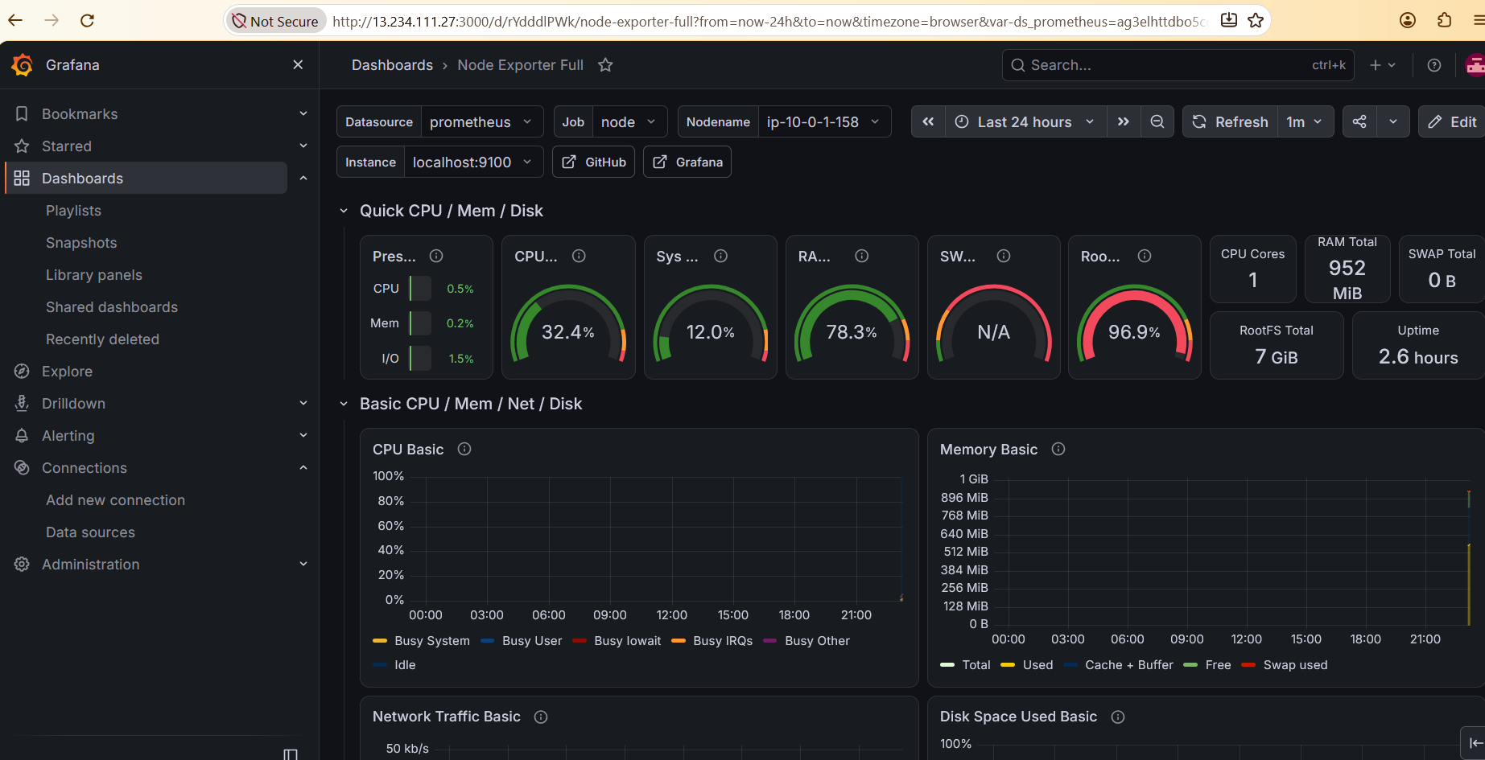

Jenkins:
Configure jenkins as Multi branch Pipeline script
Jenkins Build Console Output:(DEV)
Push event to branch dev
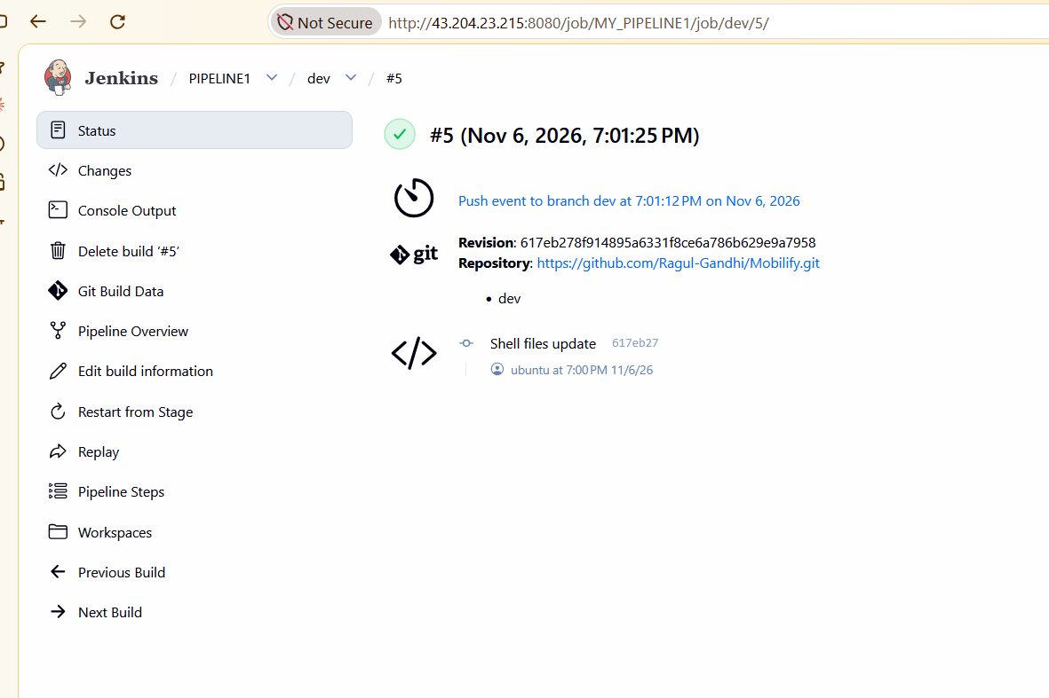
19:01:26 Connecting to https://api.github.com using Ragul-Gandhi/******
Obtained Jenkinsfile from 617eb278f914895a6331f8ce6a786b629e9a7958
[Pipeline] Start of Pipeline
[Pipeline] node
Running on Jenkins in /var/lib/jenkins/workspace/MY_PIPELINE1_dev
[Pipeline] {
[Pipeline] stage
[Pipeline] { (Declarative: Checkout SCM)
[Pipeline] checkout
The recommended git tool is: NONE
using credential git-token
> git rev-parse --resolve-git-dir /var/lib/jenkins/workspace/MY_PIPELINE1_dev/.git # timeout=10
Fetching changes from the remote Git repository
> git config remote.origin.url https://github.com/Ragul-Gandhi/Mobilify.git # timeout=10
Fetching without tags
Fetching upstream changes from https://github.com/Ragul-Gandhi/Mobilify.git
> git --version # timeout=10
> git --version # 'git version 2.53.0'
using GIT_ASKPASS to set credentials
> git fetch --no-tags --force --progress -- https://github.com/Ragul-Gandhi/Mobilify.git +refs/heads/dev:refs/remotes/origin/dev # timeout=10
Checking out Revision 617eb278f914895a6331f8ce6a786b629e9a7958 (dev)
> git config core.sparsecheckout # timeout=10
> git checkout -f 617eb278f914895a6331f8ce6a786b629e9a7958 # timeout=10
Commit message: "Shell files update"
> git rev-list --no-walk b66d2e8c823bfd871dd6d4d3b55aa325a0d5fcce # timeout=10
[Pipeline] }
[Pipeline] // stage
[Pipeline] withEnv
[Pipeline] {
[Pipeline] stage
[Pipeline] { (Dev Pipeline)
[Pipeline] withEnv
[Pipeline] {
[Pipeline] stage
[Pipeline] { (Build Image)
[Pipeline] sh
+ ./scripts/build.sh ragulgandhi/dev 5
Building image ragulgandhi/dev:5 ...
DEPRECATED: The legacy builder is deprecated and will be removed in a future release.
Install the buildx component to build images with BuildKit:
https://docs.docker.com/go/buildx/

Sending build context to Docker daemon 3.697MB

Step 1/3 : FROM nginx
---> 165ddde8751e
Step 2/3 : COPY ./build/ /usr/share/nginx/html
---> Using cache
---> 1c74a02f5c41
Step 3/3 : EXPOSE 80
---> Using cache
---> 74c9abafd311
Successfully built 74c9abafd311
Successfully tagged ragulgandhi/dev:5
Successfully tagged ragulgandhi/dev:latest
Build finished!
[Pipeline] }
[Pipeline] // stage
[Pipeline] stage
[Pipeline] { (Push to DEV repo)
[Pipeline] withCredentials
Masking supported pattern matches of $DH_PASS
[Pipeline] {
[Pipeline] sh
+ echo ****
+ docker login -u ragulgandhi --password-stdin
Login Succeeded
[Pipeline] sh
+ docker push ragulgandhi/dev:5
The push refers to repository [docker.io/ragulgandhi/dev]
161da4180452: Waiting
37fb86c2a767: Waiting
512ac5e7ce8e: Waiting
1724c05f72c6: Waiting
bbb080c71d50: Waiting
1962e1ff75b4: Waiting
7cb4701ce7cd: Waiting
6d2e43921e9e: Waiting
512ac5e7ce8e: Waiting
1724c05f72c6: Waiting
bbb080c71d50: Waiting
1962e1ff75b4: Waiting
7cb4701ce7cd: Waiting
6d2e43921e9e: Waiting
161da4180452: Waiting
37fb86c2a767: Waiting
1724c05f72c6: Waiting
bbb080c71d50: Waiting
1962e1ff75b4: Waiting
7cb4701ce7cd: Waiting
6d2e43921e9e: Waiting
161da4180452: Waiting
37fb86c2a767: Waiting
512ac5e7ce8e: Waiting
512ac5e7ce8e: Waiting
1724c05f72c6: Waiting
bbb080c71d50: Waiting
1962e1ff75b4: Waiting
7cb4701ce7cd: Waiting
6d2e43921e9e: Waiting
161da4180452: Waiting
37fb86c2a767: Waiting
512ac5e7ce8e: Waiting
1724c05f72c6: Waiting
bbb080c71d50: Waiting
1962e1ff75b4: Waiting
7cb4701ce7cd: Waiting
6d2e43921e9e: Waiting
161da4180452: Waiting
37fb86c2a767: Waiting
1724c05f72c6: Waiting
bbb080c71d50: Waiting
1962e1ff75b4: Waiting
7cb4701ce7cd: Waiting
6d2e43921e9e: Waiting
161da4180452: Waiting
37fb86c2a767: Waiting
512ac5e7ce8e: Waiting
bbb080c71d50: Waiting
1962e1ff75b4: Waiting
7cb4701ce7cd: Waiting
6d2e43921e9e: Waiting
161da4180452: Waiting
37fb86c2a767: Waiting
512ac5e7ce8e: Waiting
1724c05f72c6: Waiting
37fb86c2a767: Waiting
512ac5e7ce8e: Waiting
1724c05f72c6: Waiting
bbb080c71d50: Waiting
1962e1ff75b4: Waiting
7cb4701ce7cd: Waiting
6d2e43921e9e: Waiting
161da4180452: Waiting
6d2e43921e9e: Waiting
161da4180452: Waiting
37fb86c2a767: Waiting
512ac5e7ce8e: Waiting
1724c05f72c6: Waiting
bbb080c71d50: Waiting
1962e1ff75b4: Waiting
7cb4701ce7cd: Waiting
6d2e43921e9e: Waiting
161da4180452: Waiting
37fb86c2a767: Waiting
512ac5e7ce8e: Waiting
1724c05f72c6: Waiting
bbb080c71d50: Waiting
1962e1ff75b4: Waiting
7cb4701ce7cd: Waiting
37fb86c2a767: Waiting
512ac5e7ce8e: Waiting
1724c05f72c6: Waiting
bbb080c71d50: Waiting
1962e1ff75b4: Waiting
7cb4701ce7cd: Waiting
6d2e43921e9e: Waiting
161da4180452: Waiting
bbb080c71d50: Waiting
1962e1ff75b4: Waiting
7cb4701ce7cd: Waiting
6d2e43921e9e: Waiting
161da4180452: Waiting
37fb86c2a767: Waiting
512ac5e7ce8e: Waiting
1724c05f72c6: Waiting
161da4180452: Waiting
37fb86c2a767: Waiting
512ac5e7ce8e: Waiting
1724c05f72c6: Waiting
bbb080c71d50: Waiting
1962e1ff75b4: Waiting
7cb4701ce7cd: Waiting
6d2e43921e9e: Waiting
6d2e43921e9e: Waiting
161da4180452: Waiting
37fb86c2a767: Waiting
512ac5e7ce8e: Waiting
1724c05f72c6: Waiting
bbb080c71d50: Waiting
1962e1ff75b4: Waiting
7cb4701ce7cd: Waiting
161da4180452: Waiting
37fb86c2a767: Waiting
512ac5e7ce8e: Waiting
1724c05f72c6: Waiting
bbb080c71d50: Waiting
1962e1ff75b4: Waiting
7cb4701ce7cd: Waiting
6d2e43921e9e: Waiting
1724c05f72c6: Waiting
bbb080c71d50: Mounted from library/nginx
1962e1ff75b4: Waiting
7cb4701ce7cd: Waiting
6d2e43921e9e: Waiting
161da4180452: Waiting
37fb86c2a767: Waiting
512ac5e7ce8e: Waiting
512ac5e7ce8e: Mounted from library/nginx
1724c05f72c6: Waiting
1962e1ff75b4: Waiting
7cb4701ce7cd: Mounted from library/nginx
6d2e43921e9e: Waiting
161da4180452: Waiting
37fb86c2a767: Mounted from library/nginx
1724c05f72c6: Waiting
1962e1ff75b4: Mounted from library/nginx
6d2e43921e9e: Waiting
6d2e43921e9e: Mounted from library/nginx
1724c05f72c6: Mounted from library/nginx
161da4180452: Pushed
5: digest: sha256:74c9abafd311d935f9b64ef871bb4a6db6dc2884ef7ef693c01a64107dd6853b size: 2046
[Pipeline] sh
+ docker push ragulgandhi/dev:latest
The push refers to repository [docker.io/ragulgandhi/dev]
1724c05f72c6: Waiting
bbb080c71d50: Waiting
1962e1ff75b4: Waiting
7cb4701ce7cd: Waiting
6d2e43921e9e: Waiting
161da4180452: Waiting
37fb86c2a767: Waiting
512ac5e7ce8e: Waiting
37fb86c2a767: Waiting
512ac5e7ce8e: Waiting
1724c05f72c6: Waiting
bbb080c71d50: Waiting
1962e1ff75b4: Waiting
7cb4701ce7cd: Waiting
6d2e43921e9e: Waiting
161da4180452: Waiting
1962e1ff75b4: Waiting
7cb4701ce7cd: Waiting
6d2e43921e9e: Waiting
161da4180452: Waiting
37fb86c2a767: Waiting
512ac5e7ce8e: Waiting
1724c05f72c6: Waiting
bbb080c71d50: Waiting
1962e1ff75b4: Waiting
7cb4701ce7cd: Waiting
6d2e43921e9e: Waiting
161da4180452: Waiting
37fb86c2a767: Waiting
512ac5e7ce8e: Waiting
1724c05f72c6: Waiting
bbb080c71d50: Waiting
1724c05f72c6: Waiting
bbb080c71d50: Waiting
1962e1ff75b4: Waiting
7cb4701ce7cd: Waiting
6d2e43921e9e: Waiting
161da4180452: Waiting
37fb86c2a767: Waiting
512ac5e7ce8e: Waiting
bbb080c71d50: Waiting
1962e1ff75b4: Waiting
7cb4701ce7cd: Waiting
6d2e43921e9e: Waiting
161da4180452: Waiting
37fb86c2a767: Waiting
512ac5e7ce8e: Waiting
1724c05f72c6: Waiting
bbb080c71d50: Waiting
1962e1ff75b4: Waiting
7cb4701ce7cd: Waiting
6d2e43921e9e: Waiting
161da4180452: Waiting
37fb86c2a767: Waiting
512ac5e7ce8e: Waiting
1724c05f72c6: Waiting
161da4180452: Waiting
37fb86c2a767: Waiting
512ac5e7ce8e: Waiting
1724c05f72c6: Waiting
bbb080c71d50: Waiting
1962e1ff75b4: Waiting
7cb4701ce7cd: Waiting
6d2e43921e9e: Waiting
1962e1ff75b4: Waiting
7cb4701ce7cd: Waiting
6d2e43921e9e: Waiting
161da4180452: Waiting
37fb86c2a767: Waiting
512ac5e7ce8e: Waiting
1724c05f72c6: Waiting
bbb080c71d50: Waiting
7cb4701ce7cd: Waiting
6d2e43921e9e: Waiting
161da4180452: Waiting
37fb86c2a767: Waiting
512ac5e7ce8e: Waiting
1724c05f72c6: Waiting
bbb080c71d50: Waiting
1962e1ff75b4: Waiting
512ac5e7ce8e: Waiting
1724c05f72c6: Layer already exists
bbb080c71d50: Waiting
1962e1ff75b4: Layer already exists
7cb4701ce7cd: Waiting
6d2e43921e9e: Waiting
161da4180452: Waiting
37fb86c2a767: Waiting
bbb080c71d50: Waiting
7cb4701ce7cd: Waiting
6d2e43921e9e: Waiting
161da4180452: Waiting
37fb86c2a767: Waiting
512ac5e7ce8e: Waiting
bbb080c71d50: Layer already exists
7cb4701ce7cd: Waiting
6d2e43921e9e: Waiting
161da4180452: Waiting
37fb86c2a767: Waiting
512ac5e7ce8e: Layer already exists
7cb4701ce7cd: Waiting
6d2e43921e9e: Waiting
161da4180452: Waiting
37fb86c2a767: Waiting
7cb4701ce7cd: Layer already exists
6d2e43921e9e: Layer already exists
161da4180452: Layer already exists
37fb86c2a767: Layer already exists
latest: digest: sha256:74c9abafd311d935f9b64ef871bb4a6db6dc2884ef7ef693c01a64107dd6853b size: 2046
[Pipeline] }
[Pipeline] // withCredentials
[Pipeline] }
[Pipeline] // stage
[Pipeline] }
[Pipeline] // withEnv
[Pipeline] }
[Pipeline] // stage
[Pipeline] stage
[Pipeline] { (Prod Pipeline)
Stage "Prod Pipeline" skipped due to when conditional
[Pipeline] getContext
[Pipeline] stage
[Pipeline] { (Push to PROD repo)
Stage "Prod Pipeline" skipped due to when conditional
[Pipeline] getContext
[Pipeline] }
[Pipeline] // stage
[Pipeline] stage
[Pipeline] { (Deploy Prod)
Stage "Prod Pipeline" skipped due to when conditional
[Pipeline] getContext
[Pipeline] }
[Pipeline] // stage
[Pipeline] }
[Pipeline] // stage
[Pipeline] }
[Pipeline] // withEnv
[Pipeline] }
[Pipeline] // node
[Pipeline] End of Pipeline

GitHub has been notified of this commit’s build result

Finished: SUCCESS

Jenkins Build Console output:(MAIN)
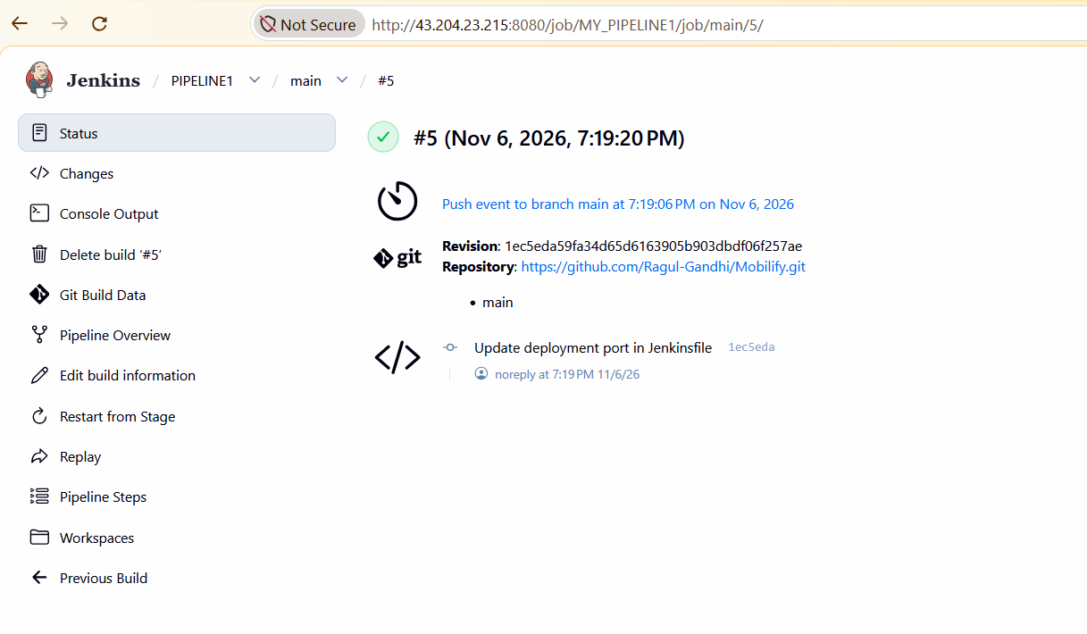

Push event to branch main
19:19:21 Connecting to https://api.github.com using Ragul-Gandhi/******
Obtained Jenkinsfile from 1ec5eda59fa34d65d6163905b903dbdf06f257ae
[Pipeline] Start of Pipeline
[Pipeline] node
Running on Jenkins in /var/lib/jenkins/workspace/MY_PIPELINE1_main
[Pipeline] {
[Pipeline] stage
[Pipeline] { (Declarative: Checkout SCM)
[Pipeline] checkout
The recommended git tool is: NONE
using credential git-token
> git rev-parse --resolve-git-dir /var/lib/jenkins/workspace/MY_PIPELINE1_main/.git # timeout=10
Fetching changes from the remote Git repository
> git config remote.origin.url https://github.com/Ragul-Gandhi/Mobilify.git # timeout=10
Fetching without tags
Fetching upstream changes from https://github.com/Ragul-Gandhi/Mobilify.git
> git --version # timeout=10
> git --version # 'git version 2.53.0'
using GIT_ASKPASS to set credentials
> git fetch --no-tags --force --progress -- https://github.com/Ragul-Gandhi/Mobilify.git +refs/heads/main:refs/remotes/origin/main # timeout=10
Checking out Revision 1ec5eda59fa34d65d6163905b903dbdf06f257ae (main)
> git config core.sparsecheckout # timeout=10
> git checkout -f 1ec5eda59fa34d65d6163905b903dbdf06f257ae # timeout=10
Commit message: "Update deployment port in Jenkinsfile"
> git rev-list --no-walk 6496f77985d2a9052aabc241c7c26b58f9162fb2 # timeout=10
[Pipeline] }
[Pipeline] // stage
[Pipeline] withEnv
[Pipeline] {
[Pipeline] stage
[Pipeline] { (Dev Pipeline)
Stage "Dev Pipeline" skipped due to when conditional
[Pipeline] getContext
[Pipeline] stage
[Pipeline] { (Build Image)
Stage "Dev Pipeline" skipped due to when conditional
[Pipeline] getContext
[Pipeline] }
[Pipeline] // stage
[Pipeline] stage
[Pipeline] { (Push to DEV repo)
Stage "Dev Pipeline" skipped due to when conditional
[Pipeline] getContext
[Pipeline] }
[Pipeline] // stage
[Pipeline] }
[Pipeline] // stage
[Pipeline] stage
[Pipeline] { (Prod Pipeline)
[Pipeline] withEnv
[Pipeline] {
[Pipeline] stage
[Pipeline] { (Push to PROD repo)
[Pipeline] withCredentials
Masking supported pattern matches of $DH_PASS
[Pipeline] {
[Pipeline] sh
+ echo ****
+ docker login -u ragulgandhi --password-stdin
Login Succeeded
[Pipeline] sh
+ docker pull ragulgandhi/dev:latest
latest: Pulling from ragulgandhi/dev
Digest: sha256:74c9abafd311d935f9b64ef871bb4a6db6dc2884ef7ef693c01a64107dd6853b
Status: Image is up to date for ragulgandhi/dev:latest
docker.io/ragulgandhi/dev:latest
[Pipeline] sh
+ docker tag ragulgandhi/dev:latest ragulgandhi/prod:5
[Pipeline] sh
+ docker tag ragulgandhi/dev:latest ragulgandhi/prod:latest
[Pipeline] sh
+ docker push ragulgandhi/prod:5
The push refers to repository [docker.io/ragulgandhi/prod]
1724c05f72c6: Waiting
37fb86c2a767: Waiting
bbb080c71d50: Waiting
512ac5e7ce8e: Waiting
1962e1ff75b4: Waiting
6d2e43921e9e: Waiting
7cb4701ce7cd: Waiting
161da4180452: Waiting
7cb4701ce7cd: Waiting
161da4180452: Waiting
1724c05f72c6: Waiting
37fb86c2a767: Waiting
bbb080c71d50: Waiting
512ac5e7ce8e: Waiting
1962e1ff75b4: Waiting
6d2e43921e9e: Waiting
161da4180452: Waiting
1724c05f72c6: Waiting
37fb86c2a767: Waiting
bbb080c71d50: Waiting
512ac5e7ce8e: Waiting
1962e1ff75b4: Waiting
6d2e43921e9e: Waiting
7cb4701ce7cd: Waiting
161da4180452: Waiting
1724c05f72c6: Waiting
37fb86c2a767: Waiting
bbb080c71d50: Waiting
512ac5e7ce8e: Waiting
1962e1ff75b4: Waiting
6d2e43921e9e: Waiting
7cb4701ce7cd: Waiting
1962e1ff75b4: Waiting
6d2e43921e9e: Waiting
7cb4701ce7cd: Waiting
161da4180452: Waiting
1724c05f72c6: Waiting
37fb86c2a767: Waiting
bbb080c71d50: Waiting
512ac5e7ce8e: Waiting
1962e1ff75b4: Waiting
6d2e43921e9e: Waiting
7cb4701ce7cd: Waiting
161da4180452: Waiting
1724c05f72c6: Waiting
37fb86c2a767: Waiting
bbb080c71d50: Waiting
512ac5e7ce8e: Waiting
1962e1ff75b4: Waiting
6d2e43921e9e: Waiting
7cb4701ce7cd: Waiting
161da4180452: Waiting
1724c05f72c6: Waiting
37fb86c2a767: Waiting
bbb080c71d50: Waiting
512ac5e7ce8e: Waiting
161da4180452: Waiting
1724c05f72c6: Waiting
37fb86c2a767: Waiting
bbb080c71d50: Waiting
512ac5e7ce8e: Waiting
1962e1ff75b4: Waiting
6d2e43921e9e: Waiting
7cb4701ce7cd: Waiting
7cb4701ce7cd: Waiting
161da4180452: Waiting
1724c05f72c6: Waiting
37fb86c2a767: Waiting
bbb080c71d50: Waiting
512ac5e7ce8e: Waiting
1962e1ff75b4: Waiting
6d2e43921e9e: Waiting
37fb86c2a767: Layer already exists
bbb080c71d50: Layer already exists
512ac5e7ce8e: Waiting
1962e1ff75b4: Waiting
6d2e43921e9e: Waiting
7cb4701ce7cd: Waiting
161da4180452: Waiting
1724c05f72c6: Waiting
512ac5e7ce8e: Waiting
1962e1ff75b4: Waiting
6d2e43921e9e: Waiting
7cb4701ce7cd: Waiting
161da4180452: Waiting
1724c05f72c6: Waiting
512ac5e7ce8e: Waiting
1962e1ff75b4: Layer already exists
6d2e43921e9e: Waiting
7cb4701ce7cd: Waiting
161da4180452: Waiting
1724c05f72c6: Layer already exists
512ac5e7ce8e: Waiting
6d2e43921e9e: Waiting
7cb4701ce7cd: Waiting
161da4180452: Waiting
6d2e43921e9e: Layer already exists
7cb4701ce7cd: Layer already exists
161da4180452: Layer already exists
512ac5e7ce8e: Layer already exists
5: digest: sha256:74c9abafd311d935f9b64ef871bb4a6db6dc2884ef7ef693c01a64107dd6853b size: 2046
[Pipeline] sh
+ docker push ragulgandhi/prod:latest
The push refers to repository [docker.io/ragulgandhi/prod]
1724c05f72c6: Waiting
bbb080c71d50: Waiting
1962e1ff75b4: Waiting
7cb4701ce7cd: Waiting
6d2e43921e9e: Waiting
37fb86c2a767: Waiting
512ac5e7ce8e: Waiting
161da4180452: Waiting
161da4180452: Waiting
1724c05f72c6: Waiting
bbb080c71d50: Waiting
1962e1ff75b4: Waiting
7cb4701ce7cd: Waiting
6d2e43921e9e: Waiting
37fb86c2a767: Waiting
512ac5e7ce8e: Waiting
6d2e43921e9e: Waiting
37fb86c2a767: Waiting
512ac5e7ce8e: Waiting
161da4180452: Waiting
1724c05f72c6: Waiting
bbb080c71d50: Waiting
1962e1ff75b4: Waiting
7cb4701ce7cd: Waiting
1724c05f72c6: Waiting
bbb080c71d50: Waiting
1962e1ff75b4: Waiting
7cb4701ce7cd: Waiting
6d2e43921e9e: Waiting
37fb86c2a767: Waiting
512ac5e7ce8e: Waiting
161da4180452: Waiting
7cb4701ce7cd: Waiting
6d2e43921e9e: Waiting
37fb86c2a767: Waiting
512ac5e7ce8e: Waiting
161da4180452: Waiting
1724c05f72c6: Waiting
bbb080c71d50: Waiting
1962e1ff75b4: Waiting
1724c05f72c6: Waiting
bbb080c71d50: Waiting
1962e1ff75b4: Waiting
7cb4701ce7cd: Waiting
6d2e43921e9e: Waiting
37fb86c2a767: Waiting
512ac5e7ce8e: Waiting
161da4180452: Waiting
7cb4701ce7cd: Waiting
6d2e43921e9e: Waiting
37fb86c2a767: Waiting
512ac5e7ce8e: Waiting
161da4180452: Waiting
1724c05f72c6: Waiting
bbb080c71d50: Waiting
1962e1ff75b4: Waiting
6d2e43921e9e: Waiting
37fb86c2a767: Waiting
512ac5e7ce8e: Waiting
161da4180452: Waiting
1724c05f72c6: Waiting
bbb080c71d50: Waiting
1962e1ff75b4: Waiting
7cb4701ce7cd: Waiting
7cb4701ce7cd: Waiting
6d2e43921e9e: Waiting
37fb86c2a767: Waiting
512ac5e7ce8e: Waiting
161da4180452: Waiting
1724c05f72c6: Waiting
bbb080c71d50: Waiting
1962e1ff75b4: Waiting
7cb4701ce7cd: Waiting
6d2e43921e9e: Waiting
37fb86c2a767: Waiting
512ac5e7ce8e: Waiting
161da4180452: Waiting
1724c05f72c6: Waiting
bbb080c71d50: Waiting
1962e1ff75b4: Layer already exists
7cb4701ce7cd: Waiting
6d2e43921e9e: Waiting
37fb86c2a767: Waiting
512ac5e7ce8e: Waiting
161da4180452: Waiting
1724c05f72c6: Waiting
bbb080c71d50: Waiting
bbb080c71d50: Waiting
7cb4701ce7cd: Layer already exists
6d2e43921e9e: Waiting
37fb86c2a767: Waiting
512ac5e7ce8e: Waiting
161da4180452: Layer already exists
1724c05f72c6: Waiting
37fb86c2a767: Waiting
512ac5e7ce8e: Waiting
1724c05f72c6: Waiting
bbb080c71d50: Waiting
6d2e43921e9e: Waiting
512ac5e7ce8e: Layer already exists
1724c05f72c6: Layer already exists
bbb080c71d50: Layer already exists
6d2e43921e9e: Layer already exists
37fb86c2a767: Layer already exists
latest: digest: sha256:74c9abafd311d935f9b64ef871bb4a6db6dc2884ef7ef693c01a64107dd6853b size: 2046
[Pipeline] }
[Pipeline] // withCredentials
[Pipeline] }
[Pipeline] // stage
[Pipeline] stage
[Pipeline] { (Deploy Prod)
[Pipeline] sh
+ ./scripts/deploy.sh ragulgandhi/prod 5 mob-prod 8081 80
Deploying ragulgandhi/prod:5 ...
5: Pulling from ragulgandhi/prod
Digest: sha256:74c9abafd311d935f9b64ef871bb4a6db6dc2884ef7ef693c01a64107dd6853b
Status: Image is up to date for ragulgandhi/prod:5
docker.io/ragulgandhi/prod:5
mob-prod
mob-prod
f1b3d18eceef4e67275757d6f964e7a89d042b60d557479587cd445a655104bc
Done! App is running on port 8081
[Pipeline] }
[Pipeline] // stage
[Pipeline] }
[Pipeline] // withEnv
[Pipeline] }
[Pipeline] // stage
[Pipeline] }
[Pipeline] // withEnv
[Pipeline] }
[Pipeline] // node
[Pipeline] End of Pipeline

GitHub has been notified of this commit’s build result

Finished: SUCCESS



