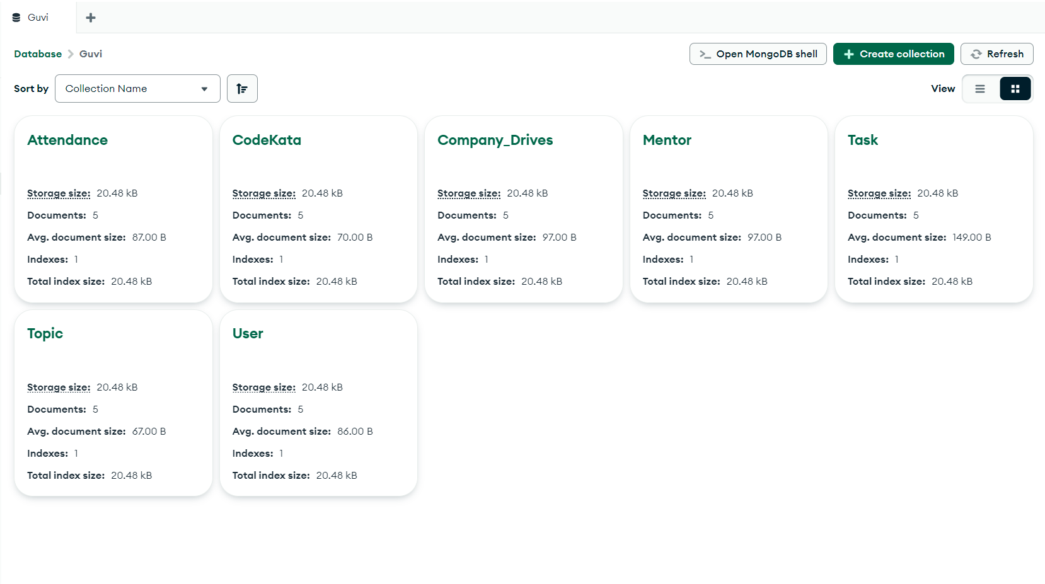

* Find all the topics and tasks which are thought in the month of October

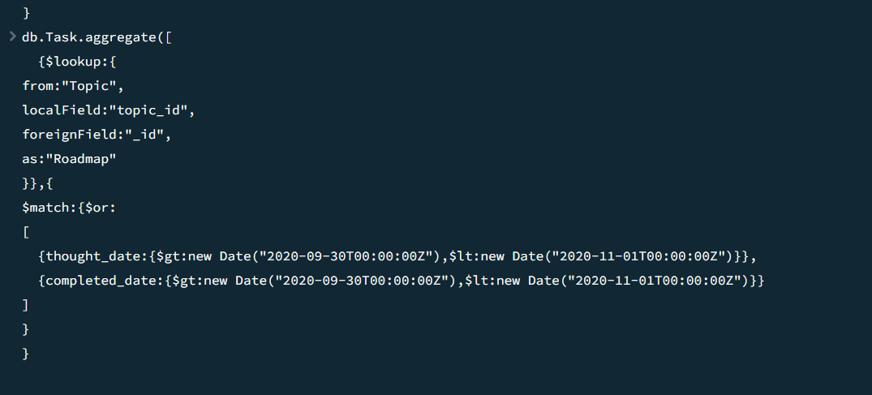

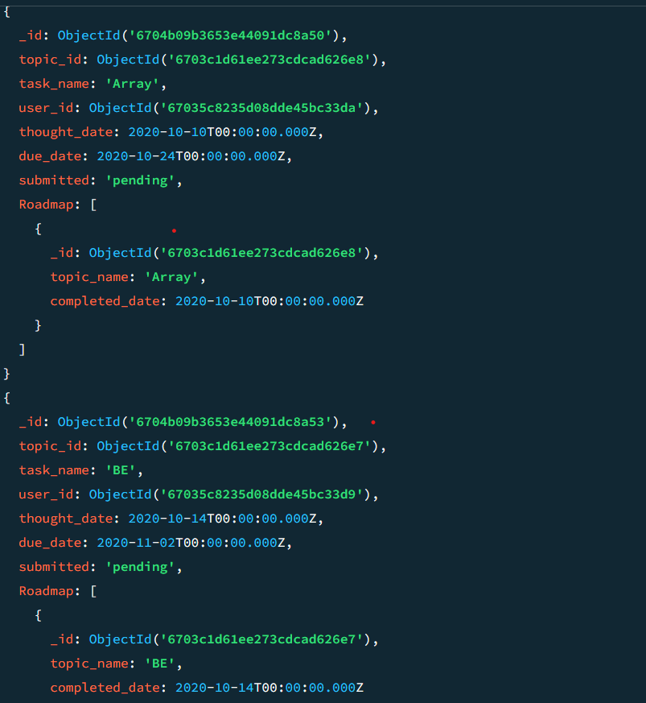

* 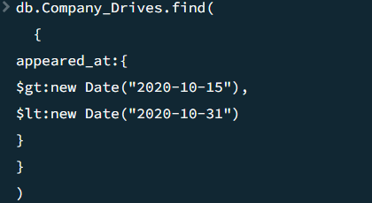Find all the company drives which appeared between 15 oct-2020 and 31-oct-2020

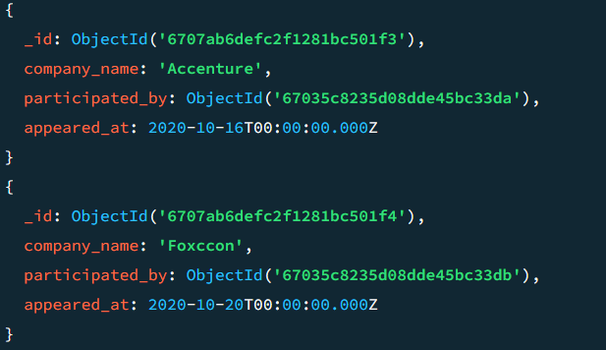

Find all the company drives and students who are appeared for the placement 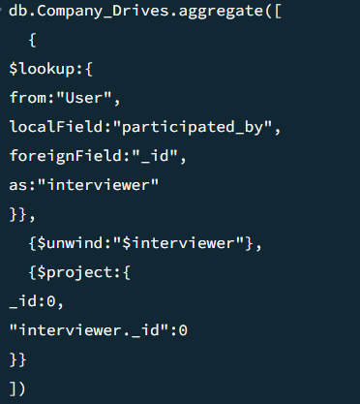

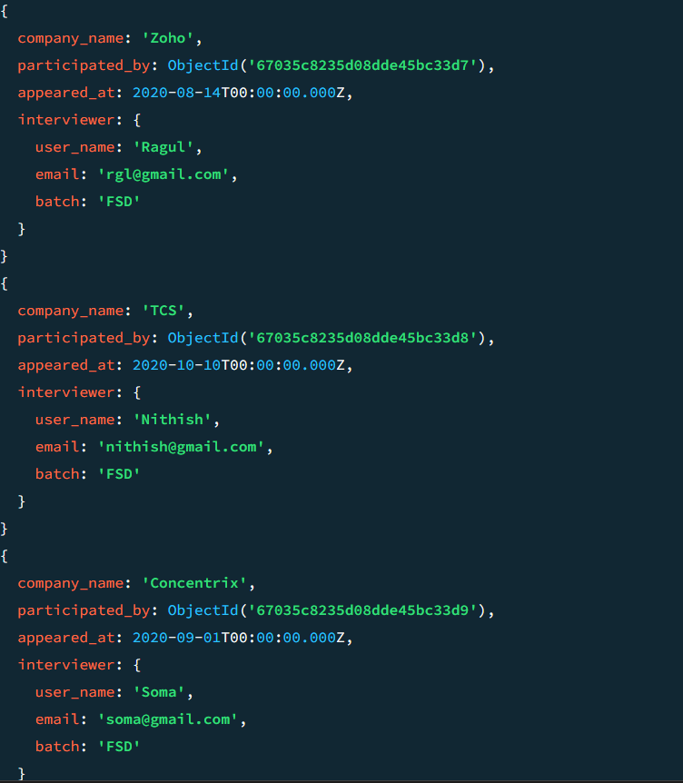

* Find the number of problems solved by the user in codekata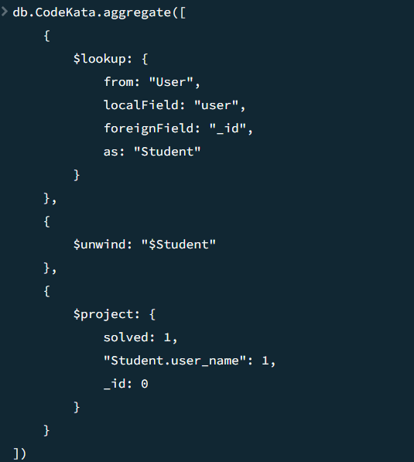

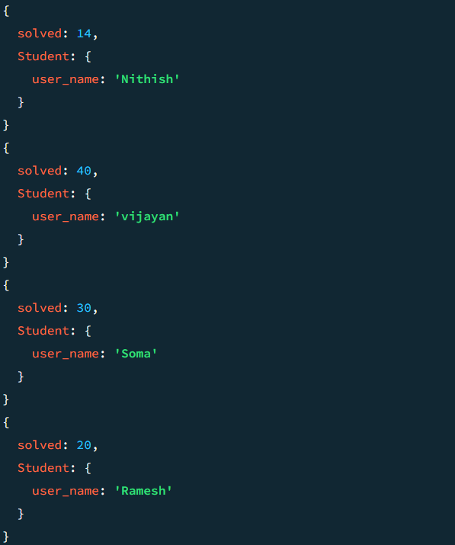

* Find all the mentors with who has the mentee's count more than 15

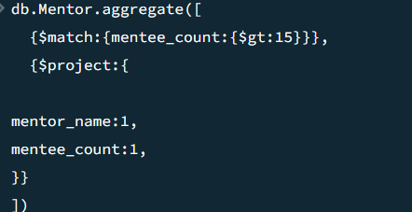

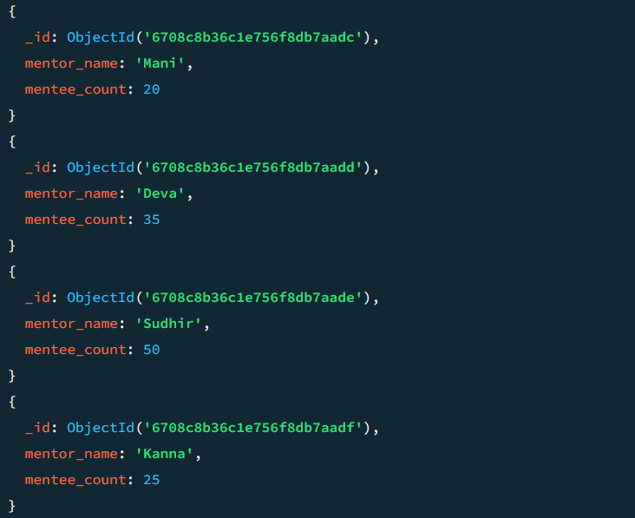

* Find the number of users who are absent and task is not submitted between 15 oct-2020 and 31-oct-2020

**db.User.aggregate([ {**

**$lookup:{**

**from:"Task",**

**localField:"_id",**

**foreignField:"user_id",**

**as:"Task_innfo"}},**

**{$lookup:{from:"Attendance",**

**localField:"_id",**

**foreignField:"user_id",**

**as:"Attended_info"}},**

**{$unwind:"$Task_innfo"},**

**{$unwind:"$Attended_info"},**

**{$match:{"Attended_info.attentance_status":"absent",**

**"Task_innfo.submitted":"pending",**

**$or:[ {"Attended_info.date":**

**{$gte:new Date("2020-10-15T00:00:00Z"),$lte:new Date("2020-10-31T00:00:00Z")}},**

**{"Task_innfo.due_date":**

**{$gte:new Date("2020-10-15T00:00:00Z"),$lte:new Date("2020-10-31T00:00:00Z")}}]}}, {$count: "No_of_students_absent"}])**

