**RAGUL G**

**CONTACT**

**Phone**

9345501854

**Email**

ragul.02468@gmail.com

**Linkedin**

https://www.linkedin.com/in/ ragul-g-77b015201

**TECHNICAL SKILLS**

HTML

CSS

JavaScript

Python

Java

SQL

**LANGUAGE**

English R+W+S

Tamil R+W+S

Hindi R+W

 **PROFILE INFO**

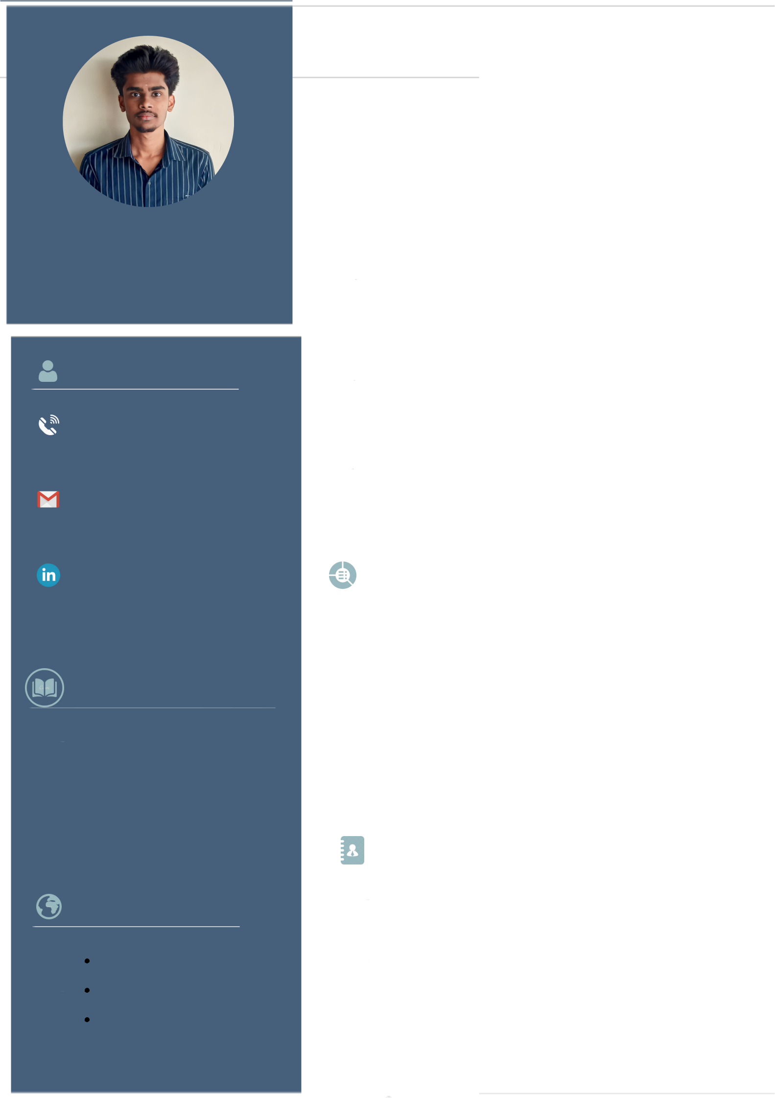

**To work in a progressive organization where I can enhance my skills and learning to contribute to the success of the organization**

 **EDUCATION**

**Bachelor of Engineering(B.E) 2020 - 2024 Electonics And Communication Engineering**

Sona College Of Technology

CGPA - **8.55**\*(upto 5th sem)

|  |  |
| --- | --- |
| **Higher Secondary(HSC)** | **2019 - 2020** |

Holy Cross Matric Higher Secondary School Percentage : **85.33%**

**Secondary(SSLC)** **2017 - 2018**

Holy Cross Matric Higher Secondary School Percentage : **91.60%**

**COURSES AND CERTIFICATES**

**Google** - Data Analytics **NPTEL** - Internet of Things(Elite)

**LIVEWIRE** - Completed JAVA , PYTHON , C , C++

**NUNNARI LABS** - Completed AI DEMYSTIFIED FOR A COMPREHENSIVE LEARNING

**WORKSHOPS / SEMINARS ATTENDED**

**EMBEDDED USING ARDUINO**

conducted by PSG iTECH , Coimbatore

**CONFERENCE ABOUT SMART CITY**

Partcipated in the International Conference about smart city that was held in periyar university

**INTERPERSONAL SKILLS**

Analytical Thinking Problem Solving Skills

Leadership Adaptability Research Attitude

**AREAS OF INTEREST**

Web Development Web Designing UI/UX

**HOBBIES**

Crypto Trading Video Editing

Photography

**ACHIEVEMENTS**

Hindi Upto ( 4

Levels)

Earned Elite Category Badge in Internet Of Things (IOT) Conducted By **NPTEL** in October 2022

**PAPERS/IDEAS PRESENTED**

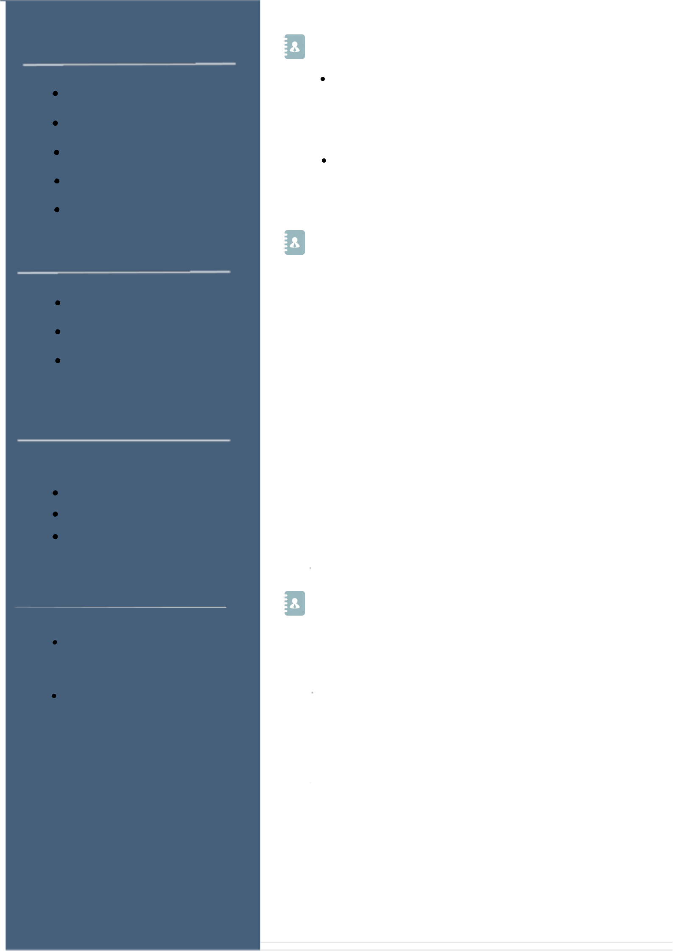

Partcipated in the International Conference about **SMART CITY** that was held in periyar university

Partcipated in **YUKTAHA** Conducted by PSG College of Technology

**CO-CURRICULAR ACTIVITIES**

**TECH QUIZ**

Participated in Tech Quiz that was held in sona college of Technology

**IQ / EQ CLUB**

Member in IQ/EQ club ,Sona College Of Technology

**FRACTACALS / IVENOR**

Organizer in fractacals / invenor event which was held in Sona College Of Technology

**ENTREPRENEUR DEVELOPMENT CELL**

Member in Sona Entrepreneur Development Cell

**PROJECTS**

1.**Portfolio Website**:

**Frontend**: HTML, CSS, JavaScript

**Backend**: Python with a framework like Flask or Django **Description:** Create a personal portfolio website showcasing your skills, projects, and resume. Utilize HTML for structure, CSS for styling, and JavaScript for interactivity. The backend can be implemented using Python to handle dynamic content and server-side functionalities.

2.**Employee Management System:**

**Frontend**: HTML, CSS, JavaScript

**Backend**: Java with Spring Boot

**Description:** Design a web-based employee management system. Use HTML for layout, CSS for styling, and JavaScript for client-side functionalities. Implement the server-side logic using Java with the Spring Boot framework, handling features like employee CRUD operations, authentication, and data storage.