Query all columns for all American cities in the **CITY** table with populations larger than 100000. The **CountryCode** for America is USA.

The **CITY** table is described as follows:

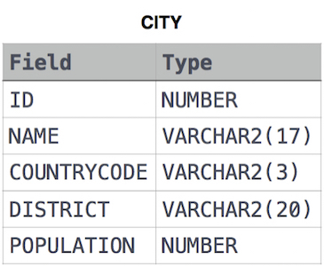

Select * FROM city where countrycode = 'USA' AND POPULATION > 100000 ;