<input type="text" class="form-control" placeholder="Normal input">  
<input type="text" class="form-control" placeholder="Disabled input" disabled>  
<input type="text" class="form-control" placeholder="Readonly input" readonly>

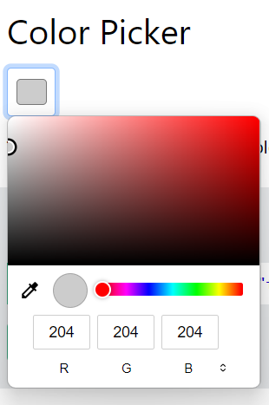

<input type="color" class="form-control form-control-color" value="#CCCCCC">

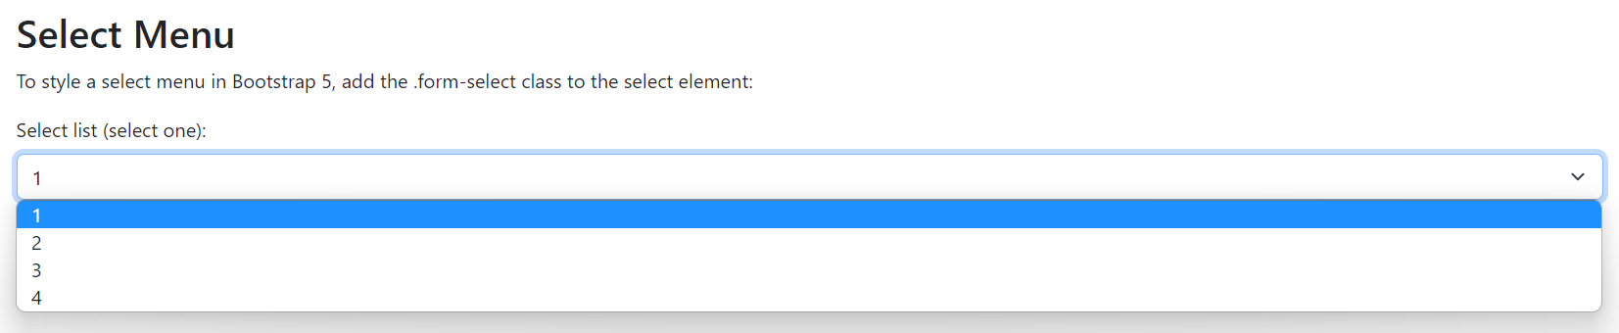

<select class="form-select">  
  <option>1</option>  
  <option>2</option>  
  <option>3</option>  
  <option>4</option>  
</select>

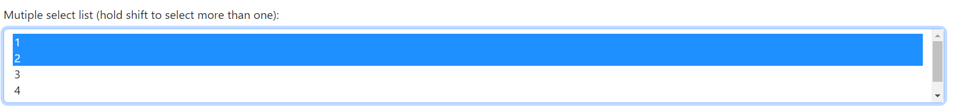

<select multiple class="form-select" id="sel2" name="sellist2">

<option>1</option>

<option>2</option>

<option>3</option>

<option>4</option>

<option>5</option>

</select>

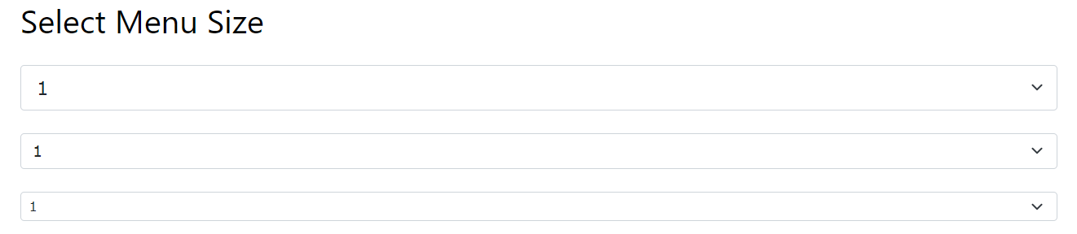

<select class="form-select form-select-lg">  
<select class="form-select">  
<select class="form-select form-select-sm">

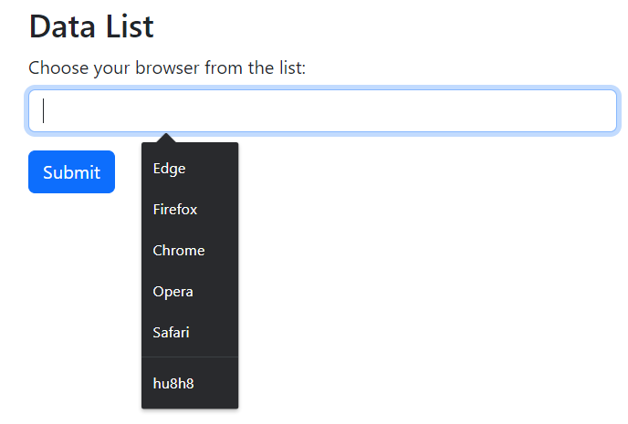

<label for="browser" class="form-label">Choose your browser from the list:</label>  
<input class="form-control" list="browsers" name="browser" id="browser">  
<datalist id="browsers">  
  <option value="Edge">  
  <option value="Firefox">  
  <option value="Chrome">  
  <option value="Opera">  
  <option value="Safari">  
</datalist>

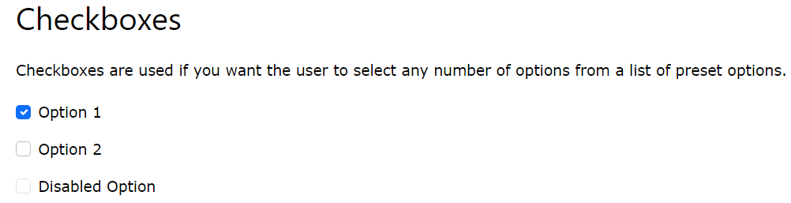

<div class="form-check">  
  <input class="form-check-input" type="checkbox" id="check1" name="option1" value="something" checked>  
  <label class="form-check-label">Option 1</label>  
</div>

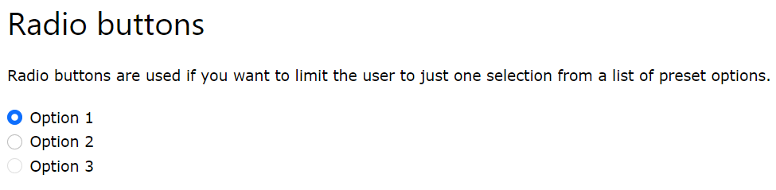<div class="form-check">  
  <input type="radio" class="form-check-input" id="radio1" name="optradio" value="option1" checked>Option 1  
  <label class="form-check-label" for="radio1"></label>  
</div>  
<div class="form-check">  
  <input type="radio" class="form-check-input" id="radio2" name="optradio" value="option2">Option 2  
  <label class="form-check-label" for="radio2"></label>  
</div>  
<div class="form-check">  
  <input type="radio" class="form-check-input" disabled>Option 3  
  <label class="form-check-label"></label>  
</div>

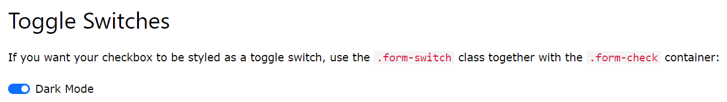

<div class="form-check form-switch">  
  <input class="form-check-input" type="checkbox" id="mySwitch" name="darkmode" value="yes" checked>  
  <label class="form-check-label" for="mySwitch">Dark Mode</label>  
</div>

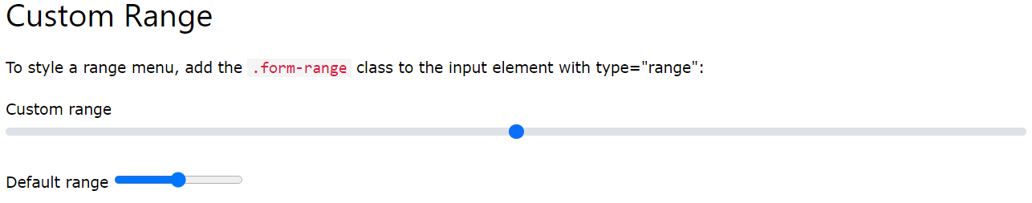

<label for="customRange" class="form-label">Custom range</label>  
<input type="range" class="form-range" id="customRange">



<input type="range" class="form-range" step="10">



<input type="range" class="form-range" min="0" max="4">

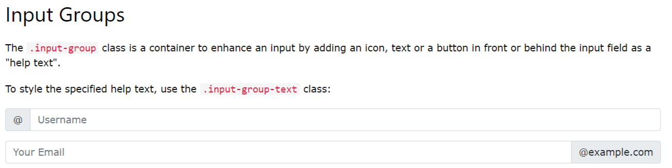

<form>  
  <div class="input-group">  
    <span class="input-group-text">@</span>  
    <input type="text" class="form-control" placeholder="Username">  
  </div>  
  
  <div class="input-group">  
    <input type="text" class="form-control" placeholder="Your Email">  
    <span class="input-group-text">@example.com</span>  
  </div>  
</form>

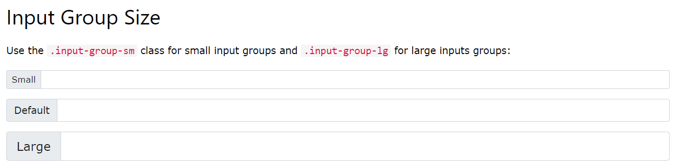

<div class="input-group mb-3 input-group-sm">  
   <span class="input-group-text">Small</span>  
  <input type="text" class="form-control">  
</div>  
  
<div class="input-group mb-3">  
  <span class="input-group-text">Default</span>  
  <input type="text" class="form-control">  
</div>  
  
<div class="input-group mb-3 input-group-lg">  
  <span class="input-group-text">Large</span>  
  <input type="text" class="form-control">  
</div>

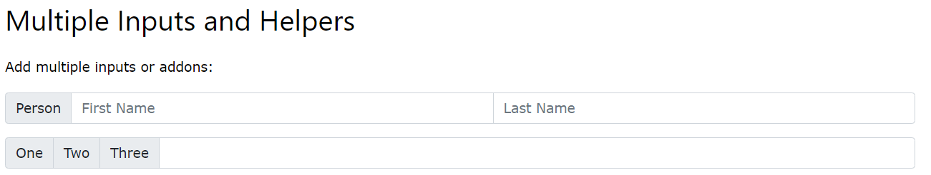

<div class="input-group mb-3">  
  <span class="input-group-text">Person</span>  
  <input type="text" class="form-control" placeholder="First Name">  
  <input type="text" class="form-control" placeholder="Last Name">  
</div>  
  
<!-- Multiple addons / help text -->  
<div class="input-group mb-3">  
  <span class="input-group-text">One</span>  
  <span class="input-group-text">Two</span>  
  <span class="input-group-text">Three</span>  
  <input type="text" class="form-control">  
</div>

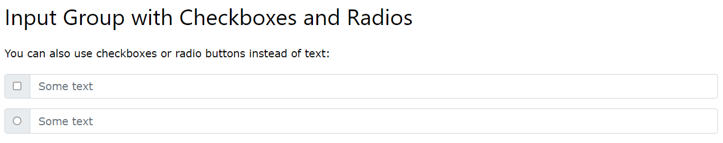

<div class="input-group mb-3">  
  <div class="input-group-text">  
    <input type="checkbox">  
  </div>  
  <input type="text" class="form-control" placeholder="Some text">  
</div>  
  
<div class="input-group mb-3">  
  <div class="input-group-text">  
    <input type="radio">  
  </div>  
  <input type="text" class="form-control" placeholder="Some text">  
</div>

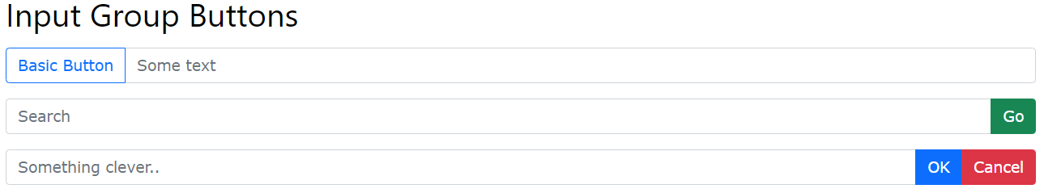<div class="input-group mb-3">  
  <button class="btn btn-outline-primary" type="button">Basic Button</button>  
  <input type="text" class="form-control" placeholder="Some text">  
</div>  
  
<div class="input-group mb-3">  
  <input type="text" class="form-control" placeholder="Search">  
  <button class="btn btn-success" type="submit">Go</button>  
</div>  
  
<div class="input-group mb-3">  
  <input type="text" class="form-control" placeholder="Something clever..">  
  <button class="btn btn-primary" type="button">OK</button>  
  <button class="btn btn-danger" type="button">Cancel</button>  
</div>

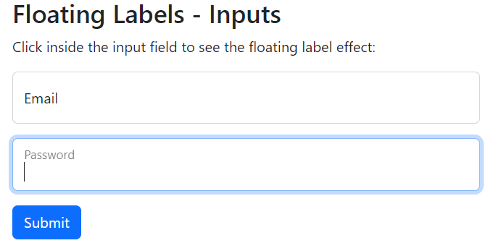

<div class="form-floating mb-3 mt-3">  
  <input type="text" class="form-control" id="email" placeholder="Enter email" name="email">  
  <label for="email">Email</label>  
</div>  
  
<div class="form-floating mt-3 mb-3">  
  <input type="text" class="form-control" id="pwd" placeholder="Enter password" name="pswd">  
  <label for="pwd">Password</label>  
</div>

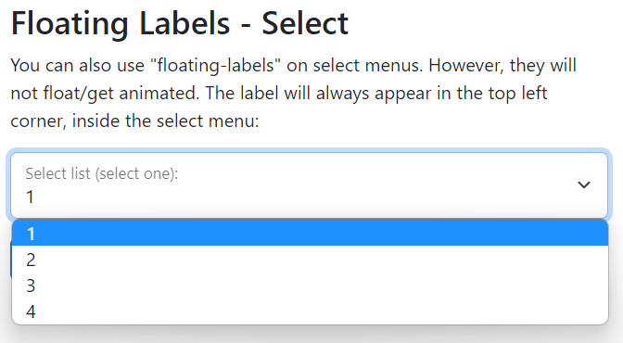

<div class="form-floating">  
  <select class="form-select" id="sel1" name="sellist">  
    <option>1</option>  
    <option>2</option>  
    <option>3</option>  
    <option>4</option>  
  </select>  
  <label for="sel1" class="form-label">Select list (select one):</label>  
</div>

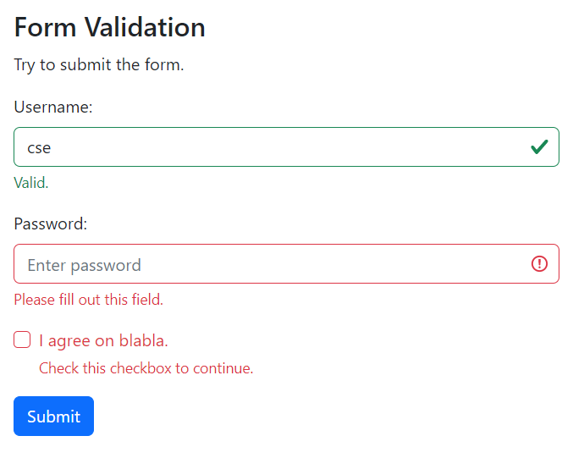

You can use different validation classes to provide valuable feedback to users. Add either .was-validated or .needs-validation to the <form> element, depending on whether you want to provide validation feedback before or after submitting the form. The input fields will have a green (valid) or red (invalid) border to indicate what's missing in the form. You can also add a .valid-feedback or .invalid-feedback message to tell the user explicitly what's missing, or needs to be done before submitting the form.

<form action="/action_page.php" class="was-validated">  
  <div class="mb-3 mt-3">  
    <label for="uname" class="form-label">Username:</label>  
    <input type="text" class="form-control" id="uname" placeholder="Enter username" name="uname" required>  
    <div class="valid-feedback">Valid.</div>  
    <div class="invalid-feedback">Please fill out this field.</div>  
  </div>  
  <div class="mb-3">  
    <label for="pwd" class="form-label">Password:</label>  
    <input type="password" class="form-control" id="pwd" placeholder="Enter password" name="pswd" required>  
    <div class="valid-feedback">Valid.</div>  
    <div class="invalid-feedback">Please fill out this field.</div>  
  </div>  
  <div class="form-check mb-3">  
    <input class="form-check-input" type="checkbox" id="myCheck" name="remember" required>  
    <label class="form-check-label" for="myCheck">I agree on blabla.</label>  
    <div class="valid-feedback">Valid.</div>  
    <div class="invalid-feedback">Check this checkbox to continue.</div>  
  </div>  
  <button type="submit" class="btn btn-primary">Submit</button>  
</form>