**1.Task: Launch two ec2-instances and connect it to a application load balancer, where the output traffic from the server must be an load balancer IP address**

Created 2 EC2 instance in same subnet:

1.Added index.html for instance 1:

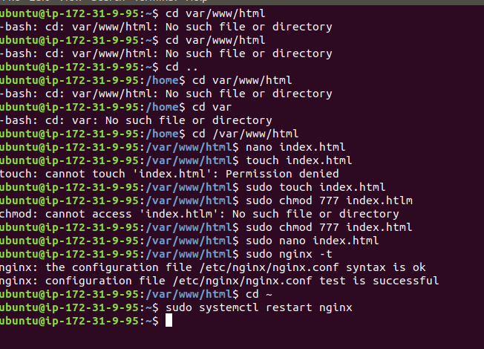

2.Added index.html for instance 2

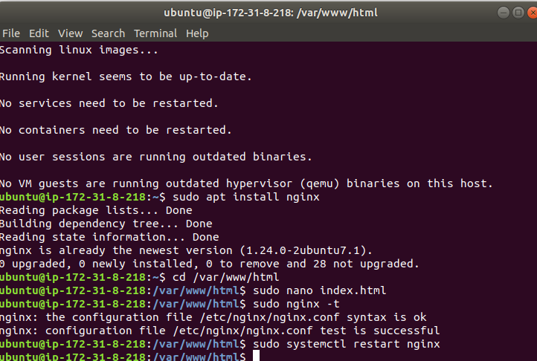

3.Created a target group and added a registered targets

4.Created a LB and Configured to Target Group:

5.Accessing Load Balancer end point:

Traffic goes to instance 2:

Traffic Goes to instance 1:

Screenshots not attached for Creating EC2 instance and allowing port 8080 for traffic in both Load Balancer and EC2 instance Since without adding We cannot access load balancer Ip Address.

2**. Task: Create a S3 bucket, with no public access and upload files to the bucket & view the logs using CloudWatch for the uploaded files.**

**S3 Bucket Creation:**

Created a role to access S3 bucket and Cloud Watch

Created a Cloud trail and attached the logs to bucket

Logs started storing into S3 bucket :

**3. Create a simple script file and push it to repo. Create a project in Jenkins connected to your GitHub repository. When a commit is made to your repo, automatically build must get triggered from Jenkins and the output must be shared to me via email.**

1.Added a webhook setup in repo

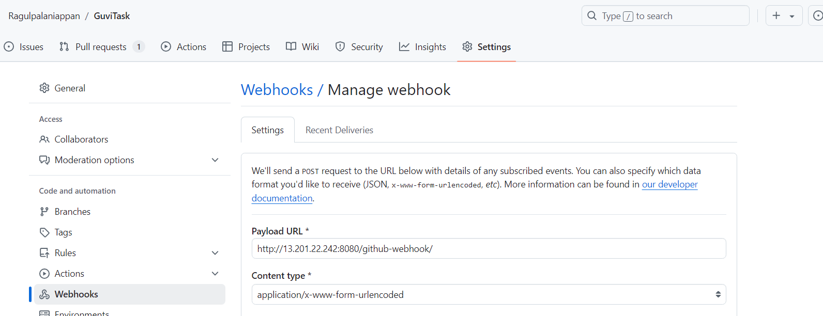

2. Added a execute.sh into Main Folder

3.Added Email Notification to job.

4.Added Git Webhook as build trigger:

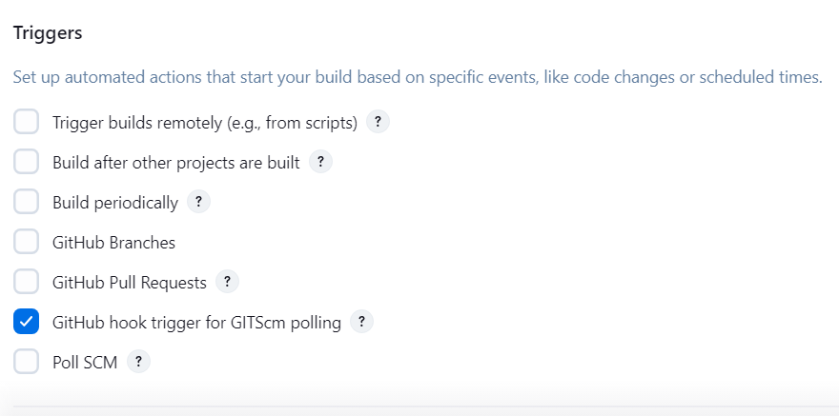

5.New Code has merged into Repo:

6.Jenkins Job triggered automatically

7.Email Notification Arrived

8.Added Email in Jenkins >System > Configure before push

