**Task Description:**

Launch Linux EC2 instances in two regions using a single Terraform file.

**1.Create a script:**

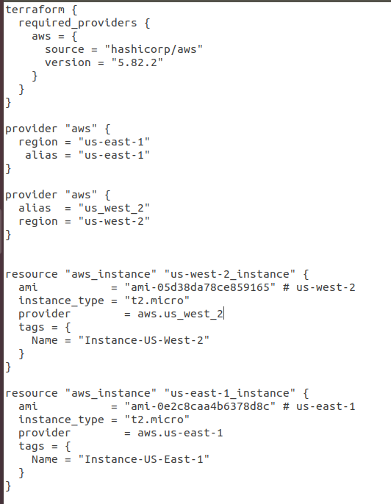

**2.Provide Terraform init, Terraform Plan**

**3.Provide Terraform apply**

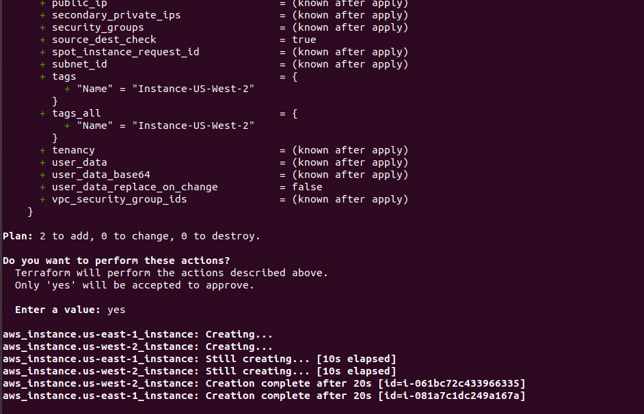

4.Verify in AWS Console:

