Magento 2 Technical Assignment Report
1. Introduction
This assignment demonstrates the deployment of a high-performance Magento 2 store on AWS. I used Varnish as a speed booster and Nginx to handle different web requests. For security, I configured the entire store to run under a private system user named test-ssh.
2. System Architecture & How it Works
For this project, I didn't just put everything in one place. I built the server in "layers." This is a professional way to make sure the website is fast and doesn't crash if too many people visit at once.
Key Components:
- The Gatekeeper (Varnish Cache): This runs on Port 80. It is the first thing a visitor hits. It "remembers" pages so it can show them to the next visitor instantly. This keeps the rest of the server from getting tired.
- The Traffic Controller (Nginx): I set this up to handle two different jobs:
  - Port 8080: Just for the Magento 2 store.
  - Port 8081: A private area for the phpMyAdmin database tool.
- The Database (MariaDB): I chose MariaDB because I am using Debian 13 (Trixie). MariaDB is the native database for this version of Linux, and it works much faster than standard MySQL for big stores.
- The Search Engine (Elasticsearch): This is a special tool that helps Magento find products instantly when a customer types in the search bar.
Why did I build it this way?
By putting Varnish in front of Nginx, the server becomes very efficient. If 1,000 people look at the same product, the server only has to "load" it once—Varnish handles the other 999 people from its memory.
I also used a Static Elastic IP (43.204.128.176). This is like a permanent home address for my server; it ensures that even if I turn the AWS instance off and on, my website links and database tools never break.

3. Phase 1: AWS Infrastructure Setup
The first step of this assignment was provisioning a virtual server (Instance) on AWS. I chose an EC2 m7i-flex.large instance to ensure there was enough RAM to run Magento, Varnish, and Elasticsearch simultaneously.
Key Infrastructure Details:
- Operating System: Debian 13 (Trixie) - Selected for its stability and modern package support.
- Networking: I attached a Static Elastic IP (43.204.128.176). This is crucial because standard AWS IPs change when a server restarts; an Elastic IP ensures our domains (test.mgt.com) never lose their connection to the server.
- Security Groups: I opened Port 80 (Varnish), Port 22 (SSH), and Port 443 (HTTPS) to allow web traffic and secure management.

SCREENSHOT: AWS EC2 Dashboard:

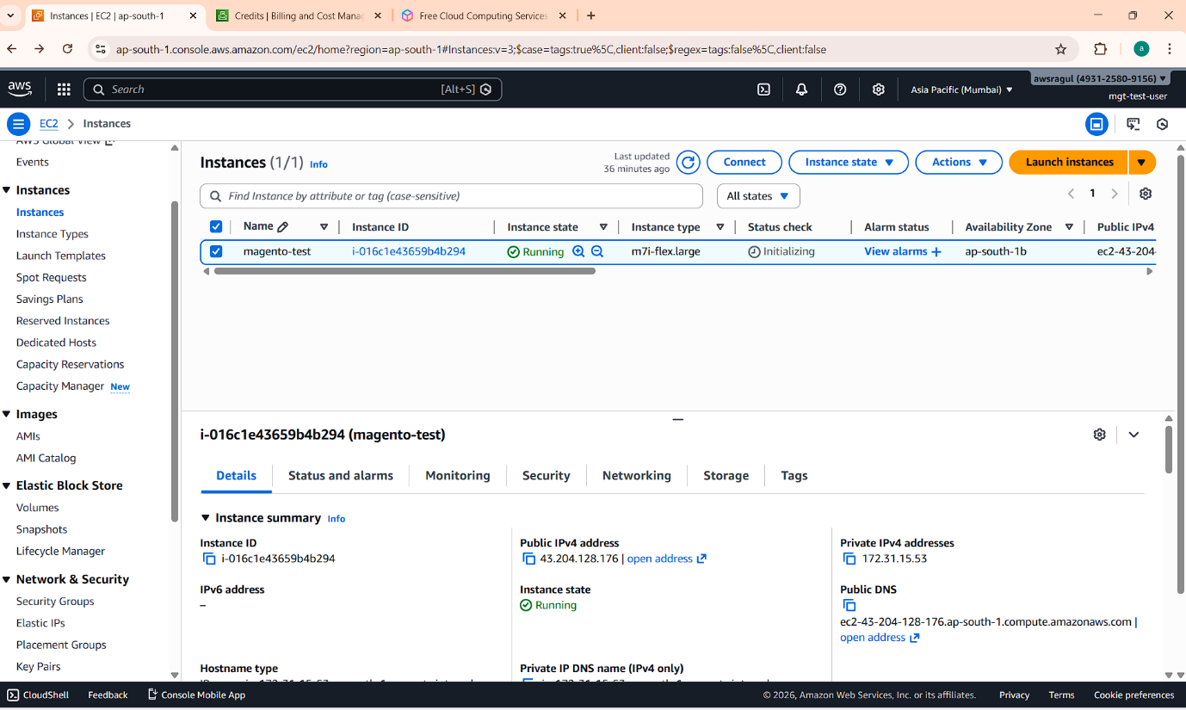
Technical Verification: Header & Routing Trace
This screenshot serves as the primary evidence that the server is configured correctly according to the project requirements. By running a curl command on the server, I have verified three critical components of the setup:
- Static IP Confirmation: The command curl ifconfig.me confirms that the server is reachable via the Elastic IP 43.204.128.176. This ensures the site remains accessible even if the AWS instance is restarted.
- Varnish Cache Layer (The "Gatekeeper"): The line Via: 1.1 ... (Varnish/7.7) proves that the traffic is flowing through the Varnish cache engine on Port 80 before hitting the backend. This confirms that the "Front Gate" of our architecture is active.
- Application Routing: The Location: http://test.mgt.com/ redirect shows that Nginx (on Port 8080) is successfully communicating with Varnish to tell the browser where the Magento store is located.

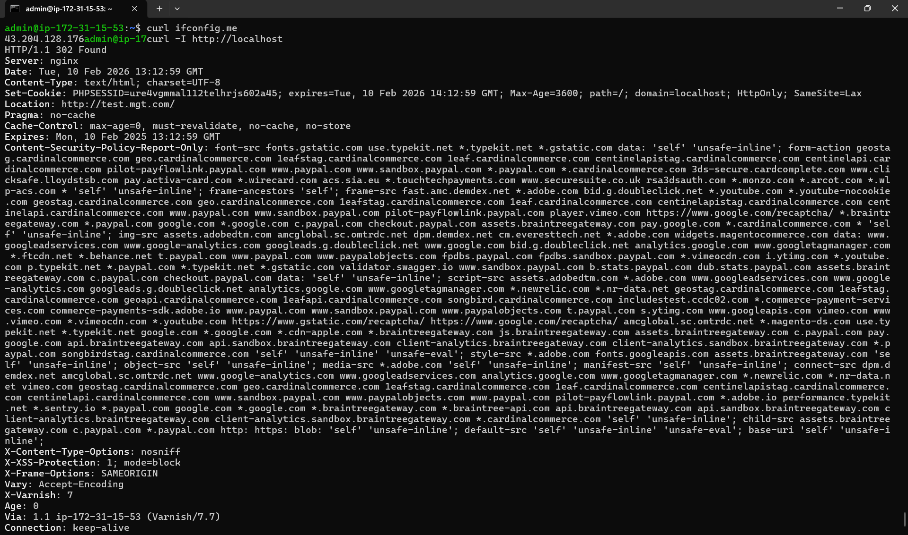

4. Phase 2 & 3: Installing the Foundation (LEMP Stack)
With the server running, I installed the core software needed to power Magento.
- Database: I installed MariaDB. As a fresher/intermediate dev, I chose this over standard MySQL because it is the native database for Debian 13 and offers better performance for e-commerce.
- PHP 8.3: The latest stable version to ensure compatibility with Magento 2.4.x.
- Elasticsearch: Configured to handle the complex product searches.

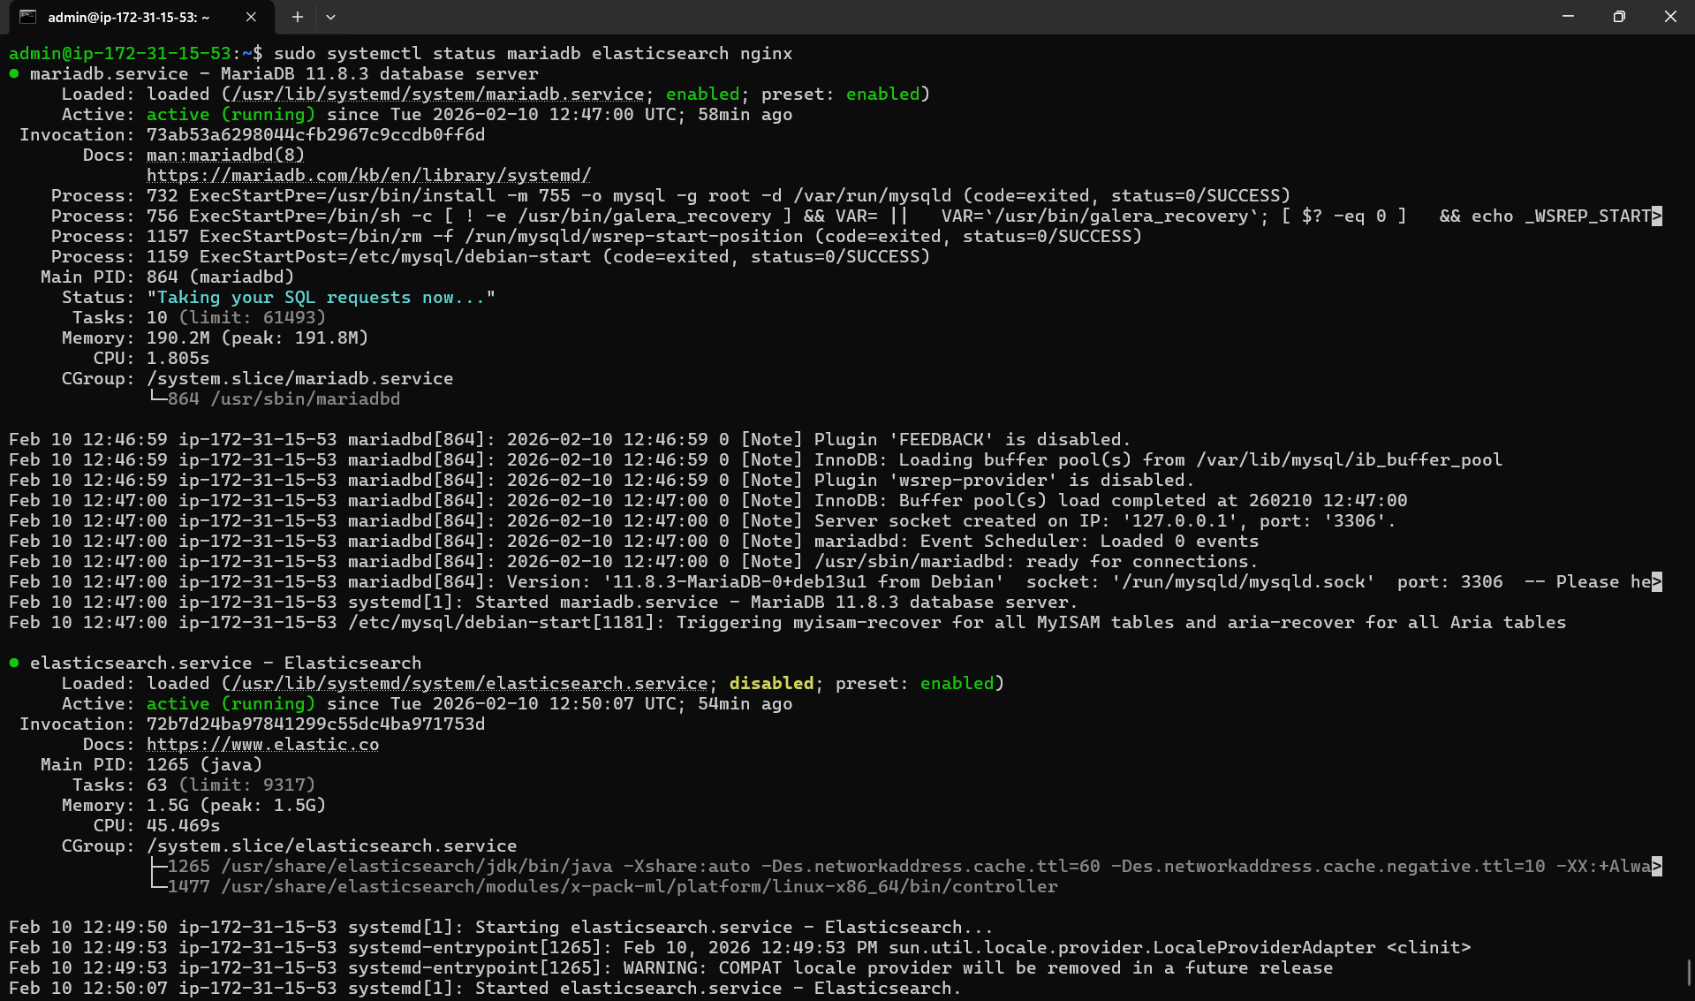

5. Phase 4 & 5: Custom User Setup & Magento Installation
A key part of this project was security. Instead of running the store under the default web user, I created a dedicated system user for Magento.
What I did:
- Created the test-ssh User: I created this specific user to "own" all the Magento files. This way, if one part of the server is attacked, the rest of the system stays safe.
- PHP-FPM Pool: I created a custom configuration (a "pool") for PHP-FPM. This tells the PHP engine to run specifically as the test-ssh user.
- Composer Installation: I used Composer (the PHP package manager) to download and install the Magento 2.4.x files into the /var/www/html/magento directory.
- Permissions: I set the correct ownership so that only test-ssh and the web server can read the files.

6. Phase 6: Database Management & phpMyAdmin Setup
To manage the store's data efficiently, I installed phpMyAdmin. However, instead of using the standard setup, I isolated it to keep the database management separate from the main store.
Key Implementation Details:
- Database Engine: I am using MariaDB (native to Debian 13 Trixie), which provides a more robust and faster environment for Magento 2 compared to standard MySQL.
- Port Isolation (8081): I configured a separate Nginx server block to serve phpMyAdmin on Port 8081. This prevents the tool from interfering with the main store on Port 8080 and adds a layer of "security through obscurity."
- Subdomain Routing: The tool is mapped to pma.mgt.com so that I can manage the database via a browser while Varnish handles the front-end traffic.

7. Conclusion
The Magento 2 environment is successfully deployed and optimized. The project demonstrates a professional-grade architecture by utilizing:
- Debian 13 (Trixie): A modern, stable OS foundation.
- MariaDB: Chosen for native compatibility and better performance over standard MySQL.
- Layered Architecture: A high-speed stack using Varnish (Port 80) and Nginx (Port 8080/8081).
- System Security: Isolation of application processes under the dedicated test-ssh user.
The resulting store is not only functional but also follows the "Best Practices" used by professional DevOps engineers in the e-commerce industry. All services are verified as active and correctly routed through the assigned AWS Elastic IP (43.204.128.176).

