29-01-2026

InCred Finance (Personal Loan Application)

1. Objective of the Research
The objective of this research is to understand how the InCred personal loan web application functions based on observable user interfaces and user flows. The research focuses on:
- How users initiate and submit loan applications
- How eligibility and credit checks are performed
- How loan decisions are presented to users
- How backend systems support the end-to-end loan journey
- How Banking and Financial Services (BFS) constraints are implicitly enforced
This analysis serves as a reference for understanding real-world loan platform behavior and for guiding the design of a Loan Management System (LMS).
Ref: https://www.incred.com/

2. High-Level System Overview
The InCred platform operates as a digital lending system where users interact through a customer-facing web portal. Behind the scenes, backend services manage eligibility checks, loan processing, and financial execution.
Certain operational activities such as loan decision validation and disbursement are handled internally and are not directly visible to end users, which is typical of most real-world lending applications.

3. Customer Journey – Step-by-Step Flow
3.1 Landing Page (User Entry Point)
Observed UI Behavior:
- Loan product information and promotional content
- Call-to-action to check loan eligibility
- Existing user login option
System Interpretation:
- No authentication required at this stage
- Static content delivery
- Entry point into the loan application flow

3.2 Credit Score and Eligibility Check
Observed UI Elements:
- “Check your credit score for free”
- Credit score powered by Equifax
- “Get Started” action button
System Flow:
- User initiates an eligibility check
- User provides basic identity details
- A soft credit inquiry is performed
- An eligibility snapshot is generated
This step helps filter applicants early and reduces unnecessary loan application submissions.

3.3 Eligibility Criteria Validation
Eligibility Parameters Observed in UI:
Criteria | Purpose
Age (21–60) | Regulatory and risk constraint
Employment type | Income stability
Minimum income | Repayment capacity
PAN and Aadhaar | Identity verification
Bank statements | Cash-flow validation

System Behavior:
- Rule-based validation of applicant details
- Early rejection of non-eligible users
- Improves system efficiency and risk control

4. Loan Application Flow (User Perspective)
4.1 Loan Application Creation
User Action:
- Submission of personal, employment, and income details
System Response:
- Loan application record is created
- A unique Loan ID is generated
- Initial loan status is set to APPLIED

4.2 Loan Lifecycle (User-Visible States)
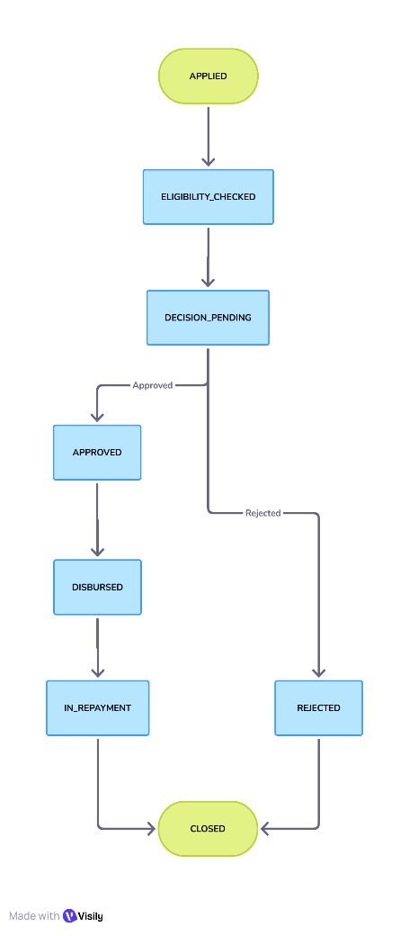

This lifecycle represents the stages visible to users through the application dashboard.
5. Backend and Operational Support
While users interact only with the customer-facing interface, the platform relies on internal backend processes to support the loan lifecycle. These processes typically include:
- Validation of eligibility and credit results
- Confirmation of loan decisions
- Controlled execution of loan disbursement
- Generation of repayment schedules
- Tracking of repayment transactions
These operational activities are standard across most digital lending platforms and are abstracted from the user experience.

6. Repayment Scheduling and Tracking
6.1 EMI Schedule Generation
After loan disbursement:
- EMI amount is calculated
- A repayment schedule is generated
- The schedule is stored as a fixed reference for the loan term

6.2 Repayment Tracking
For each repayment:
- A payment record is created
- Outstanding balance is updated
- Payment history remains accessible to the user

7. BFS Constraints Observed
Although the InCred platform presents a simple and guided user interface, several Banking and Financial Services (BFS) constraints are implicitly enforced through the application’s behavior and workflow structure.
BFS Constraint | Observed Application Area | Explanation
Auditability | Loan status changes, repayments | Each significant action such as application submission, decision outcome, and repayment updates reflects a traceable state change, indicating backend audit tracking.
Idempotency | Loan submission, disbursement | The system prevents duplicate loan creation or repeated execution of critical actions, even if users retry or refresh actions.
Data Consistency | Loan lifecycle transitions | Loan status shown on the dashboard follows a strict sequence, ensuring that users cannot skip or reverse lifecycle stages.
Financial Accuracy | EMI calculation and balances | EMI values remain consistent across sessions and views, suggesting deterministic and reproducible financial calculations.
Security | PAN and Aadhaar handling | Sensitive identity information is collected through controlled forms and never displayed in raw form after submission.
Reliability | Step-wise workflows | The platform advances users through well-defined steps, minimizing partial or inconsistent application states.
These constraints demonstrate that the system prioritizes financial correctness, data integrity, and operational safety while abstracting complexity from the user.

8. Feature Mapping – InCred vs LMS (Detailed View)
The following table maps key LMS capabilities to their observed implementation in the InCred platform, highlighting functional alignment with a standard Loan Management System.
LMS Capability | InCred Implementation |  | Observation
Loan Application | Digital web-based form |  | Users can submit complete loan applications without physical paperwork.
Eligibility Check | Credit bureau integration and rule validation |  | Early-stage eligibility checks reduce system load and risk exposure.
Decision Outcome | Deterministic approval or rejection |  | Users receive clear, unambiguous decision results.
Disbursement | Backend-controlled process |  | Disbursement is confirmed through status updates rather than user-triggered fund movement.
Repayment | EMI-based scheduling |  | Fixed EMI schedules provide transparency and predictability.
Dashboard | Loan status and repayment visibility |  | Users can track loan progress and repayment history in real time.
This mapping indicates that InCred implements core LMS features in a user-friendly manner while maintaining BFS-grade control.

9. Why This Design Works (Expanded Analysis)
The effectiveness of the InCred loan platform can be attributed to several key design decisions:
- Early Eligibility Filtering: By performing eligibility and credit checks before full loan creation, the system reduces unnecessary processing and improves risk management.
- Backend-Controlled Execution: Critical operations such as decision validation and disbursement are controlled internally, reducing the possibility of user-driven errors.
- State-Driven Lifecycle: The loan progresses through predefined states, ensuring consistent behavior and preventing invalid transitions.
- Ledger-Oriented Financial Tracking: Repayment and balance updates reflect accounting-style tracking, which enhances financial accuracy and traceability.
- Simplified User Experience: Complex backend workflows are hidden behind a clean and guided UI, improving user trust and adoption.
Together, these design choices balance user convenience with financial and operational discipline.

10. Limitations of the Analysis
This research is based solely on publicly visible user interfaces and observable workflows. As a result, certain aspects of the system could not be analyzed in detail:
- Internal credit scoring algorithms and risk models are not exposed.
- Administrative and operational dashboards are not accessible to end users.
- Regulatory compliance workflows and exception handling mechanisms remain abstracted.
These limitations are expected in competitor research and do not diminish the validity of the functional insights derived from the user-facing application.

11. Conclusion
The InCred personal loan web application demonstrates a well-structured and reliable loan processing workflow from a user perspective. The platform successfully combines a guided digital journey with robust backend controls to ensure financial accuracy, consistency, and operational reliability.
By enforcing BFS-grade constraints implicitly and maintaining a clear loan lifecycle, InCred serves as a strong real-world reference for understanding how modern Loan Management Systems operate. The insights gained from this research provide a solid foundation for designing and implementing an LMS aligned with industry practices.

