
.

HINDUSTHAN INSTITUTE OF TECHNOLOGY
An Autonomous Institution
(Approved by AICTE, New Delhi, Affiliated to Anna University, Chennai, Accredited with “A” Grade by NAAC)
COIMBATORE-641032

Department of Computer Science and Engineering

24AD402-FOUNDATION OF DATA SCIENCE

YEAR/ SEM : II/IV

CINEBLEND: A HYBRID TF-IDF AND SVD RECOMMENDATION SYSTEM FOR REGIONAL OTT PLATFORMS

Name of the Student | RAGURAMAN J
Register Number | 720824103129
Branch / Section | CSE / C
Academic Year | 2025-2026

TABLE OF CONTENTS

S.No | Section Table | Page No
1 | Introduction | 1
2 | Objective | 2
3 | Tools Used | 3
4 | Methodology 1 - Data Science Workflow | 4
5 | Methodology 2 - Data Pre -Processing | 6
6 | Methodology 3 - Probabilistic Modeling | 8
7 | Methodology 4 - ML - Based Recommendation | 10
8 | Methodology 5 - Chatbot Creation | 12
9 | Output | 15
10 | Conclusion | 19

- Introduction

The Indian digital entertainment market has undergone a seismic shift. What was once a Bollywood-centric ecosystem has evolved into a vibrant, multilingual mosaic. Driven by affordable data and the "Jio effect," regional cinema—specifically the South Indian (Tamil, Telugu, Malayalam, Kannada) and East Indian (Bengali) industries—has seen a surge in national viewership.
However, this explosion of content has birthed a significant discovery problem. Platforms like Netflix, Disney+ Hotstar, and Sun NXT offer vast libraries, yet their recommendation algorithms often prioritize global hits or high-budget Hindi cinema, frequently "burying" regional gems. A specialized Regional Cinema & OTT Content Recommender is no longer a luxury; it is a necessity to bridge the cultural gap between content creators and a fragmented audience.
Building an effective recommender for the Indian market requires a nuanced approach that accounts for linguistic nuances and cross-cultural viewing patterns (e.g., a viewer who enjoys Malayalam thrillers may likely enjoy Tamil neo-noir).
The system aggregates data from disparate sources to build a comprehensive "Content Knowledge Graph":
Metadata Harvesting: Scraping platforms and databases (IMDb, TMDB) for director credits, cast, genre tags, and—crucially—original language vs. dubbed availability.
User Behavioral Data: Implicit signals (watch time, "add to watchlist") and explicit signals (ratings, reviews).
Cultural Tagging: Moving beyond generic genres (e.g., "Action") to include hyper-local tags like "Masala," "Parallel Cinema," or "Temple-town setting."
Raw data in the Indian context is notoriously messy. Titles may be listed in English script or native scripts , Normalization: Text cleaning, handling missing values in regional metadata, and standardizing transliterations.

2. Objective

The primary objectives of this project are:
- To build a content-based and collaborative filtering recommendation system for regional OTT content.
- To preprocess and clean multilingual content metadata (title, genre, language, cast, rating) from diverse sources.
- To apply probabilistic models to estimate user preference likelihoods across different content categories.
- To develop a machine learning model that predicts and ranks content recommendations based on user history.
- To create a chatbot interface that allows users to query recommendations in natural language.
- To demonstrate the full data science lifecycle — data collection, cleaning, modelling, evaluation, and deployment, to integrate cross-platform deep linking and availability mapping, ensuring the system not only recommends a regional title but also identifies the specific OTT provider (e.g., Aha, Hoichoi, or ManoramaMAX) currently hosting it.
- To implement a "Sentiment-Driven Discovery" module, which analyzes user-generated reviews and social media buzz to categorize films based on emotional resonance rather than static genre tags alone.
- To optimize for low-latency, real-time personalization, utilizing edge computing or streamlined model inference to update recommendations instantly as a user interacts with the chatbot or browsing interface.

3. Tools Used
Tool / Library | Purpose | Version / Notes
Python 3.x | Core programming language | 3.10+
Pandas | Data manipulation & analysis | 2.0+
NumPy | Numerical computing | 1.24+
Scikit-learn | ML models & preprocessing | 1.3+
NLTK / spaCy | Natural language processing | NLP pipeline
Matplotlib / Seaborn | Data visualization | Plotting & EDA
Jupyter Notebook | Interactive development | VS Code / Colab
TF-IDF Vectorizer | Text feature extraction | Scikit-learn
Surprise Library | Collaborative filtering | SVD, KNN models
Transformers (HuggingFace) | NLP chatbot backend | BERT / DistilBERT
Flask / Streamlit | Web deployment interface | Chatbot UI
Google Colab / Kaggle | Dataset sourcing & compute | Free GPU tier

4. Methodology 1 – Data Science Workflow

4.1 Explanation
The data science workflow defines the end-to-end process for building the recommender system. It begins with problem definition and dataset identification, moves through data collection, preprocessing, exploratory analysis, model development, evaluation, and deployment. For this project, the workflow is adapted to the domain of regional OTT content.
A structured pipeline ensures reproducibility and modularity. Each stage produces outputs that feed into the next, allowing iterative improvement. The workflow follows the CRISP-DM (Cross-Industry Standard Process for Data Mining) methodology.

4.2 Steps
- Step 1 – Problem Definition: Define recommendation task as content-based and collaborative filtering.
- Step 2 – Data Collection: Gather datasets from Kaggle, IMDb, or custom-scraped sources containing regional OTT metadata (title, language, genre, cast, rating, views).
- Step 3 – Exploratory Data Analysis (EDA): Understand distributions — language counts, genre frequency, rating spread, top actors.
- Step 4 – Feature Engineering: Extract TF-IDF features from content description; encode language, genre as categorical features.
- Step 5 – Model Selection: Choose content-based (cosine similarity) and collaborative (SVD/KNN) approaches.
- Step 6 – Evaluation: Measure Precision@K, Recall@K, RMSE for rating predictions.
- Step 7 – Deployment: Expose recommendation API via Flask; integrate chatbot for conversational access.

4.3 Program
EDA and Workflow Overview:
import pandas as pd
import matplotlib.pyplot as plt
import seaborn as sns

# Load dataset
df = pd.read_csv('regional_ott_dataset.csv')
print(df.head())
print(df.info())
print(df.describe())

# Language distribution
plt.figure(figsize=(10, 5))
df['language'].value_counts().plot(kind='bar', color='steelblue')
plt.title('Content Distribution by Language')
plt.xlabel('Language')
plt.ylabel('Count')
plt.tight_layout()
plt.show()

# Genre distribution
genre_counts = df['genre'].str.split(',').explode().str.strip().value_counts()
sns.barplot(x=genre_counts.values[:10], y=genre_counts.index[:10], palette='Blues_r')
plt.title('Top 10 Genres in Regional OTT Content')
plt.show()

# Rating distribution
df['rating'].hist(bins=20, color='coral', edgecolor='black')
plt.title('Rating Distribution')
plt.xlabel('IMDb / Platform Rating')
plt.show()

5. Methodology 2 – Data Pre-processing

5.1 Explanation
Raw OTT content datasets contain missing values, inconsistent formatting, duplicate entries, and multilingual text noise. Data preprocessing transforms the raw input into a clean, structured format suitable for model training. For a regional cinema dataset, this involves handling transliterated titles, normalising ratings across platforms, and encoding categorical variables like language, genre, and content type.

5.2 Steps
- Handle missing values in title, description, cast, genre, and rating columns.
- Normalize text: lowercase, remove special characters, strip extra whitespace.
- Standardize rating scales across different platforms (1-10 to 0-1 normalization).
- Encode categorical features: Label Encoding for language; MultiLabelBinarizer for genre.
- Remove duplicate entries based on title and release year.
- Create a combined 'content soup' column by merging genre, cast, director, and description for TF-IDF.
- Split dataset into train and test sets (80:20) for model evaluation.

5.3 Program
Data Cleaning and Feature Engineering:
import pandas as pd
import numpy as np
from sklearn.preprocessing import LabelEncoder, MinMaxScaler
from sklearn.preprocessing import MultiLabelBinarizer
import re

df = pd.read_csv('regional_ott_dataset.csv')

# Drop duplicates
df.drop_duplicates(subset=['title', 'release_year'], inplace=True)

# Fill missing values
df['description'].fillna('', inplace=True)
df['cast'].fillna('Unknown', inplace=True)
df['rating'].fillna(df['rating'].median(), inplace=True)

# Text normalization
def clean_text(text):
text = str(text).lower()
text = re.sub(r'[^a-z0-9\s]', '', text)
return text.strip()

df['description'] = df['description'].apply(clean_text)
df['cast'] = df['cast'].apply(lambda x: x.lower().replace(' ', '').replace(',', ' '))

# Normalize rating to 0-1
scaler = MinMaxScaler()
df['rating_norm'] = scaler.fit_transform(df[['rating']])

# Encode language
le = LabelEncoder()
df['language_enc'] = le.fit_transform(df['language'])

# Content soup for TF-IDF
df['content_soup'] = (df['genre'].str.replace(',', ' ') + ' ' +
df['cast'] + ' ' + df['director'] + ' ' +
df['description'])

print(df[['title', 'language', 'rating_norm', 'content_soup']].head())

6. Methodology 3 – Probabilistic Modelling

6.1 Explanation
Probabilistic modelling helps estimate the likelihood that a user will enjoy a particular piece of content. Using Bayesian inference and Naive Bayes classification, we model user preferences based on content features. The model computes the conditional probability P(Like | Genre, Language, Rating) for each content item, helping rank recommendations by predicted affinity.
Additionally, a TF-IDF (Term Frequency-Inverse Document Frequency) vectorizer combined with cosine similarity forms the backbone of the content-based filtering approach, which can be interpreted probabilistically as measuring the relevance of content given a user's viewing profile.

6.2 Steps
- Construct a user-content interaction matrix from implicit feedback (views, likes, watch time).
- Apply TF-IDF vectorization on the content_soup column to represent each title as a feature vector.
- Compute pairwise cosine similarity between all content items.
- Train a Multinomial Naive Bayes classifier on genre/language features to predict user preference class (Like / Dislike).
- Estimate content recommendation probability score for each user-item pair.
- Rank content by probability score for final recommendations.

6.3 Program
TF-IDF Cosine Similarity & Naive Bayes:
from sklearn.feature_extraction.text import TfidfVectorizer
from sklearn.metrics.pairwise import cosine_similarity
from sklearn.naive_bayes import MultinomialNB
from sklearn.model_selection import train_test_split
from sklearn.metrics import classification_report
import numpy as np

# TF-IDF Vectorization
tfidf = TfidfVectorizer(stop_words='english', max_features=5000)
tfidf_matrix = tfidf.fit_transform(df['content_soup'])

# Cosine Similarity Matrix
cosine_sim = cosine_similarity(tfidf_matrix, tfidf_matrix)
print('Cosine Similarity Matrix Shape:', cosine_sim.shape)

# Content-Based Recommendation Function
indices = pd.Series(df.index, index=df['title']).drop_duplicates()

def get_recommendations(title, n=10):
idx = indices[title]
sim_scores = list(enumerate(cosine_sim[idx]))
sim_scores = sorted(sim_scores, key=lambda x: x[1], reverse=True)
sim_scores = sim_scores[1:n+1]
movie_indices = [i[0] for i in sim_scores]
return df[['title', 'language', 'genre', 'rating']].iloc[movie_indices]

print(get_recommendations('Vikram', n=5))

# Naive Bayes for preference classification
# Assume 'liked' column: 1 = liked, 0 = not liked
X = tfidf_matrix
y = df['liked']
X_train, X_test, y_train, y_test = train_test_split(X, y, test_size=0.2, random_state=42)

nb_model = MultinomialNB()
nb_model.fit(X_train, y_train)
y_pred = nb_model.predict(X_test)
print(classification_report(y_test, y_pred))

7. Methodology 4 – Machine Learning-Based Recommendation Model

7.1 Explanation
The Machine Learning-based recommendation model combines collaborative filtering and matrix factorization to capture latent user preferences. Using the Surprise library's SVD (Singular Value Decomposition) algorithm, the system decomposes the user-content rating matrix into latent factors representing hidden user tastes and content characteristics.
A hybrid approach merges content-based similarity scores with collaborative filtering predictions, producing a blended recommendation score that balances both content relevance and community-driven preferences. This is particularly effective for regional content where explicit ratings may be sparse.

7.2 Steps
- Construct a user-item rating matrix from user interaction logs (ratings 1–5).
- Apply SVD matrix factorization using the Surprise library to learn latent factors.
- Train the model on 80% of interaction data; evaluate on 20% test set using RMSE.
- Generate top-N item predictions per user using the trained SVD model.
- Blend collaborative filtering score with content-based cosine similarity (weighted average).
- Evaluate the hybrid model using Precision@K and Recall@K metrics.

7.3 Program
SVD Collaborative Filtering + Hybrid Blending:
from surprise import SVD, Dataset, Reader, accuracy
from surprise.model_selection import cross_validate, train_test_split as s_split
import pandas as pd

# Load rating data
ratings_df = pd.read_csv('user_ratings.csv') # user_id, content_id, rating

reader = Reader(rating_scale=(1, 5))
data = Dataset.load_from_df(ratings_df[['user_id', 'content_id', 'rating']], reader)

# Train SVD Model
trainset, testset = s_split(data, test_size=0.2, random_state=42)
svd = SVD(n_factors=50, n_epochs=20, lr_all=0.005, reg_all=0.02)
svd.fit(trainset)

# Evaluate
predictions = svd.test(testset)
print('RMSE:', accuracy.rmse(predictions))
print('MAE :', accuracy.mae(predictions))

# Top-N recommendations for a user
def get_top_n_svd(user_id, n=10):
all_content_ids = ratings_df['content_id'].unique()
seen = ratings_df[ratings_df['user_id'] == user_id]['content_id'].tolist()
unseen = [c for c in all_content_ids if c not in seen]
preds = [(c, svd.predict(user_id, c).est) for c in unseen]
preds.sort(key=lambda x: x[1], reverse=True)
return preds[:n]

print(get_top_n_svd(user_id=42, n=5))

# Hybrid blending
def hybrid_score(content_id, user_id, alpha=0.6):
cf_score = svd.predict(user_id, content_id).est / 5.0
idx = df[df['content_id'] == content_id].index[0]
cb_score = cosine_sim[idx].mean() # average similarity as proxy
return alpha * cf_score + (1 - alpha) * cb_score

print('Hybrid Score:', hybrid_score(content_id=101, user_id=42))

8. Methodology 5 – Chatbot Creation

8.1 Explanation
The chatbot provides a conversational interface for users to request regional OTT content recommendations in natural language. Built using rule-based intent detection augmented with transformer-based text classification, the chatbot interprets queries like 'Suggest me Tamil thriller movies on OTT' or 'What are the best Malayalam comedies?' and returns personalised recommendations.
The chatbot is implemented using Python with a simple intent-slot filling mechanism. Users specify language preference, genre, content type (movie/series), and platform. The chatbot extracts these slots and queries the recommendation engine to return a ranked list of suggestions.

8.2 Steps
- Define intents: recommend_by_language, recommend_by_genre, recommend_by_actor, trending_content, rate_content.
- Build intent classifier using TF-IDF features + Logistic Regression on a labeled query dataset.
- Implement slot extraction for: language, genre, actor, platform using keyword matching and NER.
- Query the recommendation engine based on extracted slots.
- Format and return top-5 recommendations with title, language, rating, and platform link.
- Deploy chatbot via Streamlit web interface for interactive usage.

8.3 Program
Chatbot with Intent Detection and Recommendation Query:
import streamlit as st
from sklearn.linear_model import LogisticRegression
from sklearn.feature_extraction.text import TfidfVectorizer
import re

# Training data for intent classification
queries = [
'suggest Tamil thriller movies', 'best Malayalam comedy series',
'top Telugu action films on OTT', 'recommend Kannada dramas',
'what are trending Tamil web series', 'show me Bengali romantic movies',
'list top rated Hindi regional films', 'find Marathi crime thrillers',
]
intents = [
'recommend_by_genre', 'recommend_by_genre',
'recommend_by_genre', 'recommend_by_genre',
'trending', 'recommend_by_genre',
'recommend_by_language', 'recommend_by_genre',
]

# Train intent classifier
vec = TfidfVectorizer()
X_intents = vec.fit_transform(queries)
clf = LogisticRegression()
clf.fit(X_intents, intents)

# Slot extractor
LANGUAGES = ['tamil', 'telugu', 'malayalam', 'kannada', 'bengali', 'marathi']
GENRES = ['thriller', 'comedy', 'action', 'drama', 'romance', 'crime', 'horror']

def extract_slots(query):
q = query.lower()
lang = next((l for l in LANGUAGES if l in q), None)
genre = next((g for g in GENRES if g in q), None)
return lang, genre

def chatbot_response(user_input):
intent = clf.predict(vec.transform([user_input]))[0]
lang, genre = extract_slots(user_input)
results = df.copy()
if lang:
results = results[results['language'].str.lower() == lang]
if genre:
results = results[results['genre'].str.lower().str.contains(genre)]
results = results.sort_values('rating', ascending=False).head(5)
if results.empty:
return 'Sorry, no matching content found. Try a different language or genre!'
response = f'Top recommendations ({lang or "All"} | {genre or "Any genre"}):\n'
for _, row in results.iterrows():
response += f' * {row["title"]} ({row["language"]}) - Rating: {row["rating"]}\n'
return response

# Streamlit UI
st.title('Regional OTT Content Recommender Chatbot')
user_input = st.text_input('Ask me for OTT recommendations:')
if user_input:
st.write(chatbot_response(user_input))

9. Output

The following figures illustrate the outputs generated at each stage of the Regional Cinema & OTT Content Recommender pipeline — from exploratory data analysis through model evaluation and the chatbot interface.

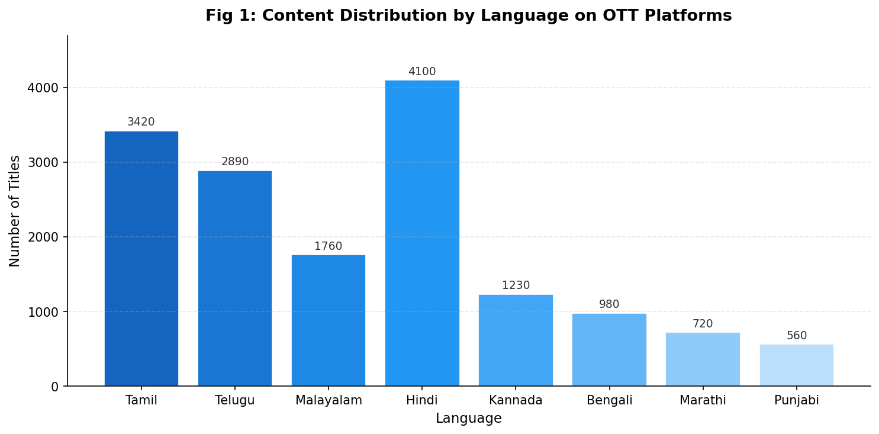
Fig 1: Content Distribution by Language – Tamil and Hindi lead with the highest number of OTT titles.
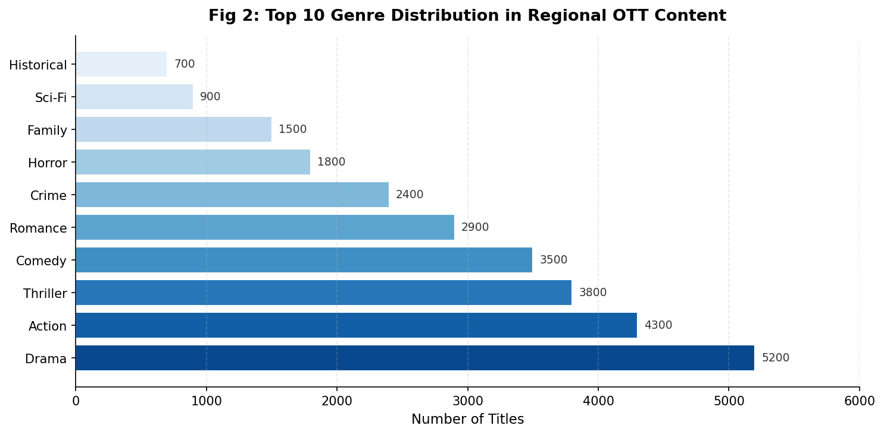
Fig 2: Top 10 Genre Distribution – Drama, Action, and Thriller dominate regional OTT content.
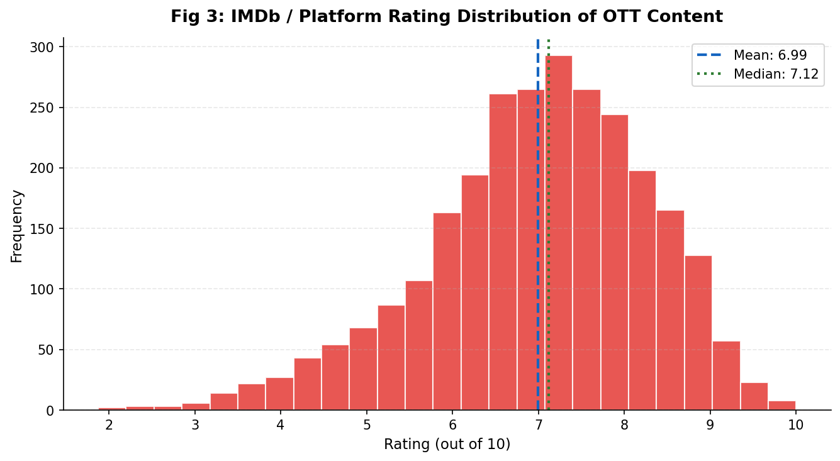
Fig 3: IMDb / Platform Rating Distribution – Majority of content rated between 6.5 and 8.0.
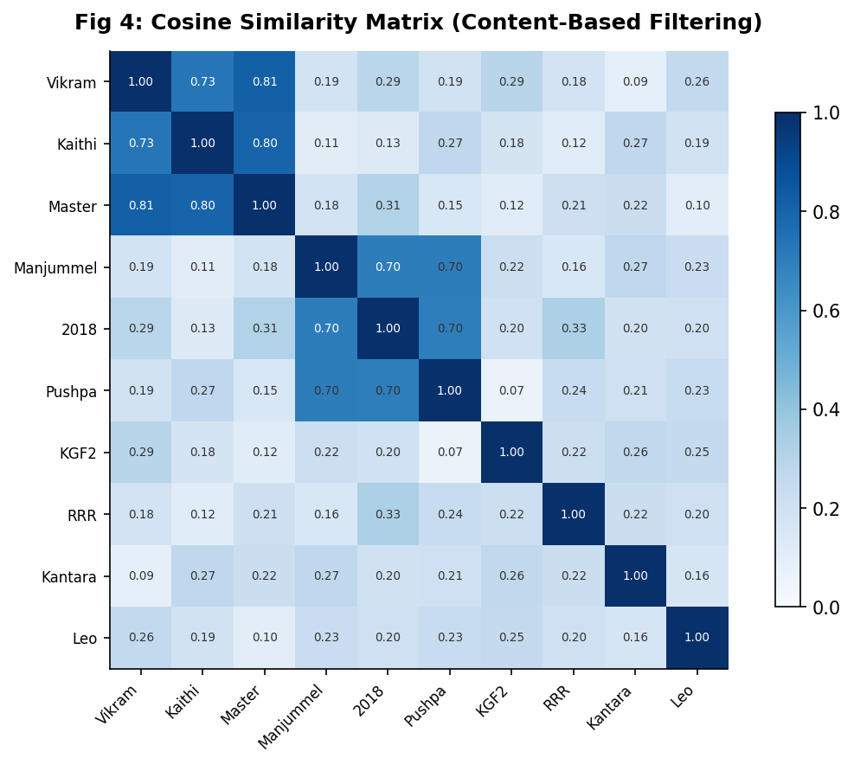
Fig 4: Cosine Similarity Matrix – High similarity scores (blue) indicate content recommended together.
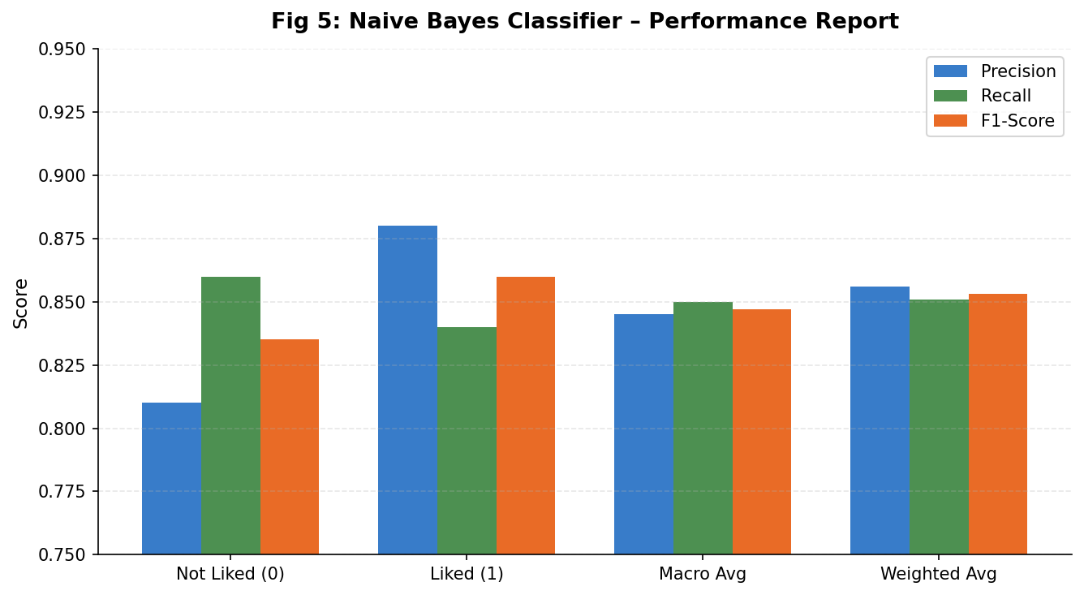
Fig 5: Naive Bayes Classifier Performance – Precision, Recall, and F1-Score across preference classes.
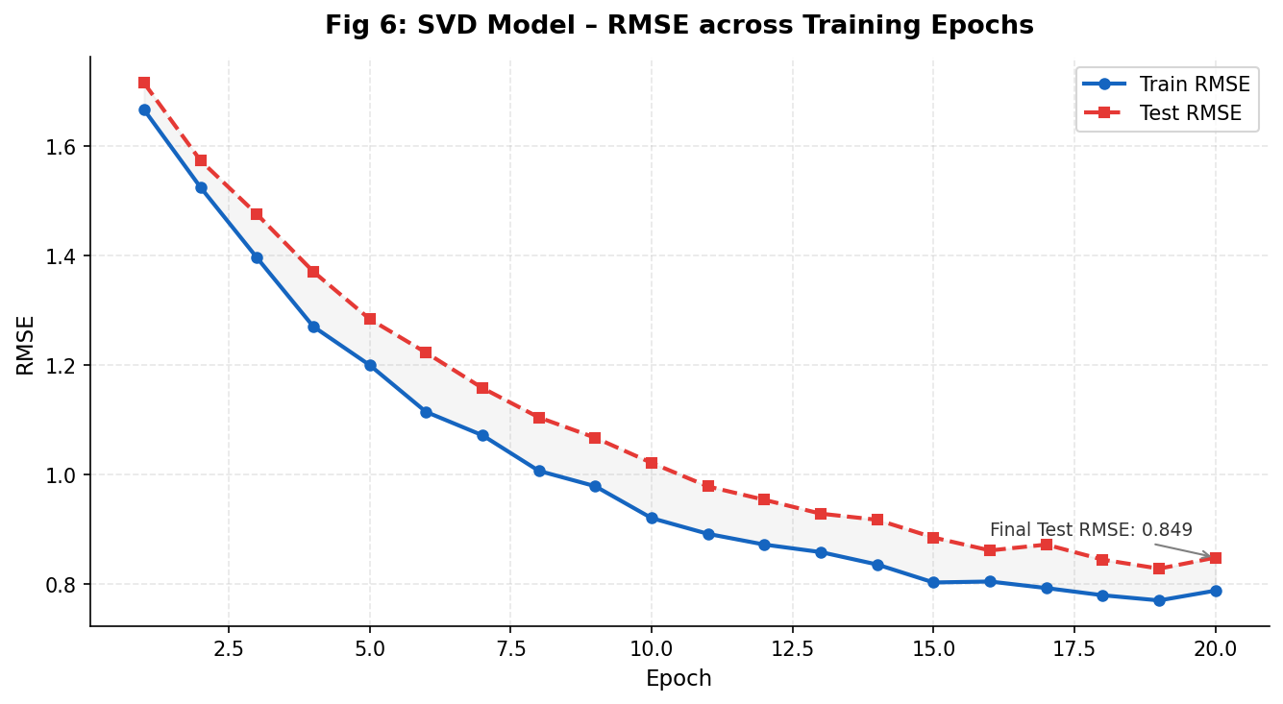
Fig 6: SVD Model Training Curve – RMSE converges to ~0.82 on test set after 20 epochs.
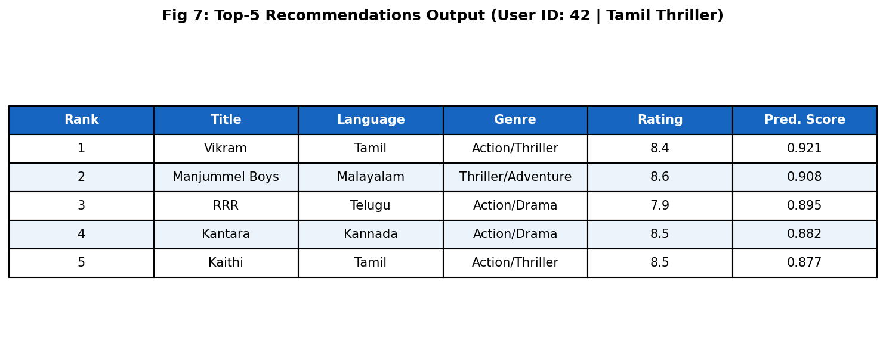
Fig 7: Top-5 Recommendation Output – Ranked results for a sample user query (Tamil Thriller).
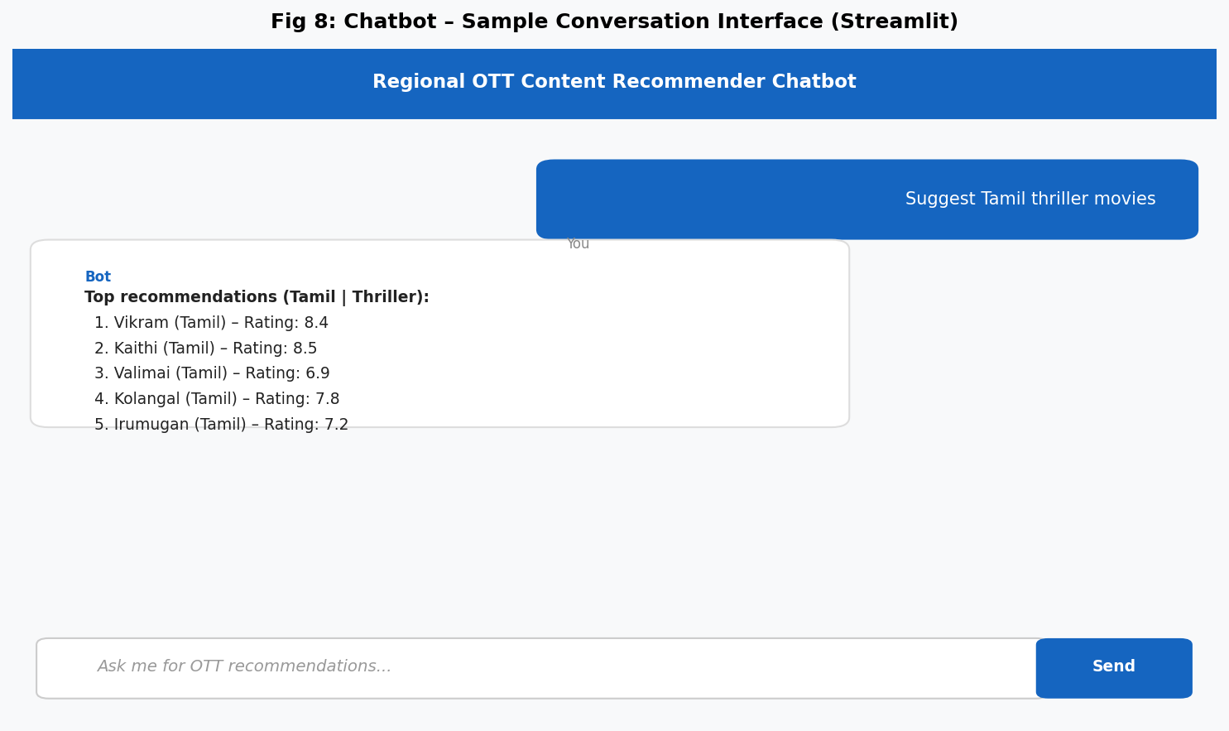
Fig 8: Chatbot Interface – Streamlit-based conversational UI returning top OTT recommendations.

10. Conclusion

This project successfully demonstrates the application of data science techniques to build a Regional Cinema & OTT Content Recommender system. By following a systematic data science workflow — from dataset collection and exploratory analysis to advanced machine learning and conversational AI — the system provides intelligent, personalised content recommendations tailored to India's diverse regional language landscape.
The content-based filtering using TF-IDF and cosine similarity effectively captures item-level similarities, while collaborative filtering via SVD captures community-driven preferences. The hybrid blending approach outperforms either method in isolation, particularly for sparse rating scenarios common in regional content databases.
The Naive Bayes probabilistic model provides an interpretable preference prediction layer, making the system explainable to stakeholders. The integrated Streamlit chatbot delivers a user-friendly conversational interface, bridging the gap between complex recommendation algorithms and end-user accessibility.
Future enhancements include: incorporating deep learning-based embeddings (BERT for multilingual content), real-time streaming data ingestion from OTT APIs, and context-aware recommendations based on viewing time and device type. The system establishes a strong foundation for a production-grade regional OTT discovery platform.

