Assignment-1

Task 1: Create a Security Group (SG) — Required Ports
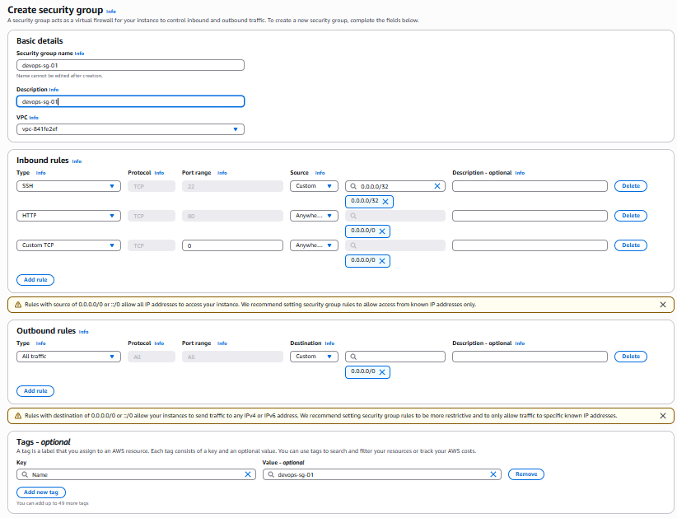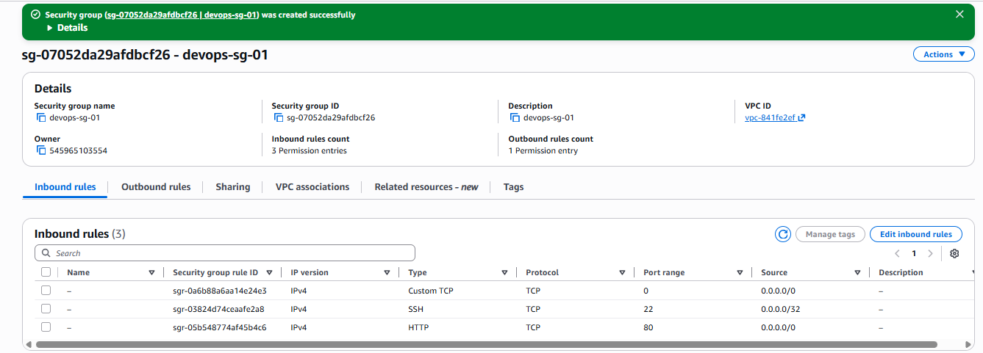
Task 2: Create SSH Key Pair — ED25519 + PEM

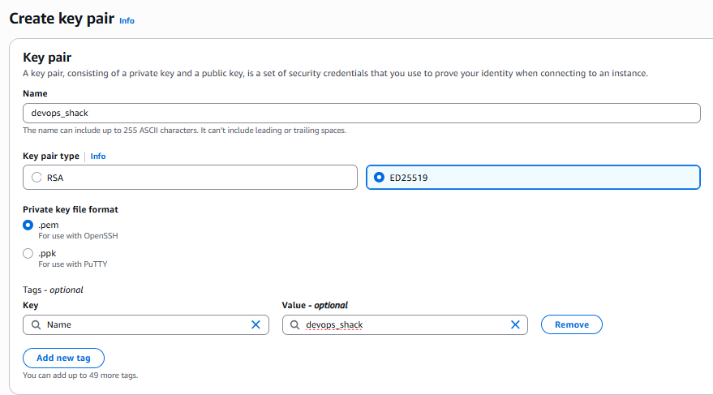

Task 3: Launch EC2 Instance (Ubuntu + t2.micro)

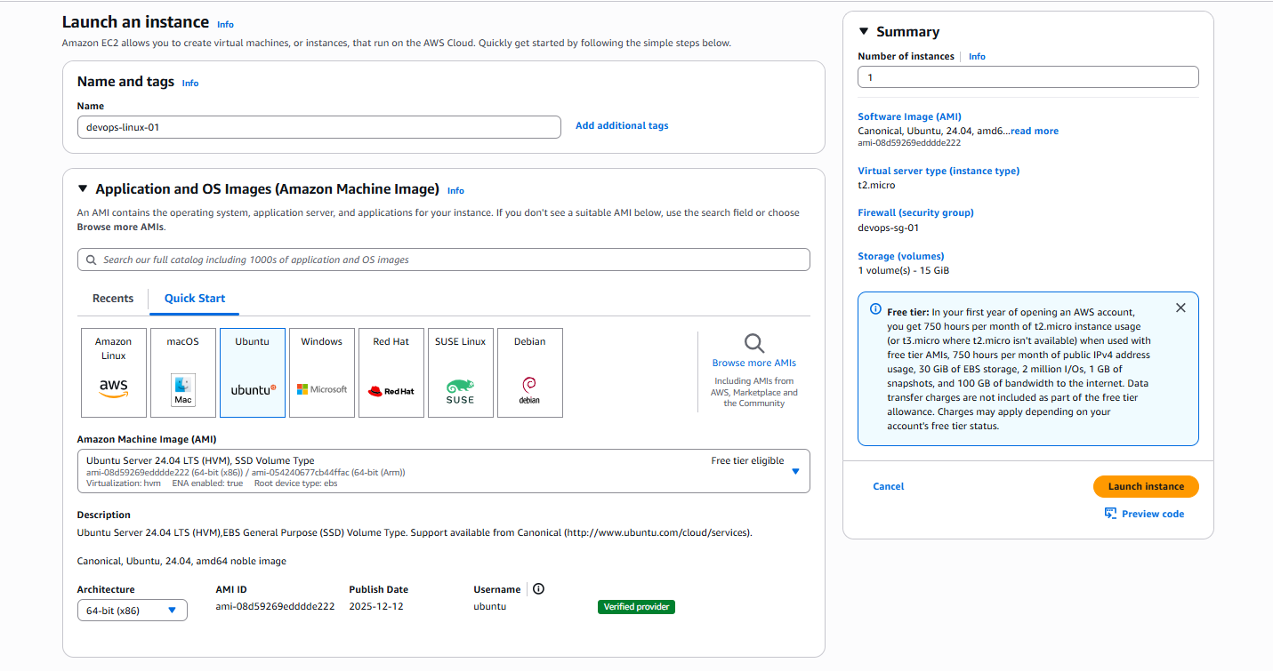

Connect to EC2 via SSH

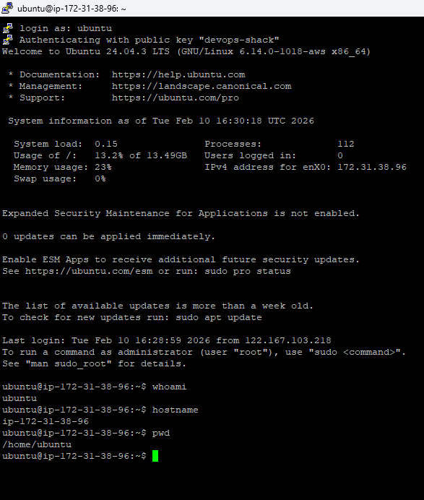

Task 5: Linux Commands Practice

A) System Basics

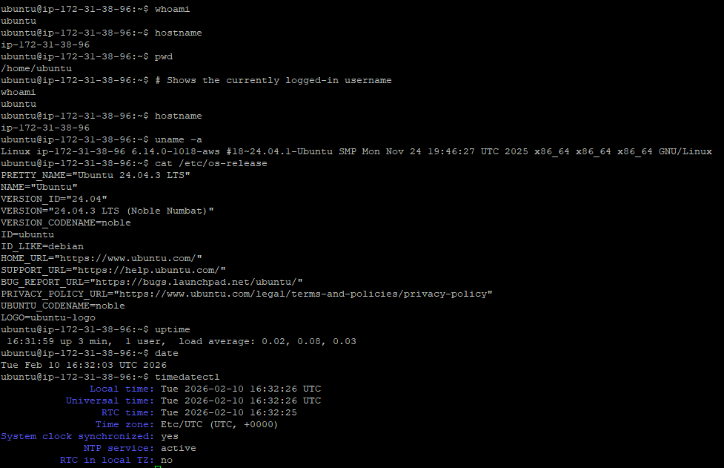

B) Navigation & Listing

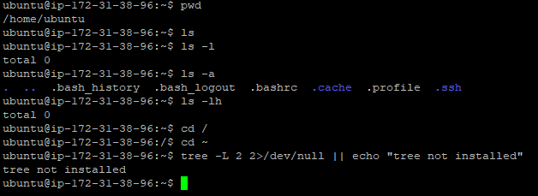

C) Create Files & Directories

ubuntu@ip-172-31-38-96:~$ mkdir devops-lab
ubuntu@ip-172-31-38-96:~$ ls
devops-lab
ubuntu@ip-172-31-38-96:~$ cd devops-lab/
ubuntu@ip-172-31-38-96:~/devops-lab$ ls
ubuntu@ip-172-31-38-96:~/devops-lab$ mkdir -p projects/app/logs
ubuntu@ip-172-31-38-96:~/devops-lab$ ls
projects
ubuntu@ip-172-31-38-96:~/devops-lab$ mkdir day1 day2 day3
ubuntu@ip-172-31-38-96:~/devops-lab$ ls
day1 day2 day3 projects
ubuntu@ip-172-31-38-96:~/devops-lab$ mkdir -p projects/app/logs
ubuntu@ip-172-31-38-96:~/devops-lab$ ls
day1 day2 day3 projects
ubuntu@ip-172-31-38-96:~/devops-lab$ cd projects/
ubuntu@ip-172-31-38-96:~/devops-lab/projects$ ls
app
ubuntu@ip-172-31-38-96:~/devops-lab/projects$ cd..
cd..: command not found
ubuntu@ip-172-31-38-96:~/devops-lab/projects$ cd.
Command 'cd.' not found, did you mean:
command 'cdw' from deb cdw (0.8.1-3)
command 'cdb' from deb tinycdb (0.81-1)
command 'cd5' from deb cd5 (0.1-4)
command 'cdp' from deb irpas (0.10-9)
command 'cdi' from deb cdo (2.3.0-1)
command 'cdo' from deb cdo (2.3.0-1)
command 'cde' from deb cde (0.1+git9-g551e54d-1.2)
Try: sudo apt install <deb name>
ubuntu@ip-172-31-38-96:~/devops-lab/projects$ cd
ubuntu@ip-172-31-38-96:~$ cd devops-lab/
ubuntu@ip-172-31-38-96:~/devops-lab$ ls
day1 day2 day3 projects
ubuntu@ip-172-31-38-96:~/devops-lab$ touch file1.txt file2.txt notes.md
ubuntu@ip-172-31-38-96:~/devops-lab$ ls
day1 day2 day3 file1.txt file2.txt notes.md projects
ubuntu@ip-172-31-38-96:~/devops-lab$ ls -lart
total 24
drwxr-x--- 5 ubuntu ubuntu 4096 Feb 10 16:37 ..
drwxrwxr-x 3 ubuntu ubuntu 4096 Feb 10 16:37 projects
drwxrwxr-x 2 ubuntu ubuntu 4096 Feb 10 16:38 day3
drwxrwxr-x 2 ubuntu ubuntu 4096 Feb 10 16:38 day2
drwxrwxr-x 2 ubuntu ubuntu 4096 Feb 10 16:38 day1
-rw-rw-r-- 1 ubuntu ubuntu 0 Feb 10 16:39 notes.md
-rw-rw-r-- 1 ubuntu ubuntu 0 Feb 10 16:39 file2.txt
-rw-rw-r-- 1 ubuntu ubuntu 0 Feb 10 16:39 file1.txt
drwxrwxr-x 6 ubuntu ubuntu 4096 Feb 10 16:39 .
ubuntu@ip-172-31-38-96:~/devops-lab$ echo "hello devops" > file1.txt
ubuntu@ip-172-31-38-96:~/devops-lab$ ls
day1 day2 day3 file1.txt file2.txt notes.md projects
ubuntu@ip-172-31-38-96:~/devops-lab$ echo "line2" >> file1.txt
ubuntu@ip-172-31-38-96:~/devops-lab$ cat file1.txt
hello devops
line2
ubuntu@ip-172-31-38-96:~/devops-lab$ cp file1.txt file1-copy.txt
ubuntu@ip-172-31-38-96:~/devops-lab$ ls
day1 day2 day3 file1-copy.txt file1.txt file2.txt notes.md projects
ubuntu@ip-172-31-38-96:~/devops-lab$ mv file2.txt renamed-file2.txt
ubuntu@ip-172-31-38-96:~/devops-lab$ ls
day1 day2 day3 file1-copy.txt file1.txt notes.md projects renamed-file2.txt
ubuntu@ip-172-31-38-96:~/devops-lab$ rm renamed-file2.txt
ubuntu@ip-172-31-38-96:~/devops-lab$ ls
day1 day2 day3 file1-copy.txt file1.txt notes.md projects
ubuntu@ip-172-31-38-96:~/devops-lab$ rmdir day3 2>/dev/null || echo "day3 not empty or already removed"
ubuntu@ip-172-31-38-96:~/devops-lab$ ls
day1 day2 file1-copy.txt file1.txt notes.md projects
ubuntu@ip-172-31-38-96:~/devops-lab$

D) View File Content Properly

ubuntu@ip-172-31-38-96:~/devops-lab$ cat notes.md
ubuntu@ip-172-31-38-96:~/devops-lab$ head -n 5 file1.txt
hello devops
line2
ubuntu@ip-172-31-38-96:~/devops-lab$ tail -n 5 file1.txt
hello devops
line2
ubuntu@ip-172-31-38-96:~/devops-lab$ wc -l file1.txt
2 file1.txt
ubuntu@ip-172-31-38-96:~/devops-lab$ wc -w file1.txt
3 file1.txt
ubuntu@ip-172-31-38-96:~/devops-lab$ nl -ba file1.txt
1 hello devops
2 line2
ubuntu@ip-172-31-38-96:~/devops-lab$ less file1.txt

