Official User Guide



SuperX v1.1 “Cassini”

Copyright © 2012 Wrishiraj Kaushik

Under Creative Commons Share-Alike 3.0 Unported license

Document Version 1.0

Written by
Wrishiraj Kaushik (alias "Wrix") and other contributors

Edited by
Bikash Narayan Sarma

Legal terms of use

Creative Commons Attribution-ShareAlike 3.0 Unported

License

THE WORK (AS DEFINED BELOW) IS PROVIDED UNDER THE TERMS OF THIS CREATIVE COMMONS PUBLIC LICENSE ("CCPL" OR "LICENSE"). THE WORK IS PROTECTED BY COPYRIGHT AND/OR OTHER APPLICABLE LAW. ANY USE OF THE WORK OTHER THAN AS AUTHORIZED UNDER THIS LICENSE OR COPYRIGHT LAW IS PROHIBITED.

BY EXERCISING ANY RIGHTS TO THE WORK PROVIDED HERE, YOU ACCEPT AND AGREE TO BE BOUND BY THE TERMS OF THIS LICENSE. TO THE EXTENT THIS LICENSE MAY BE CONSIDERED TO BE A CONTRACT, THE LICENSOR GRANTS YOU THE RIGHTS CONTAINED HERE IN CONSIDERATION OF YOUR ACCEPTANCE OF SUCH TERMS AND CONDITIONS.

1. Definitions
"Adaptation" means a work based upon the Work, or upon the Work and other pre-existing works, such as a translation, adaptation, derivative work, arrangement of music or other alterations of a literary or artistic work, or phonogram or performance and includes cinematographic adaptations or any other form in which the Work may be recast, transformed, or adapted including in any form recognizably derived from the original, except that a work that constitutes a Collection will not be considered an Adaptation for the purpose of this License. For the avoidance of doubt, where the Work is a musical work, performance or phonogram, the synchronization of the Work in timed-relation with a moving image ("synching") will be considered an Adaptation for the purpose of this License.
"Collection" means a collection of literary or artistic works, such as encyclopedias and anthologies, or performances, phonograms or broadcasts, or other works or subject matter other than works listed in Section 1(f) below, which, by reason of the selection and arrangement of their contents, constitute intellectual creations, in which the Work is included in its entirety in unmodified form along with one or more other contributions, each constituting separate and independent works in themselves, which together are assembled into a collective whole. A work that constitutes a Collection will not be considered an Adaptation (as defined below) for the purposes of this License.
"Creative Commons Compatible License" means a license that is listed at http://creativecommons.org/compatiblelicenses that has been approved by Creative Commons as being essentially equivalent to this License, including, at a minimum, because that license: (i) contains terms that have the same purpose, meaning and effect as the License Elements of this License; and, (ii) explicitly permits the relicensing of adaptations of works made available under that license under this License or a Creative Commons jurisdiction license with the same License Elements as this License.
"Distribute" means to make available to the public the original and copies of the Work or Adaptation, as appropriate, through sale or other transfer of ownership.
"License Elements" means the following high-level license attributes as selected by Licensor and indicated in the title of this License: Attribution, ShareAlike.
"Licensor" means the individual, individuals, entity or entities that offer(s) the Work under the terms of this License.
"Original Author" means, in the case of a literary or artistic work, the individual, individuals, entity or entities who created the Work or if no individual or entity can be identified, the publisher; and in addition (i) in the case of a performance the actors, singers, musicians, dancers, and other persons who act, sing, deliver, declaim, play in, interpret or otherwise perform literary or artistic works or expressions of folklore; (ii) in the case of a phonogram the producer being the person or legal entity who first fixes the sounds of a performance or other sounds; and, (iii) in the case of broadcasts, the organization that transmits the broadcast.
"Work" means the literary and/or artistic work offered under the terms of this License including without limitation any production in the literary, scientific and artistic domain, whatever may be the mode or form of its expression including digital form, such as a book, pamphlet and other writing; a lecture, address, sermon or other work of the same nature; a dramatic or dramatico-musical work; a choreographic work or entertainment in dumb show; a musical composition with or without words; a cinematographic work to which are assimilated works expressed by a process analogous to cinematography; a work of drawing, painting, architecture, sculpture, engraving or lithography; a photographic work to which are assimilated works expressed by a process analogous to photography; a work of applied art; an illustration, map, plan, sketch or three-dimensional work relative to geography, topography, architecture or science; a performance; a broadcast; a phonogram; a compilation of data to the extent it is protected as a copyrightable work; or a work performed by a variety or circus performer to the extent it is not otherwise considered a literary or artistic work.
"You" means an individual or entity exercising rights under this License who has not previously violated the terms of this License with respect to the Work, or who has received express permission from the Licensor to exercise rights under this License despite a previous violation.
"Publicly Perform" means to perform public recitations of the Work and to communicate to the public those public recitations, by any means or process, including by wire or wireless means or public digital performances; to make available to the public Works in such a way that members of the public may access these Works from a place and at a place individually chosen by them; to perform the Work to the public by any means or process and the communication to the public of the performances of the Work, including by public digital performance; to broadcast and rebroadcast the Work by any means including signs, sounds or images.
"Reproduce" means to make copies of the Work by any means including without limitation by sound or visual recordings and the right of fixation and reproducing fixations of the Work, including storage of a protected performance or phonogram in digital form or other electronic medium.

2. Fair Dealing Rights. Nothing in this License is intended to reduce, limit, or restrict any uses free from copyright or rights arising from limitations or exceptions that are provided for in connection with the copyright protection under copyright law or other applicable laws.

3. License Grant. Subject to the terms and conditions of this License, Licensor hereby grants You a worldwide, royalty-free, non-exclusive, perpetual (for the duration of the applicable copyright) license to exercise the rights in the Work as stated below:
to Reproduce the Work, to incorporate the Work into one or more Collections, and to Reproduce the Work as incorporated in the Collections;
to create and Reproduce Adaptations provided that any such Adaptation, including any translation in any medium, takes reasonable steps to clearly label, demarcate or otherwise identify that changes were made to the original Work. For example, a translation could be marked "The original work was translated from English to Spanish," or a modification could indicate "The original work has been modified.";
to Distribute and Publicly Perform the Work including as incorporated in Collections; and,
to Distribute and Publicly Perform Adaptations.

For the avoidance of doubt:
Non-waivable Compulsory License Schemes. In those jurisdictions in which the right to collect royalties through any statutory or compulsory licensing scheme cannot be waived, the Licensor reserves the exclusive right to collect such royalties for any exercise by You of the rights granted under this License;
Waivable Compulsory License Schemes. In those jurisdictions in which the right to collect royalties through any statutory or compulsory licensing scheme can be waived, the Licensor waives the exclusive right to collect such royalties for any exercise by You of the rights granted under this License; and,
Voluntary License Schemes. The Licensor waives the right to collect royalties, whether individually or, in the event that the Licensor is a member of a collecting society that administers voluntary licensing schemes, via that society, from any exercise by You of the rights granted under this License.

The above rights may be exercised in all media and formats whether now known or hereafter devised. The above rights include the right to make such modifications as are technically necessary to exercise the rights in other media and formats. Subject to Section 8(f), all rights not expressly granted by Licensor are hereby reserved.

4. Restrictions. The license granted in Section 3 above is expressly made subject to and limited by the following restrictions:
You may Distribute or Publicly Perform the Work only under the terms of this License. You must include a copy of, or the Uniform Resource Identifier (URI) for, this License with every copy of the Work You Distribute or Publicly Perform. You may not offer or impose any terms on the Work that restrict the terms of this License or the ability of the recipient of the Work to exercise the rights granted to that recipient under the terms of the License. You may not sublicense the Work. You must keep intact all notices that refer to this License and to the disclaimer of warranties with every copy of the Work You Distribute or Publicly Perform. When You Distribute or Publicly Perform the Work, You may not impose any effective technological measures on the Work that restrict the ability of a recipient of the Work from You to exercise the rights granted to that recipient under the terms of the License. This Section 4(a) applies to the Work as incorporated in a Collection, but this does not require the Collection apart from the Work itself to be made subject to the terms of this License. If You create a Collection, upon notice from any Licensor You must, to the extent practicable, remove from the Collection any credit as required by Section 4(c), as requested. If You create an Adaptation, upon notice from any Licensor You must, to the extent practicable, remove from the Adaptation any credit as required by Section 4(c), as requested.
You may Distribute or Publicly Perform an Adaptation only under the terms of: (i) this License; (ii) a later version of this License with the same License Elements as this License; (iii) a Creative Commons jurisdiction license (either this or a later license version) that contains the same License Elements as this License (e.g., Attribution-ShareAlike 3.0 US)); (iv) a Creative Commons Compatible License. If you license the Adaptation under one of the licenses mentioned in (iv), you must comply with the terms of that license. If you license the Adaptation under the terms of any of the licenses mentioned in (i), (ii) or (iii) (the "Applicable License"), you must comply with the terms of the Applicable License generally and the following provisions: (I) You must include a copy of, or the URI for, the Applicable License with every copy of each Adaptation You Distribute or Publicly Perform; (II) You may not offer or impose any terms on the Adaptation that restrict the terms of the Applicable License or the ability of the recipient of the Adaptation to exercise the rights granted to that recipient under the terms of the Applicable License; (III) You must keep intact all notices that refer to the Applicable License and to the disclaimer of warranties with every copy of the Work as included in the Adaptation You Distribute or Publicly Perform; (IV) when You Distribute or Publicly Perform the Adaptation, You may not impose any effective technological measures on the Adaptation that restrict the ability of a recipient of the Adaptation from You to exercise the rights granted to that recipient under the terms of the Applicable License. This Section 4(b) applies to the Adaptation as incorporated in a Collection, but this does not require the Collection apart from the Adaptation itself to be made subject to the terms of the Applicable License.
If You Distribute, or Publicly Perform the Work or any Adaptations or Collections, You must, unless a request has been made pursuant to Section 4(a), keep intact all copyright notices for the Work and provide, reasonable to the medium or means You are utilizing: (i) the name of the Original Author (or pseudonym, if applicable) if supplied, and/or if the Original Author and/or Licensor designate another party or parties (e.g., a sponsor institute, publishing entity, journal) for attribution ("Attribution Parties") in Licensor's copyright notice, terms of service or by other reasonable means, the name of such party or parties; (ii) the title of the Work if supplied; (iii) to the extent reasonably practicable, the URI, if any, that Licensor specifies to be associated with the Work, unless such URI does not refer to the copyright notice or licensing information for the Work; and (iv) , consistent with Ssection 3(b), in the case of an Adaptation, a credit identifying the use of the Work in the Adaptation (e.g., "French translation of the Work by Original Author," or "Screenplay based on original Work by Original Author"). The credit required by this Section 4(c) may be implemented in any reasonable manner; provided, however, that in the case of a Adaptation or Collection, at a minimum such credit will appear, if a credit for all contributing authors of the Adaptation or Collection appears, then as part of these credits and in a manner at least as prominent as the credits for the other contributing authors. For the avoidance of doubt, You may only use the credit required by this Section for the purpose of attribution in the manner set out above and, by exercising Your rights under this License, You may not implicitly or explicitly assert or imply any connection with, sponsorship or endorsement by the Original Author, Licensor and/or Attribution Parties, as appropriate, of You or Your use of the Work, without the separate, express prior written permission of the Original Author, Licensor and/or Attribution Parties.
Except as otherwise agreed in writing by the Licensor or as may be otherwise permitted by applicable law, if You Reproduce, Distribute or Publicly Perform the Work either by itself or as part of any Adaptations or Collections, You must not distort, mutilate, modify or take other derogatory action in relation to the Work which would be prejudicial to the Original Author's honor or reputation. Licensor agrees that in those jurisdictions (e.g. Japan), in which any exercise of the right granted in Section 3(b) of this License (the right to make Adaptations) would be deemed to be a distortion, mutilation, modification or other derogatory action prejudicial to the Original Author's honor and reputation, the Licensor will waive or not assert, as appropriate, this Section, to the fullest extent permitted by the applicable national law, to enable You to reasonably exercise Your right under Section 3(b) of this License (right to make Adaptations) but not otherwise.

5. Representations, Warranties and Disclaimer

UNLESS OTHERWISE MUTUALLY AGREED TO BY THE PARTIES IN WRITING, LICENSOR OFFERS THE WORK AS-IS AND MAKES NO REPRESENTATIONS OR WARRANTIES OF ANY KIND CONCERNING THE WORK, EXPRESS, IMPLIED, STATUTORY OR OTHERWISE, INCLUDING, WITHOUT LIMITATION, WARRANTIES OF TITLE, MERCHANTIBILITY, FITNESS FOR A PARTICULAR PURPOSE, NONINFRINGEMENT, OR THE ABSENCE OF LATENT OR OTHER DEFECTS, ACCURACY, OR THE PRESENCE OF ABSENCE OF ERRORS, WHETHER OR NOT DISCOVERABLE. SOME JURISDICTIONS DO NOT ALLOW THE EXCLUSION OF IMPLIED WARRANTIES, SO SUCH EXCLUSION MAY NOT APPLY TO YOU.

6. Limitation on Liability. EXCEPT TO THE EXTENT REQUIRED BY APPLICABLE LAW, IN NO EVENT WILL LICENSOR BE LIABLE TO YOU ON ANY LEGAL THEORY FOR ANY SPECIAL, INCIDENTAL, CONSEQUENTIAL, PUNITIVE OR EXEMPLARY DAMAGES ARISING OUT OF THIS LICENSE OR THE USE OF THE WORK, EVEN IF LICENSOR HAS BEEN ADVISED OF THE POSSIBILITY OF SUCH DAMAGES.

7. Termination
This License and the rights granted hereunder will terminate automatically upon any breach by You of the terms of this License. Individuals or entities who have received Adaptations or Collections from You under this License, however, will not have their licenses terminated provided such individuals or entities remain in full compliance with those licenses. Sections 1, 2, 5, 6, 7, and 8 will survive any termination of this License.
Subject to the above terms and conditions, the license granted here is perpetual (for the duration of the applicable copyright in the Work). Notwithstanding the above, Licensor reserves the right to release the Work under different license terms or to stop distributing the Work at any time; provided, however that any such election will not serve to withdraw this License (or any other license that has been, or is required to be, granted under the terms of this License), and this License will continue in full force and effect unless terminated as stated above.

8. Miscellaneous
Each time You Distribute or Publicly Perform the Work or a Collection, the Licensor offers to the recipient a license to the Work on the same terms and conditions as the license granted to You under this License.
Each time You Distribute or Publicly Perform an Adaptation, Licensor offers to the recipient a license to the original Work on the same terms and conditions as the license granted to You under this License.
If any provision of this License is invalid or unenforceable under applicable law, it shall not affect the validity or enforceability of the remainder of the terms of this License, and without further action by the parties to this agreement, such provision shall be reformed to the minimum extent necessary to make such provision valid and enforceable.
No term or provision of this License shall be deemed waived and no breach consented to unless such waiver or consent shall be in writing and signed by the party to be charged with such waiver or consent.
This License constitutes the entire agreement between the parties with respect to the Work licensed here. There are no understandings, agreements or representations with respect to the Work not specified here. Licensor shall not be bound by any additional provisions that may appear in any communication from You. This License may not be modified without the mutual written agreement of the Licensor and You.
The rights granted under, and the subject matter referenced, in this License were drafted utilizing the terminology of the Berne Convention for the Protection of Literary and Artistic Works (as amended on September 28, 1979), the Rome Convention of 1961, the WIPO Copyright Treaty of 1996, the WIPO Performances and Phonograms Treaty of 1996 and the Universal Copyright Convention (as revised on July 24, 1971). These rights and subject matter take effect in the relevant jurisdiction in which the License terms are sought to be enforced according to the corresponding provisions of the implementation of those treaty provisions in the applicable national law. If the standard suite of rights granted under applicable copyright law includes additional rights not granted under this License, such additional rights are deemed to be included in the License; this License is not intended to restrict the license of any rights under applicable law.
Creative Commons Notice

Creative Commons is not a party to this License, and makes no warranty whatsoever in connection with the Work. Creative Commons will not be liable to You or any party on any legal theory for any damages whatsoever, including without limitation any general, special, incidental or consequential damages arising in connection to this license. Notwithstanding the foregoing two (2) sentences, if Creative Commons has expressly identified itself as the Licensor hereunder, it shall have all rights and obligations of Licensor.

Except for the limited purpose of indicating to the public that the Work is licensed under the CCPL, Creative Commons does not authorize the use by either party of the trademark "Creative Commons" or any related trademark or logo of Creative Commons without the prior written consent of Creative Commons. Any permitted use will be in compliance with Creative Commons' then-current trademark usage guidelines, as may be published on its website or otherwise made available upon request from time to time. For the avoidance of doubt, this trademark restriction does not form part of the License.

Creative Commons may be contacted at http://creativecommons.org/.

Table of Contents
Philosophy 5
Introduction to SuperX 6
Where to find help 6
Via Torrent 7
Download Torrent 7
Via a mirror site 7
Burn the ISO to a DVD or create a USB startup disk 8
With a DVD 8
With a USB pen-drive 9
Install SuperX on your Hard Disk 10
Running SuperX on Older Hardware 12
Presenting the SuperX desktop 13
The K Desktop Environment (KDE Desktop) 13
Files & Folders - File Manager for SuperX 16
Interface description 16
Navigation 16
Managing archives (RAR, ZIP etc.) 17
Software Management 17
LibreOffice – Creating and Editing documents 18
Chromium – Browse website and more 19
Openshot Video Editor – Make Videos and edit them 21
Image Editor – Manipulate Images 22
Music Payer 22
Paint 23
Chat 23
SuperX Community Chat 24
Torrent Client 24
Image Viewer 25
Software Sources 25
Running applications made for Microsoft® Windows 26
Hardware 26
Conclusion 27

Philosophy
SuperX is not just an operating system, it is a technological representation of a philosophy. SuperX is a propagator of Free Software.

Most of the software made today focus on commercialization and not the users who actually uses it. It results the software vendor controls the user as they make license agreements that gives them total control over their users.

When users don't control the software, the software controls the users. The developer who controls the software, through it controls the users. This is called “proprietary” software is therefore an instrument of unjust power. This means the developer is actually controlling the user. The user has no freedom.
Answering to one of our questions in a seminar held at IIT Madras,India,Richard M Stallman,The founder of the GNU project and the Free Software Foundation told that
“Proprietary Software is an injustice to humanity”.
And we have the same philosophy when it comes to proprietary software.
The software might have “backdoor” that can steal private information of the user without the user even noticing it. In the 21st century this is the modern form of company rule.
This a form of “digital colonization”, and using such software makes the user a victim of it. The user is virtually a “slave” of the developer.
Also some companies even restrict users to download and use only the applicationsfrom their online application store. This is like “BABY SITTING” the user.
just consider an example: you are buying a car and the car vendor is telling that you can only refill gas in their gas station and think the worst scenario even filling up flat tyres or anything you need to change in that car can only be done in their garage and those changes which are actually to be given free or of low cost are charged so high that nearly in a year the cost of upgrades and tweaks exceeds the cost of the car itself.

What makes SuperX different?
SuperX respects users' freedom and community. SuperX is developed with the point-of-view of humanity, the free access to information, knowledge and ability to work without restriction. With SuperX, the developers grants you freedom to see the source-code of most of it's components. SuperX is about the core concept that make us human – the way we share our thoughts, help other and live in a community. With SuperX you are never a victim of the digital colonization.
You are free to share it, change it and make your own.
Yeah!thats true!remember when we are in our primary school what our teacher taught us?
“if you bring a candy bar or snacks you should not have it all on your own. You should share it with everyone. Thats is how we are supposed live. To help each other and move forward to achieve the greatness. Suddenly a couple of software companies came into the play and telling you
“DON'T SHARE!!! IF YOU SHARE THE SOFTWARE WITH OTHERS THEN YOU ARE A PIRATE”.
Hey wait thats unfair if I am selfish and keep the things for myself then I am considered as a THE BAD GUY but if share the software then I am a pirate. I may go to jail.
getting something??
thats why in superX You are free to help you neighbor and the community. The source-code is always available to the user,.The users can look into it and make sure that it doesn't have any backdoors.
SuperX is “democracy”, the user gets the power rather than developer. It is a matter of “liberty” not commercialization. SuperX is provided for the benefit of humanity rather than making money out of it. Making money is a secondary goal for the SuperX developers. SuperX is free both in price and freedom.

Introduction to SuperX
SuperX is a computer operating system designed to run on most modern systems, including classic PC 32-bit (x86) and 64bit (x64).
SuperX can be seen as an alternative of Microsoft Windows, Apple MAC OS etc. SuperX is also designed to work in conjunction with other operating systems (including those mentioned above), and can automatically set up a system startup mode: "dual boot" (dual boot) or "multi-boot" (multiboot) during installation (allows the user to choose an operating system at startup).
SuperX is a great operating system for individuals and businesses.
History
SuperX is a very new operating system. Its development began in 2007. However, it is built from very mature and tested codes, including the Linux kernel, GNU tools and the K Desktop Environment. It is also based on Ubuntu and Debian projects, and use their systems as a base.
The SuperX project is dedicated to making your desktop more usable and effective for everyday tasks performed by regular users.
SuperX also provides, from a very solid base, an extensive collection of software and a particularly well-integrated set of services.
SuperX has seen its popularity increase rapidly, and more people are using it daily.
Objectives
The purpose of SuperX is to provide a desktop operating system that home users and businesses can use freely. We have tried our best to make it as effective, easy to use and elegant as possible.
One of the aims of the project "SuperX" is to become the best operating system available, facilitating access to all new technologies. The goal is to develop our own idea of the ideal.
Code names of versions
Code names in SuperX are given in honor of a person, whose work has been a great contribution to humanity. The person can be anyone from a scientist to a sportsman or a singer or a political leader.
Here are the code names used by SuperX so far:

Version | Code name | In honor of | Support period
1.0 | Galileo | Italian Scientist, Galileo Galilei | Apr 2010 - Oct 2012
1.1 | Cassini | Italian/French Scientist, Giovanni Domenico Cassini | Apr 2012 - Oct 2017

There is a idea beyond these names. Even though this is beyond the scope of this user guide we would like to tell this because many interested users are suggesting us many names. So we are in a state of telling the idea behind it so that only names satisfying these conditions are taken for considerations.
The first version Galileo is to tell the world that we have broken a myth. when wrix the guy who is hmm lets say father of SuperX started this project,people said:
“YOU AIN'T NEVER GONNA MAKE THIS HAPPEN.NOT IN A MILLION YEARS”

but with hard work and the determination we proved them wrong like Galileo proved the world wrong that it is not flat.

Similarly cassini.Cassini division was discovered by the person named 'Cassini'
SuperX v1.1 "Cassini" focuses to discover the gap/division in OS market to enter mainstream.
All future versions of SuperX will be codenamed based on quoting some points

Where to find help
Ya ya I can here you people saying,Rags!ok everything is cool but what if I end up with some error or trouble who's gonna help me?Well obviously its us. we'll not let our users worry about trouble we are always there to help.
The SuperX Community is very active and helpful. If you have questions or a problem with SuperX, you can get help online from other users.
First, make sure to register on the forums. This is the first place where you can find help: forum.superxos.com.
If you want to chat with other users and get help in real time, you can connect to the IRC chat room. In SuperX, simply launch "SuperX Chat" from the Internet menu. If you use another operating system or another IRC client, connect to the server "irc.spotchat.org" and then choose the channel "#superx" (without the quotes).
SuperX is based on Ubuntu (more explanation on that later) and is therefore almost fully compatible with it. Many resources, articles, tutorials, and software developed for Ubuntu should also work with SuperX. If you can not find the help for an issue in SuperX, please do the same search for Ubuntu.
Note: SuperX and Ubuntu are relatives but not the same system, thing that work on Ubuntu may or may not work on SuperX and vice-versa.
Getting SuperX

So We hope we have convinced you enough by saying our philosophy and other stuffs. Now you might think “all right I guess I can try this OS after all”. If you haven't,read the previous sections again and again till you get that thought. ha ha just kidding let me get to the point.
The SuperX operating system is free to download as of writing this user guide. It is generally available as an ISO file that is (approximately) 1GB in size, which you can then burn to a DVD. This DVD is the boot-able (that is to say you can run SuperX from it) and provides a complete functional operating system. You can even try it out without affecting your PC or your current operating system. This is called a Live DVD.

Simply put, when you put SuperX on a DVD and you insert the DVD into your drive, you can try it without installing it, while leaving your current system as it is.
Note: It is also possible to write the ISO image onto a USB stick or similar media and boot from it, or boot from the ISO file on the hard disk, but these options are more complex , and the method described here is recommended. For guidance on alternative methods to install and run SuperX, please visit the forums.
If you like what you see by running the Live DVD, you can move on to install SuperX on your hard drive. All necessary tools (partitioning tools and installation) are present on the DVD.
Download the ISO file
Note: If you do not have a broadband connection, or if your internet connection is too slow to download 1 GB, you can order the DVD directly: https://superxos.com. if you live in India. It will cost INR 500/- only. This will also help the developers of the SuperX to raise funds to sustain the project.

Otherwise, you will find the download of SuperX at: https://superxos.com.
Then choose the edition that interests you.

On the download page of the SuperX website, you will find:
- An MD5 signature (to verify compliance of the image)
- Torrent downloads
- A list of mirror sites (download)

The file you need is an ISO file. There are two ways to download this file: torrent by (a peer-to-Peer protocol) or via a mirror site (HTTP or FTP). Once the download is complete, it is advisable to check the MD5 Sum by .

Via Torrent
Torrent is a protocol for exchanging peer-to-Peer (P2P). Basically, instead of downloading from a single address, in a torrent you can download the ISO file piece-wise among several people connected to the Internet.
The more people who download the ISO, the faster the download is. This is the most recommended method to download SuperX.(Please note that speed of download will limited as per your ISP Bandwidth subscription.)

Download Torrent
The next step is to follow the torrent link from the website of SuperX, and download the torrent file. This file is very small. Once downloaded, you must open it with your torrent client.
It will probably ask you where you want to save the ISO file. Select a destination and wait for the download to complete.
For more information about the torrent protocol, visit: http://en.wikipedia.org/wiki/BitTorrent

Via a mirror site
If you can not or don't want to use the torrent protocol, browse the list of mirror sites and pick one. They will provide a direct link to the ISO file which you just click to start download.

Note: Remember though that the bandwidth of a mirror site is limited and that there will be more people trying to download, it will be more slow. Moreover, if the download gets interrupted at one point, for one reason or another, the file might get corrupt ed and the download might have to be restarted. For these reasons, it is recommended to use a download manager, either from Linux or Windows, if you choose to do that (eg KGet on SuperX or Down Them All! Firefox addon).
Read the Release Notes
The download will probably take more than an hour, and it would be the perfect time to familiarize yourself with the new features included in the version you're downloading.

The release notes are available on the homepage and download page of the SuperX website, and answers the following questions:

- What's new in this version?(now thats where we work a lot to give you the best)
- What problems are listed for this version?(thats where we need to work on)
- How to migrate to this version?(you know what it is dont you?)
Note: They may also contain screenshots of the latest version. Of course, you might find most new highlighted features in these notes simply by using the operating system, but you probably would miss many of them. Therefore, it is really safer to read the release notes.

Verifying the MD5 Checksum

You've read the release notes, you just can not wait to play with these new features or trying SuperX, and your download just finished successfully. You're ready to burn the DVD and boot from it ... But Oh! Wait a second!
If this DVD is faulty, you will end up with weird bugs where you will be hard pressed to find help. The two most common reasons for having a faulty DVD are:

- A problem occurred during download caused errors in your ISO file.
- An error during the burning process has altered the contents of the Live DVD.
Note: The MD5 signature, which is present on the download page, offers a quick way to make sure your ISO file is exactly as it should be. So check the ISO file you just downloaded before burning, and spare us a bunch of potential problems. If you find doing all these difficult, you can skip checking MD5 also. But you're on your own. In most general cases, it's very unlikely to have an issue with the ISO you download.

If you are on a Linux based system, you probably already have a program installed on your computer to check MD5 Sum.
Open a terminal, type "cd" followed by the name of the folder where your ISO. For example, if "SuperX_v1.1_Cassini_i386.iso" is on the Downloads, open a terminal and type:

cd ~/Downloads

md5sum SuperX_v1.1_Cassini_i386.iso

This command must generate a series of numbers and letters that match the MD5 of your file. By definition, even slight changes in the file's MD5 signature changes significantly, allowing us to verify that the file is exactly as it should be.

Compare this signature with the one on the download page of the SuperX website. If the two signatures are exactly the same, then you know that your ISO file is faithful to the original and you can burn it without fear.

If it happens that you are still running Windows, it is likely that you do not already have MD5 sum. You can get it here: http://www.etree.org/md5com.html

Place the ISO file and the file md5sum.exe in one place (say in C: \ for example), and run "cmd.exe" ("Start Menu", then type "cmd.exe" in the search field). The DOS prompt will appear. Then type the following command lines:

C:

cd /

md5sum SuperX_v1.1_Cassini_i386.iso

Then compare the signature obtained with the one found on the download page of the site.

Note: If you find doing all these difficult, you can skip checking MD5 also. But you're on your own. In most general cases, it's very unlikely to have an issue with the ISO you download.

Burn the ISO to a DVD or create a USB startup disk
Now that you've checked the ISO with MD5, you are ready to burn the DVD or put it on a USB pen-drive.

With a DVD
Take a blank DVD-R (DVD-RW should also do the trick, but is known to have compatibility problems)”or DVD-RW with minimum scratch to ensure that the ISO can burn and read properly”) and your favorite permanent marker and then enter a name for your DVD. Well, identifying a DVD may seem trivial, but it is relatively important because you can very easily find yourself with a score of unidentifiable DVD on your desktop.”Naming your SuperX DVD will help you to find when it necessary so you don't need to load random unnamed DVD's to your DVD/Blu-Ray drive.”

Insert the DVD-R disc into the drive and get ready to burn the ISO image.

In Ubuntu, just right-click and select "burn image": Brasero (default burning software) does the rest.(Tutorial for burning ISO with Brasero Click here.)

In Windows, you can choose a program like Nero or ISO Recorder or InfraRecorder: burns ISO image to the DVD

Note: Be careful to burn the ISO image to disk, and not the ISO file. It's a common mistake, especially for users of Nero, to burn the ISO file to disk as a data file. The ISO file is an image of a disk and should be burned rather than appearing as a file that will appear on it. Think of the ISO as an image that will be unpacked and the contents of which will be recorded on the disc. After burning the DVD, you should not see a single ISO file on it, but records like "casper" or "isolinux". Most burning software have an option provided for this.

With a USB pen-drive
- Install the program called Unetbootin, available both on a Linux based system and Windows
- Launch the software once installed, and then tell it the location of the downloaded ISO, and run the operation.
This technique is very reliable and has the advantage to save you blank DVDs.
For more information about Live USB Drive click here
Start the test drive
Restart the computer with with the USB pen-drive connected and "boot" from it, usually through pressing F8 or F10 or F12. You should see the following screen:
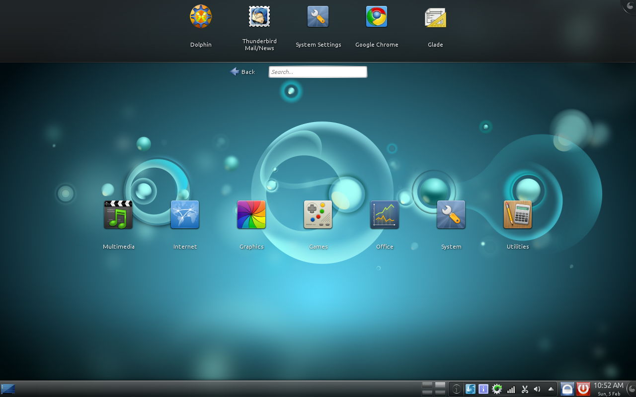

Note: If you do not see this screen and your computer starts as usual, it's probably because your BIOS is not set to boot from the DVD. Restart your computer and press the required to enter the BIOS (it appears at startup, usually "Del" key, or F1, F2, F10 see "Esc"), and change the BIOS settings (see "Start / prioritization of devices") to boot your computer from the DVD. For tutorial to setting BIOS to boot from DVD click here.
From the first screen, choose "Start SuperX" (2nd option), and press "Enter". The computer should then boot from the DVD. The boot process will take not more than 5 minutes under normal conditions. Please wait.In SuperX Cassini after selecting “Start SuperX” Please select the “Try SuperX”. This will boot up from your DVD. (Live DVD run is a process where you can test weather your system can run the OS)
After the boot process is over the graphical user interface will initialize, please wait a few more seconds. You will see the following screen:
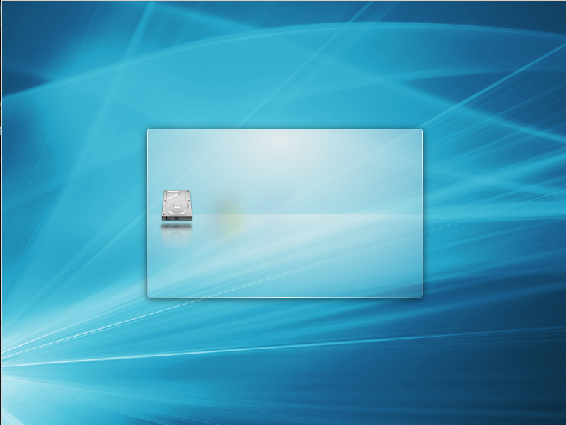

Note: If you have problems and that SuperX fails to start, try using "Start SuperX (compatibility mode)" (boot SuperX in compatibility mode) in the boot menu.
After a slight wait, "live" (on DVD) should be ready and you should see this desktop:

At this point, SuperX is not installed on your computer, but works directly from the DVD.
The operating system you have in front of you, however, is almost exactly the same as you have on your computer when the installation is finished.
Have fun with it and see if you like. Keep in mind that, when running from the DVD, SuperX is significantly slower than when installed on a hard drive, since it must read data off the DVD player, which has a transfer rate lower than that of a hard disk. From a USB pen-drive, it is faster. But once installed, it is much faster.
When you are ready, power down the computer and again boot from the DVD and select "Install SuperX" from the boot menu.
Or you may start the installer directly from the live DVD, by clicking the "Install Release" on the top favorites strip or by searching for "install superx" in the search-box in the desktop.
The installation process will start now.
It is strongly recommended that users read the release notes before installation to learn about new features and problems that could affect their personal settings.

Install SuperX on your Hard Disk

Step 1: Select your language and press the "Next" button.

Step 2: The installer will now ask you where to install SuperX (which hard drive, in which partition, etc..) select your desired option or location and press "Next"

Here are the meaning of the options:
- Guided: Use entire disk – Formats the entire hard disk and installs SuperX.
- Guided: Resize and install SuperX side-by-side – Dual boots SuperX with existing operating system.
- Manual – For advanced users.
Step 3: Select your time zone by clicking the map your country or by selecting from the drop-down menus and press "Next".
Note: Click on the city to which the time zone is allocated. For example, EST is New York, IST is Kolkata or Colombo.
Step 4: Create a user account for the system, enter your real name, a user name, password for the account (this is mandatory) and give a name to the computer and press "Next".
Note: if you have more than one computer, please give a unique name to each one if you are planning to network them.
Now wait for the installation to complete, it should take approximately 20 minutes depending upon the hardware configuration of the computer. Restart your computer, and eject the DVD or disconnect the pen drive. Now SuperX will boot from the hard disk.
Once SuperX has finished booting, you may see the following screen prompting you to enter your user name and password. This will show up only if you select “Required password on login” during user setup. This screen is the "Login Manager" .
Step 5: Enter your user name and password that you entered during user setup and hit "Enter" on your keyboard. This screen will not show up if you selected “Log-in automatically” during user setup.
Note: As stated before, password for "root" (superuser) is by default same as the one you chose during installation. If you do not understand what that means, do not worry about it.

Running SuperX on Older Hardware
SuperX actually runs best on newer computers with proper hardware. On older hardware, it might act a bit slow due to all the graphical effects. However there is an easy fix to that. If you own an old single-core machine, then follow the steps below to make sure SuperX runs properly on your computer.
First, press Alt+Shift+F12. What this does is it switches off all the desktop effects temporarily, so you can navigate easily to the next steps.
Then, on the Favorites menu on top, click on “Control Panel” or go to System → Control Panel →Desktop Effects → Advanced tab.
There you should see a drop-down list with the label “Compositing type”. It is OpenGL by default. Now, depending on your hardware it can be different settings. If you have pretty much decent hardware, you can leave Compositing type to OpenGL as it is but change “Scale method” to “Crisp”. Click “Apply” on the bottom right corner and confirm on the dialog that pops up. If it works smoothly, that's great, if not, read below.
For even older hardware with relatively less amount of support for high levels of graphics, change the Compositing type to “XRender” from the drop down list. You can choose “Scale method” to be anything from Crisp to Accurate depending on performance. Click on Apply and confirm. Your interface should be working smoothly without any “lag”.
Please take note that XRender isn't able to work with all the graphical effects which are enabled by default in SuperX. This means animation effects like Desktop Cube, Virtual Desktop Cube, Wobbly Windows, etc. won't work. But the system should be pretty smooth to work with. If you want to have the graphical effects, you'll need to get better support for graphics hardware-wise.

Presenting the SuperX desktop
This section of the guide will focus on technologies and tools specific to SuperX, and provide information on specific applications and technologies included by default in SuperX.

Note: We will not cover other editions of SuperX. As, those editions are designed for experts and technically elite user. Explaining all those is beyond the scope of this user guide for beginners.

The default SuperX desktop

The K Desktop Environment (KDE Desktop)
The graphical environment (sometimes wrongly translated as "desktop") is part of the operating system responsible for items that appear on the desktop, the wallpaper, the Control Center, menus, windows, etc..
SuperX uses the KDE desktop logically, unlike many Linux based systems "that uses" Gnome which is both intuitive and powerful. While KDE uses more system resources, it has vastly superior customization possibilities, and aesthetically much more successful ...This is the subject of sometimes very heated debates, and we will not get in to it now.

The Menu
SuperX has a unique menu system embeded into the desktop itself, which appears by default.
Although it may be a bit different from what you are used to, you will surely love it once you get used to it. The menu has a "mobile phone" like approach, divided into categories. You click a category to get the apps of that type. Like if you want to open Firefox web browser, you will find it under Internet category. Alternatively, you can seach for an application on the search-box provided on top.

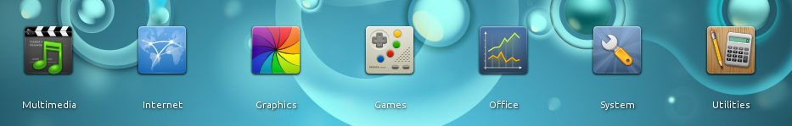
The SuperX menu, embeded in the default desktop itself

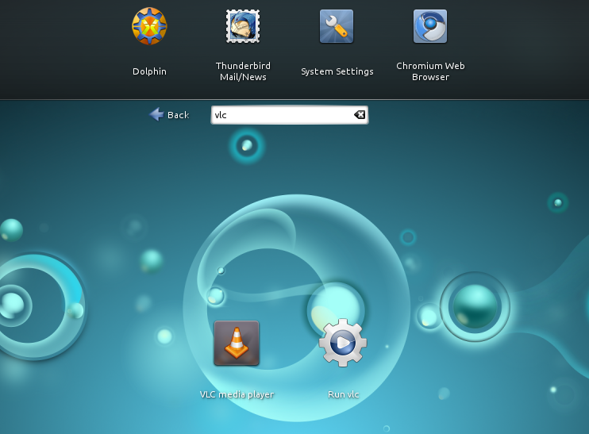
If you want to run a particular application, or a specific genre (eg "vlc" Or "media player" ), often the easiest thing to type that into the search box at the top of the menu.

The SuperX DVD is compressed and contains about 1.5 GB of data. Applications included by default are part of what we call "the default software selection".

Since one of the objectives of SuperX is to be simple to use and run directly after installation, a series of applications is included by default to allow you to perform common tasks and/or important ones.

Changing the wallpaper
One of the common things a user does after installing the operating system is change the desktop background or the wallpaper. To change the wallpaper in SuperX: Right-click → Configure Search and Launch. The following window will appear:
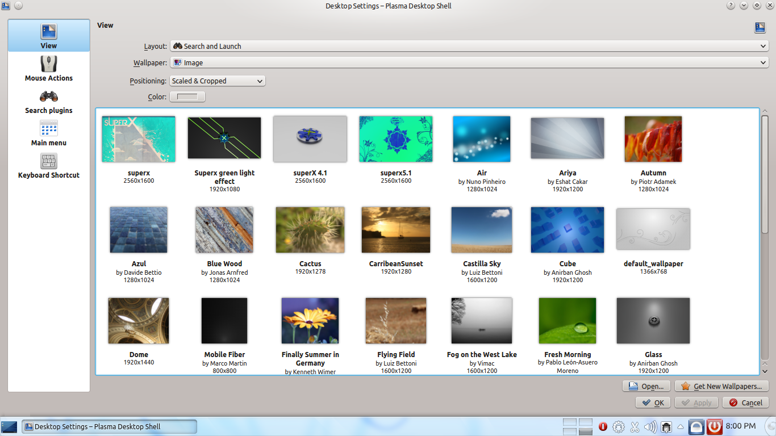
Select the wallpaper you want and click the “Apply” button and then the “OK”.

Default Software Selection(needs update)
In "Multimedia", you find (among others) the following apps:
Name | Description
CD/DVD Burner | Burning software very comprehensive, with a very attractive interface, similar to Nero.
Web Cam | Take pictures and videos from your webcam.
Sound Recorder | Record sound from standard microphone.
Music Player | An application to play your audio files. Music Player is one of the simplest and most user-friendly music players out there. You can even get the song lyrics during playback if you're connected to the Internet.
Movie Player | Audio / video free high-performance, works without codecs, compatible with all known formats.
OpenShot Video Editor | An application to edit your video files, although not for pro video editing but maybe the bast among free video editors. It has lots of features and functionality, comparable to pro editor that comes with a price-tag.
Sound Settings | Tools to configure and manipulate the sound server. Can manage the redirection of sound between different I / O, and the volume per device.
In "Internet", you find (among others) the following apps:
Name | Description
Torrent Client | Torrent client. Allows you to download from torrent sites.
SuperX Chat | SuperX Chat enables you to chat directly to other SuperX users using IRC. It is an IRC chat program for SuperX . It can be used to connect with other IRC servers abd chat rooms also. It has a cleaner interface, and some nice features.
Email | Email client by Mozilla, default in SuperX.
Chat | Instant messaging client, compatible with others: AIM, Bonjour, Google Talk, ICQ, IRC, MSN, MySpaceIM, XMPP, Yahoo! etc..
In "Graphics", you find (among others) the following apps:
Name | Description
Scan | Allows capturing photos from a scanner.
Draw | Simple vector graphics creator. Belongs to the LibreOffice office suite.
Take Screenshot | Advanced Utility Screenshot: Can be launched by pressing "Print Screen".
Image Viewer | Utility to manage photos. It has simple image manupulation features. And upload support to some websites.
In "Office", you find (among others) the following apps:
Name | Description
Presentation | Presentation, Microsoft PowerPoint equivalent and compatible with the .ppt and .pptx formats.
Spreadsheet | Spreadsheet, Microsoft Excel equivalent and compatible with .xls and .xlsx.
Word processor | Word processing, Microsoft Word equivalent and compatible with the .doc and .docx formats.

In "Games", you find (among others) the following apps:
Name | Description
Chess | Simple chess game for SuperX.
KPatience | Cards game for SuperX.
KSudoku | Sudoku for SuperX.
gbrainy | A brain teaser game for fun and to keep your brain trained.
In "System", you find (among others) the following apps:
Name | Description
System Information | Contains all information about computer components and system operation.
Additional drivers | Offers proprietary drivers for some components such as graphics cards.
Control Panel | One stop utility to configure every aspect of SuperX.
SuperX Apps Center | Install, update, remove apps in SuperX.
Package Manager | Advance package management utility for users having previous experience with Debian-based Linux systems.
Software Updater | Lets you update different components of SuperX and applications.
Password Manager | Lets you keep all your password under one master password.
Partition Manager | Partition manager of SuperX. Allows you format and partition drives.
Files & Folder | File Manager. View your files and drives. Similar to "My Computer".
Software Sources | Lets you add or remove software repositories.
System Monitor | Monitors system activities. Lets you to terminate running process and more.
System Log | Lets you to view system logs.
Terminal | Command-line interface for advance users.
Startup Disk Creator | Lets you to create bootable USB startup disks, usable for PCs with no DVD drive.
In "Utilities" you find (among others) the following apps:
Name | Description
USB Startup Disk Creator | Utility for creating bootable USB drive, enabling it to transform into mobile operating system, thanks to a persistent mode.
Terminal | Command line in SuperX. Allows you to execute Unix commands.
Notes | Utility to take quick notes.
Note Pad | SuperX Equivalent of WordPad or Gedit. Nice text editors for both general users and software developers. It has a nice UI with advance features for programmers.

Files & Folders - File Manager for SuperX
Files & Folders is the explorer / file manager in KDE 4 by default. It has many interesting features.

Interface description
The interface consists of several panels (locations, information, files, terminal). You can move the panels to your liking, or even stop the show.
A display of your files in several forms is possible:
- The view icons: displays files and folders as icons
- The details view: displays files and folders form of list with the date information, size, etc..
- The view columns can navigate folders in columns similar to the "Finder" in OS X.
Also preview mode lets you preview the file rather than a simple icon.

Navigation
Navigation can be carried out conventionally by double-clicking a folder. You can also open files by double-click. For single-click fans, go to: Control Panel → Input Devices → Mouse. You can enable single-click there.

It can also be done in "split" where the navigation area splits into two independent areas: Handy for transferring files or folders.

Hot Tip: For Files & Folders to search for files, you need to enable indexing module search, "Nepomuk And Strigi".
To do this, go to Control Panel → Desktop Search
and tick check both boxes on the main tab: "Enable Nepomuk Semantic Desktop" and "Enable Nepomuk File Indexer"....and voila! You can now search files from Files & Folders. Please let your computer run for some time, so that file indexing can be done.

Filesystem structure of SuperX

SuperX uses the conventional Unix-filesystem structure to arrange files and folder.
Everything starts from “/” or “root”. Anything else are like layers over the root directory.

The home directory is the starting directory for a SuperX user, when you log-in to the computer the directory that holds you settings and personal data is call the home directory. It is the default directory that opens up when you start Files & Folders. In a day to day use, you rarely see the root filesystem, but if you are interested in digging in more into the Linux core of SuperX here are the basics of a typical Linux filesystem:

/ - Root directory, everything starts from here.

/bin – Contains certain fundamental utilities, such as mv or cp, which are generally needed by all users.

/sbin – Contains System critical binary files. It contains core and most important part of the system, usually needed to start, maintain and recover the system.

/etc – Contains system-wide settings

/dev - Devices used in the system (yes in SuperX, every device is treated as a file)

/home - Contains home directories of users.

/mnt - Mount point for non-removable disks.

/lib – Contains system libraries, some critical files like kernel modules or device drivers.

/root – Home folder of the root user.

/tmp – Contains temporary files and folders.

/usr – Contains binaries and scripts, which are less critical. Also used to store system-wide data.

/var – Variables, files inside this directory changes very often.

/proc – Contains information regarding process running in the system.

/opt – Contains add-on software. Some software vendors prefer this over /usr.

/media – Mount point for removable devices, like USB pendrives.

/srv – Server data (data for services provided by system)

/boot – Boot loaders and similar files used to boot the system.

/sys – Contains information related to hardware.

Managing archives (RAR, ZIP etc.)
With Files & Folders, you can manage archives as well. You can simply right-click a file and compress it as RAR, ZIP and many other formats. SuperX comes with all the necessary tools to let you compress and decompress files. To decompress a file, simply right-click and select an Extraction option like “Extract Archive Here” or “Extract Archive To...”.

Software Management
Introduction to SuperX Apps Center (“SAC”)

SuperX Apps Center (“SAC”) is the package manager for SuperX. To keep things simple, it downloads the applications you select, and it will follow to the instructions included in the application's package to install your software perfectly, and all of its dependencies, in good order. There is no room for human error - if the package worked fine on the technician's computer, then it should work on yours, because the package manager has followed the same procedure. This makes SuperX very much error free.

The SuperX Apps Center. SAC allows you to install, update and remove apps in one click.

With SAC you can find applications by searching for them or by browsing the categories of applications and install them with the “Install” button on the left-side of each application. If the application is already installed, it will show “Run” if it's a program that can be “run”. It it's something that doesn't interact with the user (eg. Music codecs) it will show “Installed”.

You can update applications by going to the “Updates” tab on top of SAC. You may update all applications at once, or one by one. Similarly you have an “Uninstall” tab, where you can remove installed applications by clicking “Remove” button on the right side of each application.

LibreOffice – Creating and Editing documents
LibreOffice is a free office suite that comes with SuperX. LibreOffice is compatible with Microsoft® Office. With LibreOffice you can create, edit and format documents in ODF – Open Document Format and MS Office formats.

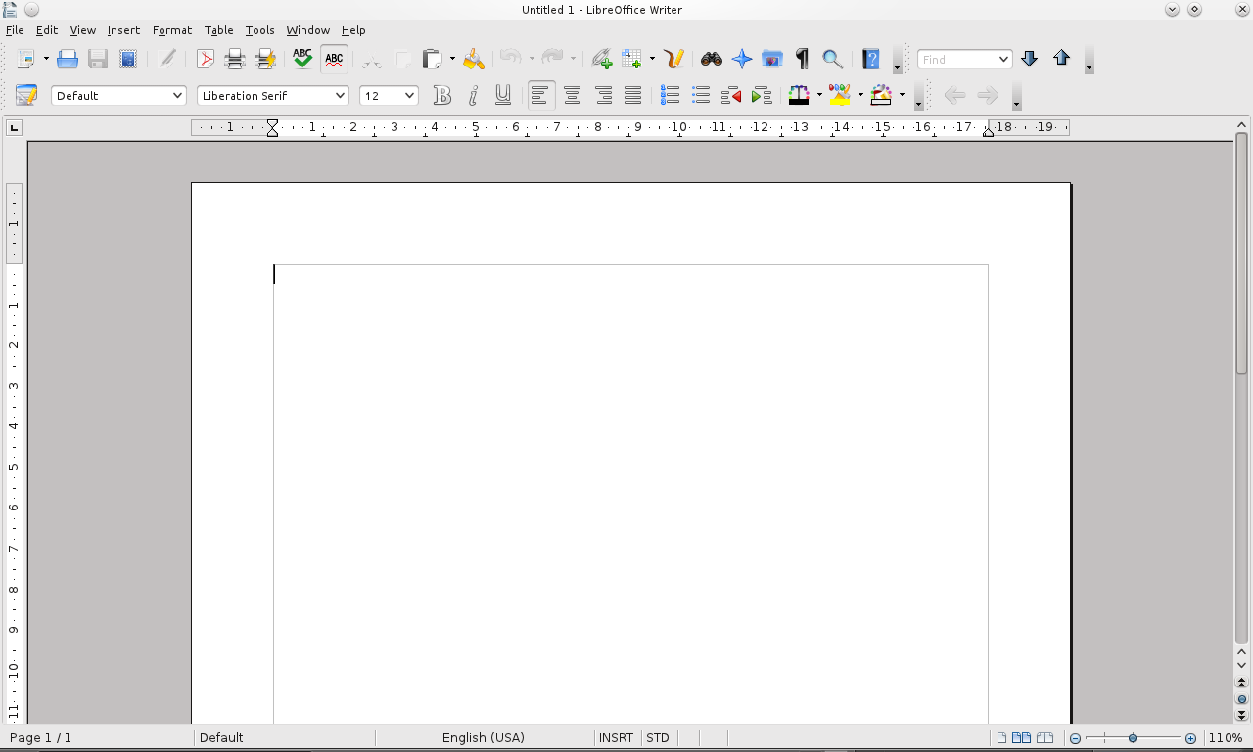
The interface of LibreOffice is like that of Microsoft® Office 2003 and all formulas and functions works the same. This guide book itself was written in LibreOffice. LibreOffice has built-in PDF export capabilities.
Please mind that although LibreOffice is compatible with Microsoft® Office, it is not the same product. So some ups and downs are there. But, for general office and day-to-day use you should not have any issue. Many governments across the world is now deploying LibreOffice to save licensing cost and bring freedom to the people.
Writing Indian or non-Latin text in LibreOffice
Install the “ibus” and “ibus-m17n” , from the SuperX Apps Center. Start Ibus from System → Ibus. Once started a small keyboard like icon will appear in the system tray. Then on the system tray Right-click → Preference → Input Method . From the droup-down menu “Select Input Method” Select the language and keyboard layout you want to use. The menu seems to be inactive but it is active. When you are on LibreOffice or any text input field, press “Alt + Space Bar” keyboard combination to turn on or off the selected language and keyboard layout.

Tips for using LibreOffice
- Use “Save As” and choose “Microsoft Word Word 97/2000/XP” format for best compatibility with Microsoft® Office. This is recommended when exchanging documents with users of Microsoft® Office. (“For example the file will show like ABC.docx”)
- Change the language to “English (USA)” or “English (UK)” to get spell check working with the English language. You can change language by the option provided at the bottom of LibreOffice.
- The “Settings” are located at Tools → Options. You can customize LibreOffice to meet your needs by altering the settings.
Other options for Office Suite includes Koffice, Abiwords and yes, Microsoft® Office. But installing and running Microsoft® Office is not as easy as other applications on SuperX, as it's a not a native solution. We will cover that later in a dedicated section.

Chromium – Browse website and more
Chromium is the web browser that comes with SuperX. A web bowser is an application that lets you to browse websites, see videos on YouTube etc.. Other examples of web browsers are: Microsoft® Internet Explorer, Mozilla Firefox, Apple® Safari etc..
Chromium showing it's default home page for SuperX
Chromium is Google Chrome, with all Google branding removed. Chrome cannot be included in SuperX, because of branding restrictions, you can still get branded Chrome from regular download method. Download the Debian file (.deb) for Ubuntu/Debian. SuperX uses the same format as Ubuntu, and is compatible with Ubuntu applications.

The Omni box
The Omni bar is a combination of the address bar and the search-box. You can directly type in a web address like “superxos.com” or you may directly search for say, “superx os”. Omni bar is a one stop solution for all your needs.
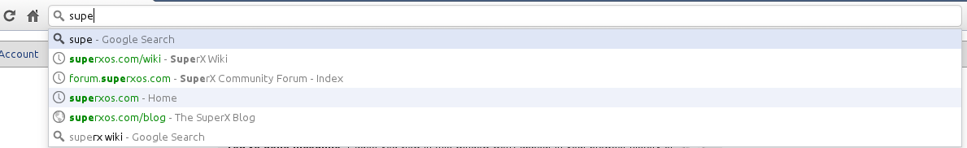
The Omni box

Apps on Chromium
Like Google Chrome, Chromium also has web applications. You can find many apps in “Web Store” available on Chromium. The apps include many games as well. SuperX sadly doesn't have much native games available due to the fact that game companies only make games for popular operating systems. But, Chromium games reduces the gap as you can play many 3D games that you find on popular operating systems like Microsoft® Windows. They may be running bit slow as they are on a web browser, but still they will satisfy any casual gamer.
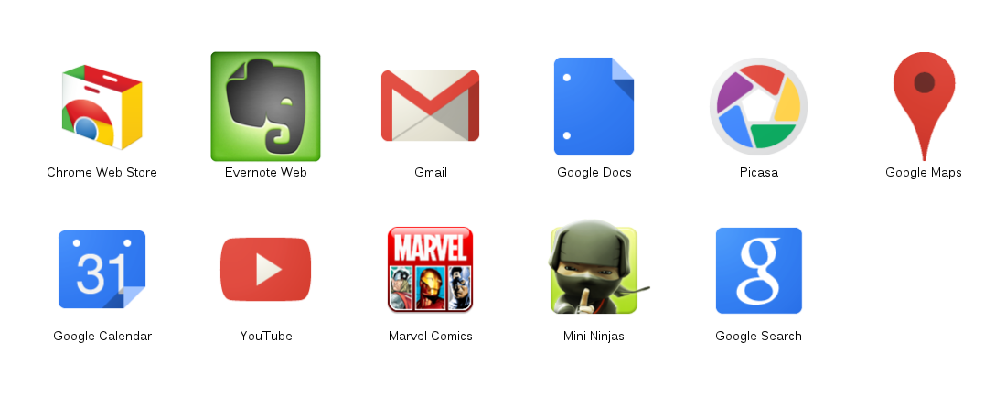
Apps in Chromium
To get apps on Chromium, open a new tab (Ctrl+T), click “>” on symbol on the right side. You will see “Chrome Web Store”. Click on it to get free and paid apps and games on Chromium.
On Chrome Web Store you will also find many extensions to increase the functionality of Chromium.
The basic thing is, if you are used to Google Chrome, Chromium is just a twin brother in terms of interface and functionality.

Thunderbird – Email, News and Calender
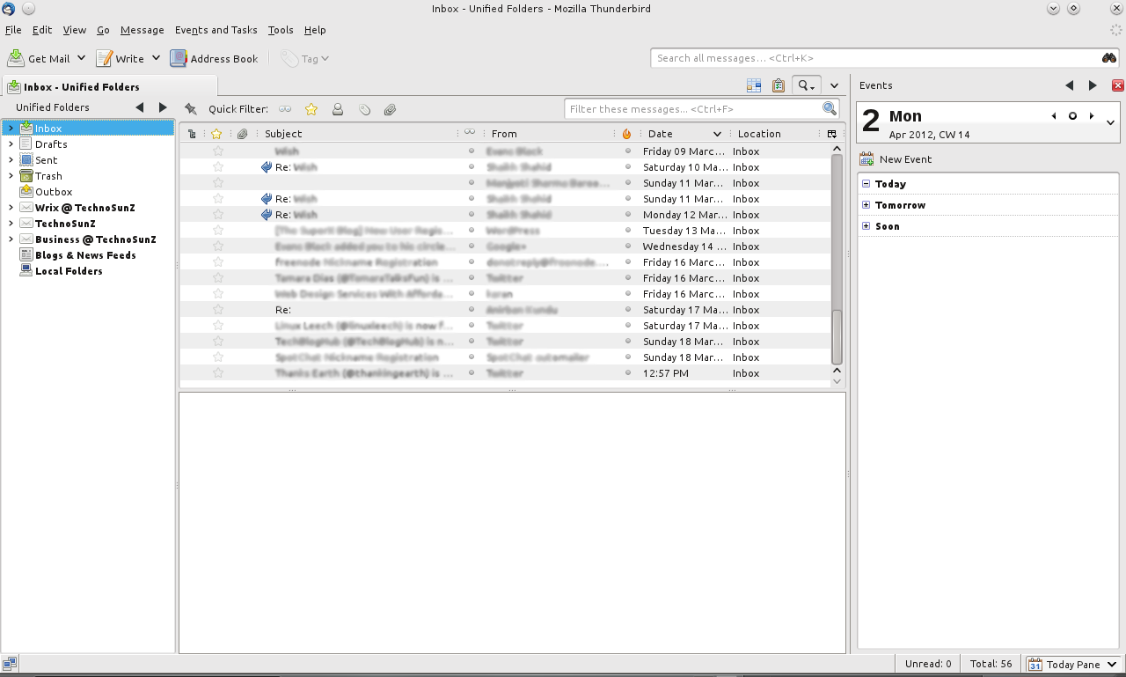
Mozilla Thunderbird – Email, News and Calender application
Thunderbird is an email client, feed reader and calender application from the Mozilla Project, the makers of Mozilla Firefox.

Email
Thunderbird is similar to Microsoft® Outlook in terms of functionality. Thunderbird allows you to access mail boxes via POP3 and IMAP protocols. You can configure Thunderbird to work with your POP3 or IMAP account with just a few clicks.
Thunderbird will prompt you to setup an email account on first run, later if you want to add more accounts go to: File → New → Mail Account.

News (Feeds)
You can setup Thunderbird as a feeds reader by going to: File → New → Other Account. Next, go to : Edit → Account Settings. A new window will appear, navigate to the bottom “Blogs and News feeds” (the name of the account) and you can manage your feed sources there.
Calender
Thunderbird can also act as a calender application. This however is not a functionality of Thunderbird itself. In SuperX, Thunderbird comes with lightning extension by default which allows you to use Thunderbird as a calendar application also.
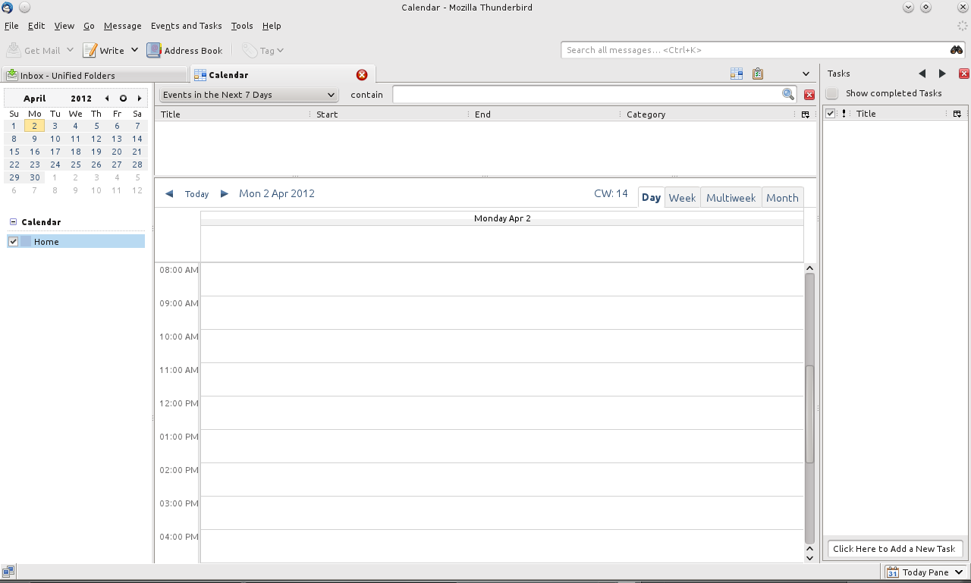
Calender in Thunderbird

When you open Thunderbird, you can see an “Events” plane on the right side of the Thunderbird window. You can create an event by clicking New Event.
You can get a full calender by going to: Events and Tasks → Calender.

Note: If you don't know what a calender application is, it's an application that lets you organize your day-to-day activities, set reminders etc..

Openshot Video Editor – Make Videos and edit them
Openshot Video Editor is the video editor of choice in SuperX. It is undoubtedly one of the best (if not the best) open source video editors out there with a rich pile of features to help you make your videos.
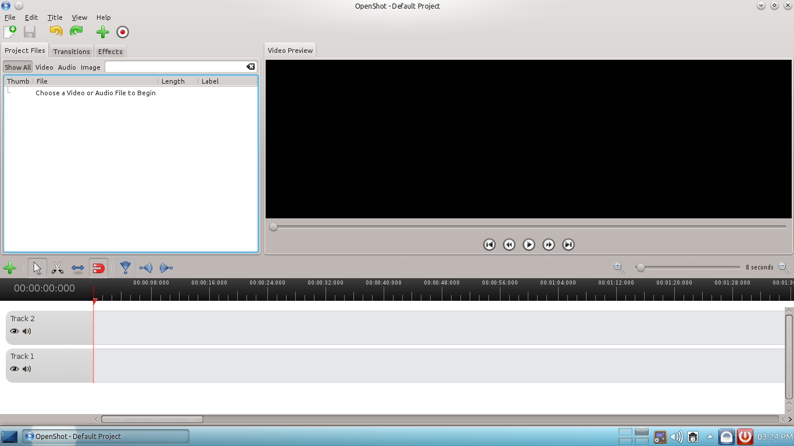
Openshot Video Editor
Openshot possesses one of the neatest interfaces ever. On the left hand side, you'll find three tabs.
- Project Files: where you add videos, images, tracks, etc. For your project and add them to the trackline below.
- Transitions: Self-explanatory. It contains some of the built-in transition effects that you can use in your video.
- Effects: Same as transitions, except that this tab contains the built-in video effects ready for use in your videos.

On the right hand side, you can see a video preview area with the basic set of player buttons. You can see a preview of your edited video in the preview area.
Directly below it, you can see the track-line, above which are a basic set of tools common to most video editors, such as Arrow, Trim, etc. You can add video tracks, audio tracks, etc. to the track-line and edit them as per your wish. You can click on the green plus (+) button above the track-line to add more tracks. You can move the red bar around with the mouse to position or edit a certain portion of your video.
Openshot is definitely one of the most powerful yet clean and simple video editors out there. It has satisfied many users and you should definitely try your hands at it.

Image Editor – Manipulate Images
For editing your photos and manipulating images, use the Image Editor (GIMP). You launch Image Editor by Graphics → Image Editor. It is the best free and open-source alternative for Adobe's Photoshop. It is a very flexible and highly used image manipulation tool.
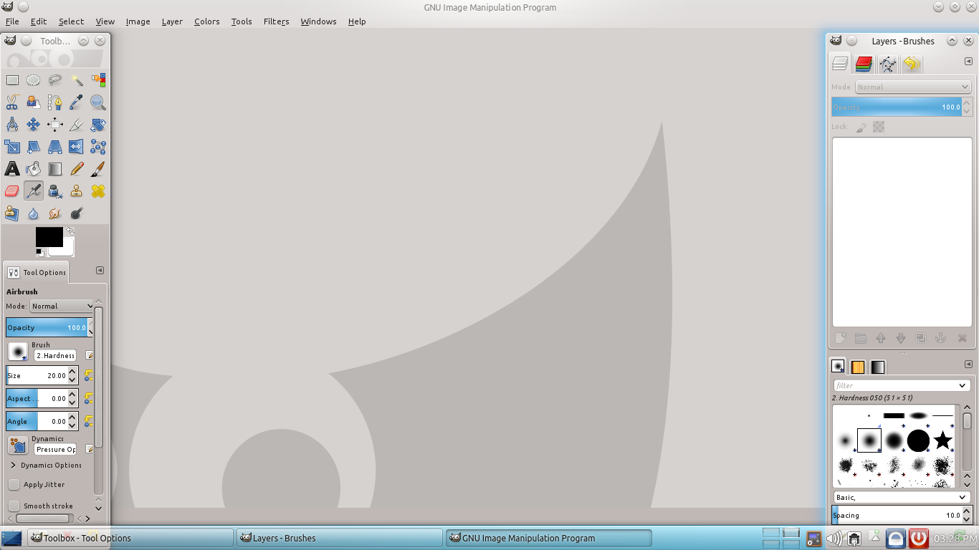
GIMP 2.8
When you open the Image Editor, you get three windows. In the screenshot above, the Grey background is where you will have your image and/or set your canvas size, etc. Think of it as your main window. On the right hand side, you can see another window with a lot of different tools and such. This is the tools window. If you'd like to have a single window then Windows → Single Window Mode. This will make the user interface similar to popular image editing programs like Adobe Photoshop. You'll find all the necessary tools and stuff here. Lastly, the window on the right shows you the various image layers and brushes. You can install additional brushes from sites like DeviantART.
Note: Check this page for GIMP related tutorials: http://www.gimp.org/tutorials/

Music Payer
If you're wondering about the program that plays your favorite songs, here it is. Music Player (Musique) is a compact player with support for most audio formats. The interface is very simple and intuitive. To launch Music Player: Multimedia → Music Player. You can find the basic player controls in the upper left corner. To the right of it you can see a bar which shows the progress of the song as it plays. The main section of the window you see in the screenshot is the music files in the library. That's the place where all the music files on your computer show up. They are categorized based on the artists.
To the right of it, you can see the playlist. You can drag items there to set up a single playlist. Also, you can click the artists in the main area to open up their albums and then the corresponding songs.
Another cool feature is the "Info" button. During playback, when you click it, it displays you information about the artist along with the song lyrics.
A small but nifty feature is the search-box in the top right corner of the window. Instead of searching manually through your files for a particular song, just type the name of the song there and Music Player will automatically display you the files it finds with the text you provided.
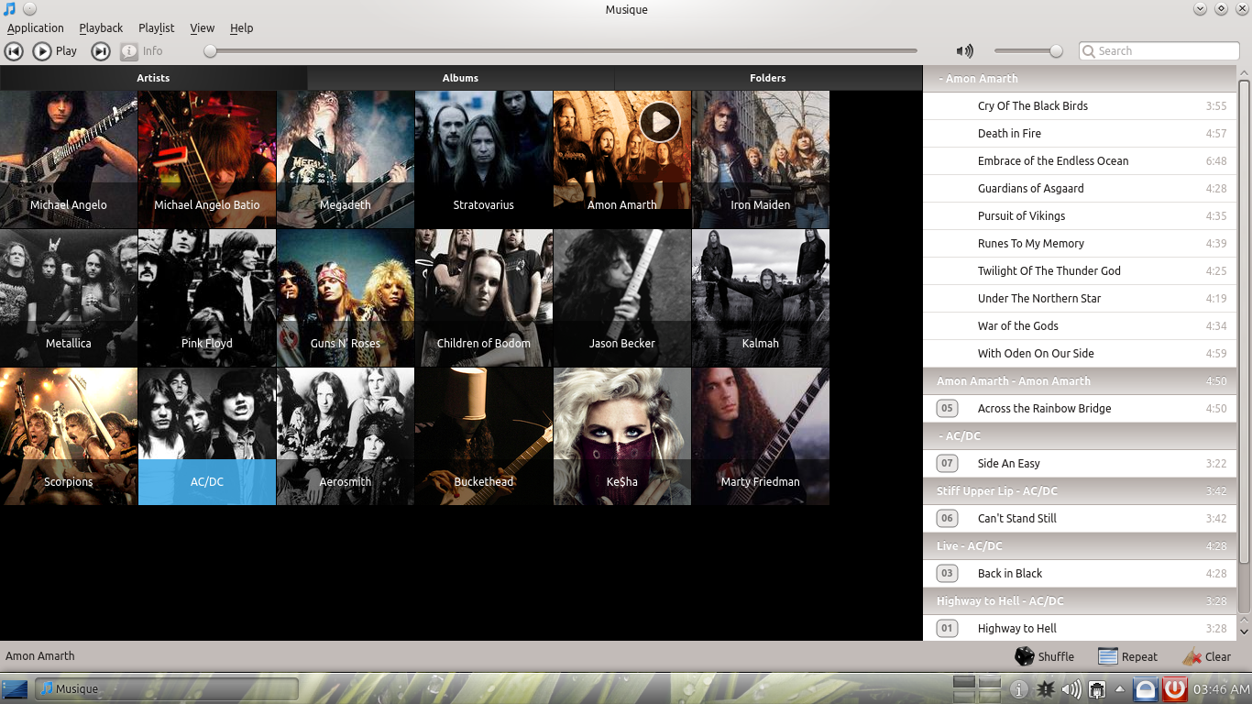
Music Player: Play your favorite songs
On your first run, Music Player will ask you for your song folder. Show it the directory. It's recommended to have all of your files in the same directory for faster indexing. It is suggested to store all your music and audio files under “Music” folder in your Home folder (/home/username). You can update later through: Application → Change Collection Folder.

Paint
If you prefer using something really simple paint application like MS-Paint, you can use Paint (KolorPaint).

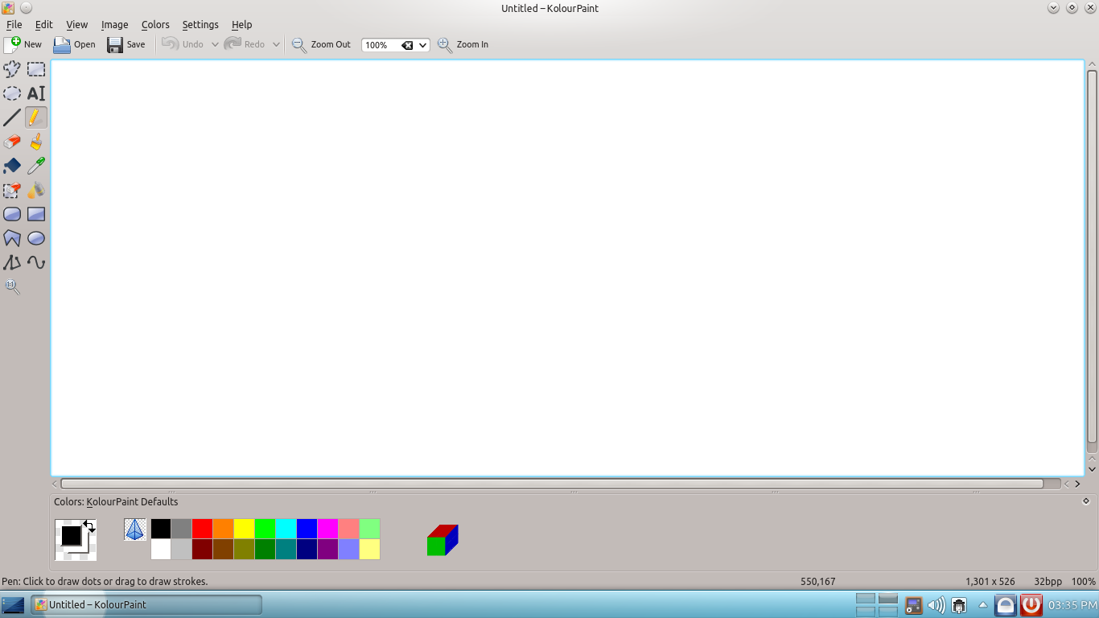
Paint – The open-source Paint application
The interface of Paint in SuperX is very similar to that of MS Paint. Everything is pretty easy and self explanatory if you've used MS Paint before. The options however are limited to just drawing simple stuff. For other image editing features, use GIMP.

Chat
Chat (Pidgin) is a free and easy to use chat client that supports a wide array of networks. It will easily take care of most of your chat needs. It supports networks like MSN, AIM, Yahoo, ICQ, IRC and much more.
You can access Pidgin in SuperX through: Internet → Chat
When you run Pidgin for the first time, it'll ask you to configure an account along with a chat network.
To configure your account in chat you can follow this thread.
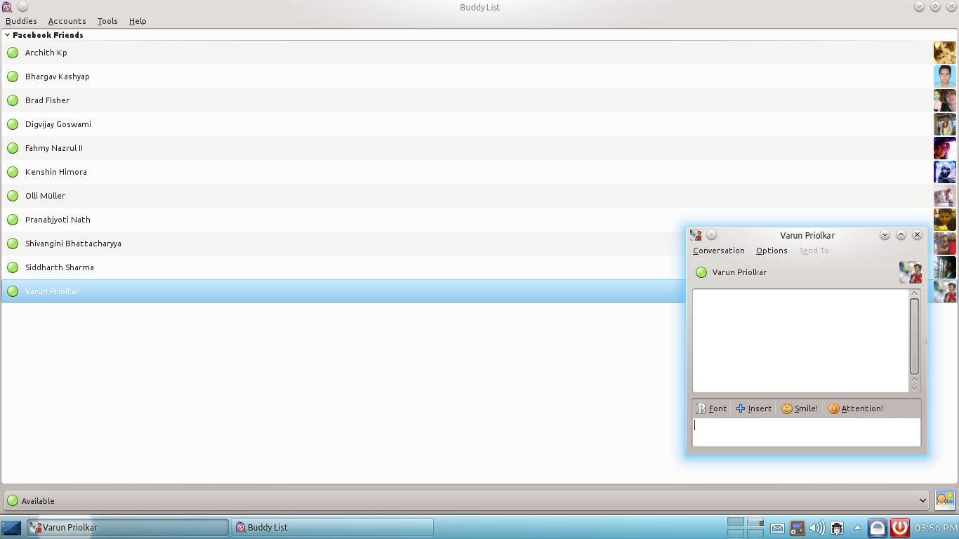
Pidgin: Connected with Facebook Chat
It'll ask you for a username and a password and you can choose from a list of chat networks. You can add more accounts later through: Accounts → Manage Accounts

SuperX Community Chat
SuperX Community Chat (Konversation) is a user-friendly IRC client that you can use to communicate through Internet Relay Chat networks.

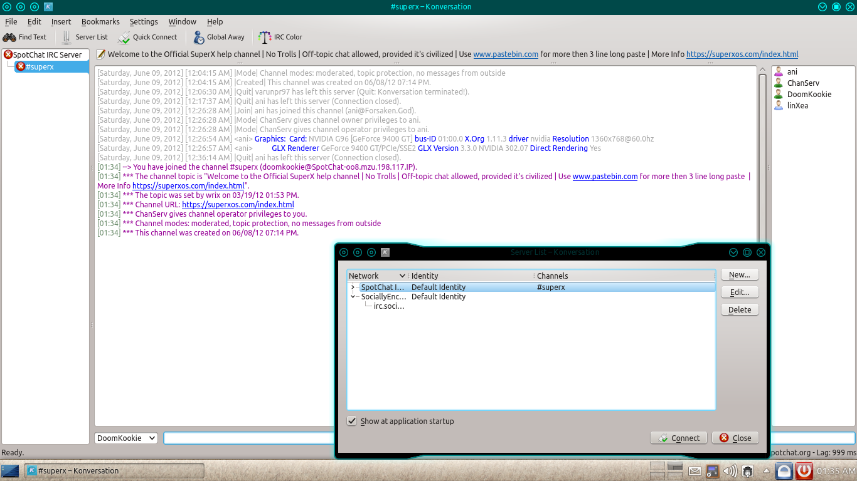
SuperX Community Chat
You can open SuperX Comminity Chat through: Internet → SuperX Community Chat
You can add more networks through: File → Server List → New

Torrent Client
If you frequently make use of torrents to download and share files, you can use Torrent Client (Transmission). It's a very lightweight, simple and easy torrent client with a very clean and intuitive user interface.
You can access Transmission through: Internet → Torrent Client
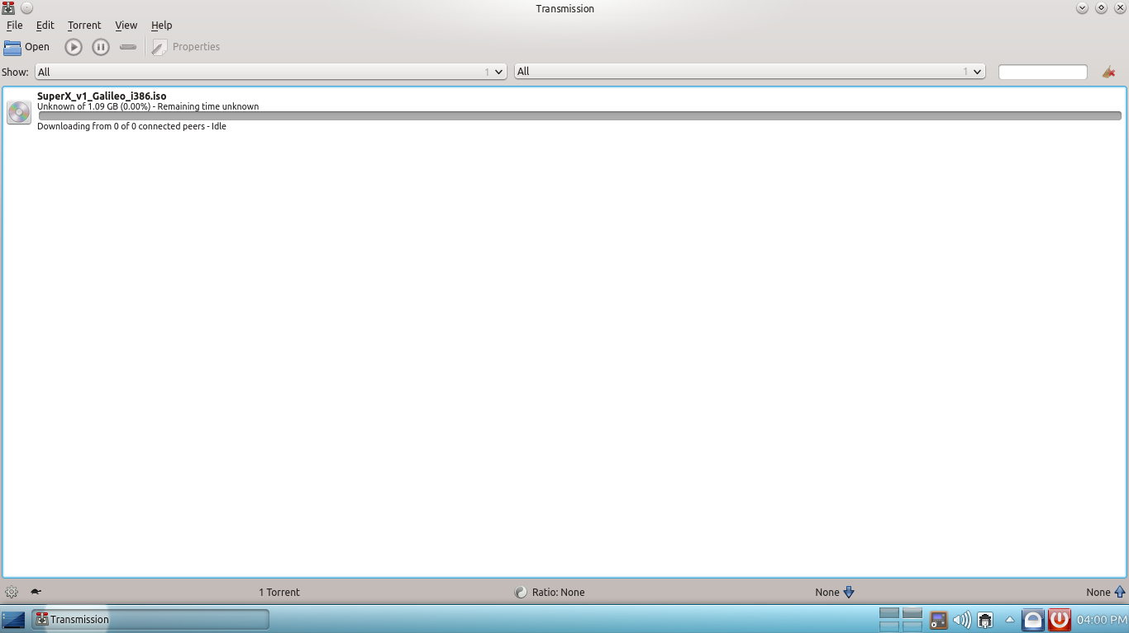
Transmission: A simple BitTorrent client
You can open new torrent files using: File → Open. The rest is similar to any other Torrent client.

Image Viewer
The Image Viewer is a simple program that allows you to view your pictures in an organized way. You might have to show it the folder where you have kept the pictures. Once done, it will show you thumbnails of the pictures in that folder. You can then choose to have a larger view of the pictures.
You can also find a set of “Next” and “Previous” buttons above the picture.
All-in-all, it's a simple yet powerful image viewer with a lot of options to check out.

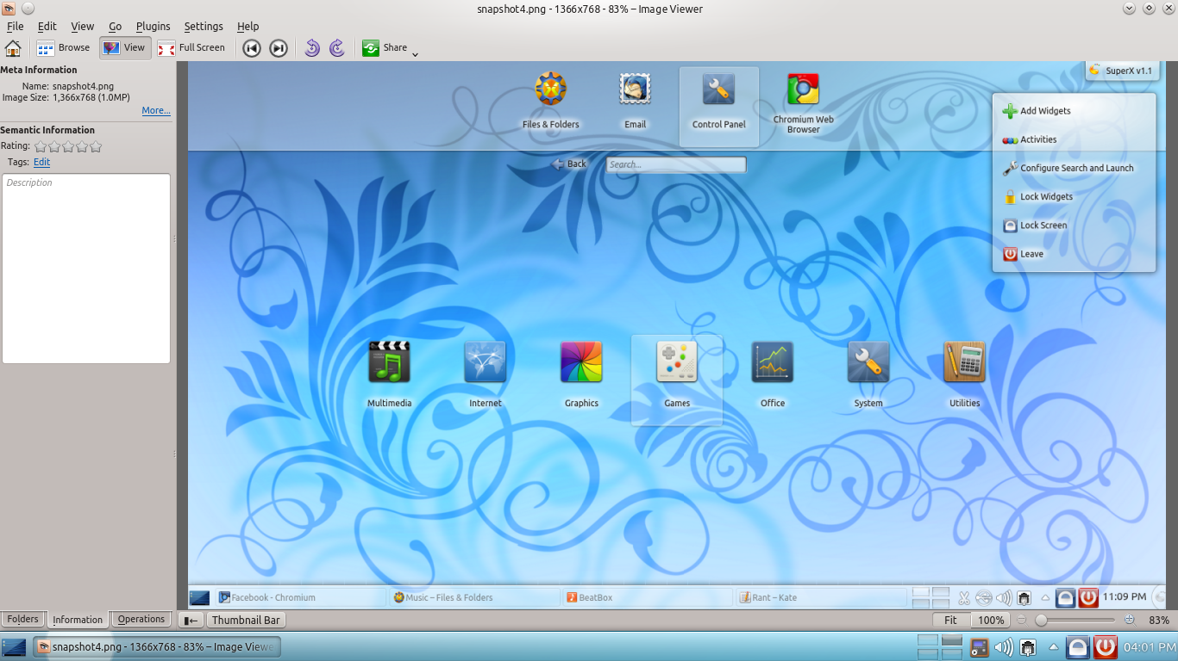
Image Viewer
You can open Image Viewer through: Graphics → Image Viewer. By default when you click on an image file, it is opened in the Image Viewer.

Software Sources

Most software in SuperX comes from different sources called “Repositories”. These repositories are maintained by a team of one or more people. These people set up the repositories such that you can install applications in SuperX without being afraid of breakage and security issues, they test the applications such that, they work the same way in all machines. You can choose what sources you want to use to download software, and add additional repositories and PPAs.
Note: PPAs are 3rd party repositories owned by some team or person having no connection with SuperX. SuperX provides some trusted PPAs by default. PPAs are not endorsed with SuperX, by any means.

Comment: Insert an Image here.

To add new repositories or PPAs goto: System → Software Sources

You can view your enabled repositories there. It is suggested no to disable official SuperX and upstream repositories (Ubuntu repositories). You can add or remove software repositories from the “Other Software” tab.

Running applications made for Microsoft® Windows
SuperX and Windows are different systems. While SuperX is based on the Linux platform, Windows is based upon Win32 API, and thus by default they are not compatible with programs made for the other. Still there exists ways which can be used to run software made for Windows on SuperX. Here we will explore them.

WINE
WINE stands for – Wine Is Not an Emulator. It is a compatibility layer that allows Windows applications to run natively on SuperX and other Linux system without any emulation, thus in theory no lag in performance. To install WINE goto SuperX Apps Center and search for “wine” from the results install both “wine” and “winetricks”. Select each one and click “Install” and enter your password when asked. Once, installed you can install applications made for Microsoft® Windows. WINE is not a full-proof replacement for Windows. WINE supports thousands of applications but still thousands are not yet supported. Some of the supported applications are:
- Adobe Photoshop 6, 7, CS2 and CS3
- Adobe Pagemaker 6 and 7
- Microsoft Office 2000, 2003 and 2007
- AutoCAD 2008
Some of the supported games are:
- Left 4 Dead (steam)
- Bioshock 1.0
- Counter-Strike Source
- Final Fantasy XI
- Battlefield 2.1
- Call of Duty 4: Modern Warfare
This is not the complete list, for a complete list visit: http://appdb.winehq.org/index.php

PlayOnLinux
PlayOnLinux is a front-end of WINE. WINE itself requires lots of tweaking to run smoothly. PlayOnLinux make WINE easier for you. It provides a easy-to-use wizard interface to install applications using WINE. Some applications require a specific version of WINE and can't be run on some other version, PlayOnLinux also manages that and selects the particular version of WINE that is required to the selected application. If you are new to Linux based systems, especially WINE than PlayOnLinux can be a real life-saver for you.
To install PlayOnLinux, simply goto SuperX Apps Center and search for “playonlinux”. You will get it the search results, click the “Install” button and provide you password when asked.

CrossOver
CrossOver is another product based on WINE. It also provides a easy-to-use GUI to install applications made for Windows under SuperX. But unlike PlayOnLinux CrossOver is a commercial product and is not a front-end of WINE. CrossOver is based on WINE and provides a proprietary version of the same, which is not freely downloadable. You need to purchase it. CrossOver provides benefits such as commercial support and other services. It comes in three flavors: Standard, Professional and Games. The first two are meant to be used no run applications and the third one is meant for Games.
If you want to know more or buy CrossOver please visit: http://www.codeweavers.com/

Hardware
SuperX itself include all the drivers needed by different devices. In most cases, you can get your device work by just plug & play. In this section we show how you can setup commonly used hardware on SuperX. There maybe some cases where you might require additional work to get your hardware work, this section also cover such cases to an extent.

Setting up Printer
To set up your printer to SuperX please plug the printer USB Cable to your systems USB Hub. Then turn the power on of printer. The system will detect your printer (if not please refer to the printer vendor's website and search for Linux driver of your printer). Now open System → Control Panel → Printer Configuration → Click on New Printer. This will open a window.
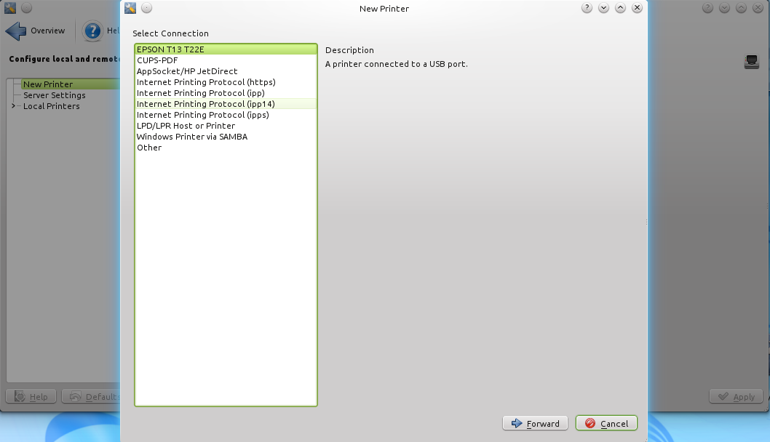
Choose your printer model from the list than click on forward. This will open another window asking to select the Printer Company, by default it is selected. Just click on forward button than this will open another window asking for printer model.

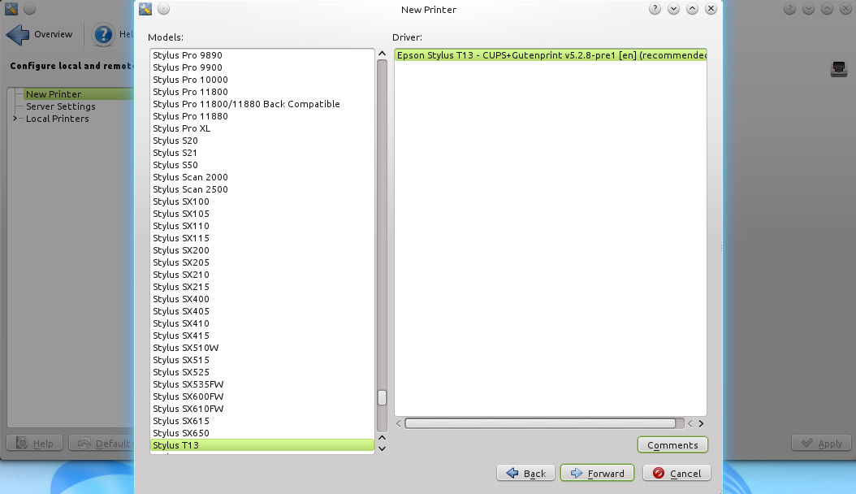
Your printer model will be selected automatically. Click on the forward button than click on ok. The configuration of your printer is completed.
Note. To be sure that you have turned on the printer and connected to PC properly.

Conclusion
We have tried to make SuperX as easy and user-friendly as possible. Everything starting from the desktop interface to the choice of applications has been done by keeping the general computer users in mind. Even an average phone user should be able to understand the SuperX user interface.
If you have any problems regarding SuperX, be sure to check out this user guide. You are also welcome to join us in our IRC Channel and join in the discussions.
Spotchat: irc://irc.spotchat.org/#superx ; port: 6667
In our quest to make SuperX a very user-friendly operating system, we might have missed or made some errors every now and then. If you find any bugs/errors/problems with SuperX, please email us at wrix@superxos.com.
We hope the SuperX experience would be a great and memorable one for you!

For advance tutorials about SuperX please check our wiki at: superxos.com/wiki

