

Department of Computer Science

COMP4200-Introduction to Graduation Project

Fall 2024/2025

Title of Project: Surplus Food Reduction Mobile Application in Ramallah

Group Members with IDs:

Rahaf Ziyadeh | 1221253
Hala Brieghieth | 1211002
Sadeel Irhimi | 1211299

Supervisor: Naimeh

Section – B

Title of Project: Surplus Food Reduction Mobile Application in Ramallah

Project No: 014

Supervisor: Naimeh

Key Areas:
- Mobile app development
- Software engineering
- Database
- Food waste reduction

Section – C

Student Signature: ___________________________ Date Submitted:

First Supervisor Name: ___________________________

First Supervisor Signature: ____________________Date Approved: ____ / ____ / _____
Abstract

Food waste has become a growing problem that affects both the environment and society. Every day, large amounts of edible food are thrown away, which leads to the unnecessary loss of natural resources such as water, energy, and land. This situation also creates additional economic and environmental pressure. Studies indicate that a large share of food produced worldwide is never actually consumed, which clearly shows how serious this issue has become.

This project aims to provide a practical solution by developing a smart system for managing and distributing surplus food. The idea is to reduce food waste while also encouraging cooperation and solidarity within the community. The proposed solution is a mobile application that brings together different groups, including restaurants, households, charitable organizations, and individuals, through a simple and easy-to-use platform.

Through the application, restaurants and individuals can share their surplus food, while charities and people in need can receive this food in an organized and fair way. The system also offers the option to receive food either for free or at a symbolic price, which helps preserve the dignity of beneficiaries and avoids any sense of discomfort.

In addition, the system includes an administrative interface that is responsible for approving users, organizing donation activities, and preventing conflicts or duplication in food distribution. By using modern technologies, this project aims to offer a sustainable and realistic solution that supports humanitarian efforts and reduces the negative environmental impact of food waste. Overall, the project is expected to contribute to better environmental sustainability, improved management of surplus food, and meaningful support for people in need through a well-structured digital platform.

Table of Contents
Chapter 1: Introduction 1
1.1 Aim and Objectives 1
1.2 Overview of the technical area 2
1.3 Overview of the report 2
Chapter 2: Background 4
2.2.1 Comparison Table 5
Chapter 3: System Analysis and Design 8
System Model and System Architecture 8
3.1 Product Description 8
3.1.1 System Objectives 8
3.1.2 System Main Features 9
3.1.3 Operating Environments 9
3.1.4 Constrains 10
3.1.5 User Requirements 11
3.1.6 System Requirements 12
3.1.6.1 Functional Requirements (FR) 12
3.1.6.1.1 User Account and Access Management 13
3.1.6.1.2 Offers and Listings (Packages / Donations / Low-Price) 13
3.1.6.1.3 Discovery and Location 13
3.1.6.1.4 Reservation, Conflict Prevention, and Pickup 14
3.1.6.1.5 Rating, Complaints, and Trust 14
3.1.6.1.6 Administration Features 14
3.1.6.1.7 Charitable Organization Features 14
3.1.6.1.8 Payment and Transactions 15
3.1.6.2 Non-Functional Requirements (NFR) 15
3.1.6.1.1 Performance and Scalability 15
3.1.6.1.2 Availability and Reliability 15
3.1.6.1.3 Security and Privacy 16
3.1.6.1.4 Usability 16
3.1.6.1.5 Maintainability and Monitoring 16
3.2 Functional Decomposition (Use Case Diagram) 16
3.2.1 Actors (actor list and description of their roles) 17
3.2.2 Use Cases (summary of the use case, full use case description in the Appendix) 18
3.2.3 Use Cases Diagram 20
3.3 System Models 22
3.3.1Class Diagram 22
3.3.2 Sequence Diagram 23
3.3.2.1 User Registration and Login 23
3.3.2.2 Donor Adds Food (Restaurant / Household) 23
3.3.2.3 Charity / Individual Requests Food 24
3.3.2.4 Food Pickup Confirmation 24
3.3.3 Activity Diagram 25
3.3.3.1 Reserve Order 25
3.3.3.2 Donation Flow 26
3.3.3.3 Confirm Pickup 26
3.3.3.4 Create Surplus Package 27
3.3.4 State Chart Diagram 27
3.4 System Architecture 28
3.4.1 Sub-System (descriptions of the sub-systems and their services) 29
1. User Mobile Application (Client Sub-System) 29
2. Restaurant Interface (Client Sub-System – Mobile / Tablet / Web) 29
3. Charitable Organization Interface (Client Sub-System – Web) 29
4. Administration and Control Sub-System (Admin Web Dashboard) 29
5. Support Services Layer (API / Server Sub-System) 29
6. Data Management and Databases 30
7. Notification Service 30
3.4.2 Software Architecture 30
1. UI Layer (Presentation Layer) 30
2. Business Logic Layer (Application Layer) 31
3. Infrastructure Layer (Data & External Services Layer) 31
4.Benefits of the Layered Architecture 32
3.6 Data Management and ERD 35
4.2 Next Semester Plan 36
Bibliograph 39
Appendices 40

List of Tables

Table 1: Comparison of Surplus Food Reduction Applications 5
Table 2: Actor List 17
Table 3: Use Case Description (Register / Login) 40
Table 4: Use Case Description (Create Surplus Package) 40
Table 5: Use Case Description (Browse / Search Offers) 41
Table 6: Use Case Description (Reserve Offer) 41
Table 7: Use Case Description (Manage Users) 42
Table 8: Use Case Description (Handle Reports & Complaints) 42
Table 9: Use Case Description (Cancel Reservation) 43
Table 10: Use Case Description (Confirm Pickup) 44

List of Figures

Figure 1: ZAD Use Case Diagrams 21
Figure 2: ZAD Class Diagrams 22
Figure 3: Sequence Diagram for User Registration & Login 23
Figure 4: Sequence Diagram for Donor Adds Food 23
Figure 5: Sequence Diagram for Charity / Individual Requests Food 24
Figure 6: Sequence Diagram for Food Pickup Confirmation 24
Figure 7: Activity Diagram for Reserve Order 25
Figure 8: Activity Diagram for Donation Flow 26
Figure 9: Activity Diagram for Confirm Pickup 26
Figure 10: Activity Diagram for Create Surplus Package 27
Figure 11: ZAD State Chart Diagram 28
Figure 12: ZAD Architecture Diagram 33
Figure 13: ZAD Deployment Diagram 34
Figure 14: ZAD ERD Diagram 35

Acknowledgements

We really want to thank our families first off, for sticking with us through all this. The project was tough but kind of fun too, and their support made it possible to keep going without too much stress.
They were patient when we needed late nights for ZAD, and that meant a lot.

Our supervisor, Dr. Naima Herbawi, deserves a huge thanks. Her guidance was spot on, and the feedback she gave helped shape everything. I think without her expertise, the direction might have gone off track a bit. She kept us on course until the end.

Then there is Dr. Ruba Awadallah, the course coordinator, who gave us some good pointers along the way. Her support during the course was helpful, and we appreciate that. The Department of Computer Science at Birzeit University also gets our thanks, especially the faculty and staff. They create an environment that is stimulating, or at least supportive enough to learn in.

Friends helped too, with their ideas and feedback that we bounced around. It contributed to ZAD's development, though some suggestions we did not use right away. Anyway, their support was there when we needed it.

Chapter 1: Introduction
Food waste is considered one of the essential issues facing modern societies, as a significant amount of good food for consumption is discarded daily, whether in restaurants or homes. This results in undesirable environmental, material, and social consequences, such as the waste of natural resources, accumulation of waste, and the failure to benefit from food despite the existence of segments suffering from poverty.

In recent years, several initiatives and electronic platforms have emerged to reduce food waste, but most of these treatments have focused on restaurants only, without involving other pillars of society such as families and non-profit organizations. The lack of coordination and unified supervision has also led to inconsistencies in procedures for donating or distributing food unfairly.

This effort aims to introduce a comprehensive digital treatment that expands the concept of reducing food waste to include restaurants, homes, charities, and individuals, through an organized and user-friendly program. The system enables the display of excess food, arrangement of receipt and distribution procedures, while providing supervisory roles for follow-up, authentication, and resolving conflicts between inquiries.

The project also focuses on the humanitarian aspect, as it provides the option of obtaining food for free or at a low price, which contributes to preserving the dignity of the needy and strengthening community solidarity. By relying on modern technologies, this work aims to support environmental stability and achieve optimal benefit from food resources.

Aim and Objectives
The objective of this project is to develop a practical application of a system to help combat the issue of food wastage by promoting the organization of excess food donations from various restaurants or homes. To this end, this system will ensure the fair allocation of this food to both individuals in need or charitable causes with respect for their dignity as recipients of the food.
Objectives:
- To reduce the problem of food waste both in restaurants and at home.
- A new mobile app that will facilitate easier donations of foodstuffs that would otherwise go to waste, rather than discarding them.
- To facilitate a clear and organized procedure so that the needy charities can be given the needed food without any confusion or duplication.
- To establish an administrative system that can assist in dealing with users, monitoring operations, and in case of any conflicts regarding the distribution of food items.
- In order to be able to receive the food either for free or at a symbolic price in order to sustain the dignity of individuals in need.
- To create a system that is flexible and easy to use, which can be changed in the future and is environmentally sustainable.

1.2 Overview of the technical area
This project belongs to the technological area of distributed client–server architecture and mobile information systems. While the use of centralized server resources for data management and processing has been common for many years, modern applications are increasingly designed to operate on intelligent devices such as smartphones and web-based platforms. These systems are particularly effective in applications that require continuous data exchange and real-time interaction between multiple entities, which is a core requirement of the ZAD system [1]. An essential technological aspect of this project is the use of location-based services (LBS). LBS enable applications to utilize the geographical location of users in order to provide location-aware functionality. Typical LBS features include proximity discovery, distance calculation, and location visualization using digital maps. Within the context of ZAD, these services are used to help users discover nearby surplus food offers provided by restaurants, charitable organizations, and individuals, thereby improving accessibility and efficiency in food redistribution [2]. The system follows a client–server architecture in which both the client and server components play distinct and complementary roles. The server side is responsible for handling the core system functionalities, including data management, offer publication, reservation processing, conflict prevention, and reservation status tracking. The client side, implemented through mobile applications and web-based dashboards, focuses on user interaction and presentation. This separation of responsibilities is particularly important in time-sensitive systems that involve reservation workflows and real-time updates, as is the case in ZAD [3].

1.3 Overview of the report
This report is organized into several chapters that present the background of the project, followed by the system analysis and design, and finally the implementation and evaluation of the ZAD system. The structure of the report is designed to present the content in a clear and logical sequence without unnecessary fragmentation. Chapter One introduces the project and presents its basic context. It explains the motivation behind developing the ZAD system and outlines the main aims and objectives of the project. In addition, this chapter provides an overview of the technical area in which the project is situated, helping to establish a foundation for the work presented in the following chapters. Chapter Two focuses on the background and supporting material related to the project. It discusses relevant theoretical concepts and reviews similar systems and related work. This chapter also introduces the technologies and tools used in the development of ZAD, providing justification for their selection and explaining their role in the system. Chapter Three covers the analysis and design phase of the project. It describes the overall system architecture and presents both the functional and non-functional requirements. To support the design discussion, several UML diagrams are included to visually represent the system structure, components, and interactions. Finally, Chapter Four concludes the report by summarizing the work completed throughout the project. It reflects on the achieved results and outlines potential future enhancements and improvements that could be explored in later development stages.

Chapter 2: Background

2.1 Details of relevant theory
Food waste is one of the most critical issues facing humanity globally in recent years. This is attributed to various effects, especially on the environment, economy, and human beings. Massive amounts of food are lost each day by restaurants and homes all over the world. This does not only result in food wastage but also the wastage of resources or materials used to produce it, for example, water, energy, or land. Food waste or loss has been defined by the Food and Agriculture Organization of the United Nations as food that is intentionally discarded or fails to be used despite it being safe for human consumption [3].
In restaurants as well as in houses, food wastage normally takes place due to poor planning, which in turn leads to poor food management. In restaurants, wastage normally takes place due to meals being prepared in bulk, but there is no sale of food. At another level, food is normally being wasted at home because of people buying more than they can consume, resulting in poor storage of food. These cases clearly portray a challenge which can be taken care of by food redistribution.
In addition, serious environmental problems arise from food waste. During landfill disposal, wasted food decomposes and generates methane gas, an extremely active greenhouse gas and one of the major contributors to climate change. Food loss and waste have been identified as responsible for a fair percentage share in global greenhouse gas emissions according to research [4], [5]. Therefore, the reduction of wasted food is another vital step toward environmental protection and supporting sustainability.

2.2 Review of past/reported work
Some authors have also carried out research on food loss/waste involving food restaurants, citing that food loss/waste happens at different food moments, including food preparation, food serving, and food left by customers. Research indicates food loss/waste can be reduced through better planning by managing food excess.
In the modern world, various digital technologies and applications, especially in relation to food, have become a vital tool in combating food waste. Applications like Too Good To Go help restaurants sell their food at a discounted price, as opposed to simply throwing them away. Studies indicate that such applications motivate consumers to buy food in excess and thus become more environmentally conscious in their consumption habits, which may help in reducing food waste in a specific marketplace [6].
Other studies have focused on determining the factors influencing the acceptance of food waste reduction platforms. The findings have indicated that simplicity, affordability, and ease of use are important factors influencing the acceptance or adoption of reduction platforms by users. However, the current platforms have mainly focused on restaurants while ignoring other kinds of organizations and administrative controls in ensuring equitable distribution and preventing conflict situations.
Based on the literature review, the project aims to expand the systems by including households, charities, individuals, and an administrative role for better management of operations and conflict resolution. This will provide a more holistic and socially responsible system for the reduction of food waste.

2.2.1 Comparison Table

Table 1: Comparison of Surplus Food Reduction Applications
Feature | ZAD (Our App) | Forsa MENA | Too Good To Go | OLIO | Flashfood | Lhaq Halak
Target Region | West bank  (Ramallah initially) | MENA (Jordan focus) | Europe, USA | Global (UK-based) | North America | Palestine (Bethlehem)
Requires Account Creation | True | True | True | True | True | True
Targets Food Waste | True | True | True | True | True | True
Supports Restaurants | True | Partial | True | Partial | True | Partial
Supports Individuals as Donors | True | False | False | True | False | True
Supports Charitable Organizations | True | False | False | False | False | True
Free Food Donations | True | False | False | True | False | True
Low-Price Offers | True | True | True | False | True | False
QR Code Pickup | True | False | True | False | False | False
Online Payment | True | True | True | False | True | False
Cash on Pickup | True | False | False | False | False | True
Location-Based Search | True | True | True | True | True | False
Rating & Feedback | True | False | True | True | False | False
Data Tracking & Reports | True | True | Partial | False | Partial | False
Mobile Application | True | True | True | True | True | True
Web Dashboard | True | True | True | False | True | False
Community-Based | True | False | False | True | False | True

2.3 Tools and Technology
A range of new tools and technologies will be employed in designing and developing the proposed application for reducing food waste, termed as “ZAD”. For developing the application, the “Flutter” platform will be adopted, as it is an open-source framework enabling developers to build mobile applications for Android and iOS platforms with a single codebase. For providing a user interface for the user as well as the restaurant, “Flutter” will be employed.
Firebase would be utilized in the handling of the registration and login processes concerning restaurants and users. The real-time database of Firebase would be used in handling the data concerning meals in surpluses and bookings. In addition, Firebase Cloud Storage would be utilized in handling images concerning restaurants, together with a notification system.
On the backend, Node.js shall be used as an environment to create application programming interfaces, commonly called APIs. The APIs shall include managing excess meals, reservations, as well as various operations concerning the restaurant. Additionally, data shall be stored using a relational database, i.e., MySQL, for secure data management, including users, data concerning restaurants, meals, as well as reservation data.
For features that require locations, Google Maps API will be used for detecting locations, displaying nearby food, and finding distance between users and food, which is an essential task when organizing food pickups. Other tools, such as Canva, will be employed for designing purposes, including designing an application logo, designing prototypes, and designing presentation slides. GitHub will be used for version control, including managing source code, for GitHub collaboration.
Lastly, the use of smartphones/laptops will be employed, alongside cloud hosting, to enable development and testing, thus supporting the real-time functionality of the system.

Chapter 3: System Analysis and Design

System Model and System Architecture

3.1 Product Description
The proposed system is a mobile-based application designed to reduce food waste by facilitating the sharing and redistribution of surplus food among different stakeholders. The system connects restaurants, individuals, and charitable organizations with people in need, in order to minimize food loss and promote efficient utilization of available resources.

Restaurants, individuals, and charitable organizations can publish surplus food items through the system instead of discarding them. These items may be offered either free of charge or at a symbolic price while preserving the dignity of beneficiaries. Individuals may participate as donors or beneficiaries, and charitable organizations can act as both receivers and providers of surplus food. Users can browse available food packages based on their geographical location, reserve items, and collect them within a specified time window.

The system supports four main actors: users, restaurants, charitable organizations, and administrators, each with a dedicated interface. Administrators are responsible for monitoring system activities, managing operations, and resolving potential conflicts. The system follows a client–server architecture, where the mobile application acts as the client and the backend server handles data management and system logic. In addition, a web-based dashboard is provided for restaurants, charitable organizations, and administrators to facilitate convenient management of listings, requests, and operational tasks using desktop or laptop devices. Both the mobile application and the web dashboard communicate with the same backend services through secure APIs. A conflict management mechanism is implemented to ensure fair and organized food distribution.

3.1.1 System Objectives
The main objectives of the proposed system are as follows:
- To reduce food waste by enabling the sharing and redistribution of surplus food among different stakeholders.
- To provide a unified digital platform that connects restaurants, individuals, and charitable organizations with people in need.
- To facilitate organized donation, reservation, and collection of surplus food through mobile and web-based interfaces.
- To support both free and symbolic-price food distribution while preserving the dignity of beneficiaries.
- To allow charitable organizations to act as both receivers and providers of surplus food.
- To ensure fair and efficient allocation of food resources through conflict management mechanisms.
- To provide administrators with tools to monitor system activities and manage operations effectively.
- To enhance accessibility to surplus food by utilizing location-based services.

3.1.2 System Main Features

3.1.3 Operating Environments
The system operates within both a mobile environment and a web-based environment in order to support different types of users. End users interact with the system through a mobile application, while restaurants, charitable organizations, and administrators access the system through a web-based dashboard. This multi-platform design ensures ease of access and continuous system availability with high reliability.
The mobile environment allows users to access the system using modern smartphones. The mobile application utilizes location-based services (GPS) to display nearby food providers and available surplus food packages, enabling users to locate and reserve food efficiently.
The web-based platform allows administrators, restaurants, and charitable organizations to log in using standard web browsers. This interface provides a convenient way to manage food listings, reservations, users, and system operations through desktop or laptop devices.
In addition, the system requires a stable internet connection to operate properly, as all system activities depend on data exchange between the clients and the backend server. The backend server is responsible for handling data storage, processing requests, and managing system logic.

3.1.4 Constrains

The proposed system is subject to several constraints that may affect its operation and overall performance. These constraints are mainly related to technical limitations, user behavior, and operational conditions.

- Internet Connectivity:
The system depends on a stable internet connection for both the mobile application and the web-based dashboard. Limited or unstable connectivity may affect system availability and delay data synchronization between clients and the backend server.

- GPS Accuracy:
Location-based services rely on GPS functionality, which may sometimes provide inaccurate location data due to environmental conditions or device limitations. This may affect the accuracy of nearby food listings.

- Limited Pickup Time Window:
Surplus food items must be collected within predefined time windows. Failure to collect food on time may result in automatic cancellation of reservations and potential food loss.

- User Commitment and Reliability:
The effectiveness of the system depends on the commitment of users, donors, and organizations to follow reservation rules and pickup schedules. No-show behavior may reduce system efficiency.

- System Scalability:
As the number of restaurants, individuals, and charitable organizations increases, the system may face challenges related to performance, response time, and resource management.

- Data Security and Privacy:
The system must ensure secure handling of sensitive data related to users and organizations. Security requirements may impose constraints on data accessibility and system functionality.

- Conflict Management Complexity:
Managing conflicts such as multiple requests for the same food package may introduce additional processing complexity and require careful system control mechanisms.

3.1.5 User Requirements
User requirements define the main functionalities that the system must provide in order to support users, restaurants, charitable organizations, and administrators in performing their tasks.
1. Account Registration
UR-01 Create Account
The system shall allow individuals, restaurants, and charitable organizations to create user accounts using valid registration information.

2. User Authentication
UR-02 Login User
The system shall allow registered users to log in using their account credentials.

3. Role-Based Access
UR-03 Assign User Role
The system shall assign a role to each registered account (individual user, restaurant, charitable organization, or administrator).

4. Browse Surplus Food
UR-04 Browse Food Offers
The system shall allow users to browse available surplus food offers based on their geographical location.

5. View Food Information
UR-05 View Offer Details
The system shall allow users to view detailed information about available food offers.

6. Restaurant Food Packages
UR-06 Publish Food Package
The system shall allow restaurants to publish surplus food packages. Restaurants may select between a mystery package, where the exact food content remains unspecified, or a regular package, where the food items are explicitly described.
7. Food Reservation
UR-07 Reserve Food Offer
The system shall allow users to reserve available surplus food offers before the defined cutoff time.

8. Reservation Cancellation
UR-08 Cancel Reservation
The system shall allow users to cancel existing reservations before the pickup deadline.

9. Food Donation
UR-09 Publish Food Donation
The system shall allow individuals and charitable organizations to publish surplus food donations.

10. Food Collection
UR-10 Collect Reserved Food
The system shall allow beneficiaries to collect reserved food during the specified pickup time window.

11. Charity Redistribution
UR-11 Redistribute Food Donations
The system shall allow charitable organizations to redistribute received surplus food to beneficiaries.

12. Web Dashboard
UR-12 Access Web Dashboard
The system shall allow restaurants, charitable organizations, and administrators to access a web-based dashboard.

13. Reservation Conflict Prevention
UR-13 Prevent Reservation Conflict
The system shall prevent multiple users from reserving the same food offer simultaneously.

14. Administrative Management
UR-14 Manage System Users
The system shall allow administrators to manage users, restaurants, and charitable organization accounts.

15. System Monitoring
UR-15 Monitor System Activity
The system shall allow administrators to monitor reservations and system activities.

16. Notifications
UR-16 Send Notifications
The system shall notify users about reservation status updates and pickup reminders.
17. Donor Verification
UR-17 Verify Donor Identity
The system shall require users who publish food offers or donations to submit identity verification documents for administrator approval.

3.1.6 System Requirements
This section presents the system requirements of ZAD, defining both the functional and non-functional requirements needed to ensure proper system operation. The requirements describe the expected behavior of the system as well as the quality constraints that guide its performance, security, and usability.

3.1.6.1 Functional Requirements (FR)
The functional requirements define the core functionalities that ZAD must provide in order to support surplus food sharing among restaurants, charitable organizations, individuals, and administrators. These requirements describe what the system shall do and are written in a clear, testable form.

User Account and Access Management
- FR-01 Register Account
ZAD shall allow a new user (restaurant, individual, charity, or administrator) to register an account by submitting the following information:
- name
- phone number
- email address
- password
- user role
- address or location
The system shall validate the provided data and store the user information in the user database.

- FR-02 Authenticate User
ZAD shall authenticate a registered user during login by verifying the submitted email and password against the stored credentials in the user database.
If the credentials are valid, the system shall grant access to the user dashboard according to the user role.

- FR-03 Logout User
ZAD shall terminate the active user session when the user selects the logout option and redirect the user to the login interface.

- FR-04 Update Profile
ZAD shall allow authenticated users to update their profile information, including:
- name
- phone number
- profile image
- address
- additional role-related information.
The system shall update the modified data in the user database.

- FR-05 Enforce Role-Based Access
ZAD shall restrict access to system features based on the authenticated user's role by verifying the user role attribute before allowing access to role-specific operations.

Offers and Listings (Packages / Donations / Low-Price)
- FR-06 Create Restaurant Package
ZAD shall allow restaurants to create a surplus food package by entering the following data:
- food title
- food description
- quantity available
- package price
- pickup time window
- pickup location coordinates
- expiration time
The system shall store the package information in the food offer database and mark its status as Available.

- FR-07 Edit Restaurant Package
ZAD shall allow restaurants to modify previously published packages by updating fields such as description, quantity, price, pickup time window, or expiration time.
The system shall update the modified data in the food offer database.

- FR-08 Delete Restaurant Package
ZAD shall allow restaurants to remove their published packages from the system by selecting the package ID.
The system shall update the offer status to Removed.

- FR-09 Submit Charity Donation
ZAD shall allow individuals or restaurants to submit a food donation request to a charitable organization by providing:
- food description
- quantity
- pickup location
- preferred pickup time
The system shall store the donation request in the donation database with the status Pending Review.

- FR-10 Create Individual Donation
ZAD shall allow individuals to publish a free food donation by entering:
- food description
- quantity
- pickup location
- pickup time window
The system shall store the donation as a Free Offer in the food offer database.

- FR-11 Create Low-Price Offer
ZAD shall allow individuals to publish a low-price food offer by providing:
- food description
- quantity
- price
- pickup time window
- pickup location.
The system shall store the offer in the food offer database.

- FR-12 View Offer Details
ZAD shall display detailed information for a selected food offer including:
- provider type
- food description
- quantity
- price or free status
- pickup time window
- pickup location.

Discovery and Location
- FR-13 Retrieve User Location
ZAD shall obtain the user’s current geographic coordinates from the mobile device GPS through the location service API.

- FR-14 Search Offers by Distance
ZAD shall retrieve food offers located within a user-selected distance range by comparing the user's coordinates with the stored offer location coordinates.

- FR-15 Filter Offers
ZAD shall filter food offers based on selected criteria including:
- free offers
- low-price offers
- provider type
- distance range.

- FR-16 Sort Offers
ZAD shall sort food offers according to selected sorting criteria such as nearest location or latest availability.

Reservation, Conflict Prevention, and Pickup
- FR-17 Reserve Offer
ZAD shall create a reservation record when a user selects an available offer.
The reservation record shall contain:
- reservation ID
- user ID
- offer ID
- reservation timestamp
- reservation status.

- FR-18 Cancel Reservation
ZAD shall cancel an existing reservation when the user requests cancellation before pickup confirmation.
The system shall update the reservation status to Cancelled.

- FR-19 Prevent Double Reservation
ZAD shall verify the offer status before creating a reservation and prevent reservation creation if the offer status is Reserved or Collected.

- FR-20 Generate QR Code
ZAD shall generate a unique QR code after a reservation is confirmed.
The QR code shall encode:
- reservation ID
- offer ID
- user ID.

- FR-21 Verify Pickup
ZAD shall verify food pickup when the food provider scans the reservation QR code.
The system shall update the reservation status to Collected.

- FR-22 Update Offer Status
ZAD shall update the food offer lifecycle status as follows:
Available → Reserved → Collected → Expired or Cancelled.

Rating, Complaints, and Trust
- FR-23 Submit Rating
ZAD shall allow users to submit a numerical rating after a completed pickup.
The rating value shall be stored in the rating database.

- FR-24 Submit Feedback
ZAD shall allow users to submit textual feedback describing their experience with a completed food offer.

- FR-25 Report Complaint
ZAD shall allow users to submit a complaint by providing:
- complaint description
- related offer ID
- related user ID.
The system shall store the complaint in the complaint database.

Administration Features
- FR-26 View User Accounts
ZAD shall allow administrators to retrieve and display registered user accounts from the user database.

- FR-27 Manage User Accounts
ZAD shall allow administrators to update the account status of users to active, suspended, or restricted.

- FR-28 Resolve Conflicts
ZAD shall allow administrators to review complaints and reservation records in order to resolve disputes.

- FR-29 Generate System Reports
ZAD shall generate administrative reports including:
- number of food offers
- number of reservations
- number of complaints.

Charitable Organization Features

FR-30 Review Donations
ZAD shall allow charitable organizations to retrieve and review submitted donation requests.

FR-31 Accept Donation
ZAD shall update the donation request status to Accepted when a charitable organization approves a donation.

FR-32 Reject Donation
ZAD shall update the donation request status to Rejected when a charitable organization declines a donation.

FR-33 Confirm Donation Receipt
ZAD shall update the donation status to Received after the charitable organization confirms the pickup.

FR-34 Schedule Pickup
ZAD shall allow charitable organizations to define a pickup time for an accepted donation.

FR-35 View Donation History
ZAD shall retrieve previous donation records for charitable organizations from the donation database.

FR-36 Publish Surplus Food
ZAD shall allow charitable organizations to create new food offers from remaining surplus food.

Payment and Transactions

FR-37 Select Payment Method
ZAD shall allow users to choose a payment method (online payment or cash on pickup) during reservation of a low-price food offer.
- FR-38 Process Online Payment
ZAD shall send the following payment information to the payment gateway:
- user ID
- offer ID
- payment amount
- payment method.
The system shall record the returned payment confirmation status.

- FR-39 Confirm Cash Payment
ZAD shall record a cash payment confirmation when the food provider confirms that payment was received during pickup.

Donor Identity Verification
- FR-40 Submit Identity Verification
ZAD shall require users who intend to publish food offers or donations to submit identity verification information, including:
- a valid government-issued ID
- a personal photo for identity confirmation
- contact phone number
The system shall store the submitted verification data securely and mark the user status as Pending Verification until reviewed by the administrator.

- FR-41 Verify Donor Identity
ZAD shall allow administrators to review the submitted identity verification documents and update the user verification status to one of the following:
- Verified
- Rejected
- Pending additional information.
Only verified users shall be allowed to publish food offers or donations in the system.

- FR-42 Restrict Unverified Users
ZAD shall prevent users whose verification status is Unverified or Rejected from publishing food offers or donations.

3.1.6.2 Non-Functional Requirements (Revised)
The non-functional requirements define the quality attributes, operational constraints, and performance characteristics of the ZAD system. These requirements describe how efficiently, securely, and reliably the system shall operate while supporting surplus food sharing among users.

3.1.6.2.1 Performance and Scalability
NFR-01 Response Time
ZAD shall return search and browsing results within 3 seconds for at least 95% of requests when the system operates under normal load conditions.
NFR-02 Concurrent Users
ZAD shall support at least 500 simultaneously active users performing browsing, reservation, and authentication operations without system failure.
NFR-03 Scalability
ZAD shall maintain acceptable response performance when the system database contains up to 10,000 active food offers and reservations.

3.1.6.2.2 Availability and Reliability
NFR-04 System Availability
ZAD shall maintain 99.9% system uptime per month, excluding scheduled maintenance periods.
NFR-05 Data Consistency
ZAD shall ensure that reservation records and food offer statuses remain consistent during simultaneous reservation requests.
NFR-06 Fault Recovery
ZAD shall automatically recover from unexpected application failures without losing stored reservation data or offer records.

3.1.6.2.3 Security and Privacy
NFR-07 Secure Communication
ZAD shall protect all data exchanged between the mobile application and backend services using HTTPS with TLS encryption.
NFR-08 Password Security
ZAD shall store user passwords using secure hashing mechanisms with salted encryption algorithms.
NFR-09 Access Authorization
ZAD shall restrict access to system functionalities according to user roles (administrator, restaurant, individual user, or charitable organization).
NFR-10 Location Privacy
ZAD shall protect user location information by limiting access to authorized system services and avoiding public exposure of precise geographic coordinates.

3.1.6.2.4 Usability
NFR-11 Task Efficiency
ZAD shall allow a first-time user to complete a food reservation process within three minutes using the mobile interface.
NFR-12 Interface Readability
ZAD shall provide a user interface with clear text labels, readable fonts, and responsive layout compatible with common smartphone screen sizes.

3.1.6.2.5 Maintainability and Monitoring
NFR-13 System Logging
ZAD shall record system activity logs for critical operations including:
login attempts
reservation creation
reservation cancellation
pickup verification
administrative actions
These logs shall be stored to support monitoring, debugging, and system maintenance.
.

3.2 Functional Decomposition (Use Case Diagram)
This section presents the functional decomposition of the ZAD system using a use case model. The use case model illustrates the primary functional services of the system and describes how the system interacts with external actors. The roles of each actor, including Admin, Restaurant, Individual Users, and Charitable Organizations, are clearly defined through the use case representation.
This section includes the general use case diagram along with an overview of the main system functionalities. Detailed descriptions of individual use cases are provided in the Appendices.

3.2.1 Actors (actor list and description of their roles)
Table 2: Actor List
Primary Actor | Use Cases | Purpose
Individual User (Donor / Beneficiary) | Register / Login | Allow individuals to participate in the system either as donors who publish surplus food or as beneficiaries who browse, reserve, and collect available food offers.
 | Manage Profile
 | Browse Food Offers
 | Search & Filter Offers
 | View Offer Details
 | Reserve Food
 | Cancel Reservation
 | Receive QR / Pickup Code
 | View Reservation Status
 | Navigate to Provider (Map)
 | Rate Provider
 | Submit Report / Complaint
 | Publish Free Donation
 | Publish Low-Price Offer
 | Donate to a Charitable Organization
 | Select Payment Method (Online / Cash)
Restaurant | Register / Login | Enable restaurants to publish surplus food in the form of mystery packages, manage reservations, and verify customer pickups.
 | Manage Profile
 | Create Surplus Package
 | Edit / Close Package
 | View Reservations
 | Confirm Pickup (Scan QR / Code)
 | Update Package Status
 | Donate to a Charitable Organization
Charitable Organization | Register / Login | Enable charitable organizations to register through a structured application form, receive and manage donations submitted by individuals and restaurants, confirm receipt of donations, and publish remaining surplus for redistribution when available.
 | Manage Profile
 | Create Donation Request Form (Charity Intake Form)
 | Receive Donation Submissions
 | Review / Accept / Reject Donations
 | Schedule Pickup
 | Confirm Donation Receipt
 | Publish Remaining Surplus for Redistribution
 | View Donation History / Reports
Admin | Manage Charitable Organizations | Maintain system integrity by managing users and organizations, moderating content, resolving conflicts, and monitoring overall system performance.
 | Manage Users
 | Manage Restaurants
 | Remove / Edit Offers
 | Monitor Offers &Reservations
 | Handle Reports & Complaints
 | Resolve Conflicts
 | View Statistics & Reports
Payment Gateway | Process Payment (Visa) | Handle secure online transactions for low-price food offers and return payment results to the system.
 | Return Payment Status / Confirmation

3.2.2 Use Cases (summary of the use case, full use case description in the Appendix)
This section provides a high-level summary of the main use cases of the ZAD system and describes how different actors interact with the system. It outlines the various ways in which individual users, restaurants, charitable organizations, and administrators use the system to perform their tasks and achieve their goals.
- UC-01 Register / Login: allows individuals, restaurants, charitable organizations, and administrators to create accounts and log in securely to access ZAD services.
- UC-02 Manage Profile: allows actors to update and manage their profile information and role-related details.
- UC-03 Browse Food Offers (Location-Based): allows individuals to view available food offers and packages based on their current location.
- UC-04 Search, Filter, and Sort Offers: allows individuals to search and filter offers by criteria such as distance, pickup time, provider type, and price range.
- UC-05 View Offer Details: allows individuals to view complete information about a selected offer, including provider type, quantity, price/free status, pickup window, and location.
- UC-06 Create Restaurant Package (Mystery Package): allows restaurants to create and publish surplus food packages with predefined size/price while keeping exact contents unspecified.
- UC-07 Manage Restaurant Packages: allows restaurants to edit, close, or remove published packages and manage their availability.
- UC-08 Publish Free Donation (Individual): allows individuals to publish free food donations for beneficiaries.
- UC-09 Publish Low-Price Offer (Individual): allows individuals to publish food offers at a low or symbolic price.
- UC-10 Submit Donation to Charity: allows individuals and restaurants to submit food donations to a selected charitable organization through the system.
- UC-11 Manage Charity Donation Intake Form: allows charitable organizations to create and manage a structured donation request/intake form.
- UC-12 Review Donations (Accept/Reject): allows charitable organizations to review submitted donations and accept or reject them based on their capacity and criteria.
- UC-13 Schedule Donation Pickup: allows donors and charitable organizations to schedule pickup times for accepted donations.
- UC-14 Confirm Donation Receipt: allows charitable organizations to confirm receipt of accepted donations for record-keeping and traceability.
- UC-15 Publish Remaining Surplus (Charity): allows charitable organizations to publish remaining surplus food for redistribution when available.
- UC-16 Reserve Offer: allows individuals to reserve an available offer within a defined time window and proceed with the selected payment method when applicable.
- UC-17 Cancel Reservation: allows individuals to cancel an existing reservation before pickup confirmation or deadline.
- UC-18 Generate and Receive QR / Pickup Code: allows the system to generate a QR/pickup code after confirmation and allow individuals to receive it for pickup.
- UC-19 Confirm Pickup (Scan/Verify QR): allows food providers (restaurants, charities, or individuals) to confirm that pickup has occurred by scanning or verifying the QR/pickup code.
- UC-20 Provide Rating and Feedback: allows individuals to submit ratings and optional feedback after successful pickup confirmation.
- UC-21 Submit Complaint / Report: allows individuals to report issues related to offers, providers, or reservation/pickup processes.
- UC-22 Administration and Monitoring: allows administrators to manage users/restaurants/charities, moderate content (remove/edit offers), resolve conflicts, handle complaints, and view statistics and reports.
- UC-23 Select Payment Method (Online / Cash): allows users to choose a payment method for low-price food offers during the reservation process.
- UC-24 Process Online Payment: allows the system to process online payments through an integrated payment gateway and receive payment confirmation.
- UC-25 Cash on Pickup: allows users to complete payment in cash at the time of pickup when the cash option is selected.

3.2.3 Use Cases Diagram
A use case diagram provides an overview of how users and system administrators interact with the software system. It illustrates the main functionalities offered by the system by showing the key interactions between external actors and the system. The use case diagram is used to identify who the actors are and what services (use cases) each actor can access while interacting with the system. It helps in understanding the functional behavior of the system from the user’s perspective. In addition, the diagram defines the relationships between different use cases through the use of include and extend notations, which represent mandatory and optional interactions between system services. Overall, the use case diagram defines the system boundaries and clarifies the roles and responsibilities of all actors involved in the system.

Figure 1: ZAD Use Case Diagrams

3.3 System Models
The models utilizing UML diagrams for demonstrating the operation of a proposed system include schematic diagrams, workflow diagrams, and structural diagrams. These models provide a visual representation of how the different parts of the system function together and interact with one another.

3.3.1Class Diagram
The class diagram represents the structural design of the ZAD system by illustrating the main classes, their attributes, methods, and the relationships between them. It provides a high-level view of the system’s data model and shows how different entities such as users, offers, reservations, payments, and donations interact with each other. The diagram also demonstrates inheritance, associations, and multiplicity relationships, which help in understanding the overall system architecture and the responsibilities of each class within the system.

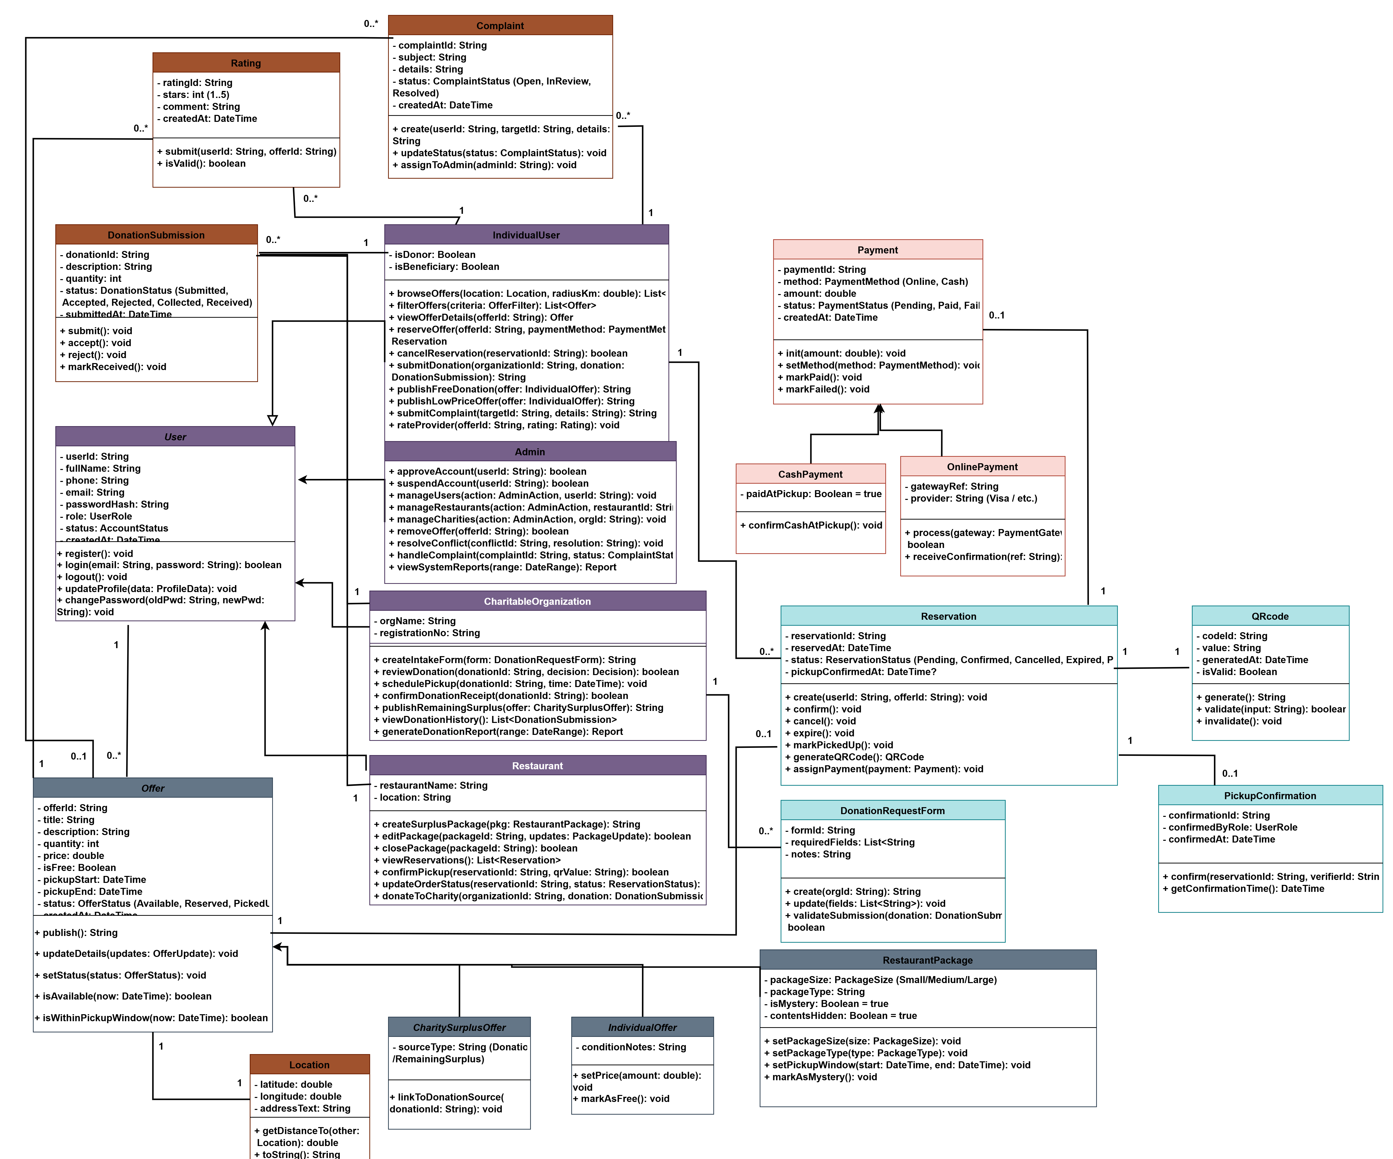
Figure 2: ZAD Class Diagrams

3.3.2 Sequence Diagram
Sequence diagrams demonstrate the interactions between system actors and components over time, highlighting how requests and responses are exchanged during specific system scenarios. They provide insight into the dynamic behavior of the system during key operational processes.

3.3.2.1 User Registration and Login

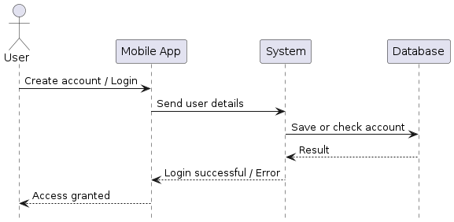
Figure 3: Sequence Diagram for User Registration & Login

3.3.2.2 Donor Adds Food (Restaurant / Household)
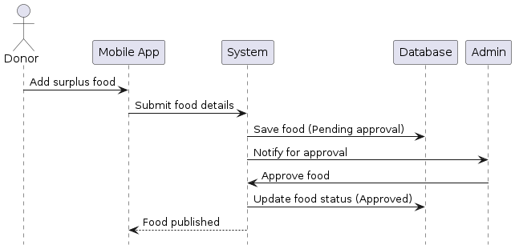

Figure 4: Sequence Diagram for Donor Adds Food

3.3.2.3 Charity / Individual Requests Food

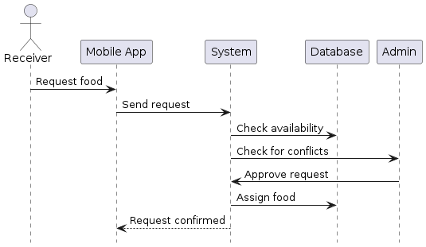
Figure 5: Sequence Diagram for Charity / Individual Requests Food

3.3.2.4 Food Pickup Confirmation

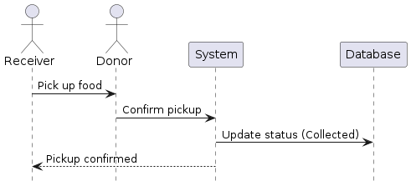
Figure 6: Sequence Diagram for Food Pickup Confirmation

3.3.3 Activity Diagram
The activity diagrams illustrate the flow of main system processes by showing the sequence of activities and decision points. They provide insight into how tasks are performed within the system from start to finish.

3.3.3.1 Reserve Order

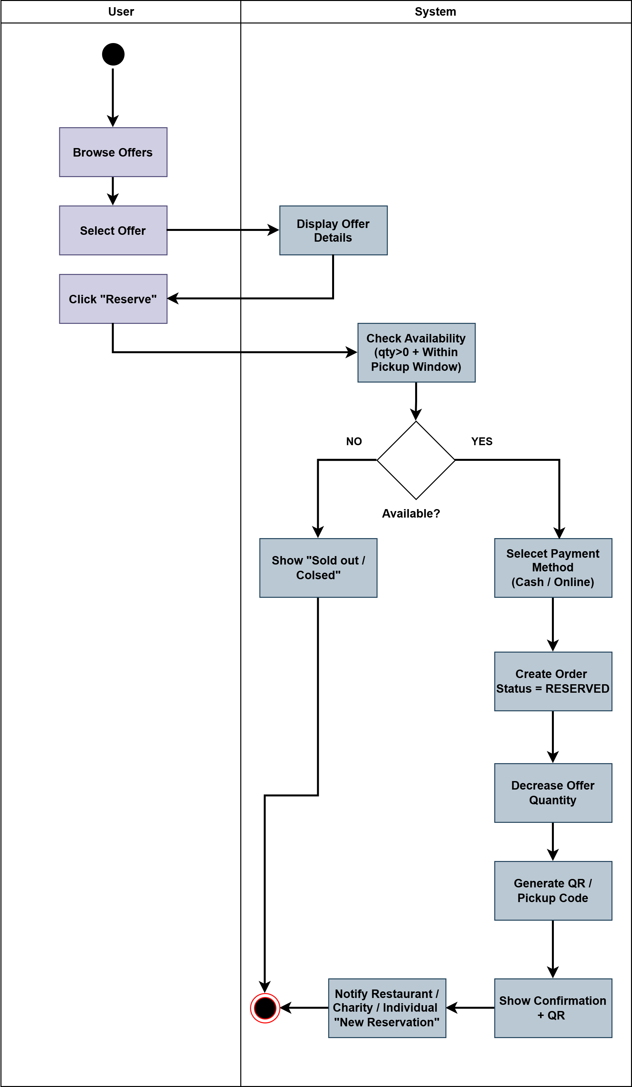
Figure 7: Activity Diagram for Reserve Order

3.3.3.2 Donation Flow

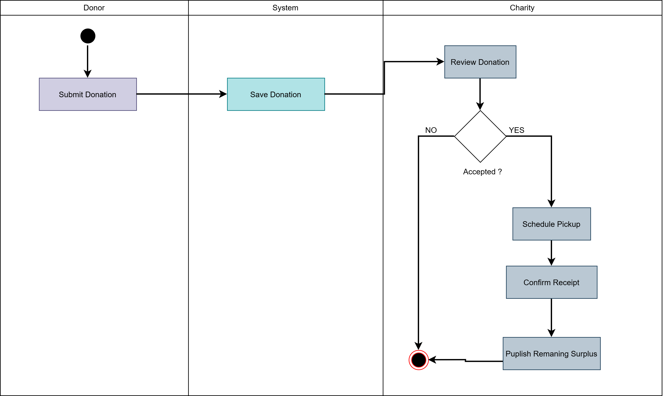
Figure 8: Activity Diagram for Donation Flow

3.3.3.3 Confirm Pickup

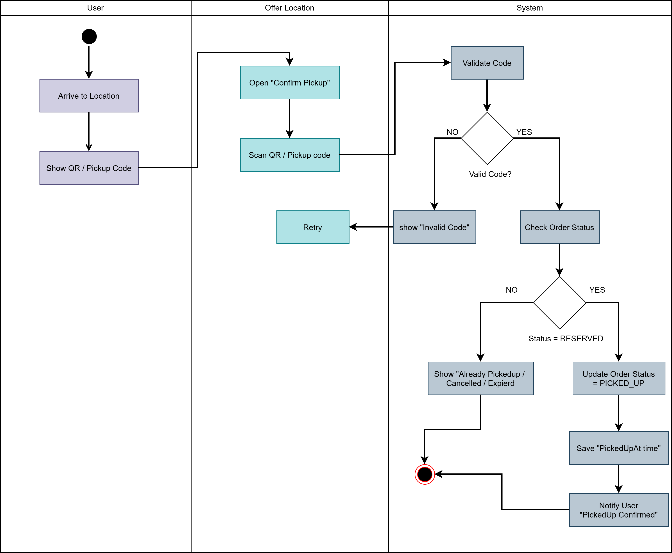
Figure 9: Activity Diagram for Confirm Pickup

3.3.3.4 Create Surplus Package

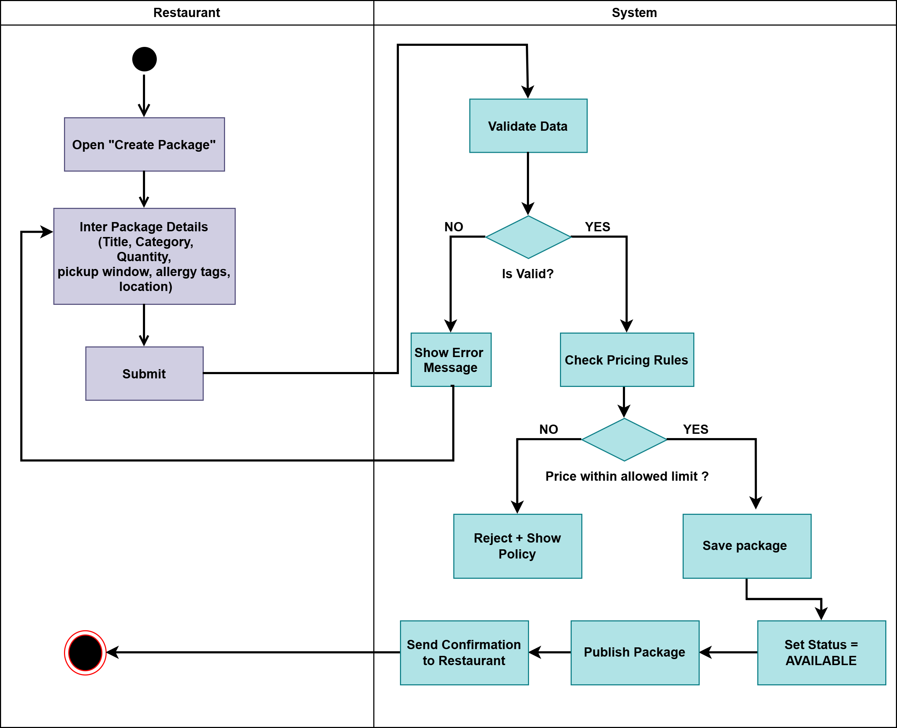
Figure 10: Activity Diagram for Create Surplus Package

3.3.4 State Chart Diagram
A state chart diagram illustrates the life cycle of a system entity by showing all possible states and the events that trigger transitions between these states. It provides a clear representation of how the system changes its state in response to different actions and conditions over time. This diagram helps in understanding the dynamic behavior of the system throughout its lifetime.
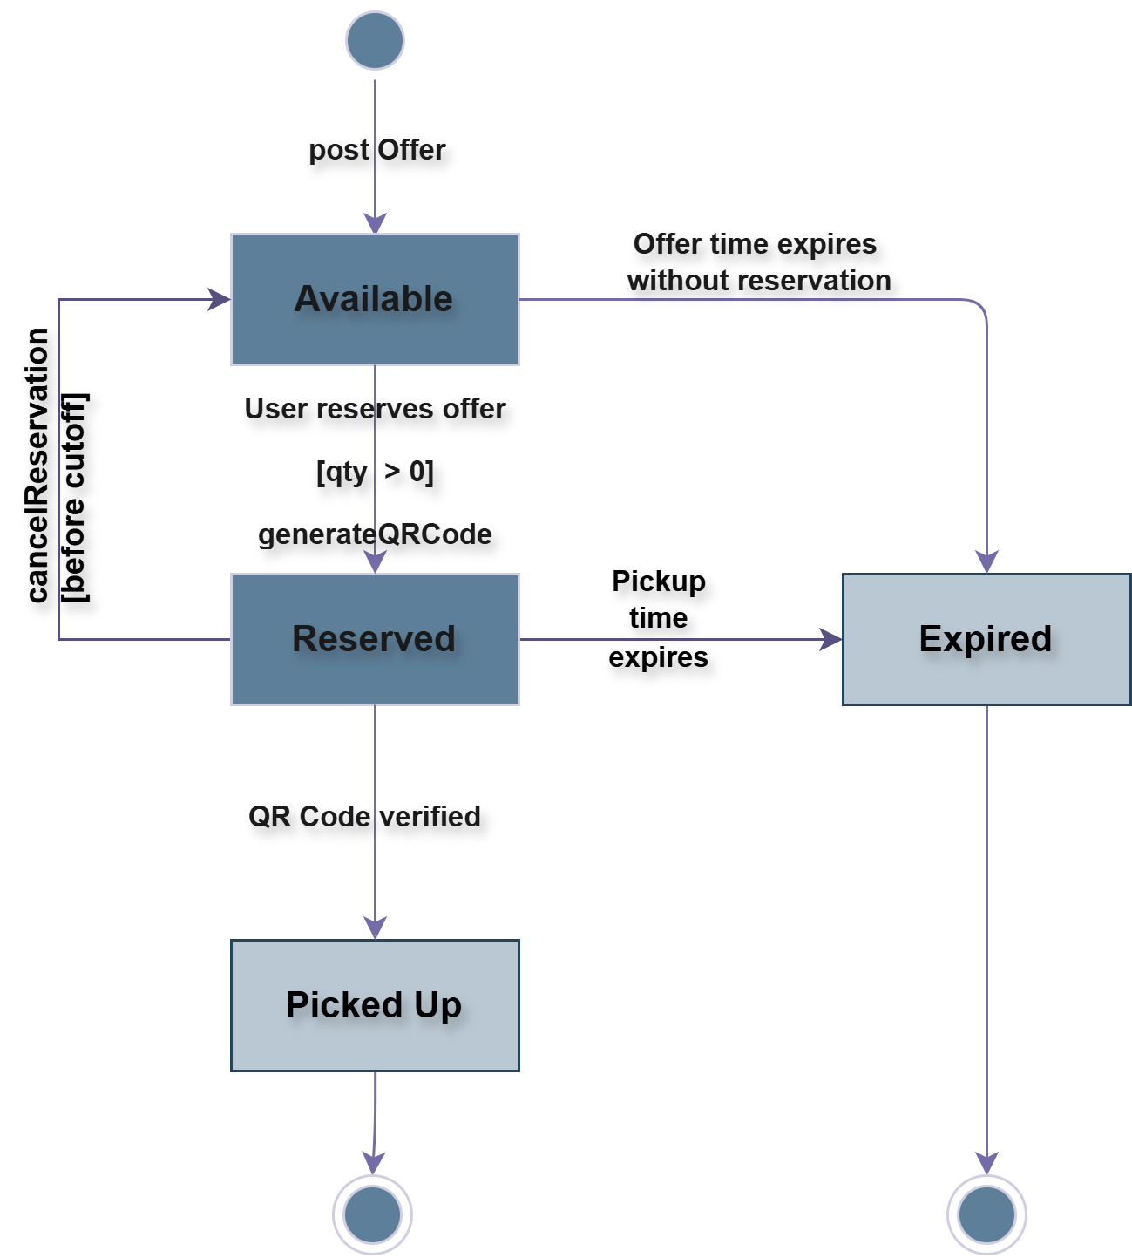
Figure 11: ZAD State Chart Diagram

3.4 System Architecture
This section describes the overall architecture of the ZAD system and the interaction between its main components in delivering the required services. The system follows a distributed client–server architecture, where mobile and web interfaces communicate with backend services through secure APIs. This architectural design ensures scalability, maintainability, and reliable data management, while supporting multiple actors, including individuals, restaurants, charitable organizations, and administrators.
In addition, the architecture supports key system features such as donation management, surplus redistribution, integrated payment services (both online and cash), and QR-based pickup confirmation. These components work together to ensure efficient coordination between users and service providers within the platform.

3.4.1 Sub-System (descriptions of the sub-systems and their services)
Each sub-system of the ZAD system provides a specific set of services as follows:

User Mobile Application (Client Sub-System)
This sub-system focuses on user interaction and allows individuals to register and log in, browse and search food offers, view offer details, reserve or cancel food packages, track order status, select payment methods (online or cash), navigate to pick-up locations, and submit complaints or feedback. Users can also submit food donations to charitable organizations through the application.

Restaurant Interface (Client Sub-System – Mobile / Tablet / Web)
This sub-system enables restaurants to manage their activities on the platform, including viewing reservations, creating and managing surplus food packages, editing or closing listings, managing Account information, confirming pickups by scanning QR codes, and donating surplus food to charitable organizations. Restaurants can also view payment statuses related to their reservations.

Charitable Organization Interface (Client Sub-System – Web)
This sub-system allows charitable organizations to manage donation activities by reviewing submitted donations, accepting or rejecting donations, scheduling pickups, confirming donation receipt, viewing donation history, generating donation reports, and publishing remaining surplus food for redistribution when available.

Administration and Control Sub-System (Admin Web Dashboard)
This sub-system is used by administrators to monitor platform activities, manage user, restaurant, and charitable organization accounts, validate registrations, handle complaints and reports, resolve conflicts, moderate food offers, and enforce system policies and regulations.

Support Services Layer (API / Server Sub-System)
This is the core backend sub-system responsible for coordinating communication between client interfaces and managing business logic. It handles operations such as managing food offers, maintaining reservation records, generating QR codes, updating order statuses, processing donation workflows, and triggering notifications based on system events. This layer also integrates with external services such as payment gateways and location-based services.

Data Management and Databases
This sub-system is responsible for storing and managing all system data, including user accounts, restaurants, charitable organizations, food offers, reservations, donations, payment transactions, QR code data, complaints, and reports. It ensures data consistency, integrity, and availability across the entire system.

Notification Service
The notification service is responsible for sending real-time notifications to users, restaurants, and charitable organizations based on system events, such as reservation confirmations, pickup reminders, donation updates, payment confirmations, and administrative actions.

3.4.2 Software Architecture
The ZAD system follows a layered software architecture that separates the system into three main layers: the UI Layer, Business Logic Layer, and Infrastructure Layer. Each layer has a specific responsibility and communicates with the adjacent layers through well-defined interfaces. This design improves modularity, scalability, maintainability, and system clarity.

UI Layer (Presentation Layer)
The UI Layer is responsible for all user interactions with the system. It provides mobile and web-based interfaces for individuals, restaurants, charitable organizations, and administrators. This layer allows users to perform actions such as authentication, browsing and searching food offers, viewing offer details, making reservations, selecting payment methods, tracking reservation status, confirming pickup using QR codes, submitting donations, and providing ratings or complaints.
The main UI components include:
  - Authentication Interface
  - Offer Browsing & Offer Details Interfaces
  - Reservation & Reservation Status Interfaces
  - QR Interface
  - Map & Navigation Interface
  - Rating & Feedback Interface
  - Report / Complaint Interface
  - Provider Portal Interface (for restaurants and charities)
  - Admin Dashboard Interface
  - Payment Method, Checkout, and Payment Status Interfaces
The UI layer does not contain business logic; it only collects input from users and displays System responses.

Business Logic Layer (Application Layer)
The Business Logic Layer contains the core processing logic of the system and enforces all business rules. It handles the coordination between different actors and manages system workflows.
The main components of this layer include:
  - Auth & RBAC Component: manages authentication and role-based access control.
  - Provider & User Management Component: manages users, restaurants, and charitable organizations.
  - Offer Management Component: manages food offers and surplus packages.
  - Reservation Management Component: handles reservations and conflict prevention.
  - QR Management Component: generates and validates QR codes for pickup confirmation.
  - Pricing Rules Component: enforces low-price and free-offer policies.
  - Payment Management Component: handles online and cash payments.
  - Notification Component: sends system notifications.
  - Map/Location Integration Component: integrates location-based services.
  - Trust & Support Component: manages ratings, complaints, and reports.
  - Admin Services Component: provides administrative control and monitoring features.
This layer is the brain of the system and ensures correct execution of all system processes.

Infrastructure Layer (Data & External Services Layer)
The Infrastructure Layer is responsible for data storage and integration with external systems. It does not contain business logic and has no direct user interface.
This layer includes:
  - MySQL Database: stores all system data such as users, restaurants, charities, offers, reservations, payments, donations, ratings, and complaints.
  - Firebase Services: provides authentication support and real-time notifications.
  - Maps / Location API: provides geolocation and navigation services.
  - External Payment Gateway: processes online payments and returns transaction status.
This layer ensures data consistency, reliability, and secure integration with external services.

Benefits of the Layered Architecture
The layered architecture provides several key benefits:
  - Modularity: Each layer can be modified independently with minimal impact on other layers.
  - Scalability: Layers can be scaled separately based on system load.
  - Maintainability: Clear separation of concerns simplifies debugging and future updates.
  - Flexibility: Infrastructure technologies (e.g., databases or APIs) can be replaced without affecting application logic.
  - Reusability: Components can be reused and extended in future system enhancements.

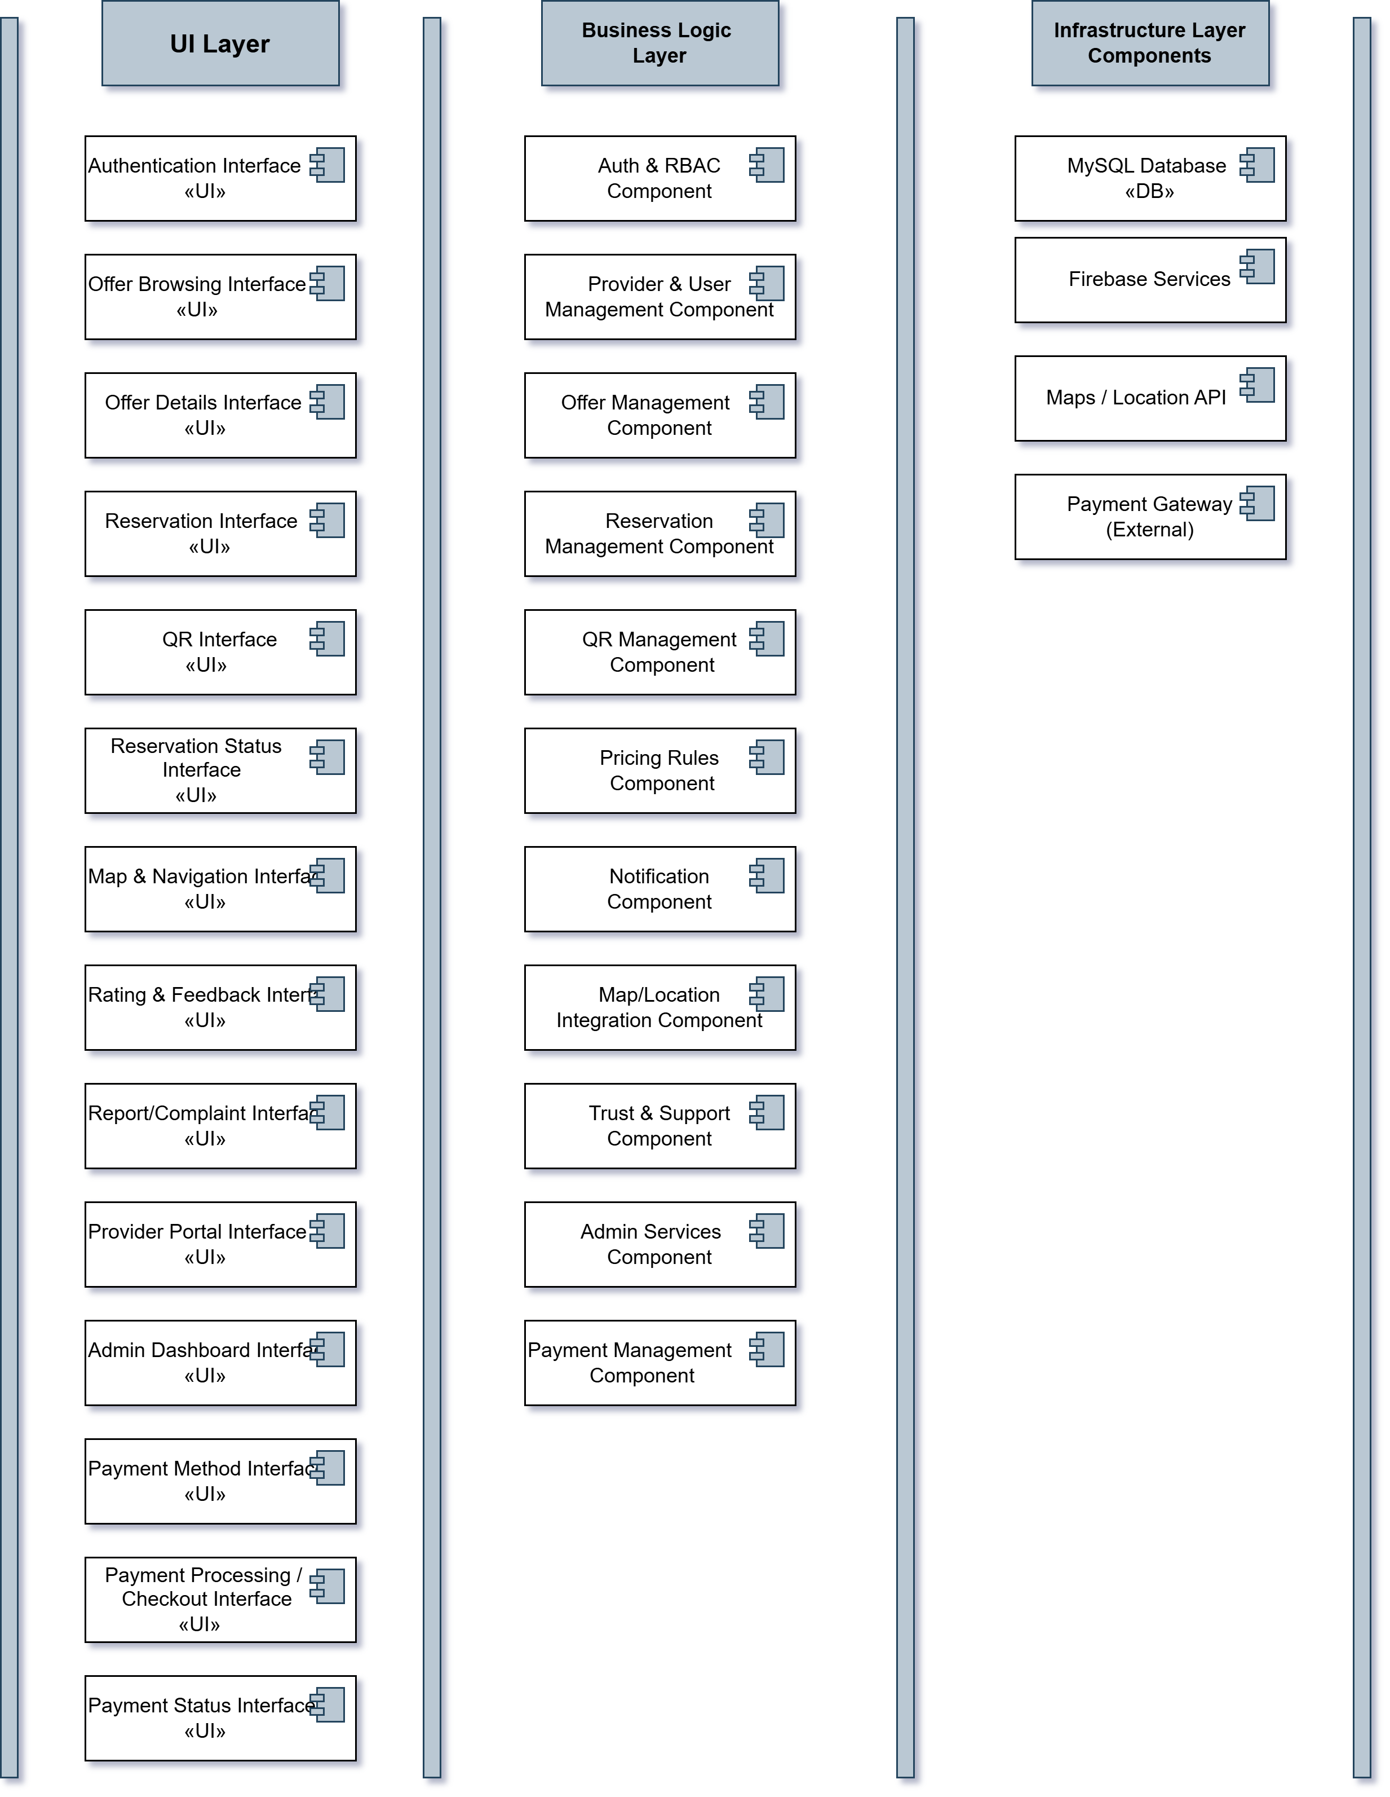
Figure 12: ZAD Architecture Diagram

3.4.3 Deployment diagram

The deployment diagram shows how the ZAD system is physically deployed in a distributed client–server environment. Mobile users, restaurants, and administrators access the system through mobile and web interfaces, which communicate securely with the backend server using HTTPS.
The backend server handles all core services such as authentication, offer management, reservations, QR code generation, notifications, and administration. The system integrates external services including Firebase for authentication and notifications, Google Maps API for location services, an external payment gateway for online payments, Firebase Storage for images, and a MySQL database for data storage.
This architecture supports secure communication, scalability, and reliable system operation.
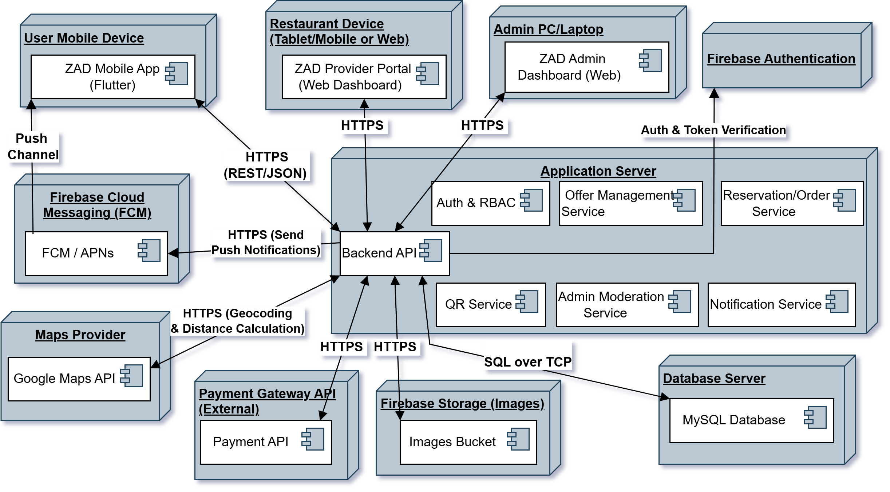
Figure 13: ZAD Deployment Diagram

3.6 Data Management and ERD
The Entity Relationship Diagram (ERD) illustrates the main data entities of the ZAD system and the relationships between them. It models how users, restaurants, charitable organizations, and individual donors interact with core system components such as offers, reservations, payments, QR codes, ratings, and complaints. The diagram also defines the structure of user profiles through specialized entities (RestaurantProfile, CharityProfile, and IndividualProfile), which extend the base User entity using shared primary keys. Overall, the ERD provides a clear representation of the system’s data architecture and ensures data consistency, integrity, and proper linkage between all system operations.

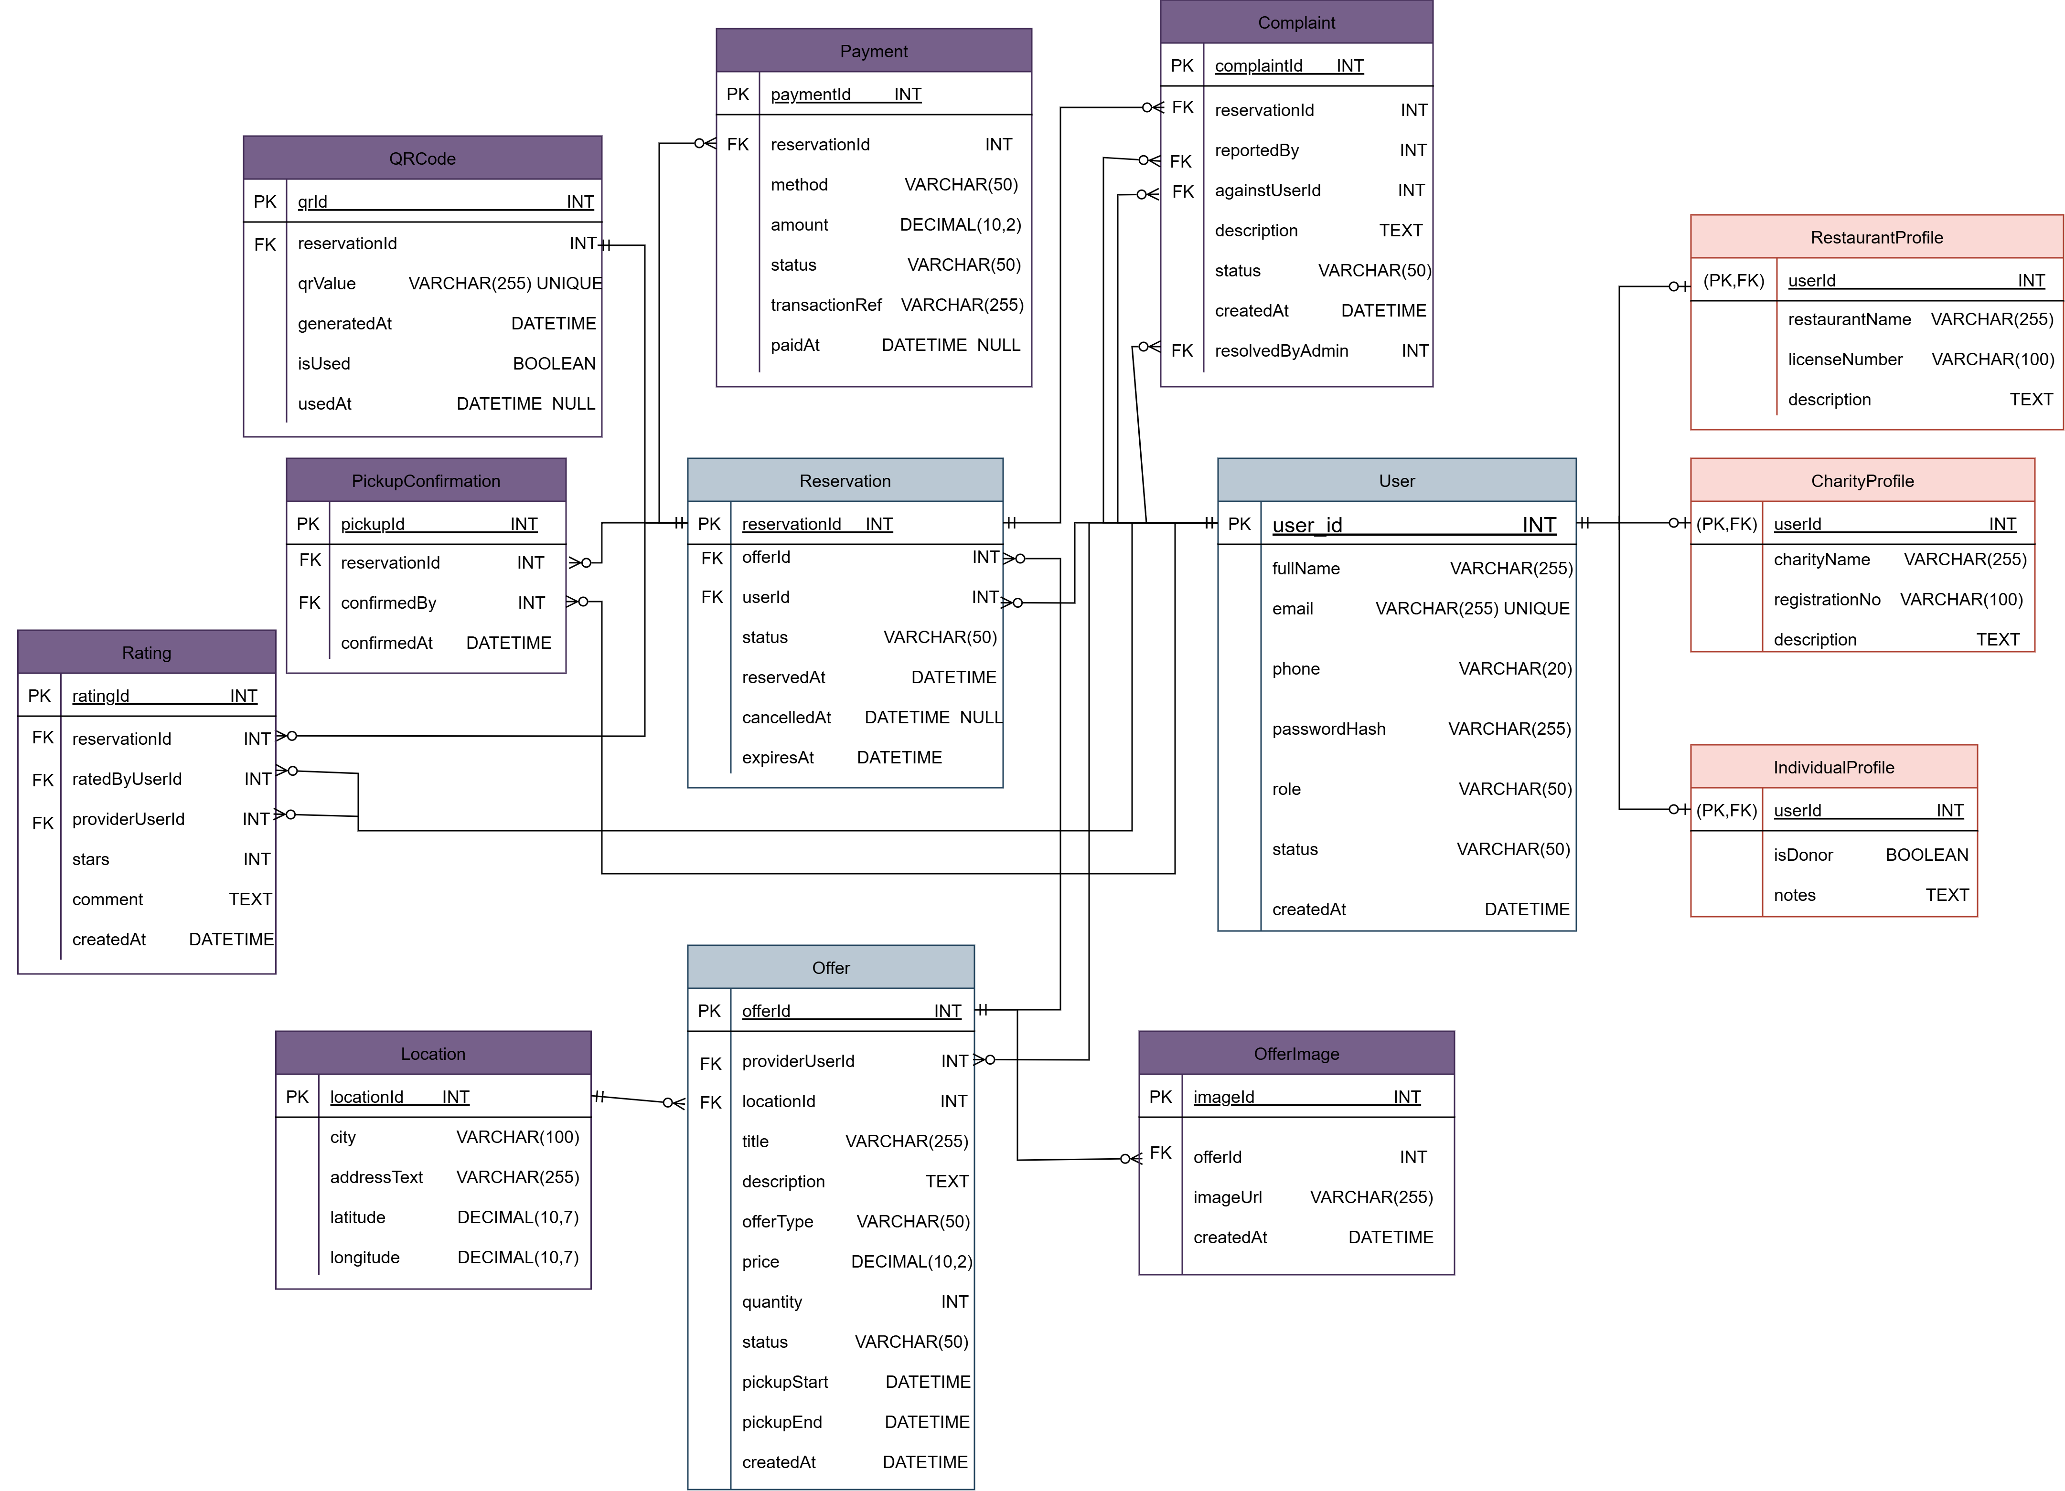
Figure 14: ZAD ERD Diagram

Chapter 4: Conclusion and Future works

4.1 Review of the project

This report presents ZAD, a surplus food management system designed to reduce food waste and support organized redistribution within the community. ZAD connects restaurants, charitable organizations, and individuals through one integrated platform, allowing providers to publish surplus food offers while enabling users to reserve and collect them within defined pickup time windows. ZAD supports two distribution modes: Free donations, mainly for charitable organizations and also available for individuals and Low-price offers, which can be used by restaurants (surplus packages) and individuals (symbolic-price offers) to support access to food while maintaining dignity for those in need.
The system is built using a client–server architecture, where a mobile application is used by individuals and charities, and web-based dashboards are used by restaurants and administrators. Location-based services are integrated to help users discover nearby offers, while a structured reservation workflow with QR-code confirmation ensures accurate pickup and prevents conflicts such as double reservations.
This report defines the system’s functional and non-functional requirements and includes UML diagrams that describe the system behavior and structure, such as use case diagrams, activity/state diagrams, class diagrams, component/architecture diagrams, and a deployment diagram. Overall, ZAD provides a practical and efficient solution for managing surplus food offers and reservations in an organized and secure manner.

4.2 Next Semester Plan
Week 1–2: Setup & Planning

- Finalize the updated system scope (restaurants, charities, individuals, admin).
- Design the database schema for offers, reservations, QR codes, reviews, and complaints.
- Set up the backend environment, project repository, and basic API structure.
- Configure Firebase services (Authentication, Notifications, Storage).

Week 3–4: Authentication & Roles

- Implement registration/login for all roles.
- Implement role-based access control (RBAC) and account approval workflow (admin verification).
- Build profile management for individuals, restaurants, and charities.

Week 5–6: Offer Publishing & Management

- Implement restaurant surplus package publishing and management (create/edit/delete).
- Implement charity offer publishing (free only).
- Implement individual offer publishing (free and low-price).
- Add offer status lifecycle (Available, Reserved, Picked Up, Expired).

Week 7–8: Location-Based Discovery

- Integrate location services and map view.
- Implement nearby offer discovery based on distance.
- Add filtering and sorting (nearest, free only, low-price only, provider type).

Week 9–10: Reservation, Conflict Prevention & QR

- Implement reservation creation and cancellation rules (before cutoff).
- Ensure conflict prevention (no double reservation for the same offer).
- Generate QR code on reservation and implement verification at pickup.
- Update status automatically (Reserved → Picked Up / Expired).

Week 11–12: Admin Panel & Trust Features

- Implement admin dashboard for approving/managing accounts.
- Add moderation tools for conflicts and repeated complaints.
- Implement rating/feedback after pickup and complaint reporting.
- Generate basic monitoring reports (offers, reservations, issues).

Week 13–14: Notifications & Enhancements

- Implement push notifications (reservation confirmation, pickup reminder, Cancellation/expiry).
- Improve UI/UX for mobile app and dashboards.
- Optimize performance for browsing and reservation workflows.

Week 15–16: Testing, Finalization & Deployment

- Perform functional testing and validation against requirements.
- Conduct basic security and performance testing.
- Fix bugs and finalize system stability.
- Prepare deployment setup, final documentation, and presentation/demo.

Bibliograph
[1] S. Beji and N. El Kadhi, “An overview of mobile applications architecture and the associated technologies,” Proceedings - The 4th International Conference on Wireless and Mobile Communications, ICWMC 2008, pp. 77–83, 2008, doi: 10.1109/ICWMC.2008.55.
[2] “Location-Based Services - Google Books.” Accessed: Jan. 25, 2026. [Online]. Available: https://books.google.ps/books?hl=en&lr=&id=wj19b5wVfXAC&oi=fnd&pg=PP1&dq=location+based+services+mobile+systems&ots=lfRr7ypeQl&sig=yBqzXTdZzQz8IuLwEG0w4SOBfpU&redir_esc=y#v=onepage&q=location%20based%20services%20mobile%20systems&f=false
[3] Jenny. Gustavsson, Global food losses and food waste : extent, causes and prevention : study conducted for the International Congress “Save Food!” at Interpack 2011 Düsseldorf, Germany. Food and Agriculture Organization of the United Nations, 2011.
[4] “Quantifying Methane Emissions from Landfilled Food Waste | US EPA.” Accessed: Jan. 25, 2026. [Online]. Available: https://www.epa.gov/land-research/quantifying-methane-emissions-landfilled-food-waste?utm_source=chatgpt.com
[5] “Food loss and waste account for 8-10% of annual global greenhouse gas emissions; cost USD 1 trillion annually | UNFCCC.” Accessed: Jan. 25, 2026. [Online]. Available: https://unfccc.int/news/food-loss-and-waste-account-for-8-10-of-annual-global-greenhouse-gas-emissions-cost-usd-1-trillion?utm_source=chatgpt.com
[6] “Food Waste Index Report 2024 | UNEP - UN Environment Programme.” Accessed: Jan. 25, 2026. [Online]. Available: https://www.unep.org/resources/publication/food-waste-index-report-2024

Appendices
Table 3: Use Case Description (Register / Login)
Field | Description
Use Case ID | UC-01
Use Case Name | Register / Login
Primary Actor(s) | User / Restaurant / Admin
Goal | Allow users to create an account and log in securely.
Pre-conditions | - User has the app installed.  - Internet connection available.
Trigger | User opens the app and selects “Sign Up” or “Login”.
Main Flow | - User selects Sign Up or Login.  - For Sign Up: user enters name, phone, email, password, and role.  - System validates information.  - System creates a new account.  - For Login: user enters email/phone and password.  - System authenticates credentials.  - User is directed to the home screen.
Alternative Flows | A1: Missing required fields → System displays validation error.  A2: Incorrect credentials → System shows login error message.  A3: Existing email/phone → System informs user that account already exists.
Post-conditions | User is redirected to the correct dashboard based on role.

Table 4: Use Case Description (Create Surplus Package)
Field | Description
Use Case ID | UC-06
Use Case Name | Create Surplus Package (Mystery Package)
Primary Actor(s) | Restaurant
Goal | Publish a surplus mystery package for users to reserve
Pre-conditions | - Restaurant account is verified by Admin.  - Restaurant is logged in.
Trigger | Restaurant selects “Create Package
Main Flow | - Restaurant opens the “Create Package” form.  - Restaurant enters package information: title, category, price, quantity, pickup time window, and pickup notes/location.  - Restaurant selects allergy warning tags (optional).  - System validates the input (e.g., price, time window, required fields).  - System publishes the package as “Available”.  - System shows confirmation to the restaurant.
Alternative Flows | A1: Missing/invalid data → System highlights fields and prevents publishing.  A2: Price violates pricing policy → System rejects submission and displays policy message.
Post-conditions | A new package listing is created and visible to users.

Table 5: Use Case Description (Browse / Search Offers)
Field | Description
Use Case ID | UC-03
Use Case Name | Browse Offer
Primary Actor(s) | User
Goal | View available offers near the user
Pre-conditions | - User is logged in.  - Internet connection available.
Trigger | User opens the app and selects “Sign Up” or “Login”.
Main Flow | - System shows a list of available offers.  - User views order cards with donor name, category, price, pickup time, and distance.  - User selects the offer to view details.
Alternative Flows | A1: No offers available → System shows “No offers available nearby” and suggests changing filters/location.
Post-conditions | offers are displayed (or empty result message shown)

Table 6: Use Case Description (Reserve Offer)
Field | Description
Use Case ID | UC-16
Use Case Name | Reserve Offer
Primary Actor(s) | User
Supporting Actor(s) | Donor/Restaurant (receives reservation),  Payment service
Goal | Reserve an offer for pickup
Pre-conditions | - User is logged in.  - Selected offer status is “Available” and quantity > 0  - Current time is within the offer reservation period.
Trigger | User clicks “Reserve”.
Main Flow | - User selects a offer and clicks “Reserve”.  - System shows reservation summary (price, pickup window, restaurant/Donor location).  - User selects payment method (Cash on pickup / Online payment).  - System creates the reservation and decreases available quantity.  - System generates a unique QR code / pickup code for the order.  - System shows confirmation screen with QR/code and pickup instructions.  - System notifies the restaurant /Donor about the new reservation.
Alternative Flows | A1: Offer becomes sold out before confirmation → System shows “Sold Out” and cancels the reservation attempt.  A2: Online payment fails → System shows failure message and allows retry or switch to cash.  A3: Pickup window expired → System prevents reservation and shows “Closed
Post-conditions | - Order is created with status “Reserved”.  - QR/pickup code is available to the user.  - Offer quantity is updated.

Table 7: Use Case Description (Manage Users)
Field | Description
Use Case ID | UC-22
Use Case Name | Manage Users
Primary Actor(s) | Admin
Goal | Manage user accounts to ensure proper use of the system and enforce platform policies.
Pre-conditions | - Admin is logged in to the system.
Trigger | Admin opens the “User Management” section.
Main Flow | - Admin opens the list of registered users.  - System displays user accounts and their details (name, status, activity).  - Admin selects a user account.  - Admin chooses an action (view details, suspend, activate, or remove account).  - System updates the user account status based on the selected action.  - System saves the changes.
Alternative Flows | A1: Admin suspends user → System restricts user access and updates status to “Suspended”.  A2: Admin removes user → System deactivates account and prevents future access.
Post-conditions | User account status is updated according to the admin’s action.
Related Use Cases | Register / Login

Table 8: Use Case Description (Handle Reports & Complaints)
Field | Description
Use Case ID | UC-22
Use Case Name | Handle Reports & Complaints
Primary Actor(s) | Admin
Goal | Review and resolve reports or complaints submitted by users regarding orders or restaurants or Donors.
Pre-conditions | - Admin is logged in to the system.  - At least one report or complaint has been submitted.
Trigger | Admin opens the “Reports & Complaints” section.
Main Flow | - Admin opens the list of submitted reports and complaints.  - System displays report details (report type, related order/restaurant/Donor description).  - Admin reviews the report information.  - Admin takes appropriate action (warn user, resolve issue, or close report).  - System updates the report status to “Resolved” or “Closed”.  - System records the admin’s action.
Alternative Flows | A1: Report requires further investigation → Admin marks report as “Under Review”.  A2: Invalid or duplicate report → Admin closes report without action.
Post-conditions | Report status is updated and the issue is resolved or closed.
Related Use Cases | Submit Report / Complaint

Table 9: Use Case Description (Cancel Reservation)
Field | Description
Use Case ID | UC-17
Use Case Name | Cancel Reservation
Primary Actor(s) | User
Goal | Cancel a reservation before pickup cutoff time
Pre-conditions | - User has an active reservation.  - Cancellation is within allowed cutoff time.
Trigger | User selects “Cancel Reservation
Main Flow | - User opens “Order Status”.  - User clicks “Cancel Reservation”.  - System asks for confirmation.  - User confirms cancellation.  - System updates order status to “Cancelled”.  - System restores reserved quantity back to the offers listing (if still within time window).  - System notifies the restaurant/Donor.
Alternative Flows | A1: Cutoff time passed → System blocks cancellation and displays message
Post-conditions | Order is cancelled and stock is updated accordingly.
Related Use Cases | Reserve Offer («extend»)

Table 10: Use Case Description (Confirm Pickup)
Field | Description
Use Case ID | UC-19
Use Case Name | Confirm Pickup
Primary Actor(s) | Providers
Supporting Actor(s) | User (presents code)
Goal | Verify that the user picked up the reserved order
Pre-conditions | - Provider is logged in.  - User has a valid reservation with status “Reserved”.  - User is physically present at the Location.
Trigger | Provider selects “Confirm Pickup” and scans code
Main Flow | - User presents QR code / pickup code.  - Provider scans QR code or enters the pickup code.  - System validates the code and checks order status and pickup time window.  - System updates the order status to “Picked Up”.  - System displays success confirmation to the Provider.  - System notifies the user that pickup is confirmed.
Alternative Flows | A1: Invalid/expired code → System rejects and shows error  A2: Order already picked up → System shows “Already Picked Up  A3: Pickup window expired → System marks as “Expired” and rejects pickup.
Post-conditions | - Order status is updated to “Picked Up”.  - Reservation is completed.

