**Pharmacy application**

We have admin of application have one or many of pharmacy , each pharmacy has name , ID pharmacy( unique) and bill , product details , address by the details of street and city . And one pharmacy have one admin .  
Each admin have  id_user (unique) , Password, name ,each admin manage one or many of delivery person and one delivery person manage by one admin .

Each delivery person have car details , id_delivery(unique) , number of phone , name and price, each delivery person deliver one or many customers, the data of delivery is saved and one customer delivery by one delivery person .

Each customer have user name(unique) , name, address by the details of street and city , payment by the details of cash or credit card , No.of phone . Customer may order or not from admin and save id order and each admin take order one or more customer.

customer may or may not get advice from doctor , and doctor give advice to one or more customer .   
Each doctor have id_doctor (unique) ,name and set experience . Each admin register one or more doctor and one doctor register by one admin only .



Shahad Alharbi

Rahaf Alyousef

Your Health

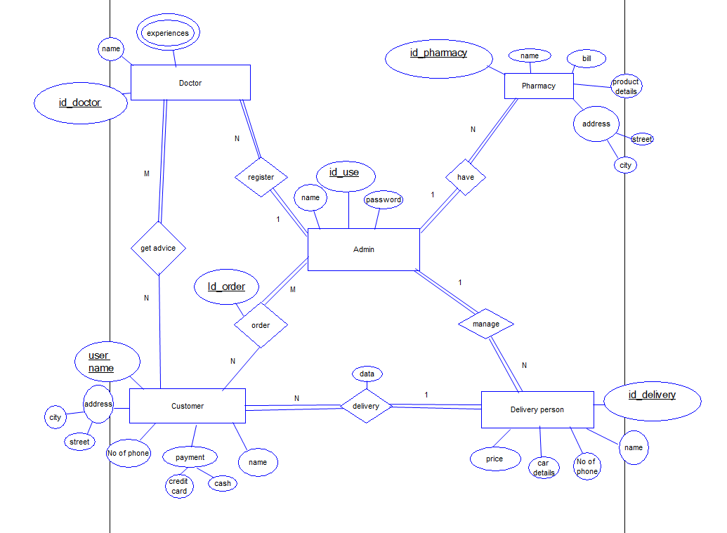**ER diagram :**

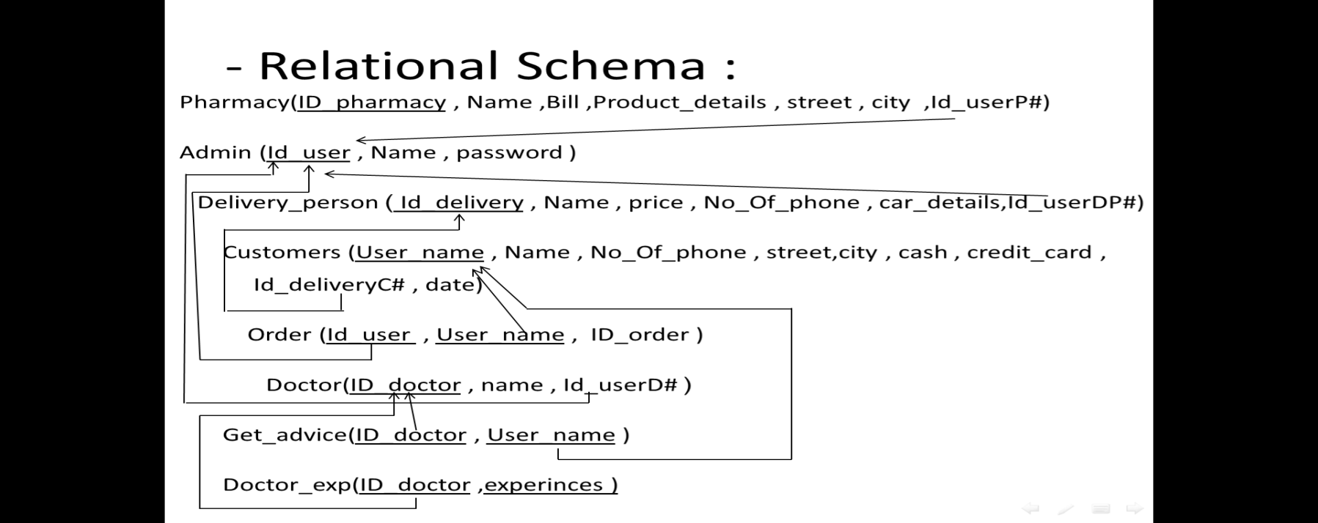

**Normalizatin into 1NF:**

**Pharmacy**

|  |  |  |  |  |  |  |
| --- | --- | --- | --- | --- | --- | --- |
| **Id_user** | **city** | **street** | **Product details** | **Bill** | **Name** | **ID_Pharmacy** |

**Pharmacy**

|  |  |  |  |  |  |
| --- | --- | --- | --- | --- | --- |
| **Id_user** | **city** | **street** | **Bill** | **Name** | **ID_Pharmacy** |

|  |  |
| --- | --- |
| **Product details** | **ID_Pharmacy** |

**Pharmacy_pro**

**Normalizatin into 1NF:**

**Delivery_person**

|  |  |  |  |  |  |
| --- | --- | --- | --- | --- | --- |
| **Id_user** | **Car_details** | **No_Of_Phone** | **price** | **name** | **Id_delivery** |

**Delivery_person**

|  |  |  |  |  |
| --- | --- | --- | --- | --- |
| **Id_user** | **No_Of_Phone** | **price** | **name** | **Id_delivery** |

**Details_delivery**

|  |  |
| --- | --- |
| **Car_details** | **Id_delivery** |

**Relational Schema After normalization :**

Pharmacy(ID_pharmacy , Name ,Bill , street , city ,Id_userP#)

Pharmacy_pro(ID_pharmacy #, Product_details )

Admin (Id_user , Name , password )

Delivery_person (Id_delivery , Name , price , No_Of_phone ,Id_userDP#)

Details_delivery(Id_delivery# , car_details)

Customer (User_name , Name , No_Of_phone , street,city , cash , credit_card , Id_deliveryC# , date)

Order_ (Id_user , User_name , ID_order )

Doctors(ID_doctor , name , Id_userD# )

Doctor_exp(ID_doctor# , experiences)

get_advice(ID_doctor , User_name )

**Code of Tables:**

Create table admin

(Id_user number(10) constraint admin_id_pk primary key ,

Name varchar2(20),password varchar2(8) not null) ;

Insert into admin

values (1,'Rana','5456677')

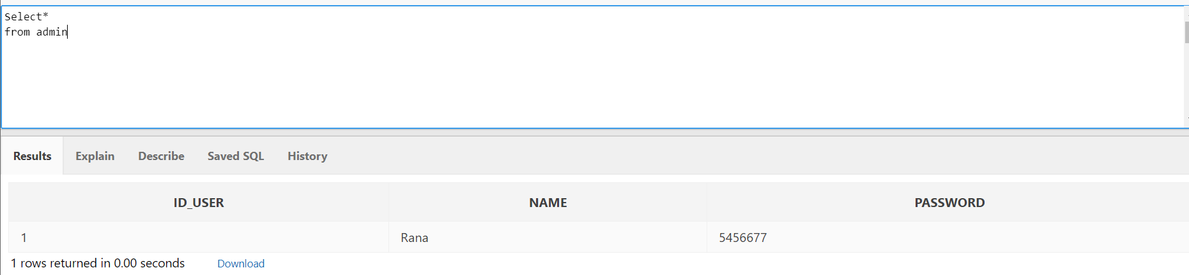

-------------------------------------------------

Create table Doctors

(Id_doctor number(10) constraint doctor_id_pk primary key ,

Name varchar2(20), Id_userD number(10) constraint doctor_admin_fk references admin (Id_user)) ;

insert into Doctors

values(1,'Ahmad Ali',1)

insert into Doctors

values(2,'Anas khalid',1)

insert into Doctors

values(3,'Bader Azam',1)

insert into Doctors

values(4,'Ali Zeed',1)

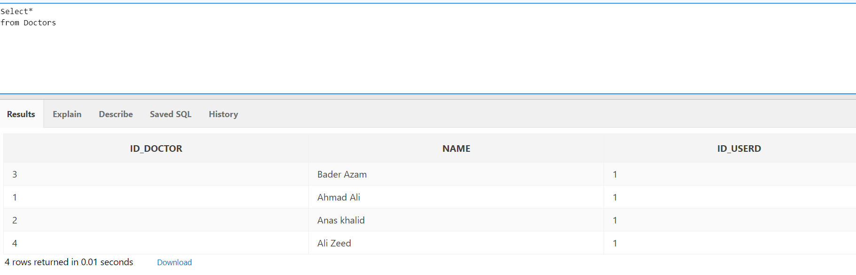

Create table doctor_exp

( Id_doctor number(10) constraint doctor_exp_fk references Doctors (Id_doctor),

Experience varchar2(1000) constraint doctor_exp_pk primary key ) ;

insert into doctor_exp

values(2,' Ophthalmologist certified by the General Authority of Civil Aviation')

insert into doctor_exp

values(3,' He received his masters degree in dermatology from the Faculty of Medicine, Cairo University')

insert into doctor_exp

values(4,' Trained in ophthalmology in Oxford and London, he worked at the Oxford Eye Hospital in Oxford')

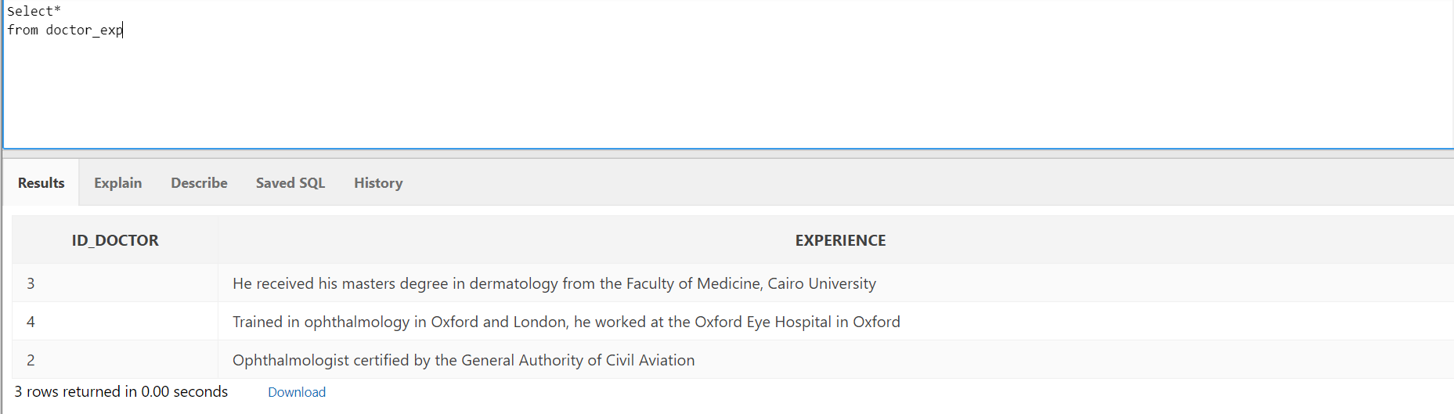

---------------------------------------------------------

Create table pharmacy

)Id_pharmacy number(10) constraint pharmacy_id_pk primary key ,Name varchar2(50) ,Bill number(20) ,street varchar2(20) not null ,city varchar2(20) not null , Id_userP number(10) constraint pharmacy_admin_fk references admin (Id_user)) ;

insert into pharmacy

values(1,'Nahdi',120 ,'Amro bin alaas','Alkharj',1)

insert into pharmacy

values(2,'whites',200,'king khalid','Abha',1)

insert into pharmacy

values(3,'Aldawa',310,'Alkhuzama','Alkharj',1)

insert into pharmacy

values(4,'Boots ',140,'Olaia','Riyadh',1)

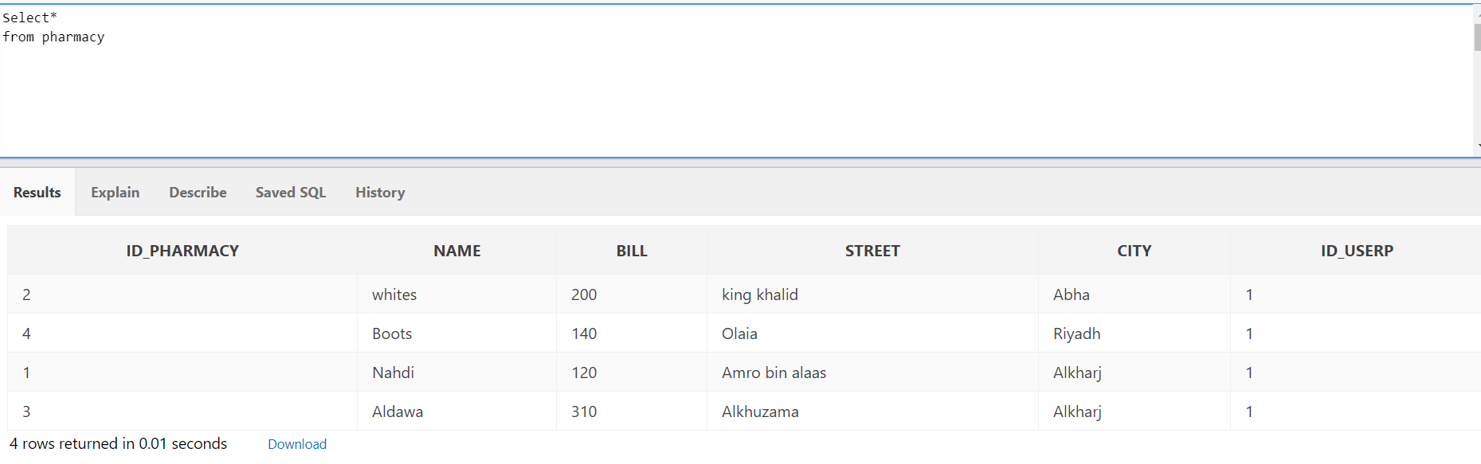

Create table pharmacy_pro

(Id_pharmacy number(10) constraint pharmacy_pro_fk references pharmacy (Id_pharmacy),

product_details varchar2(1000) , constraint pharmacy_pro _pk primary key(Id_pharmacy ,product_details) ) ;

insert into pharmacy_pro

values(1,'Body Care-Daily Care -Hair Care-Baby Care -Skin Care -Medications&Recipes –Vitamins-make-up tools')

insert into pharmacy_pro

values(2, 'Kids Accessories - Body Care - Daily Care - Hair Care - Baby Care - Skin Care - Medications & Recipes - Vitamins')

insert into pharmacy_pro

values(3, 'foundation cream - Mascara - lip balm - Body Care - Daily Care - Hair Care - Baby Care - Skin Care - Medications & Recipes – Vitamins ')

insert into pharmacy_pro

values(4 ,'care and medical devices - Body Care - Daily Care - Hair Care - Baby Care - Skin Care –

Medications & Recipes - Vitamins')

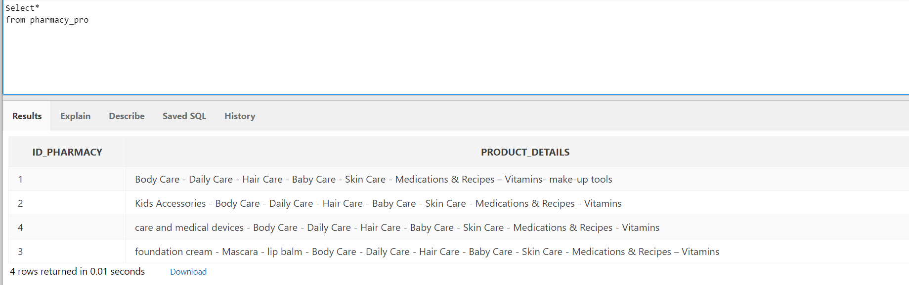

----------------------------------------------------

Create table delivery_person

)Id_delivery number(10) constraint delivery_id_pk primary key ,Name varchar2(20) ,price number(20) , No_of_phone number(10)not null, Id_userDP number(10)constraint delivery_user_fk references admin(Id_user));

insert into delivery_person

values(1,'Hasan',30 ,0543678121,1)

insert into delivery_person

values(2,'Ahmad',20,0512347612,1)

insert into delivery_person

values(3,'Azam',15 ,0509876543,1)

insert into delivery_person

values(4,'Ali',33 ,0556439201,1)

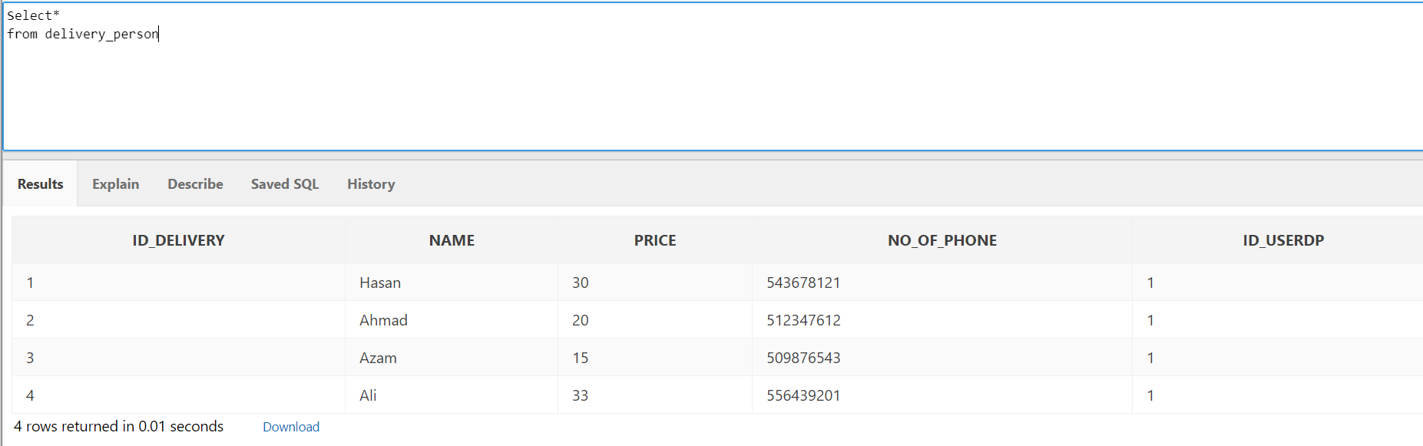

Create table details_delivery

(Id_delivery number(10) constraint details_delivery_fk references delivery_person (Id_delivery),

car_details varchar2(50) , constraint details_delivery_pk primary key(Id_delivery ,car_details) ) ;

insert into details_delivery

values(1, 'Hyundai gray 9918')

insert into details_delivery

values(2, 'Hyundai black 2345')

insert into details_delivery

values(3, 'KIA red 9083')

insert into details_delivery

values(4, 'ford black 4567')

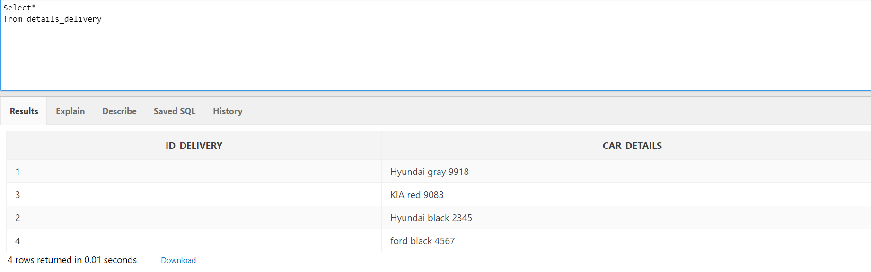

-------------------------------------

Create table customer

) user_name varchar2(20) constraint cus_user_pk primary key ,No_of_phone number(10) not null ,Name varchar2(20) , street varchar2(20) not null,city varchar2(20) not null, cash number(10), credit_card varchar2(15), data varchar2(15) ,Id_deliveryC number(10)constraint cust_delivery_fk references delivery_person(Id_delivery))

insert into customer (user_name,No_of_phone,name ,street,city)

values('RK',0534602846,'Rawan','hamza bin omar','Aldilam')

insert into customer (user_name,No_of_phone,name ,street,city)

values('Q23',0510737297,'khalid','shifa','Riyadh')

insert into customer (user_name,No_of_phone,name ,street,city)

values('PNR1',0512098456,'Asma','olia','kharj')

insert into customer (user_name,No_of_phone,name ,street,city)

values('EOT',0505626195,'Faisal','King fahad','Damam')

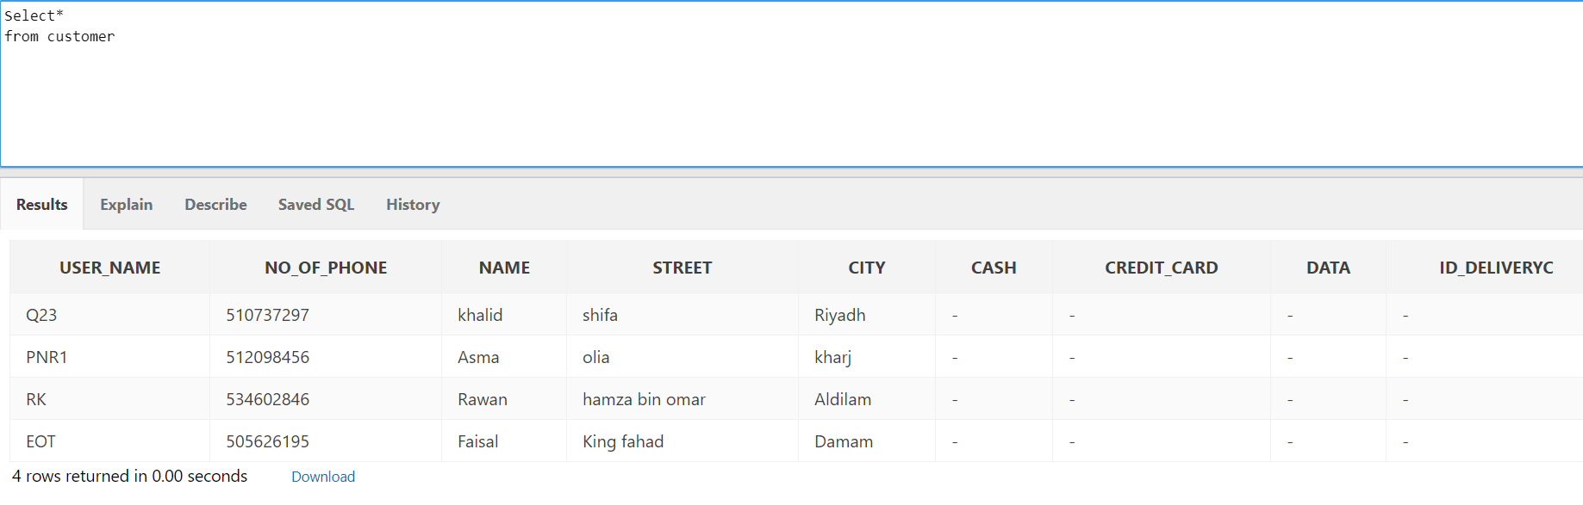

Create table order_

(Id_user number(10) constraint order_id_fk references admin (Id_user),

User_name varchar2(20) constraint order_user_fk references customer (user_name),

Id_order number(10), constraint order_pk primary key(Id_user,User_name) ) ;

insert into order_

values(1,'RK',1)

insert into order_

values(1,'Q23',2)

insert into order_

values(1,'PNR1',3)

insert into order_

values(1,' EOT ',4)

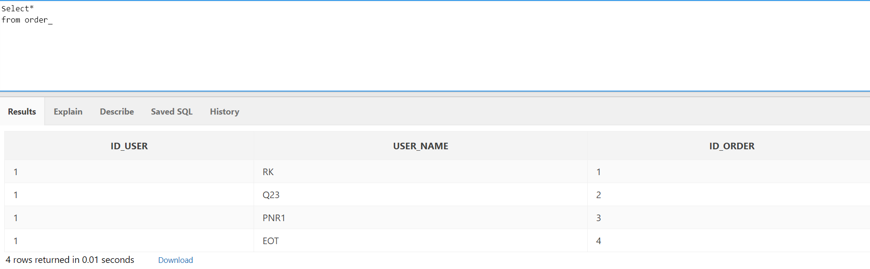

-----------------------------------------

Create table get_advice

)Id_doctor number(10) constraint get_doc_id_fk references Doctors (Id_doctor),

User_name varchar2(20) constraint get_user_fk references customer (user_name));

insert into get_advice

values(1,'EOT ')

insert into get_advice

values(2,' RK ')

insert into get_advice

values(3,' Q23')

insert into get_advice

values(4,'PNR1')

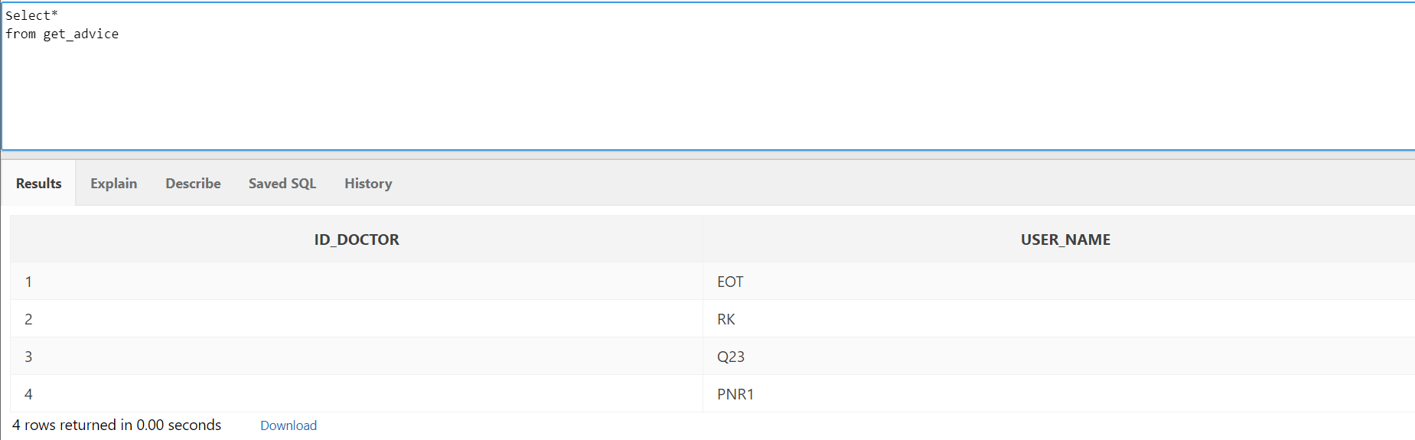

**Update & Query:**

update delivery_person

set price =20

where name ='Azam';

---------

update delivery_person

set price =0

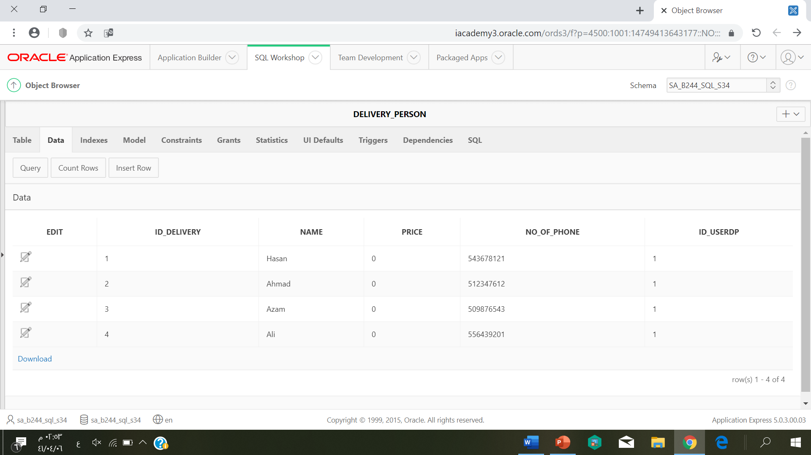

------------------------------------------------

Select*

From pharmacy

Where bill <300;

