Debugging
# Autos: Automatic variable (اول متعمل debugging بعرضها(

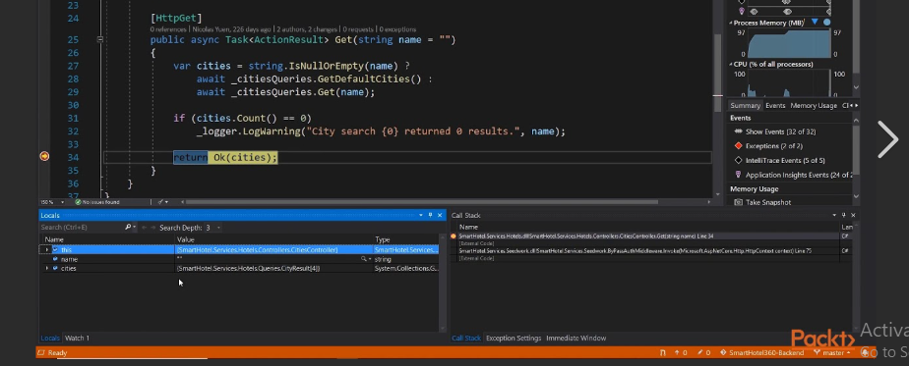

# Quick Watch Window :
It’s Customized Autos window يعني انا بحدد شو بدي ينعرض
- الطريقة highlight the expression and click “shift + f9” ,

#Step Into/Over/Out:

الأمر | الوظيفة | متى تستخدمه
Step Into | يدخل داخل الدالة | عندما تريد تتبّع التنفيذ خطوة بخطوة داخلها
Step Over | يتجاوز الدالة | عندما لا تحتاج معرفة تفاصيل تنفيذها
Step Out | يخرج من الدالة الحالية | عندما دخلت إلى دالة وتريد العودة للخارج بسرعة

#create Your Own Library(Local Library)
1-library extension .h

📚 What Is a Local Library in C++? (Simple Explanation)
A local library is a group of functions you create yourself and store in separate files, so you can reuse them in your project without rewriting the code each time.
Think of it like making your own toolbox:
- بدل ما تكتب نفس الكود في كل ملف
- بتحط الكود مرة واحدة داخل ملف .h أو ملف .cpp
- وبعدين تستدعيه بأي مكان بـ #include

⭐ Why use a local library?
- Organizes your project
- Makes your code cleaner
- Allows you to reuse your functions in many files
- Makes your project grow easily

🗂️ Example From This Project

Folder Structure
Project/
│── main.cpp
└── HeaderFiles/
└── MyLib.h

📄 Library File (MyLib.h)
#pragma once
#include <iostream>
using namespace std;

namespace MyLib
{
void Test()
{
cout << "Hi, this is my first function in my first library !";
}
}

✔ This file contains:
- Your namespace (MyLib)
- A function you can reuse (Test())
This is your local library.

📄 How you use it (main.cpp)
#include <iostream>
#include <string>
#include <cstdlib>
#include <cmath>

#include "HeaderFiles/MyLib.h"

int main()
{
srand((unsigned)time(NULL));
MyLib::Test();
}

✔ What happens here?
- You include your library:
- #include "HeaderFiles/MyLib.h"
- You call your function using your namespace:
MyLib::Test();
#include <iostream>
#include <string>
#include <cstdlib>
#include <cmath>

#include "HeaderFiles/MyLib.h"
#include "HeaderFiles/MyInputLib.h"

using namespace MyInputLib;
int main()
{
srand((unsigned)time(NULL));

MyLib::Test();
int res = MyLib ::Sum2Numbers(3, 4);
cout << "\nSum of 3 and 4 is " << res;

int number = ReadNumber();
cout << "\nThe Input user entered is " << number;
}

