1) check_user_input()

2) add() / subtract() /multiply()

OR:

3) divide()

T

F

4) calculate

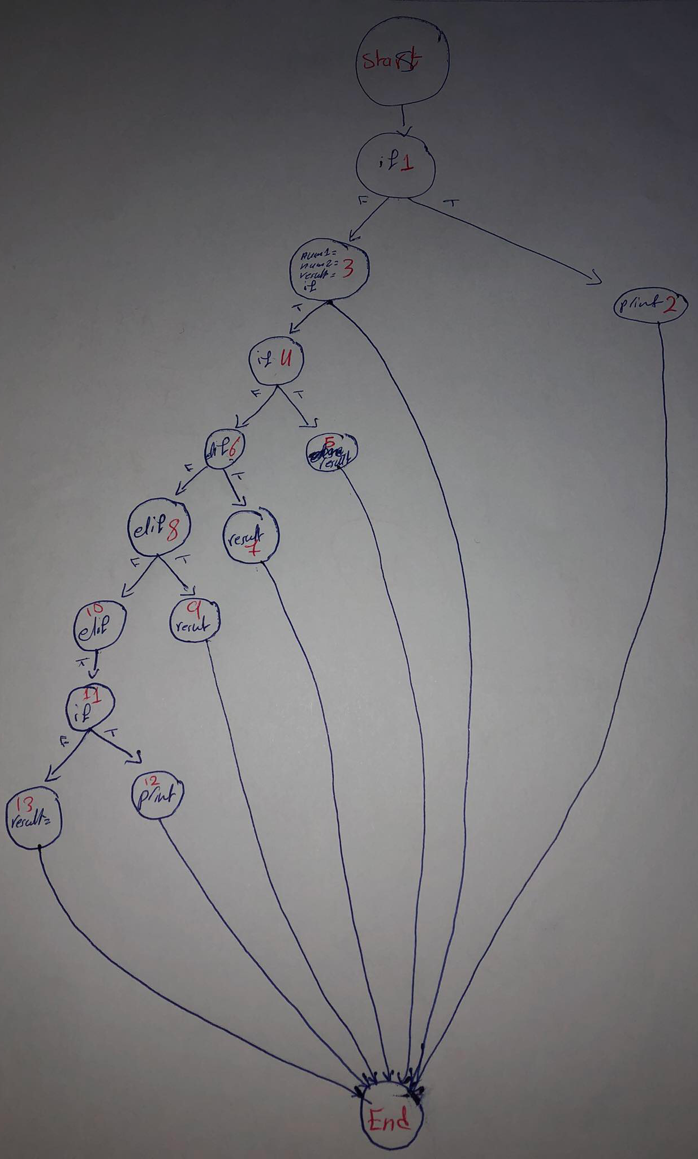

5) isExit()

F

Assume : The ”return “ & the “exception” & the “raise value error” are = “End “

1. (IGNORE THE COMMENTS)

INDEPENDENT PATH:

1. S,1,2,E statement coverage = 4/14
2. S,1,3,E statement coverage = 5/1­4
3. S,1,3,4,E statement coverage = 8/14
4. S,1,3,4,5,E statement coverage = 10/14

MIN NUMBER = 4

2)

INDEPENDENT PATH:

* S,E statement coverage = 3/3

MIN NUMBER = 1

***Or:***

* S,1,E statement coverage = 3/3

3)

INDEPENDENT PATH:

1. S,1,2,E statement coverage = 4/9
2. S,1,3,E statement coverage = 4/9
3. S,1,3,4,E statement coverage = 6/9

MIN NUMBER = 3

4)

INDEPENDENT PATH:

1. S,1,2,E statement coverage = 4/27
2. S,1,3, E statement coverage = 6/27
3. S,1,3,4,5,E statement coverage = 9/27
4. S,1,3,4,6,7,E statement coverage = 10/27
5. S,1,3,4,6,8,9,E statement coverage = 11/27
6. S,1,3,4,6,8,10,11,12,E statement coverage = 13/27
7. S,1,3,4,6,8,10,11,13,E statement coverage = 13/27

MIN NUMBER = 7

5)

INDEPENDENT PATH:

1. S,1,E statement coverage = 3/6
2. S,1,2,E statement coverage = 4/6
3. S,1,2,3,E statement coverage = 4/6

MIN NUMBER = 3