**Responsive Design:**

To make the webpage look good on all devices using HTML and CSS.

**Media Query:**

It's a technique to make the webpage responsive using the rule @media to apply certain properties if a condition is true.

**Syntax:**

**@media not|only media type and (media feature and|or|not media feature)**

**{**

**// CSS Property**

**}**

**Not Keyword:** If the conditions within not evaluate to false, the styles will apply.

Ex:

Styles will apply when the screen width is less than 600px (because the condition min-width: 600px is negated).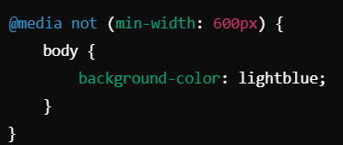

**Only Keyword:** Prevent the old browser from applying the style property.

Some older browsers would misinterpret media queries they don't recognize and apply styles improperly. The only keyword stops these browsers from applying styles.

**And Keyword:** To combine two media features and media queries.

**Media Types:**

**All:** It’s the default and for all types.

**Screen:** Targets **screens**, such as computer monitors, tablets, smartphones, and TVs.

**Speech:** For screen readers.

**Print:** creating styles that apply specifically when a user prints a webpage.

**Media Feature:**

**Max-width and max-width:** Set the maximum or minimum width for the display area of the browser.

**Max- height and max-height:** Set the maximum or minimum heightfor the display area of the browser.

Example: https://www.w3schools.com/css/tryit.asp?filename=trycss_mediaqueries_ex2