**Faker API example Get requests**

1. **User**

<http://localhost:8000/api/users/new>

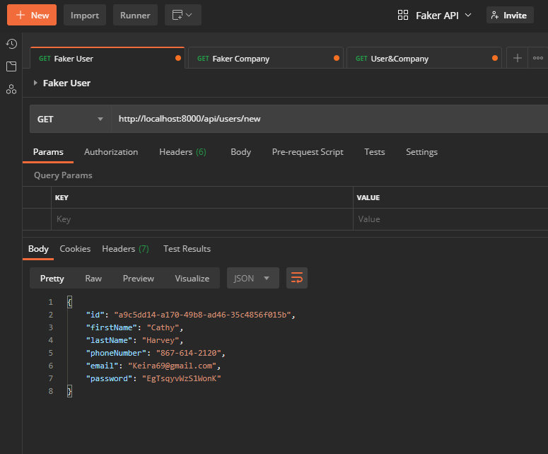

1. **Company**

<http://localhost:8000/api/companies/new>

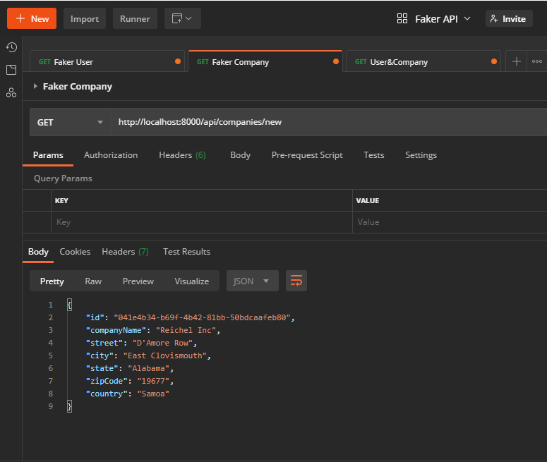

1. **User and Company**

<http://localhost:8000/api/user/company>

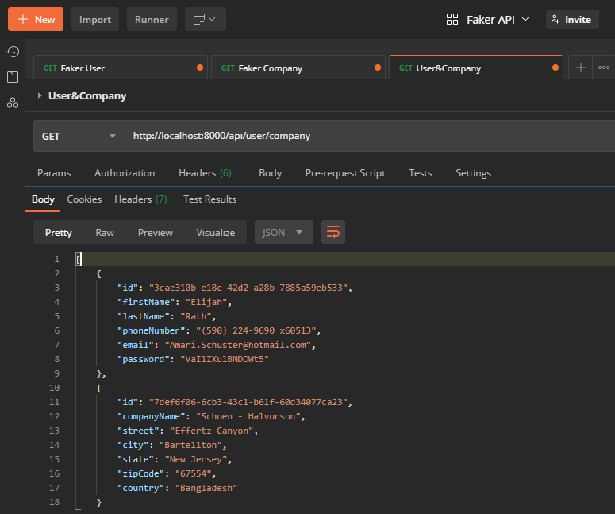

**In CMD**

