**WRO COMPETITION**

**2024**

**Pal _Dream Team**

**Car Name: Hind**

**Team Members:**

**Eng1: Rahaf Al-jabi**

**Eng2: Layan salous**

**Index:**

**Mobility management..............................................................** 3

**Power and sense management................................................** 5

**Obstacle management.............................................................** 5

**Challenges and motivations....................................................** 7

**Mobility management**

We had used Ultrasonic sensors to measure the distances and Gyro sensor to measure the orientation in order to keep the car moving straight. The care keeps moving until the left sensor gives a distance more than 70cm. at that point the car rotates left. And the same scenario was used to detect an edge on the right. we used Servo motor to steer the car direction and we used Digilent gearbox motors instead of DC due to its higher torque.

To note that, the following flowchart describe our Algorithm for Open Challenge:

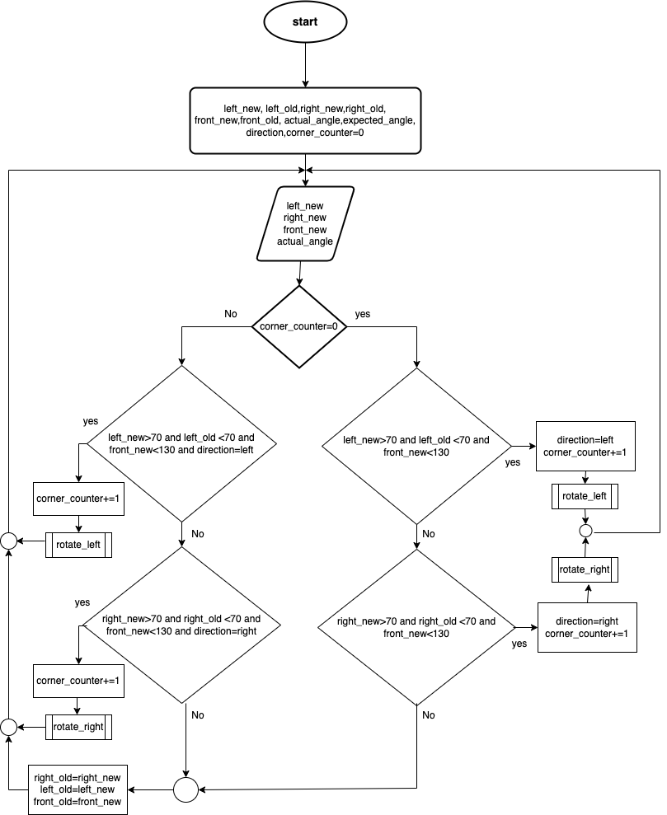

**Power and sense management**

We had used a separate power 5V for the servo motor, separate power 8V for the motors and 5V for each of Arduino and raspberry pi.

The sensors and gyro are taking the power from Arduino mega.

**Obstacle management**

We had used a raspberry pi with raspberry pi camera to capture video and analyze it frame by frame to detect the object and to know its color and location. Consequently, to decide the correct movement and the desired servo angle, we used this equation:

$$servo angle=\tan^{-1}{\frac{wheel based}{radius}}$$

Where the following flowchart describes our Algorithm in Obstacles Challenge:

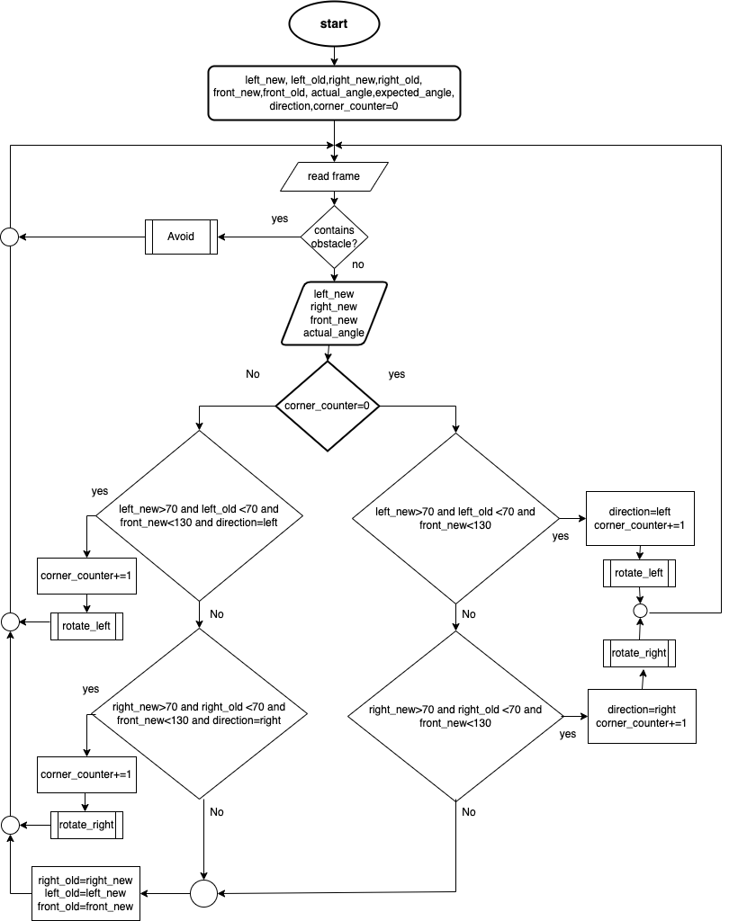

Challenges and motivations

In this part, we will mention the main challenges we faced, and the approach of fixing we followed.

1- To maintain straight-line movement in a specific direction, initially, we used ultrasonic sensors to trace the left and right distances. However, they provided some randomly illogical readings, such as zeros. Also, they provided very large distance readings when the signal has some slope with the surface, such as during rotations. in addition, they generated some delay when detecting edge.

**solution**:

we used the ToF sensor vl53l0x, but was affected by the ambient light so we switched back to ultrasonic and placed the sensor to be vertically mounted for faster edge detection. In addition, we wrote a code to handle zero and large illogical distances. Such that if the new reading is greater than 400, keep the old reading. And if the reading is equal to zero, keeps sending echoes with delays of 10 microseconds each using a gyroscope sensor. We also implemented handling in the code to manage the illogical readings.

Moreover, to maintain the straight-line movement we used the mpu6050 sensor to give the actual angle and compare it with the expected angle (desired angle).

To order the servo motor to steer the car by the required correction if needed.

We also faced a problem where the ultrasonic sensor was affected by noise, so we had to isolate the setup in a closed room.

2-it was a challenge to decide the color of the nearest obstacle because of lighting issues.

**Solution:**

we used the GIMP software for color segmentation of previously captured photos at different lighting conditions. Then from the ranges achieved, when defined masks for red color and masks for green color. Based on these masks the code defines contours around each obstacle. After that, the color of the nearest contour is decided, and based on the contour location concerning the center of the frame, the action is taken

3-We also tried using a TOF sensor, but we encountered a problem where its performance varied depending on the type of lighting. If the setup was in a room with LED lighting, the sensor responded well. However, if we placed it in a room

with different lighting conditions, its performance was inconsistent.

4-We also focused on designing an "easy model" so that if we encounter any problem with a component, we can easily replace it without having to disassemble other parts.

Initially, we used an Arduino Uno, but since the Arduino Mega has a more powerful processor, we switched to using it.

We also converted the body to metal.

We changed from DC motors to Digilent gearbox motors.

In addition to using the Arduino Mega, we also incorporated a Raspberry Pi for the image processing challenge.