**DATA INSERTION:**

**CUSTOMER TABLE:**

* insert into customer values('1101','Chandler','1714445555','chandler@gmail.com','1201','001');
* insert into customer values('1102','Joey','2223331111','joey@gmail.com','1202','002');
* insert into customer values('1103','Ross','4455552233','ross@gmail.com','1203','003');
* insert into customer values('1104','Monica','6666887799','monica@gmail.com','1204','004');
* insert into customer values('1105','Denver','9999666777','denver@gmail.com','1205','005');

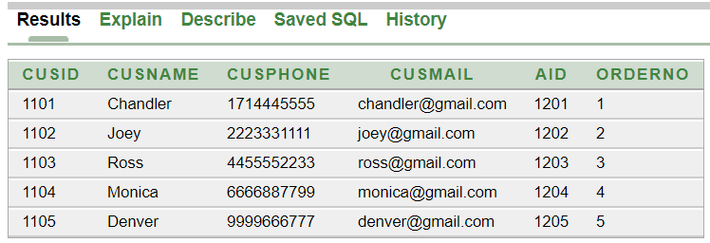

**ORDERLIST TABLE:**

* insert into orderlist values('001','12/30/2020-10AM','COD');
* insert into orderlist values('002','01/04/2021-10:20AM','Card');
* insert into orderlist values('003','01/13/2021-11AM','Card');
* insert into orderlist values('004','02/27/2021-12:30PM','COD');
* insert into orderlist values('005','03/17/2021-1PM','COD');

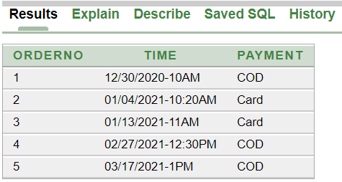

**CUSADD TABLE:**

* insert into cusadd values( '1201','New York','Broadway','42');
* insert into cusadd values( '1202','New York','Madison','78');
* insert into cusadd values( '1203','New York','Houston','23');
* insert into cusadd values( '1204','New York','Canal','7');
* insert into cusadd values( '1205','New York','Wall Street','90');

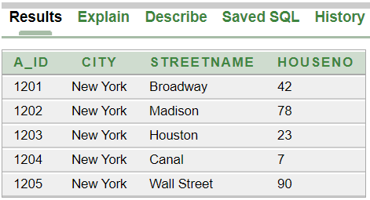

**FOOD TABLE:**

* insert into food values ('Margherita Pizza','899','6001');
* insert into food values ('Meatbox','299','6002');
* insert into food values ('Chicken Burger','299','6003');
* insert into food values ('Beef Steak','1799','6004');
* insert into food values ('Oreo Cake','700','6005');

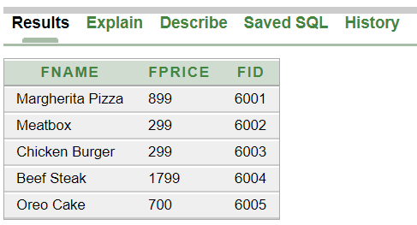

**FOREIGNKEYS TABLE:**

* insert into foreignkeys values('1101','6002');
* insert into foreignkeys values('1102','6001');
* insert into foreignkeys values('1103','6003');
* insert into foreignkeys values('1104','6005');
* insert into foreignkeys values('1105','6004');

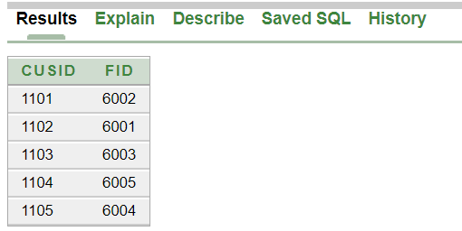

**REATAURANT TABLE:**

* insert into restaurant values('Dominos','1901','1719568426','support@dominos.com','New York','6001');
* insert into restaurant values('Khubzun','1902','71235478523','support@khubzun.com','New York','6002');
* insert into restaurant values('Chillox','1903','6521489257','support@chillox.com','New York','6003');
* insert into restaurant values('Grill House','1904','5492318764','support@grill.com','New York','6004');
* insert into restaurant values('Hot Cake','1905','9578143546','support@hotcake.com','New York','6005');

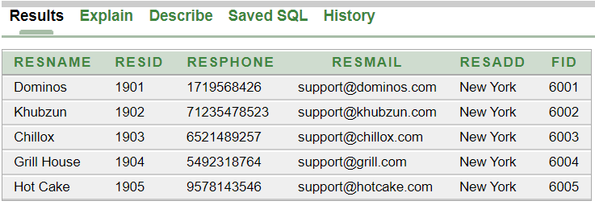

**RIDER TABLE:**

* insert into rider values('Sergio','2001','356741256','sergio@gmail.com',to_date('02-05-2017','dd-mm-yyyy'),'1900','','Houston','1101');
* insert into rider values('Silene','2002','6542549534','silene@gmail.com',to_date('16-10-2017','dd-mm-yyyy'),'1500','','Wall Street','1102');
* insert into rider values('Andres','2003','8546219547','andres@gmail.com',to_date('19-06-2019','dd-mm-yyyy'),'1400','','Madison','1103');
* insert into rider values('Anibal','2004','7965482358','anibal@gmail.com',to_date('03-04-2020','dd-mm-yyyy'),'1000','','Canal','1104');
* insert into rider values('Raquel','2005','2459631258','raquel@gmail.com',to_date('10-11-2021','dd-mm-yyyy'),'800','','Broadway','1105');

