**QUERY WRITING:**

**Single Row Function:**

**Ques:** Display the Customer Id, Name and Order No for Customer Denver.

**Ans:** select CusId, CusName, OrderNo from Customer Where Lower (CusName)= 'denver';

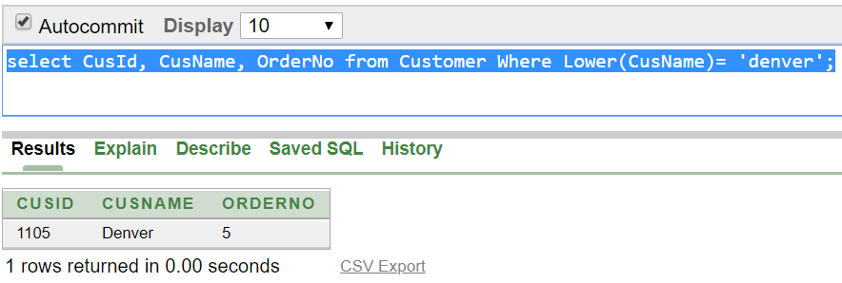

**Ques:**  Calculate and display the rounded salary of Rider Andres and Raquel after dividing salary by 300.

**Ans:** select Rname, round(sal/300) from Rider where Rname in('Andres','Raquel');

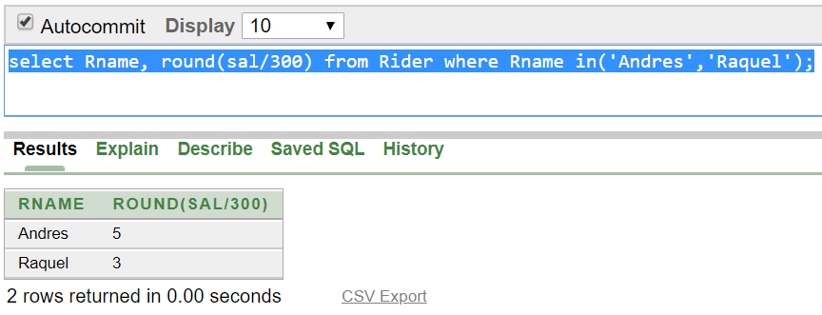

**Group Function:**

**Ques:** Find the average, minimum and maximum salary of the Riders. Label the columns AVG, MIN and MAX respectively.

**Ans:** select avg(sal) as AVG, min(sal) as MIN, max(sal) as MAX from Rider;

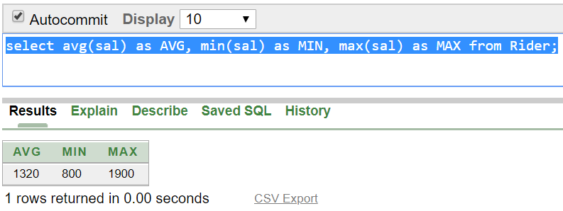

**Ques:** Display the number of Rider whose Sal is greater than 900 Tk.

**Ans:** select count (*) from Rider where sal>900;

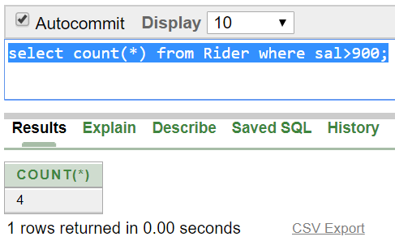

**Subquery:**

**Ques:** Display the Rider names and hire date who joined after Sergio.

**Ans:**  select Rname,hiredate from Rider where hiredate >( select hiredate from Rider where Rname='Sergio');

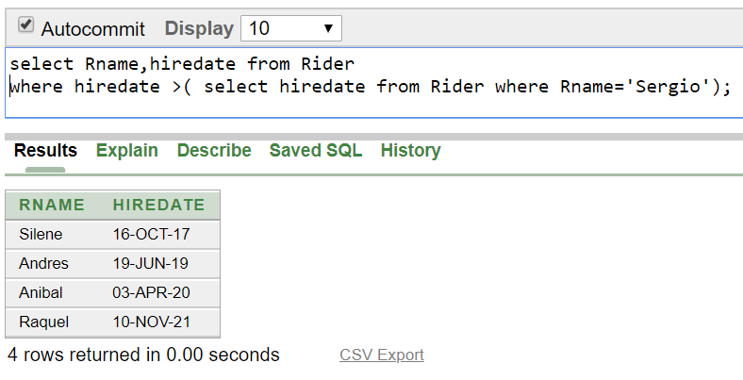

**Ques:**  Display the Rider names and salary that earn a salary that is higher than the salary of Andres.

**Ans:**  select Rname,Sal from Rider where sal > ALL ( select sal from Rider where Rname='Andres');

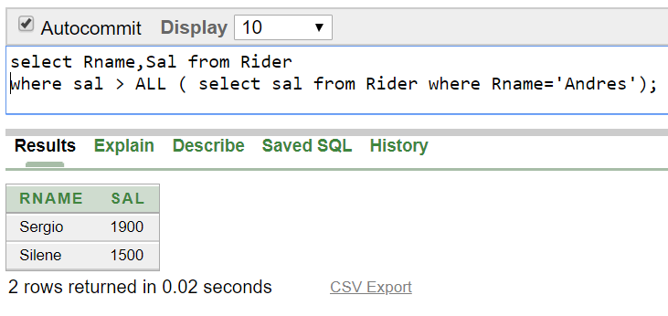

**Joining:**

**Ques:** Display the name of all the customers who lives in New York.

**Ans:** SELECT Customer.CusName,CusAdd.City FROM Customer,CusAdd WHERE Customer.Aid=CusAdd.A_id AND CusAdd.City='New York';

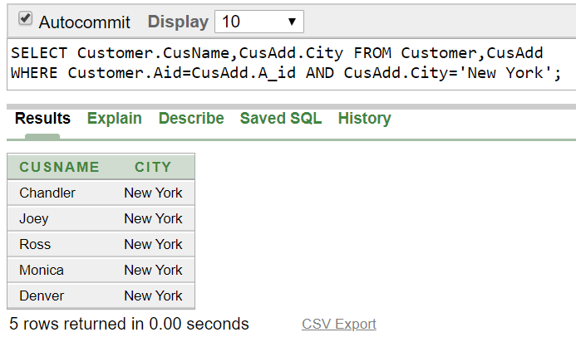

**Ques:** Write a query to display the Customer name, city,HouseNo and Street name for all Customer.

**Ans:**selectCustomer.CusName,CusAdd.City,CusAdd.StreetName,CusAdd.HouseNo FROM Customer,CusAdd WHERE Customer.Aid=CusAdd.A_id;

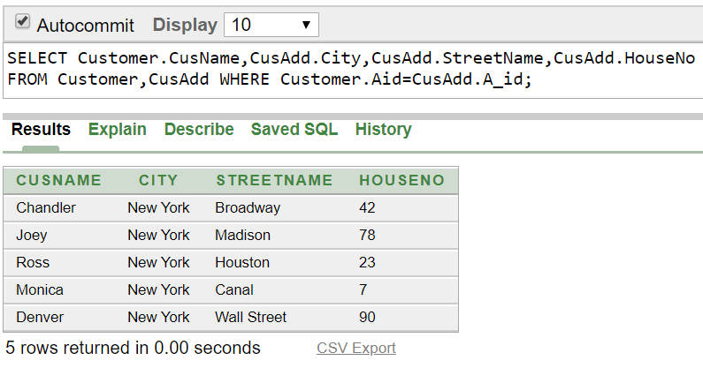

**View:**

**Ques:** Create a view called RiderLoc based on the Rname and Radd from the Rider table.

**Ans:** Create view RiderLoc as (select Rname,R_Add From Rider);

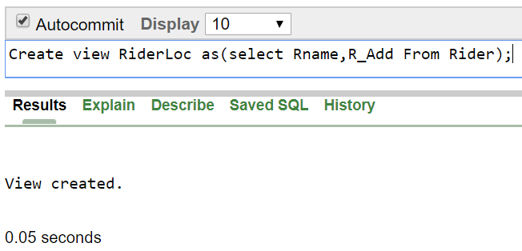

**Ques:**  Display all data From the RiderLoc View.

**Ans:** Select * From RiderLoc;

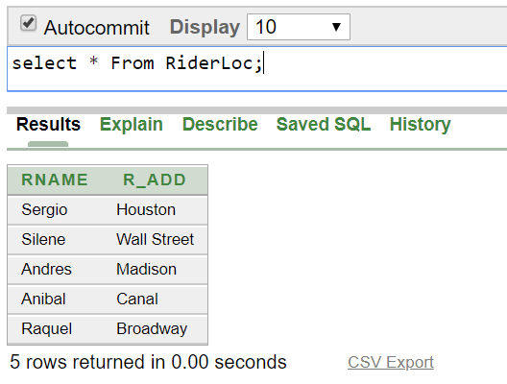

**Relational Algebra:**

Ques: Find the name of the customer which Id is 1103.

Ans: ∏CusName (σCusId= “1103” (Customer))

Ques: Find the rider who lives in Houston.

Ans: ∏Rname (σR_Add= “Houston” (Rider))

Ques: Find the name of food which price is less than 1000.

Ans: ∏Fname (σprice<“1000” (Food))

Ques: Find the name of all customer.

Ans: ∏CusName (Customer))

Ques: Find the Sal of rider Andres.

Ans: . ∏Sal (σRname= “Andres” (Rider))