**TABLE CREATION:**

1. create table Customer (CusId number (10) Primary key,CusName varchar2(20),CusPhone number(11),CusMail varchar2(40),AId number(10), OrderNo number(10));

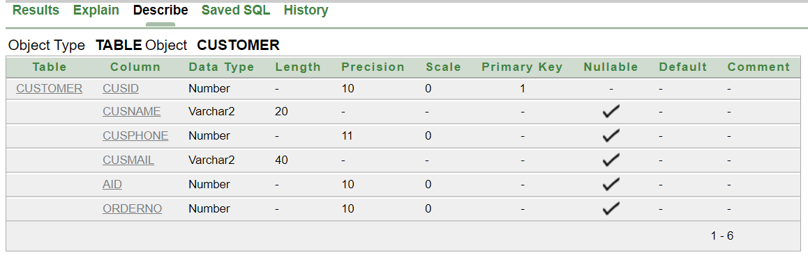

2. create table OrderList (OrderNo number (10) Primary Key, Time varchar2(20), Payment varchar2(6) check (Payment='COD' or Payment='Card'));

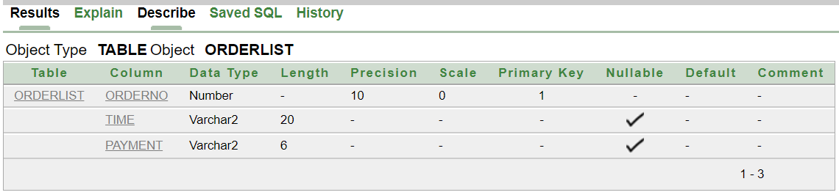

3. Create table CusAdd (A_Id number (10) Primary Key, City varchar2(20), StreetName varchar2(20), HouseNo number (10));

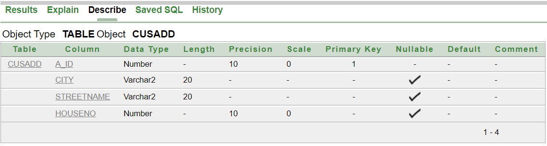

4. create table Food (Fname varchar2(20), Fprice number (10), Fid number (10) Primary Key);

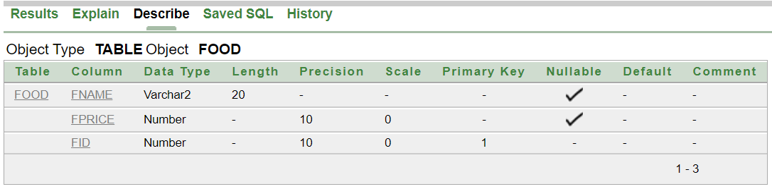

5. Create table ForeignKeys (CusId number (10), Fid number (10));

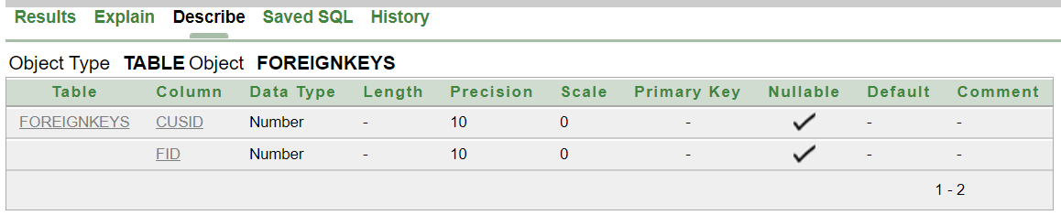

6. Create table Restaurant (ResName varchar2(20), ResId number (10) Primary Key, ResPhone number (11), ResMail varchar2(20), ResAdd varchar2(20), Fid number (10));

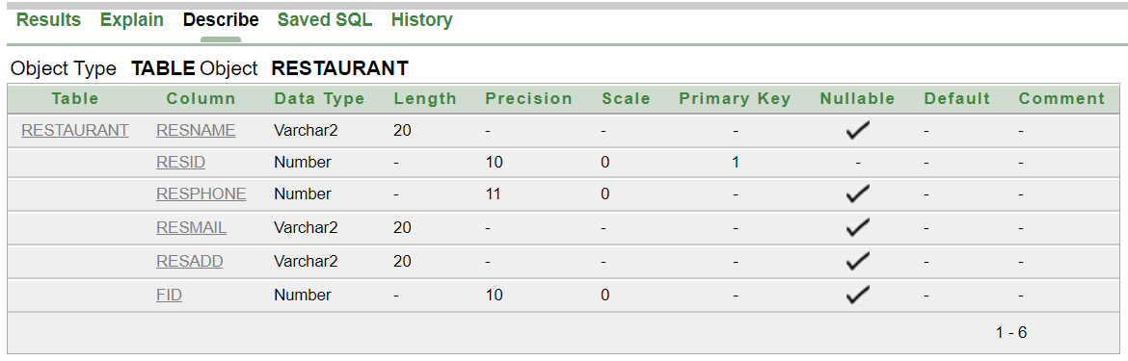

7. Create table Rider (Rname varchar2(20), R_Id number (10) Primary Key, Rphone number (11), Rmail varchar2(20), HireDate Date, sal number (10), Whour number (10), R_Add varchar2(20), CusId number (10));

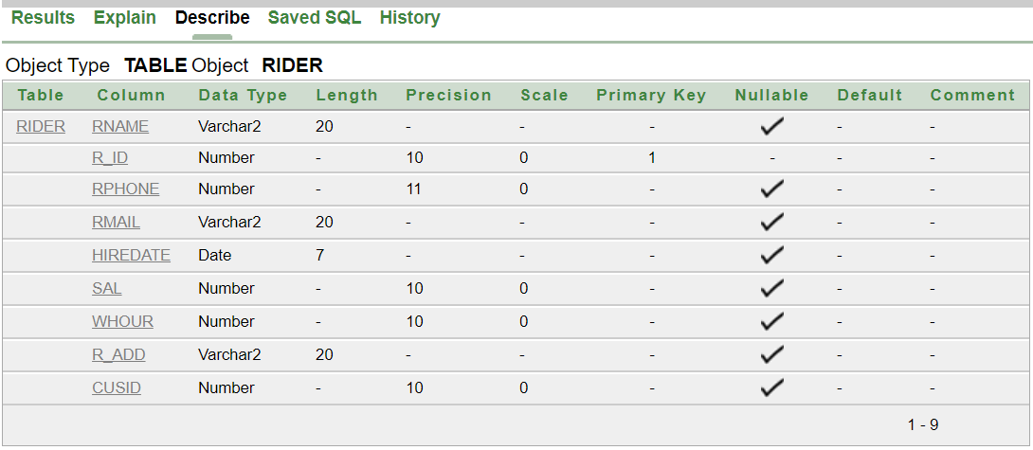

**CONTRAINTS:**

1. Alter table ForeignKeys Add Constraint FK1 Foreign Key(CusId) References Customer(CusId);
2. Alter table ForeignKeys Add Constraint FK2 Foreign Key(Fid) References Food(Fid);
3. Alter table Customer Add Constraint FK3 Foreign Key(AId) References CusAdd(A_Id);
4. Alter table Customer Add Constraint FK4 Foreign Key(OrderNo) References OrderList(OrderNo);
5. Alter table Restaurant Add Constraint FK5 Foreign Key(Fid) References Food(Fid);
6. Alter table Rider Add Constraint FK6 Foreign Key(CusId) References Customer(CusId);