**DATA INSERTION:**

**CELL TABLE:**

* insert into Cell values('1','alpha');
* insert into Cell values('2','beta');
* insert into Cell values('3','gama');
* insert into Cell values('4','charle');
* insert into Cell values('5','delta');

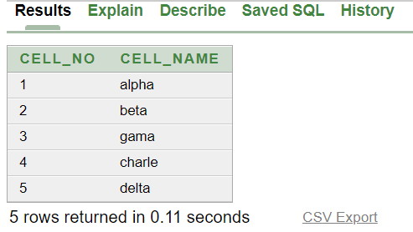

**DISTRIBUTION TABLE:**

* insert into distribution values('2001','01-JAN-17','10AM');
* insert into distribution values('2002','25-MAR-19','12AM');
* insert into distribution values('2003','13-JUN-18','11AM');
* insert into distribution values('2004','29-NOV-17','11AM');
* insert into distribution values('2005','15-FEB-20','1PM');

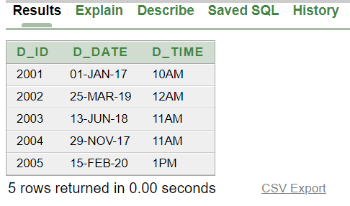

**PrisonerAddress TABLE:**

* insert into PrisonerAdd values ('3001','New York','Broadway','42');
* insert into PrisonerAdd values (3002','New York','Madison','78');
* insert into PrisonerAdd values ('3003','New York','Houston','23');
* insert into PrisonerAdd values ('3004','New York','Canal','7');
* insert into PrisonerAdd values ('3005','New York','Wall Street','90');

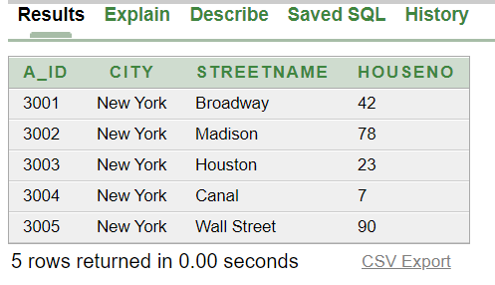

**PRISONER TABLE:**

* insert into Prisoner values

('Chandler','1001',' chandler@gmail.com','1714445555','35','1','2001','3001');

* insert into Prisoner values

('Joey','1002',' Joey@gmail.com','2223331111','25','2','2002','3002');

* insert into Prisoner values

('Ross','1003',' Ross@gmail.com','4455552233','28','3','2003','3003');

* insert into Prisoner values

('Monica','1004',' Monica@gmail.com','6666887799','40','4','2004','3004');

* insert into Prisoner values

('Denver','1005',' Denver@gmail.com','9999666777','33','5','2005','3005');

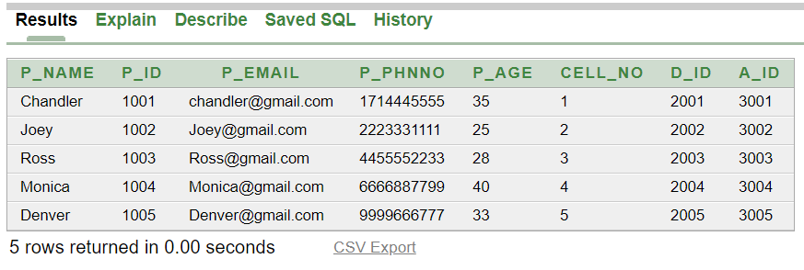

**CASE TABLE:**

* insert into Case values ('4001','assault','25-MAR-19','5 Year','1001');
* insert into Case values ('4002','arson','01-JAN-17','3 Year','1002');
* insert into Case values ('4003','child abuse','13-JUN-18','8 Year','1003');
* insert into Case values ('4004','domestic abuse','29-NOV-17','4 Year','1004');
* insert into Case values ('4005','kidnapping','15-FEB-20','10 Year','1005');

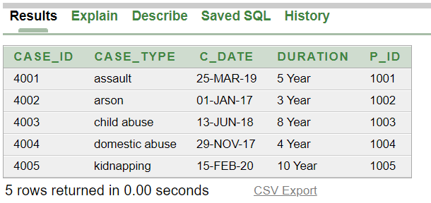

**VISITOR TABLE:**

* insert into Visitor values

('Otis Milburn','5001','11111111111','Brother','1001');

* insert into Visitor values

('Eric Effiong','5002','22222222222','Sister','1002');

* insert into Visitor values

('Maeve Wiley','5003','33333333333','Mother','1003');

* insert into Visitor values

('Jean Milburn','5004','44444444444','Wife','1004');

* insert into Visitor values

('Adam Groff','5005','5555555555','Brother','1005');

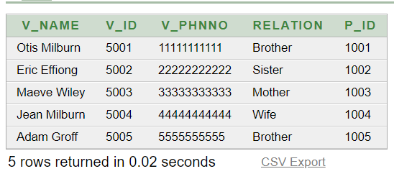

**OfficerAdd TABLE:**

• insert into OfficerAdd values ('6001','New York','Wall Street','52');

• insert into OfficerAdd values ('6002','New York','Canal','68');

• insert into OfficerAdd values ('6003','New York','Brodway','33');

• insert into OfficerAdd values ('6004','New York','Houston','14');

• insert into OfficerAdd values ('6005','New York','Madison','140');

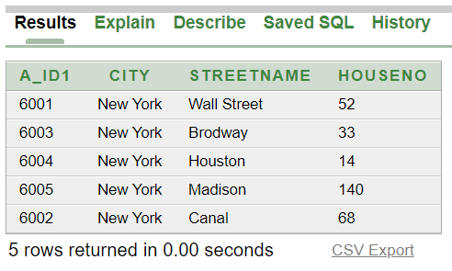

**OFFICER TABLE:**

* insert into Officer values('Tommy Shelby','7001','Tommy@gmail.com','99885544756','Enforce','1','6001');
* insert into Officer values('Arthur Shelby','7002','Arthur@gmail.com','22554488662','Supervise','2','6002');
* insert into Officer values('Michael Gray','7003','Michael@gmail.com','88552211446','Inspect','3','6003');
* insert into Officer values('Polly Gray','7004','Polly@gmail.com','66554422559','Report','4','6004');
* insert into Officer values('Ada Shelby','7005','Ada@gmail.com','11223388554','Escort','5','6005');

