**QUERY WRITING:**

**Subquery:**

**Ques:** Display the Officer names and ID who’s ID is greater than Tommy Shelby.

**Ans:**  select O_Name,O_ID from Officer where O_ID >( select O_ID from Officer where O_Name='Tommy Shelby');

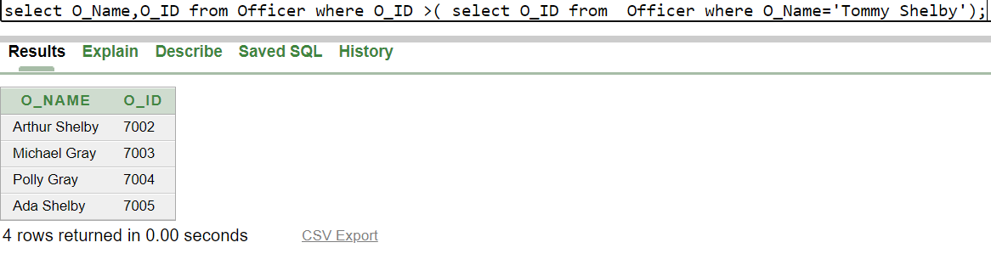

**Ques:**  Display the Prisoners names and ID who’s ID is greater than Joey.

**Ans:**  select P_Name,P_ID from Prisoner where P_ID >( select P_ID from Prisoner where P_Name='Joey');

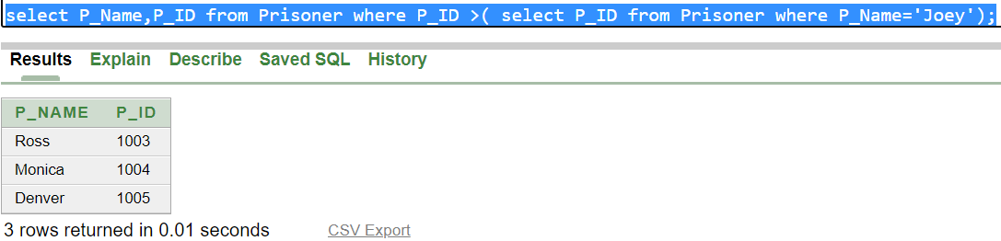

**Joining:**

**Ques:** Display the name of all the Prisoners who lives in New York.

**Ans:** SELECT Prisoner.P_Name,PrisonerAdd.City FROM Prisoner,PrisonerAdd WHERE Prisoner.A_id=PrisonerAdd.A_id AND PrisonerAdd.City='New York';

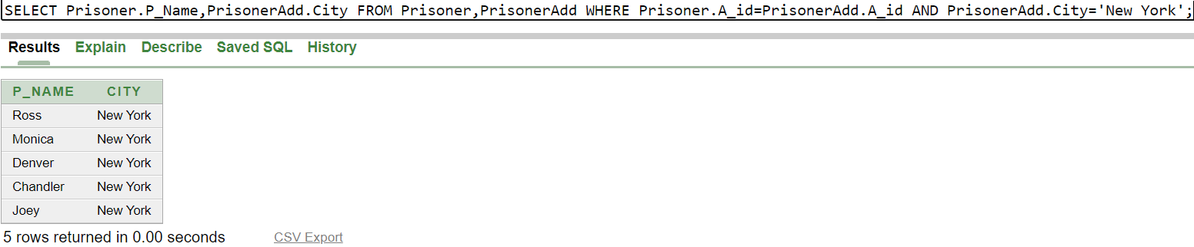

**Ques:** Write a query to display the Officer name, city,HouseNo and Street name for all Officer.

**Ans:** selectOfficer.O_Name,OfficerAdd.City,OfficerAdd.StreetName,OfficerAdd.HouseNo FROM Officer,OfficerAdd WHERE Officer.A_id1=OfficerAdd.A_id1;

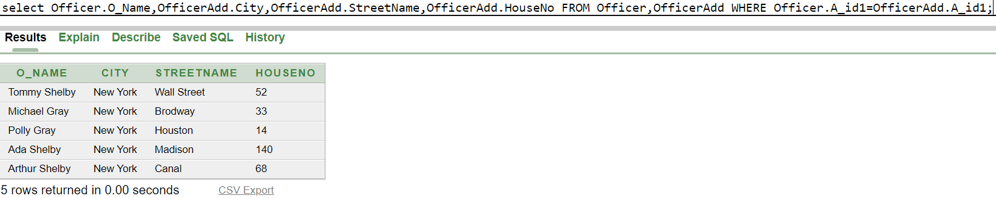

**View:**

**Ques:** Create a view called OfficerInfo based on the O_name and O_ID from the Officer table.

**Ans:** Create view OfficerInfo as (select O_name,O_ID From Officer);

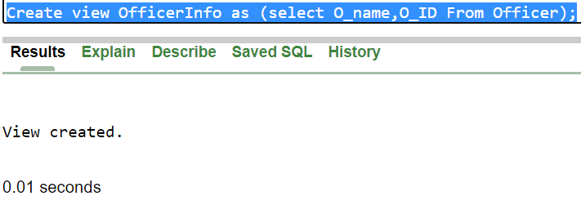

**Ques:**  Display all data From the OfficerInfo View.

**Ans:** Select * From OfficerInfo;

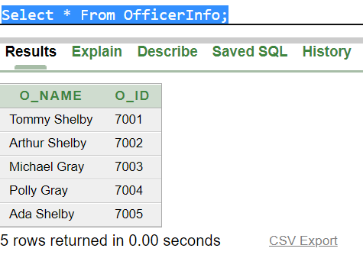

**Relational Algebra:**

Ques: Find the name of the Prisoner which Id is 1001.

Ans: ∏P_Name (σP_ID= “1001” (Prisoner))

Ques: Find the Officer who lives in Houston.

Ans: ∏O_name (σO_Add= “Houston” (Officer))

Ques: Find the name of Prisoner which ID is less than 1004.

Ans: ∏P_name (σP_ID<“1001” (Prisoner))

Ques: Find the name of all Officer.

Ans: ∏O_Name (Officer))

Ques: Find the ID of Officer 'Ada Shelby.

Ans: . ∏O_ID (σO_name= “'Ada Shelby” (Officer))