**TABLE CREATION:**

1. create table Prisoner (P_Name varchar2(40), P_ID number(10)Primary Key, P_Email varchar2(40), P_PhnNo number(11), P_Age number(10), Cell_No number(10), D_ID number(10), A_ID number(10));

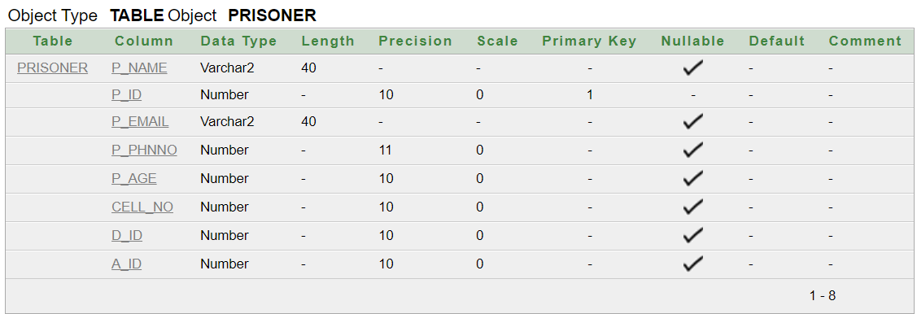

2. Create Table Officer (O_Name varchar2(40), O_ID Number(10)Primary Key, O_Email varchar2(40), O_PhnNo number(11), O_Post varchar2(20), Cell_No number(10), A_ID1 number(10));

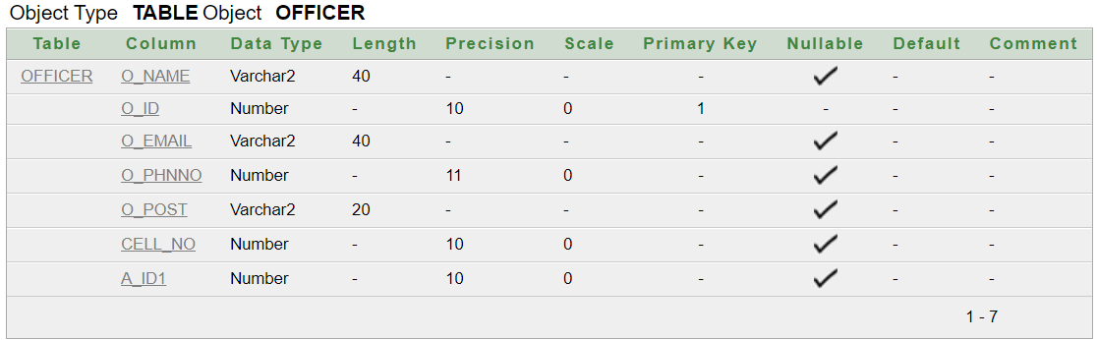

3. Create Table Case (Case_Id number(10)Primary Key, Case_Type varchar2(20), C_Date date, Duration varchar2(20), P_ID number(10));

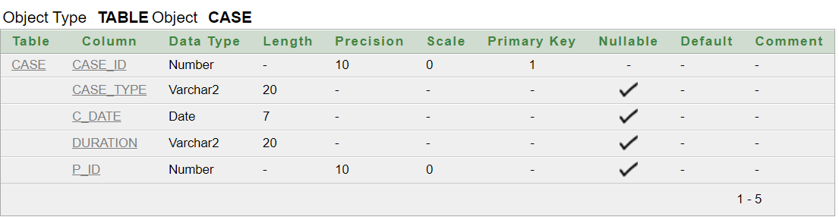

4. Create Table Visitor(V_Name varchar2(40), V_Id number(10) Primary Key, V_PhnNo number(11), Relation varchar2(20), P_ID number(10));

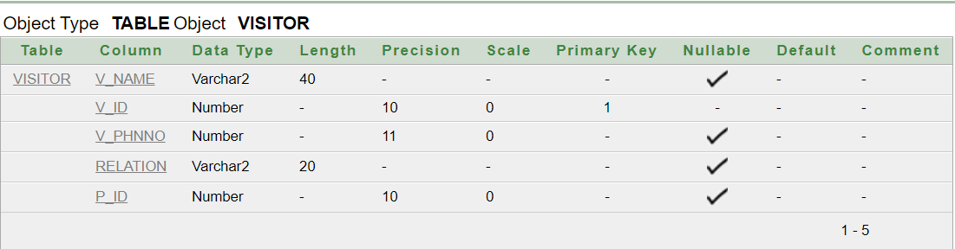

5. Create Table Distribution(D_Id number(10) Primary Key, D_Date Date, D_time varchar2(20));

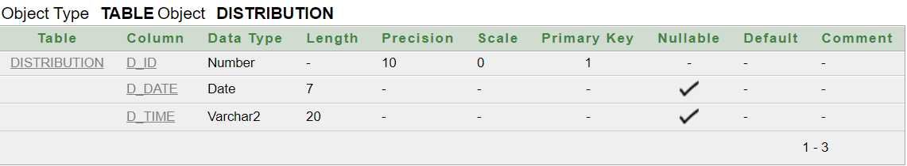

6. Create Table Cell(Cell_No number(10) Primary Key, Cell_Name varchar2(40));

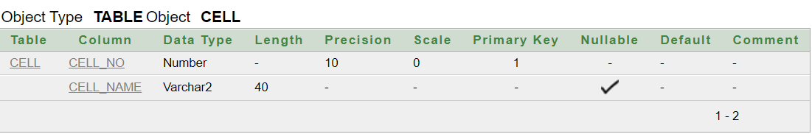

7. Create table PrisonerAdd (A_Id number (10) Primary Key, City varchar2(20), StreetName varchar2(20), HouseNo number (10));

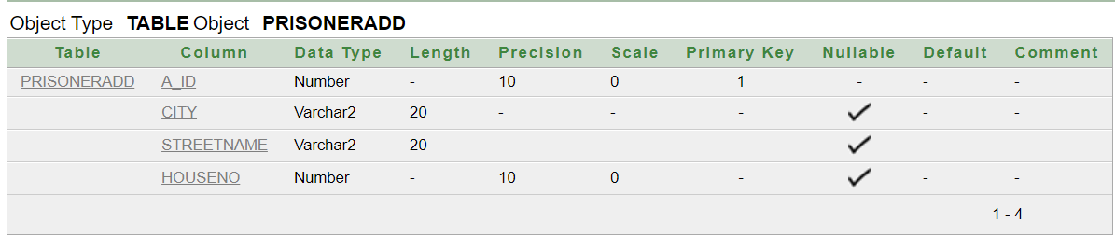

8. Create table OfficerAdd (A_Id1 number (10) Primary Key, City varchar2(20), StreetName varchar2(20), HouseNo number (10));

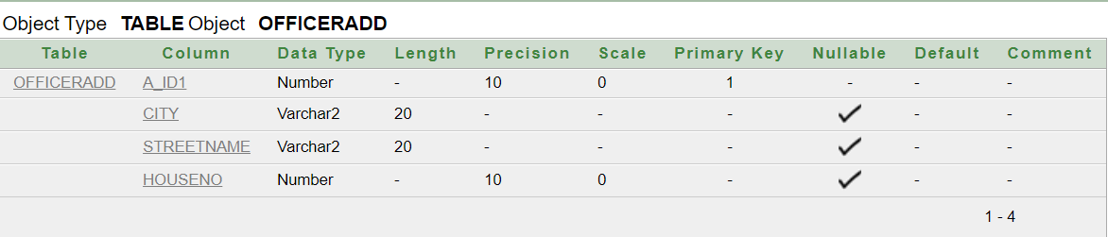

**CONTRAINTS:**

1. Alter table Prisoner Add Constraint FK1 Foreign Key(Cell_No) References Cell(Cell_No);

2. Alter table Prisoner Add Constraint FK2 Foreign Key(D_Id) References Distribution(D_Id);

3. Alter table Prisoner Add Constraint FK3 Foreign Key(A_Id) References PrisonerAdd(A_Id);

4. Alter table Officer Add Constraint FK4 Foreign Key(A_Id1) References OfficerAdd(A_Id1);

5. Alter table Officer Add Constraint FK5 Foreign Key(Cell_No) References Cell(Cell_No);

6. Alter table Case Add Constraint FK6 Foreign Key(P_ID) References Prisoner(P_ID);

7. Alter table Visitor Add Constraint FK7 Foreign Key(P_ID) References Prisoner(P_ID);