

**American International University of Bangladesh** Computer Graphics - Project Documentation

|  |  |
| --- | --- |
| Course name | Computer Graphics |
| Course Teacher | Md Masum Billah |
| Section | B |

**Group Members:**

|  |  |
| --- | --- |
| Name | Id |
| Hrichik Paul Ankan | 20-41940-1 |

**Table of Content**

|  |  |
| --- | --- |
| **Content List** | **Page No** |
| Introduction | 03 |
| Proposal | 03 |
| Schematic Diagram | 04 |
| List of Objects | 04-06 |
| Functions to Represent the Objects | 06-08 |
| Interactive Functions | 09 |
| Task Assignment and Codes of Functions | 10-11 |
| output | 12-14 |
| Conclusion | 14 |

# Introduction

The concept will showcase a seashore setting with a simplistic appearance. We created a scenario with three views: day, night, and evening. When the button is pressed, the rain will appear in each perspective. Each different scene will have a sound effect. When taken as a whole, it would produce an attractive

sea beach scene. Our application renders the objects quickly and precisely. as well as a setting meant to resemble a beach.

# Proposal

A scenario-related project. A ”cox’s Bazar view” real-world scenario will be shown. Mountain, seat, umbrella, sun, moon, stars at night, trees, sand, balloon, tower, and mill will all be present. There will be some sort of keyboard connection established. The scenario will start with a keyboard and a rain view.

# Schematic Diagram

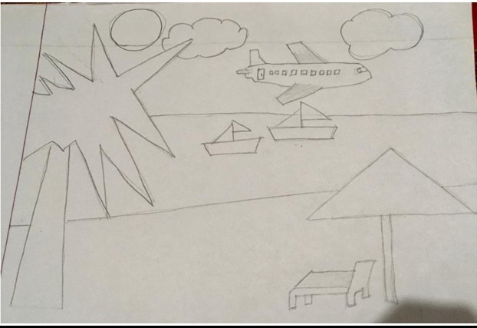

**List Of Objects**

1. Boat1
2. Boat2
3. Rain
4. Day Sun
5. Evening Sun
6. Moon
7. Cloud1
8. Cloud2
9. Bird1
10. Bird2
11. Tree
12. Umbrella
13. Seat
14. Plane
15. Balloon
16. Day sky
17. Evening sky
18. Night sky
19. Stars
20. Day sea
21. Evening sea
22. Night sea
23. Rainy sea
24. Rain Sand
25. Day Sand
26. Evening sand
27. Night sand

**Functions to Represent The objects**

|  |  |
| --- | --- |
| **Object** | **Function** |
| boat 1 | Void boat1() |
| boat 2 | Void boat2() |
| Plane | Void Plane() |
| Rain | Void rain() |
| Sun | void sun() |
| Moon | Void Mood() |
| Cloud1 | Void Cloud1() |
| Cloud2 | Void Cloud2() |
| Bird1 | Void Bird1() |
| Bird2 | Void Bird2() |
| Tree | Void Tree() |
| Umbrella | Void Umbrella() |
| Seat | Void Seat() |
| Hot Ballon | Void Hot Ballon() |
| Day Sky | Void Day Sky() |
| Evening sky | Void Evening Sky() |
| Rainy Sky | Void Rainy Sky() |
| Stars | Void Stars() |
| Night Sky | Void Night Sky() |
| Day Sea | Void Day Sea() |
| Evening Sea | Void Evening Sea() |
| Night Sea | Void Night Sea() |
| Rainy Sea | Void Rainy Sea() |
| Rainy sand | Void Rainy sand() |
| Day Sand | Void Day Sand() |
| Night Sand | Void Night Sand() |

# Interactive Functions

|  |  |
| --- | --- |
| **Interactive Functions** | **Interaction** |
| Update*sun* | sun*update* |
| update*boat*1 | boat1*update,boat*1*move* |
| update*boat*2 | Boat2*update,boat*1*move* |
| Update*plane* | Plane*move,Planeupdate* |
| update*moon* | moon*move,moonupdate* |
| update*cloud*1 | Cloud1*update* |
| update*cloud*2 | Cloud2*update* |
| update*hotballoon* | hotballoon*update* |
| update*bird*1 | Bird1*update,bird*1*move* |
| update*bird*2 | Bird2*update,bird*2*move* |
| update*rain* | rain*move,rainupdate* |

**Task Assignment and Codes of Functions**

|  |  |  |
| --- | --- | --- |
| **Name/ID** | **Contribution On project** | |
| Hrichik Paul | **1** Night sea | |
| 20-41940-1 | 1. Evening sea 2. Rainy sea 3. Cloud1 4. Big tree 5. Umbrella 6. Stand **8.** Boat1   **9.** Boat2 | |
|  | **1.** Ship1 | |
|  | 1. Rain 2. Bird 3. Evening sky 4. Night sky 5. Sea texture 6. Sea wave 7. Day sand texture 8. Event Handler | |
| **1.** Evening sea | |
| 1. Night sea 2. Day mountain 3. Evening mountain 4. Night mountain 5. Night sand 6. Evening sand   **8.**Night sand texture | |
|  | 1. Ship2 2. Seat 3. Umbrella 4. Stars 5. Tree 6. Tower 7. Day sand | |

# Output

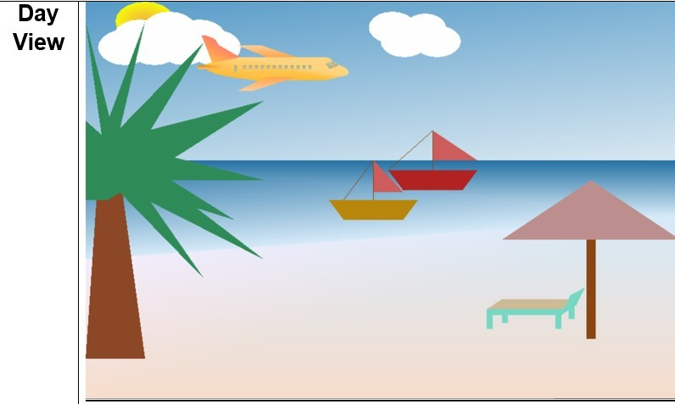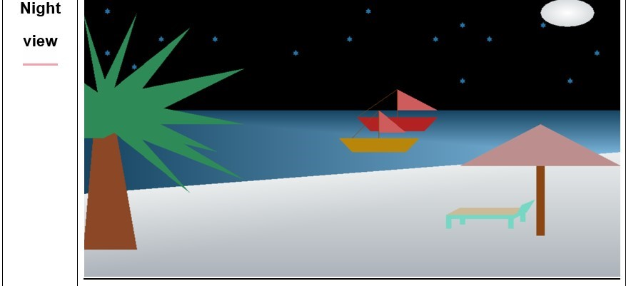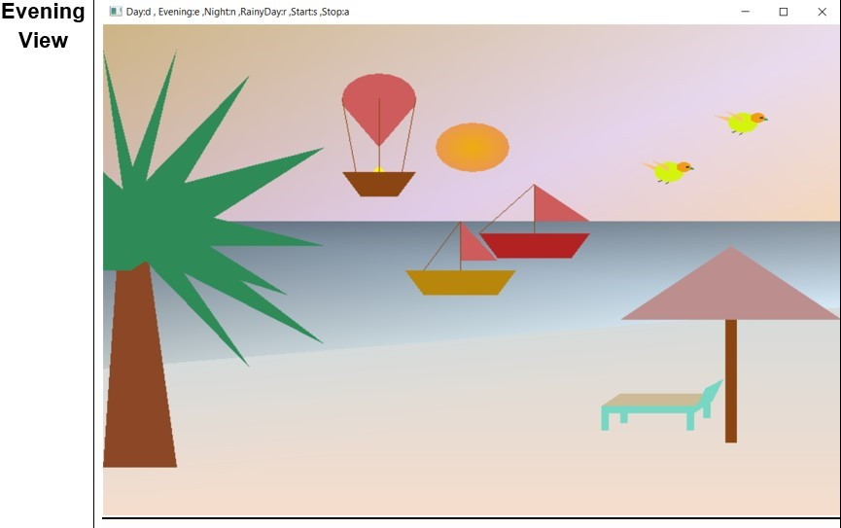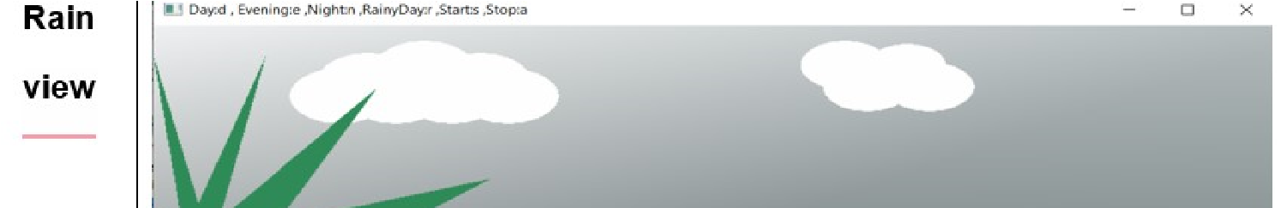

6