1.**AWS STEP FUNCTION:**

AWS Step Functions is a fully managed service offered by Amazon Web Services (AWS) that allows you to design and manage workflows for distributed applications, microservices, and serverless architectures. It provides an easy way to coordinate the components of a distributed application by defining the sequence of steps in a workflow.

Step Functions is based on *state machines* and *tasks*. In Step Functions, state machines are called *workflows*, which are a series of event-driven steps. Each step in a workflow is called a *state*. For example, a task state represents a unit of work that another AWS service performs, such as calling another AWS service or API. Instances of running workflows performing tasks are called *executions* in Step Functions.

**There are two types of workflows in AWS Step Functions:**

1. **Standard Workflows:** Ideal for long-running, auditable workflows with exactly-once execution.
2. **Express Workflows:** Suitable for high-event-rate workloads with at-least-once execution.

**Step Functions provide a visual interface to design, visualize, and debug your workflows, making it easier to manage complex processes.**

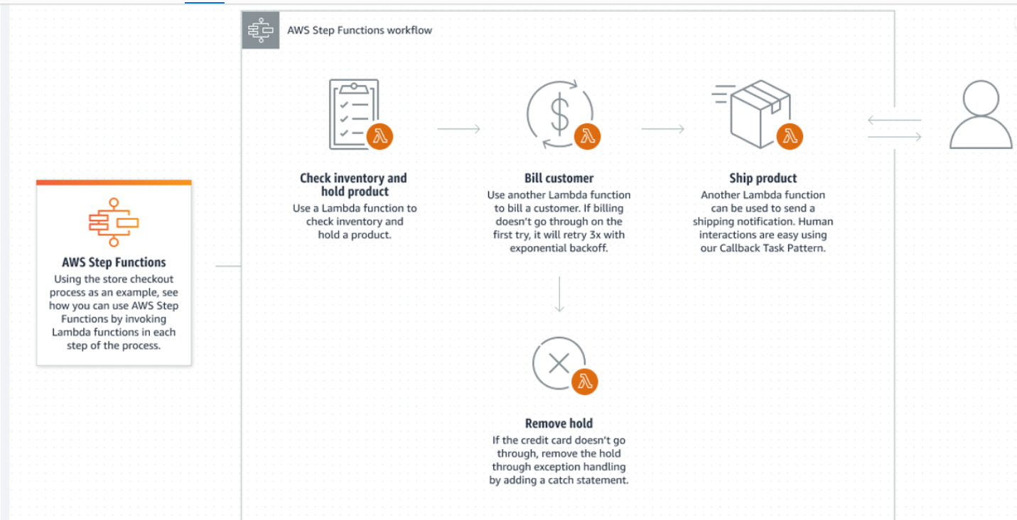

1. **AWS SQS:**

**https://www.youtube.com/watch?v=vLNDaZuA3Dc**

AWS SQS (Amazon Simple Queue Service) is a fully managed message queuing service that enables you to decouple and scale microservices, distributed systems, and serverless applications. It facilitates the communication between different components of an application by passing messages through a queue, ensuring reliable delivery and processing.

**Two Types of Queues**:

* **Standard Queues**: Provide a highly scalable, distributed message queue that guarantees **at least once delivery**, unlimited number of transactions per second. Duplicate messages occurs.
* **FIFO (First-In-First-Out) Queues**: Ensure that messages are processed in the exact order they were sent, and each message is delivered **exactly once**. FIFO queues allow up to **300 transactions per second** (TPS) for unbatched messages, and up to **3,000 TPS** for batched messages. duplicates are not possible here.

**FIFO Operations**

FIFO needs to allow two fundamental operations:

* ***dequeue*** – It lets the system remove the first element from the container.
* ***enqueue*** – The system appends/adds elements to the end of the container.

1. **what is aws scheduler**

**https://www.youtube.com/watch?v=yrUncfE7xPg**

AWS Scheduler is part of **Amazon EventBridge Scheduler**, a service that allows you to schedule and automate tasks and events. It's great for setting up recurring tasks or one-time events without having to manually trigger them each time.

**Key features include:**

* **Flexible Scheduling**: Supports cron expressions, rate-based scheduling, and one-time schedules.
* **Time Windows**: Allows for specifying start and end times for scheduled tasks.
* **Retry Policies**: Configurable retry options ensure that tasks are retried if they fail.
* **EventBridge Integration**: Easily integrates with AWS EventBridge to trigger various AWS services and applications.

**For example, :**

* Automate daily data backups.
* Trigger an AWS Lambda function at specific intervals.
* Start and stop EC2 instances based on a schedule.

1. **what is Aws api config**

You can use AWS Config to record configuration changes made to your API Gateway API resources and send notifications based on resource changes. Maintaining a configuration change history for API Gateway resources is useful for operational troubleshooting, audit, and compliance use cases.