**HTML**

**HTML (Hypertext Markup Language) is the standard language for creating webpages. It’s the skeleton that holds your content together on the web. It is created by Tim Berners-Lee In 1991 it is client side scripting language.**

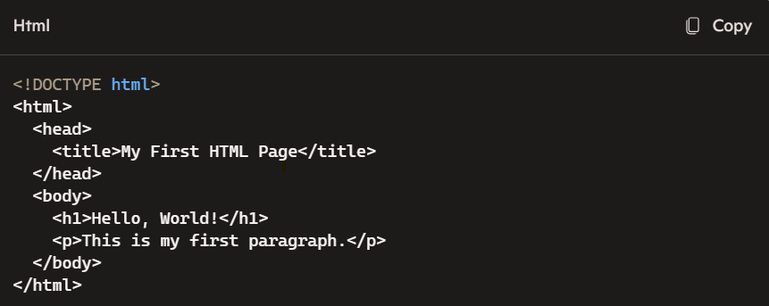

**Features of html:**

1. **It is a very easy and simple language**
2. **It can be easily understand and modified**
3. **It is basically used for the creating wed pages**
4. **It is platform independent**
5. **The extention of html file is .html (or) .htm**
6. **<a>**

<!DOCTYPE html>

<html>

<head>

<title>Anchor Tag Example</title>

</head>

<body>

<p>Visit <a href="https://www.example.com">Example.com</a></p>

</body>

</html>

1. <b>

**<!DOCTYPE html>**

**<html>**

**<head>**

**<title>Bold Tag Example</title>**

**</head>**

**<body>**

**<p><b>This text is bold.</b></p>**

**</body>**

**</html>**

1. <big>

**<!DOCTYPE html>**

**<html>**

**<head>**

**<title>Big Tag Example</title>**

**</head>**

**<body>**

**<p><big>This text is big.</big></p>**

**</body>**

**</html>**

4.<body>

**<!DOCTYPE html>**

**<html>**

**<head>**

**<title>Big Tag Example</title>**

**</head>**

**<body>**

**hello**

**</body>**

**</html>**

5.<br>

**<!DOCTYPE html>**

**<html>**

**<head>**

**<title>Line Break Tag Example</title>**

**</head>**

**<body>**

**<p>This is the first line.<br>This is the second line.</p>**

**</body>**

**</html>**

1. <button>

**<!DOCTYPE html>**

**<html>**

**<head>**

**<title>Button Tag Example</title>**

**</head>**

**<body>**

**<button type="button">Click Me!</button>**

**</body>**

</html>

1. <del>

<!DOCTYPE html>

<html>

<head>

<title>Deleted Text Tag Example</title>

</head>

<body>

<p>This is normal text. <del>This text has been deleted.</del></p>

</body>

</html>