**Creating Parameters in QuickSight**

1. **Open Your Analysis:**
   * Go to QuickSight and open the analysis where you want to add the parameter.
2. **Add a Parameter:**

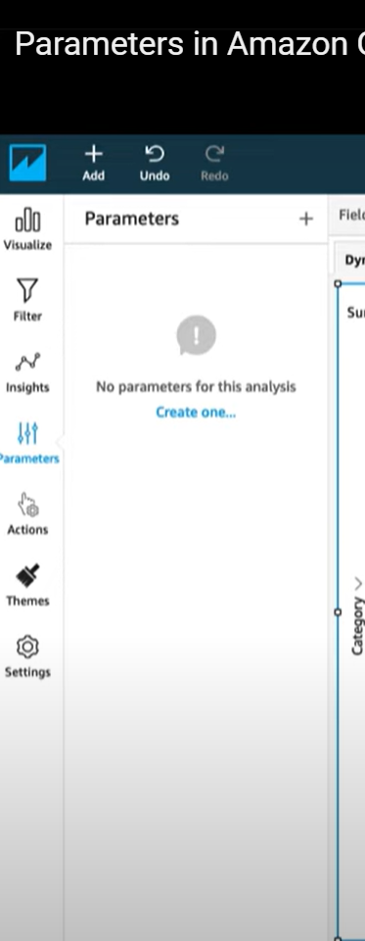

* + Click on the **“Parameters”** pane on the left sidebar.
  + Click **“+ Add”** to create a new parameter.

1. **Configure the Parameter:**
2. 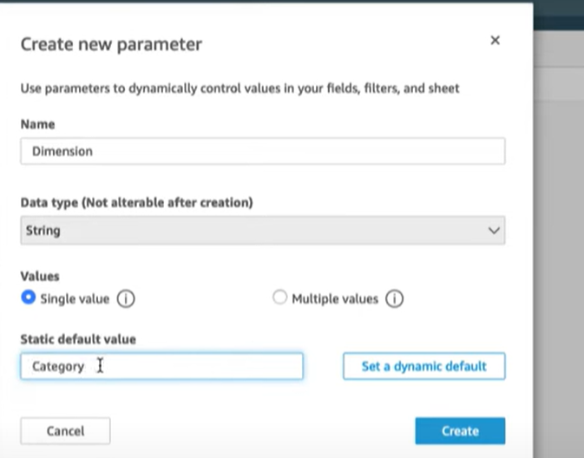
   * **Name:** Give your parameter a meaningful name.
   * **Data Type:** Choose the data type (e.g., String, Number, Date).
   * **Value Options:**
     + **Static Values:** Define a list of static values that the parameter can take.
     + **Dynamic Values:** Optionally, use a dataset to provide dynamic values.
   * **Default Value:** Set a default value for the parameter.
3. **Use the Parameter in Calculated Fields or Filters:**

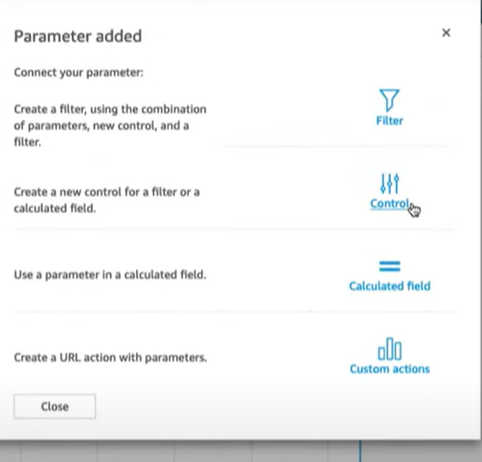

* + After creating the parameter, you can use it in calculated fields or filters.
  + For example, to filter data based on the parameter, go to the **“Filters”** pane, add a filter, and choose the parameter as the filter condition.

1. **Add a Control for the Parameter (Optional):**

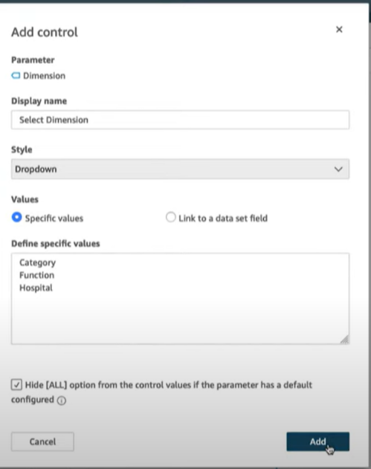

* + To make the parameter adjustable by users, add a control to your dashboard.
  + Click on **“Add control”** in the dashboard, select the parameter, and choose the control type (e.g., dropdown, slider).

1. **Apply and Save:**
   * After setting up the parameter and controls, apply them to your visuals and save your changes.

To create hyperlinks for a column in AWS QuickSight, you can use a calculated field to format the URLs and then set up the column to render those URLs as clickable links. Here’s a step-by-step guide:

2.**Creating Hyperlinks in QuickSight**

1. **Open Your Analysis:**
   * Navigate to the analysis where you want to add hyperlinks.
2. **Add a Calculated Field for Hyperlinks:**
   * Go to the **“Fields List”** pane and click **“Add”** to create a new calculated field.
   * Name your calculated field, e.g., HyperlinkColumn.
   * Use a formula to create the hyperlink. For example:

concat('https://example.com/', {YourColumnName})

* + Replace https://example.com/ with the base URL and {YourColumnName} with the field you want to link to.

1. **Add the Calculated Field to Your Table:**
   * Drag and drop the calculated field (HyperlinkColumn) into your table or visual where you want the links to appear.
2. **Set Up the Field as a URL:**
   * Click on the column header for your HyperlinkColumn in the table visual.
   * Select **“Format”** or **“Field Formatting”**.
   * Under the formatting options, find **“Data type”** and select **“URL”**. This ensures that QuickSight will render the text as clickable hyperlinks.
3. **Apply and Save:**
   * Apply the changes and save your analysis.

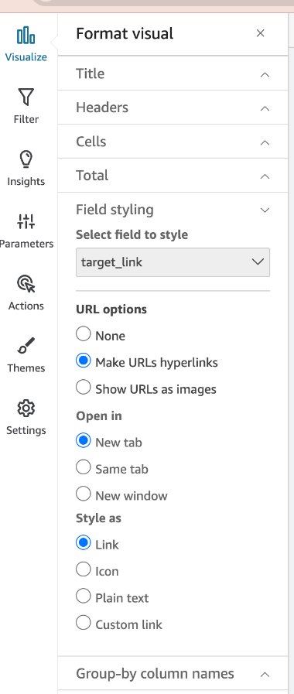

### Example

If you have a column of IDs and you want to create a link to user profiles, your calculated field formula might look like:

concat('https://profiles.example.com/user/', {UserID})

This will create a clickable link that directs to https://profiles.example.com/user/ followed by the user ID for each row.

This approach allows you to dynamically generate and display URLs in your QuickSight reports