**q1: need to calculate difference between two dates( there is issue created date and issue closed date , need to find out time length )**

**Example:**

You use the calculated field formula:

dateDiff('DD', {OrderDate}, {DeliveryDate} )

**Expected Output**

* **Input Dates**:
  + **OrderDate :** 2024-09-01
  + **DeliveryDate :** 2024-09-10
* **Calculated Difference**:
  + The difference in days is 9 days.

So, the output of the calculated field DaysToDeliver for this record will be:

o/p:

9

**Example Data in QuickSight**

| **OrderDate** | **DeliveryDate** | **DaysToDeliver** |
| --- | --- | --- |
| 2024-09-01 | 2024-09-10 | 9 |
| 2024-09-05 | 2024-09-07 | 2 |
| 2024-09-12 | 2024-09-15 | 3 |

In this table, DaysToDeliver is the result of applying the dateDiff function to the OrderDate and DeliveryDate fields.

**Example:**

Create a calculated field

**maxtime:** maxOver({End Date}, [ ] ,PRE_FILTER)

Create another calculated field to get the date difference

**datediff:** dateDiff({Created Date},maxtime,‘DD’)

[[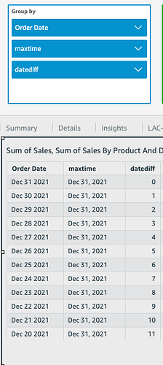](https://d1wl4jav5dp96l.cloudfront.net/original/2X/5/5cec3a6b27e33f468cb783a492140e8ab5a8d273.png)](https://d1wl4jav5dp96l.cloudfront.net/original/2X/5/5cec3a6b27e33f468cb783a492140e8ab5a8d273.png" \o "Screenshot 2023-04-17 at 09.37.16)