Retail_Sales_Analysis_SQL

-- Q.1 Write a SQL query to retrieve all columns for sales made on 2022-11-05,

select * from retail_sales
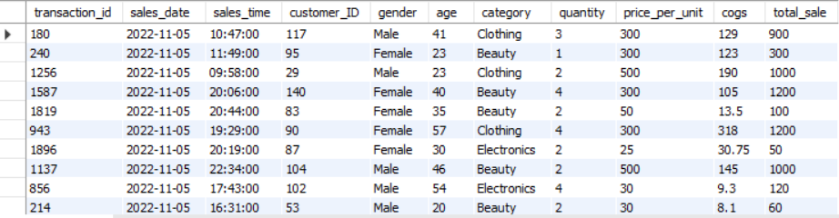
where sales_date = '2022-11-05';

-- Q.2 Write a SQL query to retrieve all transactions where the category is 'Clothing' and the quantity sold is more than 10,

SELECT * from retail_sales
where category = "Clothing" AND quantity <10;
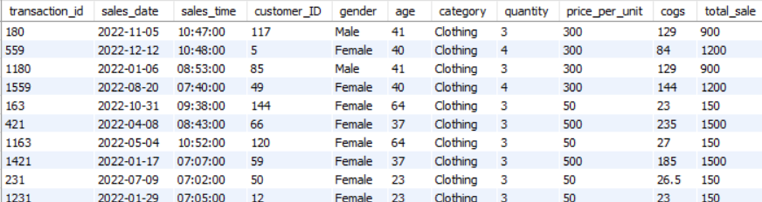

-- Q.3 Write a SQL query to calculate the total sales (total_sale) for each category.

select category, sum(total_sale) as Total_sale, count(*) as total_orders
from retail_sales
group by category;

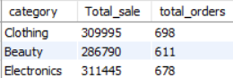

-- Q.4 Write a SQL query to find the average age of customers who purchased items from the 'Beauty' category.

select round(avg(age),2) as Avg_age, count(*)
from retail_sales
where category = "Beauty";
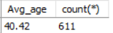

-- Q.5 Write a SQL query to find all transactions where the total_sale is greater than 1000.

SELECT *
from retail_sales
where total_sale>1000;
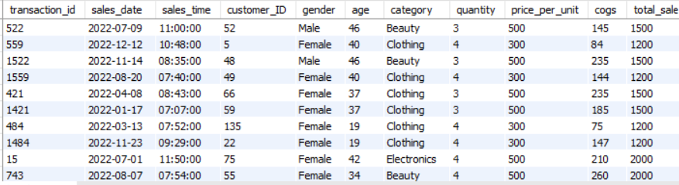
-- Q.6 Write a SQL query to find the total number of transactions (transaction_id) made by each gender in each category.

select category, count(*) as total_transaction, gender
from retail_sales
group by category, gender;
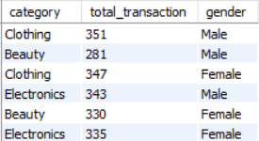
-- Q.7 Write a SQL query to calculate the average sale for each month. Find out best selling month in each year

WITH monthly_avg AS (
select
YEAR(sales_date) AS yr,
MONTH(sales_date) AS mth,
AVG(total_sale) AS avg_sale
from retail_sales
group by YEAR(sales_date), MONTH(sales_date)
),
ranked AS (
select *,
RANK() OVER (PARTITION BY yr ORDER BY avg_sale DESC) AS rnk
from monthly_avg
)
select yr, mth, ROUND(avg_sale, 2) AS avg_sale
from ranked
where rnk = 1
ORDER BY yr;
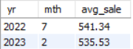

-- Q.8 Write a SQL query to find the top 5 customers based on the highest total sales

select sum(total_sale) as Total_sale, customer_id, count(*)
from retail_sales
group by customer_id
order by Total_sale desc
limit 5;
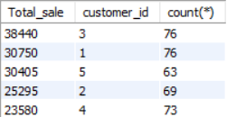

-- Q.9 Write a SQL query to find the number of unique customers who purchased items from each category.

select category,COUNT(DISTINCT customer_id) AS unique_customers
from retail_sales
group by category
order by unique_customers DESC;
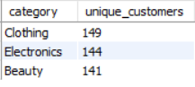

-- Q.10 Write a SQL query to create each shift and number of orders (Example Morning <=12, Afternoon Between 12 & 17, Evening >17)

WITH hourly_sale AS (
select *,
CASE
WHEN HOUR(sales_time) < 12 THEN 'Morning'
WHEN HOUR(sales_time) BETWEEN 12 AND 17 THEN 'Afternoon'
ELSE 'Evening'
END AS shift
from retail_sales
)
select
shift,
count(*) AS total_orders
from hourly_sale
group by shift
order by total_orders DESC;
