Final Project

“Analysis on Vehicles listings from Craigslist.org”

By Md Rahat Mahmud and Naga Pakalapati

# Goal

We studied used cars listed on Craigslist and visualized trends and patterns in the data in terms of market share by volume & price and popularity of cars by regions on entire dataset.

We then came up with a recommendation on the average price one has to pay for cars for daily/regular use by popularity type and top manufacturer. For this final analysis, we considered cars from year 2000 and later as older vehicles are not a good choice of regular use.

# Data Introduction

The data was originally collected from Craigslist.org. Source: [Link](https://www.kaggle.com/austinreese/craigslist-carstrucks-data)

The live Tableau dashboards used in this report: [Link](https://public.tableau.com/profile/rahat4613#!/vizhome/Project_craigslistVehiclesFull/2PricevsofCars)

We worked with following features available from the data. They include some description on what the fields are and what the values contain.

* **Main Features** o Manufacturer – Name of the Manufacturer (Ford, Chevrolet, etc.)
  + Make – Model Name (F-150, 3-series) o Fuel – Fuel Type (Gas, diesel, etc.) o Type – Vehicle Type (Sedan, coupe, etc.)
  + Year – Year of Manufacture
* **Other Features** o Transmission – Type of Transmission (Automatic, manual, etc.)
  + Drive – Wheel Drive (FWD, RWD, 4WD, etc.) o Cylinders – No of Cylinders (4,6, 8, etc.) o Size – Size of the Car (Full size, compact, etc.)
  + Pain Color – Color of the Car
* **Place**
* County Name o City o State
* **Measures** 
  + Price – Listed Price of the Car
  + Odometer – Total Miles on the Vehicle (Odometer Reading) o Number of Records – Total Amount of Records

# Data Cleaning

Below steps were taken to the raw data before the analysis.

* Removed **URL** and **Image url** columns from the dataset
* Grouped together data from the same manufacturer but with different names o alfa, alfa-romeo o aston, aston-martin o chev, chevy, chevrolet
  + mercedes, mercedes-benz, mercedesbenz
  + landrover, land rover
  + infinity, infinity o volkswagen, vw
* Data has many ‘**null**’ values which were filtered out from the analysis
* Data has ‘**FAILED**’ category in the State Names, which was filtered out from the analysis

# Exploratory Analyses

## Market Share by Volume and Price

The below chart gives market share by total cars in the market and total value of those cars per manufacturer. We can clearly see that Ford and Chevrolet take the top 2 spots in both segments. However, Chevrolet’s value is more than twice that of Ford.

It would be interesting to see why, with a small difference in total car share, there is a huge variation in value.

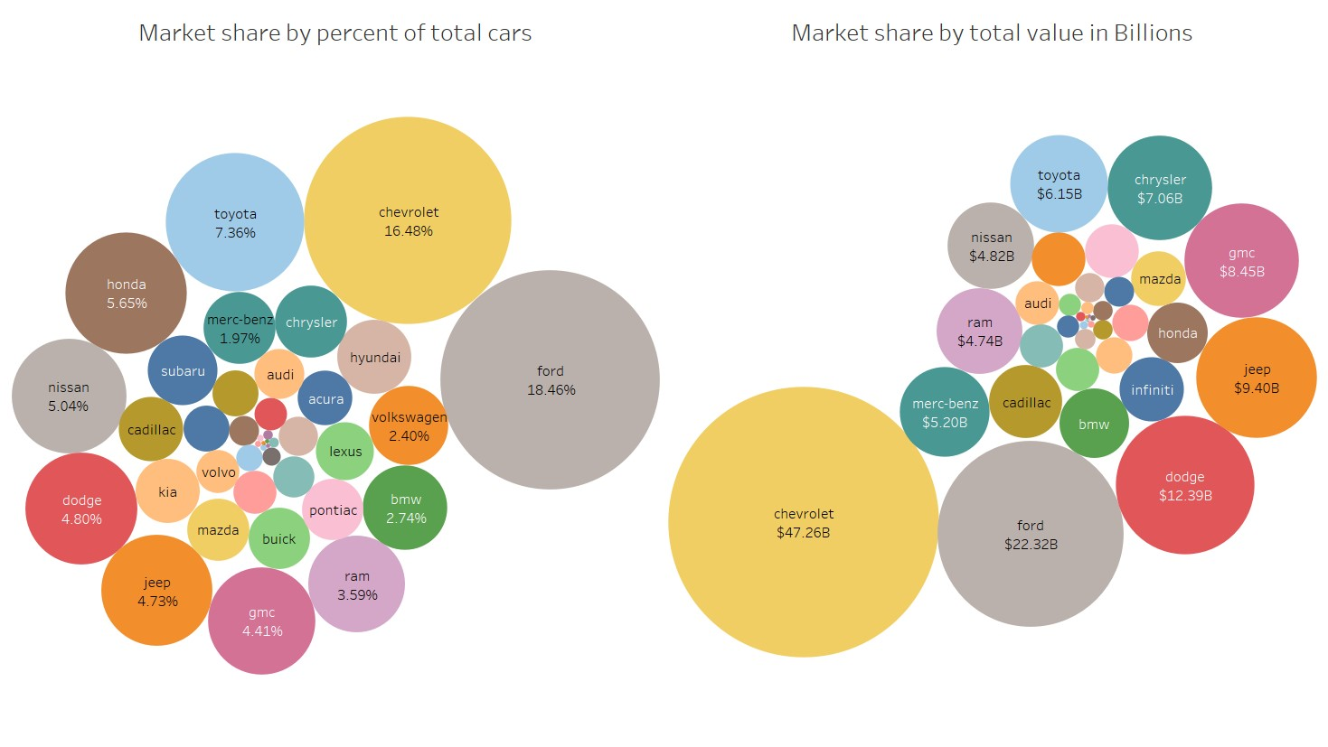

Link: [Live Dashboard](https://public.tableau.com/views/Project_craigslistVehiclesFull/1MarketShare?:display_count=y&:origin=viz_share_link)

To understand the above variation, we see the distribution of number of cars and total price over the years to get an idea on value of recent cars and older cars and then check this comparison for only Chevrolet and Ford.

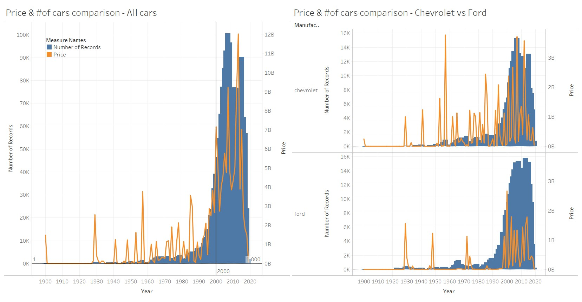

Link: [Live Dashboard](https://public.tableau.com/views/Project_craigslistVehiclesFull/2PricevsofCars?:display_count=y&:origin=viz_share_link)

We can see that the total price is approximately in proportional to number of cars for the recent years but it’s the opposite for older cars. We see a lot of spikes in price for very small number of cars. This might be a result of the older cars being tagged as vintage with high price.

When we drew this comparison between Ford and Chevrolet, it happens that the above trend continues but there are a lot of spikes for older cars in Chevy compared to Ford and hence the difference.

Here are the top 10 manufacturers by number of available cars in the market and their total value in billions for the cars made from 200 and later. We see a mix of American and foreign brands and their share in the reseller market.

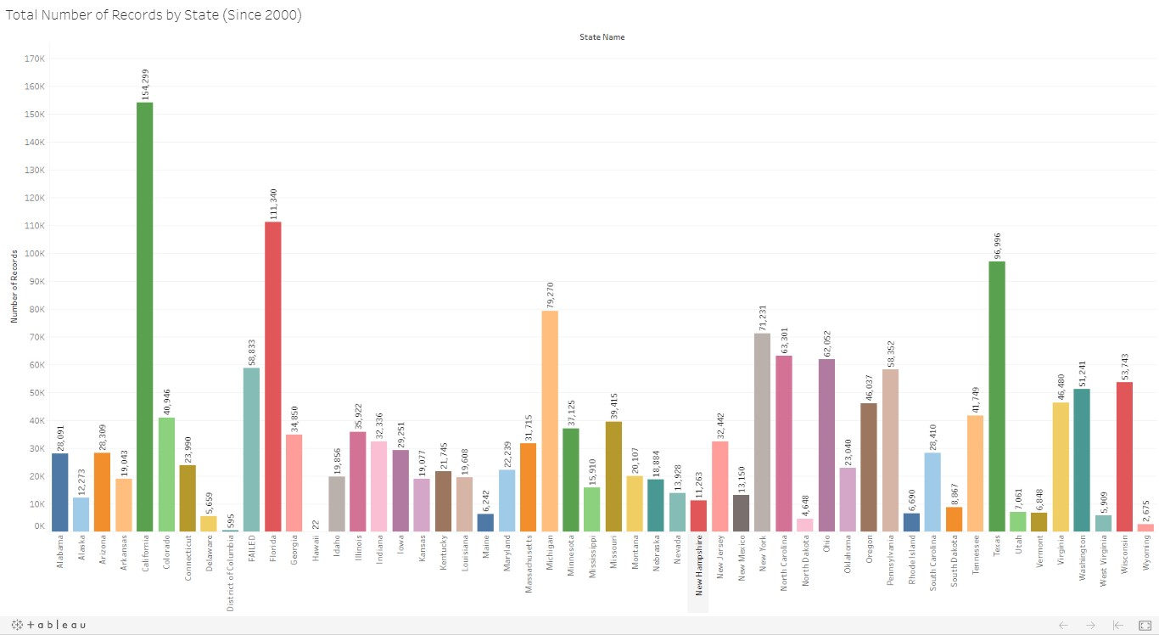

Link: Live [Dashboard](https://public.tableau.com/views/Project_craigslistVehiclesFull/Sheet12?:display_count=y&:origin=viz_share_link)

## Popularity of Cars by Region

Now, we will see the popularity of manufacturers and types of cars in specific regions of the USA. In the below chart, we can see which regions of the USA have the highest number of records for cars since 2000:

Going forward, we will look at the records pertaining to the top 3 regions with the highest number of records: California, Florida and Texas.

Looking at the below graphs, it can be seen that:

* California o Top 5 Manufacturers: Ford, Chevrolet, Toyota, Honda, Nissan o Top 5 Types of Vehicles: Sedan, SUV, Pickup, Truck, Coupe
* Florida o Top 5 Manufacturers: Ford, Chevrolet, Toyota, Nissan, Honda o Top 5 Types of Vehicles: Sedan, SUV, Pickup, Truck, Coupe
* Texas

o Top 5 Manufacturers: Ford, Chevrolet, Toyota, Nissan, Ram

o Top 5 Types of Vehicles: SUV, Sedan, Pickup, Truck, Coupe

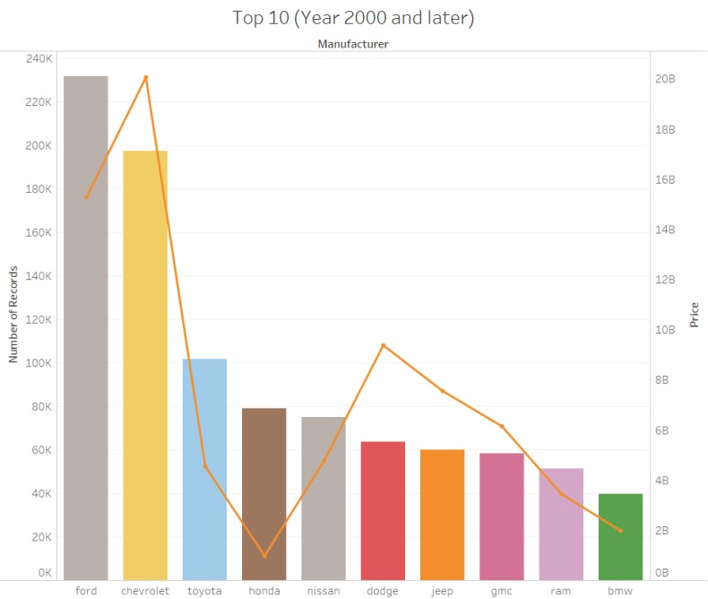

Link: [Live Dashboard](https://public.tableau.com/views/Project_craigslistVehiclesFull/3Top10?:display_count=y&:origin=viz_share_link)

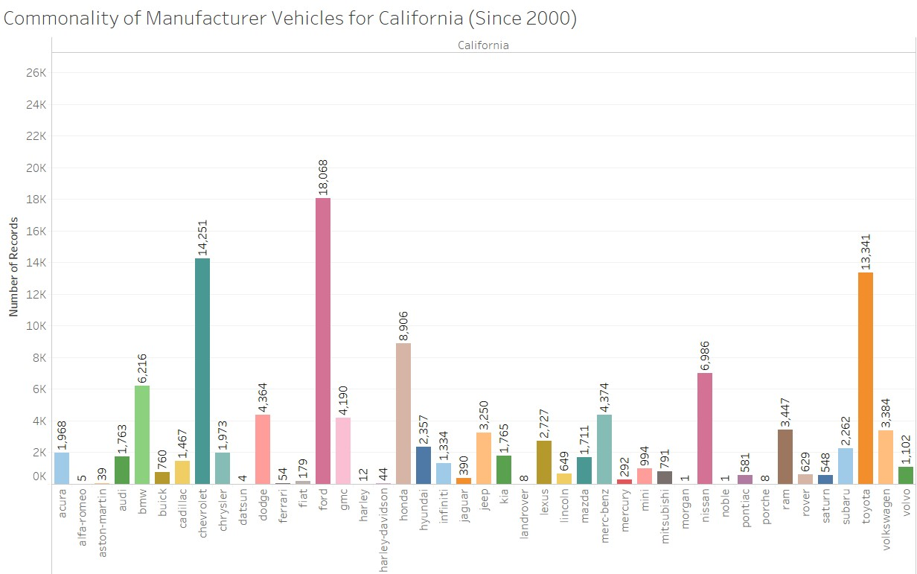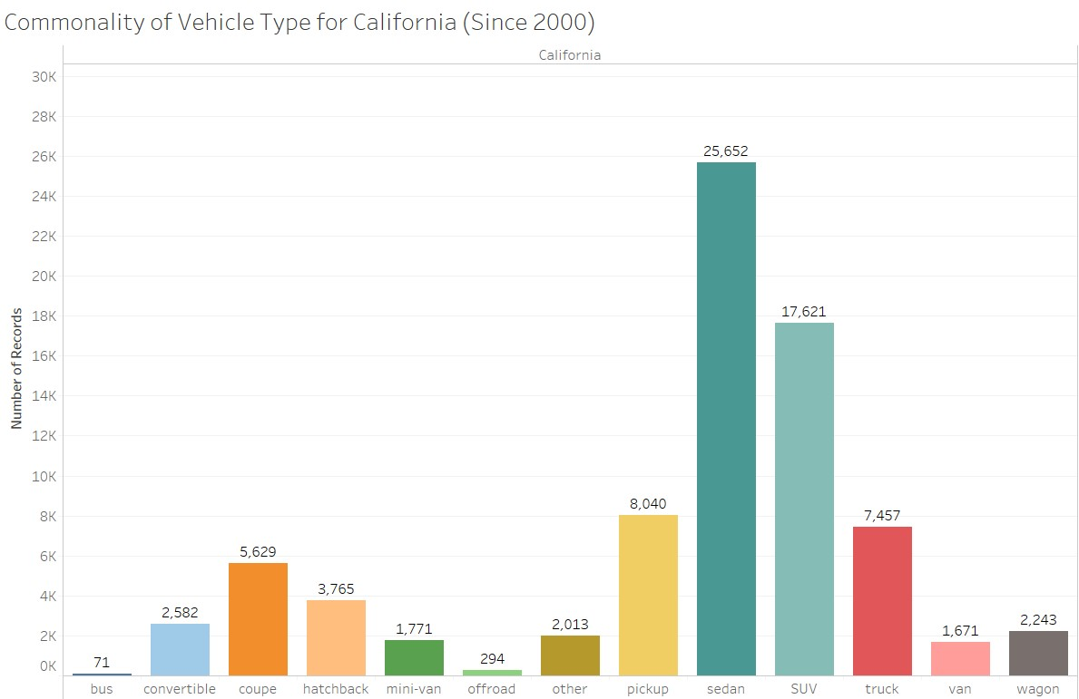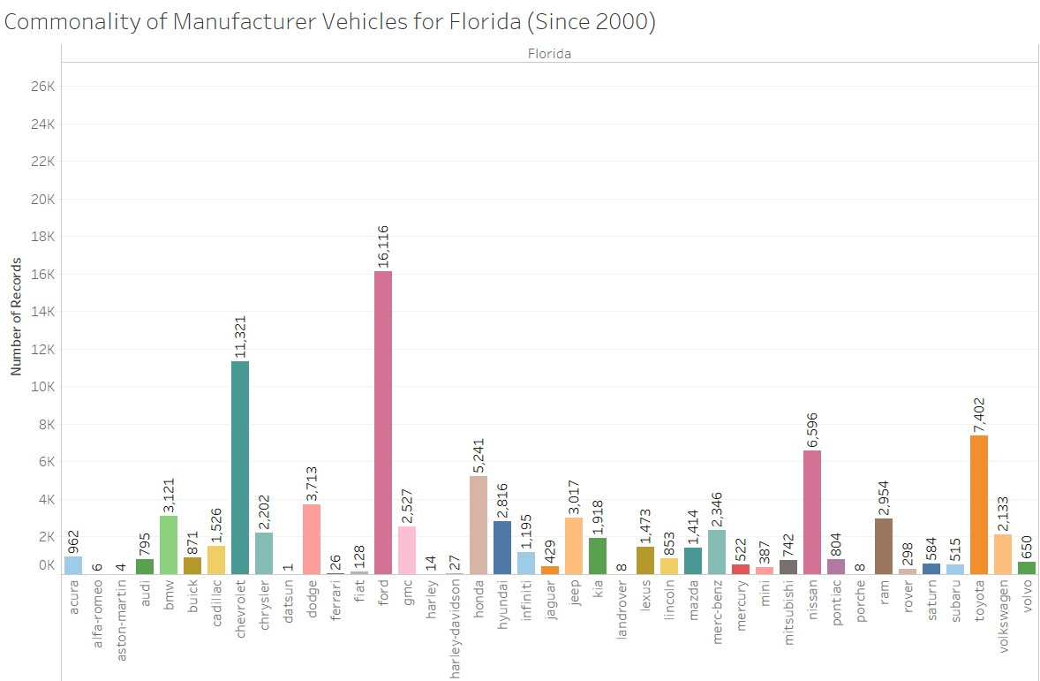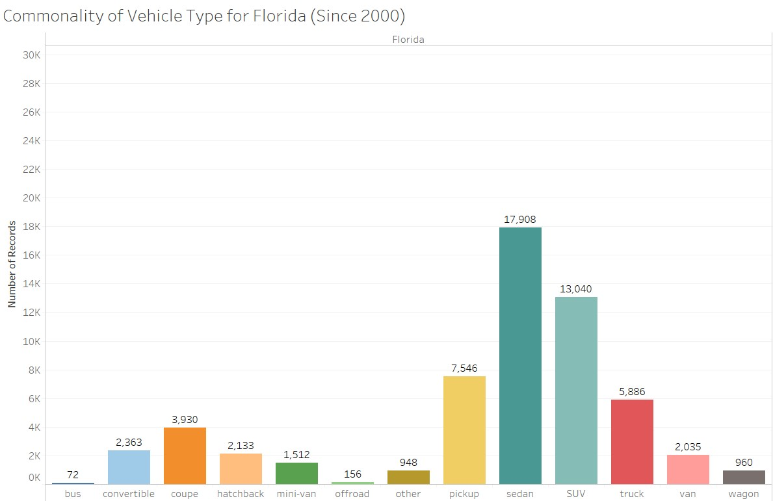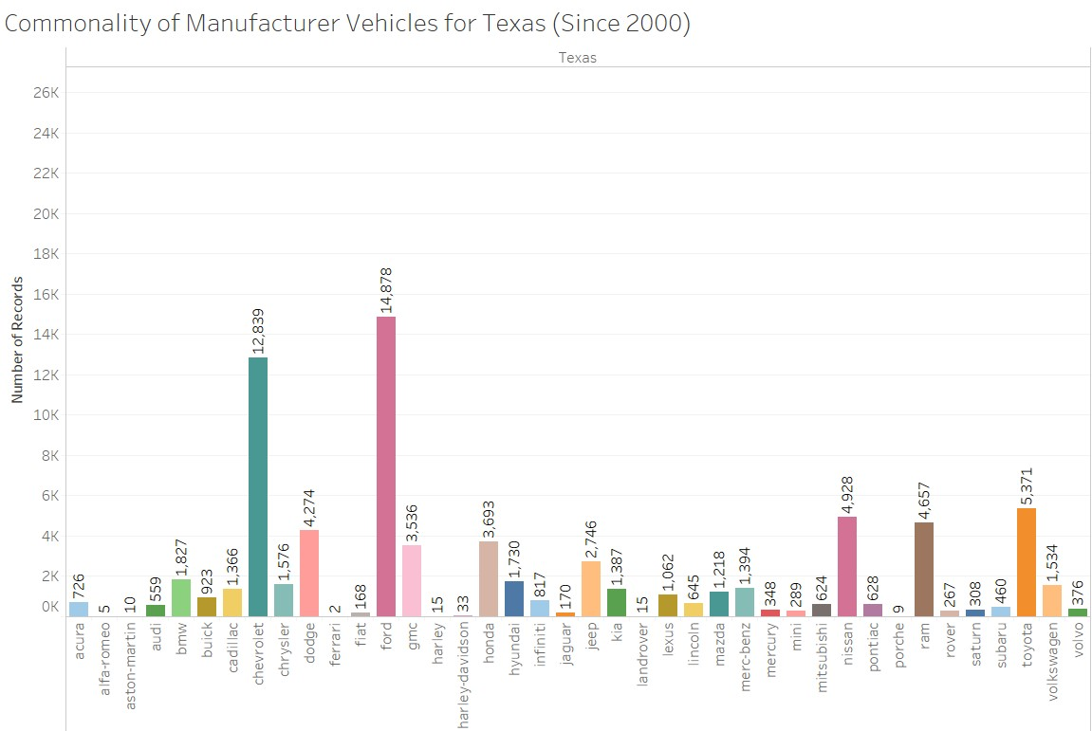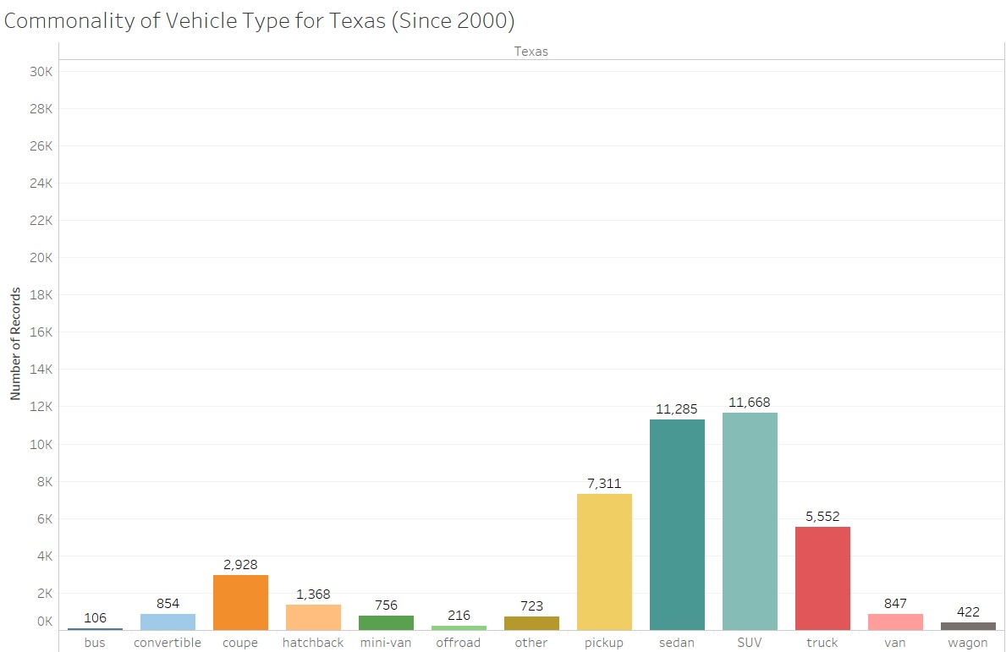

It can be determined that, among the three states looked at:

* Ford, Chevrolet & Toyota were the most popular manufacturers (since 2000)
* Sedan & SUV were the most popular types of vehicles (since 2000)

A quick glance at other regions in the USA showed that these observations remained consistent across all other regions, with only slight variation among certain regions. For example:

Hawaii, the region with the lowest number of records (possibly due to Hawaii being a chain of islands), had Ford as the most popular manufacturer (with a record number of 4) and no records for Chevrolet. There were also no records for vehicle types Sedan or SUV.

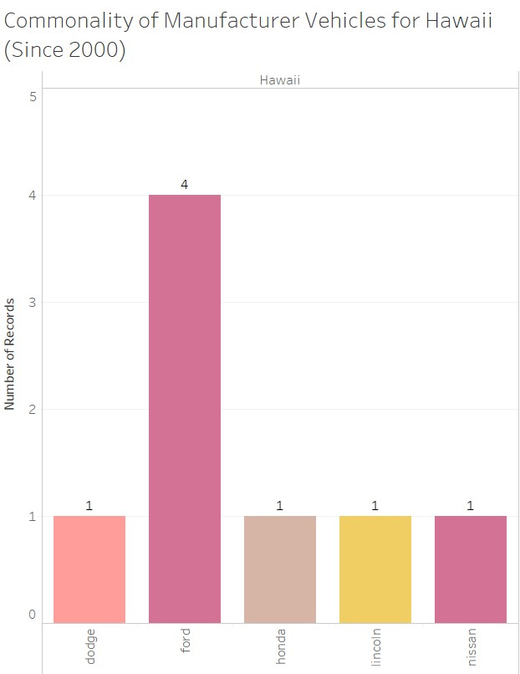 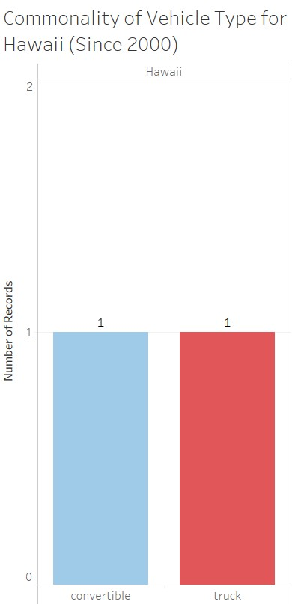

However, it should be noted that while the Sedan & SUV may be the most popular types of vehicles in all three chosen states overall, they are not the most popular types of vehicles within Ford & Chevrolet:

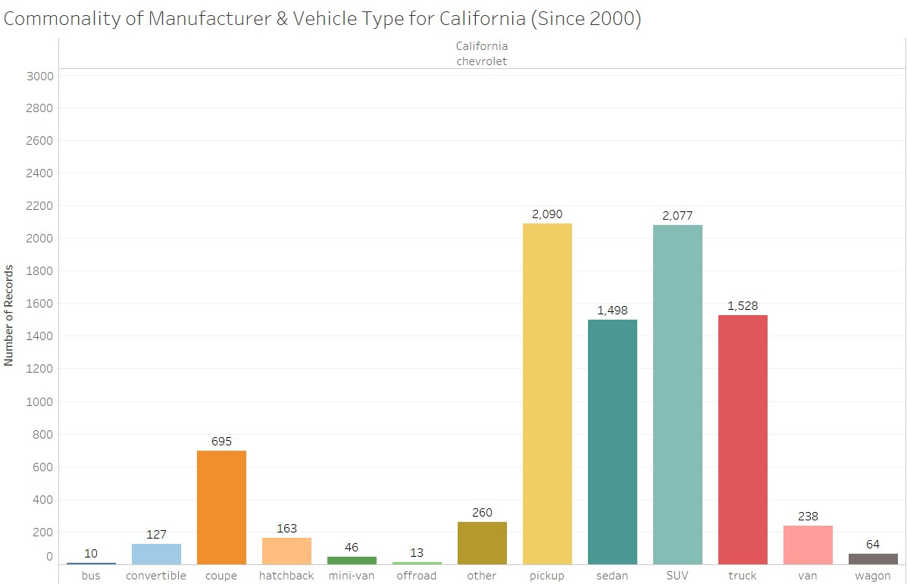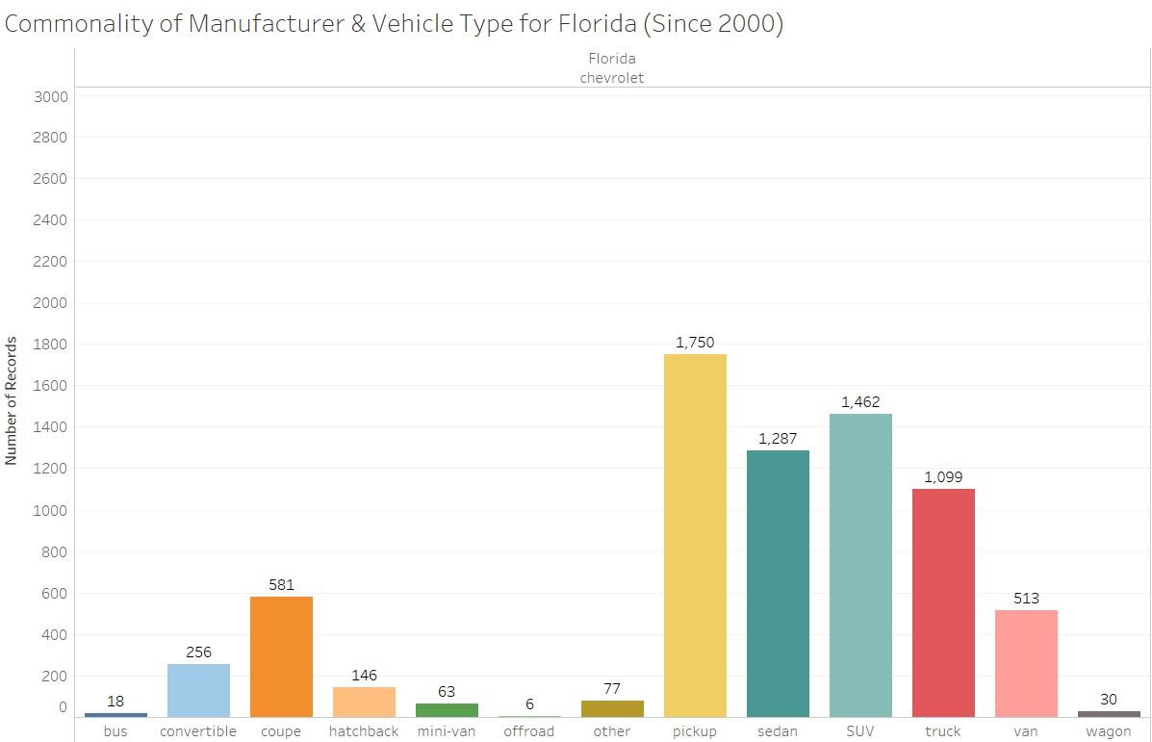

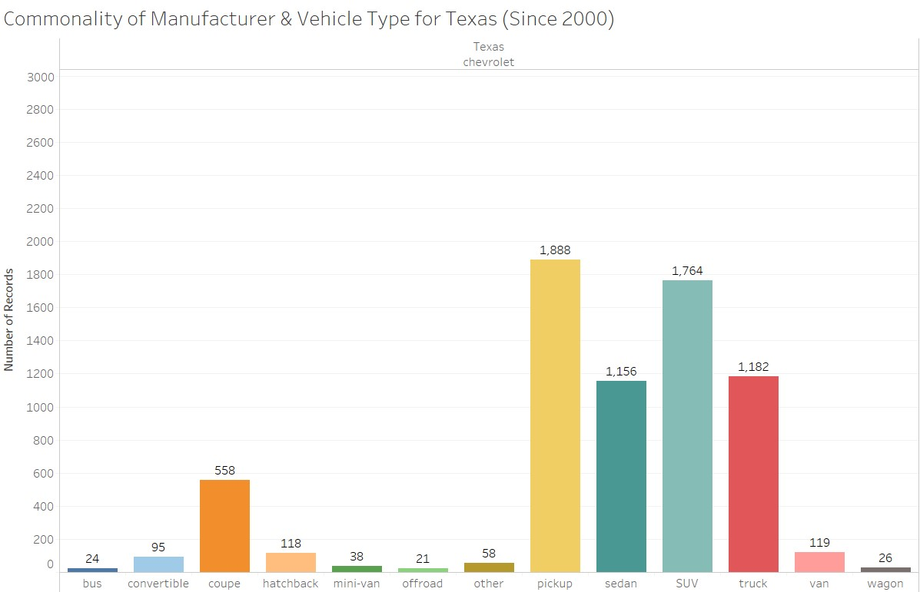

Looking at Chevrolet, it can be seen that the most popular type of vehicle in all three states was the Pickup. The Sedan and the SUV were the 2nd and 3rd popular type of vehicles, respectively.

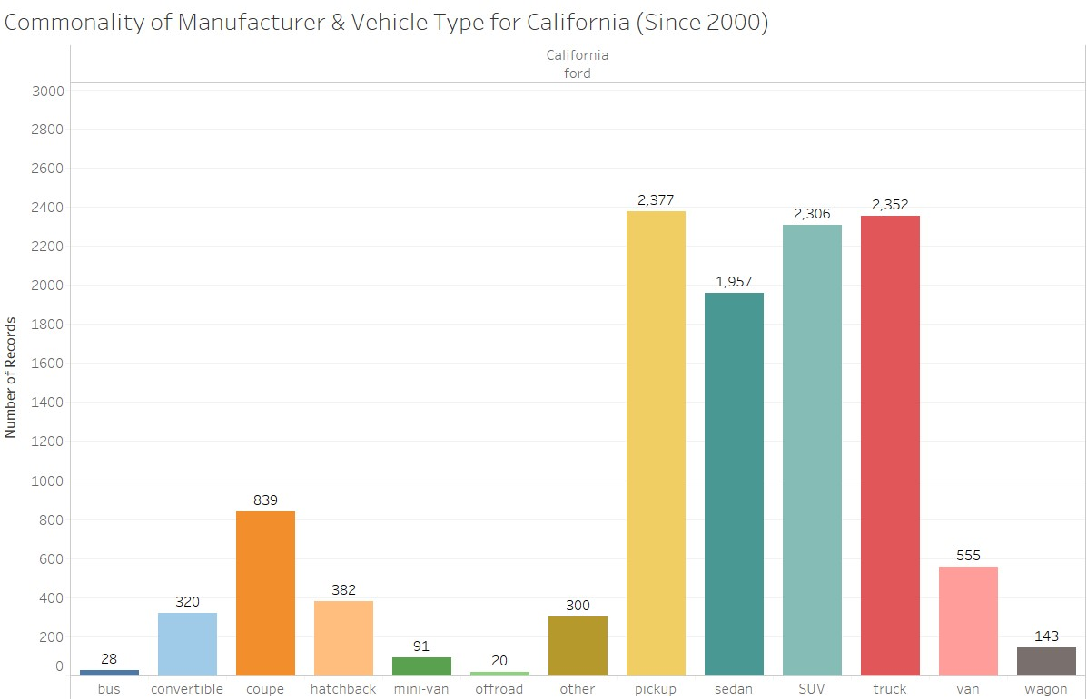

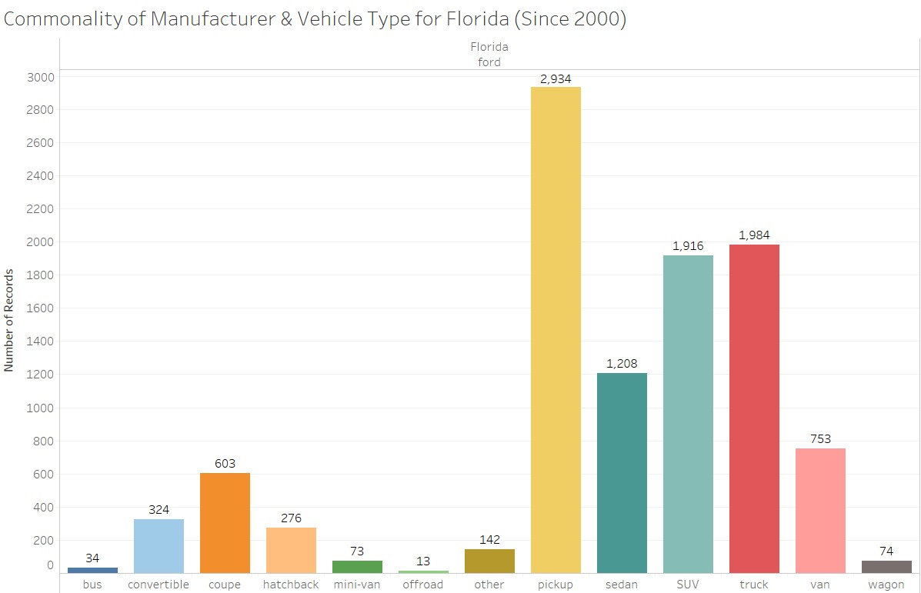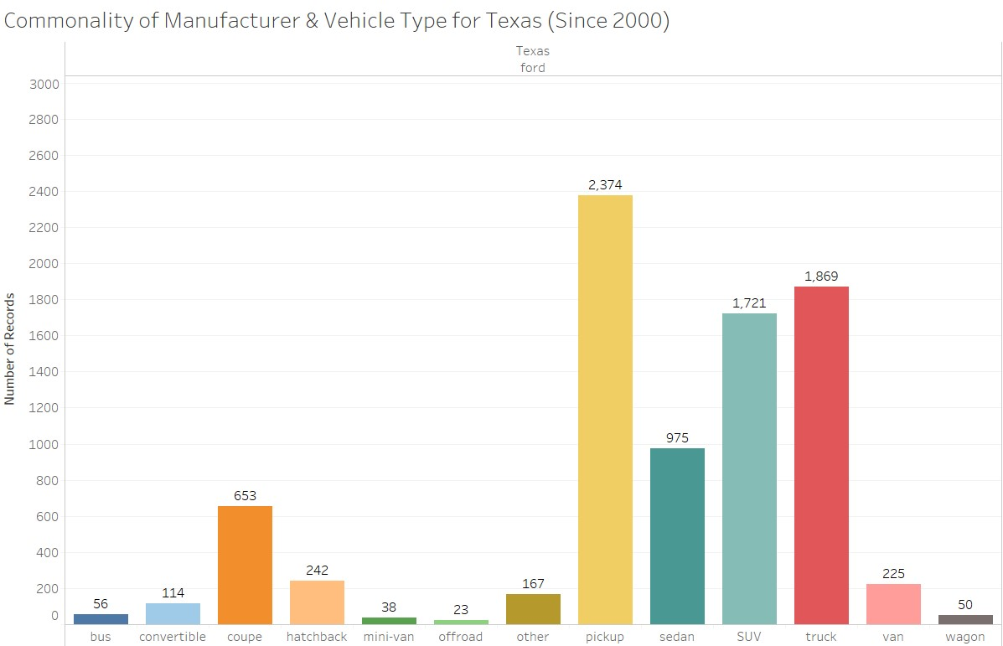

Looking at Ford, it can be seen that the most popular type of vehicle in all three states was the Pickup while the 2nd most popular with the Truck. The Sedan and the SUV were the 3rd and 4th popular type of vehicles, respectively.

## Best Car to Buy – Recommendation

Say a consumer wants to buy a used car for daily use and went on to Craigslist to check out the options they had. Based on this requirement, we analyzed data with different selection criteria as we moved along the process of final recommendation.

For initial selection range, we considered the following requirements:

* 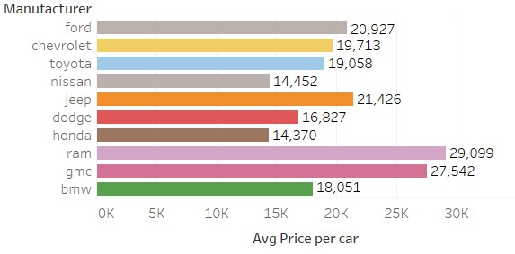Manufacturer – From Top 10 by most number of cars listed in this order
* Odometer – Cars with

100,000 miles or below

* Year – Cars that are from year 2000 and above
* Price ranging from $500 -

$100,000

The above figure shows the average price listed per manufacturer.

After seeing this, the consumer decides to look for a gas vehicle with front wheel drive. We shall further drill down the feature and come with average car price.

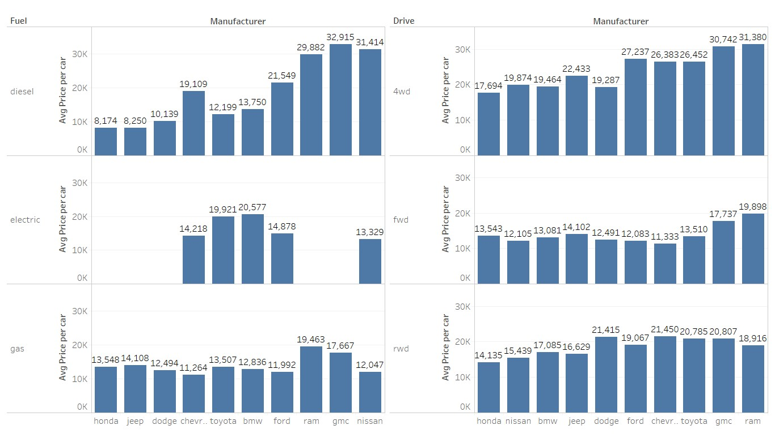

Link: [Dashboard](https://public.tableau.com/profile/rahat4613#!/vizhome/Project_craigslistVehiclesFull/3_1)

We can see that few manufacturers don’t have electric cars. The average price for gas vehicle and forward wheel drive type seems to be comparatively less to other fuel and drive types. Let’s filter our data with these options.

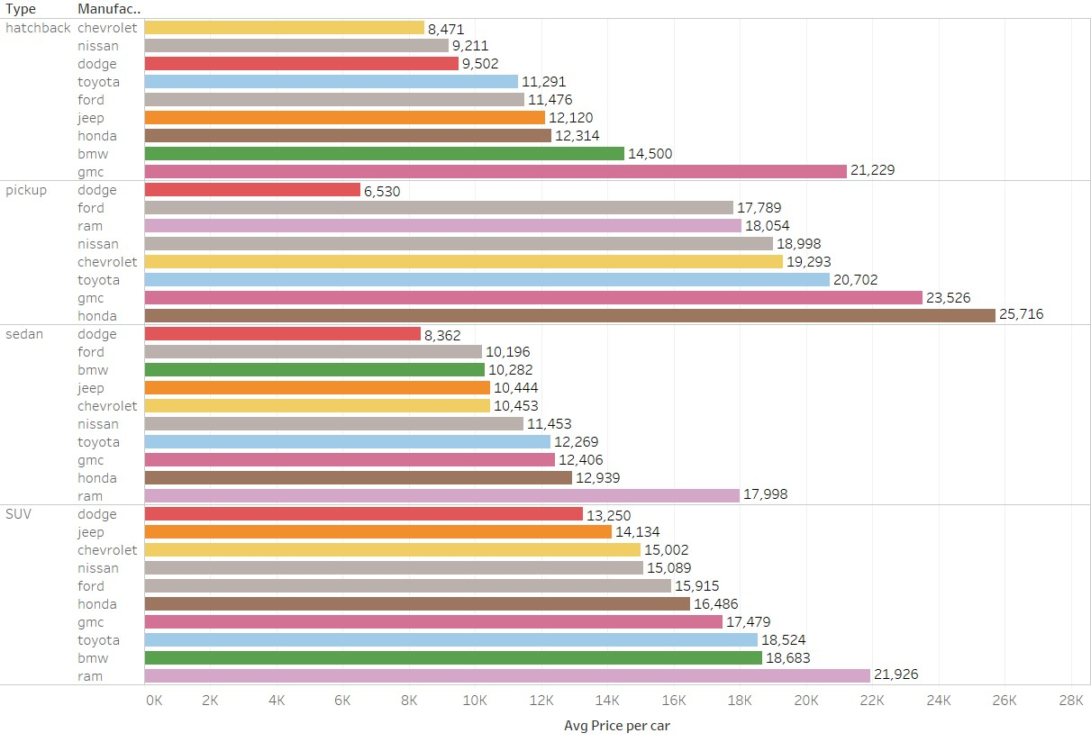

This graph shows us the average price of a used car gas fuel type and fwd drive for the 4 popular vehicle types (hatchback, pickup, sedan and SUV).

# Final Analysis

We chose the top 3 manufactures by market share in number of cars (Ford, Chevrolet and Toyota) and car types (Hatchback, Sedan, SUV and Pickup) for cars from 2000 and later. With these choices we came up with the average price for cars in each state and grouped them as:

* Cheap - Price is lower than $7000
* Moderate – Price is between $7000 and $10000
* Costly – Price is more than $10000

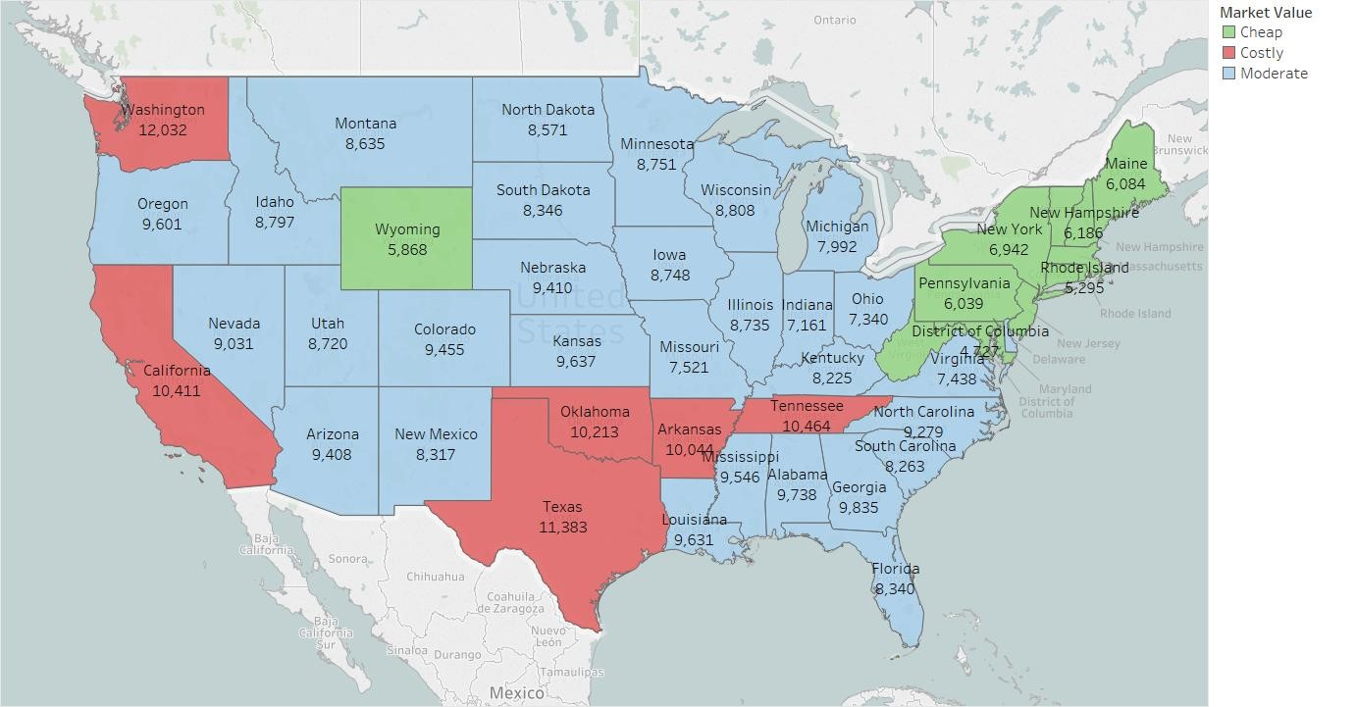

Link: [Live Dashboard](https://public.tableau.com/profile/rahat4613#!/vizhome/Project_craigslistVehiclesFull/Sheet9)

The States where buying a car off of Craigslist is Cheap Include:

* Connecticut
* District of Columbia
* Maine
* Maryland
* Massachusetts
* New Hampshire
* New Jersey
* New York
* Pennsylvania
* Rhode Island
* Vermont
* West Virginia
* Wyoming

Most of these states are located alongside the Upper-East Coast. All six states that make up the region of New England are in this category. The one outlier is the state of Wyoming.

The States where buying a car off of Craigslist is Expensive Include:

* Arkansas
* California
* Oklahoma
* Tennessee
* Texas
* Washington

Both California and Washington are located on the West Coast while the rest are in the Mid-Southern region of the USA.

THE END