Unbalanced;

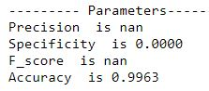 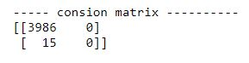

MCC : Nan

Balanced:

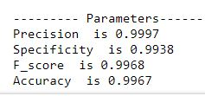 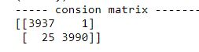

MCC: 0.9935