## BANK ASSISTANT OF BD A WEB BASED APPLICATION DEVELOPMENT

**BY**

**MD. PARVEZ**

**ID: 151-15-4987**

**HALIMA AKTER EITY**

**ID: 151- 15-4968**

**MD. MORSALIN ID: 151- 15- 4967**

This Report Presented in Partial Fulfillment of the Requirements for the Degree of Bachelor of Science in Computer Science and Engineering.

Supervised By

**Anup Majumder** Lecturer Department of CSE

Daffodil International University

Co-Supervised By

**Mr. Shaon Bhatta Shuvo**

Lecturer Department of CSE

Daffodil International University



# DAFFODIL INTERNATIONAL UNIVERSITY

## DHAKA, BANGLADESH NOVEMBER 2018

APPROVAL

This Project titled **“BANK ASSISTANT OF BD A WEB BASED APPLICATION DEVELOPMENT”** submitted by **Md. Parvez, Halima Akter Eity, Md Morsalin , ID 151-15-4987,ID 151-15-4968 and ID 151-154967** to the Department of Computer Science and Engineering, Daffodil International University, has been accepted as satisfactory for the partial fulfillment of the requirements for the degree of B.Sc. in Computer Science and Engineering and approved as to its style and contents. The presentation has been held in the First week of November, 2018.

# BOARD OF EXAMINERS



## Dr. Syed Akhter Hossain

**Professor and Head Chairman**

Department of CSE

Faculty of Science & Information Technology Daffodil International University



## Dr. Sheak Rashed Haider Noori Internal Examiner Associate Professor

Department of CSE

Faculty of Science & Information Technology Daffodil International University



## Md. Zahid Hasan Internal Examiner

**Assistant Professor**

Department of CSE

Faculty of Science & Information Technology Daffodil International University



**Dr. Mohammad Shorif Uddin External Examiner**

## Professor and Chairman

Department of Computer Science and Engineering Jahangirnagar University

# DECLARATION

We hereby declare that this project has been done by us under the supervision of **Anup Majumder, Lecturer, Department of CSE** Daffodil International University. We also declare that neither this project nor any part of this project has been submitted elsewhere for the award of any degree or diploma.

## Supervised by:



**Anup Majumder** Lecturer Department of CSE

Daffodil International University

## Submitted by:



**Md.Parvez**

ID: 151-15-4987

Department of CSE

Daffodil International University



## Halima Akter Eity

ID: 151-15-4968

Department of CSE

Daffodil International University



## Md. Morsalin

ID: 151-15-4967

Department of CSE

Daffodil International University

# ACKNOWLEDGEMENT

First we express our heartiest thanks and gratefulness to almighty God for His divine blessing makes us possible to complete the final year project successfully.

We really grateful and wish our profound our indebtedness to **Anup Majumder, Lecturer**, Department of CSE Daffodil International University, Dhaka. Deep Knowledge & keen interest of our supervisor in the field of “ **Web Application** ” to carry out this project. His endless patience, scholarly guidance, continual encouragement, constant and energetic supervision, constructive criticism, valuable advice, reading many inferior draft and correcting them at all stage have made it possible to complete this project.

We would like to express our heartiest gratitude to **Anup Majumder, Lecturer**, Department of CSE, **Shah Md. Tanvir Siddiquee, Senior Lecturer**, Department of CSE, and **Professor Dr. Syed Akhter Hossain, Head,** Department of CSE, for his kind help to finish our project and also to other faculty member and the staff of CSE department of Daffodil International University.

We would like to thank our entire course mate in Daffodil International University, who took part in this discuss while completing the course work.

Finally, we must acknowledge with due respect the constant support and patients of our parents.

# ABSTRACT

This is an web application where the users found all information about the services of banks and insurance companies .The aim of our project is to provide information and to help users to get the best services by comparing among different services. Basically this is an web based project. In this web site, we have gathered information about the services of all banks and insurance companies of BD and compared their services. In our project we have included the information about bank services like “Loan, Fixed Deposit, Deposit, Credit Card”. and the insurance companies services are “Life Insurance, Health Insurance, Fire Insurance” .To develop this project we make a web application using HTML, CSS, JAVA-SCRIPT, JQUERY, PHP, MySql. After implementation of all the functions, the system is tested in different stages and it works successfully as a prototype.

# TABLE OF CONTENTS

|  |  |
| --- | --- |
| **CONTENTS** | **PAGE** |
| Board of examiners | i |
| Declaration | ii |
| Acknowledgements | iii |
| Abstract | iv |
| Table of contents | v-vi |
| List of figures | vii |
| **CHAPTER** |  |
| **CHAPTER 1: INTRODUCTION** | **08-10** |
| 1.1 Introduction | 08 |
| 1.2 Motivation | 09 |
| 1.3 Objectives | 09 |
| 1.4 Expected Outcome | 10 |
| 1.5 Report Layout | 10 |
| **CHAPTER 2: BACKGROUND** | **11-13** |
| 2.1 Introduction | 11 |
| 2.2 Related Work | 11 |
| 2.3 Comparative Studies | 12 |
| 2.4 Scope of the Problem | 12 |
| 2.5 Challenges | 13 |
| **CHAPTER 3: REQUIREMENT SPECIFICATION** | **14-19** |
| 3.1 Business Process Modeling | 14 |
| 3.2 Requirement Collection and Analysis | 15 |

© Daffodil International University v

|  |  |
| --- | --- |
| * 1. Use Case Modeling And Description | 16 |
| 3.5 Design Requirements | 19 |
| **CHAPTER 4: DESIGN SPECIFICATION** | **20-25** |
| 4.1 Front-end-Design | 20 |
| 4.2 Back-end Design | 22 |
| 4.3 Interaction Design and | 23 |
| 4.4 Implementation Requirements | 25 |
| **CHAPTER 5: IMPLEMENTATION AND TESTING** | **26-38** |
| 5.1 Implementation of Database | 26 |
| 5.2 Implementation of Front-end Design | 27 |
| 5.3 Implementation of Interaction | 35 |
| 5.4 Testing Implementation | 36 |
| 5.5 Test Results and Reports | 37 |
| **CHAPTER 6: CONCLUSION AND FUTURE SCOPE** | **39** |
| 6.1 Discussion and conclusion | 39 |
| 6.2 Scope for Further Development | 39 |
| **APPENDIX**  Appendix A: Project Reflection Appendix B: Related Website | **40-43**  31  32 |
| **REFERENCES** | **44** |

|  |  |
| --- | --- |
| **PLAGIARISM REPORT** | **45** |

# LIST OF FIGURES

|  |  |
| --- | --- |
| **FIGURES** | **PAGE NO** |
| Figure 3.1: Business Processing Model | 14 |
| Figure 3.2: Use Case Model of project | 16 |
| Figure 3.3: Flow Chart for admin parts | 19 |
| Figure 4.1: Front End Design | 20 |
| Figure 4.2: Database Table List | 22 |
| Figure 4.3: UX Design | 23 |
| Figure 4.4: Dashboard | 24 |
| Figure 4.5: Add admin | 25 |
| Figure 5.1: Database Processing System in Project | 26 |
| Figure 5.2: Users and tablespaces | 27 |
| Figure 5.3: Homepage Design | 28 |
| Figure 5.4: Login for Admin | 29 |
| Figure 5.5: View Super Admin Access | 30 |
| Figure 5.6: Bank Policy | 32 |
| Figure 5.7: Super Admin Dashboard | 33 |
| Figure 5.8: Admin’s Dashboard | 34 |
| Figure 5.9: Test Results | 37 |
| Figure 5.10: Test Results | 38 |

**CHAPTER 1 INTRODUCTION**

* 1. **Introduction**

Banks play a vital role in developing the economic and social conditions of a country. Customers of banks have felt the positive impact of technological solutions. The major share of the profit of banks generally comes from spread. But the profitability of banks is under tremendous pressure because of continuous shrinking of spread. Today, information and communication technology has become the heart of banking sector and banking industry is at the heart of every robust economy.

The basic difference between online banking and traditional banking is that, in traditional banking the customer has to visit the branch for the basic banking needs viz. withdrawal or deposit of cash, transfer of funds, statement of accounts etc. Online-business saves customers’ time. Bank also enjoys lower overheads, establishment, premises and maintenance costs, which results in reduction of transaction cost. Low transaction cost is one of the main reasons why online business is getting popularity.

Insurance plays a crucial role in the sustainable growth of an economy. Insurance sector also encourages the virtue of savings among individuals and generates employments for millions, especially in a country like Bangladesh where savings and employment are important. There are 6 Govt. banks and 48 private banks in Bangladesh.

The expected outcome of our project is to develop a website and to provide information to users about banks and insurance company and to make the best profit of their savings.

# Motivation

The motivation to work in this project is actually our real-life experience. Time and money are the two important things in human life. We want to save time and to get best profit of our money. If someone wants to deposit their money or wants to do an insurance they may go through websites one by one, otherwise they have to go banks and insurance office. But as we know our banks and insurance companies don’t have enough established website. All information aren’t given there and it’s not possible to go banks and insurance office one by one. It also takes too much time. So we decided to make a website where all the information will be given and compared so users can know the services and easily get which one is best for them.

# Objectives

The main objective of this project is to build a information provider platform where user can choose best option for them to take services of banks and insurance companies. A platform where users can-

* + To develop a website to provide information.
  + To get update information.
  + To give a platform to compare several policy’s so that they can ensure about their savings.
  + Get best options.
  + To help people to make the best profit of their savings.
  + To save people’s time by providing all policy’s details in a single place.
  + Can ask questions.

# Expected Outcome

* + A user can get all the related information staying at home.
  + User can easily search the services which one they need.
  + A user also can compared the services with one another.
  + All the information will be updated whenever the banks and insurance companies change their policy.
  + As the website every information in detail, so it also saves the users time.

# Report Layout

The total project is included six chapters. In this report, the layout is summarized that six chapters. The Summary of the layout is given below:

In chapter one we give an introduction with a short overview of our project, importance of this web application and its motivation. We also discuss our objectives and expected outcomes of our project. In chapter two we discuss the background of our project which is covered with related works of the web application and discussion of the problem and challenges of the system. In chapter three we highlight the requirements on both software and communication services which we used in our project. In chapter four on design specification about our proposal by the flow-chart diagram, design with both front-end and back-end with practical details. In chapter five we discuss the implementation and testing of our project. In chapter six the conclusion, limitation and future scope of our project are discussed.

# CHAPTER 2 BACKGROUND

* 1. **Introduction**

In this chapter we basically discussed about background study on information provider web portal. We have discussed about few similar approaches that resembles our attempt. We discussed about what could be the possible outcome. The concept of this information provider portal is simple. Such as whenever a person wants to do a Fixed deposit into a bank they can take information from our website and analysis by comparing the information with each other. After that they will know about different policy and can choose which one is best for them.

# Related Works

After deciding to build this web application, we looked through online and found no such web site that is like ours. However, there are only one website which has some similar features like us but not a complete one.

## Policy Bazaar:

In this web application, they provide only insurance service and Fixed deposit service.

[Note: There are no related such web application available in bd.

# Comparative Studies

Similar website Policy bazaar like ours provides only insurance and fixed deposit service and information. But we have some more functionalities and features that can be more helpful for the customers.

# Scope of the Problem

Although we have added a lot of information but still there is a scope to add more information.

## Reducing time complexity

The main scope of our website is to provide information. User can get all the information staying at home, so it saves users time.

## Get best profit

Through this website user can get all information about the services of banks and insurance companies. They can compare services with one another. As a result by comparing they will get the best option which will be more profitable for them.

## Less Environmental dependency

Any change of environment, device, screen etc. shouldn't affect the system. The system will be less dependent on the environment

## 2.4.4 Privacy

Privacy of a certain user should be maintained efficiently. It mustn't record or expose what the user is clicking or browsing. If it keeps track of user activities and records it often it will be a strong violation of security.

# Challenges

In every steps of our life we face challenges. To make such a web application where we have to include a huge amount of information and compare them with one another was not easy for us.

## Comparison

Most important challenging task was compared the information because there were a huge data and we had to compare among all of them.

## Time scheduling:

It was the difficult challenge for us because no matter we have to complete it on given time. If we were unable to complete it on time, it would be a great danger for us. So we just divided our time to complete each one of the tasks to complete the whole project.

## Data collection

As our project is an information provider web application, so we had to collect information from different bank and insurance company. We went their office, some of them cooperate with us and some of them didn’t. Everyone didn’t agree to provide their information with us but we convinced them.

## Skills for the Project:

A project requires skills by which the project’s going on. A project leader determines the needed skills and other team members also should have determined to do some for the project to complete it. Without effective communication among everyone involved in the project is tough to its successful completion.

# CHAPTER 3 REQUIREMENT SPECIFICATION

* 1. **Business Process Modeling**

Basically Business Process Model presents the value of that project. In this project, the most of the part show Viewing, admin activities and some other Features. The Model given below.

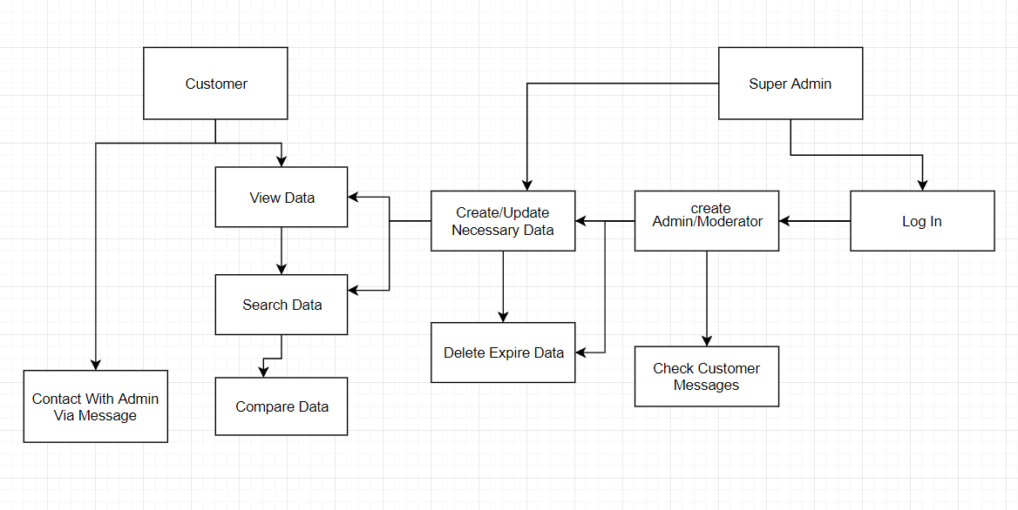

**Figure 3.1:** Business Processing Model

# Requirement collection and analysis

Application requirements:

* Customer
* Continuously update the information
* Time convenience
* User-friendly
* Easily to accessible
* Log in the system for the Admin
* Make a super admin for manage all other admin
* Browser Access
* Get feedback message via customer

## Hardware and Software Requirements for Our System

At the very first, you must check the hardware for your computer, you should first make sure that your computer supports the system requirements and ready to operate. These are the necessary specifications that must have in order to use the software and hardware to be used properly; all computer software needs some common hardware components or other software resources to be present on a computer.

In the development area, the system requires for all tools and platforms to perform the new system like

* + - * XAMPP (New version will be good)
      * TEXT editor: Netbeans IDE, Sublime Text Editor
      * Any browser which support Javascript

We have to use some design part with javascript, so If any browser are restricted about java then the design won’t works. That’s why we needed browser which able to run java code.

## Analysis

After discovering the problem of being hasty with our country’s bank/insurance website, We make the confidence to develop this new system, which stands the needs of the people. After we have seen the problem of the old system we make that understand there is a great need to develop a new system like this. We decided to take HTML as front end and PHP to backend and MYSQL for DB as a solution.

Strategy for the this problem, because PHP is a server-side scripting language for developing an web-based application and that is peaceful to be developed.

# Use Case Modeling and Description

The Use Case model which was used in our project given below:

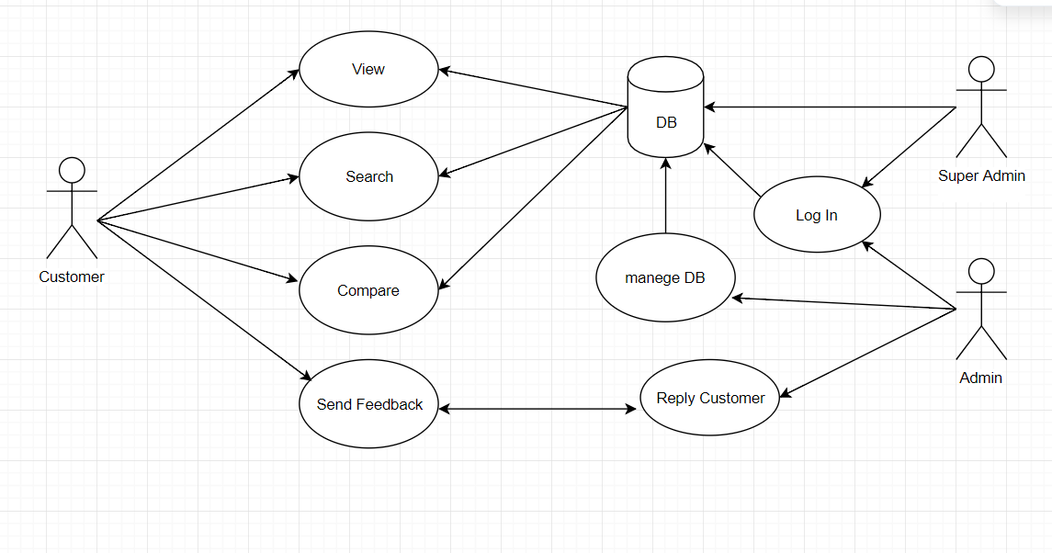

**Figure 3.2:** Use Case Model of project

**Brief Description:** The customer view data and Admin manage the data.

**Actor:** Admin

**Actor :** Customer

Main Flow:

* The User Case starts when the customer enter the system and customer search bank/insurance information.
* A customer can use the other facility of the system. For example- Comapre Poilicy, Give feedback.

## Create Admin

**Brief Description:** A Super admin only have full access of DB, not an admin.

**Actor:** Super Admin, Admin, The flow of steps:

* The Super Admin can create an admin.
* An admin can’t delete any info, only he can mute those info.
* Only super admin can delete the info permanently.

## Search Policy

**Brief Description:** Any Customer can search the policy.

**Actor:** Customer

The flow of steps:

* A customer can search the specific policy.

**Update policy**

**Brief Description:** Admin/Super-admin can add/modify the poilicy

**Actor:** Super admin, admin

Main Flow:

* Super admin can update and add new policy.
* Admin can update and add new policy.

# Design Requirements

In designing process system of this project, following some issues must be reminded that reproduce the overall design of the expected goals that the system expected to achieve. The following goals were should kept in mind while designing the whole system:

Easy to operate the system, make system simple and flexible for users means user friendly.

In this project, the flow chart we used for admin is given below:

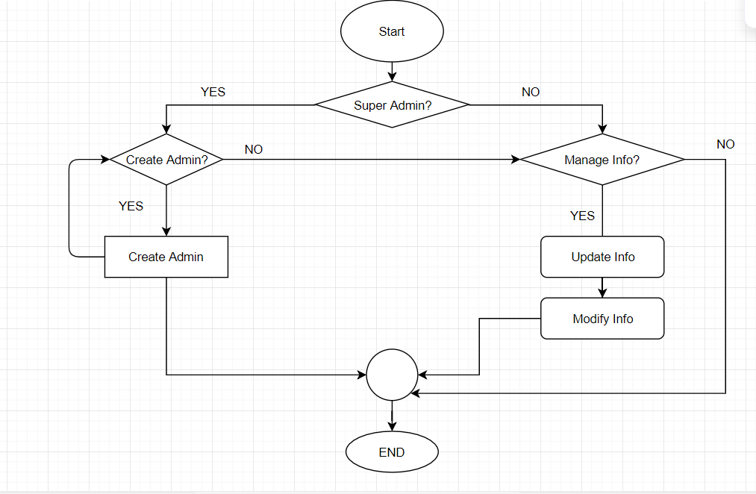

**Figure 3.4:** Flow Chart of Admin Part.

## CHAPTER 4 DESIGN SPECIFICATION

* 1. **Front-End Design**

Front-end Design we mean that web design(Front) and web development(End). Actually by these two parts consists of front-end design. Front-end design done by the HTML, CSS and JavaScript code that build up a user interface. Now everyone use Bootstrap which is a framework of HTML and CSS.

The design is visible while using a web application or site is a formation of HTML CSS and JavaScript code that is controlled by your desktop or laptop’s browser if the browser supported those languages. Design include elements such as manubar, fonts, nav bar, drop-down menu, nick sliders, contact forms like login, Insert, Send messages. Basically, we have used the Raw PHP, JavaScript, HTML, CSS, and Bootstrap framework to design our whole System. We will discuss all of the design and developing parts that we have used in our project.

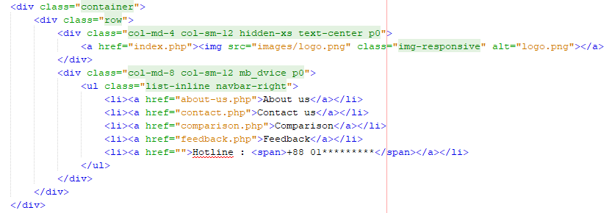

**Figure 4.1:** Front End Design

## HTML: - Hyper Text Markup Language

HTML is the standard markup language for creating dynamic Web pages. HTML stands for Hyper Text Markup Language and now html5 version running. HTML describes the structure of Web pages using markup. HTML elements are represented by so many different tags. Tags label pieces of content like "heading", "paragraph", "table", and so many others we used. Browsers do not display the HTML tags, only shown the content of the tags.

## Java-Script

[What is JavaScript?](https://javascript.info/intro#what-is-javascript)JavaScript was initially created to “make webpages alive” and attractive.The programs in thislanguage are called scripts languages. They can be written between in the HTML and execute automaticallywhen the pages loads.Scripts are executed as a plain text. They don’t need a special preparation to run.In this aspect, JavaScript is very different and effective from another language called [Java](http://en.wikipedia.org/wiki/Java).

## CSS: - Cascading Style Sheet

CSS (Cascading Style Sheets) is used to style and lay out of a web pages — for example, to change the font, color, shape and spacing of your content, divide it into multiple columns, or add animations for your pages and other features. This module gets you started on the path to CSS mastery with the basics of how it actually works, including selectors and properties of tags, writing CSS rules and regulation, applying CSS to HTML, how to specify a content length, color, and other units in CSS.

## jQuery

jQueryis an open source JavaScript library. Which simplifies the interactions between an HTML/CSS document, and JavaScript. Elaborating the content terms, jQuery extract HTML document traversing and manipulation, also browsers event handling, Ajax interactions, and the cross-browser JavaScript development.

## Bootstrap

As we say Bootstrap is a free and open-source front-end web framework for designing websites and web applications. We used bootstrap framework to build our web application mobile responsive. It also helps us to make our webpage more lucrative and dynamic and user friendly. Bootstrap provides a huge number of functions that control things such as color and padding of various components.

# Back-end Design

## Object Oriented PHP

PHP stands for Hypertext Preprocessor (no, the acronym doesn't follow the name). It's an open source language, server-side, scripting language are also used for the development of web applications. PHP is a widely-used open source general-purpose scripting language that that’s why many resources you can find in google . We use some raw level PHP code for our application.

## MySQL

MySQL works more faster and works well even with large data sets. MySQL is very user-friendly to PHP, the most committed language for web development. MySQL supports large databases, up to fifty (50) million rows or more in a table.

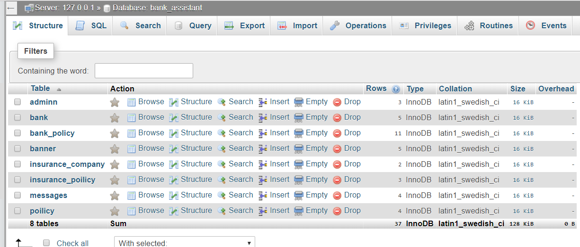

**Figure 4.2:** Database Table List

# Interaction Design

User experience design is the process of enhancing user satisfaction with a product by improving the usability, accessibility, and pleasure provided in the interaction with the product.

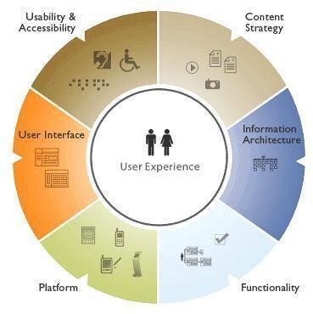

**Figure 4.3:** UX Design

## Home Page Interaction Design and UX

In our System, we have designed the main page called home page. It has two parts. Where menu bar remain with two options. One for bank and another for Insurance companies.

For our admin site here also have a home page with lots of options. Only admin can access those, some of those are only for Super Admin. We make those design with the help of bootstrap, jqery,html,css.

## Login Page Interaction Design and UX

In order to use this application only admin have to registered. Super amdin create admins account with necessary information. Admin form required with name id and images.

## Dashboard Page Interaction Design and UX

We have designed a dashboard for the admin. Here admin can add, delete, modify any info. Admin always maintain the admin panel part. Necessary all the things are uploaded by admin. A super admin have only access of everything. A admin can’t do everything which a super admin can do.

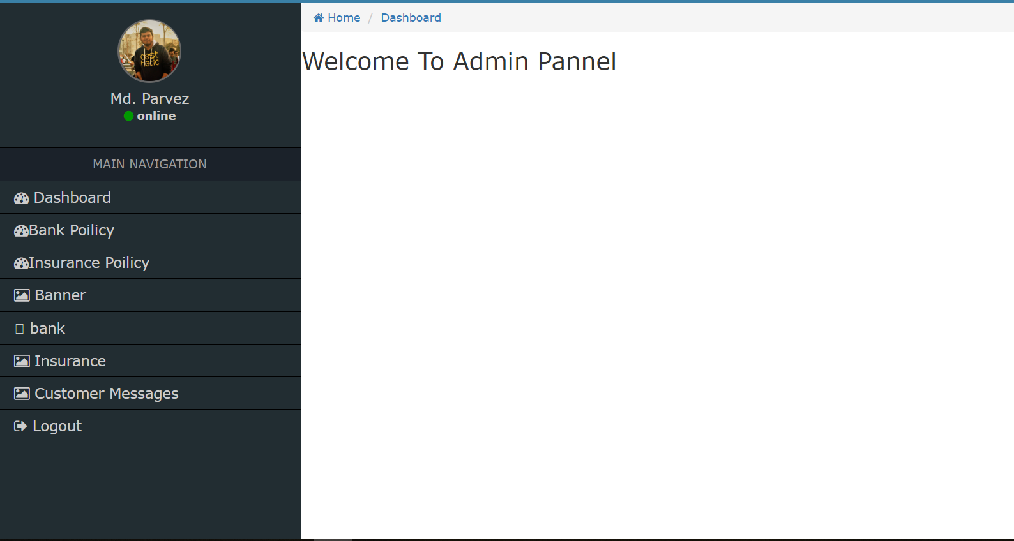

**Figure 4.4:** Dashboard

## Add Admin page Interaction Design and UX:

When Super admin want to add the admin he can add admin by these,

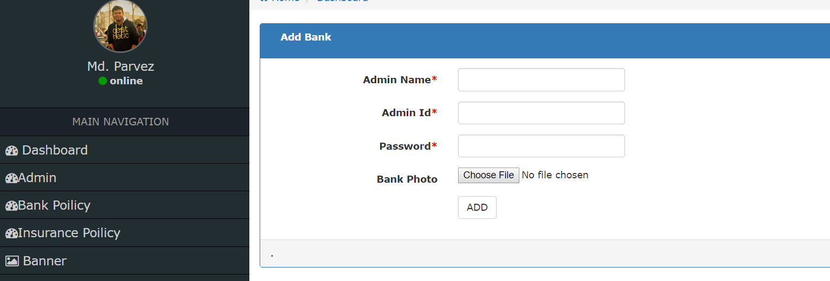

**Figure 4.5:** Add admin

# Implementation Requirements

Implementation is carrying out and execution or practice of a plan, a method or design, idea, model, specification, standard or policy for doing something. As such kind of implementation is the action that must follow in order for something to actually happen.

The main thought was to make the options and it’s access easier. The implementation Requirements was given us as a very good conceptual idea. To implement our project we need HTML coding and XAMPP for PHP. We need Photoshop to design logo, banner and some UI/UX. To implement other things we need NETBEANS or Sublime text to do HTML, CSS, JavaScript, and PHP. All of those things is mention in previous all of this are required for our project.

Software requirements for our application

* + - Operating System Windows ( XP or Higher)
    - NETBEANS or SUBLIME or any software that works like that.
    - And for the server running XAMPP or WAMP Server

## CHAPTER 5 IMPLEMENTATION AND TESTING

* 1. **Implementation of Database**

We know that the physical implementation of a database is different from the physical model. The physical model refers the database in a specific working environment that includes a distinct database product, a specific hardware and network configuration for the database, and a specific type of data modify and retrieval activity.

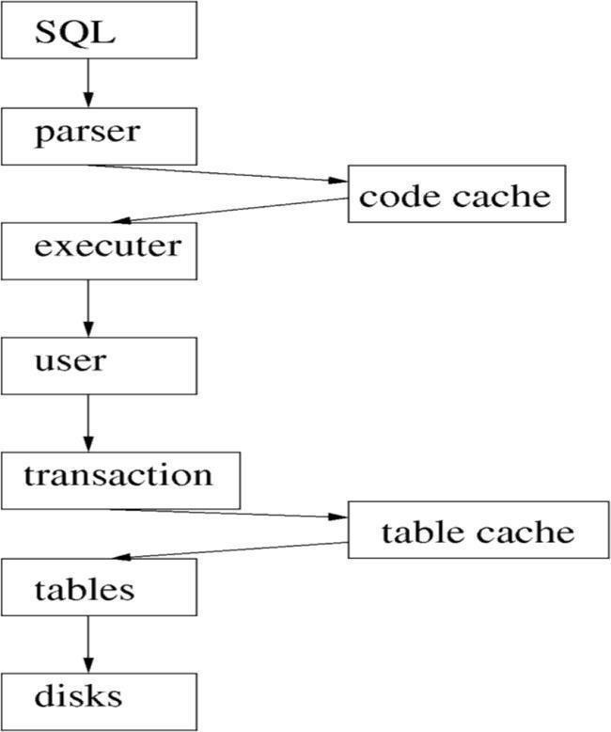

**Figure 5.1:** Database Processing System in Project

Establishment requirements involves consultation, and agreement among the stakeholders about what they want from a system, expressed as a statement of requirements.

The accompanying chart gives us a thought of the approach taken after by two unique frameworks, Oracle and MySQL.

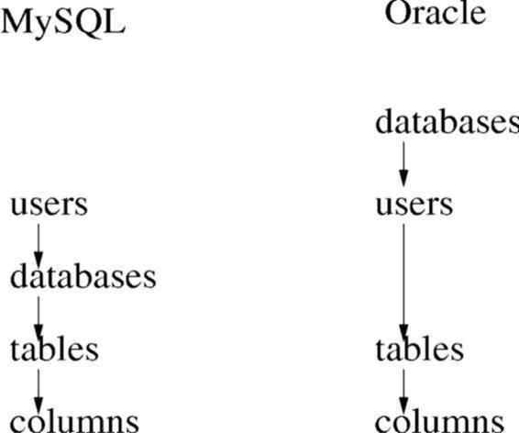

**Figure 5.2:** Users and tablespaces

From this image, we can see that how we have stored the bank and insurances companys information in each time they updated us.

# Implementation of Front-end Design

Many Front-end designs and the description are given here:

After implementing this project Front-end Design the challenges was many. When we complete the implementation part of the design from the code we write and there the color combination and perfection was the main priority for us. In Front-end implementation we have used different languages such as HTML, CSS, Bootstrap, and JavaScript to code the website. The code we write runs inside the user’s appropriate browser.

# Homepage

The homepage of this project contain bank’s and insurance company’s lists. The other manu bar are top of the site. Top bank’s and insurance’s banner and our personal banner place in the middle position. Latest bank poilicy’s and Insurance’s policy are shown in home page. All of those are remain in our home page.

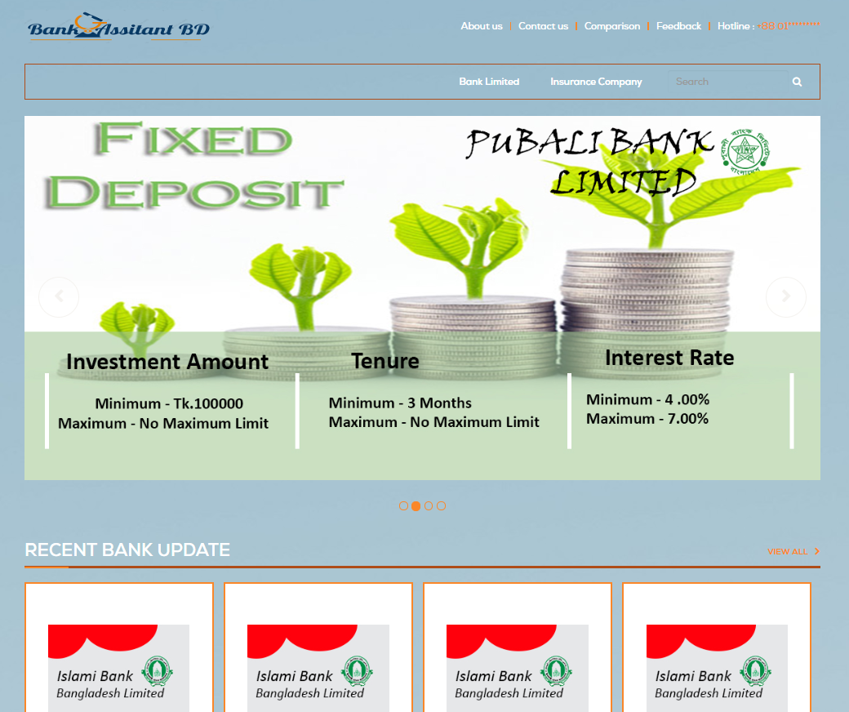

**Figure 5.3:** Homepage Design

## Admin Login form:

Basically this login form is designed for admin. It contains two fields admin id and Password. Everywhere we see the forget password option. We also have this but unfortunately this will not works. We develop this on future.

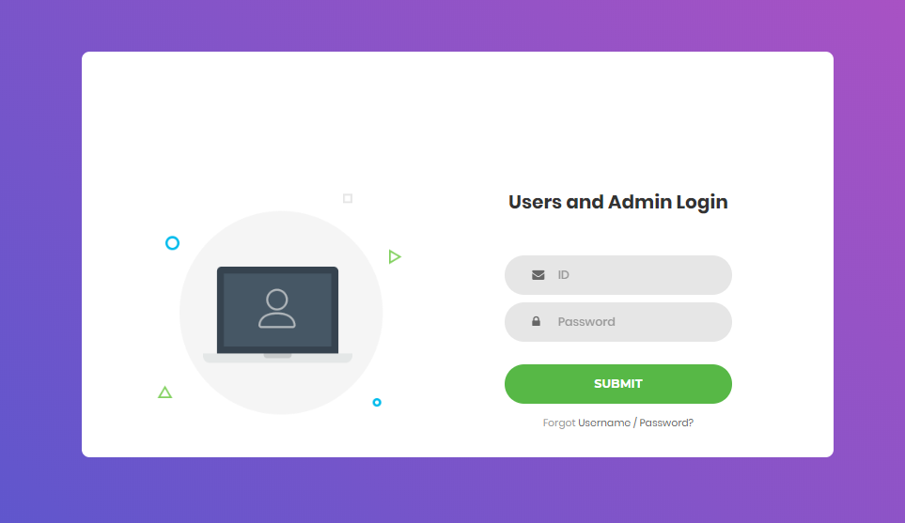

**Figure 5.4:** Login for Admin

## Super Admin can view all admin’s List

The Super admin can view all admin. The image is given below:

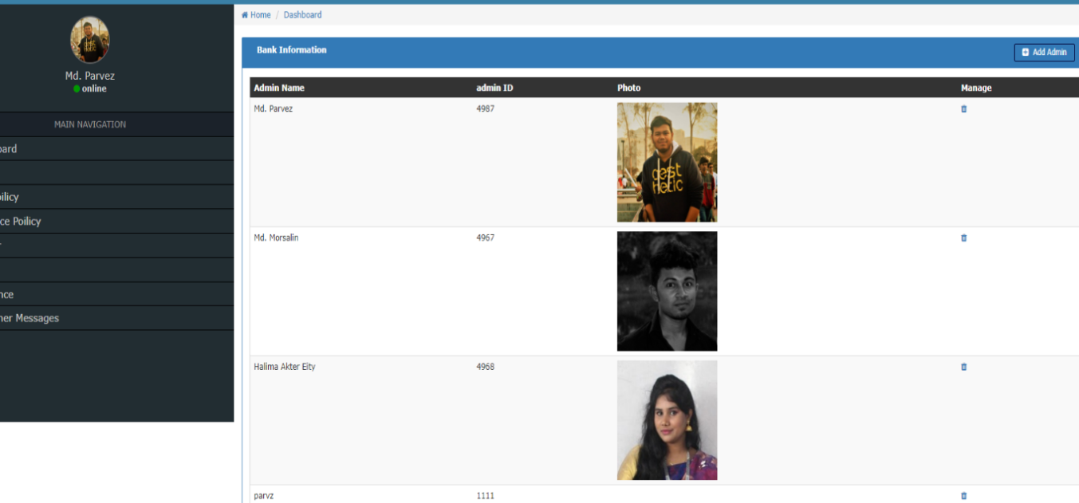

**Figure 5.5:** View Super Admin Access

## Customer can see all policy bank wise

The customer don’t need to log in. They can see through our websites. In home page latest policy are shown, and here are option to see all policy together. If the customer wants to see the policy bank wise, then

The view policy depends on bank bellow here:

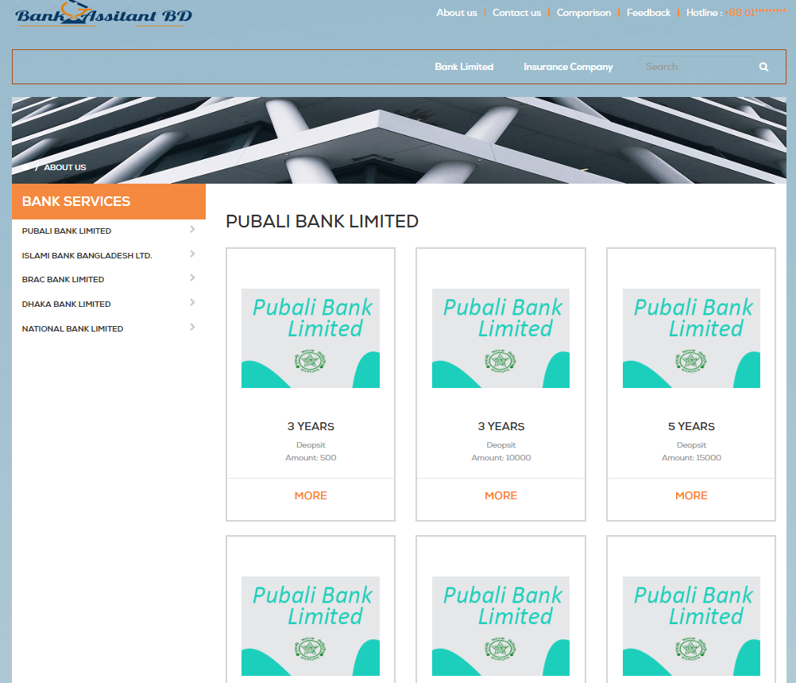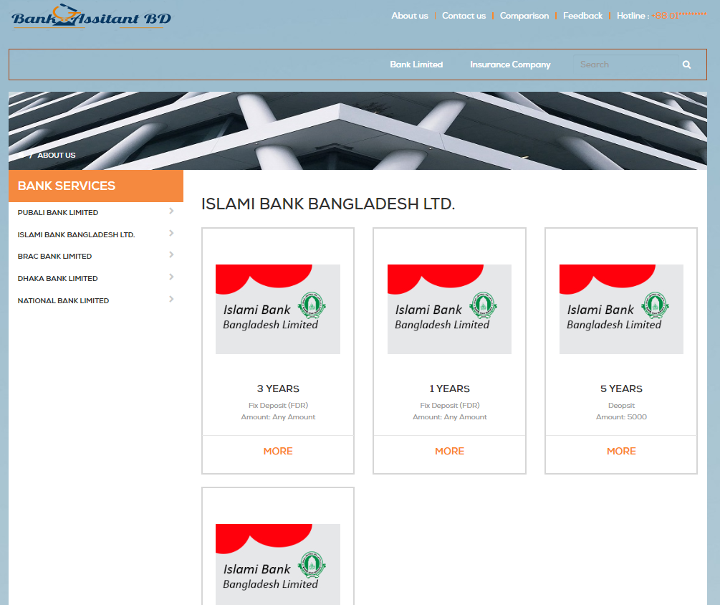

**Figure 5.6:** Bank policy

## Super Admin Dashboard

This Dashboard is only visible to Super admin.

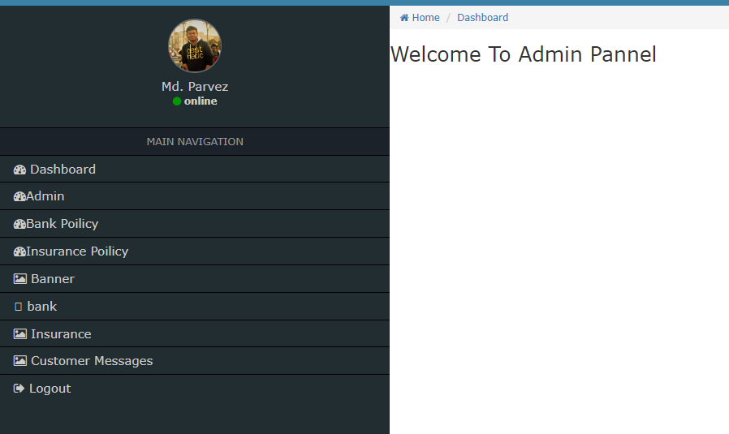

**Figure 5.7:** Super Admin Dashboard

## Admin’s Dashboard:

This dashboard can see both admin. Now see the differences that, in admin dashboard there are no option for see the admin and add admin. But for super-admin admin option are available.

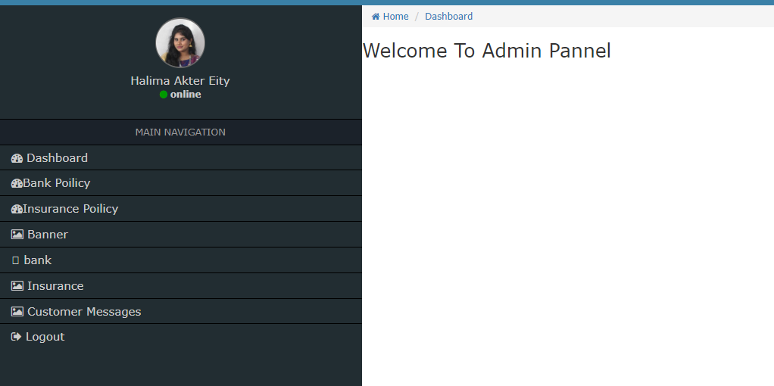

**Figure 5.8:** Admin’s Dashboard

# Implementation of Interactions

In implementation, interaction is a piece of our system. Interaction implies when we are on a particular page of a site that takes us another page on the off chance that we need the page. It happens when the pages are interlinked among them. So the interlinked pages interface with others. There are numerous components that go into the production of a site. A site is the best medium to speak with clients from everywhere throughout the world. It is along these lines basic, it ought to be planned such that clients ought to be pulled in and be locked in on the site. This is the point at which a site can achieve its clients adequately. That component is site interactivity.

When we simply work for implementation that implies we are working on the site. At the point when the client moves the mouse catch on home board that slides on a side that was the one of our interaction usage for our system.

# Testing Implementation

When we test the project features it is implemented and is called test implementation. We have tested the system many times like login, adding bank, add insurance company, add policy, add admin, add banner, customer send messages, view messages and many others features. We also check that the data is visible in right way to customer. So we have tested the followings:

* Login System.
* Add admins.
* Add banner.
* Add bank.
* Add insurance company.
* Add policy.
* Send messages to admin.
* View customer messages.
* View banner with priority.
* View policy depends on last arrival.
* Super-admin dashboard.
* Search policy.
* View single policy details.
* Logout.

## Acceptance Testing - In SDLC

The acceptance test cases are executed based on the test data or using an acceptance test script and then the results are compared with the expected ones.

# Test Results and Reports

## System Testing:

The table shows below the policy shown depends on their input’s time the results of system testing:

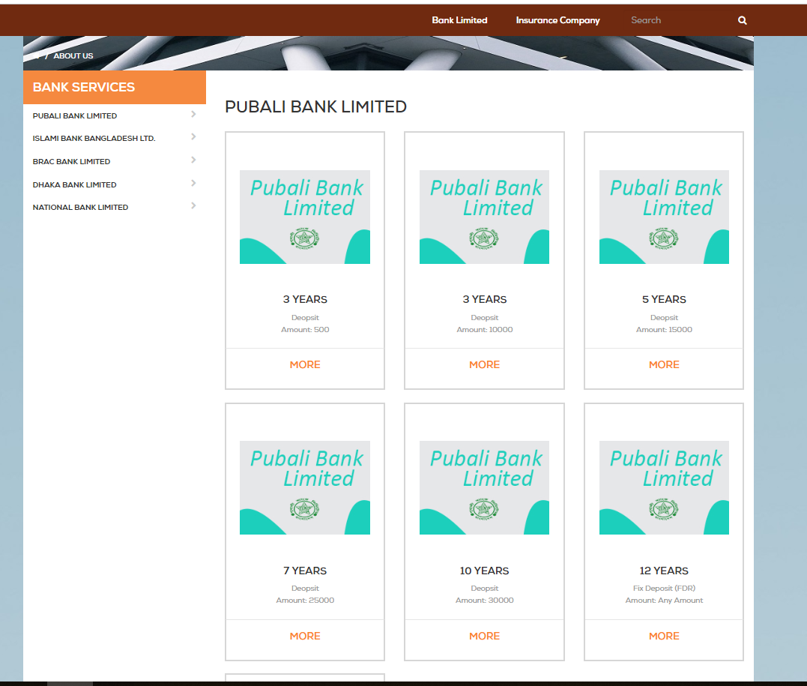

**Figure 5.9:** Test Results

## User Acceptance Testing

The table below Show the single policy details:

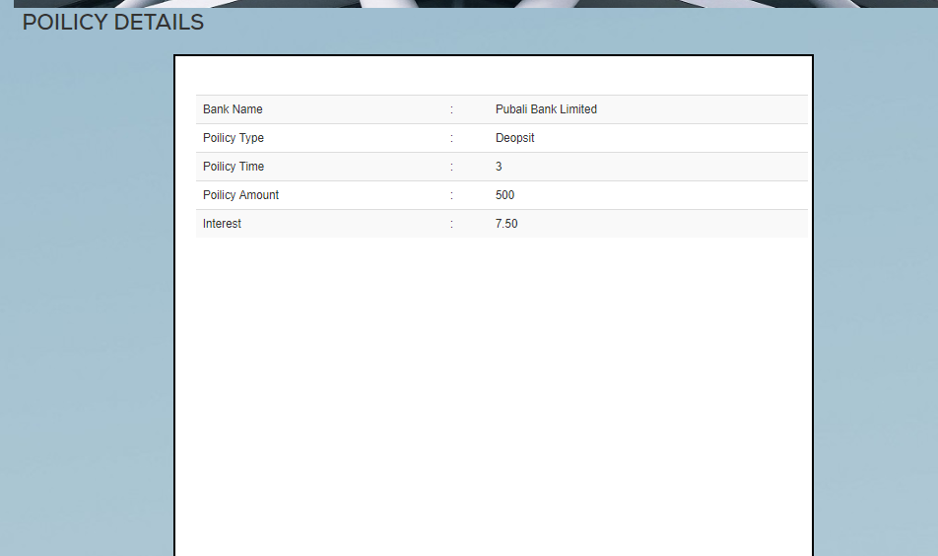

**Figure 5.10:** Test Results

## CHAPTER 6 CONCLUSION AND FUTURE SCOPE

* 1. **Discussion and Conclusion**

This project is exciting topic to work. After going through the work, we faced many challenging tasks that are surprisingly related to our economical system. We researched so many web application that showed us the direction how to develop our system.

We interact with the people that what type of problems they are facing. They were happy to know as it will save time and they will be able to know about the best policy for them. We talked with several banks. They also encouraged us a lot to do this project.

Despite everything we achieved, we faced many challenges to finish this project. After all it’s an online based system otherwise it’s goal will be failed. It’s an innovative idea. The opportunities that provided through this web application is huge.

# Scope for Further Developments

Some of the work we could have done, had we continued this project

* + User will be able to apply for any services through this website.
  + Communication between customer and banks and insurance companies will be established.
  + There will be customer care to help the customer.
  + There will be a payment system.
  + Data mining user details so that we identify user behavior.
  + Will make the website easy to use any kind of user.

# APPENDIX

**Appendix A: Project Reflection:**

The purpose of this Appendix is to provide an introduction to Project reflection. The group research project was a challenging task and also enjoyable experience typical of the course as a whole. We have had little exposed to group work at the university. So, it was a nice opportunity to be part of an effective and dynamic team. We complemented one another quite well both in bringing together interdisciplinary perspectives and in balancing the work. The experience taught us planning and crafting responses take a long time in teams than on our own. The extensive effort required ultimately a good thing. When working alone, we can end up with a result that is identical to our initial plans, but in group, we are constantly developing and refining one another’s ideas. The time seemed to fly and yet we always got a lot to do and manage to help another along the way towards the end point of having a substantive policy.

# Appendix B: Related Diagrams



**Figure 3.1:** Business Processing Model



**Figure 3.2:** Use Case Model



**Figure 3.3:** Flow Chart

# REFERENCES

1. http://www.fintechbd.com/the-digital-banking-revolution-in-bangladesh/
2. https://www.policybazaar.com/
3. https://go.gliffy.com/
4. HTML https://[www.w3schools.com/html/html_intro.asp](http://www.w3schools.com/html/html_intro.asp%20) Last Accessed on 20-Nov -2017
5. [Cascading_Style_Sheets](https://en.wikipedia.org/wiki/Cascading_Style_Sheets) https://en.wikipedia.org/wiki/Cascading_Style_Sheets Last Accessed on 20-Nov -2017
6. Bootstrap https://en.wikipedia.org/wiki/Bootstrap_(front-end_framework) Last Accessed on 20-Nov -2017
7. https://www.tutorialspoint.com/mysqli/mysqli_introduction.htm
8. Business Process Modeling: https://en.wikipedia.org/wiki/Business_process_modeling Last Accessed on 13-

Jan- 2018

1. UML Standards: <http://www.omg.org/gettingstarted/what_is_uml.htm>Last Accessed on 13-Jan-2018
2. ER Diagram.” Internet: https://[www.smartdraw.com/entity-relationship-diagram/](http://www.smartdraw.com/entity-relationship-diagram/) Last Accessed on 3- Feb.- 2018
3. https://www.geeksforgeeks.org/jquery-introduction/
4. https://javascript.info/intro/

[13] https://developer.mozilla.org/en-US/docs/Learn/CSS/Introduction_to_CSS

.