**Online Classroom Management System**

**BY**

**Syeda Tasfia Hossain**

**ID: 171-15-8581**

**Alkuma Akther**

**ID: 171-15-8582**

**AND**

**Sakib Uddin Ahmed**

**ID: 171-15-8782**

This Report Presented in Partial Fulfillment of the Requirements for the Degree of Bachelor of Science in Computer Science and Engineering.

Supervised By

**Mr. Narayan Ranjan Chakraborty**

Assistant Professor

Department of CSE

Daffodil International University

Co-Supervised By

**Md. Tarek Habib**

Assistant Professor

Department of CSE

Daffodil International University



**DAFFODIL INTERNATIONAL UNIVERSITY**

**DHAKA, BANGLADESH**

**JANUARY 2020**

**APPROVAL**

This Project titled **“Online Classroom Management System”**, submitted by Sakib Uddin Ahmed**,** Alkuma Akther and Syeda Tasfia Hossain to the Department of Computer Science and Engineering, Daffodil International University, has been accepted as satisfactory for the partial fulfillment of the requirements for the degree of B.Sc. in Computer Science and Engineering and approved as to its style and contents.

**BOARD OF EXAMINERS**

**Dr. Syed Akhter Hossain**

**Professor and Head** **Chairman**

Department of CSE

Faculty of Science & Information Technology

Daffodil International University

**Dr. Sheak Rashed Haider Noori** **Internal Examiner**

**Associate Professor and Associate Head**

Department of CSE

Faculty of Science & Information Technology

Daffodil International University

**Md. Zahid Hasan** **Internal Examiner**

**Assistant Professor**

Department of CSE

Faculty of Science & Information Technology

Daffodil International University

**DECLARATION**

We hereby declare that; this project has been done by us under the supervision of **Mr. Narayan Ranjan Chakraborty, Assistant professor, Department of CSE** Daffodil International University. We also declare that neither this project nor any part of this project has been submitted elsewhere for award of any degree or diploma.

**Supervised by:**

**Mr. Narayan Ranjan Chakraborty**

Assistant Professor

Department of CSE

Daffodil International University

**Co-Supervised by:**

**Md. Tarek Habib**

Assistant Professor

Department of CSE

Daffodil International University

**Submitted by:**

**Sakib Uddin Ahmed**

ID: 171-15-8782

Department of CSE

Daffodil International University

**Alkuma Akther**

ID: 171-15-8582

Department of CSE

Daffodil International University

**Syeda Tasfia Hossain**

ID: 171-15-8581

Department of CSE

Daffodil International University

**ACKNOWLEDGEMENT**

First, we express our heartiest thanks and gratefulness to almighty ALLAH for his divine blessing makes us possible to complete our final year project successful. But there are others, without their support, encouragement and appreciation we would not be able to bring our project into light of success. We, from the core of our heart, want to thank them all.

We want to thank our honorable **Supervisor Mr. Narayan Ranjan Chakraborty, Assistant Professor,** Department of Computer Science & Engineering, Daffodil International Universityand our honorable **Co-supervisor Mr. Tarek Habib, Assistant Professor** Department of Computer Science & Engineering, Daffodil International University. Deep knowledge and keen interest of our supervisor in the field of “Database management system” to carry out this project. His endless patience, encouragement, expert advice and above all his friendly behavior towards us have made it possible to complete this project.

We would like to express our heartiest gratitude to **Dr. Syed Akhter Hossain, Professor and Head**, Department of CSE, for his kind help to finish our project and also to other faculty member and the staff of CSE department of Daffodil International University.

Next, we must thank and acknowledge our university, Daffodil International University. We also want to thank our beloved classmates and other students of the university who took part in research purpose for our project and appreciated our work.

Lastly, we want to thank our beloved families, who were always by our side and kept faith on us. Without our family support, we could never be here, we cordially thank them for this. We also thank our friends for their support and help to us.

**ABSTRACT**

In this project, we have built up web based with different types of necessary features and unique features. The purpose of our project “**ONLINE CLASSROOM MANAGEMENT SYSTEM**” is actually easier to communicate students with teachers. It saves students time and expenses. Students can virtually contacts with teachers. For any kind of confusion at selected course they can solve with the help of this system quiet easily. It provides a answer of collaborative learning for the students. Our management system is actually for teachers and students. They can view, download lectures provided by teachers. As per the title name Online Classroom so the purpose of this system is helping the education system. Student don’t need to meet physically with teachers. Our projects special features are **chat** system and **Counselling Hour.** We have used JAVASCRIPT, HTML, CSS for design this website. After finishing our website, we also implemented an android application for more user friendly. In the wake of finishing all task, the website and application tested in various stages and was discovered working effectively.

|  |  |  |
| --- | --- | --- |
| **FIGURES** | **LIST OF FIGURES** | **PAGE NO** |
| 01 | Screenshot of related work | 10 |
| 02 | Business process model | 12 |
| 03 | Requirement collection and analysis | 14 |
| 04 | Use case modeling | 15 |
| 05 | Logical data model | 16 |

|  |  |  |
| --- | --- | --- |
|  | **TABLE OF CONTENT** |  |
| **CONTENT** | | **PAGE** |
| Board of Examiners | | II |
| Declaration | | III |
| Acknowledgements | | IV |
| Abstract | | V |
| **CHAPTER 1: INTRODUCTION** | | 10-11 |
| 1.1 | Introduction | 10 |
| 1.2 | Motivation | 10 |
| 1.3 | Objectives | 10 |
| 1.4 | Expected Outcome | 11 |
| 1.5 | Report Layout | 11 |
| **CHAPTER 2: BACKGROUND** | | 12-13 |
| 2.1 | Introduction | 12 |
| 2.2 | Related Works | 12 |
| 2.3 | Comparative Studies | 12 |
| 2.4 | Challenges | 12-13 |
| **CHAPTER 3: REQUIREMENT SPECIFICATION** | | 13-20 |
| 3.1 | Business Process Modeling | 14 |
| 3.2 | Requirement Collection and Analysis | 15-16 |
| 3.3 | Use Case Modeling and Description | 17 |
| 3.4  3.5  3.6 | Logical Data Model  Server Flow Diagram  Activity Diagram | 18  19  20 |
| **CHAPTER 4: DESIGN SPECIFICATION** | | **17-22** |
| 4.1 | Home page Introduction design | 17 |
| 4.2  4.2.1  4.2.2  4.2.3 | Implementation Requirements  Resource Requirement  Xampp  Visual Studio Code | 21  21  21  21 |
| **CHAPTER 5: IMPLEMENTING AND TESTING** | | 22-26 |
| 5.1 | Implementation of Database | 22 |
| 5.2 | Implementation of Front-end Design | 23 |
| 5.3 | Implementation of Interactions | 25 |
| 5.4 | Testing Implementation | 26 |
| **CHAPTER 6: CONCLUSION AND FUTURE SCOPE** | | 27 |
| 6.1  6.2 | Discussion and Conclusion  Goal | 27  27 |
| 6.3 | Scope for Further Developments | 27 |
| **REFERENCES** | | 28 |
| **APENDIX** | | 29 |
| Appendix A: Project Reflection | | 29 |
| Appendix B: Related Diagrams | | 29 |

**CHAPTER 1**

**Introduction**

* 1. **Introduction**

This project is basically a website for the Educational System in Bangladesh. We are trying to make a platform so that user can easily connect to the online classroom.

This website will help the Students to make their online class easier. Online Classroom Management System will also help the teacher and students to let them know about the information of the Desire subject in online system. There are two new feature those are **chatting system** and **counselling hour**. User can know about the information of every registered class. It saves students time and expenses. Students can virtually contacts with teachers. For any kind of confusion at selected course they can solve with the help of this system quiet easily. It provides an answer of collaborative learning for the students.

After making the website we will make an android application related to our site so that it can be more user friendly.

There are no such website or applications till now in Bangladesh.

* 1. **Motivation**

For users-

It will reduce the sufferings of Student and teachers. By using our site one can easily know about the counselling Hour of their teacher. They can fix their meeting by using chatting system. Students does not need to meet with their teacher physically. It saves their valuable time.

* 1. **Objective**

Using this system user will be able to know about their Online Class system.

**Services at a glance:**

* Firstly, they need to register their desire course with a joining code. Which is generate by their course teacher.
* Login section for each type of users
* Dashboard for every user, with associated functions
* Section of news, FAQ, information and administration of those announcements.
* Output an HTML file with video frame, slide frame and a table of contents of course material. This HTML page must be viewable in all popular browsers.
* Manage course and study material of that courses
* Communication with teachers
* Chatting option
* Share any kind of documents.
  1. **Expected Outcome**
* At first students need to register at their required course.
* A user can get all the related information staying at home and they can sit for a meeting if they need.
* Students can easily search the counselling Hour of a teacher.
* Students can easily connect with their teacher by chatting method.
* All the information will be updated. When any user creates any post then an automatic notification will be generated.
* As the website every information in detail, so it also saves the users time.
  1. **Report Layout**

**In the chapter (1)** we have described about the introduction of the project, motivation, objective and expected outcome of our project.

**In the chapter (2)** we have described about the background of our work. We included the previous work which is related to our work. Also described about the comparative studies and find out the problems, challenges.

**In the chapter (3)** we have described about the requirements and some models like business process modeling, use case modeling, and logical data model. Also described about the designs, required data and analysis them.

**In the chapter (4)** we have described about the resources which are needed to build our site.

**In the chapter (5)** we have described about the implementation and testing part. It includes the standards of coding, test results, reports etc.

**In the chapter (6)** we conclude our site and discuss about the future scope for further development.

**CHAPTER 2**

**Background**

**2.1 Introduction**

Bangladesh is a developing country. Bangladesh is developing in its every section. Nowadays everything is becoming internet based. In this chapter we basically discussed about background study on information. We have discussed about few similar approaches that resembles our attempt. We discussed about what could be the possible outcome. And we discuss about the challenges of our project.

**2.2 Related Works**

There is a similar type of work called google classroom. But our project has some extra and special features. We want to modify google classroom as well. We designed and implement our project on our own way. We want to make our project more efficient than google classroom. So, it is not fully similar to google classroom.

**2.3 Comparative studies**

Comparing previous works our project is unique. There are features like Chatting system, counselling hour etc. are different from another project. There are no such websites or applications which can provide all chatting system, counselling hour, group chatting, both teacher and students file uploading system etc. in one platform.

**2.4 Challenges**

In every steps of our life we face challenges. To make such a web application where we have to include a huge amount of information and compare them with one another was not easy for us.

To do our project we faced some problems-

* Most important challenging task was compared the information because there were a huge data and we had to compare among all of them.
* It was the difficult challenge for us because no matter we have to complete it on given time. If we were unable to complete it on time, it would be a great harm on our . So, we just divided our time to complete each one of the tasks to complete the whole project.
* One big challenge was to generating our database. There are so much data. So, it was hard to organize that dataset.
* Without effective communication among everyone involved in the project is tough to its successful completion.

At the end we overcame all the challenges by the grace of Almighty Allah.

**CHAPTER 3**

**Requirement Specification**

**3.1 Business process Model**

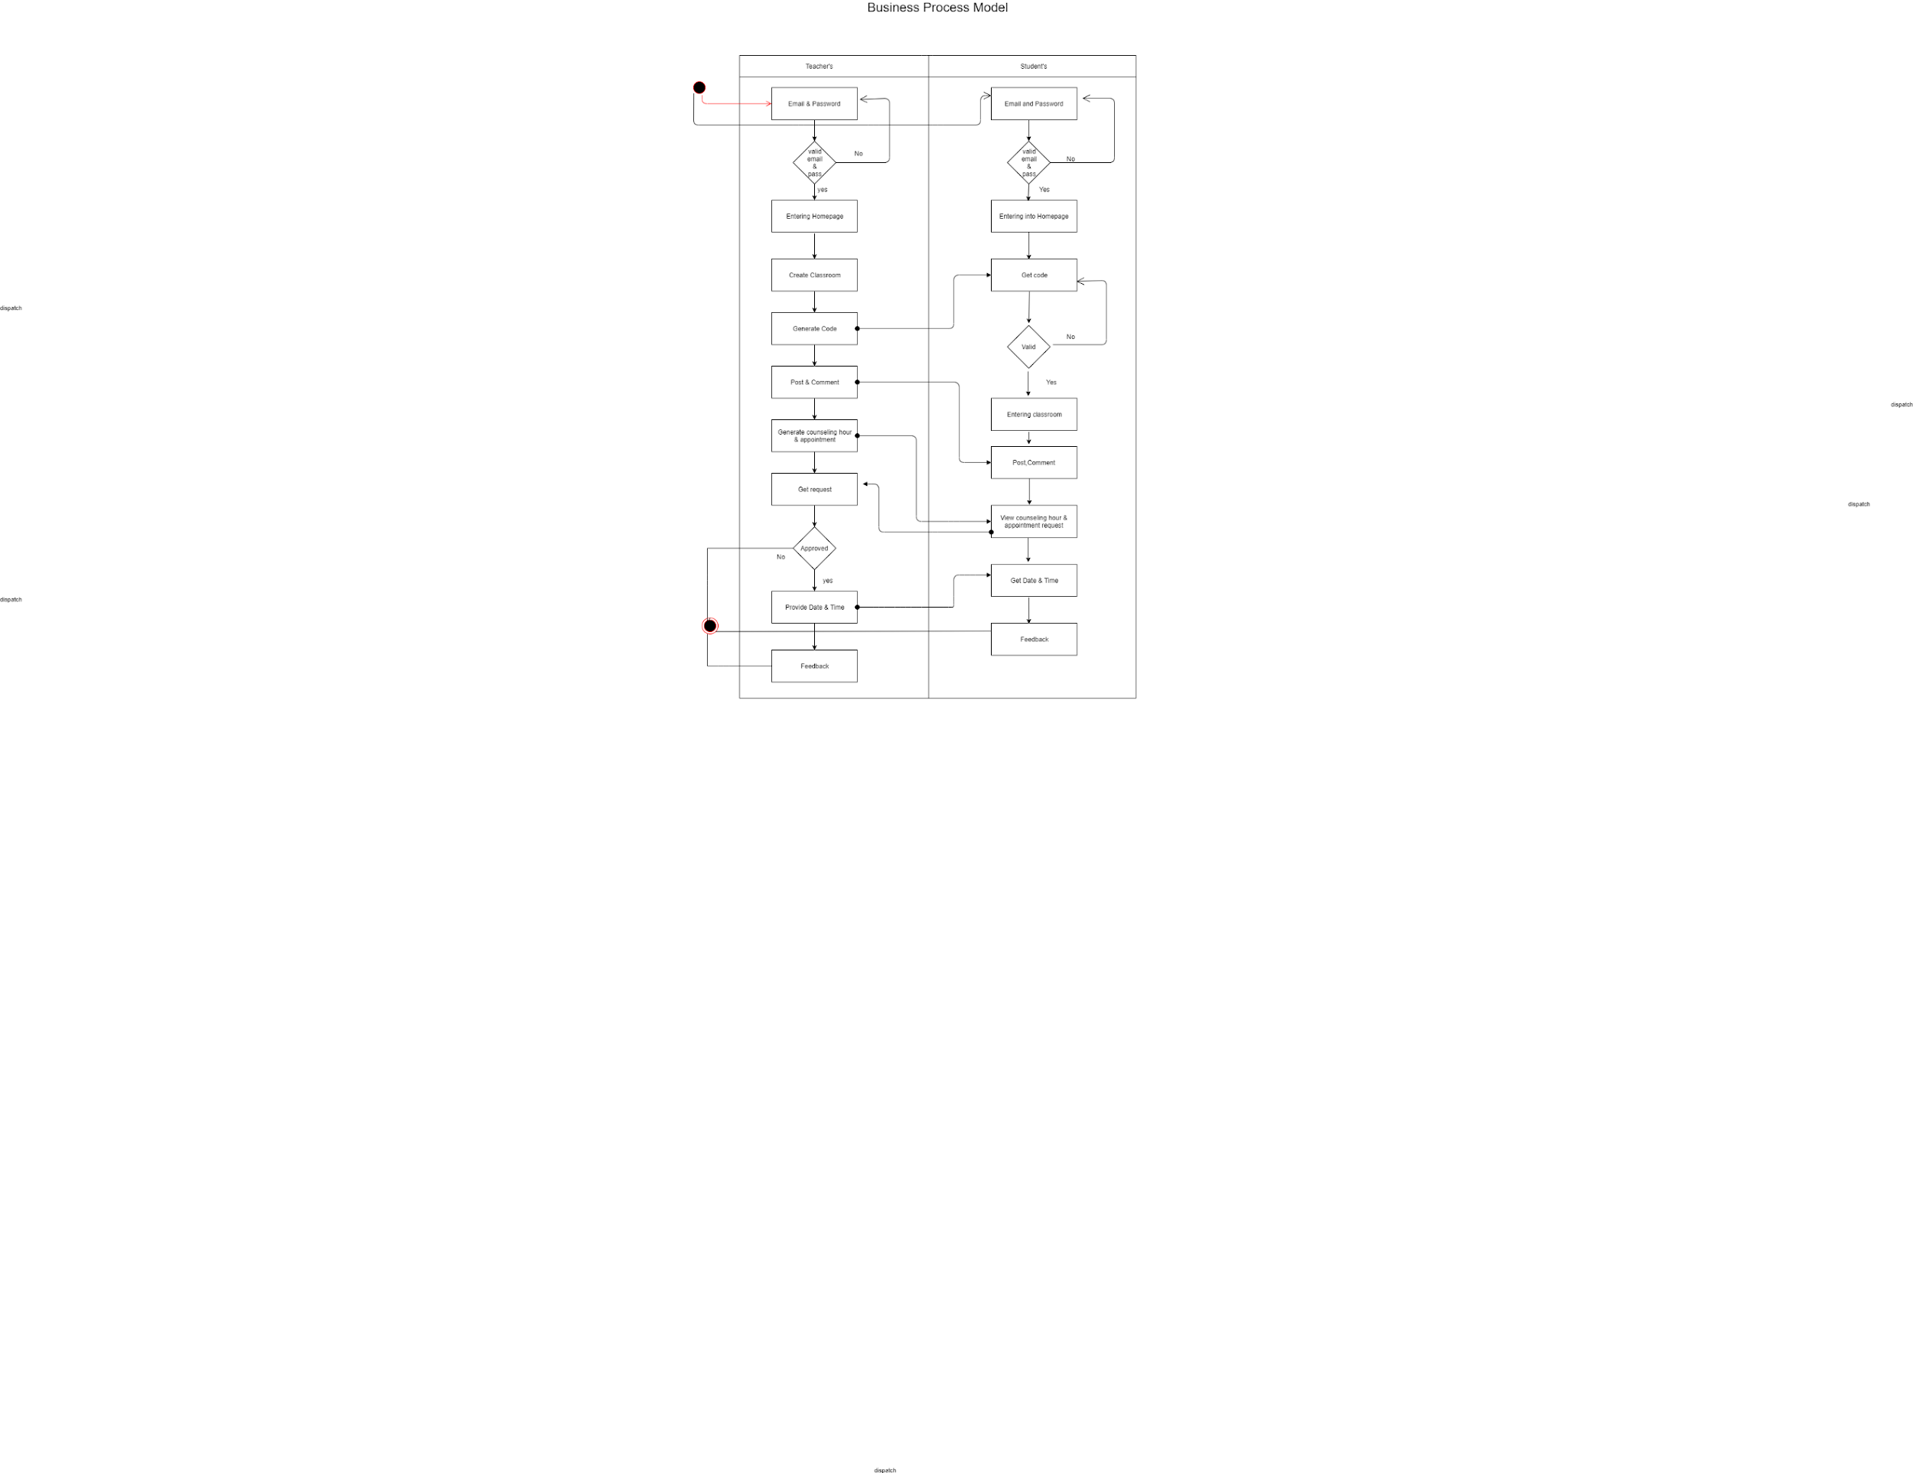

# Requirement collection and analysis

Application requirements:

* User
* Continuously update the information
* Time convenience
* User-friendly
* Easily to accessible
* Log in the system for the Admin
* Browser Access
* Get feedback message via user

## 3.2.1Hardware and Software Requirements for Our System

At the very first, you must check the hardware for your computer, you should first make sure that your computer supports the system requirements and ready to operate. These are the necessary specifications that must have in order to use the software and hardware to be used properly; all computer software needs some common hardware components or other software resources to be present on a computer.

In the development area, the system requires for all tools and platforms to perform the new system like

* + - 1. XAMPP (New version will be good)
      2. TEXT editor: Sublime Text Editor
      3. Any browser which support JavaScript

We have to use some design part with JavaScript, so If any browser is restricted about java then the design won’t work. That’s why we needed browser which able to run java code

## 3.2.2Analysis

After we have seen the problem of the old system we make that understand there is a great need to develop a new system like this. We decided to take HTML and CSS as front end and PHP to backend and MYSQL for DB as a solution.

Strategy for this problem, because PHP is a server-side scripting language for developing a web-based application and that is peaceful to be developed.

**3.3Use Case Modeling and Description**

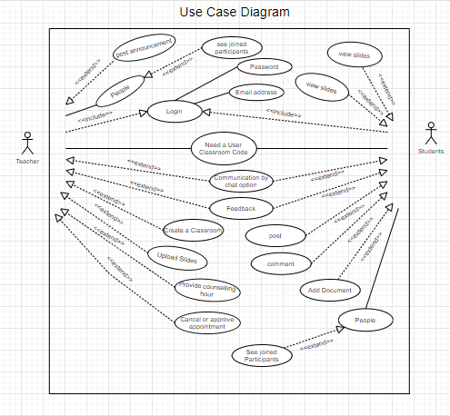

**3.4Logical Data Model**

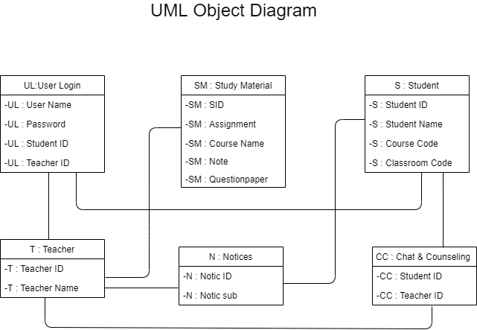

**3.5 server flow Diagram**

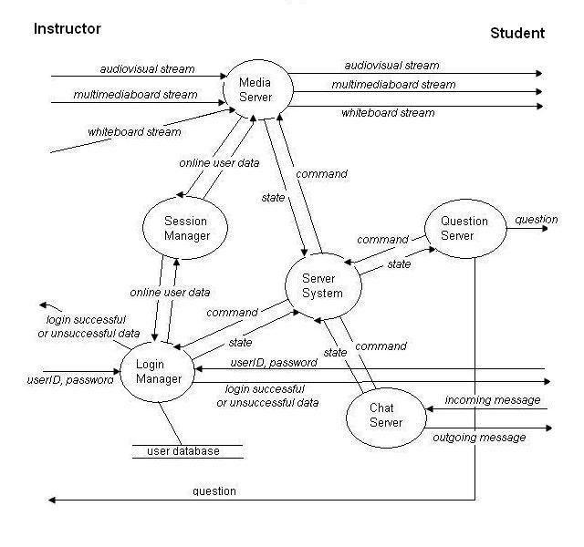

**3.6 Activity Diagram**

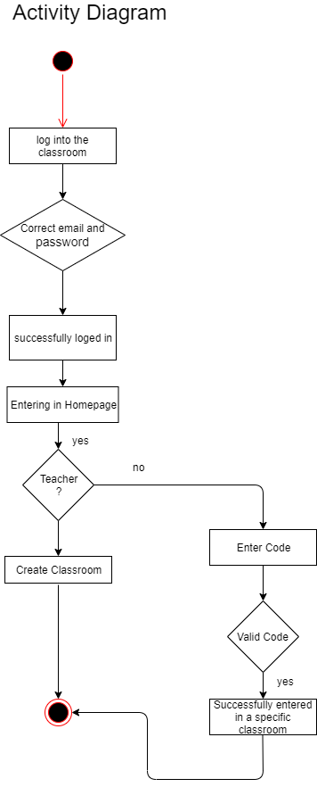

**CHAPTER 6**

**Conclusion and Future Scope**

**6.1 Discussion and Conclusion**

This project is exciting topic to work. After going through the work, we faced many challenging tasks that are related to our educational system. We researched so many web applications that showed us the direction how to develop our system.

We interact with the teacher and students that what type of problems they are facing. They were happy to know as it will save time and they will be able to attend in online class. They don’t need to meet their teachers physically.

Despite everything we achieved, we faced many challenges to finish this project. After all it’s an online based system. The opportunities that provided through this web application is huge.

**6.2 Goal**

Our goal is to make a complete platform for our education system. Because in Bangladesh, most of the sectors are now much developed than this. By our project users can save their valuable time. Basically, we are trying to make life easier with this section also.

**Goals of Implementation**

* Follow the guiding principles established for the project.
* Maximize the opportunities and usage of the new system by search engine friendly scripts.
* Develop a comprehensive timeline; and develop work flow and decision making to ensure that milestone dates are met and the project is completed within the established timeline.
* Develop and follow decision making structure will insure that required decisions are made within the designated time frame in order to keep the project on time and on budget.
* Manage implementation costs to stay within the established project budget.
* Develop and follow strategies that will result in an orderly and efficient transfer of system knowledge to users.

**6.3 Scope for Further Developments**

The current situation does not provide an internet registration process. The only service available on the internet is the organization of the schedule of the student for the incoming semester, without any sort of official version of the schedule. The student still must go to his advisor’s office, talk his schedule over with him, get it approved and signed, then take the approved schedule at the registrar’s office to be officially signed in.

The scope of this project is not much beneficial for developer but it’s very beneficial for our generation. Students nowadays showing interest on easier life lead and want everything possible on internet. For their perspective we are building this project. Especially we include a chatting system and a counselling hour behind sharing post. It helps students to develop their study. Whom are don’t feel free to communicate with teachers they can easily solve their problem with a counselling hour. It will create a huge space for students to share anytime with teachers by chatting. They can get their lectures via online.

**REFERENCES**

1. W3School.com
2. google.com
3. <https://www.scribd.com/doc/59220739/SRS-documentation-of-Virtual-Classroom-System-SRS-documentation-of-Personal-Identity-Management-SRS-documentation-of-EMentoring-for-women-system>
4. <https://www.academia.edu/15823029/Software_Requirements_Specification_For_Online_Training_Application>
5. <https://web.wpi.edu/Pubs/E-project/Available/E-project-050118-070149/unrestricted/EduLinkUserGuide.pdf>
6. <https://ac.aup.edu/~croda/SampleStudentsWork/cs348/finalProjectS07/final%20presentation/final/Volere_Specifications_FV.pdf>
7. <https://www.researchgate.net/publication/289292796_A_web-based_virtual_classroom_system_model>
8. <http://www.fao.org/3/i2516e/i2516e.pdf>
9. *Kerr, Dara (May 6, 2014).*[*"Google unveils Classroom, a tool designed to help teachers"*](https://www.cnet.com/news/google-unveils-classroom-a-tool-designed-to-help-teachers/)*.*[*CNET*](https://en.wikipedia.org/wiki/CNET)*.*[*CBS Interactive*](https://en.wikipedia.org/wiki/CBS_Interactive)*. Retrieved April 28, 2017.*
10. <http://www.uft.org/linking-learning/pros-and-cons-google-classroom>
11. <https://edtechreview.in/trends-insights/trends/2902-10-exciting-new-google-classroom-features>
12. <https://en.wikipedia.org/wiki/Learning_management_system>
13. <http://blog.online.colostate.edu/blog/online-teaching/5-discussion-ground-rules-for-the-online-classroom/>

**APENDIX**

**Appendix A: Project Reflection**

If we can complete our project with all over our country then it will be a huge platform for our education system. It can be a startup business also. Our target is to work on it in future. Hope that it will help students a lot.

**Appendix B: Related Diagrams**

As there are no such work on our project but there is an app which is partially related to our work. Only some website is available on online classroom.