This app allows user to maintain a watch list for movies, when you have watched them it saves into a watched list. The movies will be stored in Core Data, used image Caching.

This app will have 5 view controllers:

**Login View:** For users to login

**Movie Picker View:** Allows users to pick a movie and save it in watch list view

**Watch List View:** Allows the user to maintain a checklist of movies.

**Watched List View:** Allows the user to save the movies watched

**Profile View:** It gives the user an option to logout and also displays the number of watch List and watched List movies.

**Movie Detail View:** Shows information regarding the movie like Rating, overview, time and Genre.

**Login View Controller:**

When the app first starts it will open the Login View

User will be able to click on Authenticate with MovieDB button when the user is not logged in.

When the user is logged in then it skips the Login View.

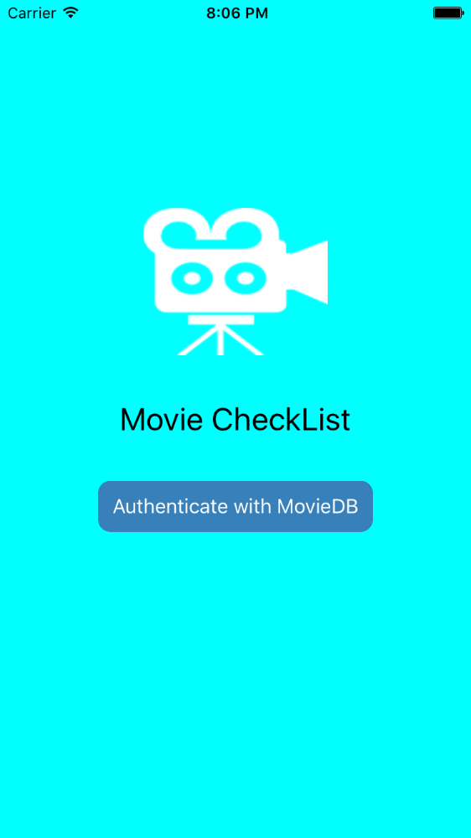

**Movie Picker View Controller:**

User will be able to enter the movie name in the search bar, which will populate the search results.

User will be able to click on Cancel to navigate back to Watch List View Controller.

When the user clicks on a row with a movie name, the app navigates to Watch List View Controller and adds the selected movie to it.

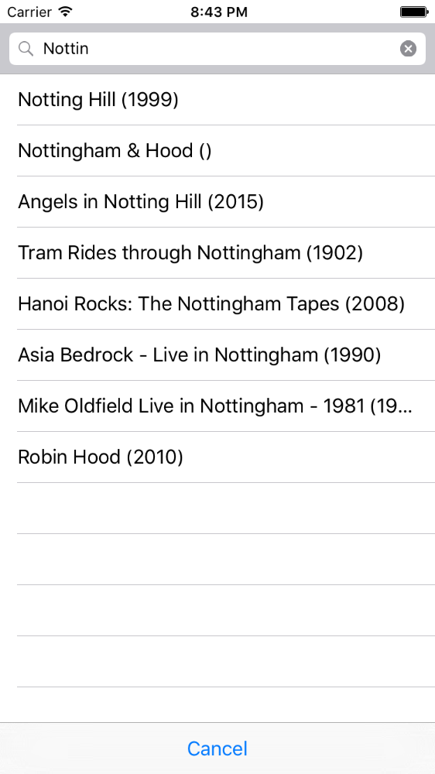

**Watch List View Controller:**

Users will be able to look at the list of movies that have to be watched. If there are no movies then nothing will be displayed.

When the + button is clicked it opens up the Movie Picker View Controller, from here movies are added to the Watch List.

Users are able to delete the movie by swiping right.

Users will be able to click on the check mark which will delete the movie from the watch list and add it to the watched list (You can look at this movie in Watched List View Controller).

Users can select any movie the app will then navigate to Movie Detail View Controller to show movie information.

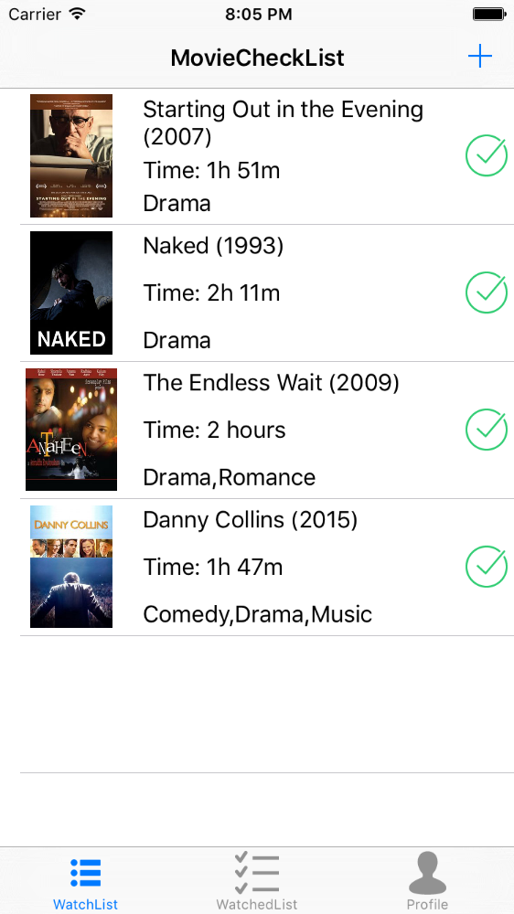

**Watched List View Controller:**

Users will be able to look at the list of movies that have to be watched. If there are no movies then nothing will be displayed.

Users are able to delete the movie by swiping right.

Users can select any movie the app will then navigate to Movie Detail View Controller to show movie information.

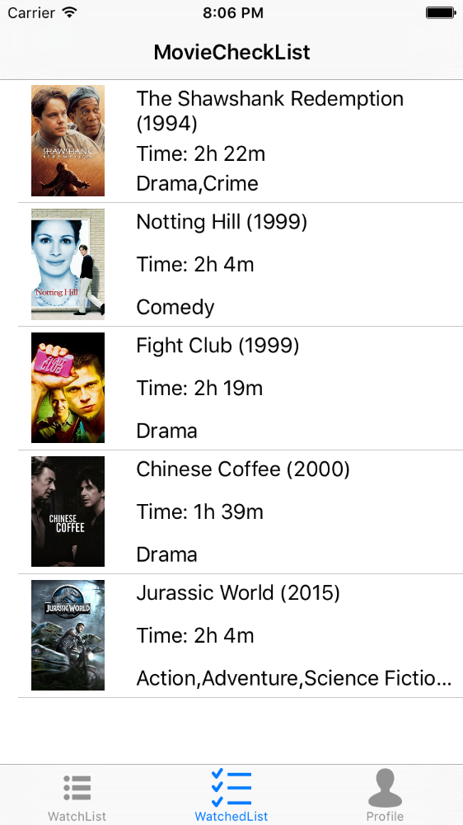

**Profile View Controller:**

User will be able to click on Sign Out, it will sign out the user and delete all the data with regards to that user.

User will be able to look at the number of movies to Watch and the number of movies watched.

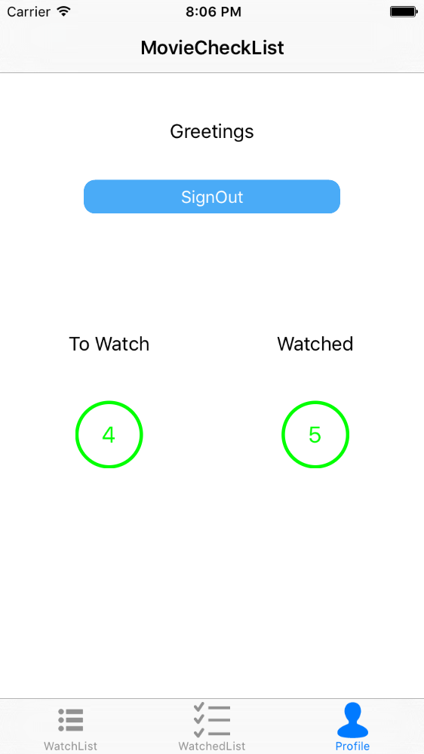

**Movie Detail View:**

Users will be able to look at information regarding the selected movie like Rating, overview, time and genre.

