UPDATED TECHNICAL CORRECTION PACKAGE
Lanmodulin Dy-selectivity workflow
Corrected figures, tables, reviewer-response map, and validated OpenMolcas prototype evidence
Manuscript: JMGM-D-26-01758
Scope: Technical corrections and prototype evidence; main manuscript intentionally unchanged
Repository: https://github.com/RahatulAshakin/lanm-dy-selectivity
Audit trail: original audit 549b22918e1edf409e0c75831cb9af7069468275; update prepared from main e425926d3b22de50beef9dda92a657767b52df66
Updated: 2026-08-16

Targeted result after correction
The technically supportable result is a model-prioritized Hans pocket candidate for additional quantum and experimental testing. The present repository does not establish thermodynamic binding free energy, Dy selectivity, zero-waste separation, or a validated quantum-state mechanism.

Area | Status | Submission use
Classical data correction | Ready | Corrected masks, funnel, lineage, model settings, OpenMM replica data, and dimensionless model score
Quantum prototype execution | Validated | Genuine OpenMolcas H2 reference and atomic Dy CAS(9,7)/SOC/SINGLE_ANISO runs completed; these are not LanM results
Manuscript text | Unchanged | Author name, title/abstract claims, citations, and prose edits are recorded but not applied
Repository remediation | Included | Updated report/status tables plus prototype inputs, logs, figures, tables, provenance, and selected source artifacts
Classical corrections trace to original audit commit 549b22918e1edf409e0c75831cb9af7069468275; this update was prepared from main commit e425926d3b22de50beef9dda92a657767b52df66.

1. Scope and correction decision
This package responds to the supplied reviewer comments through technical and reproducibility corrections only. It does not alter the manuscript. The package separates supported corrections from author-dependent work so that unsupported quantum values, mechanisms, or experimental claims are not introduced merely to satisfy a review point.

1.1 What can be corrected now
Correction | Concrete update
Metric terminology | Remove the energy-like transformation and report a dimensionless Composite Quality Index.
Design accounting | Reconcile 70 role memberships to 66 unique positions and separate positions from generated sequences.
Sampling transparency | Report exact MPNN temperatures, seeds, counts, and shortlist units.
Rosetta description | Replace structural-realism wording with one-structure score-only triage and explicit limitations.
OpenMM reporting | Expose all 45 replica/metal/candidate means, parameter values, seeds, duration, metric definition, and force-field caveats.
Structure scope | Distinguish deposited A-D chains from author/PISA A2 assemblies and clarify chain-A versus multichain computational contexts.
Full machine-readable tables are included in the tables/ directory.

1.2 What cannot be corrected without author data
The project repository still contains no project-specific Dy/Nd ORCA or OpenMolcas production inputs and outputs for the LanM clusters. This update adds genuine OpenMolcas reference and atomic-Dy prototype files, including natural occupations, SOC energies, orbital artifacts, and independent repeat evidence. Because the prototype is not a LanM cluster and includes no Nd production calculation, it does not regenerate or validate manuscript Figures 6-7.

2. Reviewer-response correction matrix
The matrix below remains the point-by-point technical response. Prototype evidence is marked separately from project-specific evidence; a prototype result never changes a project-data gap to complete.
Item | Reviewer issue | Technical correction | Status
R1.1 / R2-B | Undefined and thermodynamically invalid pocket delta-G proxy | Replace with dimensionless Composite Quality Index = 0.7 ligand confidence + 0.3 overall confidence; remove -RT ln transformation. Evidence: Figure TC5; model_quality_index.csv. | Corrected
R1.2 | Natural occupations and active-space suitability | Add exact seven-orbital natural occupations for every root of the official atomic Dy CAS(9,7) prototype and preserve source logs. Project-specific Dy/Nd LanM occupations and active-space justification remain required. | Partially addressed: prototype only
R1.3 | CASPT2 shift, intruder states, number of states | Add a validated H2 CASPT2 reference energy check. Project-specific Dy/Nd CASPT2 state counts, shifts, intruder diagnostics, energies, and convergence remain required. | Partially addressed: reference only
R1.4 | Reduced-cluster size and environmental effect | Require atom/residue inventory, total charge/multiplicity, caps/constraints, coordinates, and sensitivity comparison. Evidence: quantum_evidence_gap_register.csv. | Blocked: source data absent
R1.5 | Zero-waste claim lacks experimental evidence | Technical package states that no experimental separation or waste-balance evidence is present and narrows the result to a computational candidate-prioritization claim. Evidence: Technical report Sections 1 and 6. | Flagged; manuscript wording outside scope
R1.6 | Only Al and Fe competitors | State that Al(III)/Fe(III) were the tested off-target subset. Do not generalize to Ca/Mg/Zn; recommend an expanded panel. Evidence: modeling_specification.csv. | Corrected limitation
R1.7 | MPNN parameters and filtering unspecified | Expose exact temperatures, seeds, generated/unique/retained counts, and selection units. Evidence: Figure TC2; sequence_funnel.csv; modeling_specification.csv. | Corrected
R1.8 / R2-S4 | Rosetta realism criteria/cutoffs unspecified | Correct description to score-only triage: score_jd2, nstruct=1, fixed seed, no relax, no acceptance cutoff, within-topology ranking only. Evidence: modeling_specification.csv. | Corrected and qualified
R1.9 | Hans pocket versus interface unclear | Distinguish chain-A pocket model from chain-A-designed/B-D-fixed crystallographic context; attribute score difference to model confidence, not inferred structural causality. Evidence: Figure TC3; finalist_lineage.csv. | Corrected
R2-A1 | Spin-orbit coupling not documented | Add genuine atomic-Dy RASSI/SOC and SINGLE_ANISO outputs with 66 states and 33 Kramers pairs. Project-specific LanM SOC treatment and state ordering remain required. | Partially addressed: prototype only
R2-A2 | Relativistic Hamiltonian and basis sets absent | Record OpenMolcas v26.06, DKH/AMFI, ANO-RCC contraction, RICD/CDTH settings for the atomic-Dy prototype. Project-specific Hamiltonian/ECP and basis definitions remain required. | Partially addressed: prototype only
R2-A3 | Active orbitals/occupations across roots not demonstrated | Add prototype occupation tables, RasOrb and Molden source artifacts. These demonstrate the extraction path but do not establish the LanM active space or replace Figure 7. | Partially addressed: prototype only
R2-C1 | Metal force-field provenance and Al/Fe artifacts | Report actual generic OPC3-compatible 12-6-4 parameters; state tuned chelator values are absent; treat Al/Fe distances as model-dependent geometry, not affinity evidence. Evidence: metal_parameter_values.csv; Figure TC4. | Corrected with caution
R2-Minor 1 | Christopher Stuetzle spelling | Record the requested spelling correction in the response matrix only; manuscript author line is intentionally unchanged in this package. Evidence: reviewer_response_matrix.csv. | Deferred: manuscript outside scope
R2-Minor 2 | Arg100 not labeled | Identify chain-A Arg100 explicitly and show when it becomes Lys100 in the Hans pocket seed. Evidence: Figure TC3; finalist_lineage.csv. | Corrected
R2-Minor 3 | References 30-36 irrelevant | Record as a manuscript bibliography action; no bibliography is modified in this technical-only package. Evidence: reviewer_response_matrix.csv. | Deferred: manuscript outside scope
R2-S4 Y-distance | Y distances converge near 2.19 Å | Report all nine replica values. Similarity is due to the common Y(III) model and near-identical local coordination; displayed equality was rounding, not duplicated data. Evidence: Figure TC4; openmm_replicates.csv. | Corrected
R2-Data | Deposit raw ORCA .in/.out | Deposit genuine OpenMolcas prototype inputs, successful console logs, extracted tables, plots, provenance, and selected orbital/anisotropy sources. Original project-specific ORCA/LanM files remain absent. | Partially addressed: project files required
Machine-readable version: tables/reviewer_response_matrix.csv.

3. Corrected figures
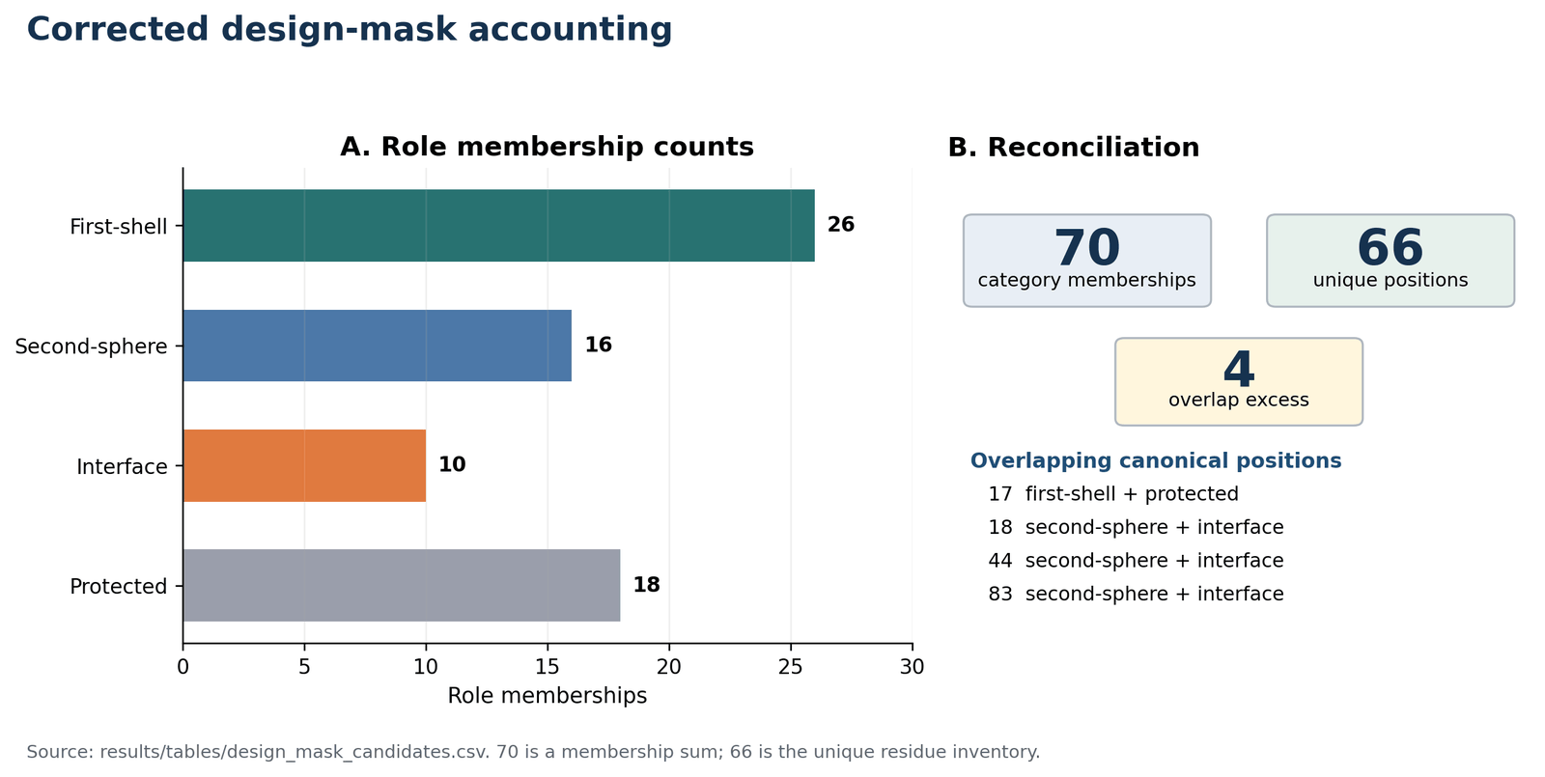
Figure TC1. Corrected design-mask accounting. Role categories overlap: 70 memberships correspond to 66 unique residue positions, with four one-count overlaps.
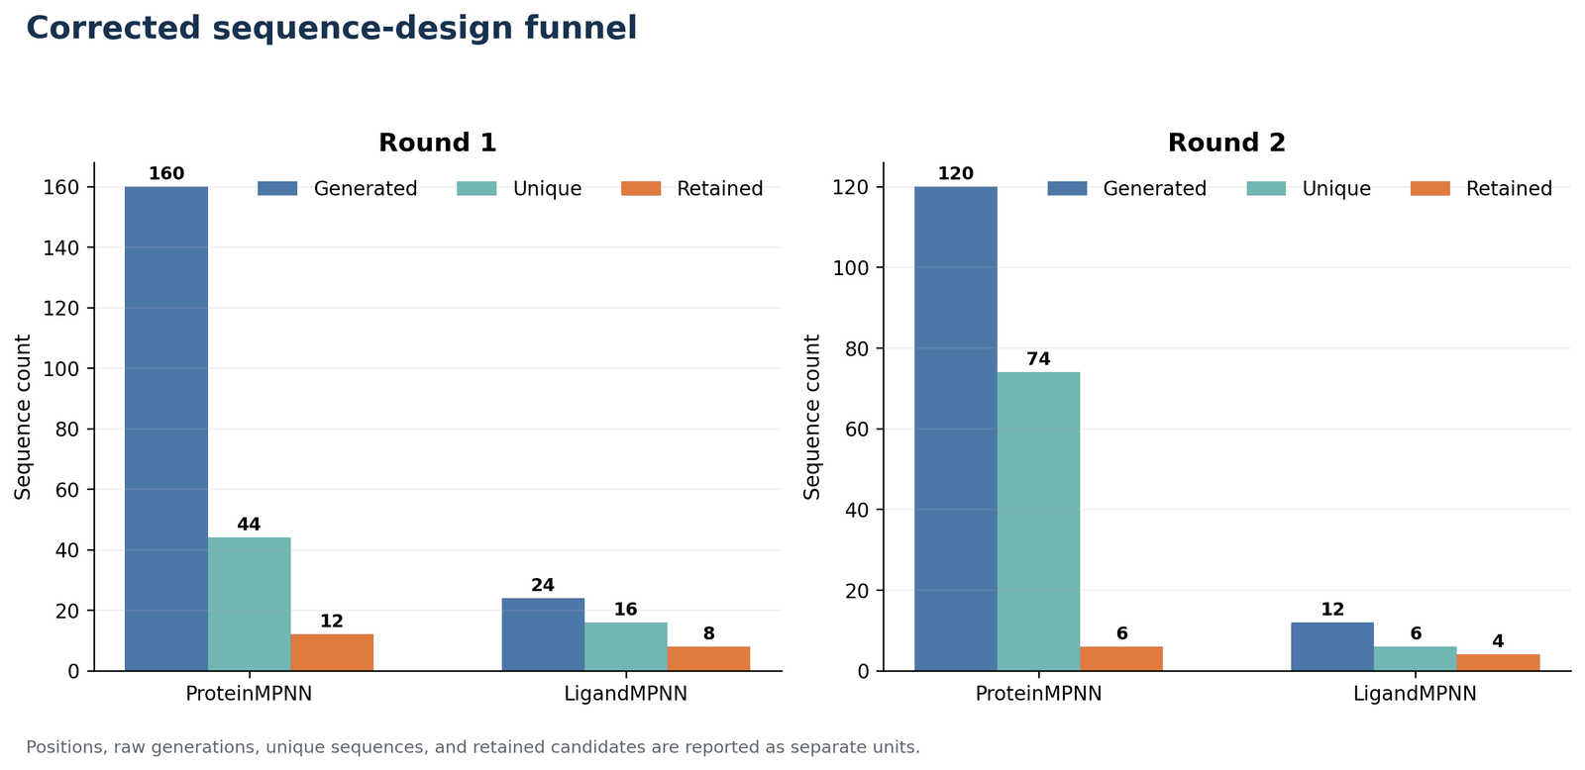
Figure TC2. Corrected design funnel. Raw generations, unique sequences, shortlisted sequences, scored candidates, and final OpenMM finalists are reported separately.
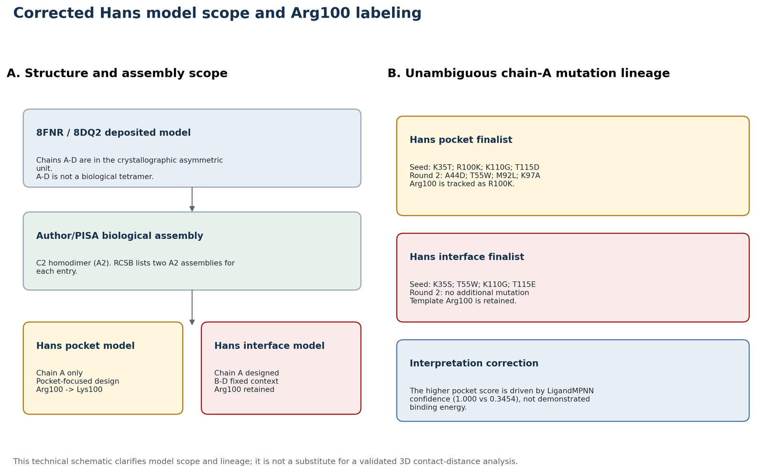
Figure TC3. Corrected Hans model scope and Arg100 labeling. The diagram distinguishes the crystallographic A-D context from A2 biological assemblies and explicitly tracks chain-A Arg100/Lys100.

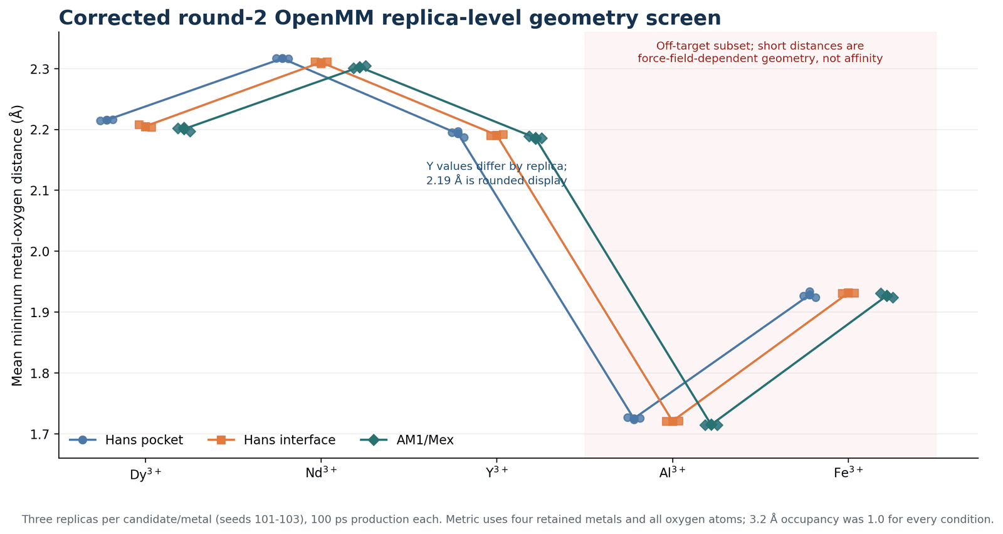
Figure TC4. Corrected round-2 OpenMM geometry screen. Every point is a replica mean. The Al/Fe values are force-field-dependent geometry results and are not interpreted as affinity or selectivity.
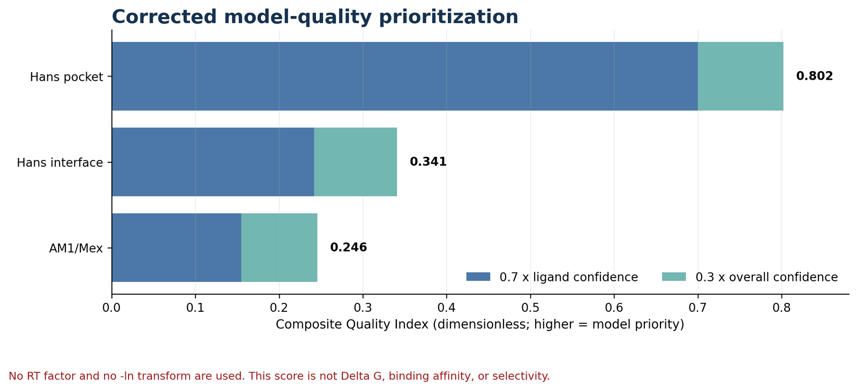
Figure TC5. Corrected model-quality prioritization. The Composite Quality Index is dimensionless and must not be labeled as Delta G, free energy, or thermodynamic affinity.

4. Corrected tables and exact technical settings

4.1 Design-mask reconciliation
Role | Memberships
First-shell | 26
Second-sphere | 16
Interface | 10
Protected | 18
Unique inventory | 66
Membership sum | 70
Overlap excess | 4
Source: design_mask_candidates.csv; overlap detail is in mask_overlaps.csv.

4.2 MPNN and Rosetta specification
Component | Exact setting | Interpretation limit
ProteinMPNN round 1 | 20 sequences/target at temperatures 0.10 and 0.15; seed 37; batch size 1 | Generative sequence sampling; not deterministic in the mathematical sense despite fixed seed.
ProteinMPNN round 2 | 20 sequences/target at temperatures 0.10 and 0.15; seed 37; batch size 1 | Same fixed-seed sampling settings.
LigandMPNN rounds 1/2 | Temperature 0.10; seed 37; 2 designs per candidate; one batch; side-chain and ligand context enabled | Model confidence is not a probability of thermodynamic binding.
Rosetta round 2 | score_jd2; nstruct=1; seed 37; fa_elec weight=0; waters retained; auto metal setup; rank within topology | Score-only triage. No relaxation, no structural-realism acceptance cutoff, and no cross-topology score comparison.
Sources: recorded run_command.txt files; rosetta_round2_candidate_ranking.csv; repository scoring code.

4.3 OpenMM protocol and metric
Component | Exact setting | Interpretation limit
OpenMM round 2 | 298 K; 1 atm; 2 fs; friction 1 ps^-1; 100 ps production; 3 replicas, seeds 101-103; 500-step reporting | Short reduced rescreen; not a binding free-energy calculation.
OpenMM metric | Mean over frames of the minimum distance from each retained metal atom to any oxygen; 3.2 Å inner-sphere cutoff | Occupancy=1.0 at this cutoff does not establish selectivity or experimentally persistent binding.
Force field | amber19-all.xml + amber19/opc3.xml; generic published OPC3-compatible 12-6-4 metal family | LanM-chelator-tuned numeric parameters are absent; Al/Fe short distances require sensitivity analysis.
Sources: simulation_config.yaml, system_build_log.txt, and 45 screening_log.txt files under results/round2_openmm_screening/.

4.4 Generic OPC3-compatible 12-6-4 metal parameters
Metal | Charge | Rmin/2 (Å) | epsilon (kcal/mol) | C4 (kcal/mol Å^4)
Dy | 3 | 1.632 | 0.0962022 | 183
Nd | 3 | 1.712 | 0.1464093 | 184
Y | 3 | 1.626 | 0.09289608 | 192
Al | 3 | 1.361 | 0.01031847 | 363
Fe | 3 | 1.455 | 0.02662782 | 429
Source: config/metal_parameter_values.yaml. The repository does not contain chelator-tuned numeric coefficients.

4.5 OpenMM candidate means
Candidate | Dy | Nd | Y | Al | Fe
Hans pocket | 2.215 ± 0.0007 | 2.316 ± 0.0004 | 2.193 ± 0.0055 | 1.725 ± 0.0017 | 1.928 ± 0.0050
Hans interface | 2.205 ± 0.0023 | 2.310 ± 0.0017 | 2.190 ± 0.0013 | 1.721 ± 0.0005 | 1.931 ± 0.0006
AM1/Mex | 2.200 ± 0.0032 | 2.302 ± 0.0021 | 2.186 ± 0.0022 | 1.715 ± 0.0006 | 1.927 ± 0.0034
Values are mean ± sample SD of three replica-level means in Å. Full six-decimal data are in openmm_replicates.csv and openmm_summary.csv.
The near-identical Y values are expected from the common Y(III) parameter model and similar first-shell coordination. The underlying nine replica means range from 2.183940 to 2.196893 Å; the repeated '2.19 Å' statement was only rounded display.

4.6 Dimensionless model-quality index
Rank | Candidate | Ligand confidence | Overall confidence | CQI
1 | Hans pocket | 1.0000 | 0.3399 | 0.801970
2 | Hans interface | 0.3454 | 0.3303 | 0.340870
3 | AM1/Mex | 0.2213 | 0.3023 | 0.245600
CQI = 0.7 x ligand confidence + 0.3 x overall confidence. It is dimensionless and has no thermodynamic interpretation.

5. Structure and model-scope correction
PDB | Deposited model | Biological assembly | Technical use
8FNR | A,B,C,D; Dy: A=4, B=3, C=3, D=4 (14 total) | A2 homodimer (C2); two author/PISA assemblies are listed | Pocket model uses chain A; interface model keeps A-D crystallographic context
8DQ2 | A,B,C,D; La: 3 per chain (12 total) | A2 homodimer (C2); author/PISA; gel-filtration evidence for assembly 1 | Reference only; do not call A-D the biological tetramer
8FNS | A; Nd: 4 | Monomeric reference in repository workflow | AM1/Mex chain-A model
6MI5 | X; Y: 3 | Monomeric reference in repository workflow | AM1/Mex reference
Primary structure sources: https://www.rcsb.org/structure/8FNR and https://www.rcsb.org/structure/8DQ2; repository inventory: results/tables/template_chain_summary.csv.
The deposited metal counts are crystallographic inventories, not numbers of equivalent functional sites. Any interface conclusion should identify the specific biological assembly or explicitly state that A-D was retained as crystallographic context.

6. Quantum evidence gap and submission gate
Submission gate after prototype execution
Do not present the atomic-Dy prototype figures, occupations, SOC values, or H2 CASPT2 reference as repository-reproduced LanM results. Manuscript Figures 6-7 remain gated until project-specific Dy and Nd cluster inputs and full outputs are added and independently regenerated.

Required artifact | Minimum content | Status | Affected output
Dy CASSCF input and full output | Coordinates, charge/multiplicity, Hamiltonian/ECP, basis sets, CAS(9,7), roots, convergence, occupations | LanM absent; atomic prototype added | Dy active-space claims; Figures 6-7
Nd CASSCF input and full output | Coordinates, charge/multiplicity, Hamiltonian/ECP, basis sets, CAS(3,7), roots, convergence, occupations | Absent | Nd active-space claims; Figures 6-7
Dy/Nd CASPT2 inputs and outputs | State count, imaginary and IPEA shifts, intruder-state diagnostics, energies and convergence | LanM absent; H2 reference added | CASPT2 comparison
SOC calculation files | SOC method, states mixed, spin-free roots, matrices/energies, convergence | LanM absent; atomic-Dy prototype added | Electronic-state ordering and anisotropy claims
Reduced-cluster coordinate and definition files | Atom/residue inventory, caps, constraints, charge/multiplicity, retained waters, cluster size | Absent | Environmental-scope claims
Natural occupation tables for every root | Seven active-orbital occupations per root with orbital identities | LanM absent; atomic-Dy prototype added | Active-space appropriateness
Orbital image source data | Molden/gbw or equivalent files plus orbital indices and plotting settings | LanM absent; atomic-Dy prototype added | Figure 7
Updated repository audit: genuine OpenMolcas prototype inputs, logs, tables, and selected orbital/anisotropy artifacts are now included. Project-specific Dy/Nd LanM production inputs and full outputs remain unavailable.

7. Repository correction set
Path | Purpose
README.md | Replaces the complete/reproducible and Delta-G language with a technical-correction notice and accurate limitations.
docs/technical_corrections/README.md | Human-readable scope, reviewer mapping, and regeneration instructions.
docs/technical_corrections/SOURCE_DATA_GAPS.md | Explicit quantum and manuscript-only actions that remain open.
docs/technical_corrections/LanM_Technical_Corrections_Report.{docx,pdf} | Shareable Word and PDF report.
results/technical_corrections/figures/* | Five corrected technical figures.
results/technical_corrections/tables/* | Machine-readable corrected data and provenance.
scripts/build_technical_corrections.py | Deterministic rebuild of tables, figures, report, and manifest.
requirements-technical-corrections.txt | Pinned reporting dependencies.
docs/technical_corrections/LanM_Updated_Technical_Corrections_Report.{docx,pdf} | Updated shareable report including the prototype addendum and revised submission gate.
docs/technical_corrections/OPENMOLCAS_PROTOTYPE_STATUS.md | Scope, completion evidence, and the project-specific evidence boundary.
results/openmolcas_prototype/* | Prototype figures, tables, successful logs, provenance, and selected source artifacts.
inputs/openmolcas_prototype/*; scripts/openmolcas_prototype/* | Exact prototype inputs and extraction/rerun scripts.
The manuscript file and its figures are intentionally not edited by this repository correction set.

8. Package manifest
The v2.0 bundle includes this updated Word report and PDF, seven distinct figures (five technical corrections and two prototype plots), the original twelve corrected/source-audit CSV tables, two updated status tables, eight prototype CSV tables plus one extraction JSON file, the complete validated prototype ZIP, repository-update files, manifests, and SHA-256 checksums.
Recommended share note
This v2.0 package resolves the technical, terminology, sampling, model-scope, and classical-data presentation corrections supported by the repository and adds authentic, independently repeated OpenMolcas prototype evidence. The prototype is method-validation evidence only; project-specific quantum claims and manuscript Figures 6-7 remain open.

9. Genuine OpenMolcas prototype execution update
Scope control
The following outputs are authentic OpenMolcas calculations and were independently checked. They validate an execution and extraction workflow, not the manuscript's Dy-LanM or Nd-LanM models. The two plots are prototype figures OM-P1 and OM-P2; they must not be renamed as manuscript Figures 6 or 7.

OpenMolcas v26.06 was built and run locally. A standard H2 reference exercised RASSCF and CASPT2, and an atomic Dy(III) workflow derived from official additional test 321 exercised CAS(9,7) RASSCF, RASSI spin-orbit coupling, and SINGLE_ANISO. The Dy workflow was repeated from a clean work directory and reproduced all extracted values at printed precision.

9.1 Software and execution record
Item | Recorded value
OpenMolcas | v26.06; source commit 8355057f32d65706a35996b5ab07cac2962bb728
Driver / compiler | pymolcas py2.32; GNU Fortran 13.3.0; Release build
Linear algebra / parallel mode | Internal BLAS/LAPACK; serial, one process and one thread
Dy integral treatment | Explicit RICD with CDTH 1.0D-6; DKH scalar relativity and AMFI integrals
Completion markers | _RC_ALL_IS_WELL_ for required stages and driver Happy landing
Exact build and input-change records are included under OpenMolcas_Prototype_Evidence and the repository prototype directories.

9.2 H2 RASSCF/CASPT2 reference validation
Method | Expected (Eh) | Observed (Eh) | Difference (Eh) | Within 1e-8
SCF | -1.122765460009 | -1.122765460000 | 9.000e-12 | TRUE
RASSCF | -1.141134852262 | -1.141134852300 | -3.800e-11 | TRUE
CASPT2 | -1.143847618496 | -1.143847618500 | -4.000e-12 | TRUE
Source: unedited h2_console.log and h2_reference_validation.csv. All three energy differences are far below 1e-8 Eh.

9.3 Atomic Dy(III) CAS(9,7) workflow
Component | Prototype setting | Interpretation boundary
Model | Dy at origin with official test point-charge field | No protein, ligand shell, waters, MD frame, or reduced LanM cluster
Basis / relativity | ANO-RCC 7s6p4d2f1g; DKH; AMFI | Recorded only for this prototype
RASSCF | CAS(9,7), sextet, 11 state-averaged roots | Not a project-specific Dy-LanM active-space validation
SOC / anisotropy | RASSI mixing all 11 roots; 66 SOC states; SINGLE_ANISO | Not project-specific electronic-state ordering or anisotropy
Repeat | Two clean RICD runs; 89.29 s and 88.64 s | Numerical reproducibility of this test only
Source: dy3_ricd_core_console.log, dy3_ricd_repeat_console.log, and the supplied prototype input.

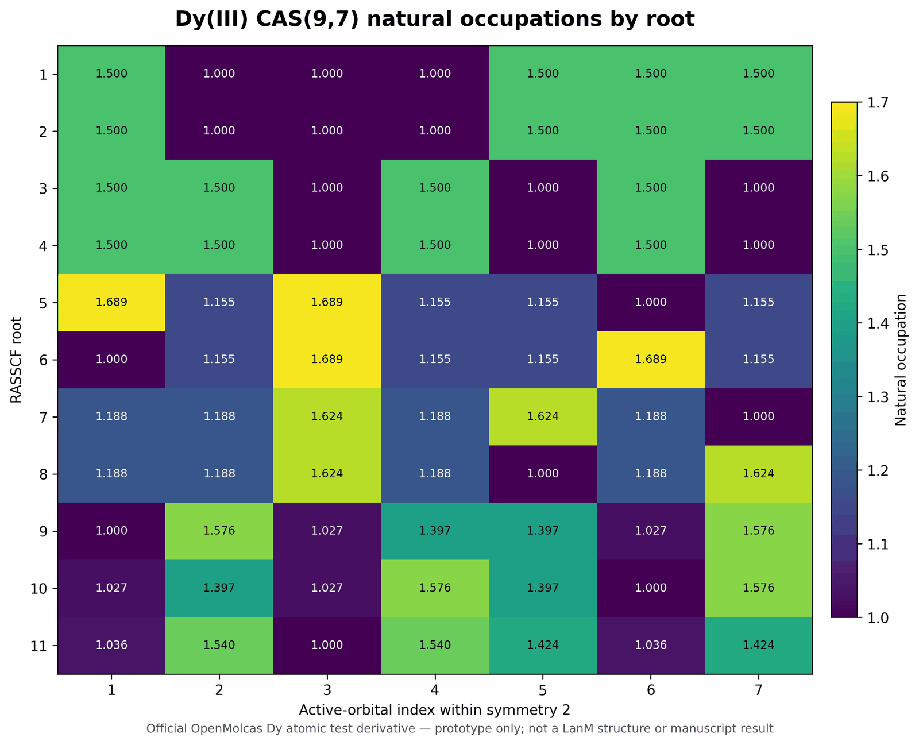
Figure OM-P1. Natural occupations for all 11 roots of the official atomic-Dy CAS(9,7) prototype. This is exact prototype output, not a Dy-LanM result and not manuscript Figure 7.
Each root has seven printed active-orbital occupations. Printed occupation sums are 9.000000 for roots 1-10 and 8.999998 for root 11 because of six-decimal rounding. The complete numeric table is supplied as dy3_natural_occupations_all_roots.csv.

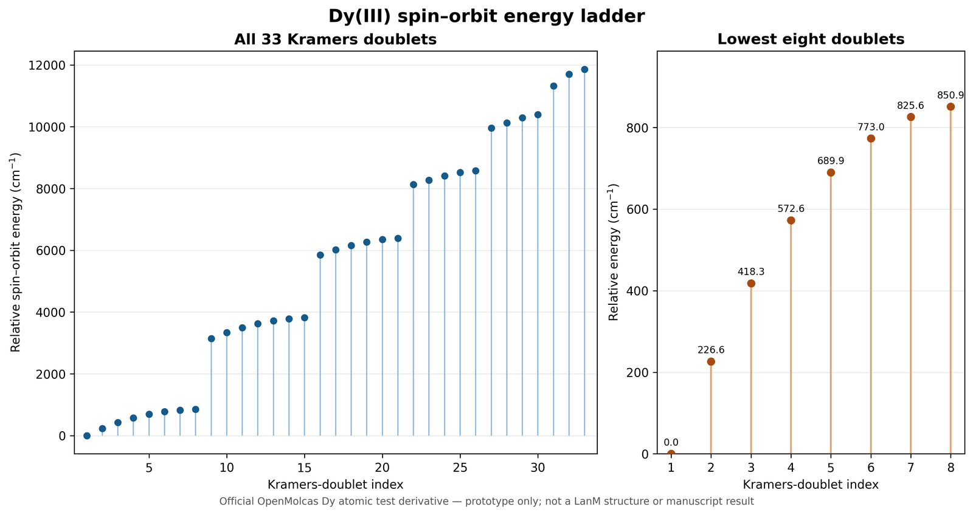
Figure OM-P2. Kramers-doublet energy ladder from the official atomic-Dy prototype RASSI/SOC calculation. This is exact prototype output, not a Dy-LanM state ordering and not manuscript Figure 6.
The 66 spin-orbit states form 33 Kramers pairs at printed precision. The lowest eight doublets occur at 0.0000, 226.5908, 418.3032, 572.5900, 689.9061, 773.0012, 825.5790, and 850.9258 cm-1. The idealized prototype ground doublet has principal values gX = 0.0000000, gY = 0.0000000, and gZ = 20.0115965.

9.4 Independent-repeat validation
Quantity | Maximum absolute difference | Identical at printed precision
RASSCF root energies (Eh) | 0 | TRUE
natural occupations | 0 | TRUE
spin-orbit relative energies (cm-1) | 0 | TRUE
ground-doublet g values | 0 | TRUE
Both complete successful Dy console logs are included; failed/partial conventional-integral attempts remain separated as diagnostics in the complete prototype ZIP.

9.5 What the prototype establishes
Question | Answer
Does an authentic OpenMolcas executable complete RASSCF/CASPT2 reference work? | Yes.
Does an atomic Dy CAS(9,7) -> SOC -> SINGLE_ANISO workflow complete and repeat? | Yes, twice with explicit RICD.
Are inputs, logs, tables, plots, and source artifacts supplied? | Yes, for the prototype.
Does this reproduce Dy-LanM or Nd-LanM? | No.
Does this validate manuscript Figures 6-7 or project-specific CASPT2 ordering? | No.
Does this close reduced-cluster/environment sensitivity? | No.

10. Updated quantum evidence gate
Reviewer-submission gate
The technical correction package and the prototype run are complete and auditable. The primary manuscript's project-specific quantum goal is not achieved: Dy-LanM and Nd-LanM production calculations, CASPT2 comparison, SOC interpretation, reduced-cluster sensitivity, and authentic regeneration of Figures 6-7 still require project coordinates/definitions and full production outputs.

Evidence area | Added in v2.0 | Project-specific status | Submission use
Dy CAS(9,7) occupations | Atomic-Dy prototype, all 11 roots | LanM absent | Method/execution evidence only
CASPT2 | H2 reference validation | Dy/Nd LanM absent | Installation/reference evidence only
SOC / SINGLE_ANISO | Atomic-Dy prototype and repeat | LanM absent | Workflow evidence only
Orbital source data | Prototype RasOrb/Molden artifacts | LanM absent | Prototype traceability only
Reduced cluster | None | Absent | Cannot support environment claims
Figures 6-7 | No project regeneration | Open | Do not claim corrected/reproduced

11. Repository and package changes
Change | Location / result
Updated technical report | Word and PDF under docs/technical_corrections/ and in the submission ZIP
Corrected technical figures | TC1-TC5 retained under results/technical_corrections/figures/
Updated correction tables | Revised reviewer and quantum-evidence status CSVs added without deleting the original audit tables
Prototype figures and tables | Added under results/openmolcas_prototype/ with explicit non-manuscript labels
Authentic source evidence | Inputs, successful logs, provenance, scripts, and selected orbital/anisotropy artifacts added
Integrity | SHA-256 manifests supplied for the package and repository subset
Technical conclusion
The targeted technical-correction result is achieved: the classical correction set is documented, figures and tables are packaged, the OpenMolcas execution path is authentically demonstrated, and repository artifacts are prepared. This is not equivalent to achieving the primary manuscript's project-specific quantum result.

