TECHNICAL CORRECTION PACKAGE
Lanmodulin Dy-selectivity workflow
Corrected figures, tables, reviewer-response map, and repository remediation
Manuscript: JMGM-D-26-01758
Scope: Technical correction only; main manuscript intentionally unchanged
Repository: https://github.com/RahatulAshakin/lanm-dy-selectivity
Audited base: 549b22918e1edf409e0c75831cb9af7069468275
Prepared: 2026-08-16

Targeted result after correction
The technically supportable result is a model-prioritized Hans pocket candidate for additional quantum and experimental testing. The present repository does not establish thermodynamic binding free energy, Dy selectivity, zero-waste separation, or a validated quantum-state mechanism.

Area | Status | Submission use
Classical data correction | Ready | Corrected masks, funnel, lineage, model settings, OpenMM replica data, and dimensionless model score
Quantum evidence | Not ready | Raw ORCA/CASSCF/CASPT2 files are absent; Figures 6-7 cannot be regenerated defensibly
Manuscript text | Unchanged | Author name, title/abstract claims, citations, and prose edits are recorded but not applied
Repository remediation | Prepared | New technical-correction artifacts, reproducible builder, provenance tables, and corrected README notice
Status is based on repository audit at main commit 549b22918e1edf409e0c75831cb9af7069468275.

1. Scope and correction decision
This package responds to the supplied reviewer comments through technical and reproducibility corrections only. It does not alter the manuscript. The package separates supported corrections from author-dependent work so that unsupported quantum values, mechanisms, or experimental claims are not introduced merely to satisfy a review point.

1.1 What can be corrected now
Correction | Concrete update
Metric terminology | Remove the energy-like transformation and report a dimensionless Composite Quality Index.
Design accounting | Reconcile 70 role memberships to 66 unique positions and separate positions from generated sequences.
Sampling transparency | Report exact MPNN temperatures, seeds, counts, and shortlist units.
Rosetta description | Replace structural-realism wording with one-structure score-only triage and explicit limitations.
OpenMM reporting | Expose all 45 replica/metal/candidate means, parameter values, seeds, duration, metric definition, and force-field caveats.
Structure scope | Distinguish deposited A-D chains from author/PISA A2 assemblies and clarify chain-A versus multichain computational contexts.
Full machine-readable tables are included in the tables/ directory.

1.2 What cannot be corrected without author data
The repository contains no ORCA inputs or outputs and no files named for CASSCF or CASPT2. Therefore natural occupations, active-space root character, CASPT2 settings, intruder-state diagnostics, cluster sizes, relativistic treatment, and spin-orbit coupling cannot be reconstructed. Existing quantum Figures 6-7 should not be submitted as regenerated figures until the source files listed in Section 6 are deposited.

2. Reviewer-response correction matrix
The matrix below is the shareable point-by-point technical response. 'Blocked' means the correction requires source data that are not in the repository; it does not mean a value should be estimated.
Item | Reviewer issue | Technical correction | Status
R1.1 / R2-B | Undefined and thermodynamically invalid pocket delta-G proxy | Replace with dimensionless Composite Quality Index = 0.7 ligand confidence + 0.3 overall confidence; remove -RT ln transformation. Evidence: Figure TC5; model_quality_index.csv. | Corrected
R1.2 | Natural occupations and active-space suitability | Do not regenerate without raw multiroot orbital and occupation data. Require all roots, orbitals, occupations, and active-space justification. Evidence: quantum_evidence_gap_register.csv. | Blocked: source data absent
R1.3 | CASPT2 shift, intruder states, number of states | Require program/version, state averaging, imaginary/IPEA shifts, state counts, convergence, and intruder-state diagnostics. Evidence: quantum_evidence_gap_register.csv. | Blocked: source data absent
R1.4 | Reduced-cluster size and environmental effect | Require atom/residue inventory, total charge/multiplicity, caps/constraints, coordinates, and sensitivity comparison. Evidence: quantum_evidence_gap_register.csv. | Blocked: source data absent
R1.5 | Zero-waste claim lacks experimental evidence | Technical package states that no experimental separation or waste-balance evidence is present and narrows the result to a computational candidate-prioritization claim. Evidence: Technical report Sections 1 and 6. | Flagged; manuscript wording outside scope
R1.6 | Only Al and Fe competitors | State that Al(III)/Fe(III) were the tested off-target subset. Do not generalize to Ca/Mg/Zn; recommend an expanded panel. Evidence: modeling_specification.csv. | Corrected limitation
R1.7 | MPNN parameters and filtering unspecified | Expose exact temperatures, seeds, generated/unique/retained counts, and selection units. Evidence: Figure TC2; sequence_funnel.csv; modeling_specification.csv. | Corrected
R1.8 / R2-S4 | Rosetta realism criteria/cutoffs unspecified | Correct description to score-only triage: score_jd2, nstruct=1, fixed seed, no relax, no acceptance cutoff, within-topology ranking only. Evidence: modeling_specification.csv. | Corrected and qualified
R1.9 | Hans pocket versus interface unclear | Distinguish chain-A pocket model from chain-A-designed/B-D-fixed crystallographic context; attribute score difference to model confidence, not inferred structural causality. Evidence: Figure TC3; finalist_lineage.csv. | Corrected
R2-A1 | Spin-orbit coupling not documented | Require SOC/RASSI-SO/NEVPT2-SO treatment or an explicit scope-limited justification. No claim made from absent data. Evidence: quantum_evidence_gap_register.csv. | Blocked: source data absent
R2-A2 | Relativistic Hamiltonian and basis sets absent | Require exact Hamiltonian/ECP, basis sets for all atoms, auxiliary bases, scalar-relativistic settings, and software version. Evidence: quantum_evidence_gap_register.csv. | Blocked: source data absent
R2-A3 | Active orbitals/occupations across roots not demonstrated | Require orbital plots and natural occupation numbers for every reported root; verify seven 4f orbitals remain active. Evidence: quantum_evidence_gap_register.csv. | Blocked: source data absent
R2-C1 | Metal force-field provenance and Al/Fe artifacts | Report actual generic OPC3-compatible 12-6-4 parameters; state tuned chelator values are absent; treat Al/Fe distances as model-dependent geometry, not affinity evidence. Evidence: metal_parameter_values.csv; Figure TC4. | Corrected with caution
R2-Minor 1 | Christopher Stuetzle spelling | Record the requested spelling correction in the response matrix only; manuscript author line is intentionally unchanged in this package. Evidence: reviewer_response_matrix.csv. | Deferred: manuscript outside scope
R2-Minor 2 | Arg100 not labeled | Identify chain-A Arg100 explicitly and show when it becomes Lys100 in the Hans pocket seed. Evidence: Figure TC3; finalist_lineage.csv. | Corrected
R2-Minor 3 | References 30-36 irrelevant | Record as a manuscript bibliography action; no bibliography is modified in this technical-only package. Evidence: reviewer_response_matrix.csv. | Deferred: manuscript outside scope
R2-S4 Y-distance | Y distances converge near 2.19 Å | Report all nine replica values. Similarity is due to the common Y(III) model and near-identical local coordination; displayed equality was rounding, not duplicated data. Evidence: Figure TC4; openmm_replicates.csv. | Corrected
R2-Data | Deposit raw ORCA .in/.out | Repository audit finds no ORCA/CASSCF/CASPT2 inputs or outputs. Package lists the required filenames/metadata and marks Figs. 6-7 non-regenerable. Evidence: quantum_evidence_gap_register.csv; SOURCE_DATA_GAPS.md. | Blocked: author files required
Machine-readable version: tables/reviewer_response_matrix.csv.

3. Corrected figures
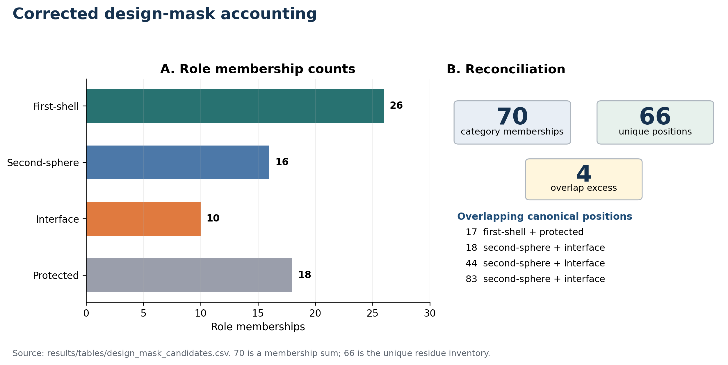
Figure TC1. Corrected design-mask accounting. Role categories overlap: 70 memberships correspond to 66 unique residue positions, with four one-count overlaps.
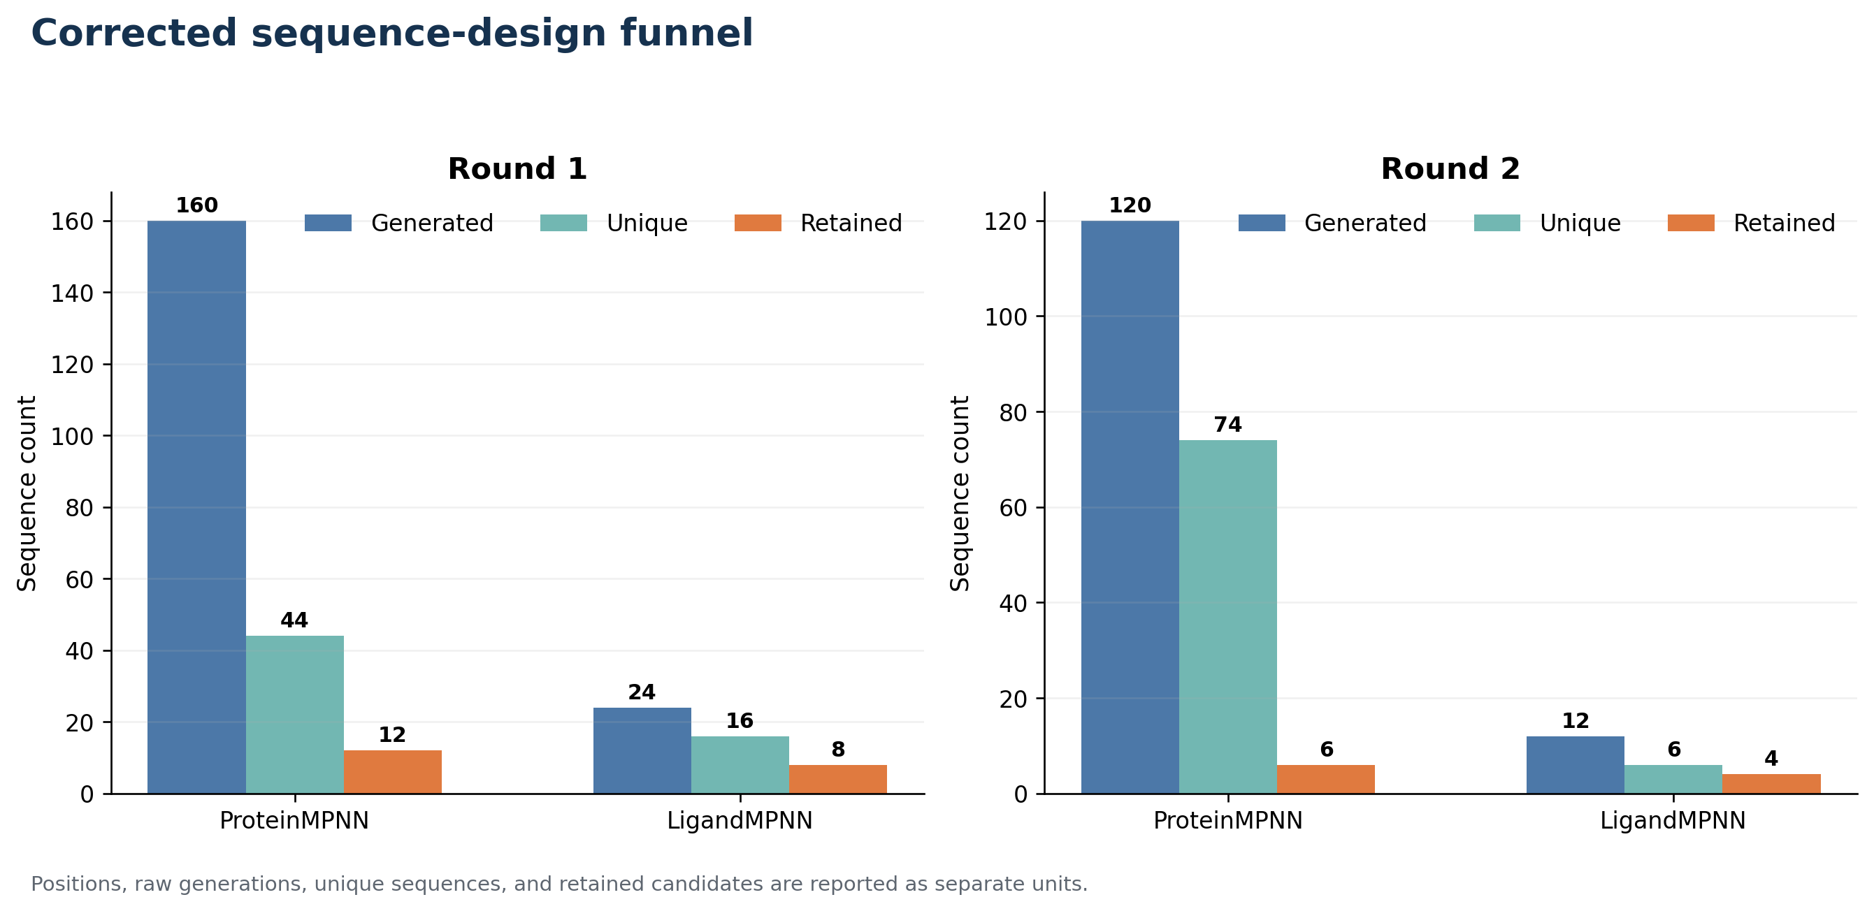
Figure TC2. Corrected design funnel. Raw generations, unique sequences, shortlisted sequences, scored candidates, and final OpenMM finalists are reported separately.
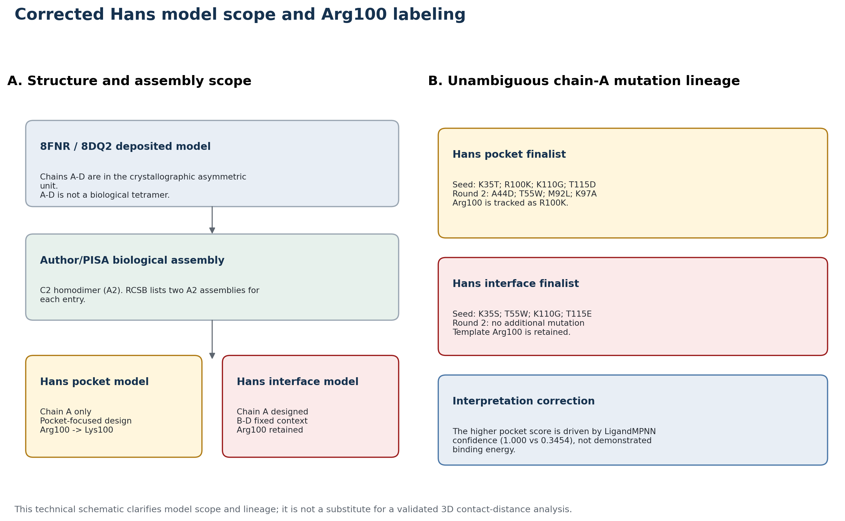
Figure TC3. Corrected Hans model scope and Arg100 labeling. The diagram distinguishes the crystallographic A-D context from A2 biological assemblies and explicitly tracks chain-A Arg100/Lys100.

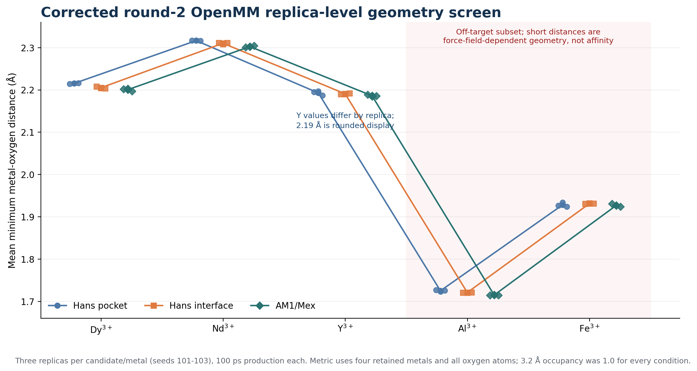
Figure TC4. Corrected round-2 OpenMM geometry screen. Every point is a replica mean. The Al/Fe values are force-field-dependent geometry results and are not interpreted as affinity or selectivity.
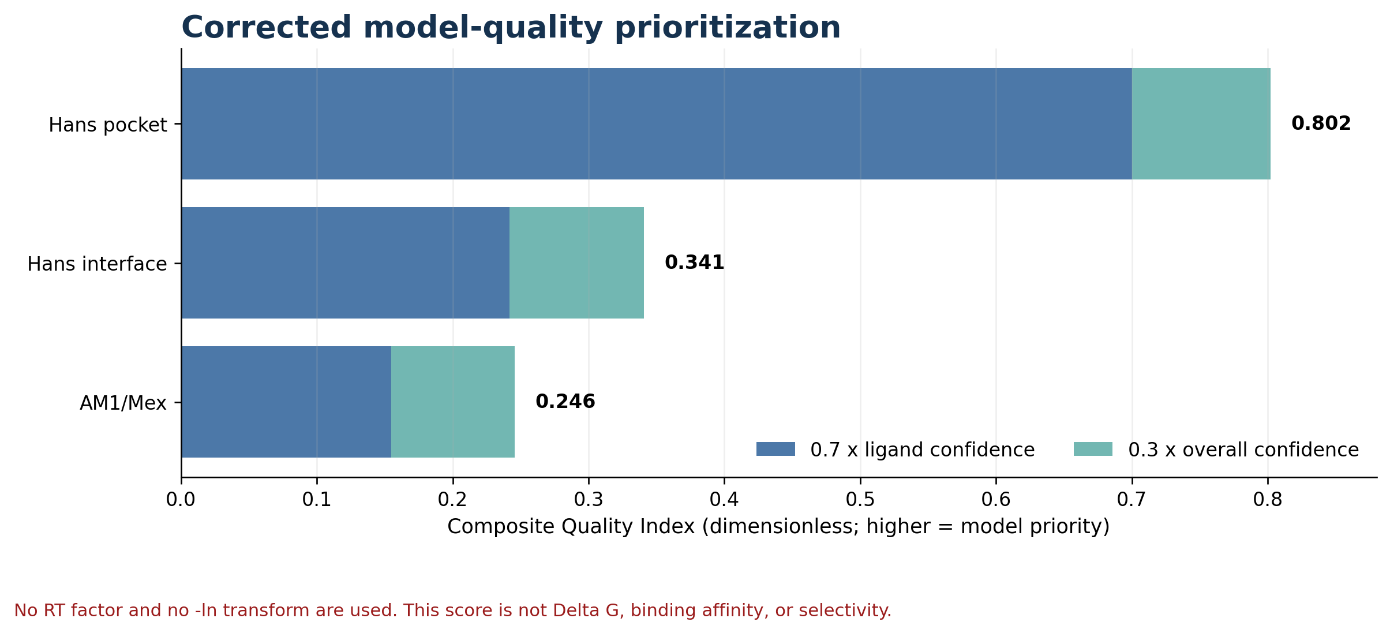
Figure TC5. Corrected model-quality prioritization. The Composite Quality Index is dimensionless and must not be labeled as Delta G, free energy, or thermodynamic affinity.

4. Corrected tables and exact technical settings

4.1 Design-mask reconciliation
Role | Memberships
First-shell | 26
Second-sphere | 16
Interface | 10
Protected | 18
Unique inventory | 66
Membership sum | 70
Overlap excess | 4
Source: design_mask_candidates.csv; overlap detail is in mask_overlaps.csv.

4.2 MPNN and Rosetta specification
Component | Exact setting | Interpretation limit
ProteinMPNN round 1 | 20 sequences/target at temperatures 0.10 and 0.15; seed 37; batch size 1 | Generative sequence sampling; not deterministic in the mathematical sense despite fixed seed.
ProteinMPNN round 2 | 20 sequences/target at temperatures 0.10 and 0.15; seed 37; batch size 1 | Same fixed-seed sampling settings.
LigandMPNN rounds 1/2 | Temperature 0.10; seed 37; 2 designs per candidate; one batch; side-chain and ligand context enabled | Model confidence is not a probability of thermodynamic binding.
Rosetta round 2 | score_jd2; nstruct=1; seed 37; fa_elec weight=0; waters retained; auto metal setup; rank within topology | Score-only triage. No relaxation, no structural-realism acceptance cutoff, and no cross-topology score comparison.
Sources: recorded run_command.txt files; rosetta_round2_candidate_ranking.csv; repository scoring code.

4.3 OpenMM protocol and metric
Component | Exact setting | Interpretation limit
OpenMM round 2 | 298 K; 1 atm; 2 fs; friction 1 ps^-1; 100 ps production; 3 replicas, seeds 101-103; 500-step reporting | Short reduced rescreen; not a binding free-energy calculation.
OpenMM metric | Mean over frames of the minimum distance from each retained metal atom to any oxygen; 3.2 Å inner-sphere cutoff | Occupancy=1.0 at this cutoff does not establish selectivity or experimentally persistent binding.
Force field | amber19-all.xml + amber19/opc3.xml; generic published OPC3-compatible 12-6-4 metal family | LanM-chelator-tuned numeric parameters are absent; Al/Fe short distances require sensitivity analysis.
Sources: simulation_config.yaml, system_build_log.txt, and 45 screening_log.txt files under results/round2_openmm_screening/.

4.4 Generic OPC3-compatible 12-6-4 metal parameters
Metal | Charge | Rmin/2 (Å) | epsilon (kcal/mol) | C4 (kcal/mol Å^4)
Dy | 3 | 1.632 | 0.0962022 | 183
Nd | 3 | 1.712 | 0.1464093 | 184
Y | 3 | 1.626 | 0.09289608 | 192
Al | 3 | 1.361 | 0.01031847 | 363
Fe | 3 | 1.455 | 0.02662782 | 429
Source: config/metal_parameter_values.yaml. The repository does not contain chelator-tuned numeric coefficients.

4.5 OpenMM candidate means
Candidate | Dy | Nd | Y | Al | Fe
Hans pocket | 2.215 ± 0.0007 | 2.316 ± 0.0004 | 2.193 ± 0.0055 | 1.725 ± 0.0017 | 1.928 ± 0.0050
Hans interface | 2.205 ± 0.0023 | 2.310 ± 0.0017 | 2.190 ± 0.0013 | 1.721 ± 0.0005 | 1.931 ± 0.0006
AM1/Mex | 2.200 ± 0.0032 | 2.302 ± 0.0021 | 2.186 ± 0.0022 | 1.715 ± 0.0006 | 1.927 ± 0.0034
Values are mean ± sample SD of three replica-level means in Å. Full six-decimal data are in openmm_replicates.csv and openmm_summary.csv.
The near-identical Y values are expected from the common Y(III) parameter model and similar first-shell coordination. The underlying nine replica means range from 2.183940 to 2.196893 Å; the repeated '2.19 Å' statement was only rounded display.

4.6 Dimensionless model-quality index
Rank | Candidate | Ligand confidence | Overall confidence | CQI
1 | Hans pocket | 1.0000 | 0.3399 | 0.801970
2 | Hans interface | 0.3454 | 0.3303 | 0.340870
3 | AM1/Mex | 0.2213 | 0.3023 | 0.245600
CQI = 0.7 x ligand confidence + 0.3 x overall confidence. It is dimensionless and has no thermodynamic interpretation.

5. Structure and model-scope correction
PDB | Deposited model | Biological assembly | Technical use
8FNR | A,B,C,D; Dy: A=4, B=3, C=3, D=4 (14 total) | A2 homodimer (C2); two author/PISA assemblies are listed | Pocket model uses chain A; interface model keeps A-D crystallographic context
8DQ2 | A,B,C,D; La: 3 per chain (12 total) | A2 homodimer (C2); author/PISA; gel-filtration evidence for assembly 1 | Reference only; do not call A-D the biological tetramer
8FNS | A; Nd: 4 | Monomeric reference in repository workflow | AM1/Mex chain-A model
6MI5 | X; Y: 3 | Monomeric reference in repository workflow | AM1/Mex reference
Primary structure sources: https://www.rcsb.org/structure/8FNR and https://www.rcsb.org/structure/8DQ2; repository inventory: results/tables/template_chain_summary.csv.
The deposited metal counts are crystallographic inventories, not numbers of equivalent functional sites. Any interface conclusion should identify the specific biological assembly or explicitly state that A-D was retained as crystallographic context.

6. Quantum evidence gap and submission gate
Submission gate
Do not present Figures 6-7, natural occupations, CASPT2 state ordering, spin-orbit conclusions, or reduced-cluster sensitivity as repository-reproduced results until the corresponding raw files are added and independently regenerated.

Required artifact | Minimum content | Status | Affected output
Dy CASSCF input and full output | Coordinates, charge/multiplicity, Hamiltonian/ECP, basis sets, CAS(9,7), roots, convergence, occupations | Absent | Dy active-space claims; Figures 6-7
Nd CASSCF input and full output | Coordinates, charge/multiplicity, Hamiltonian/ECP, basis sets, CAS(3,7), roots, convergence, occupations | Absent | Nd active-space claims; Figures 6-7
Dy/Nd CASPT2 inputs and outputs | State count, imaginary and IPEA shifts, intruder-state diagnostics, energies and convergence | Absent | CASPT2 comparison
SOC calculation files | SOC method, states mixed, spin-free roots, matrices/energies, convergence | Absent | Electronic-state ordering and anisotropy claims
Reduced-cluster coordinate and definition files | Atom/residue inventory, caps, constraints, charge/multiplicity, retained waters, cluster size | Absent | Environmental-scope claims
Natural occupation tables for every root | Seven active-orbital occupations per root with orbital identities | Absent | Active-space appropriateness
Orbital image source data | Molden/gbw or equivalent files plus orbital indices and plotting settings | Absent | Figure 7
Repository tree audit: no paths containing ORCA, CASSCF, or CASPT2 and no .in/.inp/.out quantum files were present at the audited base commit.

7. Repository correction set
Path | Purpose
README.md | Replaces the complete/reproducible and Delta-G language with a technical-correction notice and accurate limitations.
docs/technical_corrections/README.md | Human-readable scope, reviewer mapping, and regeneration instructions.
docs/technical_corrections/SOURCE_DATA_GAPS.md | Explicit quantum and manuscript-only actions that remain open.
docs/technical_corrections/LanM_Technical_Corrections_Report.{docx,pdf} | Shareable Word and PDF report.
results/technical_corrections/figures/* | Five corrected technical figures.
results/technical_corrections/tables/* | Machine-readable corrected data and provenance.
scripts/build_technical_corrections.py | Deterministic rebuild of tables, figures, report, and manifest.
requirements-technical-corrections.txt | Pinned reporting dependencies.
The manuscript file and its figures are intentionally not edited by this repository correction set.

8. Package manifest
The submission bundle includes this Word report, a PDF rendering, five corrected figures, twelve corrected/source-audit CSV tables, a figure/table manifest, repository-ready documentation, a reproducible build script, pinned reporting requirements, and SHA-256 checksums. The original reviewer PDF and manuscript are not redistributed in the generated ZIP.
Recommended share note
This technical package resolves the reproducibility, terminology, sampling, model-scope, and classical-data presentation issues that can be corrected from the repository. Quantum-source-data and manuscript-only edits remain explicit author actions.

