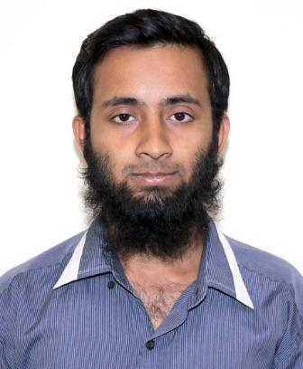

Md. Rashed Miah

(Web Developer)

Address: Wireless Gate, Mohakhali. Dhaka 1212.

Mobile: 01762223976

Email: rahbarrashed95@gmail.com

**Profile** Building up career with a challenging environment at an organization that is dynamic and where creativity, sincerity, skills and performance are the criteria for once appraisal recognition.



**Personal Details**

| Name: | MD. Rashed Miah |
| --- | --- |
| Father's Name: | Md. Khalilur Rahman |
| Mother's Name: | Rahima Begum |
| Religion: | Islam |
| Date of Birth: | 12-04-1996 |
| Gender: | Male |
| Nationality: | Bangladeshi |
| NID No: | 6455875515 |
| Permanent Address: | Vill: Kalagachia, Post: Monipur, Thana: Homna, Dist: Cumilla. |



**Education** GRADUATION IN WORLD UNIVERSITY OF BANGLADESH

SUBJECT: CSE

RESULT: 2.71 OUT OF 4



H.S.C IN KHILGAON MODEL COLLEGE, 2014.

GROUP: SCIENCE

GPA: 4.50 OUT OF 5



S.S.C IN KALAGACHIA M. A. HIGH SCHOOL, 2012.

GROUP: SCIENCE.

GPA: 4.38 OUT OF 5

*Relevant Courses:*

Web design and developing (LICT).



| **Key Skills** | **Computer Skills:** |  |
| --- | --- | --- |
|  | **Web Technologic** | ***Web Languages & Databases:***  *HTML 5, CSS 3 , Java-script, PHP*  ***Databases:*** *Mongo-DB (Mongoose), My-SQL* |
|  |  | ***Framework:*** *LARAVEL****,*** *Node-JS (Express)* |
|  |  | ***E-Commerce Platforms:*** *Woo-commerce (WordPress)* |
|  |  | ***CMS:*** *WordPress* |
|  |  |  |
|  | **Others Skills:** | *MS Word*  *Adobe Photoshop*  *Excel*  *Adobe illustrator*  *MS PowerPoint* |

| **Language** | **Reading**  Bangla High | **Writing** High | **Speaking** High |
| --- | --- | --- | --- |
| English High High Medium | | | |

**Signature**

Date: