# Technical Design Document: RahdnerSavain_ProgrammingExcercise_2

# Name: Rahdner Savain

# Date: Feb 13, 2026

# Program Description: This program prompts user to enter an email message. The program scans the message for each of the 30 common spam keywords or phrases. Each occurrence of a spam keyword increases the spam score by 1 point. The program then calculates the “spam score” and displays the likelihood that the message is spam based on the “spam score”

## Function: calculateSpamScore
Description: Scans the user email message and calculates a spam score based on occurrences of spam keywords or phrases.

Parameters:
- emailMessage (str) - the email message entered by user

Variables:
- spamScore (int) - total spam score
- foundSpam (list) - spam keywords detected
- instance (int) - number of times keyword appears

Logical Steps:
1. Initialize spamScore and foundSpam
2. Convert emailMessage to lowercase
3. Loop through SPAM_WORDS
4. Count each instance of each spam keyword
5. Add instance to spamScore
6. Store detected keywords to foundSpam list
7. Return spamScore and foundSpam

Returns:
spamScore (int)
foundSpam (list)

## Function: spamLikelihood
Description: Determines likelihood that email is spam based on spam score.

Parameters:
- rating (int) - calculated spam score

Variables:
- likelihood (str) - spam likelihood rating

Logical Steps:
1. Compare rating to spam keywords ranges
2. Assign likelihood rating
3. Return likely rating

Returns:
likelihood (str)

# Link to your repository: https://github.com/RahdnerS7335?tab=repositories

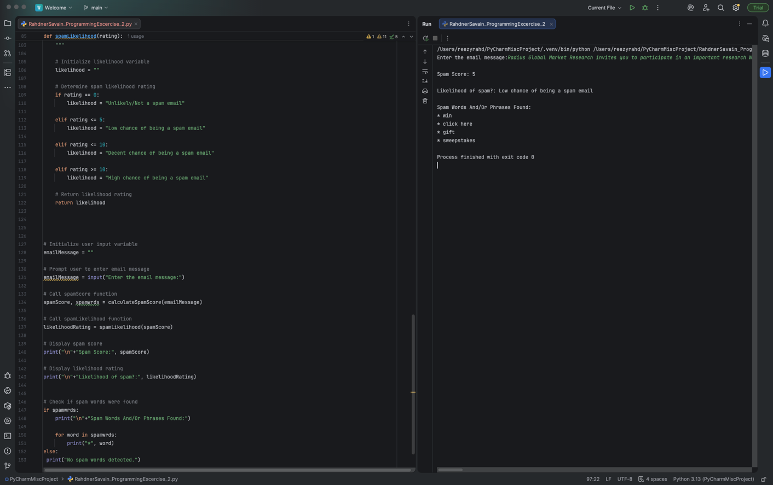
Output Screenshot

