**Name of Student: Raheel Kotwal**

**Roll Number: 45**

**Experiment Number: 6.1**

**Title: Multithreading**

**Theory:** Multithreading is the ability of a central processing unit to provide multiple threads of execution concurrently, supported by the operating system. The code below achieves that using Thread. Where two threads with a distinctive target is created and then both threads are started side by side and joined to end the execution of the threads once joined.

**Code:**

**from threading import Thread**

**from time import sleep**

***def* hi():**

**for i in range(10):**

**print("Hi")**

**sleep(0.5)**

***def* hello():**

**for i in range(10):**

**print("Hello")**

**sleep(0.5)**

**thread1=Thread(*target*=hi)**

**thread2=Thread(*target*=hello)**

**thread1.start()**

**thread2.start()**

**thread1.join()**

**thread2.join()**

**print("End of execution")**

**Output:(screenshot):**

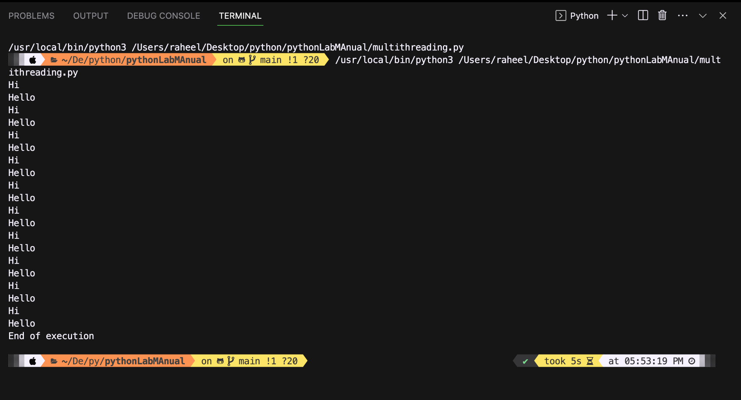

**Conclusion:**

**The code correctly shows multithreading and joining of threads before ending the execution.**